S-Table1: Phenotypic BLUEs and stability parameters for 178 GRIN soybean accessions evaluated under varying herbicide treatment conditions. Stability metrics include the AMMI Stability Value (ASV), Yield Stability Index (YSI), and their respective ranks (rASV and rYSI) and Mean trait values across environments.
Sr# | PI | MG | Flowe color | Growth Type | Origin | BLUEs |  |  |  |  | Stability Values
 |  |  |  |  |  | 150T1 | 150T2 | 300T1 | 300T1 | Dicamba Y | ASV | YSI | rASV | rYSI | means
1 | PI324924 | MG V | Purple | Indeterminate | South Africa | 2.33 | 2.33 | 3.67 | 3.00 | 3.17 | 0.35 | 223 | 126 | 97 | 2.83
2 | PI548178 | MG III | White | Determinate | United States | 3.33 | 3.33 | 4.00 | 3.33 | 2.37 | 0.17 | 63 | 52 | 11 | 3.50
3 | PI567060A | MG V | Purple | Indeterminate | Indonesia | 4.00 | 2.67 | 4.67 | 3.33 | 2.92 | 0.71 | 196 | 189 | 7 | 3.67
4 | PI567476 | MG IV | Purple | Indeterminate | China | 2.33 | 3.00 | 3.33 | 3.67 | 3.00 | 0.29 | 148 | 103 | 45 | 3.08
5 | PI495017C | MG IV | Purple | Indeterminate | China | 3.33 | 3.00 | 4.00 | 3.00 | 2.92 | 0.34 | 139.5 | 120 | 19.5 | 3.33
6 | PI567415A | MG IV | Purple | Indeterminate | China | 3.33 | 2.33 | 3.33 | 3.00 | 2.62 | 0.34 | 178 | 117 | 61 | 3.00
7 | PI430595 | MG IV | Purple | Determinate | China | 2.01 | 3.67 | 3.00 | 3.00 | 2.24 | 0.48 | 242.5 | 162 | 80.5 | 2.92
8 | PI603526 | MG IV | White | Indeterminate | China | 3.00 | 3.00 | 4.00 | 3.67 | 1.92 | 0.21 | 91.5 | 76 | 15.5 | 3.42
9 | PI525454 | MG IV | White | Indeterminate | United States | 2.67 | 2.33 | 2.67 | 2.33 | 2.50 | 0.18 | 219 | 58 | 161 | 2.50
10 | PI80837 | MG IV | Purple | Determinate | Japan | 3.67 | 2.67 | 5.00 | 4.33 | 3.0 | 0.60 | 185.5 | 183 | 2.5 | 3.92
11 | PI253661B | MG III | White | Indeterminate | China | 3.33 | 2.33 | 3.00 | 2.67 | 2.17 | 0.36 | 224 | 127 | 97 | 2.83
12 | PI603170 | MG IV | Purple | Determinate | North Korea | 3.67 | 2.00 | 4.33 | 3.00 | 2.33 | 0.81 | 223.5 | 194 | 29.5 | 3.25
13 | PI602492 | MG III | Purple | Indeterminate | China | 2.33 | 2.33 | 2.00 | 3.00 | 3.00 | 0.39 | 310.5 | 141 | 169.5 | 2.42
14 | PI603675 | MG III | Purple | Semi determinate | China | 2.67 | 2.33 | 2.67 | 2.67 | 4.49 | 0.14 | 190.5 | 38 | 152.5 | 2.58
15 | PI603162 | MG IV | White | Indeterminate | North Korea | 3.00 | 2.67 | 3.33 | 3.00 | 2.50 | 0.15 | 104 | 43 | 61 | 3.00
16 | PI62203 | MG V | White | Indeterminate | China | 2.33 | 2.33 | 4.00 | 2.67 | 2.2 | 0.55 | 271 | 174 | 97 | 2.83
17 | PI567381B | MG V | White | Determinate | China | 2.33 | 2.67 | 3.00 | 2.33 | 2.25 | 0.08 | 166.5 | 21 | 145.5 | 2.58
18 | PI157487B | MG IV | White | Indeterminate | South Korea | 3.00 | 3.00 | 4.00 | 4.00 | 2.87 | 0.18 | 72 | 61 | 11 | 3.50
19 | PI548464 | MG V | White | Determinate | China | 2.00 | 3.00 | 3.98 | 3.00 | 2.92 | 0.45 | 220 | 159 | 61 | 3.00
20 | PI639740 | MG IV | NA | NA | United States | 2.33 | 2.67 | 2.67 | 3.00 | 3.17 | 0.21 | 214.5 | 77 | 137.5 | 2.67
21 | PI567390 | MG V | White | Determinate | China | 3.00 | 3.00 | 3.33 | 3.33 | 2.23 | 0.04 | 43.5 | 8 | 35.5 | 3.17
22 | PI91132-3 | MG IV | White | Indeterminate | China | 3.00 | 3.33 | 4.00 | 3.67 | 1.9 | 0.16 | 60 | 49 | 11 | 3.50
23 | PI200503 | MG V | Purple | Determinate | Japan | 2.67 | 3.00 | 4.00 | 3.67 | 2.04 | 0.27 | 118.5 | 95 | 23.5 | 3.33
24 | PI603497 | MG III | Purple | Determinate | China | 1.67 | 2.33 | 2.33 | 2.67 | 1.42 | 0.28 | 282 | 98 | 184 | 2.25
25 | PI88448 | MG III | White | Indeterminate | China | 3.00 | 2.33 | 3.00 | 3.00 | 2.7 | 0.18 | 160 | 63 | 97 | 2.83
26 | PI598358 | MG V | Purple | Determinate | United States | 2.33 | 2.00 | 2.33 | 3.00 | 1.67 | 0.16 | 220.5 | 51 | 169.5 | 2.42
27 | PI417479 | MG IV | Purple | Determinate | Japan | 2.00 | 3.00 | 2.33 | 2.67 | 3.04 | 0.41 | 304 | 143 | 161 | 2.50
28 | PI458515 | MG IV | White | Semi determinate | China | 3.00 | 3.00 | 3.00 | 3.00 | 2.87 | 0.25 | 114.5 | 85 | 29.5 | 3.25
29 | PI567336B | MG IV | Purple | Indeterminate | China | 2.33 | 2.33 | 2.67 | 3.00 | 2.17 | 0.15 | 108 | 47 | 61 | 3.00
30 | PI68423 | MG III | Purple | Indeterminate | China | 2.67 | 2.67 | 2.67 | 3.33 | 3.7 | 0.11 | 172.5 | 27 | 145.5 | 2.58
31 | PI603574 | MG IV | Purple | Indeterminate | China | 2.67 | 3.00 | 2.67 | 3.67 | 1.92 | 0.25 | 198 | 87 | 111 | 2.83
32 | PI578495 | MG IV | White | Indeterminate | China | 2.33 | 2.00 | 2.67 | 2.00 | 2.83 | 0.41 | 208 | 147 | 61 | 3.00
33 | PI92604 | MG IV | White | Indeterminate | China | 3.33 | 2.50 | 2.67 | 3.00 | 3.3 | 0.23 | 264 | 80 | 184 | 2.25
34 | PI548402 | MG IV | White | Determinate | China | 2.67 | 3.00 | 3.00 | 2.67 | 3.42 | 0.32 | 202.5 | 116 | 86.5 | 2.88
35 | PI70242-2 | MG IV | Purple | Indeterminate | China | 2.00 | 2.00 | 2.00 | 2.33 | 2.1 | 0.07 | 126 | 15 | 111 | 2.83
36 | PI424078 | MG III | Purple | Indeterminate | South Korea | 2.67 | 2.33 | 3.00 | 3.33 | 2.50 | 0.19 | 256 | 65 | 191 | 2.08
37 | PI398610 | MG V | Purple | Determinate | South Korea | 2.33 | 2.67 | 3.33 | 2.67 | 2.50 | 0.02 | 99 | 2 | 97 | 2.83
38 | PI81785 | MG III | Purple | Indeterminate | Japan | 2.33 | 3.00 | 4.00 | 3.67 | 2.8 | 0.18 | 178.5 | 56 | 122.5 | 2.75
39 | PI567552 | MG IV | White | Semi determinate | China | 2.33 | 2.33 | 3.33 | 3.00 | 2.58 | 0.36 | 157.5 | 128 | 29.5 | 3.25
40 | PI342434 | MG V | Purple | Determinate | Japan | 1.33 | 2.00 | 3.48 | 3.01 | 1.49 | 0.21 | 197.5 | 75 | 122.5 | 2.75
41 | PI597387 | MG III | Purple | Indeterminate | United States | 2.00 | 2.00 | 1.67 | 3.00 | 4.50 | 0.52 | 336 | 169 | 167 | 2.46
42 | PI567548 | MG IV | White | Indeterminate | China | 2.00 | 2.00 | 2.67 | 3.00 | 2.79 | 0.46 | 350 | 160 | 190 | 2.17
43 | PI90479P | MG IV | White | Determinate | China | 2.00 | 2.00 | 2.67 | 2.33 | 2.5 | 0.11 | 197.5 | 25 | 172.5 | 2.42
44 | PI593258 | MG III | White | Indeterminate | United States | 3.33 | 3.00 | 3.33 | 3.00 | 3.21 | 0.10 | 207 | 23 | 184 | 2.25
45 | PI632654 | MG V | NA | NA | Vietnam | 2.00 | 2.33 | 1.67 | NA | 2.75 | 0.18 | 94.5 | 59 | 35.5 | 3.17
46 | PI399058 | MG V | White | Determinate | South Korea | 2.00 | 2.33 | 3.00 | 2.67 | 2.08 | 0.43 | 336 | 152 | 184 | 2.25
47 | FC3654-1 | MG IV | White | Indeterminate | China | 2.67 | 2.67 | 2.67 | 3.00 | 2.8 | 0.39 | 332 | 140 | 192 | 2.03
48 | PI398595 | MG V | Purple | Determinate | South Korea | 3.00 | 2.67 | 3.67 | 2.33 | 2.17 | 0.16 | 211 | 50 | 161 | 2.50
49 | PI603401 | MG IV | White | Indeterminate | China | 2.67 | 2.67 | 3.33 | 3.33 | 3.17 | 0.19 | 188.5 | 66 | 122.5 | 2.75
50 | PI592937 | MG IV | Purple | Indeterminate | China | 2.67 | 3.00 | 3.33 | 3.00 | 2.67 | 0.42 | 228.5 | 148 | 80.5 | 2.92
51 | PI438500 | MG III | Purple | Indeterminate | United States | 3.00 | 3.00 | 3.00 | 2.33 | 2.58 | 0.07 | 80 | 19 | 61 | 3.00
52 | PI603556 | MG III | Purple | Indeterminate | China | 3.00 | 3.33 | 2.00 | 3.00 | 2.92 | 0.06 | 70 | 9 | 61 | 3.00
53 | PI574477 | MG IV | White | Indeterminate | China | 2.67 | 3.33 | 2.67 | 3.33 | 2.19 | 0.18 | 157 | 60 | 97 | 2.83
54 | PI603557 | MG IV | Purple | Indeterminate | China | 1.50 | 3.33 | NA | 1.97 | 1.99 | 0.66 | 283 | 186 | 97 | 2.83
55 | PI424005 | MG III | White | Determinate | South Korea | 3.33 | 2.33 | 3.67 | 3.67 | 1.17 | 0.44 | 216 | 155 | 61 | 3.00
56 | PI91725 | MG V | White | Indeterminate | North Korea | 3.67 | 2.49 | NA | NA | 3.1 | 0.38 | 312 | 138 | 174 | 2.36
57 | PI567458 | MG IV | Purple | Indeterminate | China | 2.67 | 3.00 | 3.33 | 3.00 | 2.83 | 0.27 | 122.5 | 93 | 29.5 | 3.25
58 | PI594922 | MG V | Purple | Determinate | United States | 3.33 | 2.99 | NA | 2.98 | 2.75 | 0.35 | 150 | 124 | 26 | 3.26
59 | PI79832 | MG V | White | Indeterminate | China | 3.00 | 2.67 | 2.67 | 3.00 | 3.5 | 0.06 | 71 | 10 | 61 | 3.00
60 | PI84656 | MG III | Purple | Indeterminate | South Korea | 3.33 | 3.33 | 3.00 | 3.67 | 3.3 | 0.19 | 97 | 64 | 33 | 3.19
61 | PI632418 | MG V | NA | NA | United States | 2.67 | 2.67 | 3.00 | 3.33 | 2.75 | 0.24 | 193 | 82 | 111 | 2.83
62 | PI567731 | MG III | Dark purple | Semi determinate | China | 2.33 | 2.67 | 2.00 | 3.33 | 3.17 | 0.34 | 137.5 | 118 | 19.5 | 3.33
63 | PI567331 | MG IV | Purple | Indeterminate | China | 3.00 | 3.67 | 3.00 | 3.67 | 2.08 | 0.11 | 108.5 | 28 | 80.5 | 2.92
64 | PI404188A | N/A | White | Indeterminate | China | 2.67 | 3.00 | 3.00 | 3.67 | 2.83 | 0.55 | 323.5 | 178 | 145.5 | 2.58
65 | PI79797 | MG III | White | Indeterminate | China | 2.33 | 3.00 | 3.00 | 3.00 | 3.3 | 0.44 | 176.5 | 153 | 23.5 | 3.33
66 | PI91731-1 | MG IV | Purple | Indeterminate | China | 2.67 | 3.00 | 3.33 | 3.33 | 2.4 | 0.28 | 151 | 101 | 50 | 3.08
67 | PI398881 | N/A | Purple | Indeterminate | South Korea | 2.67 | 3.33 | 3.33 | 3.00 | 2.17 | 0.20 | 170 | 73 | 97 | 2.83
68 | PI549023B | MG V | White | Determinate | China | 3.00 | 2.33 | 3.67 | 2.98 | 2.17 | 0.11 | 74 | 29 | 45 | 3.08
69 | PI603494 | MG IV | White | Indeterminate | China | 3.00 | 3.00 | 3.00 | 3.67 | 2.67 | 0.12 | 77 | 32 | 45 | 3.08
70 | PI603687A | MG IV | White | Determinate | China | 2.67 | 2.67 | 3.00 | 3.00 | 1.83 | 0.36 | 191 | 130 | 61 | 3.00
71 | PI597384 | MG IV | NA | NA | United States | 2.67 | 2.67 | 3.00 | 3.00 | 2.92 | 0.25 | 127 | 88 | 39 | 3.17
72 | PI378682C | MG IV | Purple | Semi determinate | Japan | 2.67 | 2.00 | 3.33 | 2.67 | 2.83 | 0.04 | 116 | 5 | 111 | 2.83
73 | PI603457B | MG IV | White | Indeterminate | China | 3.00 | 3.00 | 3.33 | 3.33 | 1.87 | 0.04 | 118 | 7 | 111 | 2.83
74 | PI556511 | MG III | Purple | Indeterminate | United States | 2.33 | 3.00 | 3.00 | 3.00 | 3.83 | 0.36 | 269.5 | 132 | 137.5 | 2.67
75 | PI79870-4 | MG IV | Purple | Indeterminate | China | 2.00 | 3.00 | 3.00 | 3.00 | 2.4 | 0.04 | 39.5 | 4 | 35.5 | 3.17
76 | PI538386A | MG III | White | Semi determinate | China | 3.00 | 2.67 | 3.33 | 3.00 | 3.00 | 0.20 | 167 | 70 | 97 | 2.83
77 | PI54615-1 | MG III | Purple | Indeterminate | China | 3.00 | 3.00 | 2.33 | 4.00 | 2.8 | 0.30 | 231.5 | 109 | 122.5 | 2.75
78 | PI123587 | MG V | Purple | Indeterminate | China | 2.00 | 2.00 | 2.67 | 2.67 | 2.25 | 0.15 | 105 | 44 | 61 | 3.00
79 | PI605839A | MG IV | Purple | Determinate | Vietnam | 2.33 | 2.33 | 3.33 | 3.00 | 2.92 | 0.60 | 229 | 184 | 45 | 3.08
80 | PI567428 | MG IV | Purple | Indeterminate | China | 1.67 | 3.00 | 1.67 | 3.00 | 2.42 | 0.07 | 196 | 17 | 179 | 2.33
81 | PI90495N | MG IV | Purple | Determinate | China | 2.00 | 3.00 | 3.00 | 3.00 | 3.5 | 0.25 | 221 | 90 | 131 | 2.70
82 | PI574486 | NA | White | Indeterminate | China | 1.67 | 2.33 | 2.33 | 2.67 | 3.19 | 0.21 | 196.5 | 74 | 122.5 | 2.75
83 | PI90763 | MG IV | Purple | Indeterminate | China | 2.33 | 3.00 | 2.33 | 3.00 | 3.3 | 0.78 | 368.5 | 192 | 176.5 | 2.33
84 | PI603492 | MG IV | White | Indeterminate | China | 3.33 | 3.00 | 2.00 | 2.67 | 3.25 | 0.30 | 232.5 | 110 | 122.5 | 2.75
85 | PI235347 | MG IV | White | Determinate | Japan | 2.33 | 3.00 | 4.67 | 4.33 | 2.62 | 0.28 | 283 | 99 | 184 | 2.25
86 | PI87076 | MG V | Purple | Indeterminate | North Korea | 3.00 | 2.67 | 4.33 | 3.00 | 2.6 | 0.44 | 287 | 154 | 133 | 2.67
87 | PI567439 | MG V | Purple | Indeterminate | China | 4.00 | 3.00 | 2.67 | 2.98 | 1.83 | 0.59 | 303.5 | 181 | 122.5 | 2.75
88 | PI567519 | MG III | White | Indeterminate | China | 2.00 | 3.00 | 3.33 | 3.33 | 4.00 | 0.58 | 187 | 179 | 8 | 3.58
89 | PI475812B | MG III | Purple | Determinate | China | 2.67 | 2.33 | 3.33 | 2.67 | 2.42 | 0.55 | 202.5 | 173 | 29.5 | 3.25
90 | PI587804 | MG IV | Purple | Indeterminate | China | 4.00 | 3.33 | 4.33 | 4.00 | 2.42 | 0.53 | 209 | 170 | 39 | 3.17
91 | PI90499-1 | MG III | Purple | Indeterminate | China | 2.67 | 3.33 | 2.33 | 3.00 | 3.3 | 0.34 | 196.5 | 123 | 73.5 | 2.92
92 | PI398593 | MG V | Purple | Determinate | South Korea | 2.67 | 2.67 | 3.00 | 3.00 | 2.00 | 0.27 | 214.5 | 92 | 122.5 | 2.75
93 | PI603911B | MG III | White | Indeterminate | North Korea | 2.67 | 3.00 | 3.00 | 3.00 | 3.42 | 0.25 | 88.5 | 86 | 2.5 | 3.92
94 | PI548158 | MG IV | White | Indeterminate | United States | 4.33 | 3.67 | 4.00 | 3.67 | 1.67 | 0.51 | 264 | 167 | 97 | 2.83
95 | PI92618 | MG III | White | Indeterminate | China | 2.00 | 2.67 | 2.67 | 2.67 | 3.3 | 0.04 | 117 | 6 | 111 | 2.83
96 | PI567387 | MG IV | Purple | Indeterminate | China | 2.33 | 3.33 | 3.00 | 3.00 | 1.92 | 0.13 | 117.5 | 37 | 80.5 | 2.92
97 | PI603505 | MG IV | White | Determinate | China | 2.67 | 2.67 | 2.67 | 2.67 | 1.58 | 0.30 | 110.5 | 108 | 2.5 | 3.92
98 | PI88788 | MG III | White | Indeterminate | China | 1.67 | 3.00 | 2.33 | 3.00 | 3.5 | 0.20 | 230 | 69 | 161 | 2.50
99 | PI567651 | MG IV | White | Semi determinate | China | 3.33 | 3.00 | 3.00 | 3.00 | 1.67 | 0.30 | 179.5 | 106 | 73.5 | 2.92
100 | PI398965 | MG IV | White | Indeterminate | South Korea | 3.33 | 3.00 | 2.33 | 2.67 | 3.45 | 0.15 | 182.5 | 45 | 137.5 | 2.67
101 | PI88499 | MG IV | White | Determinate | China | 3.67 | 3.00 | 3.00 | 3.00 | 2.2 | 0.55 | 336 | 175 | 161 | 2.50
102 | PI92651 | MG IV | White | Indeterminate | China | 2.00 | 2.33 | 2.33 | 2.00 | 3.2 | 0.24 | 126 | 81 | 45 | 3.08
103 | PI508269 | MG IV | Purple | Determinate | United States | 2.00 | 1.33 | 2.67 | 2.00 | 2.12 | 0.46 | 258 | 161 | 97 | 2.83
104 | PI603154 | MG V | White | Determinate | North Korea | 3.00 | 2.33 | 3.46 | 2.67 | 2.58 | 0.34 | 158 | 119 | 39 | 3.17
105 | PI567435B | MG III | White | Indeterminate | China | 2.67 | 3.00 | 3.00 | 2.67 | 2.92 | 0.48 | 187.5 | 164 | 23.5 | 3.33
106 | PI209331 | MG III | White | Indeterminate | Japan | 3.33 | 3.33 | 3.67 | 3.33 | 2.50 | 0.07 | 204.5 | 16 | 188.5 | 2.17
107 | PI594599 | MG IV | Purple | Semi determinate | China | 2.00 | 1.33 | 2.33 | 1.48 | 2.67 | 0.36 | 324.5 | 131 | 193.5 | 2.00
108 | PI417581 | MG V | White | Indeterminate | United States | 2.33 | 2.00 | 4.00 | 2.00 | 2.67 | 0.38 | 222.5 | 136 | 86.5 | 2.88
109 | PI438112B | MG III | Purple | Indeterminate | China | 2.67 | 3.00 | 2.67 | 3.33 | 2.62 | 0.07 | 125 | 14 | 111 | 2.83
110 | PI437679 | MG IV | Purple | Semi determinate | China | 2.33 | 2.67 | 2.33 | 3.51 | 2.75 | 0.06 | 25 | 11 | 14 | 3.42
111 | PI603910C | MG V | Purple | Indeterminate | North Korea | 3.00 | 3.00 | 2.33 | 3.01 | 1.92 | 0.01 | 156 | 1 | 155 | 2.53
112 | PI437476 | MG III | Purple | Indeterminate | Russia | 2.00 | 3.00 | 3.00 | 4.00 | 2.64 | 0.36 | 329 | 133 | 196 | 1.79
113 | PI567361 | MG III | White | Indeterminate | China | 2.67 | 3.00 | 4.00 | 2.33 | 3.00 | 0.75 | 336.5 | 191 | 145.5 | 2.58
114 | PI603174A | MG IV | White | Indeterminate | North Korea | 2.67 | 3.00 | 3.00 | 3.00 | 2.92 | 0.38 | 234 | 137 | 97 | 2.83
115 | PI437655 | MG III | Purple | Indeterminate | China | 2.33 | 2.33 | 2.48 | 1.98 | 3.50 | 0.34 | 202.5 | 122 | 80.5 | 2.92
116 | PI479735 | MG III | Purple | Indeterminate | China | 2.67 | 3.33 | 3.00 | 2.67 | 2.74 | 0.45 | 288 | 158 | 130 | 2.71
117 | PI404161 | MG IV | White | Indeterminate | Georgia | 2.00 | 2.33 | 3.00 | 2.33 | 2.42 | 0.44 | 253 | 156 | 97 | 2.83
118 | PI87571 | MG IV | White | Determinate | North Korea | 2.00 | 3.33 | 2.67 | 3.33 | 2.9 | 0.52 | 229 | 168 | 61 | 3.00
119 | PI253656B | MG IV | Purple | Indeterminate | China | 3.00 | 2.98 | 2.33 | NA | 2.08 | 0.43 | 212 | 151 | 61 | 3.00
120 | PI567599 | MG III | White | Semi determinate | China | 2.33 | 2.33 | 2.00 | 2.33 | 2.25 | 0.13 | 116.5 | 36 | 80.5 | 2.92
121 | PI438310 | MG III | White | Indeterminate | North Korea | 3.00 | 4.00 | 3.00 | 4.00 | 2.49 | 0.37 | 195 | 134 | 61 | 3.00
122 | PI54614 | MG IV | Purple | Indeterminate | China | 3.00 | 2.67 | 3.00 | 3.00 | 2.5 | 0.12 | 211 | 31 | 180 | 2.29
123 | PI407742 | MG V | White | Determinate | China | 3.67 | 2.67 | 3.67 | 3.00 | 2.27 | 0.16 | 128.5 | 48 | 80.5 | 2.92
124 | PI68521-1 | MG III | Purple | Determinate | China | 2.00 | 2.33 | 4.00 | 3.00 | 2.2 | 0.18 | 226.5 | 57 | 169.5 | 2.42
125 | PI438335 | MG III | Purple | Indeterminate | Algeria | 2.67 | 2.67 | 3.33 | 2.67 | 2.67 | 0.13 | 187.5 | 35 | 152.5 | 2.58
126 | PI567698A | MG IV | White | Semi determinate | China | 2.33 | 2.33 | 2.67 | 2.33 | 2.25 | 0.18 | 250.5 | 62 | 188.5 | 2.17
127 | PI567392 | MG V | Purple | Determinate | China | 3.67 | 2.67 | 4.33 | 2.67 | 3.08 | 0.81 | 377 | 193 | 184 | 2.25
128 | FC31571 | MG III | White | Indeterminate | China | 2.00 | 3.00 | 3.00 | 3.00 | 2.3 | 0.55 | 273 | 176 | 97 | 2.83
129 | PI549018 | MG V | White | Indeterminate | China | 3.00 | 3.00 | NA | 3.97 | 2.08 | 0.43 | 266 | 150 | 116 | 2.81
130 | PI54591 | MG III | Purple | Indeterminate | China | 2.33 | 3.00 | 3.33 | 3.00 | 4.0 | 0.29 | 289 | 105 | 184 | 2.25
131 | PI86972-2 | MG IV | Purple | Indeterminate | South Korea | 2.67 | 2.67 | 2.67 | 2.33 | 3.9 | 0.61 | 196 | 185 | 11 | 3.50
132 | PI567265 | MG IV | Purple | Semi determinate | China | 2.33 | 2.33 | 3.33 | 2.33 | 2.58 | 0.32 | 259.5 | 114 | 145.5 | 2.58
133 | PI567726 | MG IV | Purple | Indeterminate | China | 3.00 | 2.67 | 3.00 | 3.00 | 3.83 | 0.14 | 120.5 | 40 | 80.5 | 2.92
134 | PI567638 | MG IV | White | Indeterminate | China | 3.99 | 2.33 | 3.67 | 2.33 | 2.08 | 0.41 | 174.5 | 145 | 29.5 | 3.25
135 | PI567582A | MG IV | White | Semi determinate | China | 3.00 | 2.33 | 2.67 | 2.33 | 3.08 | 0.11 | 152.5 | 30 | 122.5 | 2.75
136 | PI92728 | MG III | Purple | Indeterminate | China | 2.67 | 3.33 | 3.67 | 2.33 | 2.8 | 0.25 | 226.5 | 89 | 137.5 | 2.67
137 | PI602993 | MG IV | White | Indeterminate | China | 2.33 | 2.67 | 3.00 | 2.33 | 2.75 | 0.54 | 268 | 171 | 97 | 2.83
138 | PI567721 | MG IV | White | Semi determinate | China | 2.00 | 2.67 | 3.00 | 3.00 | 2.6 | 0.17 | 164 | 53 | 111 | 2.83
139 | PI79691-4 | MG III | White | Determinate | China | 3.67 | 4.00 | 5.00 | 3.00 | 1.8 | 0.06 | 181.5 | 12 | 169.5 | 2.42
140 | PI90486 | MG III | Purple | Indeterminate | China | 3.00 | 3.33 | 2.67 | 3.33 | 2.4 | 0.69 | 211.5 | 188 | 23.5 | 3.33
141 | PI464920B | MG III | White | Determinate | China | 2.67 | 2.67 | 2.33 | 2.67 | 3.79 | 0.30 | 233.5 | 111 | 122.5 | 2.75
142 | PI209332 | MG IV | Purple | Indeterminate | Japan | 3.33 | 3.67 | 4.67 | 3.33 | 2.67 | 0.11 | 43 | 26 | 17 | 3.42
143 | PI84946-2 | MG IV | Purple | Determinate | South Korea | 1.67 | 3.00 | 4.00 | 2.33 | 2.8 | 0.17 | 128.5 | 55 | 73.5 | 2.92
144 | PI377574 | MG IV | White | Determinate | Japan | 3.00 | 2.33 | 3.67 | 2.67 | 2.67 | 0.15 | 194.5 | 42 | 152.5 | 2.58
145 | PI86084 | MG V | Purple | Indeterminate | Japan | 3.00 | 2.49 | NA | 2.48 | 2.8 | 0.31 | 257.5 | 112 | 145.5 | 2.58
146 | PI567532 | MG IV | White | Semi determinate | China | 1.67 | 3.00 | 2.00 | 2.67 | 2.67 | 0.14 | 119.5 | 39 | 80.5 | 2.92
147 | PI438312 | MG III | Purple | Indeterminate | Algeria | 2.00 | 2.00 | 3.33 | 3.00 | 2.42 | 0.75 | 235 | 190 | 45 | 3.08
148 | PI567780B | MG IV | Dark purple | Semi determinate | China | 2.33 | 2.00 | 3.00 | 2.00 | 2.08 | 0.30 | 252.5 | 107 | 145.5 | 2.58
149 | FC33243 | MG IV | White | Indeterminate | Unknown | 2.00 | 2.33 | 2.00 | 3.00 | 3.9 | 0.20 | 128 | 67 | 61 | 3.00
150 | PI430598B | MG IV | Purple | Indeterminate | China | 2.67 | 2.00 | 3.00 | 2.00 | 3.58 | 0.08 | 165.5 | 20 | 145.5 | 2.58
151 | PI398614 | MG V | Purple | Determinate | South Korea | 2.67 | 3.00 | 3.04 | 2.33 | 2.42 | 0.23 | 216.5 | 79 | 137.5 | 2.67
152 | PI437725 | MG IV | Purple | Semi determinate | China | 2.00 | 1.00 | 2.33 | 2.00 | 3.50 | 0.49 | 167.5 | 165 | 2.5 | 3.92
153 | PI549017 | MG IV | White | Indeterminate | China | 2.33 | 1.33 | 4.00 | 2.33 | 1.62 | 0.42 | 194 | 149 | 45 | 3.08
154 | PI572239 | NA | Purple | Determinate | United States | 2.33 | 2.00 | 1.96 | 1.67 | 2.7 | 0.29 | 256.5 | 104 | 152.5 | 2.58
155 | PI548364 | MG IV | White | Indeterminate | Japan | 2.33 | 2.00 | 2.67 | 3.00 | 3.33 | 0.37 | 140 | 135 | 5 | 3.75
156 | FC31697 | MG IV | Purple | Indeterminate | Costa Rica | 2.33 | 3.00 | 3.00 | 3.00 | 3.0 | 0.55 | 299.5 | 177 | 122.5 | 2.75
157 | PI561271 | MG V | White | Indeterminate | China | 3.98 | 2.49 | NA | 4.48 | 2.42 | 0.44 | 237.5 | 157 | 80.5 | 2.92
158 | PI552538 | MG III | Purple | Indeterminate | United States | 2.33 | 2.33 | 3.00 | 3.00 | 4.17 | 0.25 | 213 | 84 | 129 | 2.75
159 | PI416768 | MG V | White | Determinate | Japan | 2.33 | 3.02 | 3.33 | 3.00 | 2.33 | 0.58 | 356.5 | 180 | 176.5 | 2.33
160 | PI506862 | MG IV | White | Determinate | Japan | 3.33 | 3.00 | 3.67 | 2.33 | 2.75 | 0.31 | 258.5 | 113 | 145.5 | 2.58
161 | PI507480 | MG IV | White | Determinate | Japan | 2.00 | 2.67 | 2.67 | 2.67 | 2.12 | 0.34 | 297.5 | 121 | 176.5 | 2.33
162 | PI561387 | MG V | White | Determinate | Japan | 2.00 | 2.33 | 4.00 | 3.00 | 2.08 | 0.41 | 322.5 | 146 | 176.5 | 2.33
163 | PI70208 | MG IV | Purple | Indeterminate | China | 2.33 | 3.00 | 3.00 | 3.00 | 2.3 | 0.40 | 314.5 | 142 | 172.5 | 2.42
164 | PI379618 | MG V | Purple | Determinate | Taiwan | 2.67 | 3.00 | 3.67 | 2.67 | 3.00 | 0.07 | 135.5 | 13 | 122.5 | 2.75
165 | PI587712B | MG V | White | Determinate | China | 3.00 | 2.67 | 3.00 | 3.33 | 2.36 | 0.35 | 320 | 125 | 195 | 1.83
166 | PI92718-2 | MG III | Purple | Indeterminate | China | 1.67 | 2.67 | 3.00 | 2.67 | 3.3 | 0.87 | 356 | 195 | 161 | 2.50
167 | PI594883 | MG IV | Purple | Semi determinate | China | 2.33 | 2.33 | 3.00 | 2.67 | 2.67 | 0.26 | 284.5 | 91 | 193.5 | 2.00
168 | PI567357 | MG III | White | Indeterminate | China | 2.33 | 3.00 | 3.33 | 2.67 | 2.33 | 0.02 | 164 | 3 | 161 | 2.50
169 | PI583366 | MG IV | White | Indeterminate | United States | 3.00 | 3.00 | 3.00 | 3.00 | 2.33 | 0.20 | 169 | 72 | 97 | 2.83
170 | PI603496B | MG IV | White | Indeterminate | China | 2.00 | 3.33 | 3.67 | 3.00 | 3.00 | 0.28 | 106 | 100 | 6 | 3.75
171 | PI548619 | MG IV | White | Indeterminate | United States | 3.33 | 2.33 | 3.33 | 4.33 | 3.83 | 0.07 | 151 | 18 | 133 | 2.67
172 | PI540555 | MG IV | White | Indeterminate | United States | 2.67 | 3.00 | 2.67 | 3.00 | 3.33 | 0.17 | 127.5 | 54 | 73.5 | 2.92
173 | PI567604A | MG IV | White | Determinate | China | 2.33 | 3.00 | 2.00 | 2.67 | 3.06 | 0.39 | 184 | 139 | 45 | 3.08
174 | PI424608A | MG IV | Purple | Indeterminate | South Korea | 4.00 | 2.67 | 4.33 | 3.00 | 2.08 | 0.20 | 232 | 71 | 161 | 2.50
175 | PI93563 | MG III | White | Indeterminate | China | 2.00 | 2.33 | 3.33 | 3.00 | 3.2 | 0.54 | 269 | 172 | 97 | 2.83
176 | PI594660A | MG V | White | Determinate | China | 3.00 | 2.00 | 2.67 | 3.00 | 2.25 | 0.20 | 165 | 68 | 97 | 2.83
177 | PI404182 | MG III | Light purple | Indeterminate | China | 2.00 | 3.33 | 3.33 | 3.67 | 2.17 | 0.91 | 215.5 | 196 | 19.5 | 3.33
178 | PI548162 | MG IV | White | Semi determinate | United States | 3.00 | 3.33 | 3.00 | 3.33 | 3.17 | 0.22 | 139 | 78 | 61 | 3.00

Supplementary Table 2. ANOVA table of metribuzin injuries.
 |  | F | Df | Df.res | Pr(>F)
TRIAL 1 | Taxa | 3.8628 | 195 | 663.86 | < 2.2e-16 | ***
 | DOSE | 53.7249 | 1 | 8.08 | 7.75E-05 | ***
 | Taxa:DOSE | 1.5353 | 188 | 666.27 | 6.36E-05 | ***
TRIAL 2 | Taxa | 2.6681 | 195 | 655.01 | <2.2e-16 | ***
 | DOSE | 26.112 | 1 | 7.99 | 0.0009222 | ***
 | Taxa:DOSE | 1.016 | 191 | 656.56 | 0.437333
TRIAL 1 + TRIAL 2 | Taxa | 4.426 | 195 | 1458.1 | <2.2e-16 | ***
 | DOSE | 79.5836 | 1 | 16.09 | 1.26E-07 | ***
 | TRAIL | 1.1545 | 1 | 16.04 | 0.2985059
 | Taxa:DOSE | 1.4334 | 194 | 1457.2 | 0.0002215 | ***
 | Taxa:TRAIL | 2.2082 | 195 | 1411.71 | 2.56E-16 | ***
 | DOES:TRAIL | 8.5228 | 1 | 16.38 | 0.0098418 | **
 | Taxa:DOSE:TRAIL | 1.1415 | 185 | 1415.16 | 0.1064806

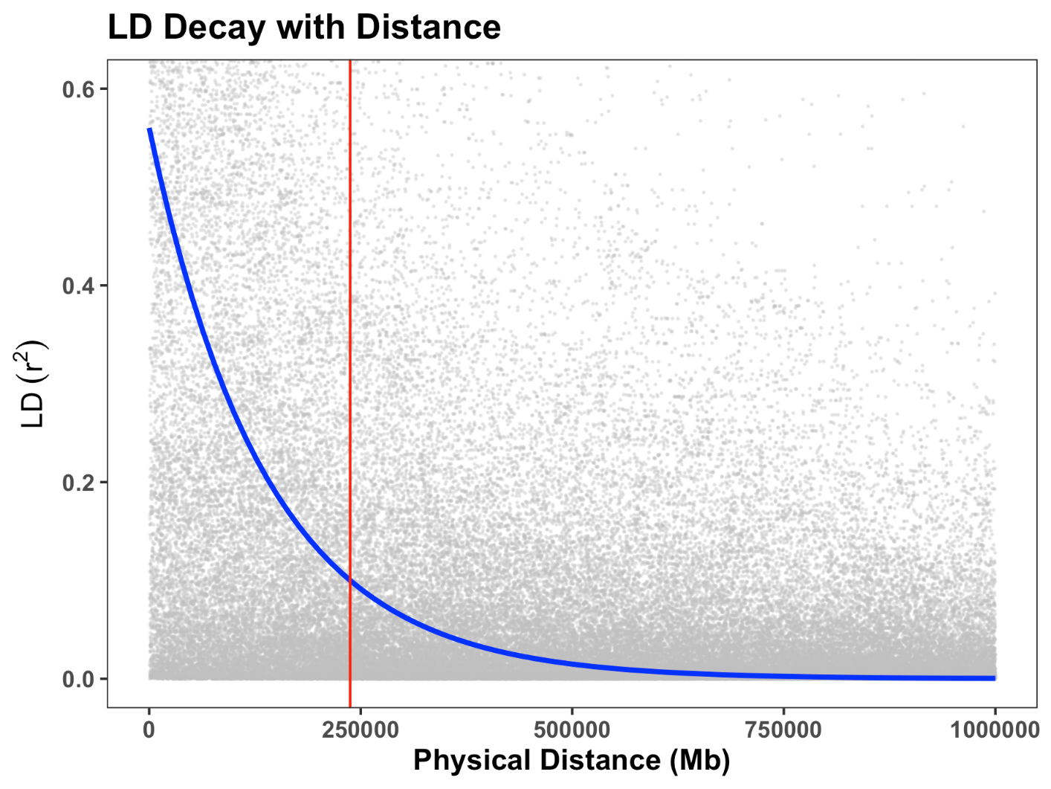
S-Figure1: Linkage disequilibrium (LD) decay plot for soybean chromosome 3. The scatter plot displays pairwise LD (measured as r²) against physical distance (Mb) between SNP markers. The blue curve represents the locally weighted LOESS regression line showing the average LD decay trend. The red vertical line indicates the physical distance at which r² decays below the critical threshold of 0.2, commonly used to estimate the extent of LD decay for candidate gene identification.
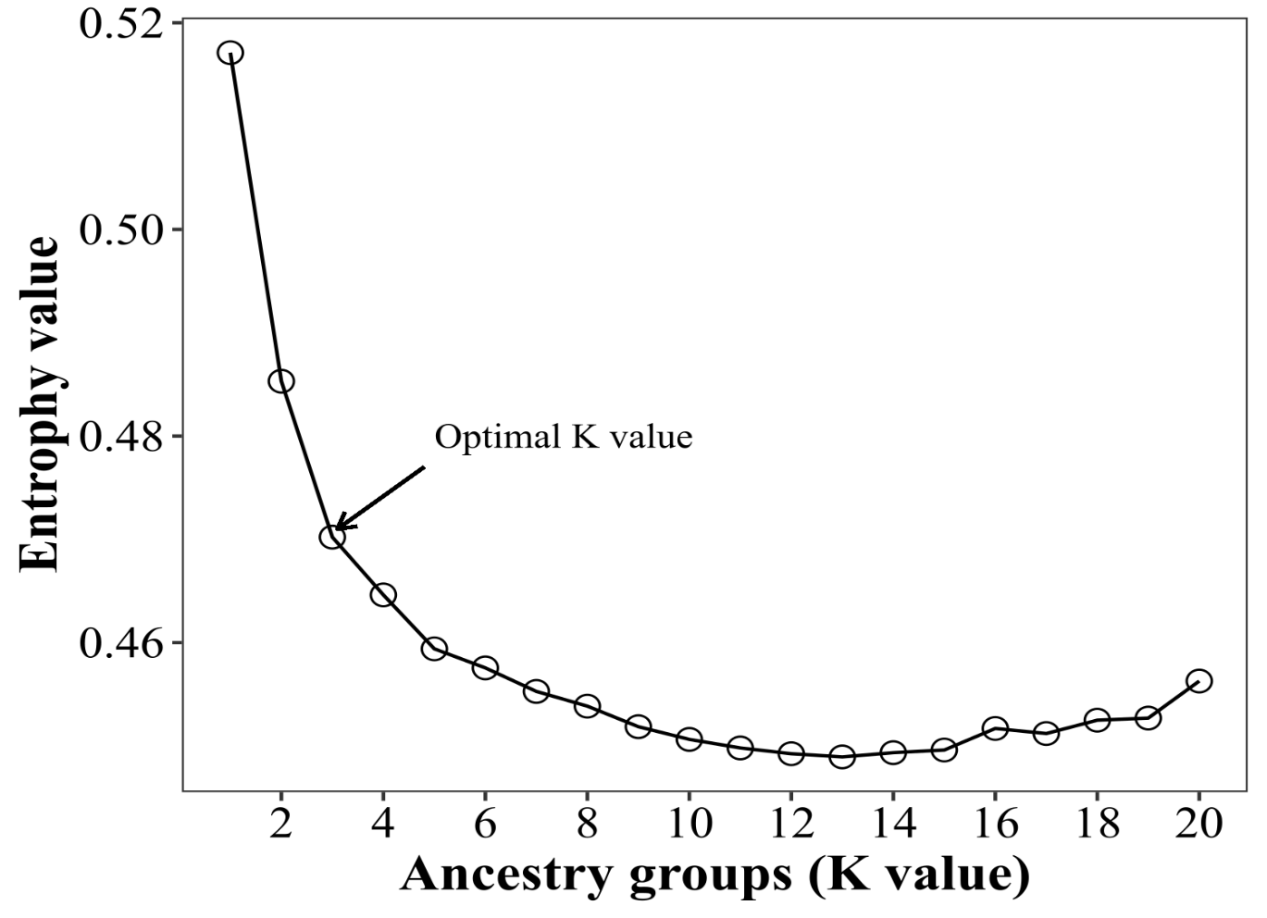
S-Figure2: Determination of the optimal number of genetic clusters (K) based on entropy values derived from ancestry inference analysis. The plot shows entropy values across K values ranging from 1 to 20. The optimal K value was identified at K = 3, where a clear inflection point indicates the most likely number of ancestral populations contributing to the genetic structure of the soybean panel.

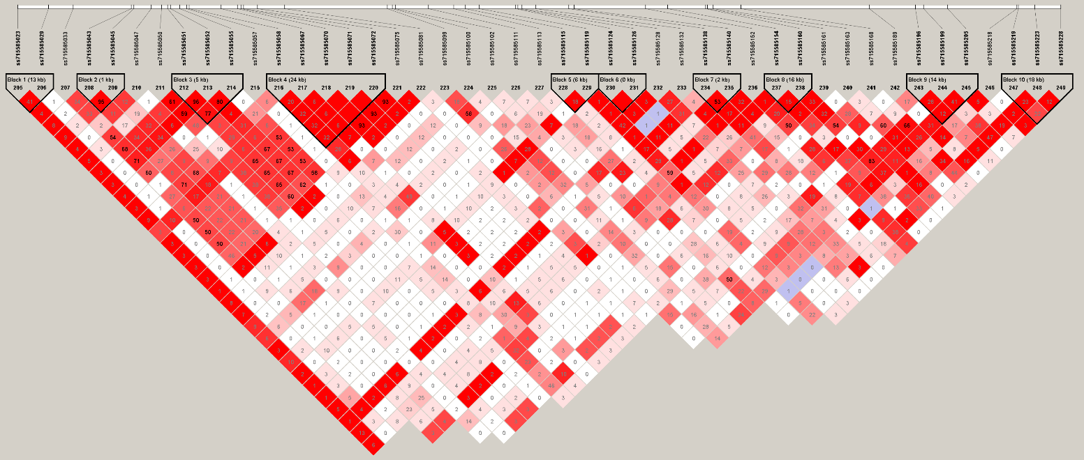
S-Figure3: Linkage disequilibrium (LD) block structure on soybean chromosome 3. The triangular heatmap displays pairwise LD between SNP markers in terms of D' values, with color intensity representing the strength of LD (red = strong LD, white = weak LD, blue = low confidence). Haplotype blocks were defined using Haploview. Block numbers and marker positions are shown along the top and within each block.

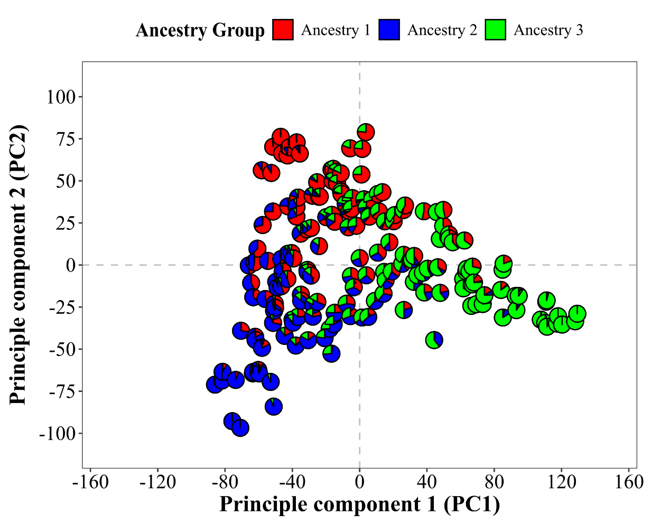

S-Figure4: Principal component analysis (PCA) of 196 soybean accessions based on genome-wide SNP markers. The first two principal components (PC1 and PC2) explain the major axes of genetic variation. Individuals are color-coded by ancestry group (Ancestry 1 = red, Ancestry 2 = blue, Ancestry 3 = green) as inferred from population structure analysis at K = 3.

S-Figure5. Examples of each injury rating.
