Article Title: Phytoremediation Potential and Differential Chromium (Cr) Accumulation and Gene Expression in Brassica juncea Varieties for Contaminated Soils in Turkey
Journal Name: Environmental Science and Pollution Research
Author Names: Nuriye Meraklıª, Abdulrezzak Memon^{a*}, Huseyin Altundag^{b,e}, Barıs Kaki^{c}, Liaquat Ali Bhutto^{d}, and Ahmet Kahramanª
*Corresponding author: Prof. Dr. Abdulrezzak Memon
Department of Molecular Biology and Genetics, Faculty of Engineering and Natural Sciences, Usak University, Usak, Turkey
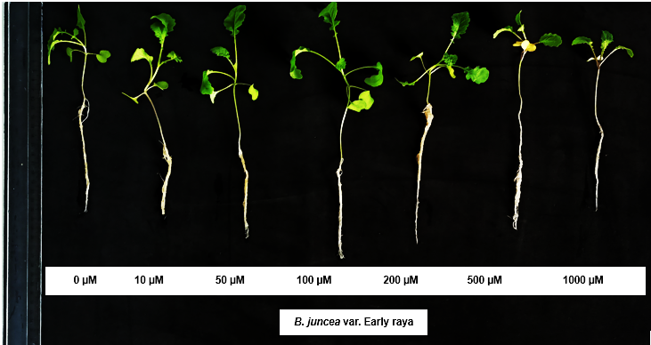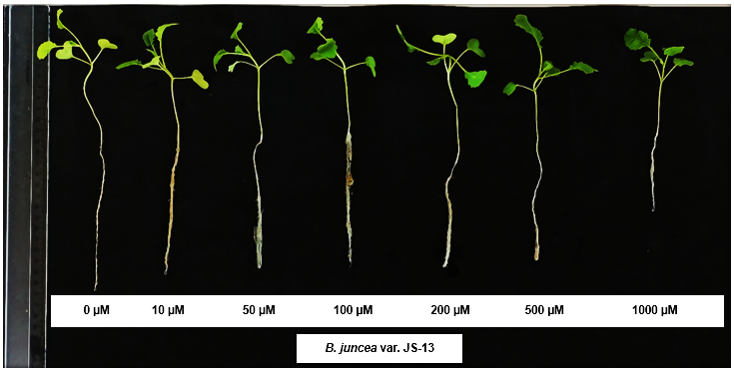
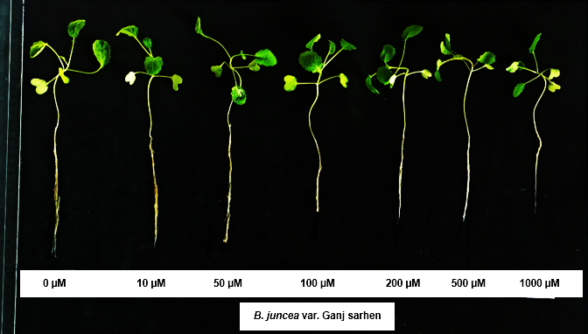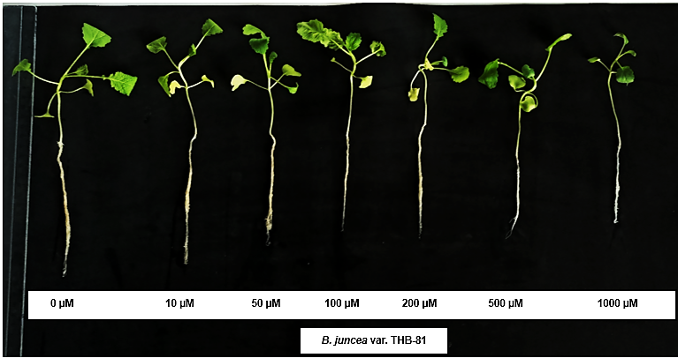
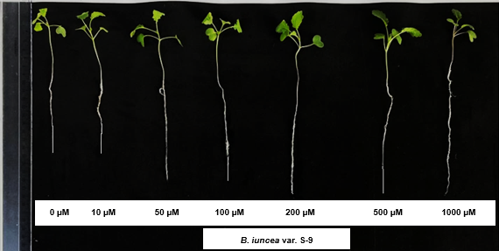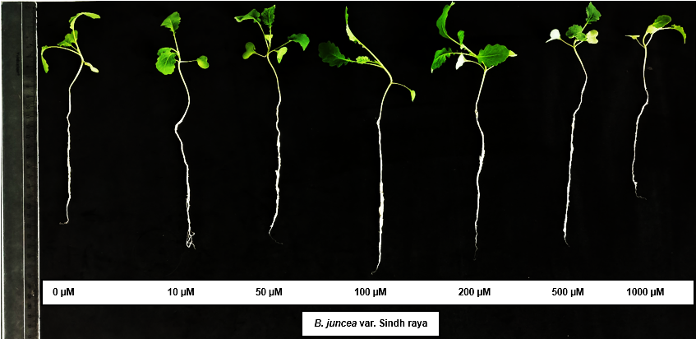
Fig. S1 Morphological response of Brassica juncea L. var. Early raya, JS-13, Sindh raya, S-9, Ganj sarhen, and THB-81 seedlings to different concentrations of chromium (Cr). Plants were grown under 0, 10, 50, 100, 200, 500, and 1000 µM Cr for two weeks (15 days).
Article Title: Phytoremediation Potential and Differential Chromium (Cr) Accumulation and Gene Expression in Brassica juncea Varieties for Contaminated Soils in Turkey
Journal Name: Environmental Science and Pollution Research
Author Names: Nuriye Meraklıª, Abdulrezzak Memon^{a*}, Huseyin Altundag^{b,e}, Barıs Kaki^{c}, Liaquat Ali Bhutto^{d}, and Ahmet Kahramanª
*Corresponding author: Prof. Dr. Abdulrezzak Memon
Department of Molecular Biology and Genetics, Faculty of Engineering and Natural Sciences, Usak University, Usak, Turkey

Table S1 Forward and reverse primers for ubiquitin, APX, RBOH, and FeSOD in Brassica juncea were designed using Primer3 and validated with the BLAST tool.
Gene ID | Primer Sequence (5’-3’)
Brassica juncea-BjUBQ9-F | GAAGACATGTTCATTGGCA
BjUBQ9-R | ACACCTTAGTCCTAAAAGCCACC
Brassica juncea-BjuRBOH-F | ACGGGGTGTGATAGAGATGC
BjuRBOH-R | TTTTTCCAGTTGGGTCTTGC
Brassica juncea-BjuFSD-F | TAGCTGTTTCTGGTGTTGTCAGA
BjuFSD-R | GTCATTGGAAGAGGTTGTGCTAC
Brassica rapa-BraAPX-F | GACGAAGAACTACCCAGCTGTTAGC
BraAPX-R | GAGCTCGGGTTTGCTGATGCTTAAGC

Article Title: Phytoremediation Potential and Differential Chromium (Cr) Accumulation and Gene Expression in Brassica juncea Varieties for Contaminated Soils in Turkey
Journal Name: Environmental Science and Pollution Research
Author Names: Nuriye Meraklıª, Abdulrezzak Memon^{a*}, Huseyin Altundag^{b,e}, Barıs Kaki^{c}, Liaquat Ali Bhutto^{d}, and Ahmet Kahramanª
*Corresponding author: Prof. Dr. Abdulrezzak Memon
Department of Molecular Biology and Genetics, Faculty of Engineering and Natural Sciences, Usak University, Usak, Turkey

Table S2 P-values for the interactions of Cr with Ca, Fe, Mg, and K in the roots of Brassica juncea varieties under Cr stress
 | Cr-Ca | Cr-Fe | Cr-Mg | Cr-K
Early raya | 0.00271376 | 0.00348941 | 0.00092082 | 0.02433222
Sindh raya | 0.18552376 | 0.03655961 | 0.0227967 | 0.10097923
THB-81 | 0.03081469 | 0.09799536 | 0.1469331 | 0.00177669
JS-13 | 0.19604857 | 0.38503407 | 0.29369512 | 0.06087727
S-9 | 0.04633256 | 0.09944781 | 0.11110817 | 0.20562271
Ganj sarhen | 0.05407848 | 0.10578966 | 0.07255562 | 0.0017182

