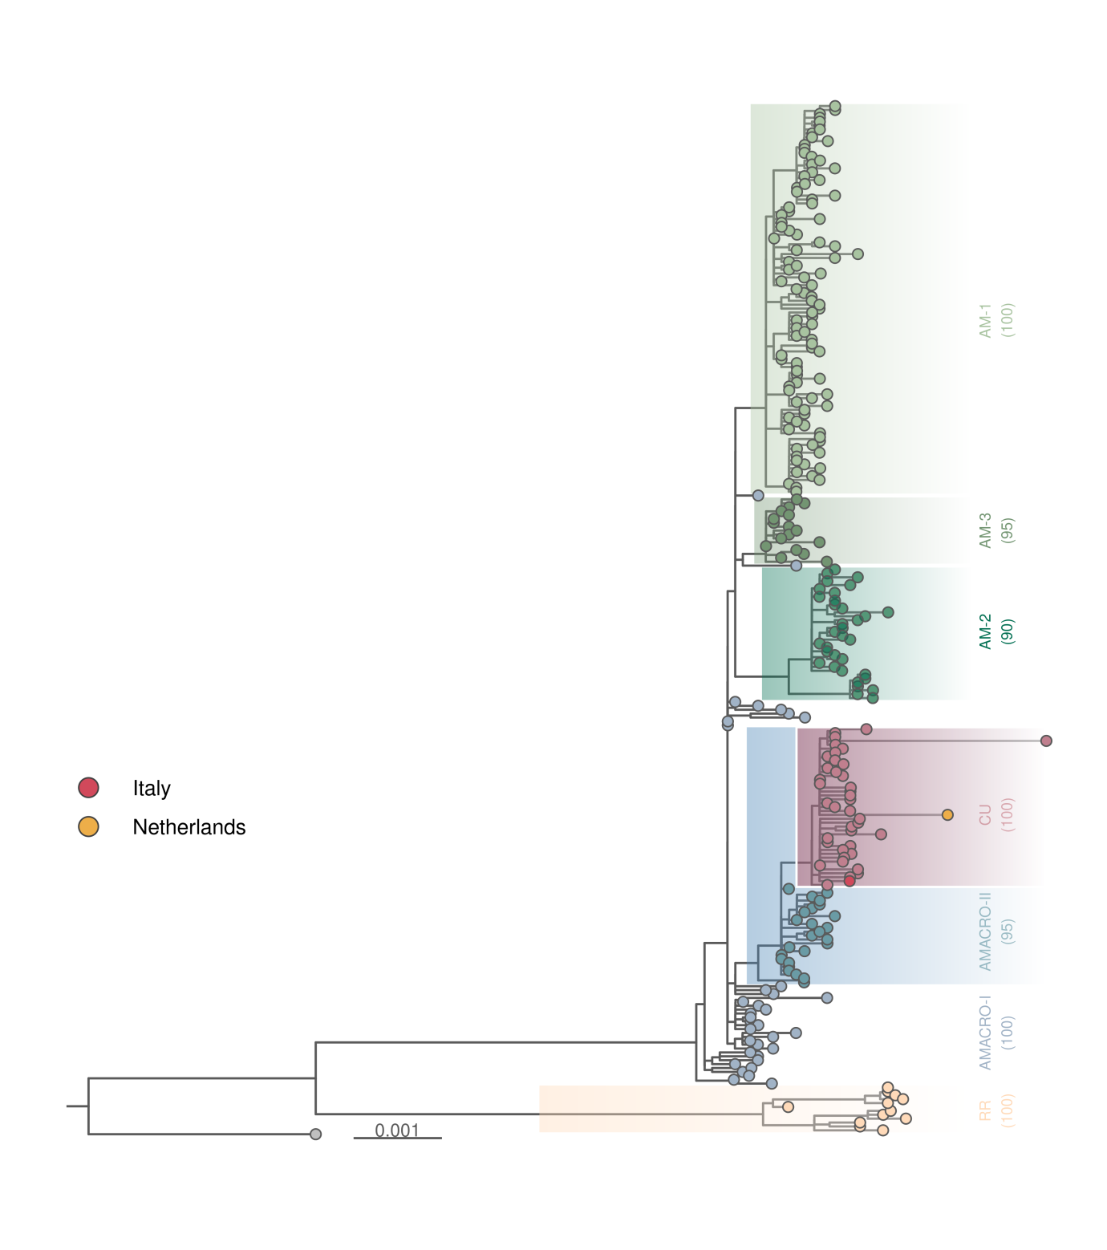
Supplementary Figure 2. International Dissemination of the Cuban OROV Clade. Maximum likelihood phylogenetic tree based on concatenated OROV genomes (n = 284) from the OROV_{BR-2015-2024} clade, including Cuban OROV genomes (n = 39), and two OROV genomes sampled in Italy (n = 1) and the Netherlands (n = 1). Clusters are annotated with their respective names and statistical support values (aLRT). The tree is scaled according to the legend at the bottom of the panel.

