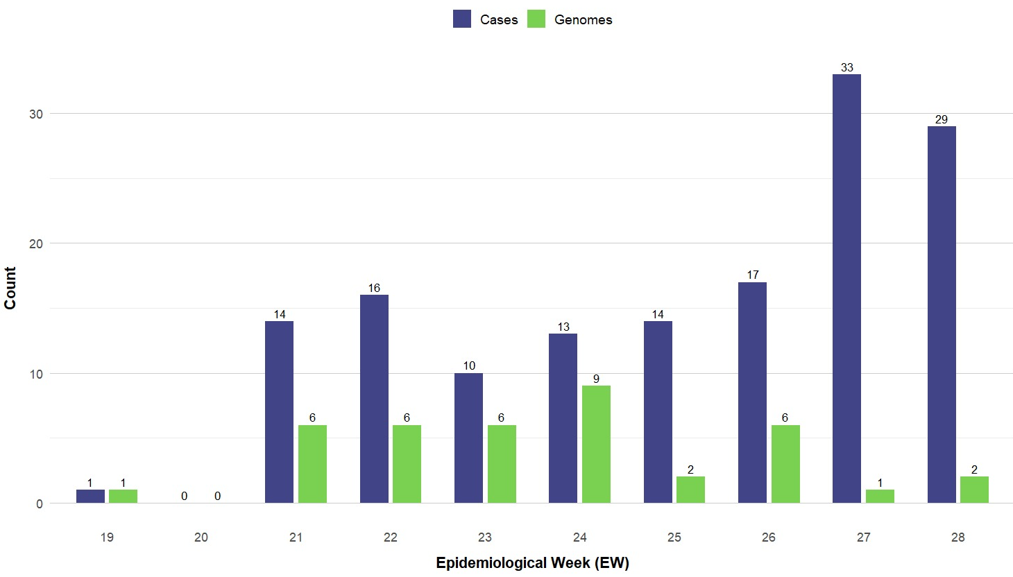
Supplementary figure 1. Oropouche cases in Cuba and OROV genomes by epidemiological week. The blue bars represent the number of Oropouche cases throughout the country, whereas the green bars represent the number of genomes generated in this study for each Epidemiological Week (EW). Therefore, OROV genomes were represented during all EW of the OROV Cuban outbreak.

