SUPPLEMENTAL MATERIALS

Supplementary Table 1
Univariate Cox proportional hazard analyses for predictors of CV-death following PCI

 | HR | 95% CI | p-value
Age (1 year older) | 1.06 | 1.03–1.10 | <0.0001
Male | 1.71 | 0.83–4.12 | 0.184
BMI¹ (1 kg/m² higher) | 0.87 | 0.80–0.94 | 0.001
Hypertension | 1.01 | 0.54–2.04 | 0.986
Dyslipidemia | 1.30 | 0.69–2.73 | 0.45
Acute coronary syndrome | 1.08 | 0.59–1.88 | 0.795
Multivessel disease | 1.20 | 0.69–2.16 | 0.54
Chronic kidney disease | 2.61 | 1.56–4.36 | 0.0002
LVEF² (1% higher) | 0.96 | 0.94–0.98 | 0.0004
Former smoker | 1.70 | 1.02–2.86 | 0.04
Beta-blockers | 1.17 | 0.70–1.95 | 0.55
ACEIs³/ARBs⁴ | 1.16 | 0.69–1.99 | 0.57
Statins | 0.78 | 0.47–1.34 | 0.36
Ezetimibe | 0.65 | 0.11–2.08 | 0.55
Hemoglobin (1 g/dL higher) | 0.67 | 0.57–0.79 | <0.0001
Triglycerides (1 mg/dL higher) | 0.99 | 0.986–0.996 | 0.001
LDL-C⁵ (1 mg/dL higher) | 0.99 | 0.979–0.999 | 0.04
HDL-C⁶ (1 mg/dL higher) | 1.01 | 0.987–1.02 | 0.45
HbA1c-NG⁷ (1 % higher) | 0.73 | 0.54–0.96 | 0.036
1,5-AG⁸ (1 μg/mL higher) | 0.90 | 0.84–0.97 | 0.006
IRI⁹ (1 μU/mL higher) | 1.00 | 0.98–1.02 | 0.67
Fasting blood glucose (1 mg/dL higher) | 1.00 | 0.997–1.005 | 0.38
Log BNP¹⁰ (1 higher) | 4.57 | 2.95–7.04 | <0.0001
eGFR¹¹ (10 mL/min/1.73m² higher) | 0.77 | 0.71–0.84 | <0.0001
hs-CRP¹² (0.1 mg/dL higher) | 1.02 | 1.01–1.03 | <0.0001
IGF-1¹³ (1 ng/mL higher) | 0.99 | 0.979–0.997 | 0.009
IGFBP-3¹⁴ (1 ng/mL higher) | 1.00 | 1.001–1.003 | 0.001
IGF-1/IGFBP-3 (quartile higher) | 0.47 | 0.34–0.64 | <0.0001
Sulfonylurea | 0.60 | 0.30–1.10 | 0.12
Metformin | 0.46 | 0.178–0.996 | 0.049
Thiazolidinedione | 1.17 | 0.54–2.27 | 0.66
α-Glucosidase inhibitor | 1.13 | 0.62–1.97 | 0.67
Glinide | 0.59 | 0.14–1.58 | 0.37
Insulin | 2.46 | 1.45–4.12 | 0.0007
DPP4i¹⁵ | 0.39 | 0.17–0.78 | 0.01
1 body mass index, 2 left ventricular ejection fraction, 3 angiotensin converting enzyme inhibitors, 4 angiotensin Ⅱ receptor blockers, 5 low-density lipoprotein, 6 high-density lipoprotein, 7 glycated hemoglobin, 8 1,5-anhydroglucitol, 9 immunoreactive insulin, 10 B-type natriuretic peptide, 11 estimated glomerular filtration rate, 12 high-sensitivity C-reactive protein, 13 insulin-like growth factor-1, 14 insulin-like growth factor binding protein-3, 15 dipeptidyl peptidase-4 inhibitors.

Supplementary Table 2
Univariate Cox proportional hazard analyses for predictors of 3P-MACE following PCI

 | HR | 95% CI | p-value
Age (1 year older) | 1.04 | 1.02–1.06 | 0.001
Male | 1.47 | 0.83–2.84 | 0.19
BMI¹ (1 kg/m² higher) | 0.93 | 0.87–0.99 | 0.03
Hypertension | 1.17 | 0.69–2.11 | 0.58
Dyslipidemia | 1.22 | 0.73–2.16 | 0.47
Acute coronary syndrome | 1.23 | 0.76–1.91 | 0.39
Multivessel disease | 1.33 | 0.84–2.17 | 0.23
Chronic kidney disease | 2.34 | 1.54–3.55 | <0.0001
LVEF² (1% higher) | 0.97 | 0.96–0.99 | 0.005
Former smoker | 1.45 | 0.96–2.21 | 0.08
Beta-blockers | 1.02 | 0.67–1.54 | 0.93
ACEIs³/ARBs⁴ | 1.10 | 0.73–1.70 | 0.65
Statins | 0.67 | 0.44–1.03 | 0.06
Ezetimibe | 0.63 | 0.15–1.67 | 0.39
Hemoglobin (1 g/dL higher) | 0.69 | 0.61–0.79 | <0.0001
Triglycerides (1 mg/dL higher) | 0.99 | 0.992–0.999 | 0.04
LDL-C⁵ (1 mg/dL higher) | 0.99 | 0.988–1.002 | 0.29
HDL-C⁶ (1 mg/dL higher) | 1.00 | 0.984–1.02 | 0.92
HbA1c-NG⁷ (1 % higher) | 1.05 | 0.86–1.25 | 0.60
1,5-AG⁸ (1 μg/mL higher) | 0.93 | 0.88–0.98 | 0.01
IRI⁹ (1 μU/mL higher) | 1.01 | 0.99–1.02 | 0.25
Fasting blood glucose (1 mg/dL higher) | 1.00 | 0.999–1.005 | 0.06
Log BNP¹⁰ (1 higher) | 3.69 | 2.59–5.23 | <0.0001
eGFR¹¹ (10 mL/min/1.73m² higher) | 0.98 | 0.97–0.99 | <0.0001
hs-CRP¹² (0.1 mg/dL higher) | 1.02 | 1.01–1.03 | <0.0001
IGF-1¹³ (1 ng/mL higher) | 0.99 | 0.985–0.999 | 0.04
IGFBP-3¹⁴ (1 ng/mL higher) | 1.00 | 1.001–1.003 | <0.0001
IGF-1/IGFBP-3 (quartile higher) | 0.55 | 0.43–0.68 | <0.0001
Sulfonylurea | 0.64 | 0.37–1.04 | 0.07
Metformin | 0.69 | 0.37–1.20 | 0.20
Thiazolidinedione | 0.92 | 0.46–1.66 | 0.80
α-Glucosidase inhibitor | 1.01 | 0.61–1.61 | 0.97
Glinide | 0.97 | 0.41–1.94 | 0.93
Insulin | 2.35 | 1.52–3.58 | 0.0002
DPP4i¹⁵ | 0.43 | 0.23–0.74 | 0.002
1 body mass index, 2 left ventricular ejection fraction, 3 angiotensin converting enzyme inhibitors, 4 angiotensin Ⅱ receptor blockers, 5 low-density lipoprotein, 6 high-density lipoprotein, 7 glycated hemoglobin, 8 1,5-anhydroglucitol, 9 immunoreactive insulin, 10 B-type natriuretic peptide, 11 estimated glomerular filtration rate, 12 high-sensitivity C-reactive protein, 13 insulin-like growth factor-1, 14 insulin-like growth factor binding protein-3, 15 dipeptidyl peptidase-4 inhibitors.

Supplementary Table 3
Multivariate cox proportional hazard analyses using 4 models assessed the hazard ratios of DPP4i for CV-death and 3P-MACE

Model 1: Hazard ratios for dipeptidyl peptidase-4 inhibitors (DPP4i) were adjusted by age and sex

For CV-death
 | HR | 95% CI | p-value
Age (1 year older) | 1.07 | 1.04–1.10 | <0.0001
Male | 2.04 | 0.99–4.94 | 0.054
DPP4i | 0.38 | 0.16–0.75 | 0.005

For 3P-MACE
 | HR | 95% CI | p-value
Age (1 year older) | 1.04 | 1.02–1.07 | 0.0004
Male | 1.67 | 0.94–3.23 | 0.08
DPP4i | 0.42 | 0.23–0.73 | 0.001

Model 2: Hazard ratios for dipeptidyl peptidase-4 inhibitors (DPP4i) were adjusted by age, sex, body mass index (BMI), chronic kidney disease (CKD), BNP (B-type natriuretic peptide) and insulin use

For CV-death
 | HR | 95% CI | p-value
Age (1 year older) | 1.06 | 1.03–1.09 | 0.0003
Male | 3.88 | 1.66–11.35 | 0.0009
BMI (1 kg/m² higher) | 0.93 | 0.85–1.02 | 0.14
Chronic kidney disease | 0.98 | 0.53–1.81 | 0.95
Log BNP (1 higher) | 5.02 | 2.96–8.52 | <0.0001
Insulin | 2.26 | 1.24–4.05 | 0.009
DPP4i | 0.39 | 0.16–0.82 | 0.01

For 3P-MACE
 | HR | 95% CI | p-value
Age (1 year older) | 1.03 | 1.00–1.06 | 0.01
Male | 2.45 | 1.31–5.13 | 0.004
BMI (1 kg/m² higher) | 0.99 | 0.93–1.06 | 0.81
Chronic kidney disease | 1.17 | 0.71–1.91 | 0.54
Log BNP (1 higher) | 3.61 | 2.40–5.44 | <0.0001
Insulin | 1.92 | 1.19–3.06 | 0.009
DPP4i | 0.47 | 0.25–0.84 | 0.01

Model 3: Hazard ratios for dipeptidyl peptidase-4 inhibitors (DPP4i) were adjusted by age, sex, acute coronary syndrome (ACS), left ventricular ejection fraction (LVEF), statins and hemoglobin

For CV-death
 | HR | 95% CI | p-value
Age (1 year older) | 1.05 | 1.01–1.09 | 0.01
Male | 4.28 | 1.50–18.05 | 0.004
ACS | 0.74 | 0.29–1.73 | 0.50
LVEF | 1.00 | 0.98–1.01 | 0.46
statins | 0.82 | 0.42–1.70 | 0.59
Hemoglobin (1 g/dL higher) | 0.66 | 0.55–0.78 | <0.0001
DPP4i | 0.44 | 0.19–0.95 | 0.04

For 3P-MACE
 | HR | 95% CI | p-value
Age (1 year older) | 1.03 | 1.00–1.06 | 0.04
Male | 3.35 | 1.44–9.75 | 0.003
ACS | 0.98 | 0.46–1.94 | 0.95
LVEF | 1.00 | 0.99–1.01 | 0.91
statins | 0.79 | 0.44–1.43 | 0.42
Hemoglobin (1 g/dL higher) | 0.67 | 0.58–0.77 | <0.0001
DPP4i | 0.55 | 0.29–1.01 | 0.052

Model 4: Adjusted by anti-diabetic medications

For CV-death
 | HR | 95% CI | p-value
Metformin | 0.50 | 0.19–1.10 | 0.12
Sulfonylurea | 0.72 | 0.35–1.39 | 0.33
Alpha-glucosidase inhibitors | 1.23 | 0.66–2.18 | 0.50
Thiazolidinedione | 1.40 | 0.63–2.76 | 0.38
Glinide | 0.64 | 0.15–1.78 | 0.43
Insulin | 2.11 | 1.21–3.62 | 0.009
DPP4i | 0.48 | 0.21–0.99 | 0.046

For 3P-MACE
 | HR | 95% CI | p-value
Metformin | 0.75 | 0.39–1.32 | 0.33
Sulfonylurea | 0.79 | 0.44–1.35 | 0.40
Alpha-glucosidase inhibitors | 1.06 | 0.63–1.71 | 0.82
Thiazolidinedione | 1.03 | 0.51–1.87 | 0.94
Glinide | 1.08 | 0.44–2.22 | 0.86
Insulin | 2.05 | 1.30–3.18 | 0.002
DPP4i | 0.51 | 0.27–0.88 | 0.02

Supplementary Table 4
Multivariate Cox proportional hazard analyses using Model 2 assessed the hazard ratios of IGF-1/IGFBP-3 ratio for CV-death and 3P-MACE

Model 2: Hazard ratios for dipeptidyl peptidase-4 inhibitors (DPP4i) were adjusted by age, sex, body mass index (BMI), chronic kidney disease (CKD), BNP (B-type natriuretic peptide) and insulin use

For CV-death
 | HR | 95% CI | p-value
Age (1 year older) | 1.05 | 1.01–1.09 | 0.01
Male | 4.62 | 1.77–15.83 | 0.0009
BMI (1 kg/m² higher) | 0.96 | 0.87–1.06 | 0.47
Chronic kidney disease | 0.83 | 0.39–1.75 | 0.63
Log BNP (1 higher) | 3.32 | 1.83–6.07 | <0.0001
Insulin | 2.83 | 1.38–5.69 | 0.005
IGF-1/IGFBP-3 (quartile increase) | 0.58 | 0.40–0.80 | 0.002

For 3P-MACE
 | HR | 95% CI | p-value
Age (1 year older) | 1.01 | 0.99–1.05 | 0.31
Male | 2.99 | 1.46–6.96 | 0.002
BMI (1 kg/m² higher) | 0.99 | 0.92–1.07 | 0.89
Chronic kidney disease | 1.03 | 0.56–1.86 | 0.93
Log BNP (1 higher) | 2.70 | 1.69–4.30 | <0.0001
Insulin | 2.31 | 1.31–4.01 | 0.004
IGF-1/IGFBP-3 (quartile increase) | 0.59 | 0.45–0.77 | 0.0001

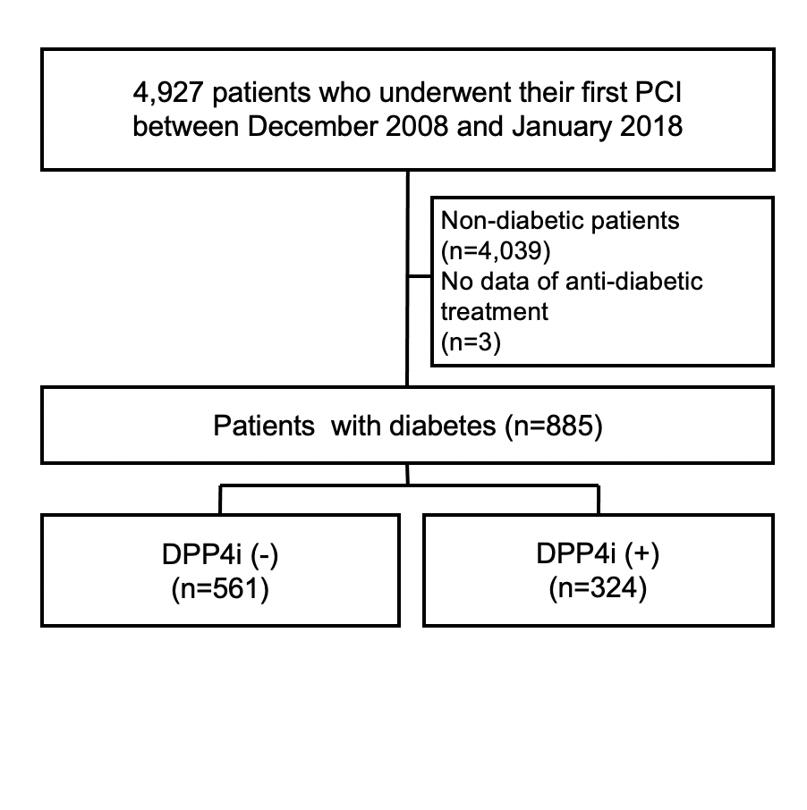
Supplementary Figure 1

Supplementary Figure 1: Consort diagram

Supplementary Figure 2
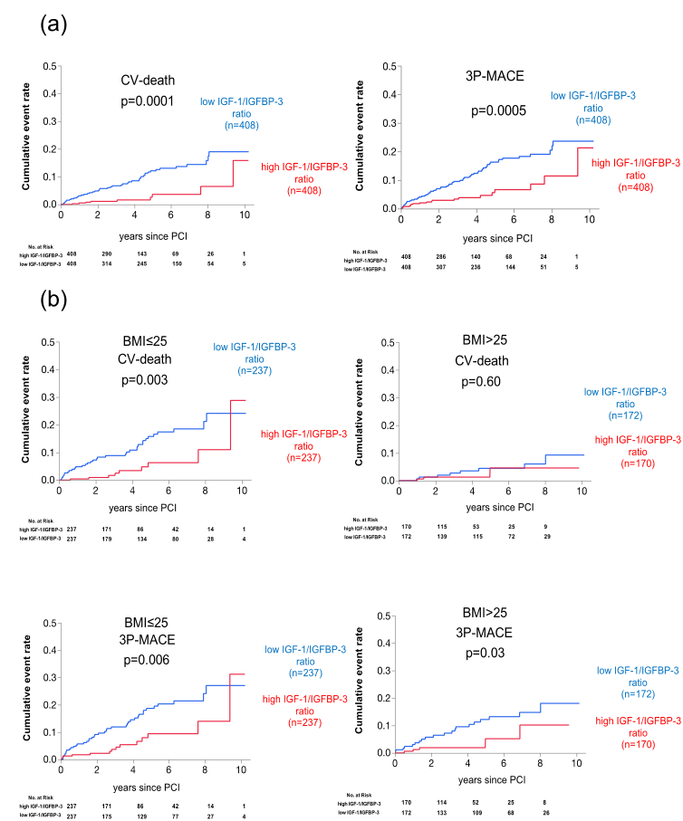

Supplementary Figure 2: Cumulative incidence of adverse outcomes following PCI in two groups divided by the median of IGF-1/IGFBP-3 ratio
(a) Cumulative incidences of cardiovascular (CV)-death and the composite of CV-death, non-fatal myocardial infarction and ischemic stroke (3P-MACE) in the high and low IGF-1/IGFBP-3 ratio groups. (b) Cumulative incidences of CV-death and 3P-MACE in the high and low IGF-1/IGFBP-3 ratio groups in patients with and without low BMI (≤ and > median BMI, 25).

