Supplementary Materials for

Room-Temperature Magnetoelectrical Skyrmions in LiNbO₃ with Suppressed DC drift and Enhanced Electro-Optic Functionality

Authors: Yalong Yu^{1, 2}, Bo Xiong^{1, 2}, Siqi Wu³, Yekai Ren^{1, 2} Zhaojie Zheng^{1, 2}, Nuo Chen^{1, 2}, Xiaolian Liu⁴, Qingjiao Mi^{1, 2}, Jiayi Lu³, Fangwen Yang⁵, Wei Zhang^{1, 2}, Xuanjian He^{1, 2}, Kangping Lou^{1, 2}, Zhong Li⁴, Rui Wang^{1, 2}, Xuefeng Zhang⁴, Guanghan Cao³, and Tao Chu^{1, 2,} *
Affiliations:
¹ College of Information Science and Electronic Engineering, Zhejiang University, Hangzhou 310027, P. R. China
² State Key Laboratory of Extreme Photonics and Instrumentation, Zhejiang University, Hangzhou 310027, P. R. China
³ School of Physics, Zhejiang University, Hangzhou 310058, P. R. China
⁴ Institute of Advanced Magnetic Materials, College of Materials and Environmental Engineering, Hangzhou Dianzi University, Hangzhou 310012, P. R. China
⁵ Center of Electron Microscopy and State Key Laboratory of Silicon Materials, School of Materials Science and Engineering, Zhejiang University, Hangzhou, 310027, P. R. China

*Corresponding author. Email: chutao@zju.edu.cn

Section 1 (S1): Excitation protocols and classification of SK-LNs
Section 2 (S2): Excitation of the skyrmion bundles and spiral domains in LN
Section 3 (S3): Electric field intensity distribution during the polarization process and the corresponding LTEM results
Section 4 (S4): Response of PNRs to external electric and magnetic fields
Section 5 (S5): Effect of the annealing temperature on SK-LN
Section 6 (S6): Responses of short/long dc drift with the excitation of SK-LN
Section 7 (S7): Mechanism analysis of the magnetoelectric coupling in SK-LN
Section 8 (S7): Supplementary Figures (SFig)

Section 1 (S1): Excitation protocols and classification of SK-LNs
This section details the skyrmion excitation processes in lithium niobate (LN) systems. Here, we utilized a “field-first-then-temperature” excitation approach to excite skyrmions in LN (SK-LN), as shown in SFig. 1. Initially, a 1T magnetic field was applied to the LN sample at room temperature, with the field direction not being fixed, as we have confirmed that skyrmions can be excited by magnetic fields in any direction. Then, the temperature was increased at a rate of 100 K/min until it reached 773 K, where it was held for 30 minutes. Afterward, the temperature was reduced to 653 K, at which point the magnetic field was rapidly removed, bringing it down to 0. Finally, the sample was gradually cooled to room temperature, completing the skyrmion excitation process.
In this study, both pre-magnetic-annealed and untreated samples (including LN crystals and SOI substrates) were processed into lamellae for LTEM characterization using FIB lift-out techniques, with fresh cross-sections of LN prepared to investigate their intrinsic material properties (SFig. 2). SFigs. 3(a-f) show the LTEM images of LN thin film before and after excitation, where PNRs only appear after skyrmions are formed, confirming their magnetoelectric coupling characteristics. Remarkably, TFLN modulators exhibited analogous phenomena (Fig. S3(g)). Skyrmion domains were observed in both ridge waveguides and adjacent slab layers, while remaining absent in the buried SiO₂ oxide.
Furthermore, it is important to note that for TFLN wafers, temperatures above 823 K can cause the LN layer to delaminate from the SiO₂ layer, leading to wafer damage and affecting the final device performance. When only considering the excitation of skyrmions, the temperature can be adjusted to over 823 K. In our experiments, the highest temperature used was 973 K, and skyrmions were still successfully excited in LN single crystals.

Section 2 (S2): Excitation of the skyrmion bundles and spiral domains in LN
This section presents the excitation of skyrmion tube structures in LN. During experiments, all skyrmions generated from bulk LN crystals exhibited spherical morphologies, while no spiral domain structures were observed. However, when the dimensions of LN were confined, spiral domains could be directly excited. SFig. 4(a) illustrates an example observed in a 600 nm-thick TFLN sample. The domain diameter matched that of spherical skyrmions, with chirality reversal occurring in the domain’s midsection.
Furthermore, in this constrained condition, pre-excited skyrmion spheres could transition into spiral domains via an annealing process. For instance, a 50 nm-thick LN film, containing initially stabilized skyrmion spheres via magnetic annealing (SFig. 4(b)), was subjected to annealing at 673 K for 1 hour, followed by gradual cooling. Post-annealing, stress-induced striped patterns emerged on the film, accompanied by newly formed spiral domains not present initially (SFig. 4(c)). The intermediate stages of this transformation (SFigs. 4(d, e)) reveal individual magnetic vortices from discrete skyrmions within the tube region. This confirms that during annealing, skyrmion spheres interact dynamically, first merging vortices into skyrmion bundles. The transition progresses from spherical to cylindrical geometries, ultimately stabilizing as spiral domains (SFig. 4(f, g)).

Section 3 (S3): Electric field intensity distribution during the polarization process and the corresponding LTEM results
In this section, we systematically investigate the anisotropic electrical response of SK-LN through directional electric field experiments. As discussed in the main text, during the experiment, we initially investigated the effect of applying an electric field (E_{z}) along the spontaneous polarization direction Z of LN. To this end, we fabricated an electrode structure on an x-cut LN single crystal, as illustrated in SFig. 5(a), which depicts the distribution of the electric field. Through LTEM observations, it was found that the SK-LN between the electrodes did not exhibit significant changes after polarization treatment. However, the SK-LN beneath the electrodes showed marked differences. Specifically, as shown in SFig. 5(b), the diameter of the SK-LN in this region increased substantially, forming a multi-ring structure. In SFig. 5(a), brightness is used to represent the magnitude of the electric field component perpendicular to the interface under an applied voltage of 30 V, revealing a high degree of consistency between the regions where SK-LN changed and this image.
Furthermore, we fabricated an electrode structure on a z-cut LN single crystal, where the electric field applied between the electrodes was perpendicular to the spontaneous polarization direction of LN. The brightness in SFig. 5(c) represents the magnitude of the electric field component parallel to the interface (E_{x}), under an applied voltage of 60 V. SFig. 5(d) shows the corresponding LTEM results, indicating that the area of SK-LN transforming significantly increased, with the boundary of this region highly consistent with the distribution of E_{x}. These findings provide compelling evidence that the response of SK-LN to E_{z} is considerably weaker than that to E_{x}.

Section 4 (S4): Response of PNRs to external electric and magnetic fields
Here, we report the response of PNRs to external magnetic and electric fields, from which distinct structural changes were observed under field application. As shown in SFig. 6, applying an electric field along the x-direction significantly increases PNR size and sharpens domain boundaries (SFigs. S6(b, c)). This correlates with magnetic vortex expansion during multi-shell skyrmion formation (SFig. 5). Under a 0.8 T magnetic field, PNRs exhibit moderate size increases (albeit less pronounced than under electric fields) alongside enhanced contrast and further boundary sharpening (SFigs. 6(d-f)). These results demonstrate that both electric and magnetic fields enhance PNR dimensions and stability.

Section 5 (S5): Effect of the annealing temperature on SK-LN
This section examines the temperature-dependent behavior of SK-LN. During experiments, we maintained a constant temperature during excitation (773 K) and performed post-excitation annealing. All subsequent measurements were conducted after annealing, with the LN film stabilized at room temperature. SFig. 7 presents LTEM images under varying conditions. Initially, excited magnetic vortices exhibited ~70 nm diameters with low areal density (60/μm², SFig. 7(a)). As annealing temperatures increased, vortex diameters decreased progressively from 70 nm to 25 nm (SFigs. 7(b-d)), while areal density rose sharply to 650/μm². Statistical analysis of skyrmion size distributions and corresponding densities across annealing temperatures reveals pronounced thermal tuning trends. These findings demonstrate that annealing significantly enhances skyrmion density in LN—a critical factor for optimizing skyrmion-embedded modulators.

Section 6 (S6): DC Drift Response Modulation via SK-LN Excitation
We conducted detailed DC drift analysis on thin-film LN MZI modulators with/without SK-LN excitation. A synchronized square-wave voltage sequence was applied: initiating baseline stabilization at 0 V (0 s), stepping to -4 V (0–40 s), reversing polarity to +4 V (40–80 s), and returning to 0 V (80–120 s), enabling simultaneous assessment of transient responses and short-term stabilization. As shown in SFig. 11(a), Control samples (S0) exhibited severe short-term drift characterized by an instantaneous intensity spike followed by rapid relaxation (seconds duration), sharply transitioning into persistent long-term drift. Samples annealed at 0.005T (S1) showed similar two-stage drift, given that short-term attenuation may reflect initial phase variations rather than magnetic effects. Critically, at the 0.3T annealing threshold—coinciding with SK-LN nucleation—short-term drift vanished entirely within 120 s (S2), with only residual long-term drift persisting in higher-field samples (S3, 1T). Subsequent zero-field thermal annealing (773K for S4; 823K for S5) enhanced SK-LN density proportionally to drift suppression intensity, definitively excluding magnetic moments as the primary mechanism.
Extended 1-hour measurements revealed fundamental drift transformations (SFig. 11(b)): while S0 maintained clear separation between short-term (1-minute duration) and long-term drift components with a sharp transition peak, SK-LN-integrated devices (S3) demonstrated short-term drift with >5-fold reduced slope extended to minutes, merging with long-term drift into a continuous relaxation profile devoid of transitional peaks and achieving full stabilization within 1 hour—unattainable in S0. High-density SK-LN devices (S4/S5) completed this unification, suppressing total drift from 13 dB/h (S0) to 1.5 dB/h (S4) and ultimately to undetectable levels (<0.1 dB/h) in S5. These results confirm SK-LN formation converts short-term to long-term drift before complete suppression, implicating shared physical origins (unbound interfacial charges) between drift phenomena and skyrmion stabilization.
These comprehensive measurements establish that SK-LN formation fundamentally restructures DC drift dynamics through a two-stage process: initial conversion of short-term drift into protracted long-term evolution, followed by complete suppression at critical skyrmion densities. This sequential transformation—observed across the S0→S5 sample series—provides decisive evidence for shared physical origins between drift phenomena and skyrmion stabilization, specifically implicating unbound interfacial charges as the unifying agent. Here, we consider the widely accepted equivalent capacitance model (SFig. 11(c))³⁷. In this model, the DC drift is entirely attributed to contributions from unbound charges at the interfaces of LN, SiO2, and electrodes. Upon bias application, the heterogeneous material stack (LN thin film, SiO₂ cladding, and electrode interfaces) forms a distributed RC network governed by the time constant τ = RC. This fundamental relationship dictates the temporal evolution of charge redistribution—reducing either resistance (R) or capacitance (C), for example, can significantly accelerate the transient response (τ ↓), thereby intensifying DC drift amplitude within operational timescales. Revaluating suppression mechanisms through the RC-network framework, we distinguish two pathways:
1) Acceleration pathway (τ↓): Reduces RC time constants, compressing long-term drift into observable transients—exemplified by plasma-bombarded LN where disorder-induced free charges lower resistance (R↓).
2) Deceleration pathway (τ↑): Increases effective R or C, flattening drift below detection thresholds within operational timescales.
Our experiments unambiguously validate the latter mechanism: Progressive flattening of drift profiles with increasing SK-LN density (Fig. S11b) signifies enhanced effective resistance (R↑). We attribute this primarily to the ordering of unbound electrons—essential participants in SK-LN formation—which transition into topological states and cease contributing to DC drift responses. As definitive proof, we observed spontaneous SK-LN nucleation at charge-rich inhomogeneities in zero-field conditions within pristine LN crystals (SFig. 11d), demonstrating that material defects or heterogeneous regions critically promote skyrmion stabilization. These findings conclusively establish the reciprocity between DC drift suppression and SK-LN formation. Critically, the observed phenomena strongly suggest defect-mediated excitation of SK-LNs—potentially via Dzyaloshinskii-Moriya interaction (DMI) pathways—a mechanism explored in detail in Section 7."

Section 7 (S7): Mechanism analysis of the magnetoelectric coupling in SK-LN
In this section, we propose a theoretical framework to elucidate the magnetoelectric coupling mechanism of SK-LN. In the preceding sections, we presented experimental evidence showing that SK-LN exhibits multiferroic properties and strong magnetoelectric coupling, responding robustly to both electric and magnetic fields. Four key experimental phenomena warrant further investigation:
1) Anomalous magnetic threshold: SK-LN excitation requires ≥0.3T—6-fold higher than LN's ferromagnetic coercivity (0.05T)—indicating decoupling from Li/Nb vacancy-mediated ferromagnetism;
2) Field-dependent PNR genesis: Ferroelectric PNRs are exclusively excited by magnetic fields within skyrmion phases;
3) Anisotropic electric response: The magnetic vortex can be modulated by electric fields but remains insensitive to fields aligned with spontaneous polarization;
4) Defect-correlated nucleation: Spontaneous SK-LN formation at charge-rich heterogeneities confirms unbound electron involvement in topological stabilization;
We first consider the lattice structure of paraelectric LN (PE-LN), as depicted in SFig. 12(a). In PE-LN, the midpoints of Nb-Nb and Li-Li atomic pairs coincide with the inversion center. In the presence of oxygen vacancies (V_{o}), antiferromagnetic coupling arises between neighboring Nb atoms²². Clearly, the inversion symmetry center of the magnetic sites in the LN lattice at this point is the midpoints of the Nb-Nb pairs. Under these conditions, once the temperature is lowered below the Curie temperature, leading to the displacement of Nb atoms and the generation of spontaneous polarization, the symmetry of the magnetic structure is simultaneously broken (Illustrated in SFig. 12(b)). This mechanism is referred to as Ferroelectrically-induced ferromagnetism (FE-induced FM), which was proposed in 2008^{45, 46} and was initially confirmed in FeTiO₃⁴⁹. However, further verification at room temperature has not yet been achieved. According to this theory, LN with oxygen defects can generate non-collinear magnetic moments and Dzyaloshinskii-Moriya (DM) interactions, which can be controlled by an electric field. We used STEM to observe the atomic arrangement of the LN single crystal used in the experiment and confirmed the presence of oxygen vacancies, as shown in SFig. 12(c). Moreover, based on this theory, we can also explain the anisotropy in the electric field response of SK-LN. The LN lattice has a space group of R3c, with a threefold rotational axis in the XY plane. When an electric field is applied along the direction of spontaneous polarization, no new symmetry breaking occurs in the magnetic structure. However, when the electric field is applied perpendicular to the spontaneous polarization direction, the original rotational symmetry is also broken, leading to a potentially more pronounced response of SK-LN.
Further consideration of the crystal structure of LN with non-collinear spins of adjacent Nb atoms reveals another magnetoelectric coupling mechanism within LN. Specifically, for Nb atoms oriented along the [012] crystal plane (as shown in SFig. 12(d)), adjacent Nb atoms interact as magnetic ions, with O atoms acting as ligand ions, forming an M-X-M clusters in the inverse DM model (where M denotes magnetic sites and X denotes ligand sites)^{43, 44}. This mechanism causes the DMI to induce additional electric polarization via RKKY exchange interactions. As observed, the magnetic vortices and PNRs in SK-LN appear simultaneously upon excitation by a magnetic field, thus confirming the presence of the inverse DM mechanism (i-DM) in LN. This also serves as evidence for the existence of non-collinear magnetic moments at the Nb sites, i.e., the FE-induced FM mechanism.
Based on this analysis, we conclude that two complementary magnetoelectric coupling mechanisms—FE-induced FM and i-DM interactions—coexist in LN. As schematized in SFig. 12(e), oxygen-vacancy-mediated DMI enables magnetic-field-induced transition from high-thermal-fluctuation states to stabilized non-collinear magnetic order (skyrmions), simultaneously immobilizing unbound electrons at Nb-O vacancy sites, which directly links DC-drift suppression to SK-LN formation. Concurrently, i-DM-driven magnetoelectricity generates non-zero polarization vectors at magnetic vortex cores, forming PNRs. Externally applied electric fields modulate SK-LN vortices via FE-FM, inducing Bloch→Target and skyrmion→skyrmionium transitions—consistent with our magnetic-field observations. Furthermore, PNRs exhibit enhanced electro-optic responses comprising:
(1) intrinsic Pockels effect in LN;
(2) Pockels-like enhancement from coupled FE-FM/i-DM interactions;
collectively explaining the unprecedented r₃₃ enhancement (32→80 pm/V). Thus, V_{o}-activated FE-FM and Nb-O-Nb i-DM interactions resolve all interconnected electromagnetic anomalies reported herein. Nevertheless, we emphasize this model remains phenomenological, grounded in lattice symmetry analysis, and requires further theoretical/experimental validation.
Section 8 (S8): Supplementary Figures (SFig)

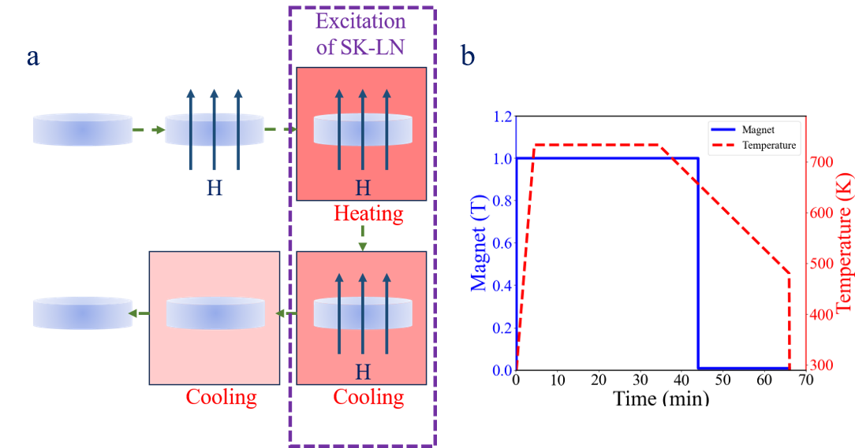

SFig. 1. Schematic of SK-LN excitation. (a) Sequential steps involved in the excitation process of SK-LN. (b) Corresponding external field parameters and their respective durations for each step.

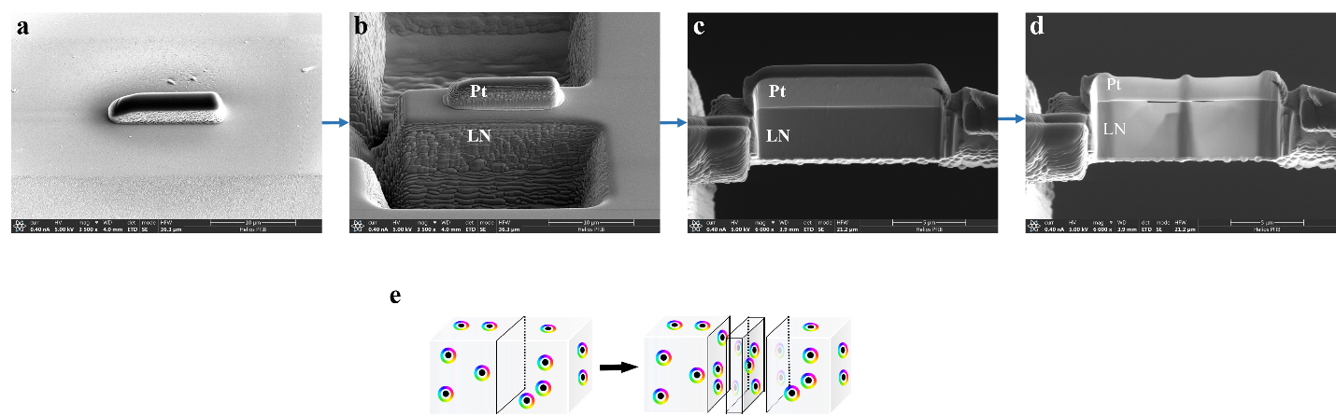 SFig. 2. FIB lift-out sample preparation process. (a-d) SEM images showing the sequential FIB milling procedure, where the extracted thin film surface represents a fresh cross-section of the LN material. (e) Schematic illustration of the cross-sectional sampling method.

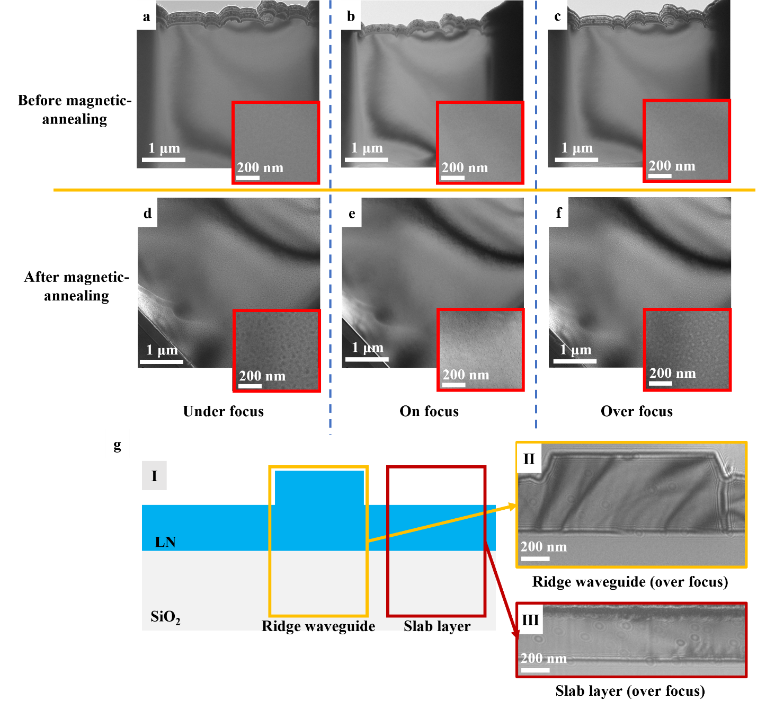

SFig. 3. LTEM images of LN: (a–c) Intrinsic LN film without skyrmion excitation: The absence of any discernible magnetic structure is evident across all focal lengths. (d–f) Following magnetic field annealing: The presence of skyrmions can be observed in all regions of the film, accompanied by corresponding PNRs. (g) Skyrmion distribution in LNOI. I: Schematic cross-section of the LNOI ridge waveguide structure. II: LTEM image of the waveguide region in the unetched area. III: LTEM image of the slab layer in the etched region.

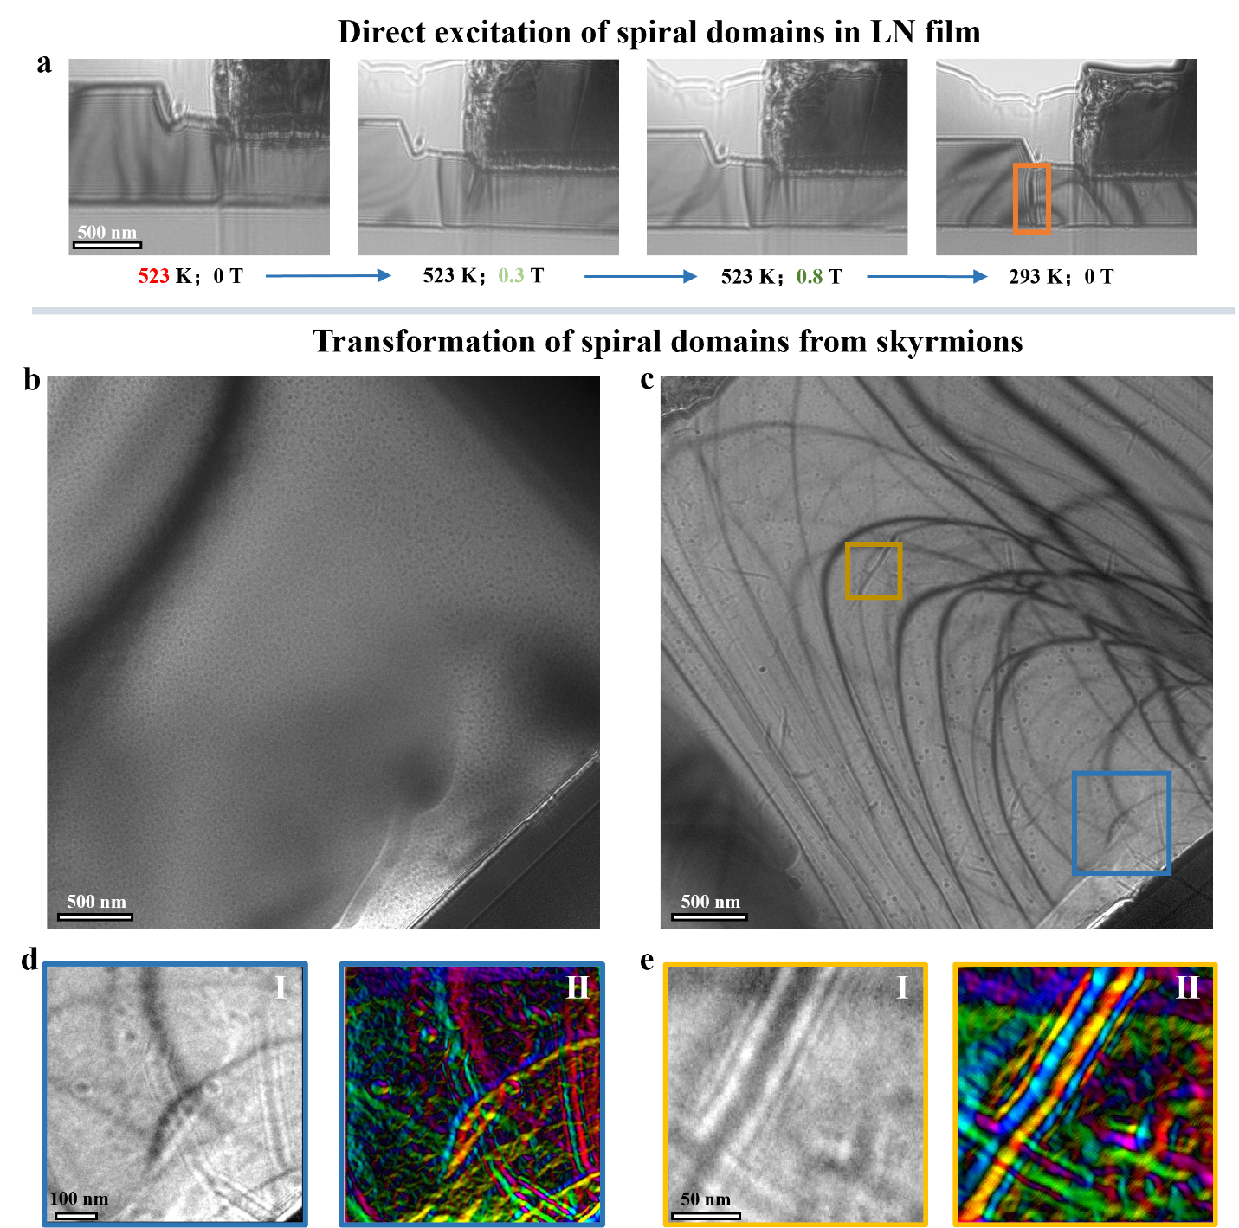

SFig. 4. Transformation of skyrmion bundles and tubes from spherical structures. (a) Processes of the excitation of skyrmion tubes in TFLN (b) LN film prepared using FIB, with skyrmion spheres already excited. At this state, no skyrmion tube structure exists. (c) LN film following the annealing process from (b). (d) LTEM image of skyrmion bundles formed by the fusion of skyrmion spheres (Ⅰ) with Corresponding spin distribution (Ⅱ). (e) LTEM image of spiral domains transformed from skyrmion bundles (Ⅰ) with Corresponding spin distribution (Ⅱ).

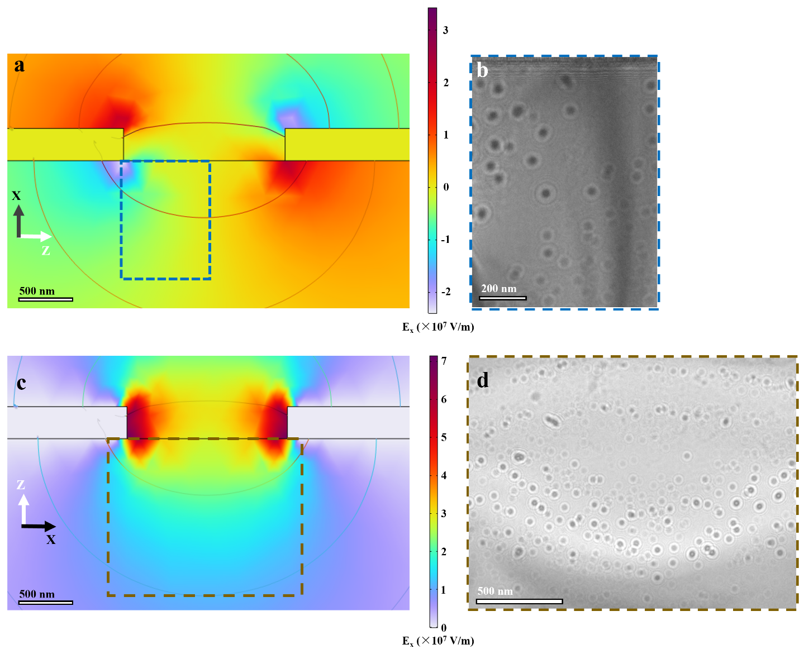

SFig. 5. COMSOL simulation results of electrostatic polarization and corresponding LTEM results: (a) Electric field distribution under an applied electric field of 30 V, where the contrast in brightness indicates the intensity of the electric field perpendicular to the interface. (b) Corresponding SK-LN response results, with the observation area delineated in (a). (c) Electric field distribution under an applied electric field of 60 V, where the contrast in brightness indicates the intensity of the electric field parallel to the interface. (d) Corresponding SK-LN response results, with the observation area delineated in (c). It should be noted that the electric field distribution parallel to the interface in (a) is similar to that in (c), while the electric field distribution perpendicular to the interface in (c) is similar to that in (a).

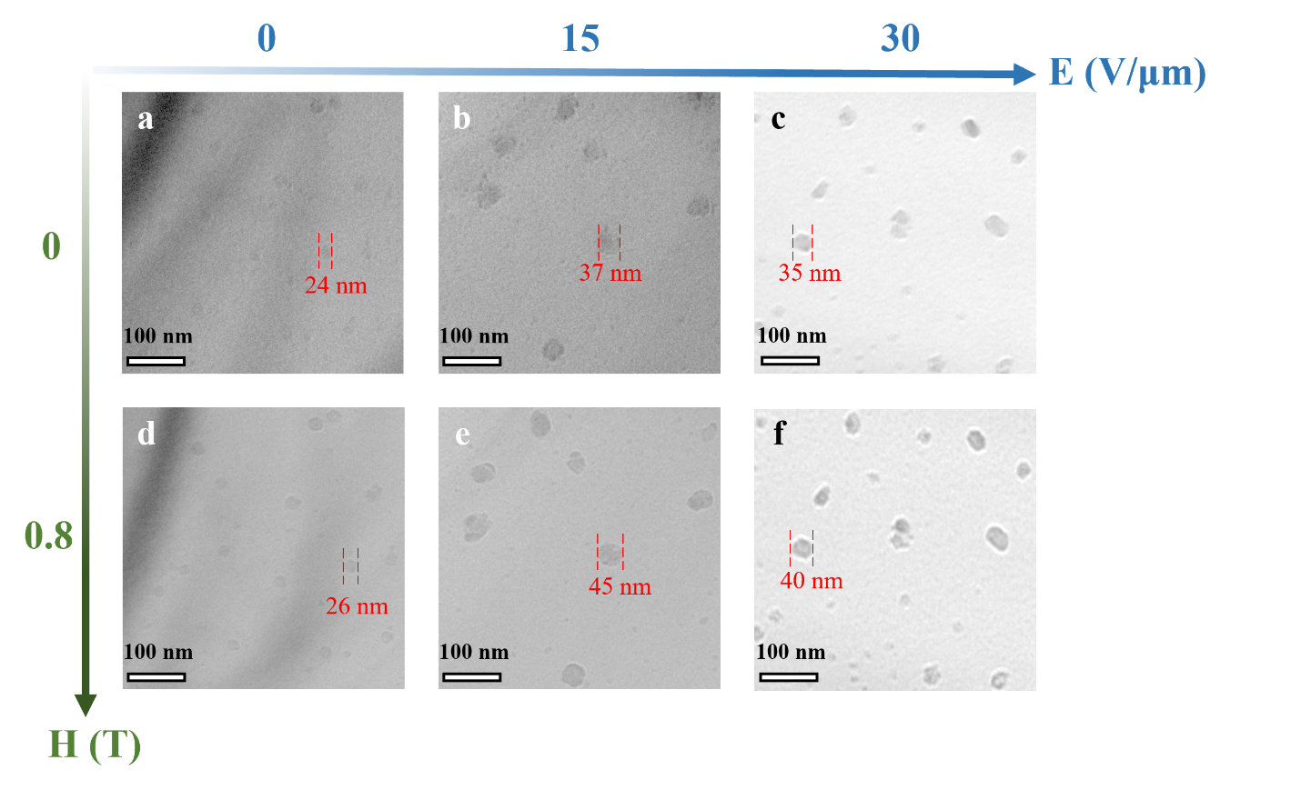

SFig. 6. Responses of PNRs in SK-LNs across experimental conditions. (a-c) Electric field-induced PNR expansion and boundary sharpening without external magnetization. (d-f) Magnetic field-modulated PNR contrast enhancement and interfacial refinement (H = 0.8 T).

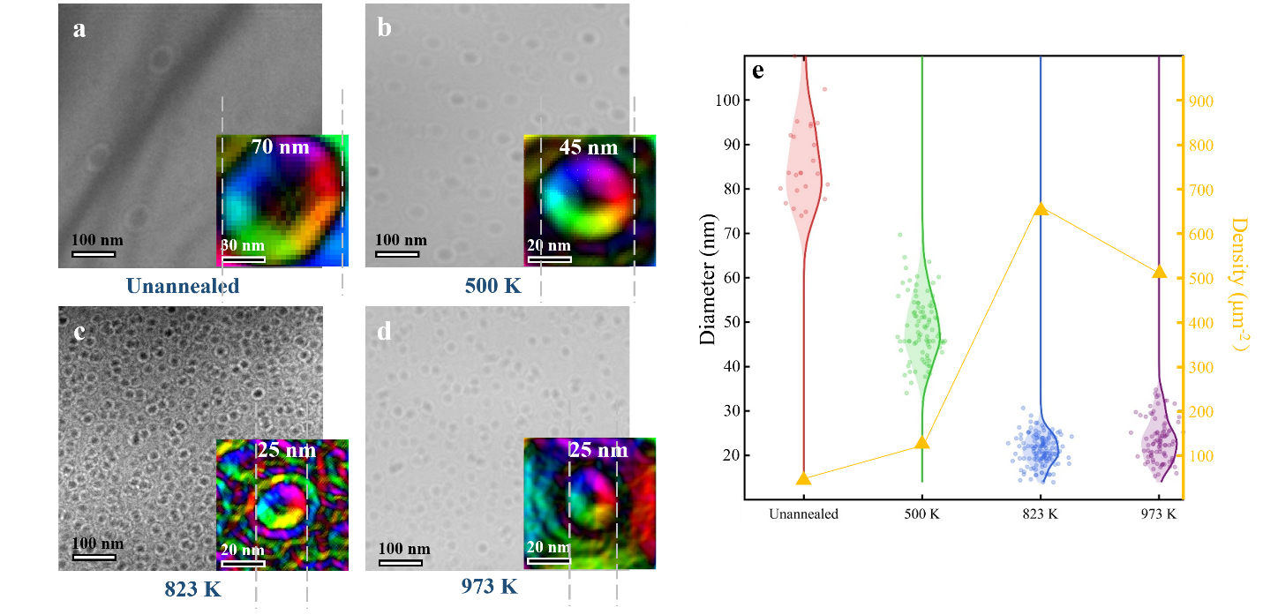

SFig. 7. The temperature response of SK-LN. (a) Initial state, after only the excitation process (b) After annealing at 500 K for 30 minutes (c) After annealing at 823 K, (d) After annealing at 973 K (e) Statistical analysis of the size of SK-LN after annealed at various temperatures.

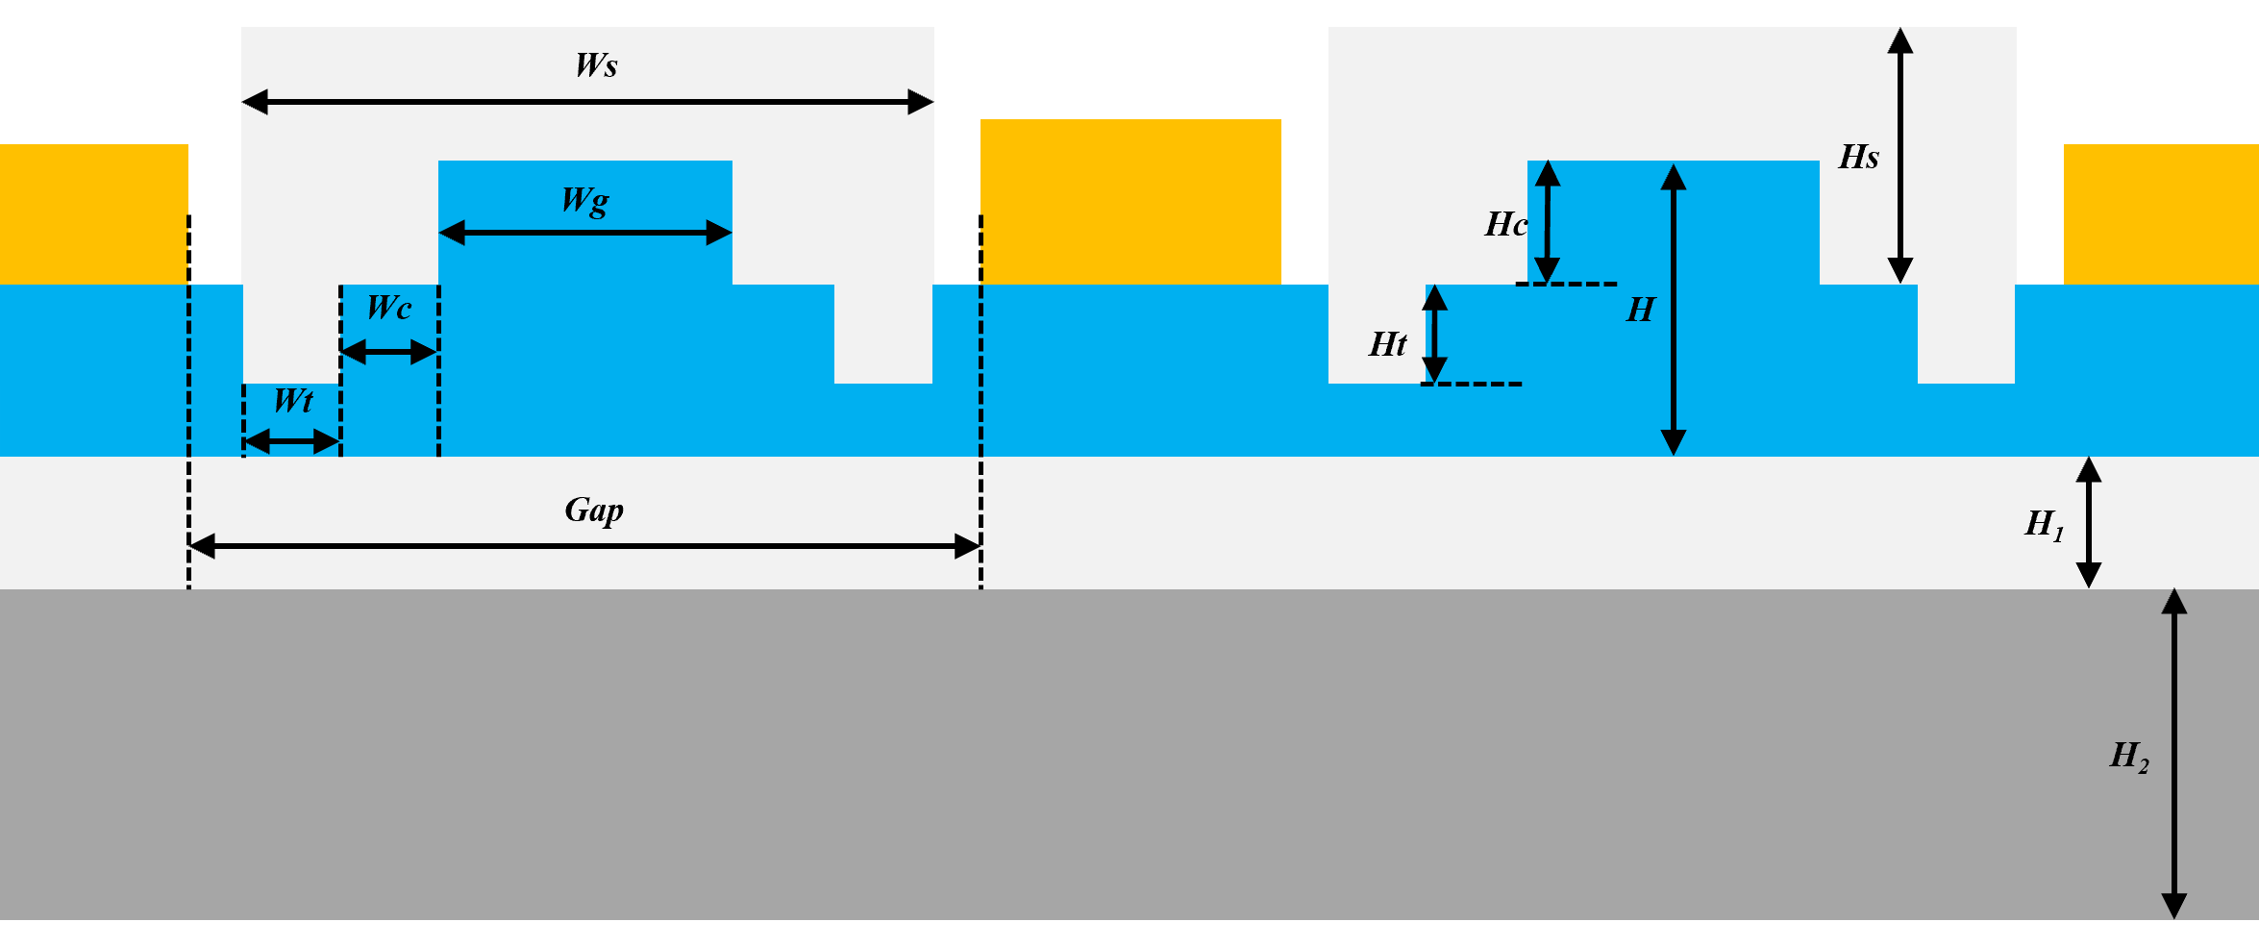 SFig. 8. Schematic of the design of the MZI-based modulator. Wg: Width of the LN waveguide. Ws: Width of the SiO₂ upper cladding. Wc: Interval of the waveguide and optical isolation trench. Wt: Width of the optical isolation trench. Gap: Interval of the electrodes. H: Thickness of the LN film. H₁: Thickness of the SiO₂ BOX layer. H₂: Thickness of the Si substrate. Hc: Etching depth of the LN waveguide. Ht: Etching depth of the LN waveguide. Hs: Thickness of the SiO₂ upper cladding.

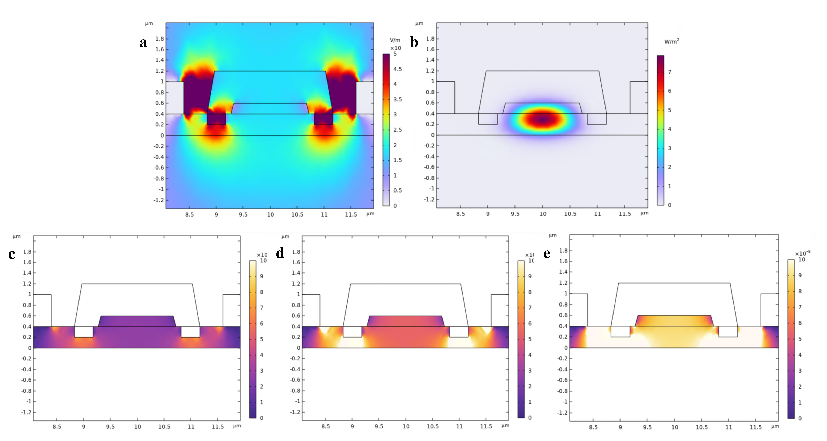

SFig. 9. Simulation of the modulator with an external electric potential of 1 V. (a) Distribution of electric field intensity across the cross-section of the modulation region. (b) Intensity distribution of light in the waveguide. The impact of the refractive index change induced by the applied electric field with Pockels coefficients of (c) 30 pm/V, (d) 60 pm/V, and (e) 100 pm/V.

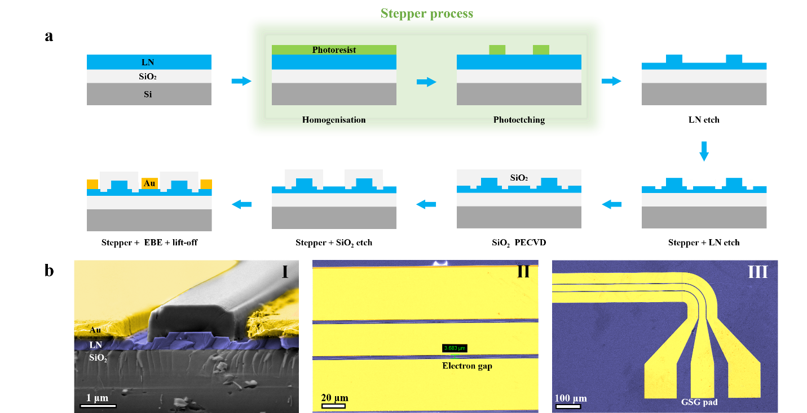 SFig. 10. Fabrication of the modulator. (a) Schematic of micro/nano fabrication processes for the electro-optic modulator. (b) Colorized SEM of the (Ⅰ) Cross-sectional view of the modulation region. (Ⅱ) Top view confirming electrode spacing (measured: 3.7 μm vs. designed: 3.6 μm). (Ⅲ) Ground-signal-ground (GSG) electrodes for high-frequency signal application.

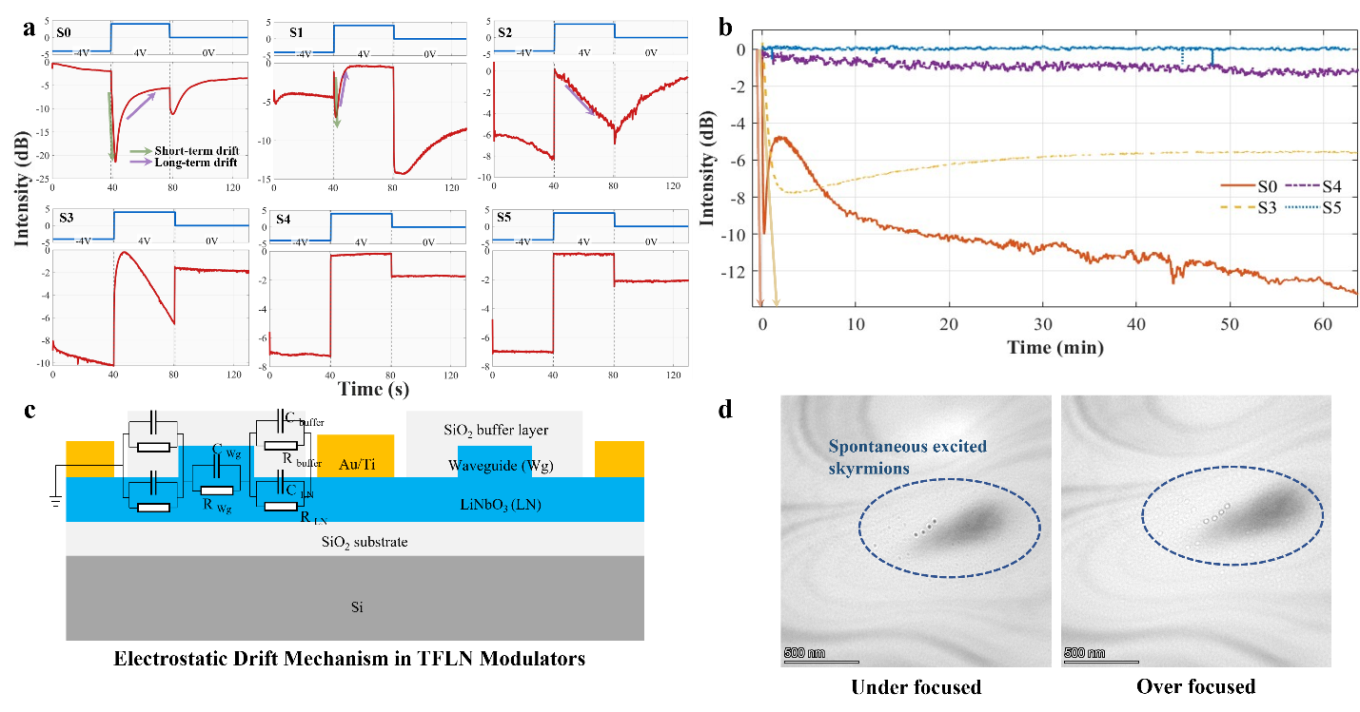

SFig. 11. DC drift phenomenon in LN with corresponding theory model. (a) Short-term DC-drift dynamics under voltage steps: 0→-4V (t = 0s), -4V→4V (t = 40s), 4V→0V (t = 80s). Samples: S0 (0T), S1 (0.005T), S2 (0.3T), S3 (1T) magnetic annealing; S4: S3+773K annealing; S5: S3+823K annealing. (b) Long-term drift suppression: 1-hour stability test at 8V bias. S0: severe drift (>10 dB/h); S3: intermediate suppression; S4: ultralow drift (<2 dB/h); S5: undetectable drift (<0.1 dB/h). The short-term drift slope of S0 and S3 is described by arrows. (c) Acknowledged electrostatic model of dc drift in TFLN. (d) LTEM images of skyrmions spontaneously formed on the untreated LN film.

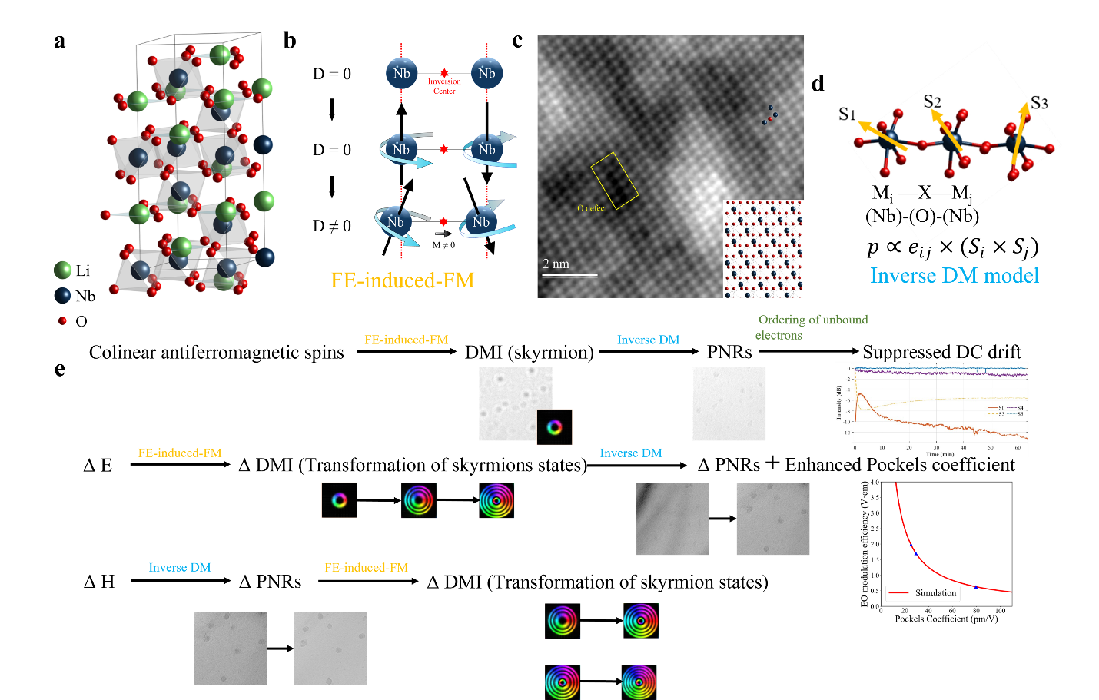

SFig. 12. Potential mechanisms in SK-LN: (a) Lattice structure of paraelectric LN (b) Schematic diagram of FE-induced FM in LN. (c) STEM images of LN crystal, in which O vacancies can be observed. (d) Schematic diagram of inverse DM mechanism in LN.(e) Statistical analysis and mechanism classification of all magnetoelectric coupling phenomena observed in SK-LN

Table S1. Design parameters of the electro-optic modulator
Designation | Value | Designation | Value
Wg | 1.4 μm | H | 0.6 μm
Ws | 3.2 μm | H₁ | 4.7 μm
Wc | 0.3 μm | H₂ | 550 μm
Wt | 0.5 μm | Hc | 0.2 μm
Gap | 3.6 μm | Ht | 0.2 μm
 |  | Hs | 0.8 μm

