Supplemental Information - 3

MARINE DEBRIS IN RIVER MARGINS: WET AND DRY WEATHERING EFFECTS ON THE FRAGMENTATION AND DEGRADATION OF DISCARDED PLASTIC

Natalie Mladenov¹*, Ella Knight¹, Alexi Olney², Fernando Wakida³, Teresita de Jesus Piñon-Colin³, George Youssef⁴, Alicia Kinoshita¹

¹ Department of Civil, Construction, and Environmental Engineering, 5500 Campanile Drive, San Diego State University, San Diego, CA, USA
² Department of Statistics, 5500 Campanile Drive, San Diego State University, San Diego, CA, USA
³ Universidad Autónoma de Baja California, Calzada Universidad 14418, Parque Industrial Internacional Tijuana, C.P. 22390 Tijuana, Baja California, Mexico
⁴ Department of Mechanical Engineering, 5500 Campanile Drive, San Diego State University, San Diego, CA, USA
* Corresponding author: nmladenov@sdsu.edu

This document contains:
- Supplemental Tables S3-1 to S3-10 showing FTIR-ATR bands and wavenumbers of polymer reference material and the pristine (unweathered) samples.
- Supplemental Figures S3-1 to S3-20 showing FTIR-ATR spectra under pristine and weathered conditions.

Table S3-1. Main bands and wavenumber identified of pristine cigarette filter sample compare to reference cellulose acetate material.

Functional group or bond | Reference wavenumber (cm⁻¹) Cellulose acetate (CA) | Wavenumber of pristine cigarette filter (cm⁻¹).
C-H stretching | 2900 | 2951, 2880
C=O ester | 1750-1730 | 1737
CH₃ flexion | 1450 y 1375 | 1450 y 1365
C-O symmetrical | 1300-1000 | 1031
CH₂ flexion | 1465 | 1433
Asymmetric stretch  C-O- C=O | 1300-1000 | 1217
Swinging CH₂ | 720 | 718
Swinging C=0 |  | 686
-OH Hydroxyl | 3750-3300 | 3543 weak signal
C= O Carbonyl acid | 1725-1700 | 1644 weak signal
C-O unsaturated | 1200-1000 | 1031

Figure S3-1. FTIR-ATR absorbance spectrum of pristine CA cigarette filter.
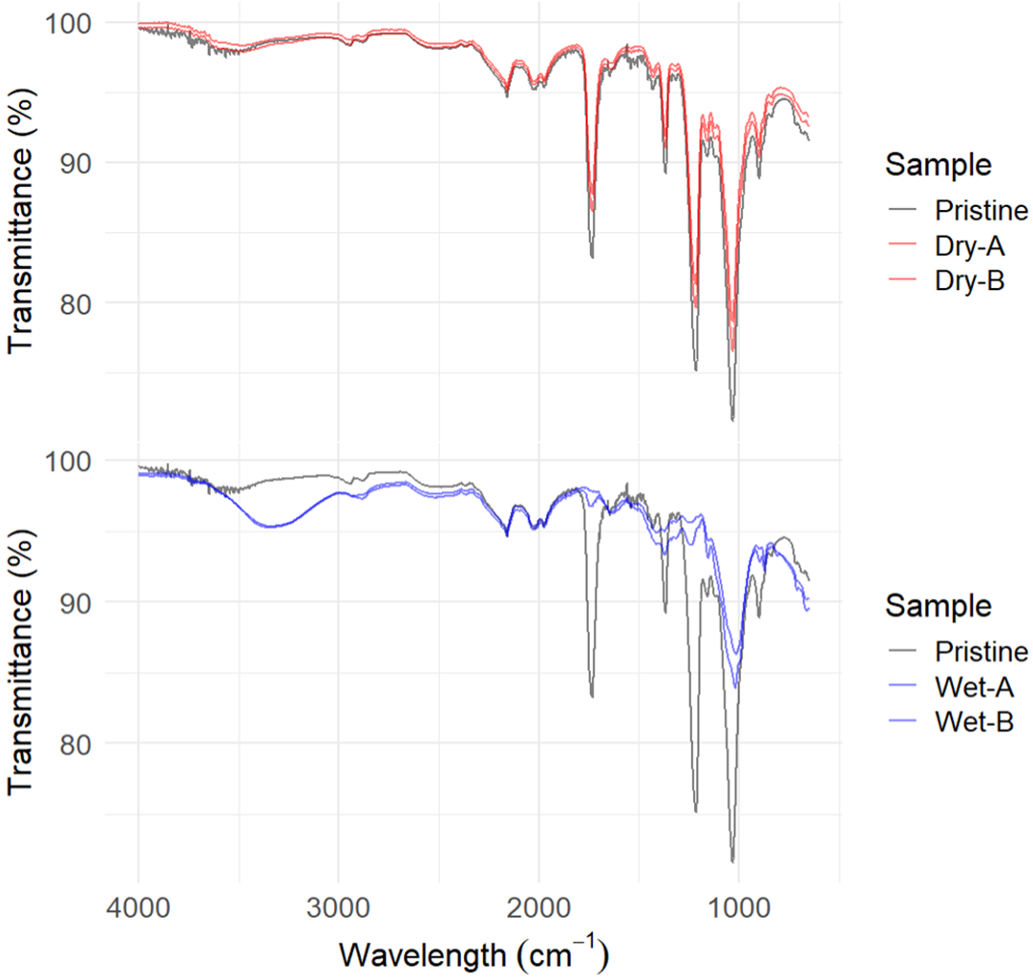
Figure S3-2. FTIR-ATR transmittance spectra of pristine, dry, and wet weathered CA cigarette filters.

Table S3-2. Main bonds and wavenumbers found in pristine blanket.
Functional group or bond. | Reference wavenumber (cm⁻¹) for polyethylene terephthalate (PET) | Wavenumber of pristine blanket (cm⁻¹)
-CH₂-asymmetric and symmetric stretching | 3000-2850 | 2973, 2910
=C-H aromatic stretch | 3150-3050 | 3100 weak signal
C=O ester | 1750-1705 | 1713
C=C aromatic ring  C=C aromatic polyester | 1600 y 1475  1615, 1580 y 1505 | 1576 y 1455
C-H asymmetric and symmetric in the plane | 1471, 1409 y 1340 | 1409 y 1337
C-C(O)-O | 1260-1250 | 1239
-O-C- | 1130-1120  1100-1090 | 1094
C-H aromatic ring in the plane | 1016 y 970 | 1017 y 970
C-H aromatic ring out of plane | 900-690 | 870
C-H aromatic ring winging | 720 | 727
CO₂ | 2380 | 2380
-OH Hydroxyl | 3750-3300 | -----
C= O Carbonyl |  | -----
C-O unsaturated | 1200-1000 | 1094

Figure S3-3. FTIR-ATR absorbance spectrum of pristine PET blanket.
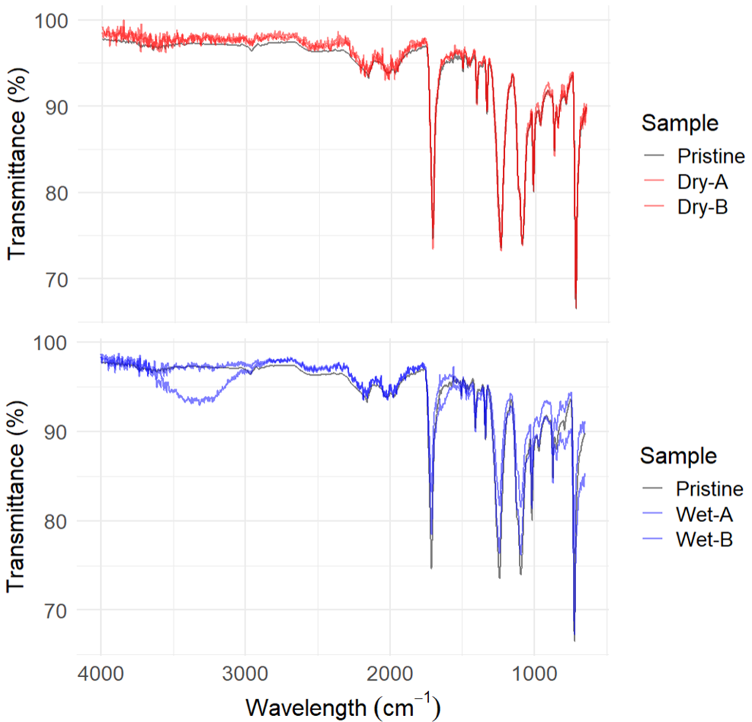
Figure S3-4. FTIR-ATR transmittance spectra of pristine, dry, and wet weathered PET blanket.

Table S3-3. Main bonds and wavenumbers found in pristine tent.
Functional group or bond. | Reference wavenumber (cm⁻¹) for polyethylene terephthalate | Wavenumber of pristine tent (cm⁻¹)
-CH₂-asymmetric and symmetric stretching | 3000-2850 | 2965, 2915
=C-H aromatic stretch | 3150-3050 | 3050 weak signal
C=O ester | 1750-1705 | 1716
C=C aromatic ring  C=C aromatic polyester | 1600 y 1475  1615, 1580 y 1505 | 1576 y 1472
C-H asymmetric and symmetric in the plane | 1471, 1409 y 1340 | 1411 y 1340
C-C(O)-O | 1260-1250 | 1242
-O-C- | 1130-1120  1100-1090 | 1098
C-H aromatic ring in the plane | 1016 y 970 | 1017 y 968
C-H aromatic ring out of plane | 900-690 | 872
C-H aromatic ring winging | 720 | 727
CO₂ | 2380 | 2491
-OH Hydroxyl | 3750-3300 | -----
C= O Carbonyl |  | 1607
C-O unsaturated | 1200-1000 | 1099

Figure S3-5. FTIR-ATR absorbance spectrum of pristine PET tent.
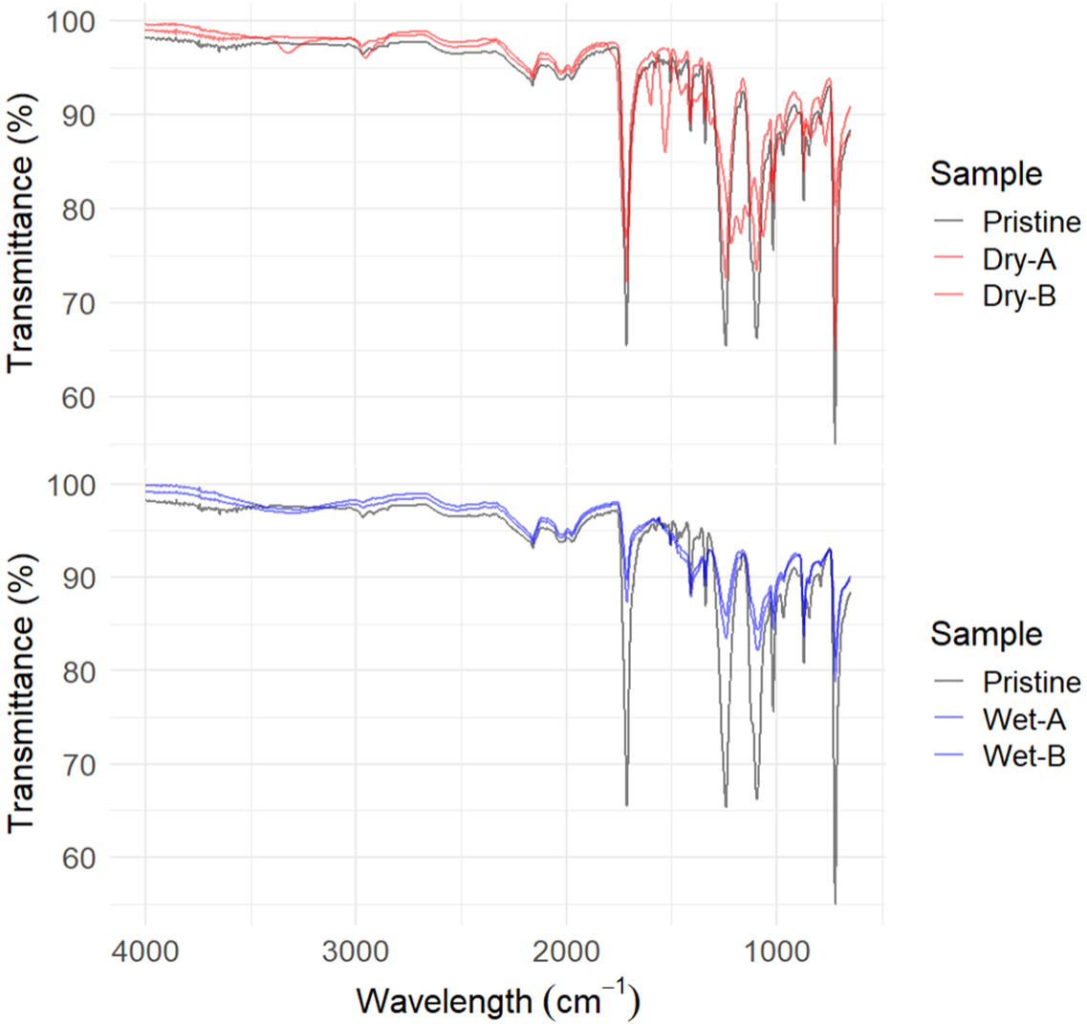
Figure S3-6. FTIR-ATR transmittance spectra of pristine, dry, and wet weathered PET tent.

Table S3-4. Main bonds and wavenumbers found in pristine medical mask.

Functional group or bond. | Reference wavenumber (cm⁻¹) for polypropylene (PP). | Wavenumber of pristine mask (cm⁻¹).
C-H stretching | 2900 | 2954, 2915, 2836
C-C stretching | 1350-1450 | 1376
CH₃ bending | 1450 y 1375 | 1461 y 1376
-OH Hydroxyl | 3750-3300 | --------
C= O Carbonyl |  | 1653
C-O unsaturated | 1200-1000 | 1099 weak signal

Figure S3-7. FTIR-ATR absorbance spectrum of pristine PP medical mask.
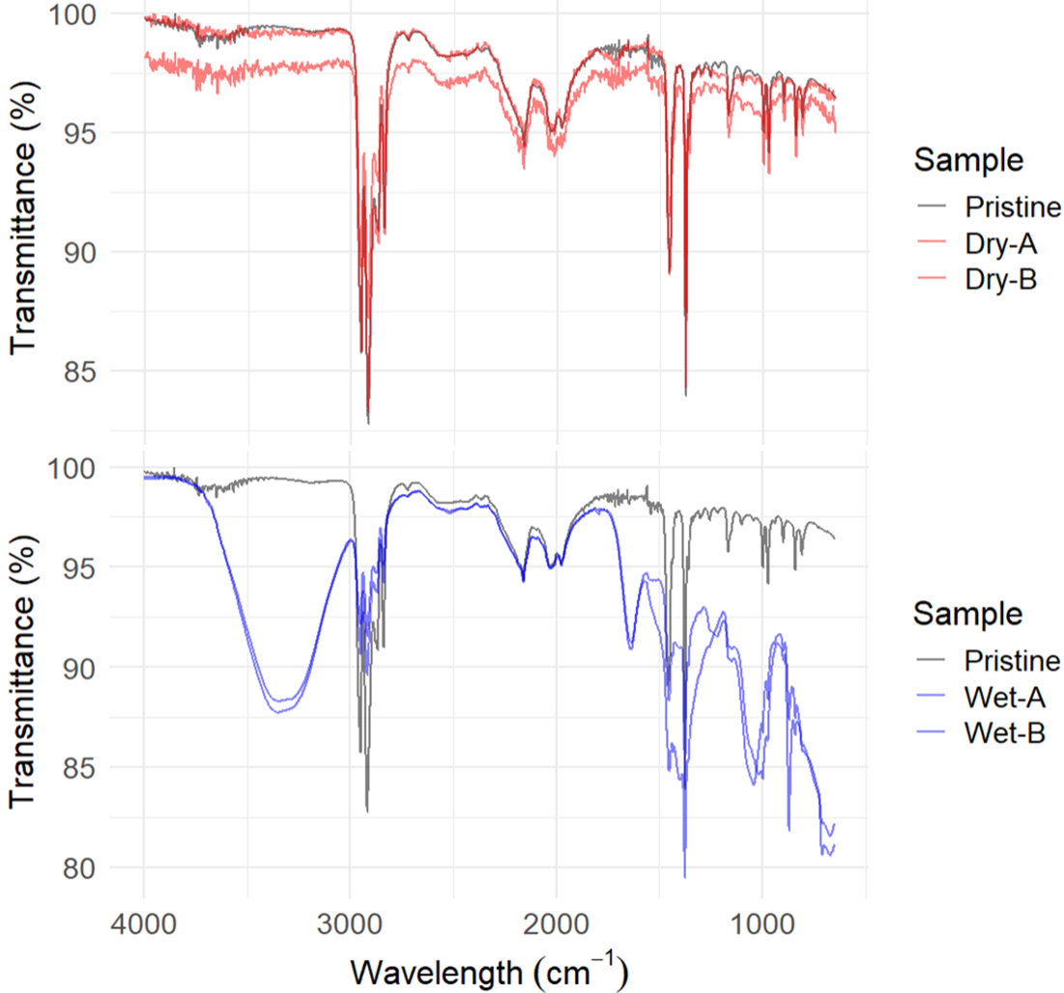
Figure S3-8. FTIR-ATR transmittance spectra of pristine, dry, and wet weathered PP medical mask.
Table S3-5. Main bonds and wavenumbers found in pristine thick bag.

Functional group or bond. | Reference wavenumber (cm⁻¹) for polyethylene (PE). | Wavenumber of pristine thick bag (black film) (cm⁻¹).
CH stretching | 2965-2915 | 2915
CH stretching | 2865-2840 | 2850
CH₂ in the plane | 1470-1465 | 1469
CH deformation out of plane | 720-710 | 724
-OH Hydroxyl | 3750-3300 | ------
C= O Carbonyl |  | 1647 weak signal
C-O unsaturated | 1200-1000 | 1014

Figure S3-9. FTIR-ATR absorbance spectrum of pristine LDPE thick bag.

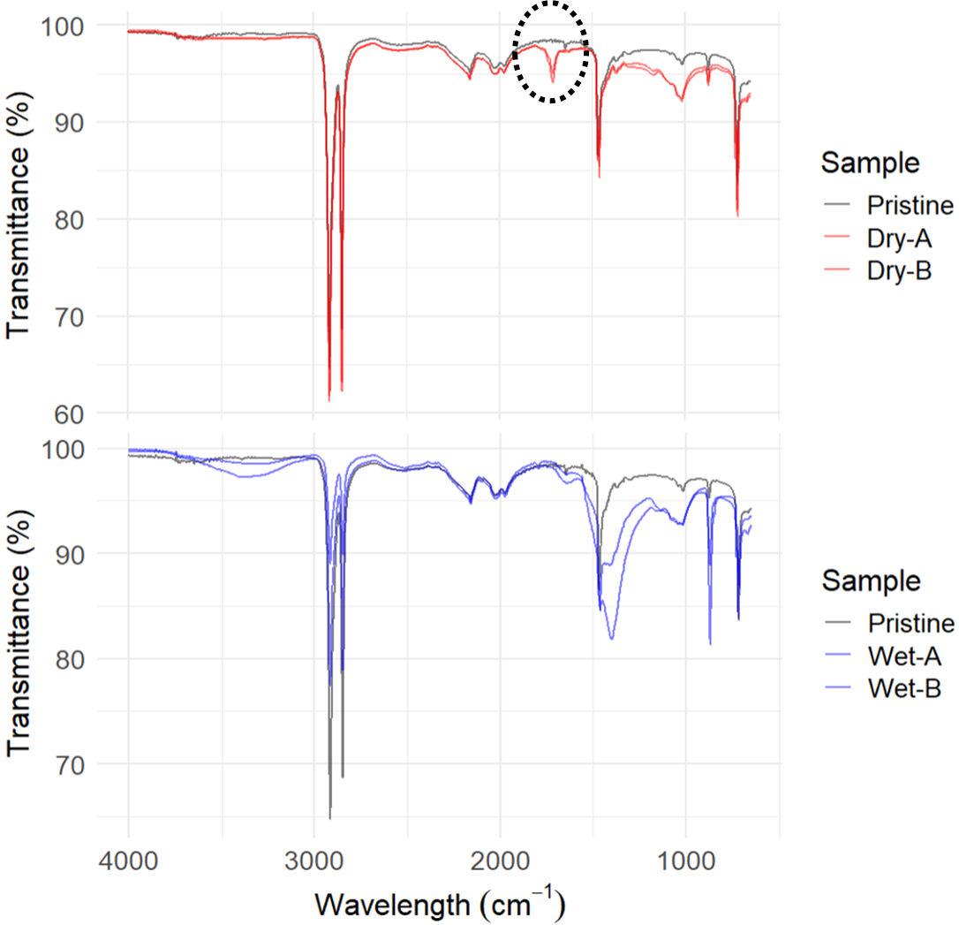

Figure S3-10. FTIR-ATR transmittance spectra of pristine, dry, and wet weathered LDPE thick bag. C-O carbonyl area is circled with dashed line.

Table S3-6. Main bonds and wavenumbers found in pristine thin bag.

Functional group or bond. | Reference wavenumber (cm⁻¹) for polyethylene (PE). | Wavenumber of pristine thin bag (cm⁻¹).
CH stretching | 2965-2915 | 2918
CH stretching | 2865-2840 | 2852
CH₂ in the plane | 1470-1465 | 1474
CH deformation out of plane | 720-710 | 721
-OH Hydroxyl | 3750-3300 | ------
C= O Carbonyl |  | -------
C-O unsaturated | 1200-1000 | 1044

Figure S3-11. FTIR-ATR absorbance spectrum of pristine LDPE thin bag.

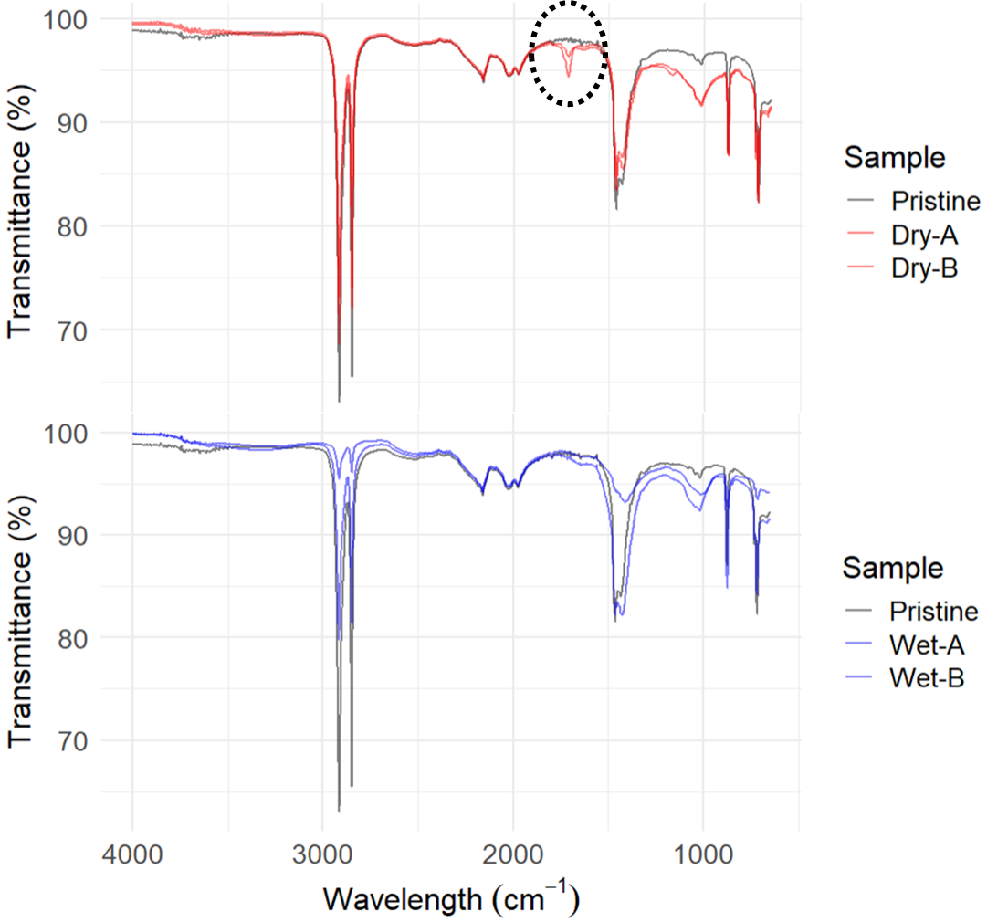

Figure S3-12. FTIR-ATR transmittance spectra of pristine, dry, and wet weathered LDPE thin bag. C-O carbonyl area is circled with dashed line.

Table S3-7. Main bonds and wavenumbers found in pristine water bottle.
Functional group or bond. | Reference wavenumber (cm⁻¹) for polyethylene terephthalate | Wavenumber of pristine water bottle (cm⁻¹)
-CH₂-asymmetric and symmetric stretching | 3000-2850 | 2970, 2910
=C-H aromatic stretch | 3150-3050 | 3100 weak signal
C=O ester | 1750-1705 | 1716
C=C aromatic ring  C=C aromatic polyester | 1600 y 1475  1615, 1580 y 1505 | 1576 y 1469
C-H asymmetric and symmetric in the plane | 1471, 1409 y 1340 | 1406 y 1338
C-C(O)-O | 1260-1250 | 1247
-O-C- | 1130-1120  1100-1090 | 1096
C-H aromatic ring in the plane | 1016 y 970 | 1017 y 970
C-H aromatic ring out of plane | 900-690 | 872
C-H aromatic ring winging | 720 | 727
CO₂ | 2380 | 2370 weak signal
-OH Hydroxyl | 3750-3300 | ----
C= O Carbonyl ester |  | 1716
C-O unsaturated | 1200-1000 | 1096

Figure S3-13. FTIR-ATR absorbance spectrum of pristine PET water bottle.

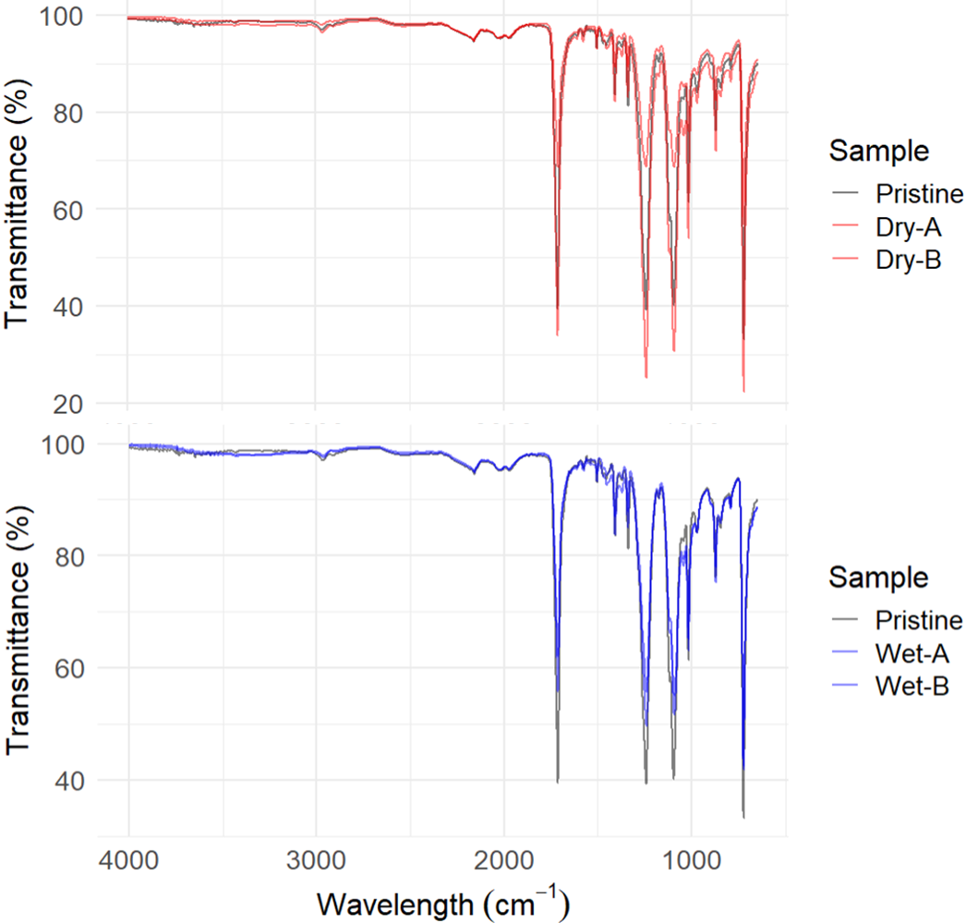

Figure S3-14. FTIR-ATR transmittance spectra of pristine, dry, and wet weathered PET water bottle.

Table S3-8. Main bonds and wavenumbers found in pristine Styrofoam food container.
Functional group or bond. | Reference wavenumber (cm⁻¹) for polystyrene (PS). | Wavenumber of pristine Styrofoam (cm⁻¹).
C-H of the aromatic ring | 3150-3050 | 3025
CH asymmetric stretch | 3000-2850 | 2916, 2844
C-C aromatic compounds | 1600-1450 | 1600
-CH₂ of bending | 1570 | 1491

Figure S3-15. FTIR-ATR absorbance spectrum of pristine PS food container.
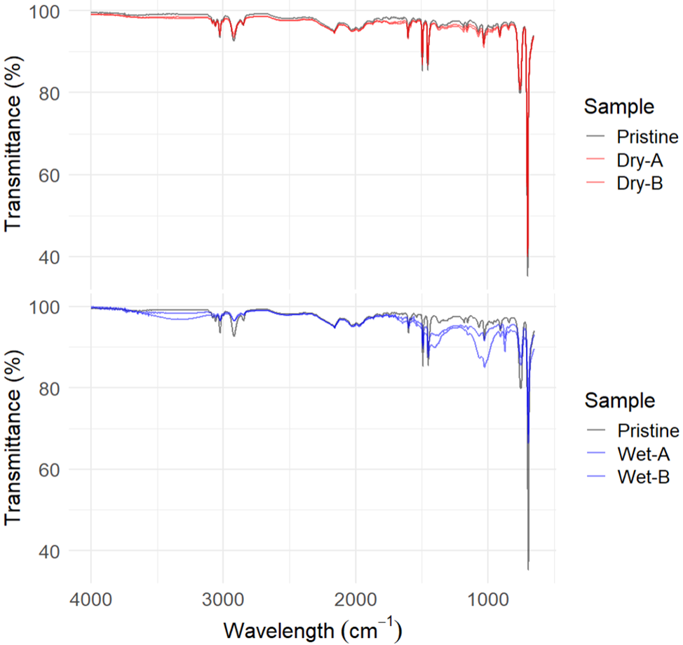

Figure S3-16. FTIR-ATR transmittance spectra of pristine, dry, and wet weathered PS food container.

Table S3-9. Main bonds and wavenumbers found in pristine PP food container.

Functional group or bond. | Reference wavenumber (cm⁻¹) for polypropylene (PP). | Wavenumber of pristine PP food container (cm⁻¹).
C-H stretching | 2900 | 2951, 2915, 2839
C-C stretching | 1350-1450 | 1381
CH₃ bending | 1450 y 1375 | 1458 y 1381

Figure S3-17. FTIR-ATR absorbance spectrum of pristine PP food container.

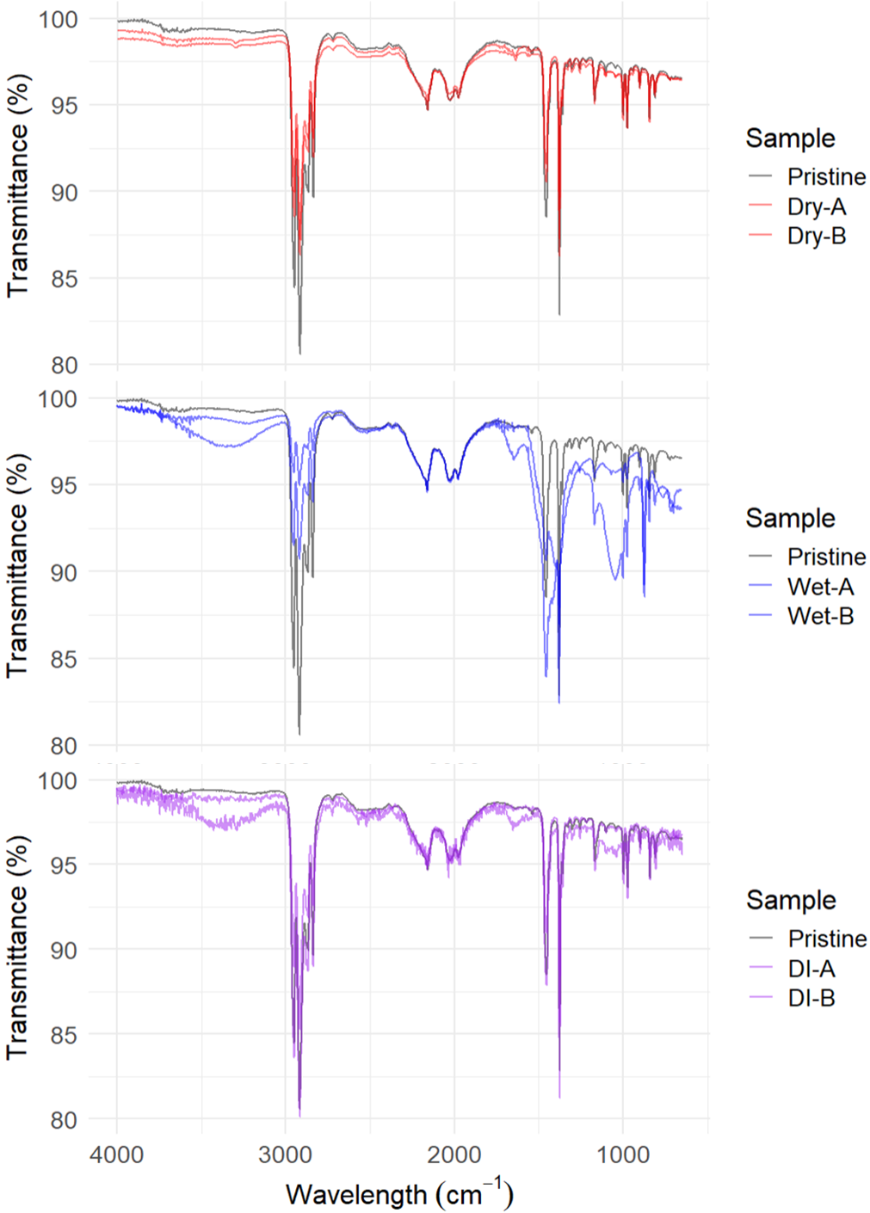
Figure S3-18. FTIR-ATR transmittance spectra of pristine, dry, and wet weathered (both in creek water (Wet) and deionized water (DI)) PP food container.

Table S3-10. Main bonds and wavenumbers found pristine bioplastic (PP+CC) food container.

Functional group or bond. | Reference wavenumber (cm⁻¹) for polypropylene (PP). | Wavenumber of pristine bioplastic container (cm⁻¹).
C-H stretching | 2900 | 2954, 2966, 2839
C-C stretching | 1350-1450 | 1376
CH₃ bending | 1450 y 1375 | 1455 y 1376
-OH Hydroxyl | 3750-3300 | ----
C= O Carbonyl |  | 1625 weak signal
C-O unsaturated | 1200-1000 | 1047

Figure S3-19. FTIR-ATR absorbance spectrum of pristine bioplastic food container.

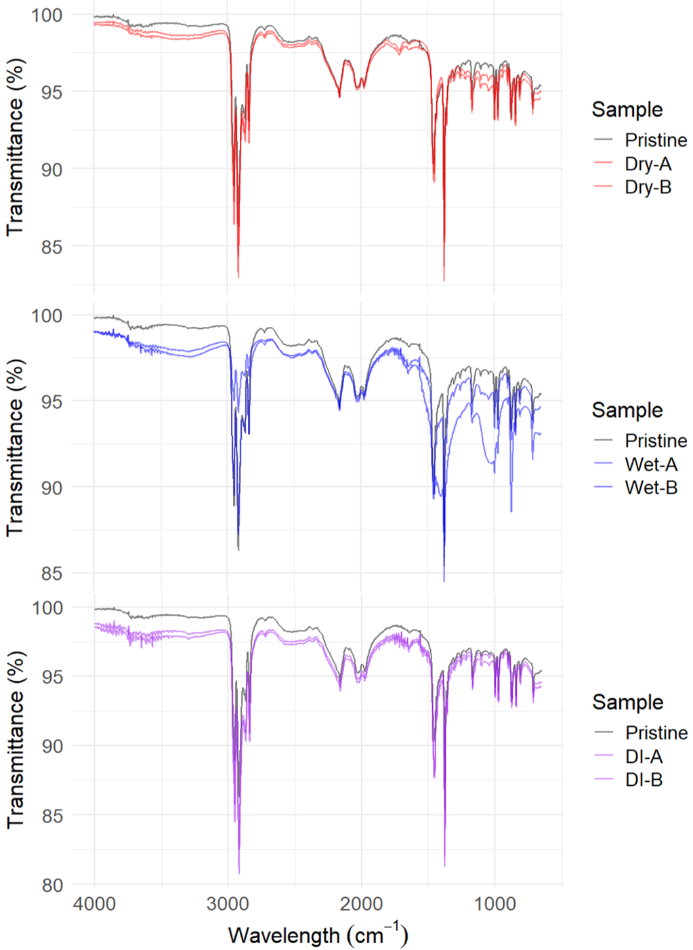

Figure S3-20. FTIR-ATR transmittance spectra of pristine, dry, and wet weathered (both in creek water (Wet) and deionized water (DI)) bioplastic food container.

