Supplemental Information - 2

MARINE DEBRIS IN RIVER MARGINS: WET AND DRY WEATHERING EFFECTS ON THE FRAGMENTATION AND DEGRADATION OF DISCARDED PLASTIC

Natalie Mladenov¹*, Ella Knight¹, Alexi Olney², Fernando Wakida³, Teresita de Jesus Piñon-Colin³, George Youssef⁴, Alicia Kinoshita¹

¹ Department of Civil, Construction, and Environmental Engineering, 5500 Campanile Drive, San Diego State University, San Diego, CA, USA
² Department of Statistics, 5500 Campanile Drive, San Diego State University, San Diego, CA, USA
³ Universidad Autónoma de Baja California, Calzada Universidad 14418, Parque Industrial Internacional Tijuana, C.P. 22390 Tijuana, Baja California, Mexico
⁴ Department of Mechanical Engineering, 5500 Campanile Drive, San Diego State University, San Diego, CA, USA
* Corresponding author: nmladenov@sdsu.edu

This document contains:
- Supplementary Photographs, Figures S2-1 to S2-95

Photographs of pristine item replicates
The photographs below were taken on 10 October 2022 prior to microcosm deployment.

Items intended for wet weathering in creek water

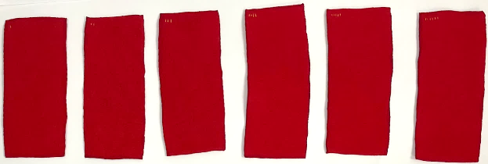
1 Pristine Wet Blanket, Samples 1-6
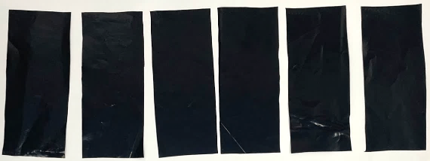
2 Pristine Wet Black Bag, Samples 1-6
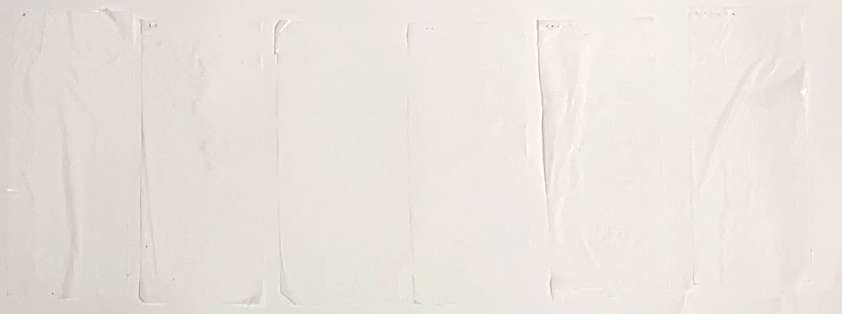
3 Pristine Wet White Bag, Samples 1-6
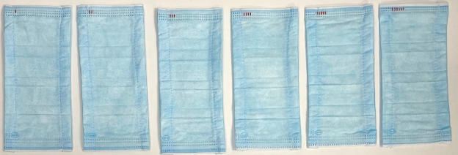
4 Pristine Wet Mask, Samples 1-6
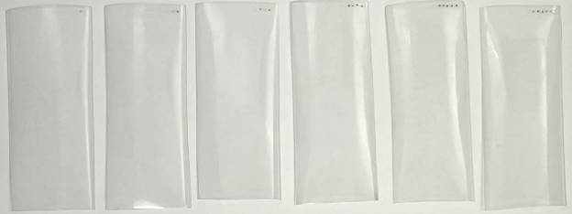
5 Pristine Wet Water Bottle, Samples 1-6
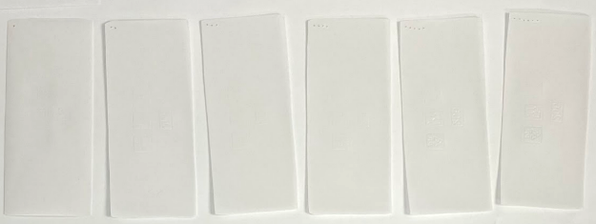
6 Pristine Wet Styrofoam, Samples 1-6
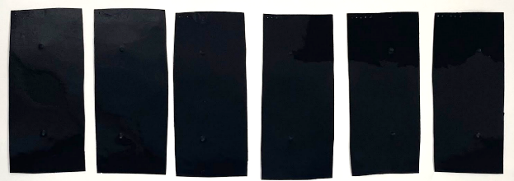
7 Pristine Wet Black To-Go, Samples 1-6
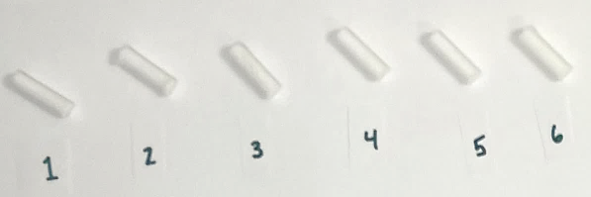
8 Pristine Wet Cigarette Butts, Samples 1-6
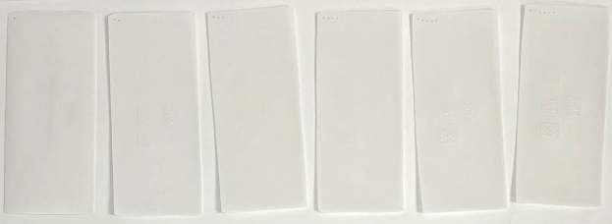
9 Pristine Wet Bioplastic, Samples 1-6
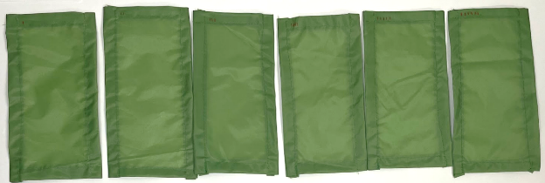
10 Pristine Wet Tent, Samples 1-6

Items intended for dry weathering

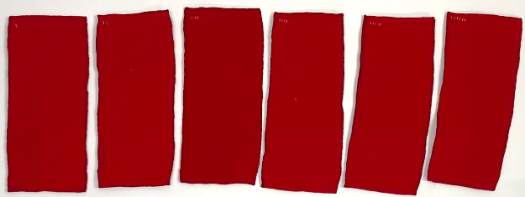
11 Pristine Dry Blanket, Samples 1-6
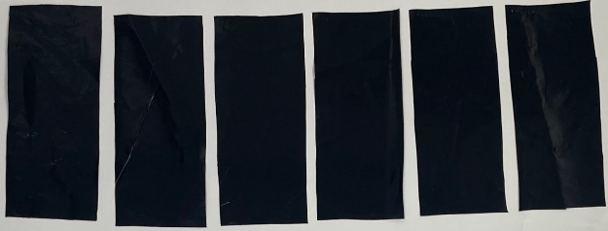
12 Pristine Dry Black Bag, Samples 1-6
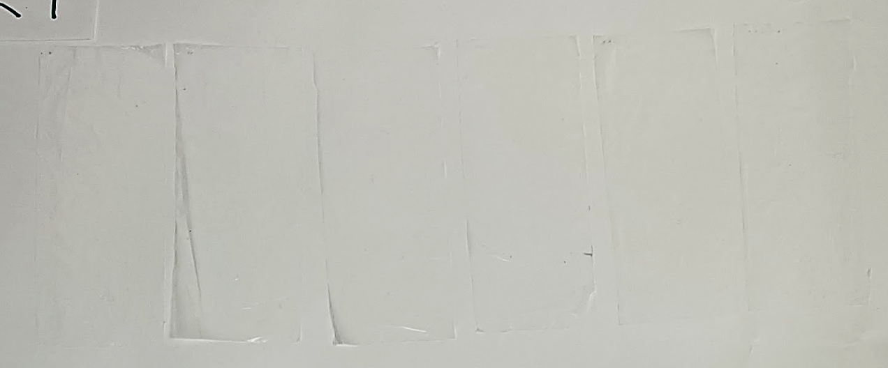
13 Pristine Dry White Bag, Samples 1-6
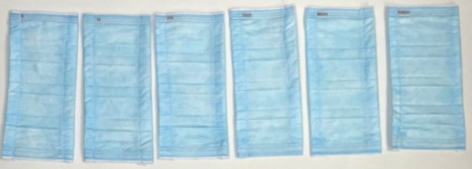
14 Pristine Dry Mask, Samples 1-6
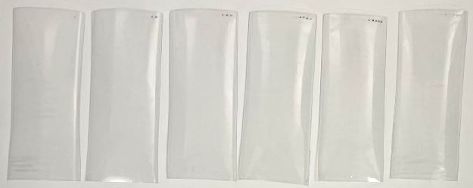
15 Pristine Dry Water Bottle, Samples 1-6
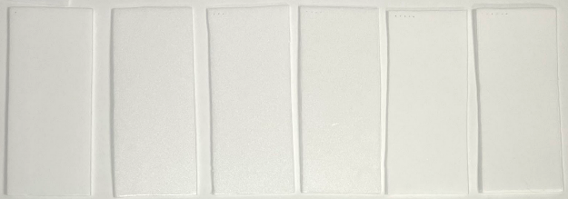
16 Pristine Dry Styrofoam, Samples 1-6
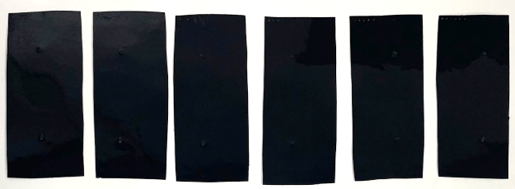
17 Pristine Dry Black To-Go, Samples 1-6
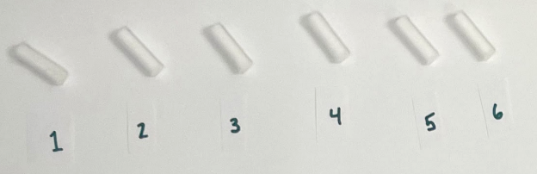
18 Pristine Dry Cigarette Butts, Samples 1-6
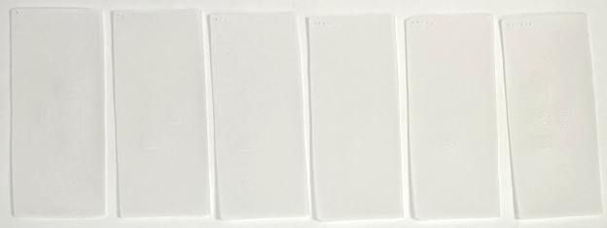
19 Pristine Dry Bioplastic, Samples 1-6
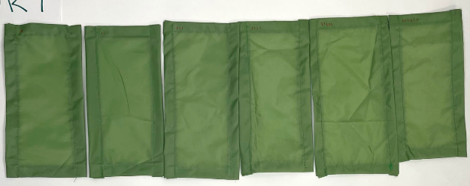
20 Pristine Dry Tent, Samples 1-6

1.3 Items intended for wet weathering in DI water

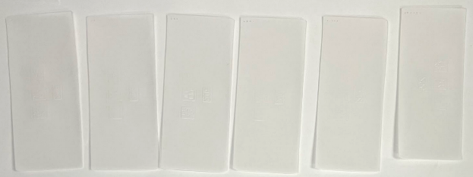
21 Pristine DI Bioplastic, Samples 1-6
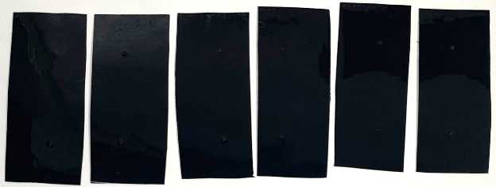
22 Pristine DI Black To-Go, Samples 1-6

Weathered items
The photographs below were taken on 10 July 2023 (after 271 days of weathering).

2.1 Items placed into wet weathering tanks filled with creek water

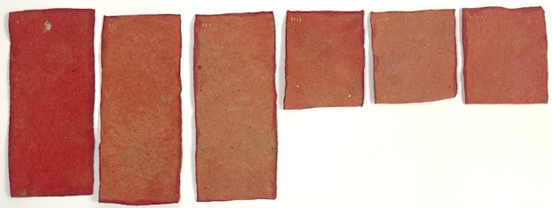
23 Weathered Wet Blanket, Front, Samples 1-6
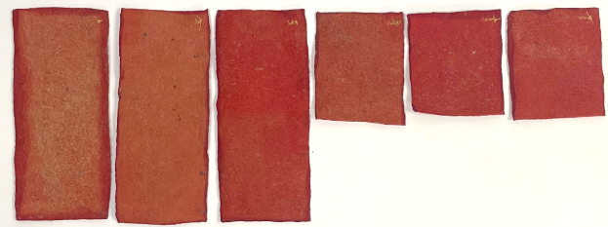
24 Weathered Wet Blanket, Back, Samples 1-6
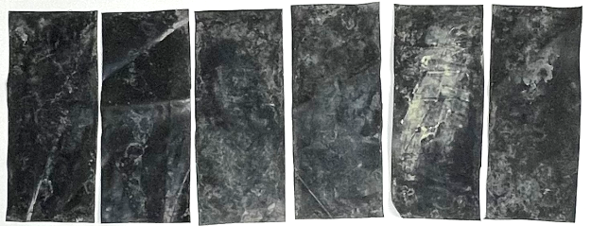
25 Weathered Wet Black Bag, Front, Samples 1-6
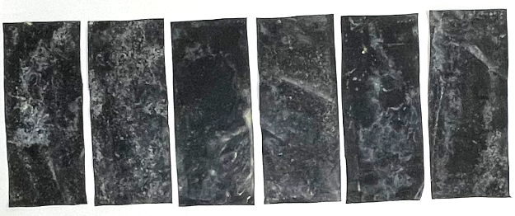
26 Weathered Wet Black Bag, Back, Samples 1-6
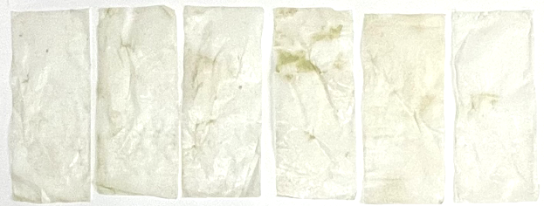
27 Wet Weathered White Bag, Front, Samples 1-6
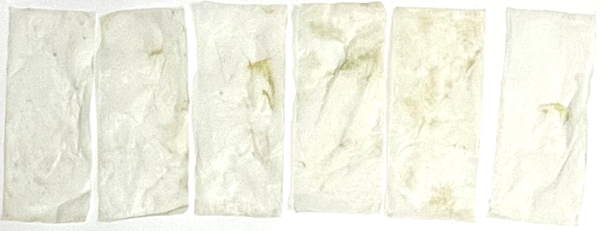
28 Wet Weathered White Bag, Back, Samples 1-6
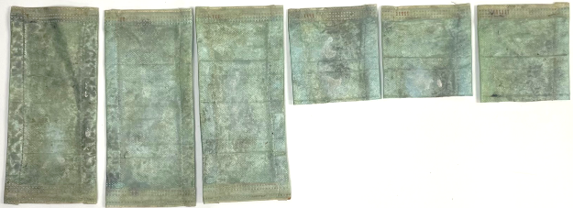
29 Wet Weathered Mask, Front, Samples 1-6
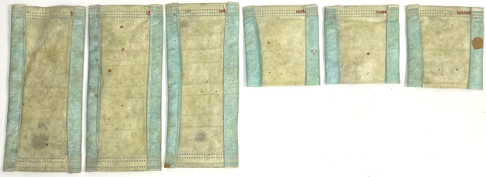
30 Wet Weathered Mask, Back, Samples 1-6
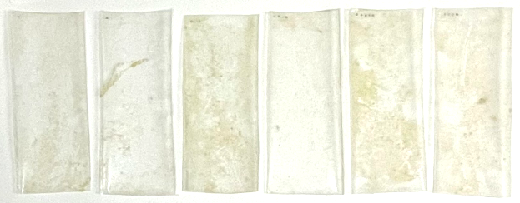
31 Wet Weathered Water Bottle, Front, Samples 1-6
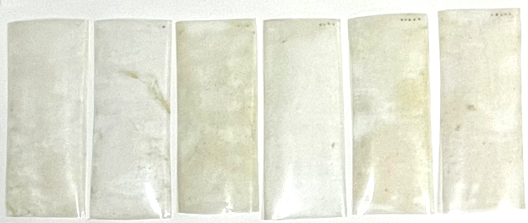
32 Wet Weathered Water Bottle, Back, Samples 1-6
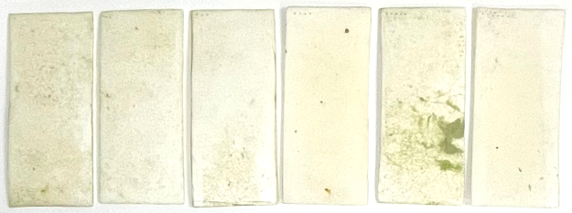
33 Wet Weathered Styrofoam, Front, Samples 1-6
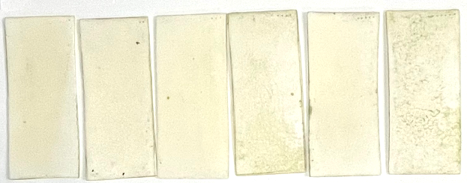
34 Wet Weathered Styrofoam, Back, Samples 1-6
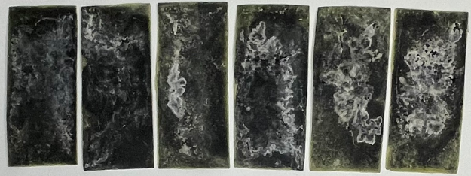
35 Wet Weathered Black To-Go, Front, Samples 1-6
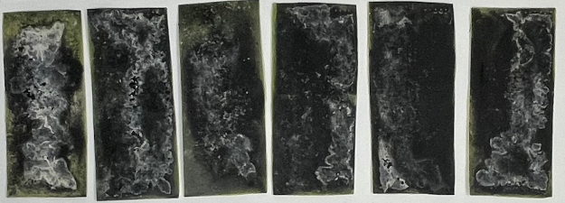
36 Wet Weathered Black To-Go, Back, Samples 1-6
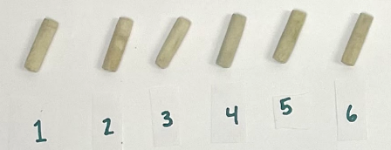
37 Wet Weathered, Cigarette Butts, Samples 1-6
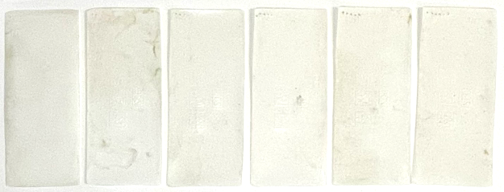
38 Wet Weathered Bioplastic, Front, Samples 1-6
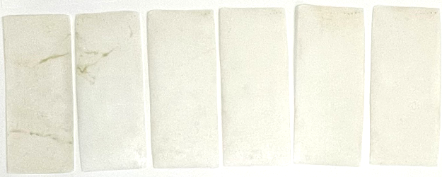
39 Wet Weathered Bioplastic, Back, Samples 1-6
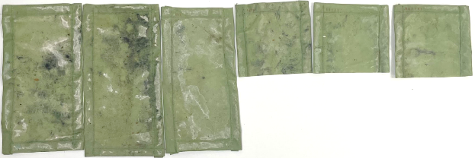
40 Wet Weathered Tent, Front, Samples 1-6
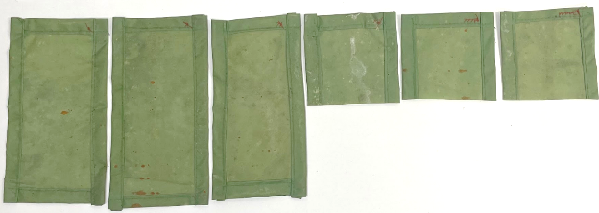
41 Wet Weathered Tent, Back, Samples 1-6

Items placed into dry weathering enclosures

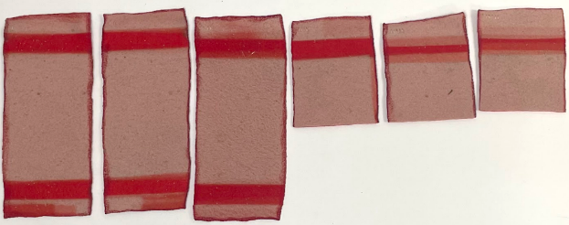
42 Dry Weathered Blanket. Front, Samples 1-6
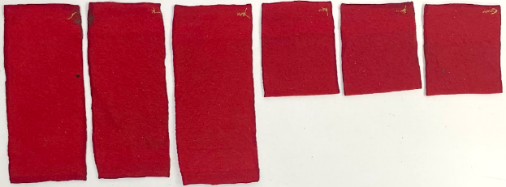
43 Dry Weathered Blanket, Back, Samples 1-6
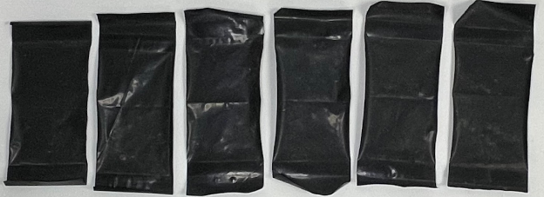
44 Dry Weathered Black Bag, Front, Samples 1-6
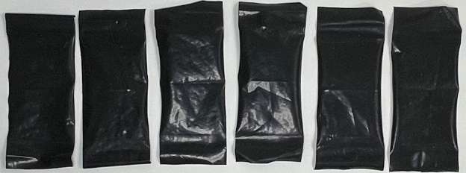
45 Dry Weathered Black Bag, Back, Samples 1-6
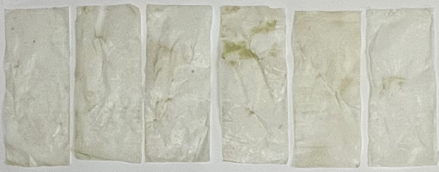
46 Dry Weathered White Bag, Front, Samples 1-6
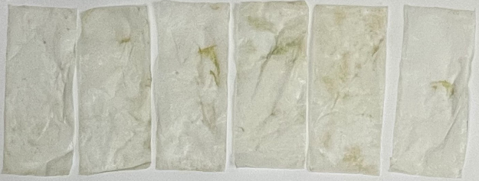
47 Dry Weathered White Bag, Back, Samples 1-6
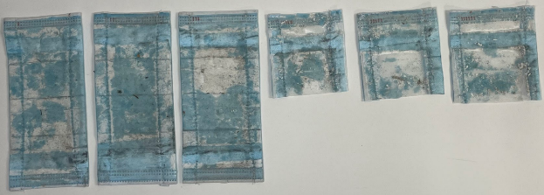
48 Dry Weathered Mask, Front, Samples 1-6
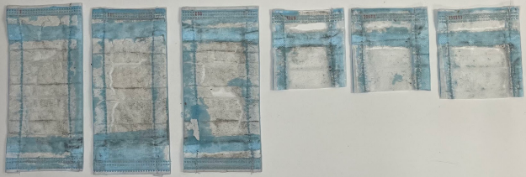
49 Dry Weathered Mask After Light Shaking, Front, Samples 1-6
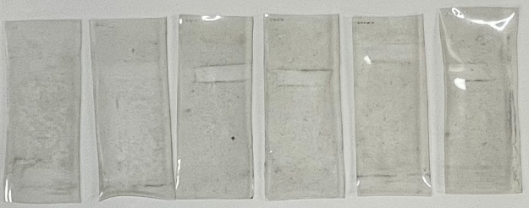
50 Dry Weathered Water Bottle, Front, Samples 1-6
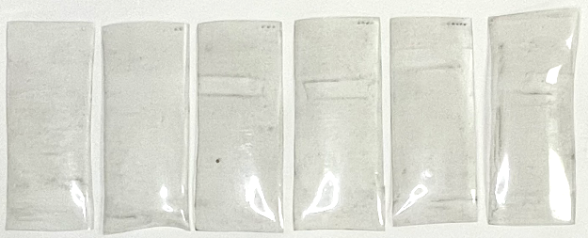
51 Dry Weathered Water Bottle, Back, Samples 1-6
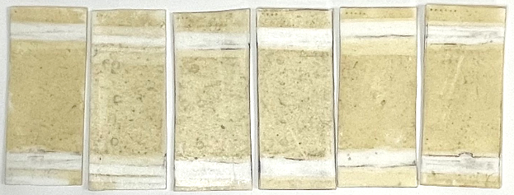
52 Dry Weathered Styrofoam, Front, Samples 1-6
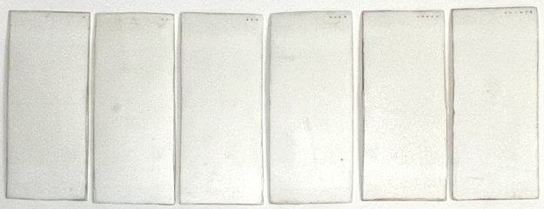
53 Dry Weathered Styrofoam, Back, Samples 1-6
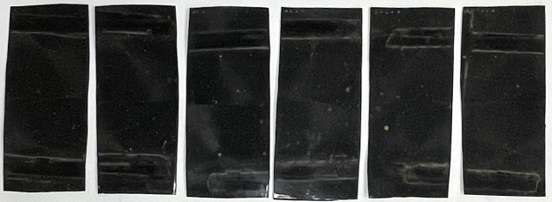
54 Dry Weathered Black To-Go, Front, Samples 1-6
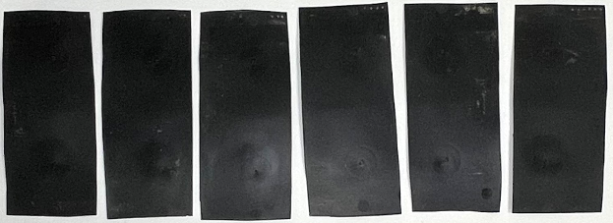
55 Dry Weathered Black To-Go, Back, Samples 1-6
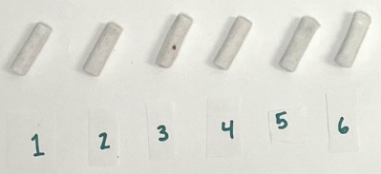
56 Dry Weathered Cigarette Butts, Samples 1-6
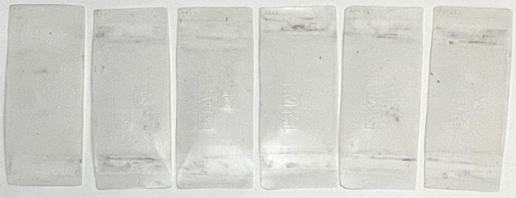
57 Dry Weathered Bioplastic, Front, Samples 1-6
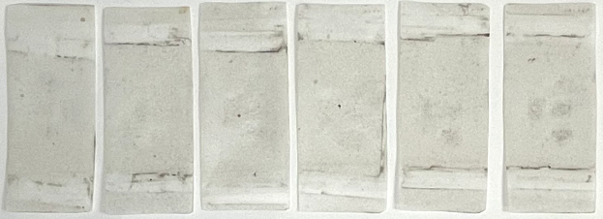
58 Dry Weathered Bioplastic, Back, Samples 1-6
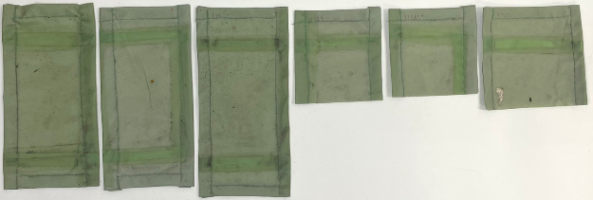
59 Dry Weathered Tent, Front, Samples 1-6
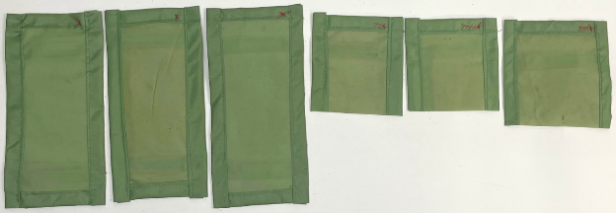
60 Dry Weathered Tent, Back, Samples 1-6

2.3 Items placed into tanks with deionized (DI) water

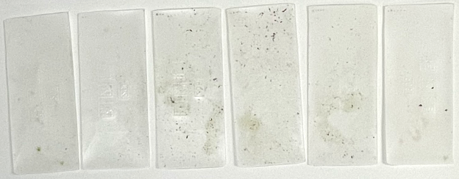
61 DI Weathered Bioplastic, Front, Samples 1-6
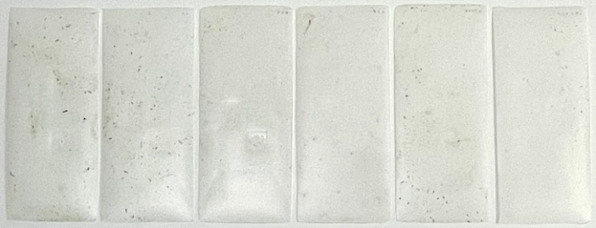
62 DI Weathered Bioplastic, Back, Samples 1-6
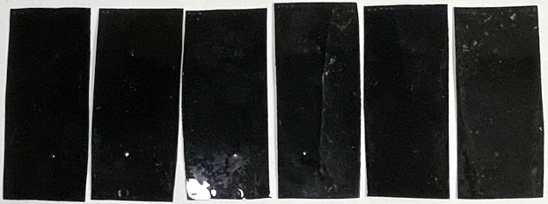
63 DI Weathered Black To-Go, Front, Samples 1-6
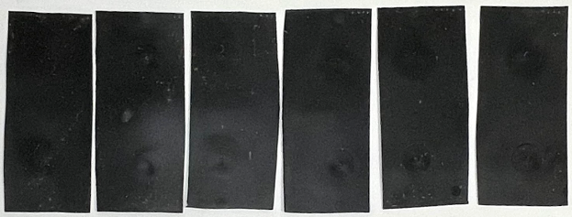
64 DI Weathered Black To-Go, Back, Samples 1-6

Tumbled items

3.1 Pristine items after tumbling

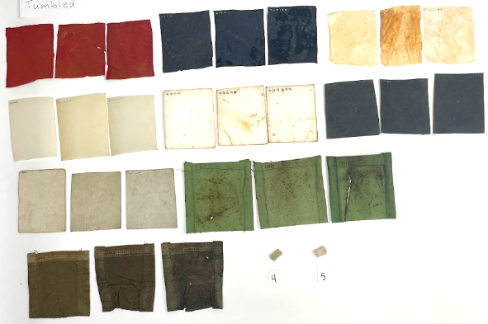
65 Tumbled Pristine, All Plastics, Samples 4-6
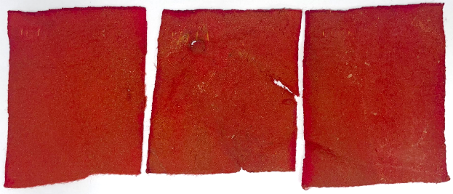
66 Tumbled Pristine Blanket, Front, Samples 4-6
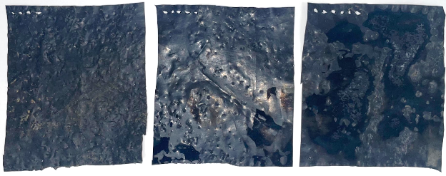
67 Tumbled Pristine Black Bag, Front, Samples 4-6
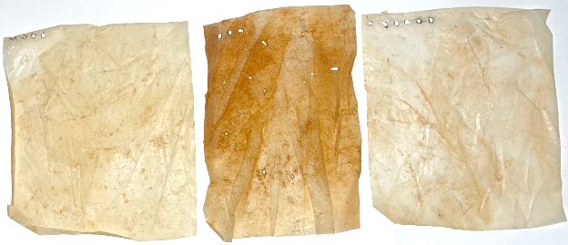
68 Tumbled Pristine White Bag, Front, Samples 4-6
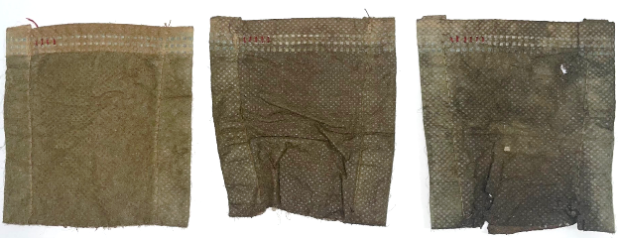
69 Tumbled Pristine Mask, Front, Samples 4-6
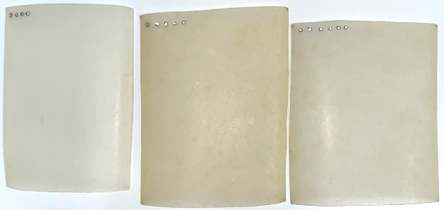
70 Tumbled Pristine Water Bottle, Front, Samples 4-6
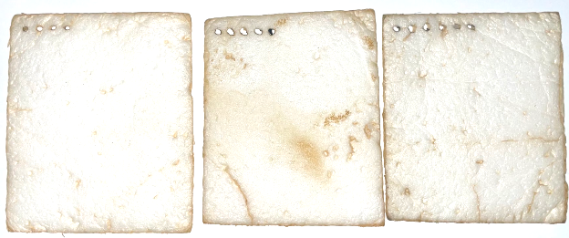
71 Tumbled Pristine Styrofoam, Front, Samples 4-6
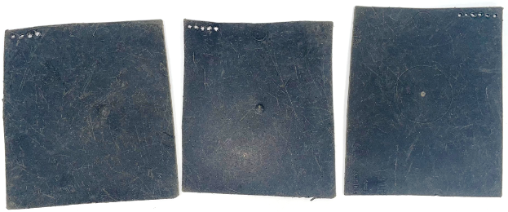
72 Tumbled Pristine Black To-Go, Front, Samples 4-6
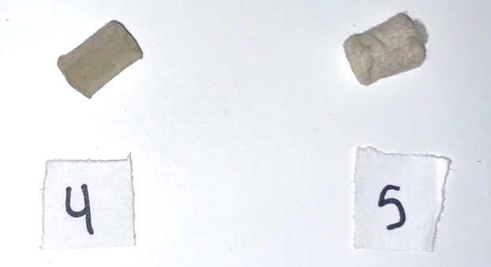
73 Tumbled Pristine Cigarette Butts, Samples 4-5
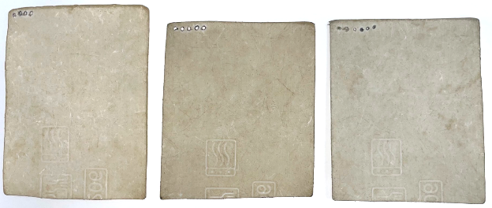
74 Tumbled Pristine Bioplastic, Front, Samples 4-6
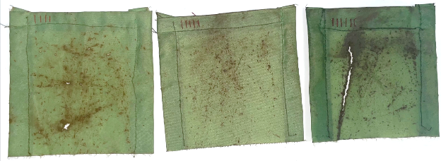
75 Tumbled Pristine Tent, Front, Samples 4-6

Wet weathered items after tumbling

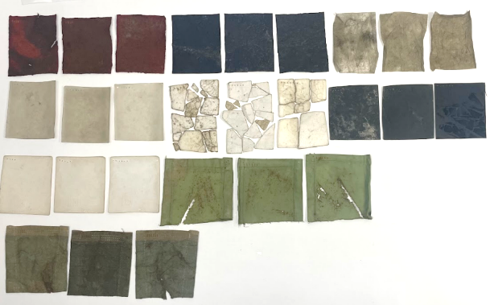
76 Tumbled Wet Weathered, All plastics except cigarette butts, Samples 4-6
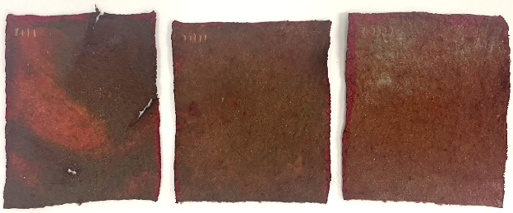
77 Tumbled Wet Blanket, Front, Samples 4-6
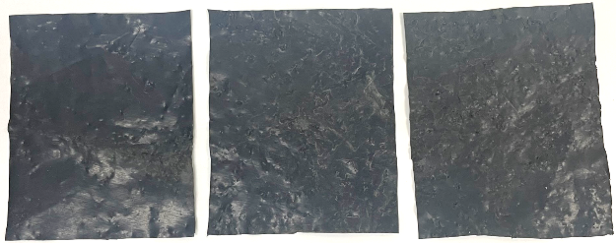
78 Tumbled Wet Black Bag, Front, Samples 4-6
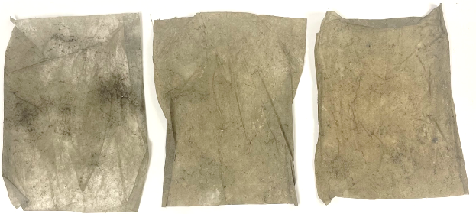
79 Tumbled Wet Weathered White Bag, Front, Samples 4-6
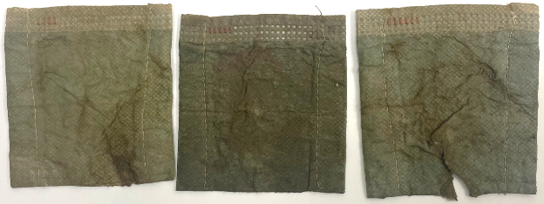
80 Tumbled Wet Weathered Mask, Front, Samples 4-6
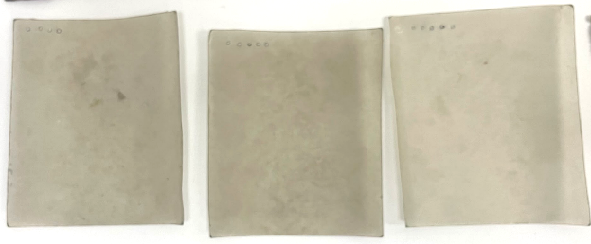
81 Tumbled Wet Weathered Water Bottle, Front, Samples 4-6
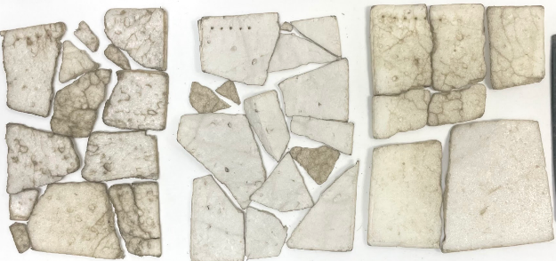
82 Tumbled Wet Weathered Styrofoam, Front, Samples 4-6

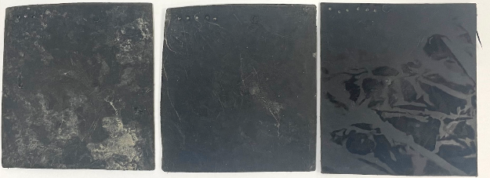
83 Tumbled Wet Weathered Black To-Go, Front, Samples 4-6
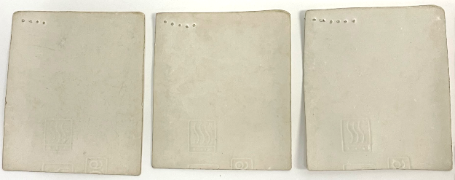
84 Tumbled Wet Weathered Bioplastic, Front, Samples 4-6
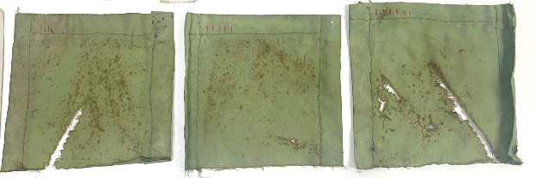
85 Tumbled Wet Weathered Tent, Front, Samples 4-6

Dry weathered items after tumbling

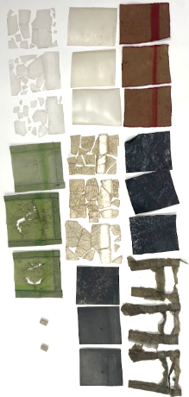
86 Tumbled Dry Weathered, All Plastics, Samples 4-6
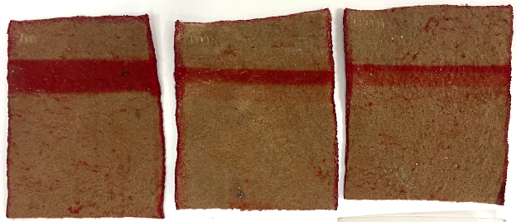
87 Tumbled Dry Weathered Blanket, Front, Samples 4-6
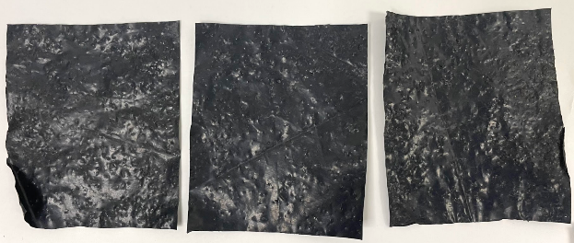
88 Tumbled Dry Weathered Black Bag, Front, Samples 4-6
No white bag
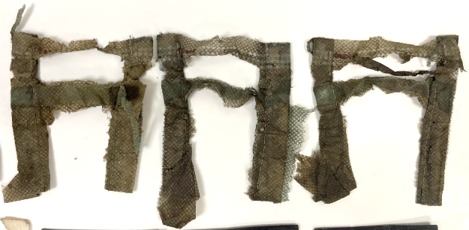
89 Tumbled Dry Weathered Mask, Front, Samples 4-6
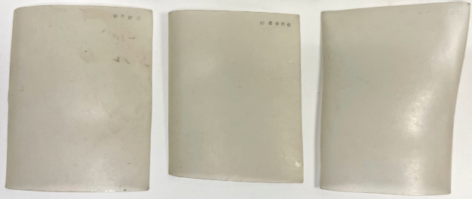
90 Tumbled Dry Weathered Water Bottle, Back, Samples 4-6
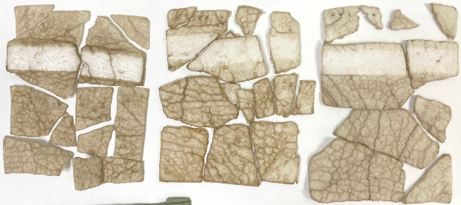
91 Tumbled Dry Weathered Styrofoam, Front, Samples 4-6
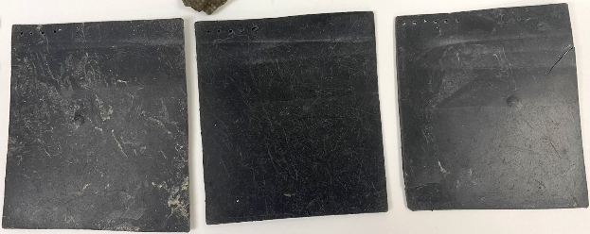
92 Tumbled Dry Weathered Black To-Go, Front, Samples 4-6

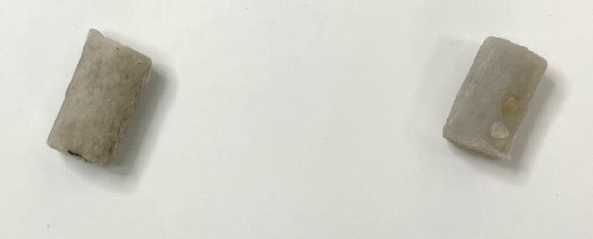
93 Tumbled Dry Weathered Cigarette Butts
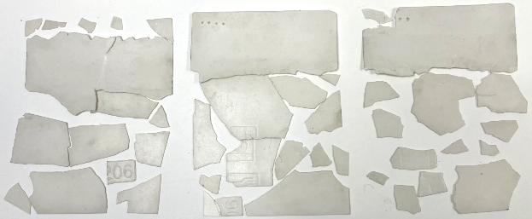
94 Tumbled Dry Weathered Bioplastic, Front, Samples 4-6
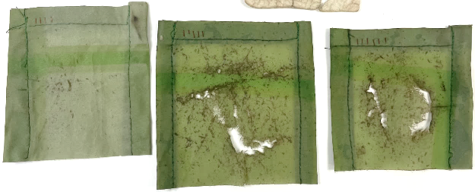
95 Tumbled Dry Weathered Tent, Front, Samples 4-6

