Supplemental Information - 1

MARINE DEBRIS IN RIVER MARGINS: WET AND DRY WEATHERING EFFECTS ON THE FRAGMENTATION AND DEGRADATION OF DISCARDED PLASTIC

Natalie Mladenov¹*, Ella Knight¹, Alexi Olney², Fernando Wakida³, Teresita de Jesus Piñon-Colin³, George Youssef⁴, Alicia Kinoshita¹

¹ Department of Civil, Construction, and Environmental Engineering, 5500 Campanile Drive, San Diego State University, San Diego, CA, USA
² Department of Statistics, 5500 Campanile Drive, San Diego State University, San Diego, CA, USA
³ Universidad Autónoma de Baja California, Calzada Universidad 14418, Parque Industrial Internacional Tijuana, C.P. 22390 Tijuana, Baja California, Mexico
⁴ Department of Mechanical Engineering, 5500 Campanile Drive, San Diego State University, San Diego, CA, USA
* Corresponding author: nmladenov@sdsu.edu

This document contains:
- Supplementary Methods
- Supplementary Tables S1-1 to S1-3
- Supplementary Figures S1-1 to S1-7

Supplementary Methods

S1. WATER REFRESH AND MONITORING
In order to maintain realistic microbial communities and simulate natural conditions, including seasonal changes in creek water, the water in the tanks was refreshed every two weeks. To do this, DI water was first poured into each tank to replace water that evaporated during the two-week period. The water was then gently mixed to ensure the DI water was homogenized with the creek water. Next, 4 L of water were removed from each tank and discarded. Finally, 4 L of creek water, collected from Alvarado Creek on the water refresh day were added to each tank and mixed. To evaluate the influence of water quality on weathering, tanks were also prepared containing only DI water, and the biweekly replacement of water was done with 4 L of fresh DI water instead of creek water.
After each water refresh, different water quality markers were measured. Using a Mettler Toledo SevenGo Duo portable meter, field measurements of pH, temperature, total dissolved solids (TDS), salinity, and conductivity were recorded for each tank, as well as a sample of fresh creek water.
Water quality monitoring of tank water during field weathering showed that the pH, conductivity, temperature, and salinity values follow the patterns measured in the freshly sampled creek water (Figure S1-2). The gap in temperature measurements occurred between January and March, when readings were missed.
Tanks containing DI water (dashed lines, Figure S1-2) had conductivity and salinity near zero (due to the removal of ions in the deionization process) compared to tanks with creek water. By June 2023, the pH of both DI water tanks increased substantially, from ~8.7 to almost 9.9, which may be due to water supply from a different DI water system for that time period due to maintenance on the primary system, while the pH of creek water tanks remained between 8.5 and 9.0.

Environmental conditions during weathering
Over the duration of the weathering experiment, there was seasonal variability in solar intensity that would have affected both wet and dry exposed samples. Modeled irradiance for San Diego, CA is given in Table S1-1 and shows that the weathering period missed two months of elevated temperature and solar irradiance (August and September), which may have lessened the amount of weathering each item received. Dry weathered samples remained exposed to all elements and underwent both wetting and drying in response to local weather conditions. A total of 58 days of rain (~345 mm) occurred during the exposure period (Table S1-1); these would have mostly influenced the dry samples by providing occasional moisture and possibly washing dust or debris from the dry samples. Wet weathered samples (tanks) were covered prior to each major rain event (>13 mm); therefore, water quality was minimally influenced by rainwater.

Water quality during wet weathering
Basic water quality parameters, including pH, electrical conductivity, salinity were recorded approximately every two weeks from 13 October 2022 to 13 June 2023. The instruments used are described in SI-1 Methods, and the temporal variability in water quality is described in SI-1 Figure S2. Overall, water quality in the experimental tanks followed the same trends observed in Alvarado Creek, which are also shown in SI-1 Figure S2.

S3. SAMPLE MASS MEASUREMENTS
Once every 90 d, each sample was retrieved temporarily from wet and dry exposures and weighed. The “fabric” samples were first dried in a Fisher Scientific Isotemp Oven at 40 ℃ for 24 hours, and the harder plastic samples were air dried at ambient conditions for the same amount of time to remove moisture. The mass, M, of each replicate item was recorded three times and averaged. For days 0 and 90, Mettler Toledo ML204/03 scale was used to weigh samples. A higher precision Sartorius Secura 224-1S scale became available for the project and was used for measurements on days 180 and 270. Overlapping measurements between the two instruments showed no significant differences in mass readings.

S4. MICROSCOPY and SEM
A Nikon SMZ18 microscope was used to measure and photograph microplastic particles that resulted from field weathering of the polypropylene mask. Particles collected after the conclusion of the microcosm experiment were stored in the dark in air-conditioned, dry conditions until microscopy analysis in May of 2024. To analyze the samples, one drop of DI water was placed onto a glass slide. Using a stainless-steel lab scoop, a small amount of the sample was carefully removed from the bag and placed onto the drop of water. A microscope slide was then placed on top of the water and sample. Efforts were made to minimize air pockets around the sample, but complete elimination was not possible. The slides were then placed under the microscope for imaging. Different magnifications were used to view various particles, and areas of sample particles were measured using NIS-Elements AR software.
A FEI Quanta 450 Field Emission Scanning Electron Microscope equipped with an Everhart Thornley Detector (ETD) was used to acquire magnified images of the samples. Samples were cut from replicates using scissors and attached to a 32 mm stub using carbon conductive adhesive tabs and coated with 6 nm platinum using an EMS 150 Sputter Coater to prevent surface charging. Using a spot size of 3.0 or 3.5, an accelerating voltage between 2 and 10 kV and a magnification between 37x and 1024x, multiple images were taken of each sample. The magnifications chosen varied depending on the size of pits and other weathering features on the surface of the samples and are provided in the figure descriptions. Bioplastic, tent, blanket, and styrofoam samples were the only wet-weathered samples analyzed with SEM because the debris on wet-weathered items damaged the SEM apertures. A decision was made to discontinue wet weathered item SEM imaging to avoid additional repairs and costly replacement.

S5. PARTICLE ENUMERATION
To estimate the number of fragments resulting from the dry weathering of the medical mask (PP) the images of fragments taken during microscopy were used. Fragments were categorized as flakes or rods (Figure 2.2). The areas measured from randomly photographed fragments were averaged for flakes and rods.
ImageJ software (Java version 8) was then used to calculate the area missing from the samples photographed during the microcosm experiment. The image was calibrated using the known length of a text label that was present in all photographs. The freehand tool was then used to outline the missing places where material was missing, and the area was measured (Figure 2.3).
Because the mask comprises three layers, missing area was measured for each layer. The number of fragments was calculated by dividing the total missing area of each layer by the average fragment size as follows:
N = [A_{missing}]/[A_{fragment}]_{avg}, (Eq 2.2)
where A_{missing} is the missing area of each layer and [A_{fragment}]_{avg} is the average of either 14 of the imaged rods or 22 of the imaged flakes. Due to there being two fragment shapes, two estimates for the number of fragments were calculated: one assuming that the missing area was made up of all flake-shaped fragments and one assuming all rod-shaped fragments. Since the average area of the rods was much smaller than the flake area, this gives a high and low estimate of the number of fragments; the actual number of fragments is thought to be somewhere in between the two extremes. Samples 4-6 were cut in half after 270 days of dry weathering in order to complete all analysis, so measured areas were doubled to represent a full sample. Cutting the sample in half most likely caused more material loss, but in more realistic conditions samples would likely rip/tear and release material in a similar manner.

Supplementary Tables

Table S1-1. Average monthly incident shortwave solar energy and weather data for San Diego during the months of the microcosm experiments (October – July). Data from three weather stations; San Diego International Airport, Naval Air Station North Island, Ream Field.
Month | Average Solar Energy (kWh)¹ | Max Temp (℃)² | Min Temp (℃)² | Days of Precipitation² | Precipitation (mm)²
October | 5 | 35 | 11 | 4 | 2.30
November | 3.8 | 28 | 6 | 4 | 20.1
December | 3.2 | 28 | 4 | 7 | 40.1
January | 3.4 | 23 | 4 | 14 | 130.6
February | 4.3 | 26 | 4 | 9 | 45.2
March | 5.7 | 24 | 4 | 12 | 100.8
April | 7 | 28 | 8 | 4 | 3.05
May | 7.8 | 21 | 12 | 3 | 2.29
June | 8.3 | 23 | 14 | 1 | 0.76
July | 8 | 28 | 16 | 0 | 0.00
Total | - | - | - | 58 | 345.2
¹ Weatherspark data averaged from 1 January 1980 to 31 December 2016, https://weatherspark.com/y/1816/Average-Weather-in-San-Diego-California-United-States-Year-Round#Sections-SolarEnergy (accessed on 5 May 2024).
² NOAA, National Weather Service temperature and precipitation data from October 2022 to July 2023 retrieved from https://www.weather.gov/wrh/Climate?wfo=sgx (accessed on 5 May 2024).

Table S1-2. Results of buoyancy testing in tap water for pristine, 270 day dry weathered, and 270 day wet weathered (creek and DI) with comparison to density testing. ¹

Sample | Pristine | Dry | Wet | DI
Cigarette filter | Sink ✖ | Sink ✔ | Sink ✔
Blanket | Sink ✔ | Float ✔ | Partial sink ✔
Tent | Float ✔ | Float ✔ | Partial float ✔
Mask | Float ✔ | Float ✔ | Float ✔
Thick bag | Float ✖ | Float ✖ | Float ✖
Thin bag | Float ✔ | Float NA | Sink ✖
Water bottle | Sink ✔ | Sink ✔ | Sink ✖
Styrofoam | Float ✔ | Float ✔ | Float ✔
Food Container | Float ✔ | Float ✔ | Float ✔ | Float ✔
Bioplastic | Sink ✖ | Sink ✖ | Sink ✔ | Sink ✔

¹ ✔ = buoyancy testing agrees with density calculations; ✖ = buoyancy does not agree with density calculations; NA = not analyzed due to extensive fragmentation prior to analysis.

Table S1-3. Checkmarks indicate that the degradation categories (discoloration, dent/scratch, tear, or fragment) were observed under pristine (P), dry weathered (D), and wet weathered (W) samples after tumbling. ¹
Sample | Discoloration |  |  | Dent/Scratch |  |  | Tear |  |  | Fragment
Sample | P | D | W | P | D | W | P | D | W | P | D | W
Cigarette Filter¹ | ✔ | ✔ | NA |  |  | NA |  |  | NA |  |  | NA
Blanket |  | ✔ | ✔ |  |  |  | ✔ |  | ✔
Tent | ✔ | ✔ | ✔ |  |  |  | ✔ | ✔ | ✔ |  | ✔
Mask | ✔ | ✔ | ✔ |  |  |  | ✔ | ✔ | ✔
Thick Bag |  |  |  | ✔ | ✔ | ✔
Thin Bag¹ | ✔ | NI | ✔ | ✔ | NI | ✔ |  | NI |  |  | NI
Water Bottle | ✔ | ✔ | ✔ | ✔ | ✔ | ✔
Styrofoam | ✔ | ✔ | ✔ | ✔ | ✔ | ✔ |  |  |  |  | ✔ | ✔
To-Go Box |  |  |  | ✔ | ✔ | ✔
Bioplastic | ✔ | ✔ | ✔ | ✔ | ✔ | ✔ |  |  |  |  | ✔

¹ NA= not analyzed due to samples being lost. NI = not included due to extensive fragmentation prior to tumbling.

Supplementary Figures

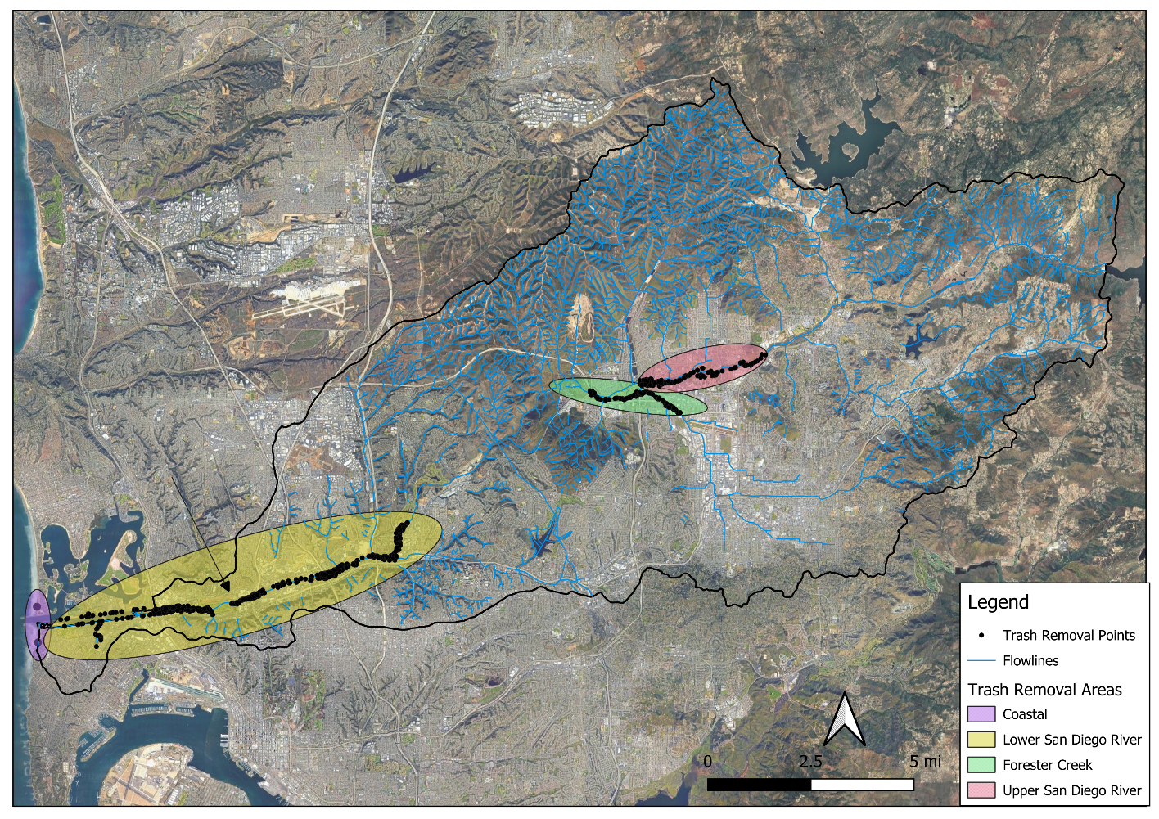Figure S1-1. The primary contributing streams and the locations of trash removal data points in the San Diego River watershed as inventoried by the San Diego River Park Foundation from 2018 – 2023. Trash removal sites were concentrated along the Upper and Lower San Diego River and along the lower section of Forester Creek in East County San Diego and Central San Diego.

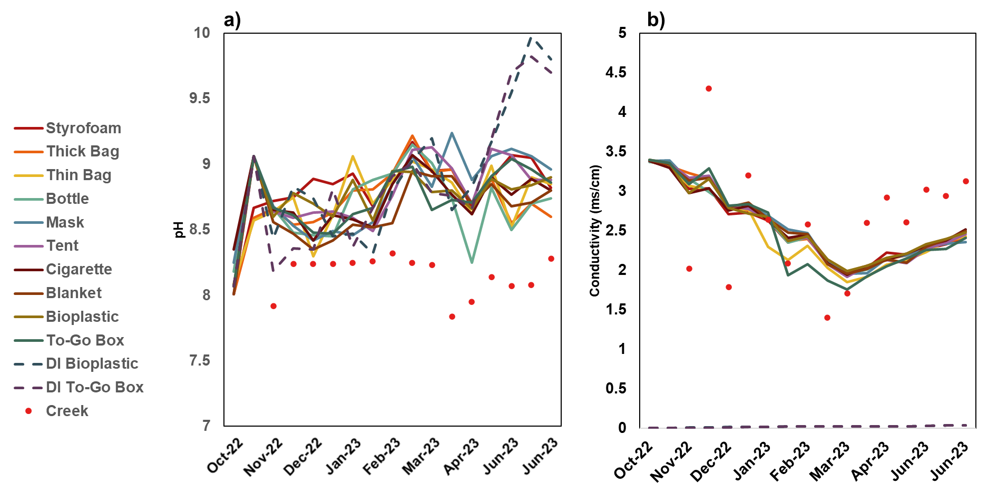
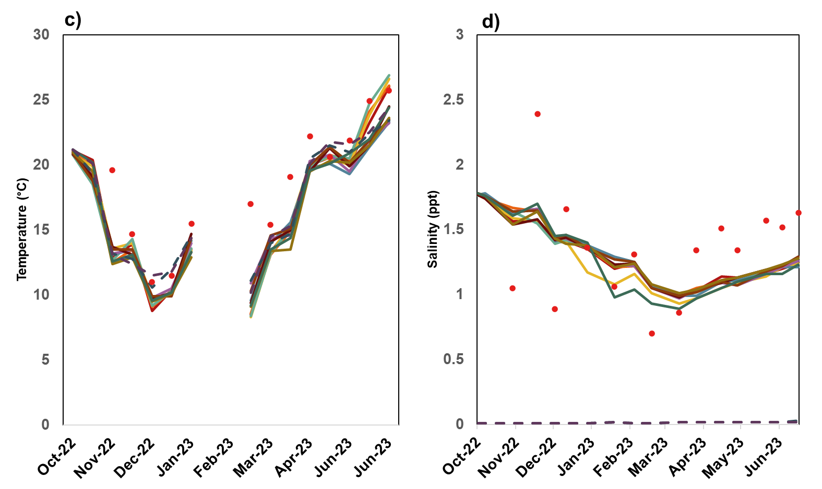

Figure S1-2. Measurements of a) pH, b) conductivity, c) temperature, d) salinity, recorded approximately every two weeks from 13 October 2022 to 13 June 2023. Red dots show the water quality of discrete samples collected from Alvarado Creek. For comparison tap water had a specific conductivity of 986 ± 1.83 µS/cm on 26 October 2023.

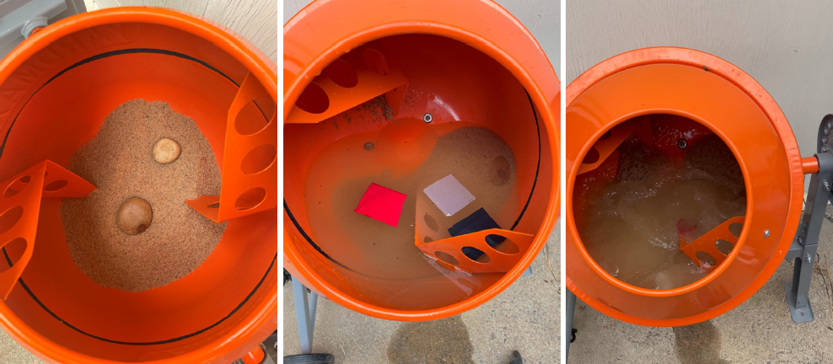
Figure S1-3. Yardmax® concrete mixer containing sand and river cobbles (left), with water and sample items added (middle), and after 2 h of tumbling (right).

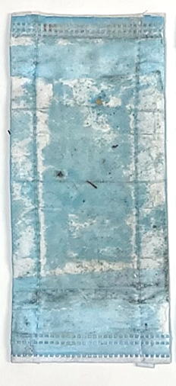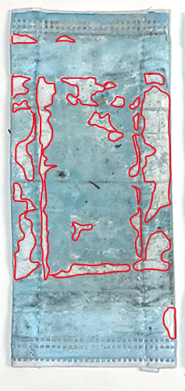
Figure S1-4. Example of how the missing areas in the original image (left) were outlined (right) for the missing area calculation, shown here for the top layer of the 271 d dry weathered medical mask sample. (Sample dimensions are 5 cm × 15 cm).

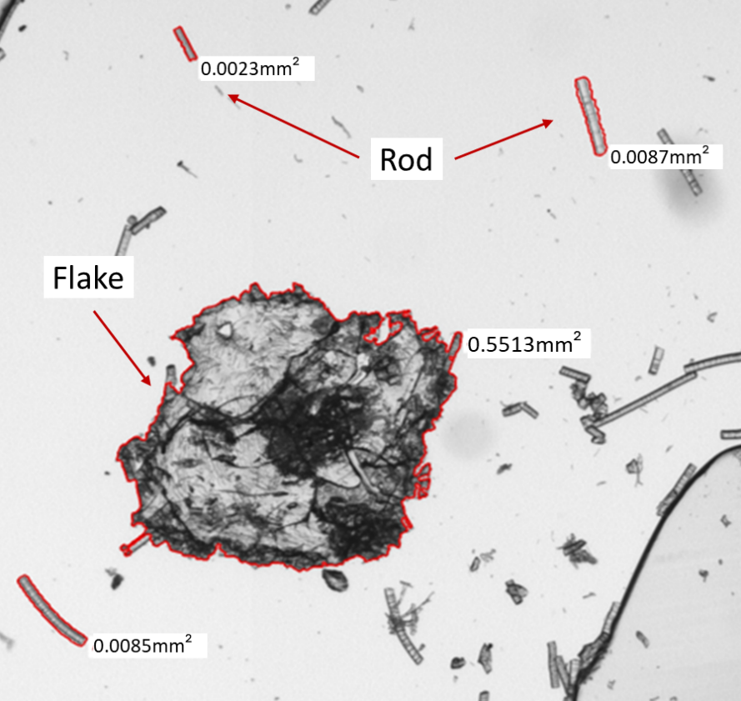
Figure S1-5. Image of flake and rod particles taken during microscopy. Scale bar unavailable.

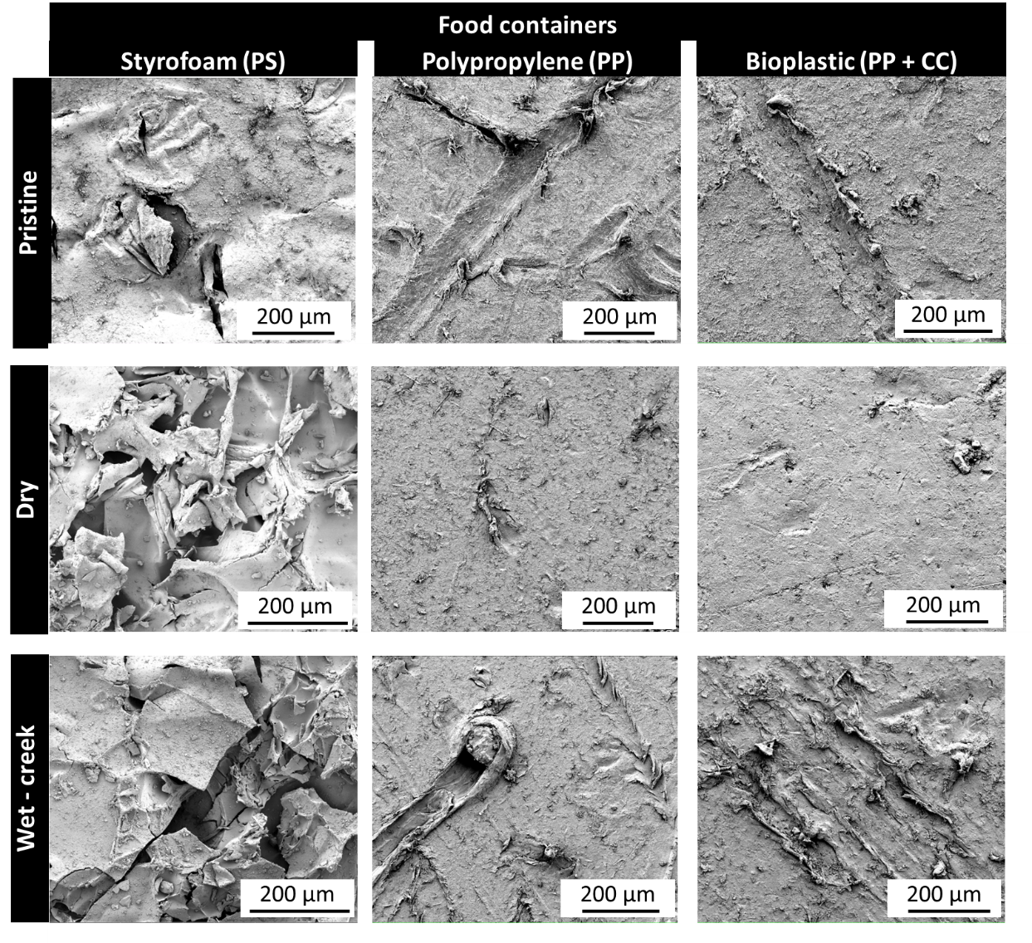
Figure S1-6. SEM images of pristine, 271 day dry weathered, 271 day wet weathered food containers after tumbling with cobble, sand, and water for 2 h. Scale bar shows magnification. DI water weathered samples were not imaged.

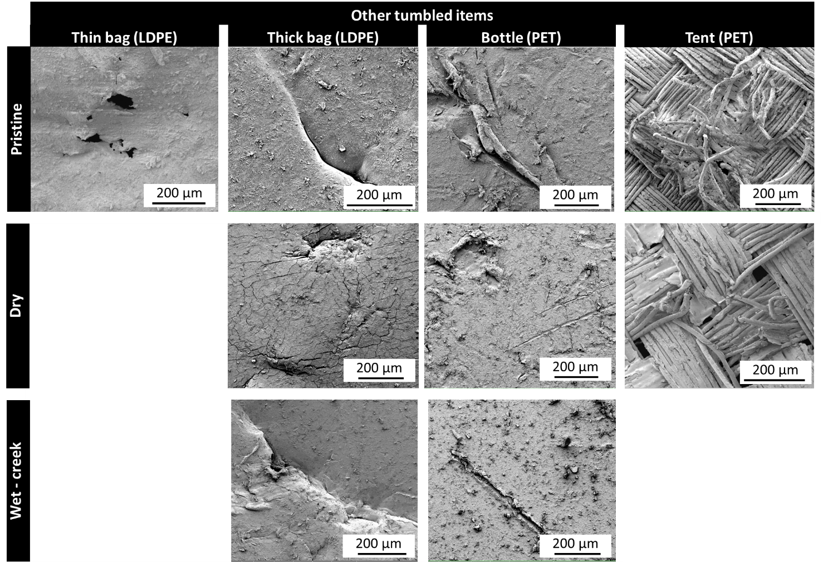
Figure S1-7. SEM images of pristine, 271 day dry weathered, 271 day wet weathered thin bag, thick bag, water bottle, and tent after tumbling with cobble, sand, and water for 2 h. Scale bar shows magnification. Some weathered samples were not imaged.

