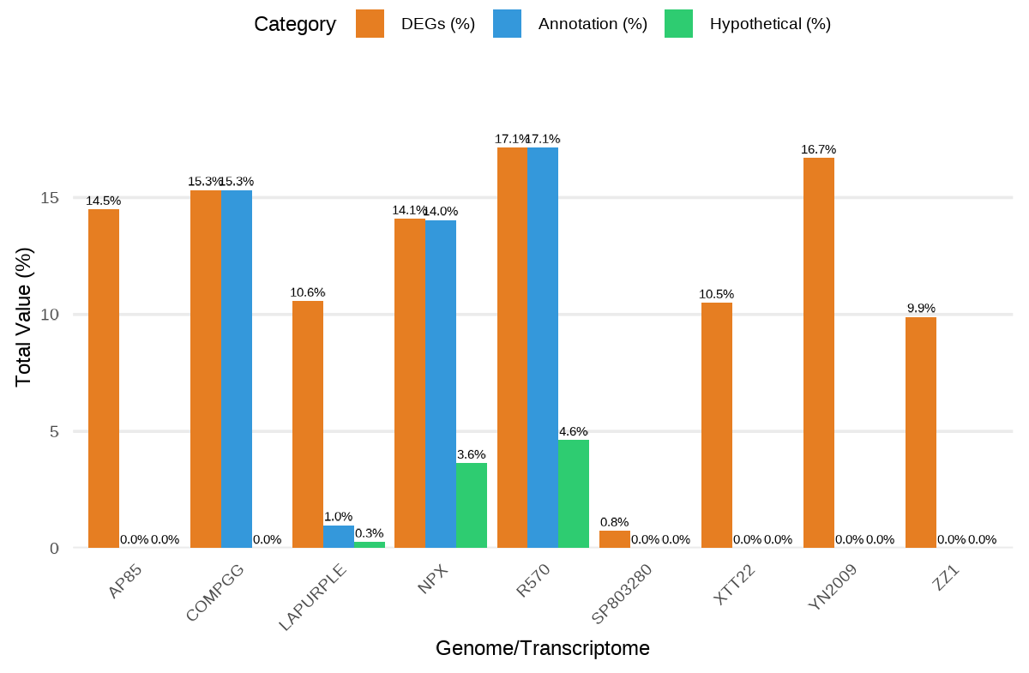
Supplementary Figure S1. Histogram comparing the number of identified differentially expressed genes (DEGs), the number of DEGs with annotation, and Gene Ontology (GO) terms using various Saccharum genomic or assembled transcriptome resources. The number of DEGs (Value) is expressed depending on the available genome or assembled transcriptome used for annotation, such as Saccharum. spontaneum genomes AP85 [38] and ‘Np-X’ [9]; a S. officinarum genome (LA Purple) (NCBI ID PRJNA744175); and Saccharum hybrid genomes ‘SP80-3280’ [37], ‘R570’ [36], ‘XTT22’ [38] and ‘ZZ1’ [39]; Erianthus rufipilus ‘YN2009‐3’ [10]; and ‘COMPGG’ transcriptome [41,42].

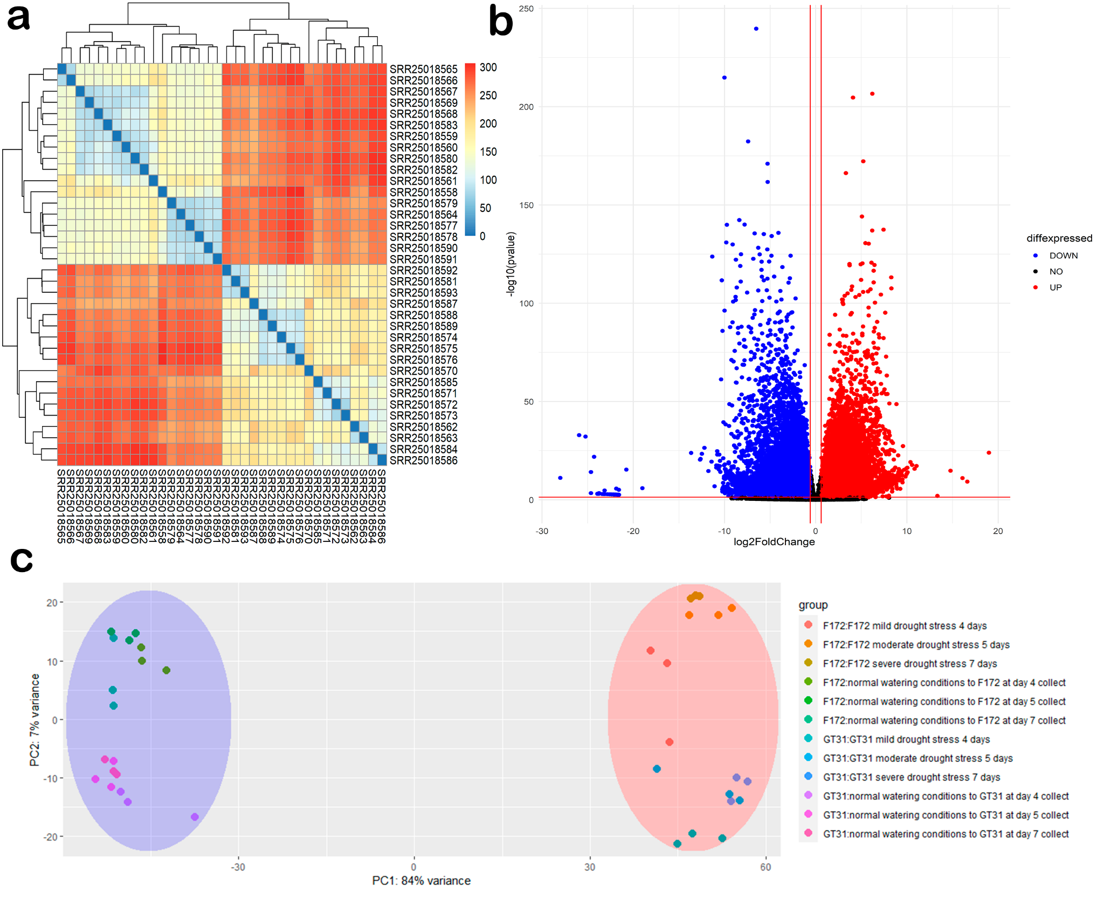
Supplementary Figure S2. Individual differential expression analysis of reads from the PRJNA975299 BioProject. (a) Heatmap for the distance matrix cross-reference comparison of each read with each other, highlighting different groups by the lower distances (in blue) to higher distances (in red). (b) The VolcanoPlot illustrates all genes mapped within the BioProject, representing differentially expressed genes by downregulated genes in blue and upregulated genes in red, showing that the majority of the genes are differentially expressed compared to those that are not, indicated in black. (c) Principal Component Analysis (PCA) distinguishes between watering conditions, clustering normal watering conditions in blue and different drought conditions in red, with one genotype (F172) positioned on the upper side and the other genotype on the lower side (GT31).

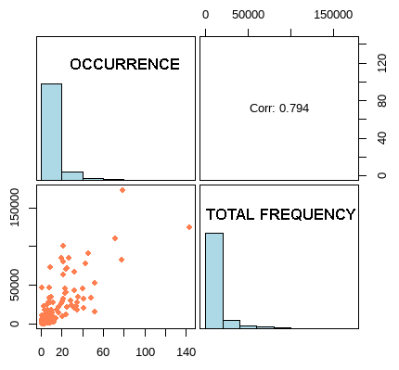
Supplementary Figure S3. Correlation analysis between the values of occurrence and total frequency for all differentially expressed genes (DEGs) observed in the functional gene-term categorization analysis of the present study. The diagonal panels represent the histograms of distribution of values from occurrence (top left) and total frequency (lower right). The scatterplot at the lower left panel represents the points of correlation between the occurrence and total frequency data. The correlation value of 0.794 is represented in the upper right panel.

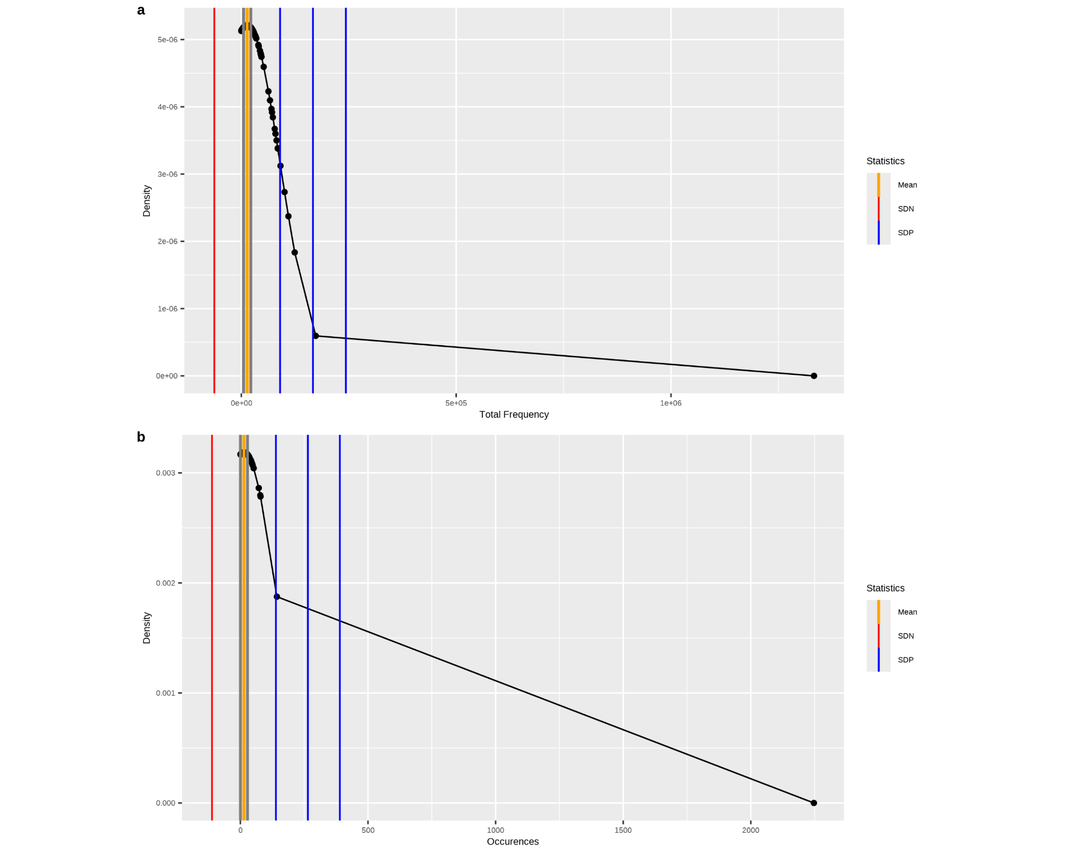
Supplementary Figure S4. Distribution of density values in function of (a) occurrence and (b) total frequency related to their mean, represented in yellow, and standard deviation, represented as negative values in red and positive values in blue.

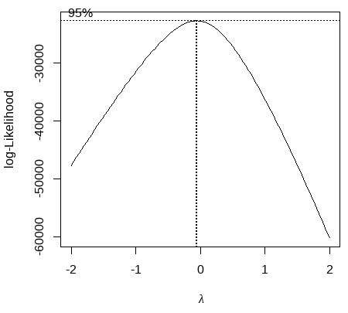
Supplementary Figure S5. Sine curve of the log-likelihood in function of the values of lambda predicted from the Box-Cox transformation for the data from the present study within the 95% interval level.

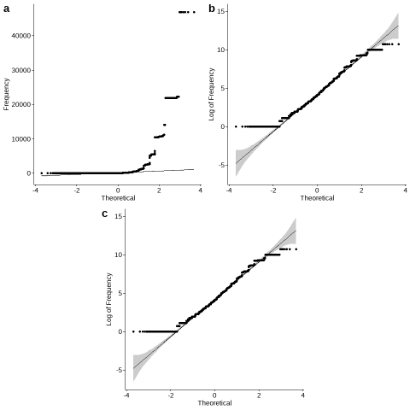
Supplementary Figure S6. Q-Q plots expressed in function of the theoretical value of: (a) the raw frequency data; (b) data transformed for the logarithmic scale; and (c) the data transformed for lambda from the Box-Cox transformation.

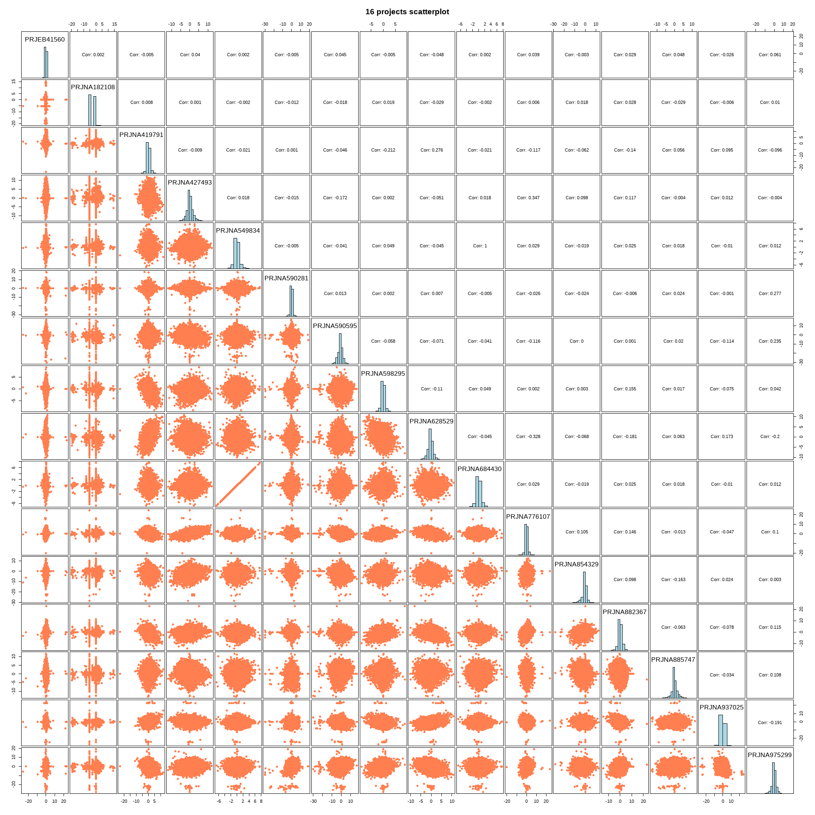
Supplementary Figure S7. Correlation analysis between the values of expression in log 2 Fold-Change of all differentially expressed genes (DEG) observed in the analysis from the 16 BioProjects. The raw values are expressed in the upper-right panels, the histograms of distribution and the named BioProject in the middle panel and the scatterplot in the lower left panels. The middle diagonal panels represents the histograms of distribution of values from each BioProject. The lower left panels from the diagonal represents the scatterplots for each combination of BioProjects. The correlation values are represented in the upper right panels from the diagonal.

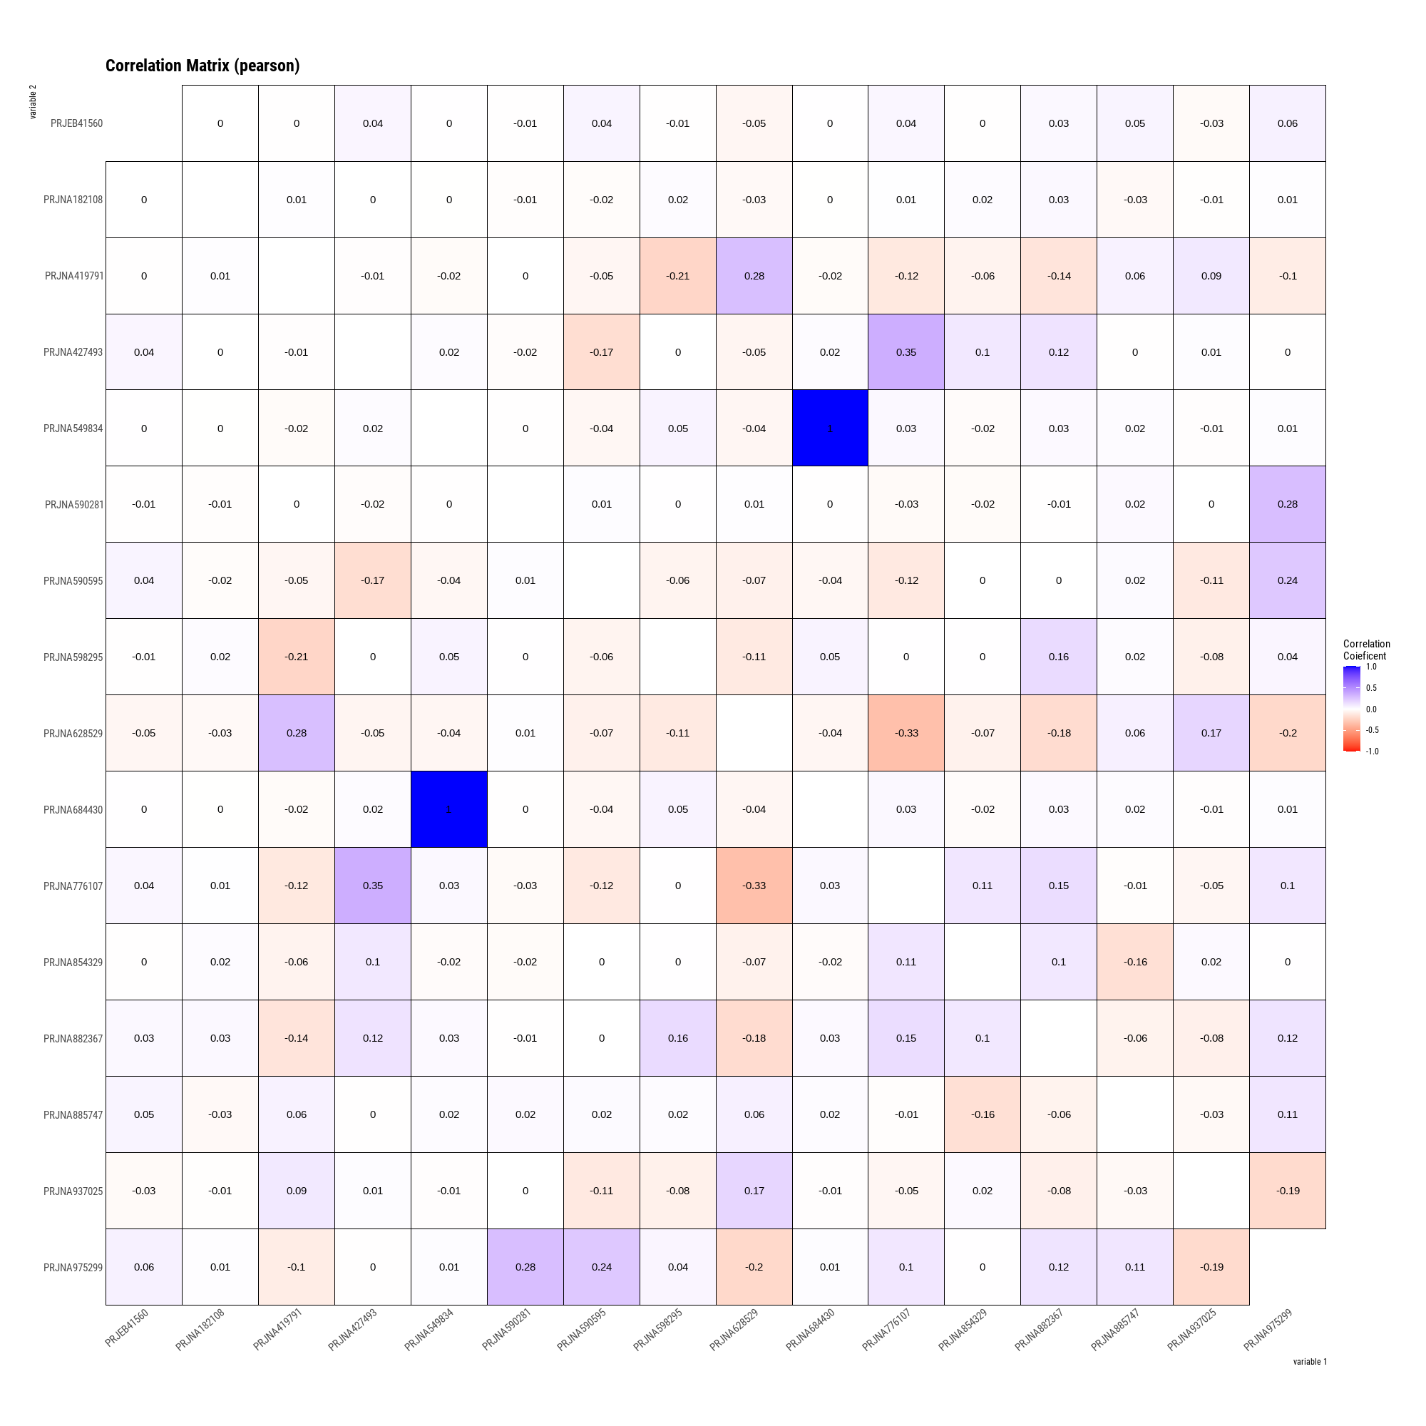
Supplementary Figure S8. Pearson’s correlation coefficient (PCC) matrix of coexpression between all 16 BioProjects from the present study. A positive correlation is expressed by the value of 1 (blue), 0 represents no correlation (gradient of white between red and blue), and a negative correlation is expressed by -1 (red).

