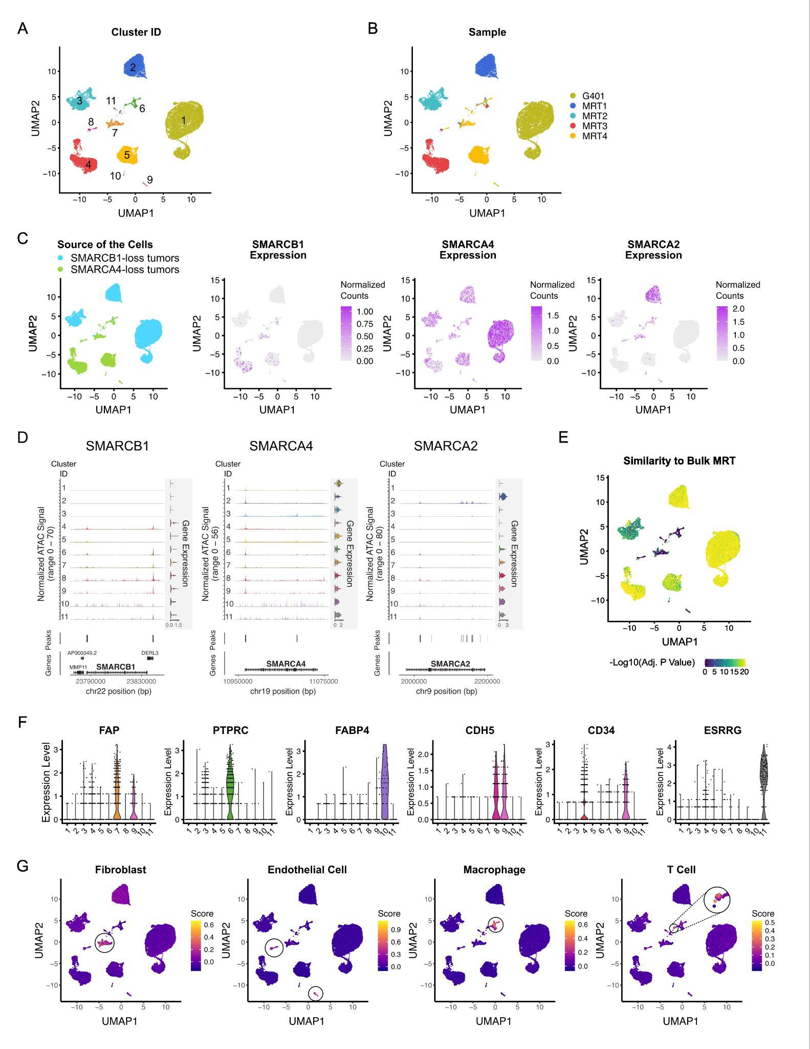

Figure S1. Related to Figure 1
- Clustering analysis of multimodal single-cell sequencing data of MRT cell line G401 and four flash frozen MRT samples. UMAP visualizations were colored by cluster ID (A) or tumor sample (B).
- UMAP visualization of the clustering result colored by their origins (left; blue if the cell came from SMARCB1-deficient tumor samples or green if from SMARCA4-deficient tumor samples) and SMARCB1, SMARCA4, and SMARCA2 expression.
- Chromatin accessibility at the promoter regions of SMARCB1, SMARCA4, and SMARCA2 in each cluster. Gene expression levels are also shown as horizontal violin plots next to the chromatin accessibility tracks.
- UMAP visualization of the clustering results. Colors indicate the similarity between the single-cell gene expression profile and bulk MRT RNA-seq profiles.
- Violin plot showing the expression of canonical cell type genes in each cluster.
- UMAP visualization of the clustering result colored by the overall expression scores of cell type signature gene sets.

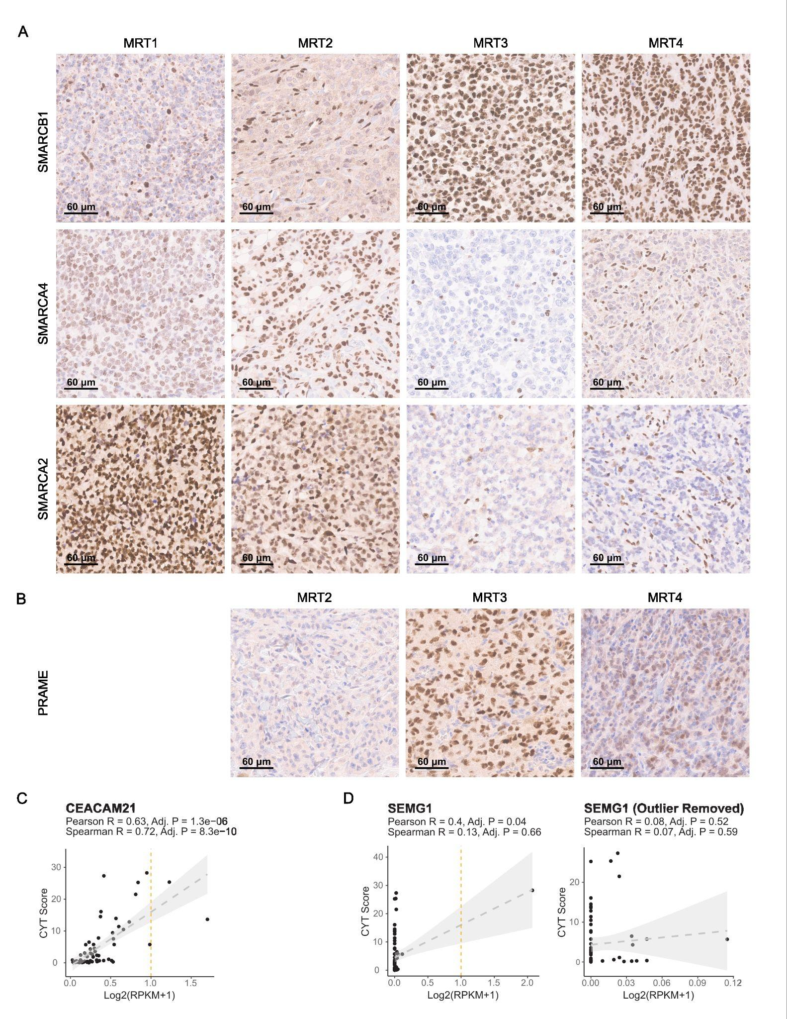

Figure S2. Related to Figure 1-2
- Representative IHC images of SMARCB1, SMARCA4, and SMARCA2 staining in tumors.
- Representative IHC images of PRAME staining in tumors MRT2, MRT3, and MRT4.
- Scatter plots showing the correlation between the expression levels of CEACAM21 (C) and SEMG1 (D, with or without outlier) and the CYT scores across 65 MRT tumors profiled using bulk RNA-Seq. The grey band shows the 95% confidence interval. The orange dashed line indicates RPKM = 1.

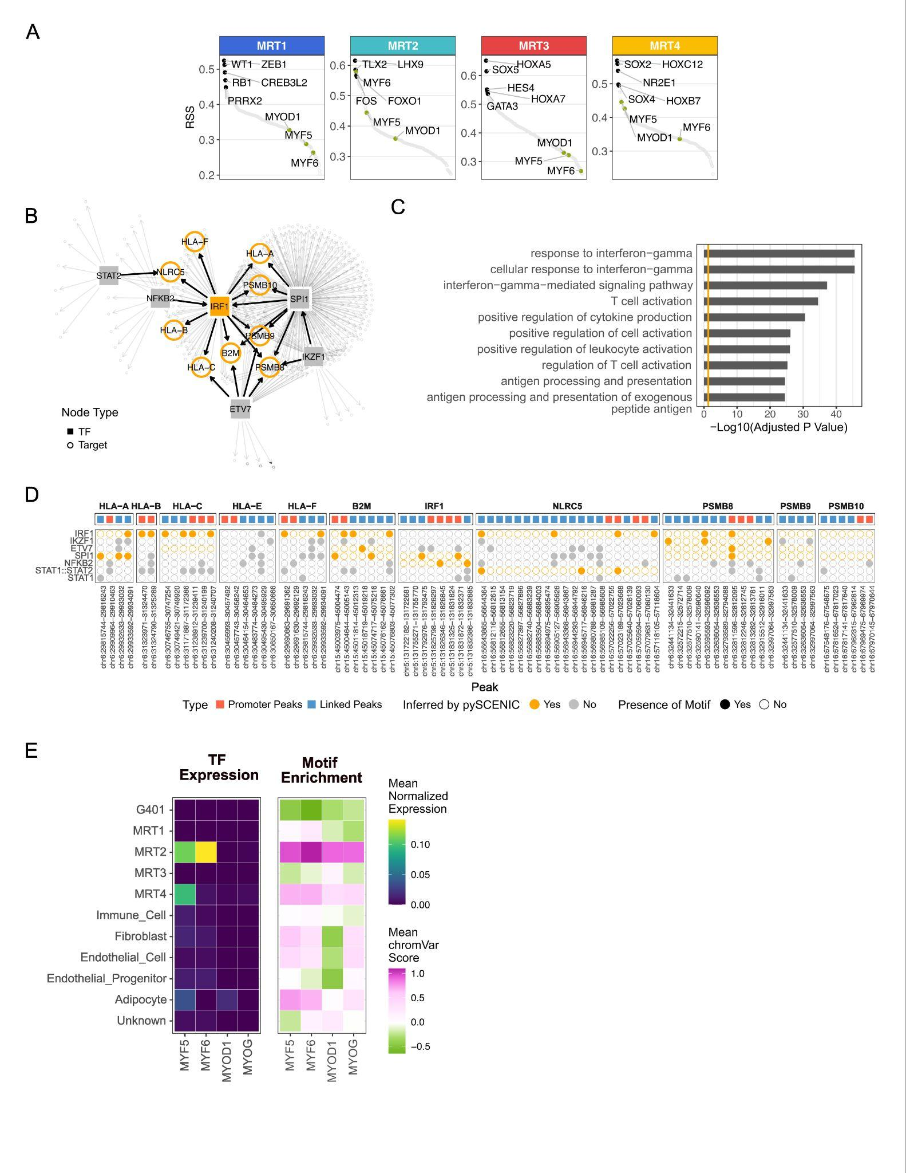

Figure S3. Related to Figure 4-5
- Regulon-specific score (RSS) plot depicting the specificity of regulons in tumor cells from each sample profiled by single-cell Multiome assay.
- Transcription regulatory network constructed based on regulon analysis inferred using bulk RNA-Seq data. TFs and targets are shown as solid squares and open circles, respectively. MHC class I genes, B2M, IRF1, NLRC5, and PSMB8/9/10 are highlighted in orange.
- Functional enrichment analysis of genes (TFs and their targets) in Cluster 3 (Fig. 4I) (orange line at adjusted p = 0.05).
- Visualization of TF motifs within the promoters and inferred linked peaks of of the genes involved in antigen processing and presentation. The top panel shows the promoter (red) and linked peaks (blue). In the bottom panel, solid and open circles represent the presence and absence of motifs in each peak, respectively. Circles are colored orange if the genes are inferred to be regulated by the TFs by pySCENIC.
- Heatmap showing the mean gene expression levels (normalized counts, left) and mean motif enrichment scores (chromVar scores, right) of MYF5, MYF6, MYOD1, and MYOG per cluster (Fig. 1E).

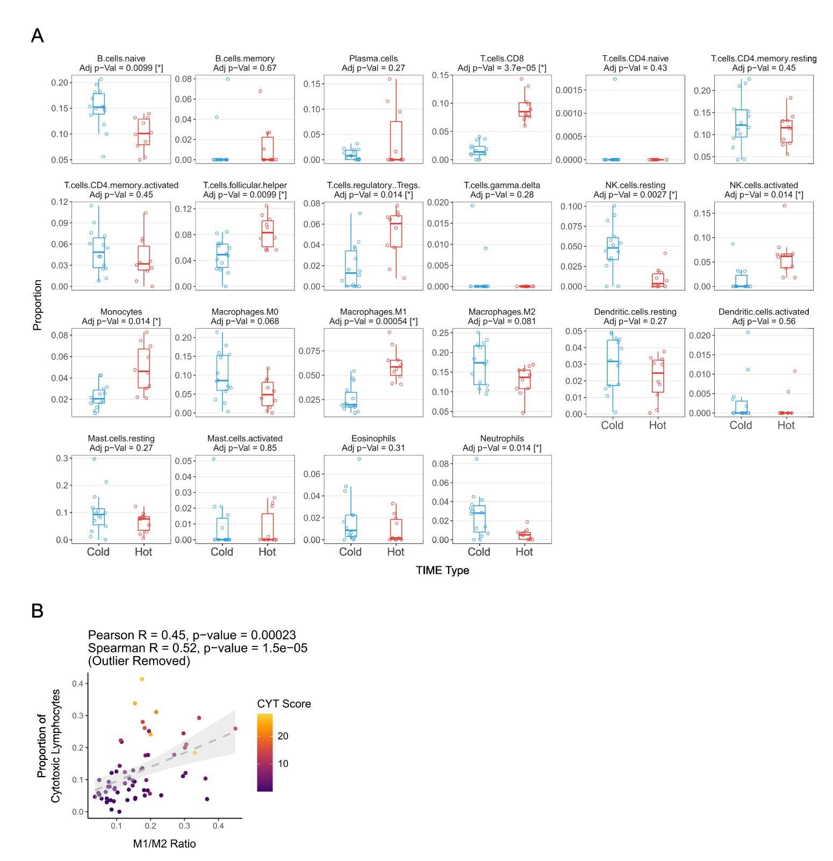

Figure S4. Related to Figure 6
- Box plots showing differences in immune cell types inferred by CIBERSORTx between immune segments from “hot” and “cold” ROIs. P-values were calculated using two-sided Welch t-tests, with false discovery rate correction for multiple comparisons.
- Scatterplot showing the correlation between M1/M2 macrophage ratio and proportion of cytotoxic lymphocytes inferred by CIBERSORTx using bulk RNA-Seq data, without the outlier. The grey band shows the 95% confidence interval.

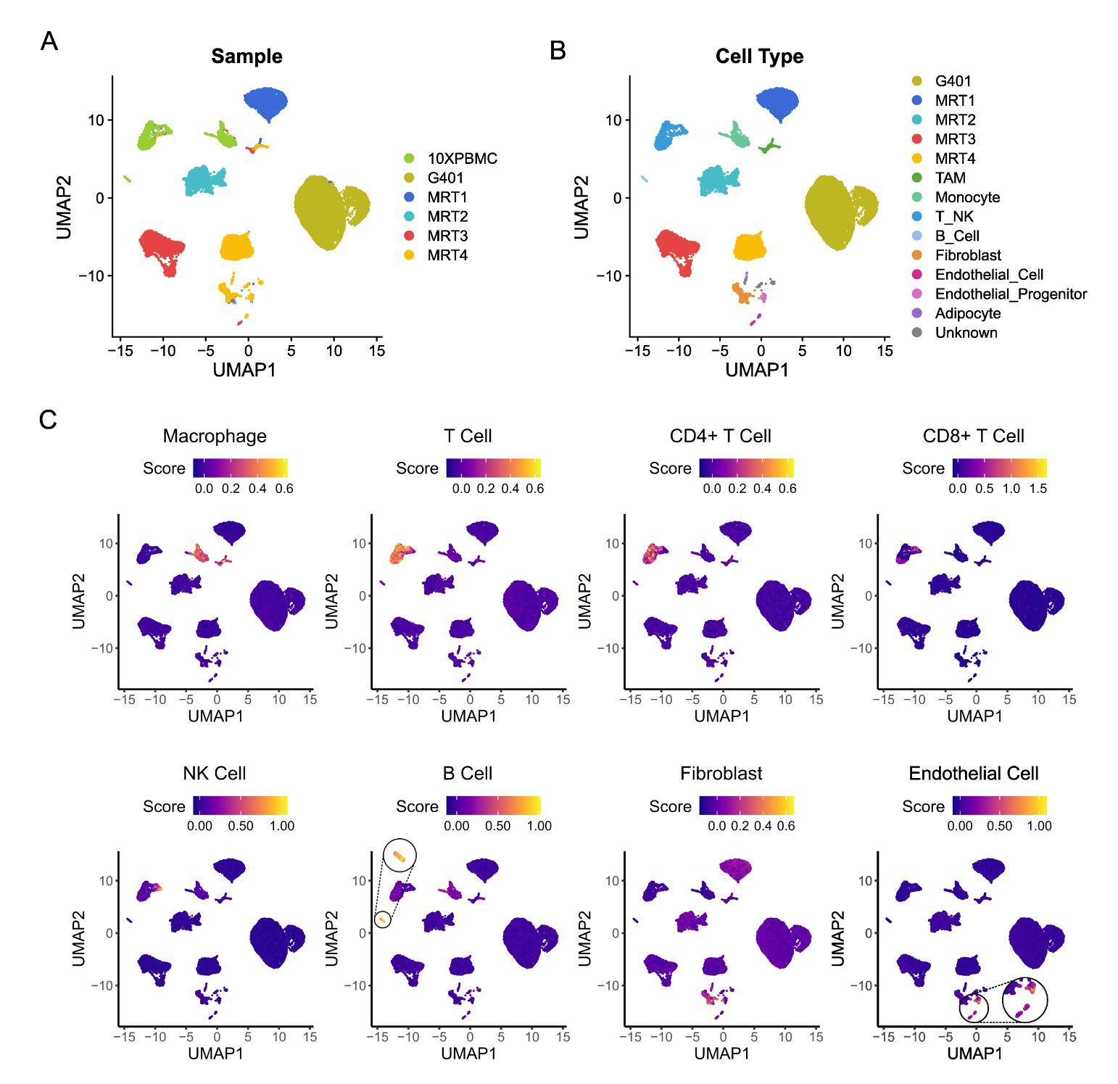

Figure S5. Related to Figure 7
- UMAP visualization of the clusters from the merged BPMC and MRT dataset, colored by cell types (A), sample (B), and the overall expression scores of cell type signature gene sets (C).

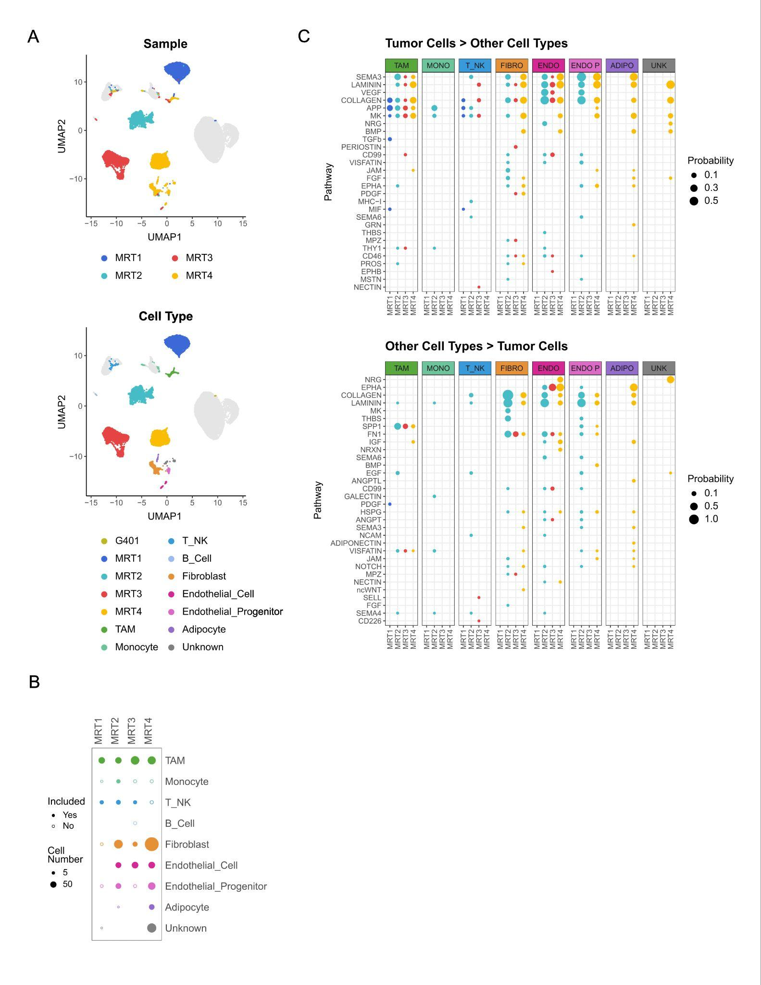

Figure S6. Related to Figure 7
- UMAP visualizations of PBMC and MRT clusters profiled by single-cell multi-omic assay (Fig. S5). The cells from the 4 flash-frozen MRT samples used for cell-cell communication inference are colored by sample (top) and cell types (bottom).
- Bubble heatmap depicting the number of cells in each cell type from each MRT sample, colored by cell type. The dot size represents the number of cells in each population. The populations included for the inference of cell-cell communication (populations with more than 10 cells) are shown as solid dots.
- Bubble heatmap summarizing inferred cell-cell interactions across MRT1-4. The top panel shows all communications sent from tumor cells (columns) to non-malignant cell types (subpanels), and the bottom panel shows all communications sent from non-malignant cell types (subpanels) to tumor cells (columns). The dot size represents communication probabilities inferred by CellChat. The dot color represents tumor samples.

