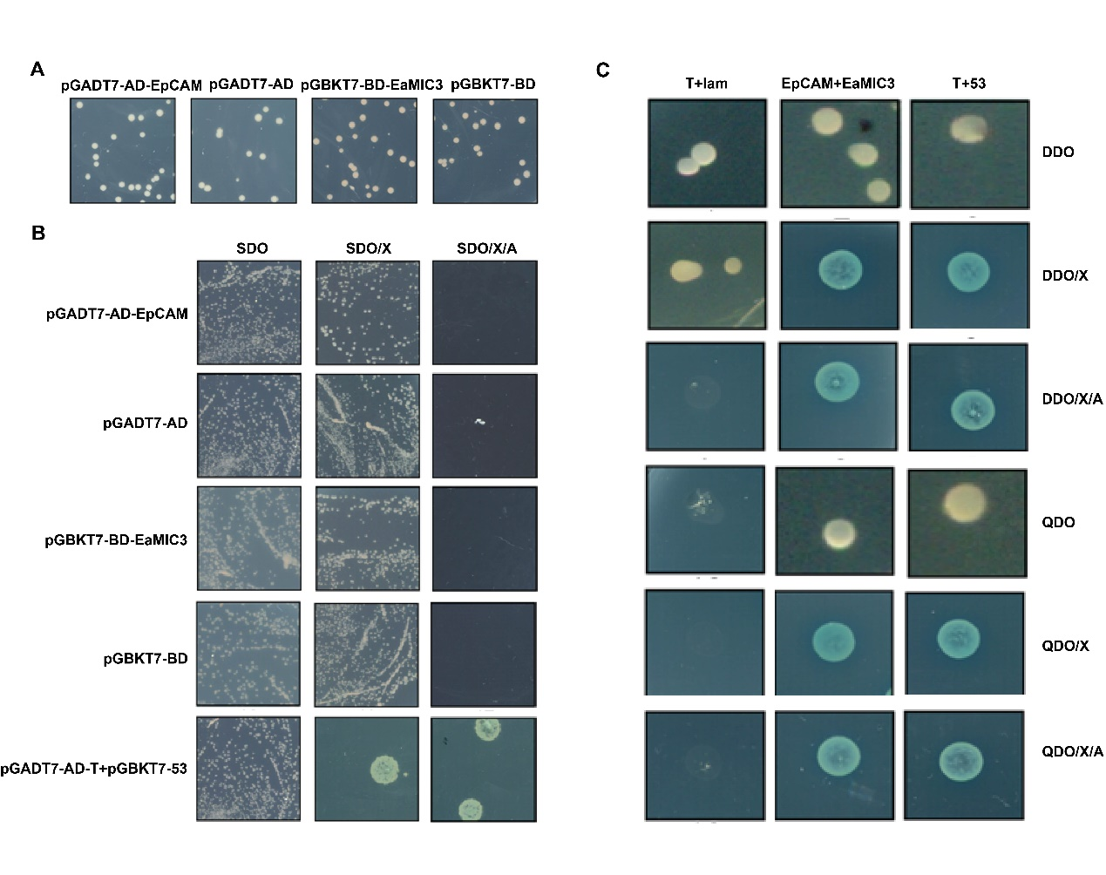
Fig. S1. Interaction between EaMIC3 and EpCAM identified by yeast two-hybrid test
A. Toxic detection of recombinant plasmid in yeasts. B. The autoactivation detection of pGADT7-AD-EpCAM and pGBKT7-BD-EaMIC3. C. α-galactosidase activity of the transformants. pGBKT7-53 + pGADT7-T and pGBKT7-Lam + pGADT7-T were used as positive control and negative control, respectively. SDO/X/A, SD/-Trp/X-α-gal/AbA or SD/-Leu/X-α-gal/AbA; DDO /X/A, DD/-Leu/-Trp/X-α-gal/AbA; QDO /X/A, DD/-Ade/-His/-Leu/-Trp/X-α-gal/AbA.

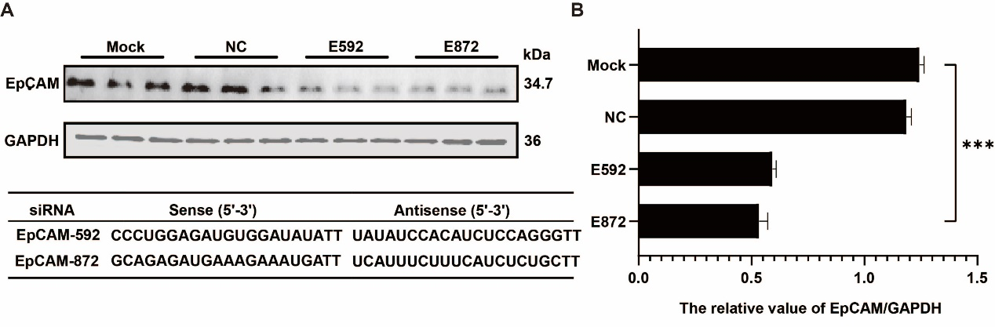
Fig. S2. Screening of siRNAs against EpCAM
A. Detection of EpCAM expression after transfecting siRNAs using Western blotting; B. The relative values of EpCAM/GAPDH after transfection. NC, negative control; ‘***’, P < 0.001.

