Supplementary Information

Syntheses of microcrystalline cellulose-graft bottlebrush copolymer elastomers with hydrogen bonding interactions to endow applicable mechanical property

Wanyu Wang, Rou Chen, Xuehui Wang, Huanjuan Sun*, Zhigang Wang*

Shared first authorship: Wanyu Wang and Rou Chen contributed equally to this manuscript.

WY Wang, R Chen, XH Wang, HJ Sun
State Key Laboratory of Precision and Intelligent Chemistry, Department of Polymer Science and Engineering, University of Science and Technology of China, Hefei, Anhui 230026, P. R. China
Corresponding author: Huanjuan Sun, E-mail: shjjj@mail.ustc.edu.cn (HJ Sun)

ZG Wang
College of Materials Engineering, Fujian Agriculture and Forestry University, Fuzhou 350002, P. R. China
Corresponding author: Zhigang Wang, E-mail: zgwang@fafu.edu.cn (ZG Wang)

Table S1. Synthetic formulae and characteristics for MCC-g-P(nBA-co-tBA) graft copolymers.
sample codeᵅ | feed molar ratioᵇ | feed molar ratio of nBA to tBA | measured molar ratio of nBA to tBAᶜ | T_{g}^{d} (ºC)
tBA350-MCC0.9 | 1/650/350 | 1.86/1 | 1.76/1 | -22.2
tBA320-MCC0.9 | 1/680/320 | 2.13/1 | 1.98/1 | -24.7
tBA300-MCC0.8 | 1/700/300 | 2.33/1 | 2.12/1 | -26.5
tBA250-MCC0.9 | 1/750/250 | 3.0/1 | 2.79/1 | -30.3
tBA220-MCC1.1 | 1/780/220 | 3.55/1 | 3.06/1 | -33.1
ᵅSample codes are defined as follows: the numbers behind “tBA”, and “MCC” stand for the molar numbers of tBA and MCC contents (percentage), respectively. ᵇMolar ratio: MCC-BiB/nBA/tBA. ᶜMeasured by ¹H NMR spectroscopy. ^{d}Measured by DSC.

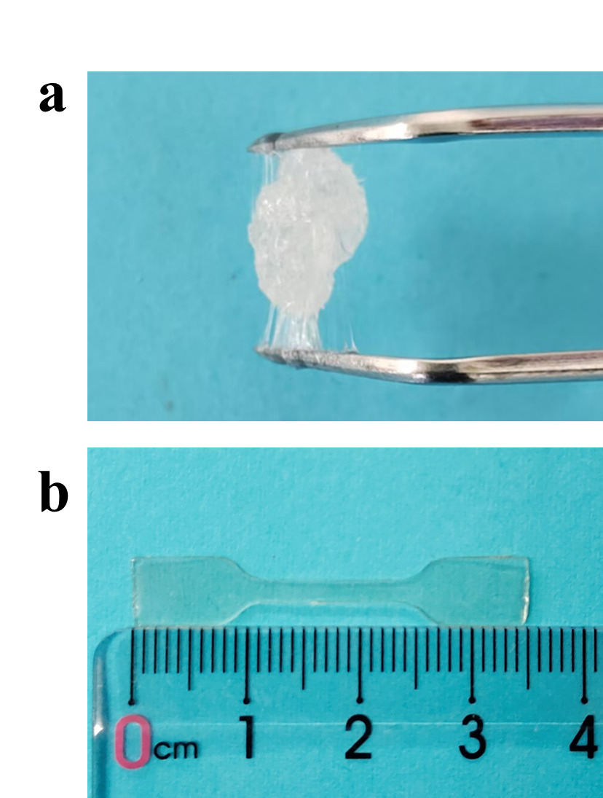
Fig. S1. Photos of tBA250-MCC0.9 (a) and dumbbell-shaped AA250-MCC0.9 (b) at room temperature.
Fig. S2. ¹H NMR spectrum for MCC-BiB in DMSO-d₆.

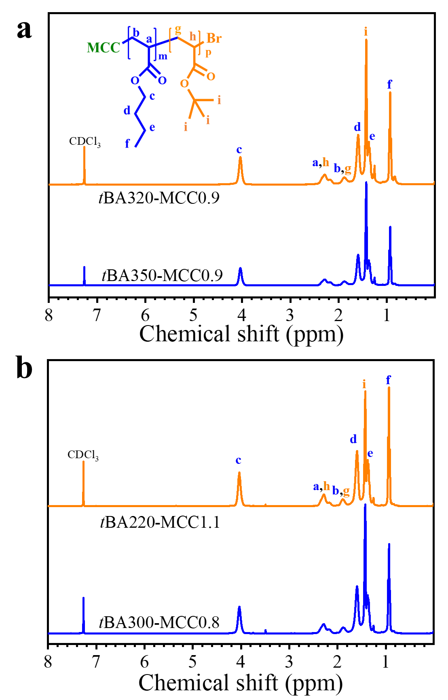
Fig. S3. ¹H NMR spectra for MCC-g-P(nBA-co-tBA) in CDCl₃, (a) tBA350-MCC0.9 and tBA320-MCC0.9 and (b) tBA300-MCC0.8 and tBA220-MCC1.1.

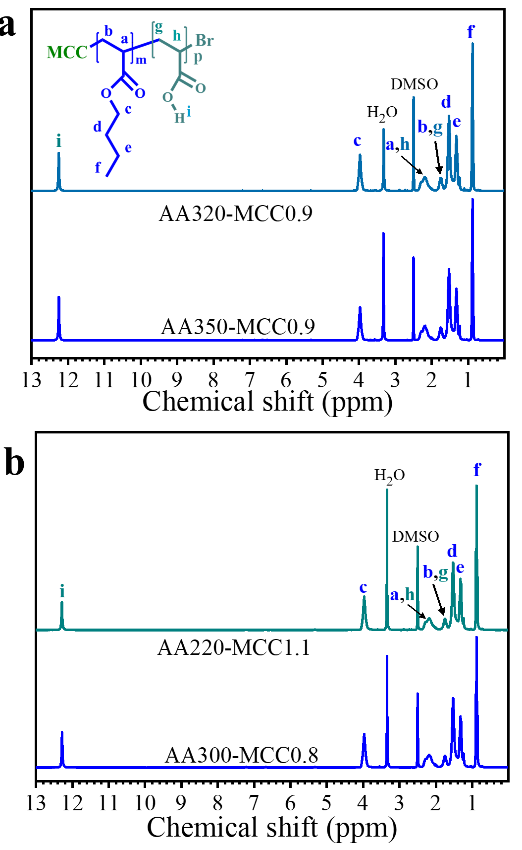
Fig. S4. ¹H NMR spectra for MCC-g-P(nBA-co-AA) in DMSO-d₆, (a) AA350-MCC0.9 and AA320-MCC0.9 and (b) AA300-MCC0.8 and AA220-MCC1.1.

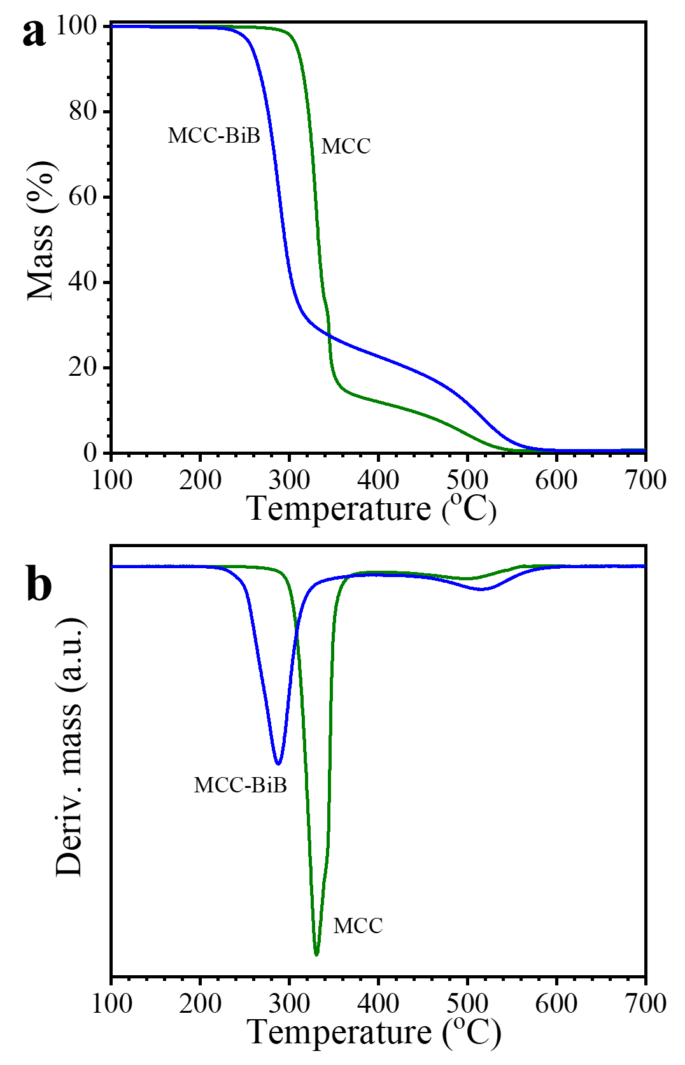
Fig. S5. Mass loss (a) and derivative mass loss curves (b) for MCC and MCC-BiB from TGA measurement.

