Monitoring how the metabolic behavior of mycoplasma is affected by the nutrients: a proof-of-concept demonstration on Mycoplasma gallisepticum by DART-HRMS

Marco Bottinelli^{1$}, Carmela Zacometti^{2$}, Andrea Massaro², Annalucia Tondo¹, Davide Prataviera¹, Beatrice Colò¹, Micaela Picchi¹, Miklós Gyuranecz³, Roberto Piro², Alessandra Tata^{2*}, Salvatore Catania¹.

¹Mycoplasma Unit, WOAH Reference Laboratory for Avian Mycoplasmosis (M. gallisepticum, M. synoviae), SCT-1 Verona, Istituto Zooprofilattico Sperimentale delle Venezie, Buttapietra, Italy.
²Laboratorio di Chimica Sperimentale, SCT-3 Vicenza, Istituto Zooprofilattico Sperimentale delle Venezie, Vicenza, Italy.
³HUN-REN Veterinary Medical Research Institute, Budapest, Hungary
*Corresponding author: Alessandra Tata
email: atata@izsvenezie.it
$ These authors contributed equally to the work.

Supplementary material

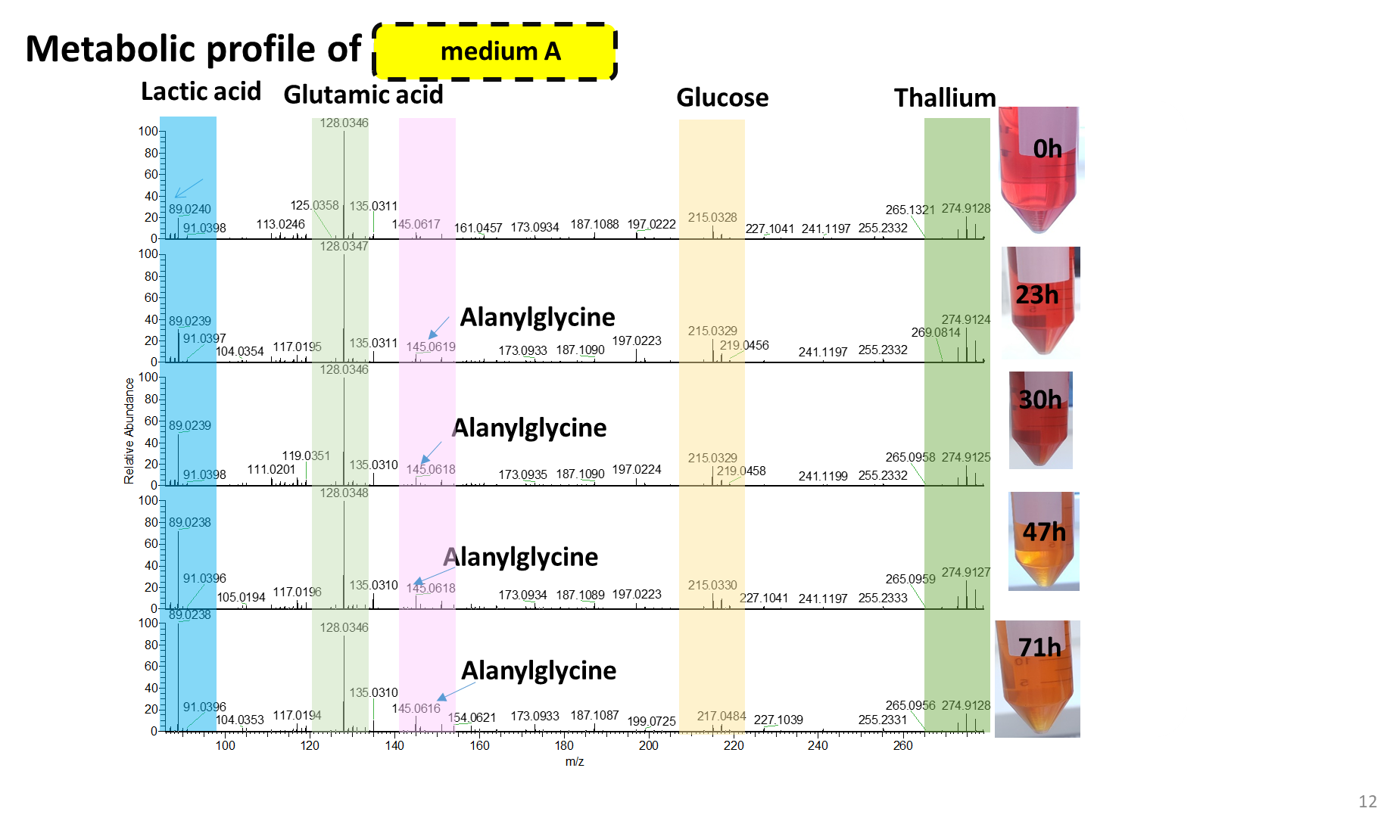
Figure S1. Representative spectra showing the changes of metabolic fingerprinting of M. gallisepticum growing in medium A within 71 hours. Negative ion mode data.

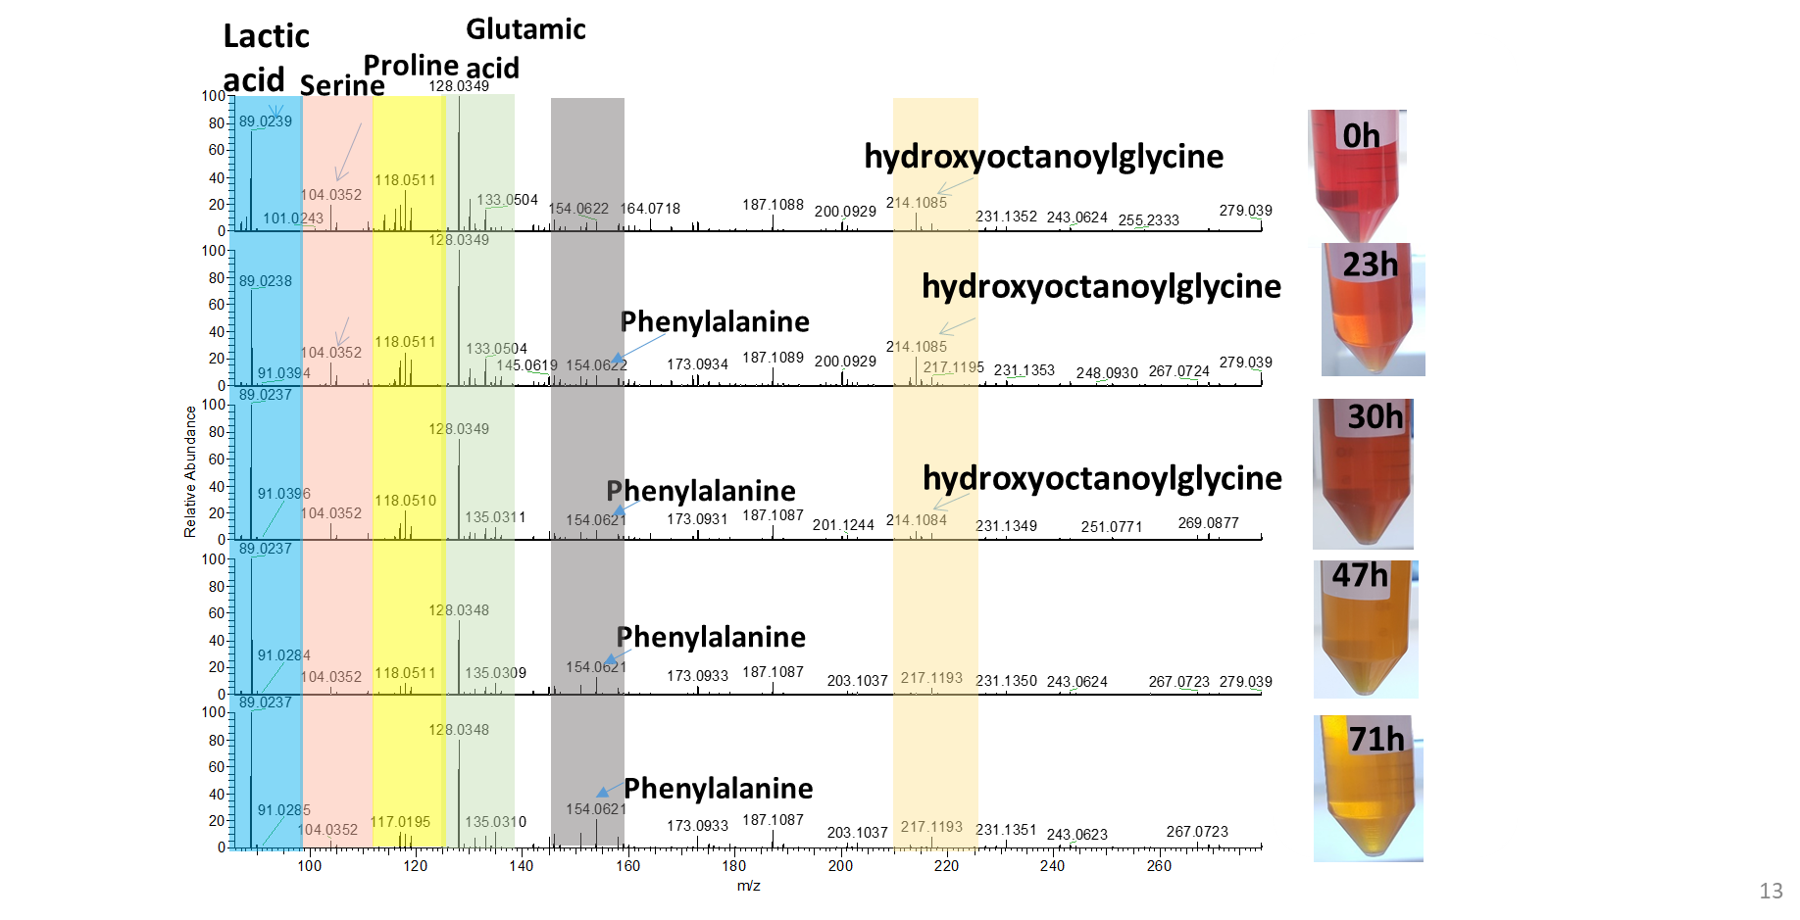
Figure S2. Representative pectra showing the changes of metabolic fingerprinting of M. gallisepticum growing in medium B within 71 hours. Negative ion mode data.

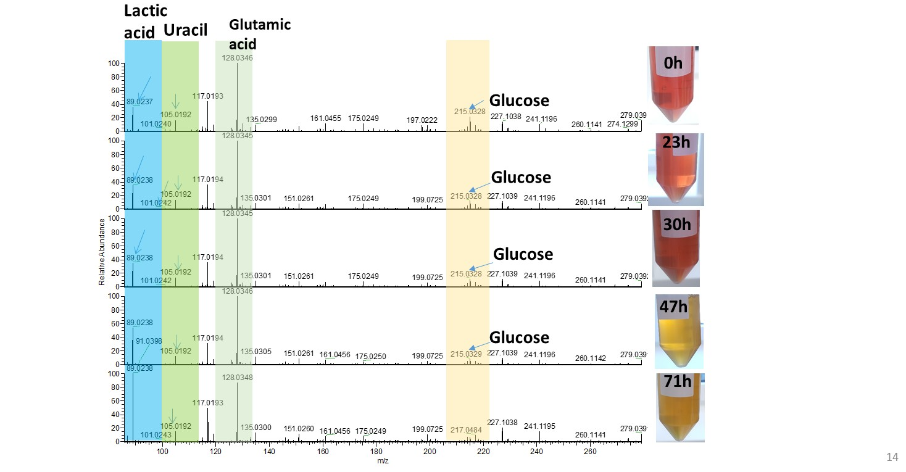
Figure S3. Representative spectra showing the changes of metabolic fingerprinting of M. gallisepticum growing in medium C within 71 hours. Negative ion mode data.

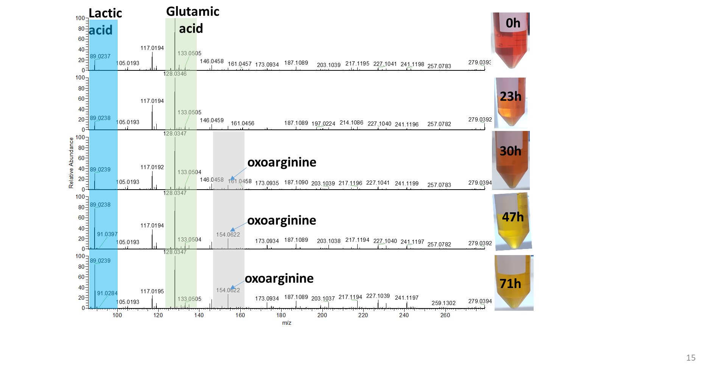
Figure S4. Representative spectra showing the changes of metabolic fingerprinting of M. gallisepticum growing in medium D within 71 hours. Negative ion mode data.

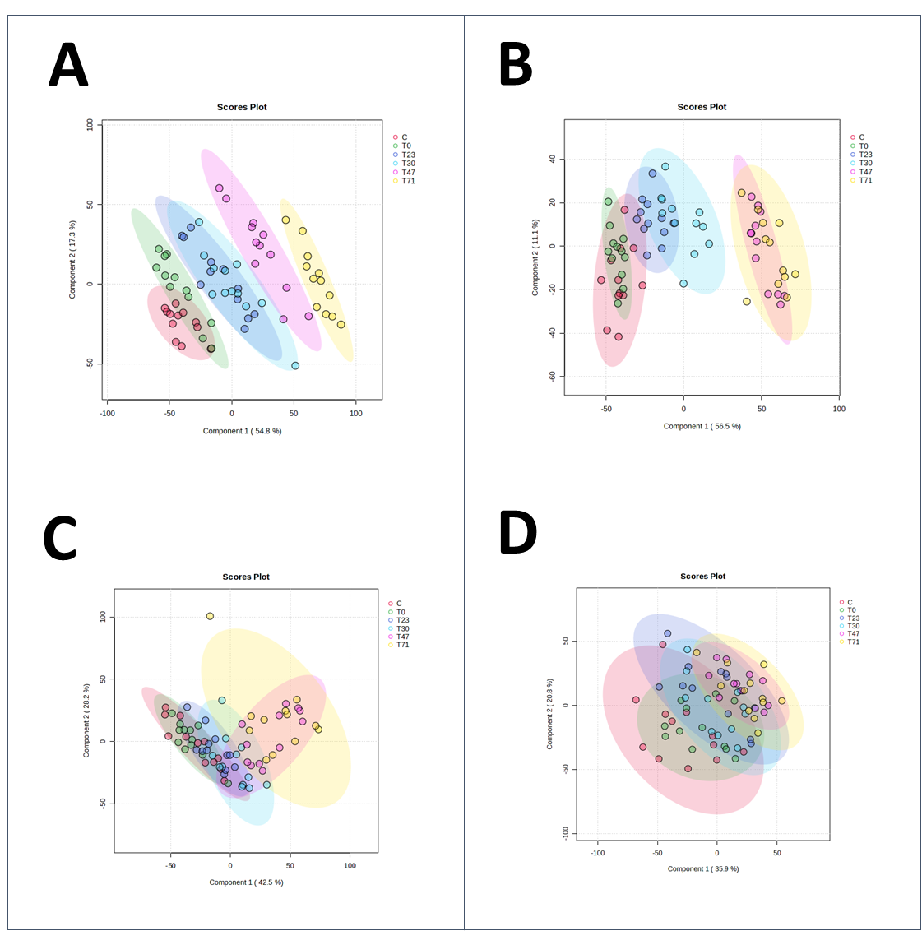
Figure S5. PLS-DA scores plot showing the changes of metabolic fingerprinting of M. gallisepticum growing in four different media within 71 hours. Positive ion mode data.

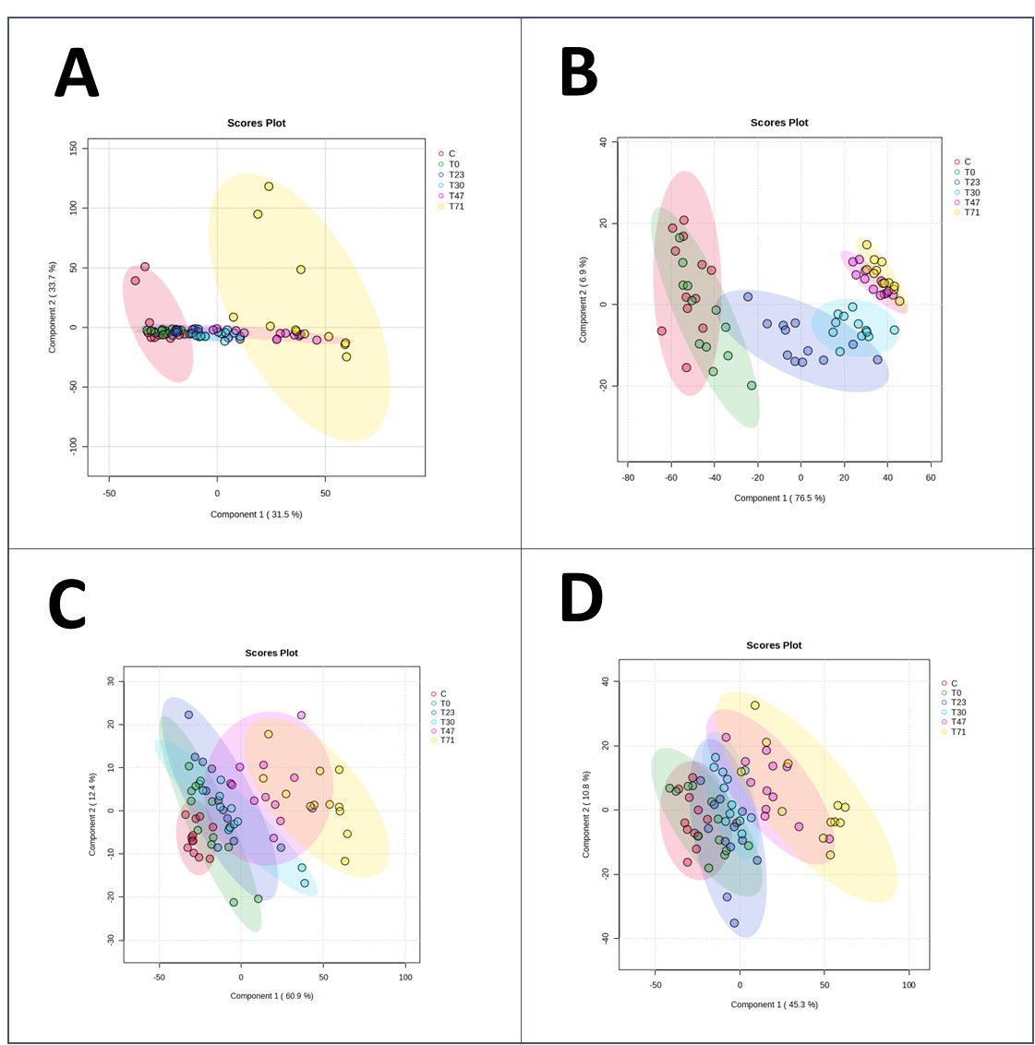

Figure S5 PLS-DA scores plot showing the changes of metabolic fingerprinting of M. gallisepticum growing in four different media within 71 hours. Negative ion mode data.

