Supplementary Information for

Bending-fatigue-resistant hierarchical NiTi shape memory alloy

Kai Yan^{1, 2}, Kangjie Chu¹, Maoli Wang¹, Peng Hua³, Pengbo Wei^{1, 2}, Hanlin Gu⁴, Qiming Zhuang¹, Weifeng He^{5, 6}, Qingping Sun^{2, *}, Robert O. Ritchie^{7, *}, Fuzeng Ren^{1, *}
¹Department of Materials Science and Engineering, Southern University of Science and Technology, Shenzhen, China
²Department of Mechanical and Aerospace Engineering, The Hong Kong University of Science and Technology, Hong Kong, China
³School of Science, Harbin Institute of Technology, Shenzhen, China
⁴Department of Mechanics and Engineering Science, Peking University, Beijing, China
⁵State Key Laboratory for Manufacturing Systems Engineering, School of Mechanical Engineering, Xi’an Jiaotong University, Xi’an, China
⁶Science and Technology on Plasma Dynamics Laboratory, Air Force Engineering University, Xi’an, China
⁷Department of Materials Science and Engineering, University of California, Berkeley, CA, USA

*Corresponding authors. Email: renfz@sustech.edu.cn (F.R.); meqpsun@ust.hk (Q.S.); roritchie@lbl.gov (R.O.R)

Supplementary Text
1. Calculation of residual elastic strain and relief strain
The residual elastic strain along the x and z directions (defined in fig. S6) can be calculated using Eqns. (1-2).
$ε_{rxx}=-\frac{(ε_{xx}+νε_{zz})}{\left(1-ν^{2}\right)}$ (1)
$ε_{rzz}=-\frac{(ε_{zz}+νε_{xx})}{\left(1-ν^{2}\right)}$ (2)
where $ε_{xx}$ and $ε_{zz}$ respectively represent the relief strain along the x and z directions, ν is Poisson’s ratio, and $ε_{rxx}$ and $ε_{rzz}$ are respectively the residual elastic strain along the x and z directions. By measuring the change in distance of two points along the x and z directions, $ε_{rxx}$ and $ε_{rzz}$ can be calculated using Eqns. (3-4).
$ε_{xx}=\frac{L_{x1}-L_{x0}}{L_{x0}}$ (3)
$ε_{zz}=\frac{L_{z1}-L_{z0}}{L_{z0}}$ (4)
where L_{x0} and L_{z0} represent the actual distance between two marks and L_{x1}, and L_{z1} the distance of the two marks after stress relaxation by drilling a rectangular trench.

2. Calculation of the effect of LSP
The depth of the residual stress layer ($L_{p}$), the plastic strain of the pw-LSP-treated surface ($ε_{p}$), and the residual stress of the pw-LSP-treated surface ($σ_{surf}$) can also be determined by:
$L_{p}=(\frac{C_{el}C_{pl}τ}{C_{el}-C_{pl}})(\frac{P-σ_{HEL}}{2σ_{HEL}})$ (5)
$ε_{p}=\frac{-2σ_{HEL}}{3λ+2μ}(\frac{P}{σ_{HEL}}-1)$ (6)
$σ_{surf}=σ_{0}-[\frac{με_{p}\left(1+ν\right)}{\left(1-ν\right)}+σ_{0}][1-\frac{4\sqrt{2}}{π}(1+ν)\frac{L_{p}}{a}]$ (7)
where C_{el} and C_{pl} are the velocities of elastic and plastic wave, τ is the duration of a pressure pulse, P is the pressure, $λ$ and $μ$ are Lame’ constants, $a$ is the edge length of a square laser spot, and $σ_{0}$ is the initial surface residual stress.
From the above equations, the depth of the residual stress layer can be found to increase with an increase in the peak pressure and a decrease in $σ_{HEL}$; thus, increasing the laser power density and increasing the pre-strain will both increase the residual stress affected layer. From Eqn. (7), it is evident that if $σ_{HEL}<P$, $ε_{p}>0$, while if $σ_{HEL}>P$, $ε_{p}<0$.

3. Calculation of the surface heat flux induced by laser ablation
Laser ablation is a process during which the material is heated above its boiling temperature very rapidly. To model this rapid heating process, the absorptivity is assumed to be η = 90%. The absorbed energy (E_{abs}) can be calculated as: E_{abs} = E * η = 4.97*90% = 4.473 J.
For the nanosecond laser shock peening treatment of metal in air, as the energy for one pulse of laser is 4.97 J, the pulse width of nanosecond laser (Δt) is 20 ns, and the diameter of laser beam is 2 mm, the surface heat flux (q) can be calculated as:
q = E_{abs} / (S * Δt) (8)
where S is the laser beam area, and Δt is the laser pulse.
From Eqn. (8), the calculated surface heat flux is 7.11 GW/cm².

Figures

Fig. S1. Schematic illustration of the pw-LSP processing. The specimen is pre-strained to 10% and heated to 150 ℃ before laser shock peening treatment.

Fig. S2. Microstructure of the as-received NiTi sample. (A) Bright-field TEM image. (B) The histogram of grain size distribution. (C) DSC curve of the as-received nanocrystalline NiTi specimen. (D) XRD pattern.

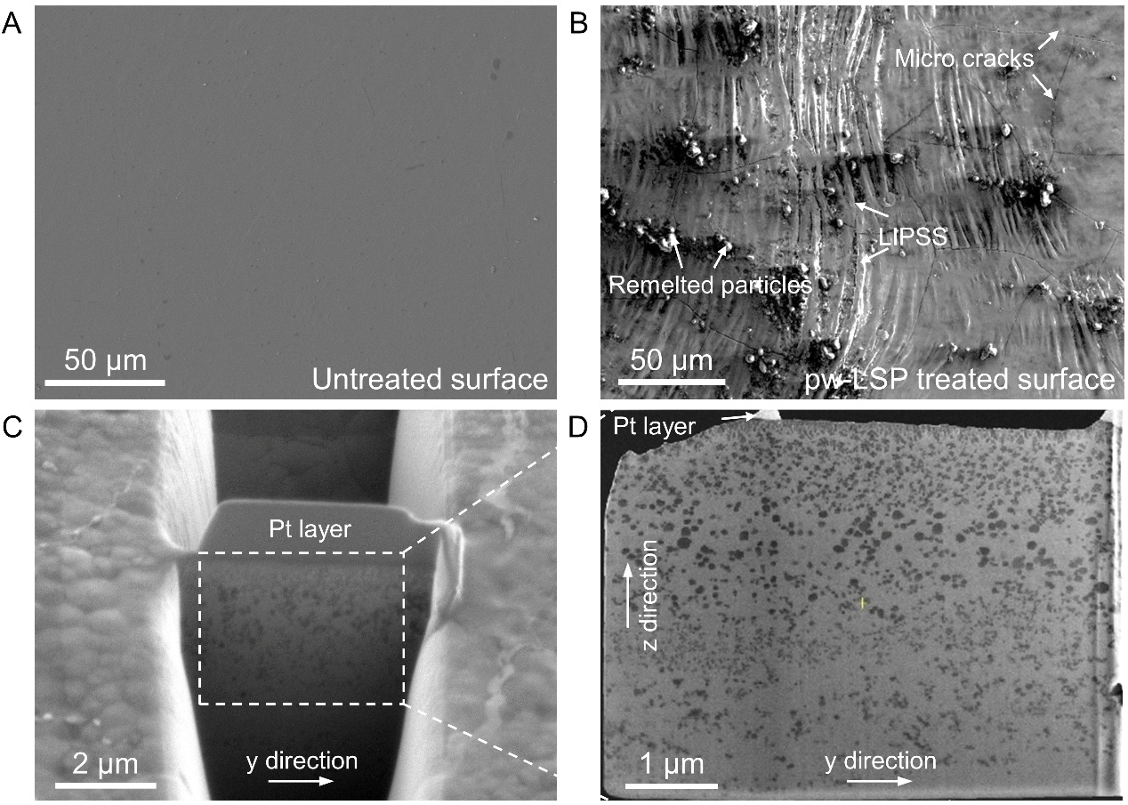
Fig. S3. Surface morphology and cross-sectional microstructure of the TEM sample. (A) SEM image of the as-received NiTi specimen surface. (B) SEM image of the pw-LSP-treated surface. (C) TEM sample preparation using FIB lift-out technique. (D) SEM image of the cross-sectional TEM thin foil lifted out from the pw-LSP-treated surface region.

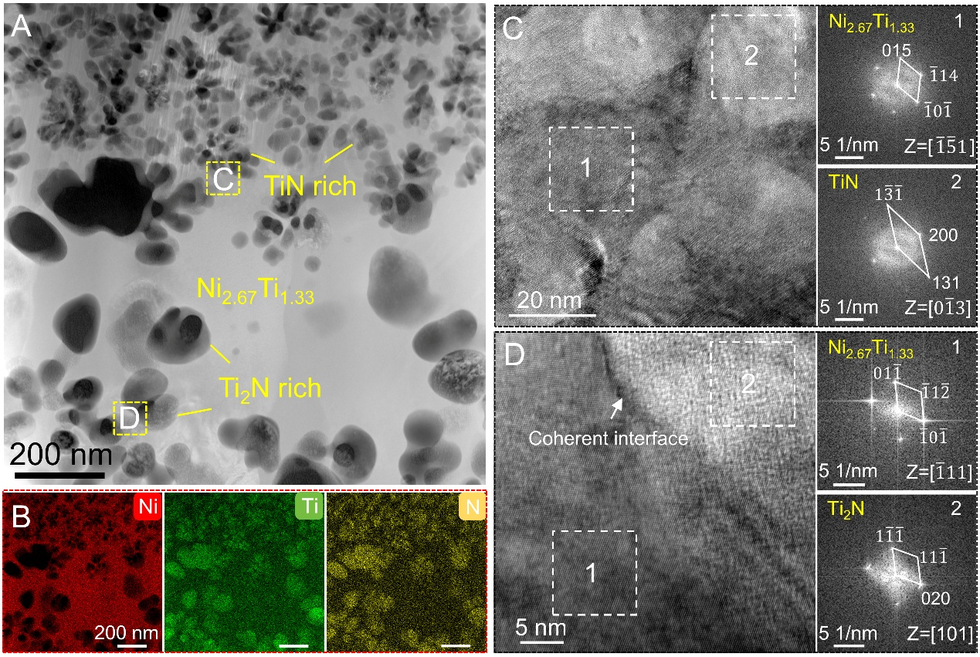
Fig. S4. The cross-sectional microstructure of the topmost surface after pw-LSP treatment. (A) HAADF-STEM image. (B) EDS mapping, showing the elements distribution. (C) The high-resolution TEM images and the corresponding fast Fourier transform (FFT). (D) The high-resolution TEM images, showing the coherent interface.

Fig. S5. XRD pattern of the hierarchical NiTi surface.
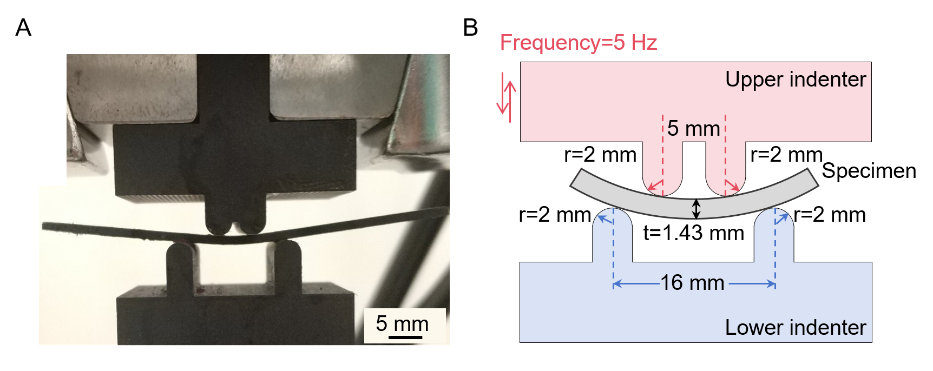
Fig. S6. Photograph (A) and schematic diagram (B) of the four-point bending test.

Fig. S7. Load-indentation depth curves of the cross-section of hierarchical NiTi. It reveals a consistent pattern of increasing indentation depth from the top surface to a depth of 20 μm, which remains stable with further depth increments.

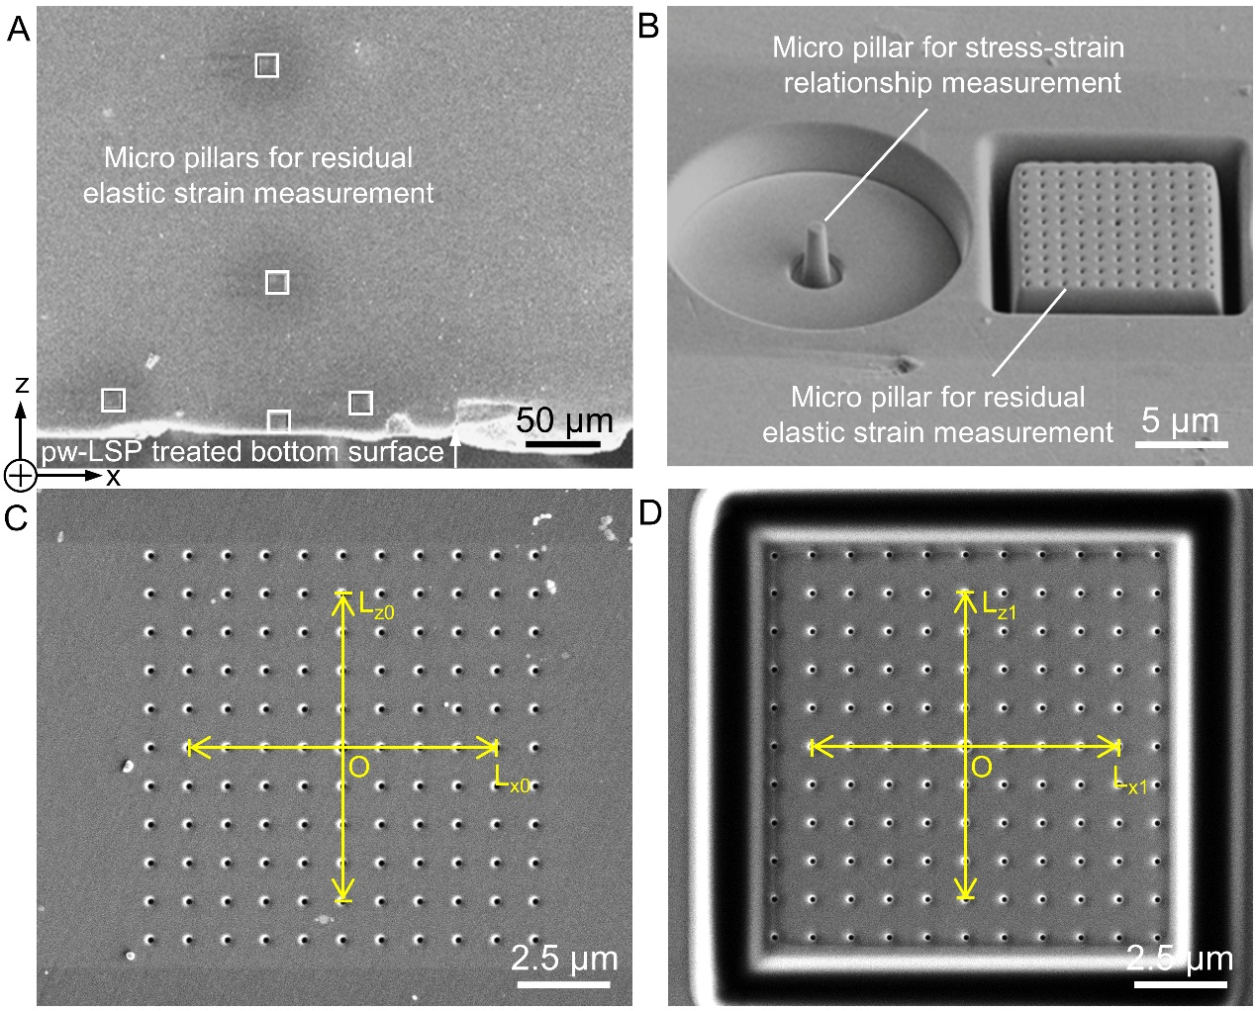

Fig. S8. Methodology of residual stress measurement with FIB-DIC method. (A) SEM image of the cross-section of the pw-LSP-treated sample after FIB-DIC measurement. (B) SEM image of micropillars for the compression test and relief strain measurement. (C-D) SEM images of the dot matrix before and after the residual stress relaxation by milling a rectangular trench for residual stress measurement.

Fig. S9. Distribution of relief strain before and after bending fatigue test of 5 million cycles at different depths of the LSP-treated surface. (A) Relief strain before bending fatigue test. (B) Relief strain after bending fatigue test. (C) Residual elastic strain before bending fatigue test. (D) Residual elastic strain after bending fatigue test. (E) Residual stress before bending fatigue test. (F) Residual stress after bending fatigue test.

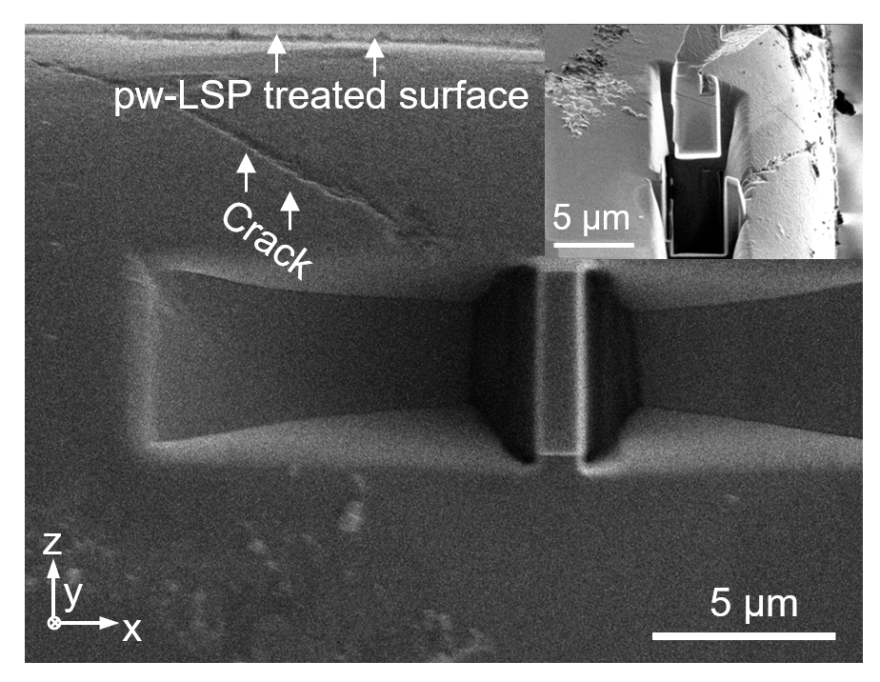
Fig. S10. The SEM image of the fatigue crack and the location of the TEM sample.

