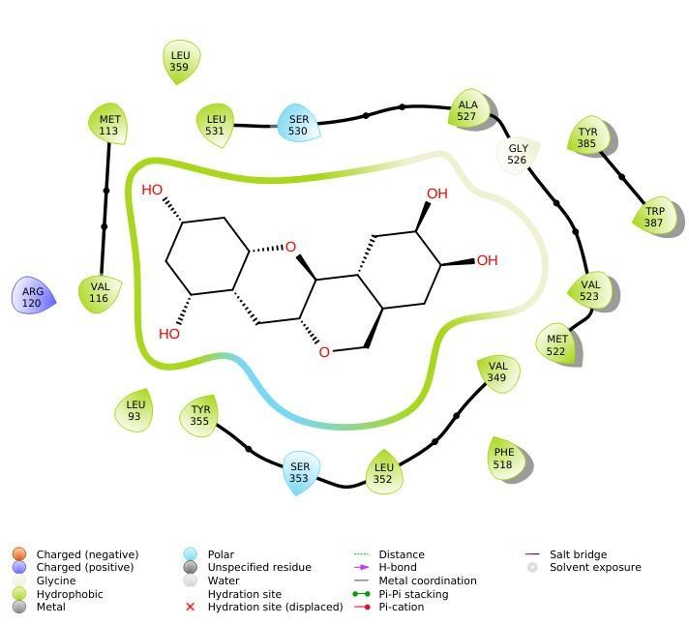
Supplementary data

Fig. S1: 2D Interaction Diagram of the COX-2_SAP N Complex Showing Residues Involved in Hydrophobic Interactions.
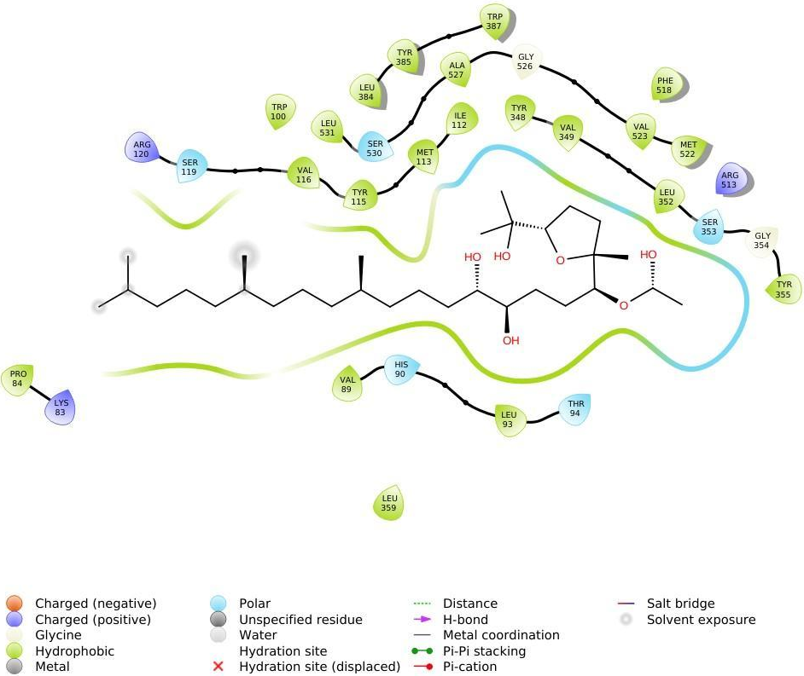
Fig. S2: 2D Interaction Diagram of the COX-2_SAP J Complex Showing Residues Involved in Hydrophobic Interactions.

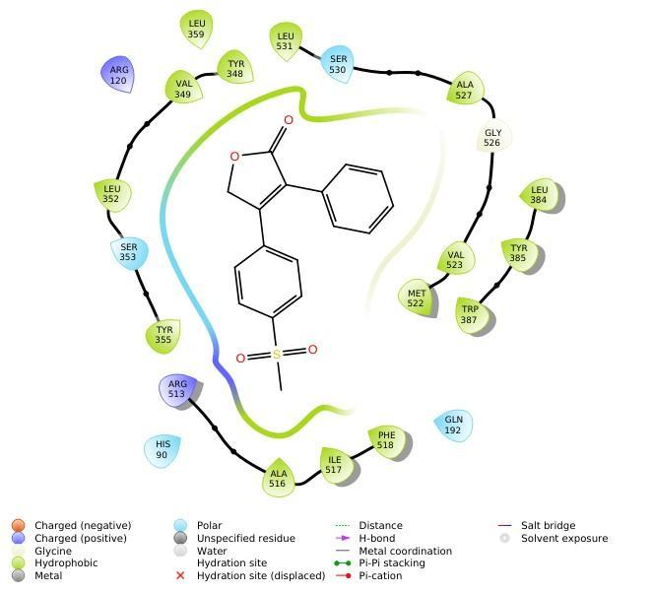
Fig. S3: 2D Interaction Diagram of the COX-2_Rofecoxib Complex Showing Residues Involved in Hydrophobic Interactions.

