Supplementary Information

Ag/YBCO superconducting round wires fabricated by bimaterial 3D printing

Fenyan Zhao^{1,2}†, Baoqiang Zhang^{1,2}†, Xiyang Su³, Yantang Zhao^{1,2}，Xingyi Zhang^{1,2}*, and You-He Zhou^{1,2}
Affiliations:
¹Key Laboratory of Mechanics on Disaster and Environment in Western China attached to the Ministry of Education of China, Lanzhou University; Lanzhou, Gansu 730000, PR China
²Department of Mechanics and Engineering Sciences, College of Civil Engineering and Mechanics, Lanzhou University; Lanzhou, Gansu 730000, PR China
³Department of Mechanical and Aerospace Engineering, The Hong Kong University of Science and Technology; Hong Kong, 999077, PR China.

*Corresponding author. Email: zhangxingyi@lzu.edu.cn
†These authors contributed equally to this work.

The PDF file includes:

Supplementary Discussion
Figs. S1 to S39
Tables S1 to S8
References

Other Supplementary Materials for this manuscript include the following:

Videos S1 to S2
Data S1 to S3

Supplementary Discussion
Section 1: Rheological properties of aqueous and oil-based inks
The rheological properties of the four inks were systematically characterized (Fig.S2). For the aqueous YBCO ink, the storage modulus (G') exceeded the loss modulus (G'') at shear stresses below 110 Pa (τ < 110 Pa) (Fig.S2a), confirming a gel-like behavior that provides excellent structural support and shape retention—crucial for the formation of the shell structure¹⁻³. In contrast, the oil-based YBCO ink exhibited G' > G'' only at ultralow shear stresses (τ < 1.2 Pa) (Fig.S2b), indicating limited structural integrity and poor shape retention. Above this threshold (τ > 1.2 Pa), it transitioned to a sol-like state with enhanced fluidity, rendering it suitable for core structure fabrication^{4,5}. Both YBCO inks exhibited typical shear-thinning behavior, with apparent viscosity (η) decreasing progressively as shear rate ($\dot{γ}$) increased (Fig.S2c). Notably, the aqueous formulation displayed significantly higher viscosity (~2000 Pa·s at 1 s⁻¹), further validating its suitability as a structural support in 3D printing applications^{6,7}. Similar rheological trends were observed for the Ag inks (Fig.S2d,e). The aqueous Ag ink exhibited gel-like behavior (G' > G'' at τ < 100 Pa), while its oil-based counterpart consistently showed sol-like behavior (G' < G'') throughout the tested the range of τ. More pronounced shear-thinning was observed in the aqueous Ag ink (Fig.S2f), supporting its suitability for shell structures fabrication. In contrast, the enhanced fluidity of the oil-based Ag ink enabled efficient pore-filling in the core region, thereby facilitating improved interfacial bonding.

Section 2: Selection of nozzle configuration
Nozzle configuration selection proved critical for both printing quality and final material properties⁸. As summarized in Table S1, the theoretical YBCO shell thicknesses and Ag core diameters corresponding to different nozzle configurations used during printing. The morphological characteristics of as-printed filaments produced using four distinct bimaterial co-printing nozzle configurations are presented (Fig.S3). When employing the 19+27G nozzle combination, the exceptionally small outlet diameter (0.2 mm) led to inconsistent filament extrusion and discontinuous Ag core deposition (Fig.S3a). The 18+22G configuration produced an Ag core diameter of 0.4 mm but only achieved 0.2 mm YBCO shell thickness—insufficient for complete core encapsulation, resulting in silver ink exudation (Fig.S3b). Both 16+22G and 16+20G nozzles generated precursor filaments with mechanically robust supporting structures and smooth, defect-free morphologies (Fig.S3c,d). However, the 16+20G combination created disproportionate dimensions (0.6 mm Ag core versus 0.3 mm YBCO shell), raising concerns about potential shell fracture during subsequent high-temperature co-sintering processes. Consequently, the 16+22G configuration was selected for this study due to its optimal core/shell dimensional balance (0.4 mm Ag core with 0.5 mm YBCO shell).

Section 3: SEM analysis of the microstructure of aqueous YBCO ink at different thermal treatment stages
The microstructural evolution of the aqueous YBCO ink during various stages of thermal processing was systematically investigated using SEM (Fig.S4). In the dried state at room temperature (Fig.S4a), three types of raw material particles are clearly distinguishable: spherical CuO particles⁹, rod-shaped Y₂O₃ particles¹⁰, and irregular BaCO₃ particles¹¹. A thin oily film observed on the particle surfaces consists of residual CMC and ESO from the ink binder system. After pyrolysis at 450 °C for 5 hours (Fig.S4b), the oily residues were completely removed, revealing sharp and distinct particle features. At 820 °C with a 10-hour dwell time (Fig.S4c), partial particle contact was observed, but the reaction remained incomplete. As the temperature increased, the microstructure underwent significant changes. At 910 °C for 10 hours (Fig.S4d), inhomogeneous grain growth occurred, with a broad particle size distribution. A more desirable microstructure was observed after sintering at 920 °C for 10 hours (Fig.S4e), where uniform grain size distribution and a three-dimensionally interconnected pore network were formed. This structure facilitates atomic diffusion during subsequent high-temperature co-sintering with Ag. However, further increasing the temperature to 930 °C (Fig.S4f) led to excessive grain growth and pore closure. The resulting densification hindered atomic diffusion kinetics. Grain necks became irregularly enlarged, and the reduced porosity was unfavorable for diffusion. Therefore, 920 °C was identified as the optimal sintering temperature.

Section 4: TG-DTG analysis of aqueous YBCO ink
The TG-DTG curves of the aqueous YBCO ink, obtained at a heating rate of 2 °C/min up to 1000 °C, reveal three distinct thermal events. As shown in Fig.S5, the first weight loss at approximately 235 °C corresponds to the decomposition of CMC and ESO¹², releasing H₂O and CO₂. The second event occurs at 749.1 °C, attributed to the decomposition of BaCO₃ and the release of CO₂ gas¹³. The third reaction, observed at 883.5 °C, is associated with the solid-state formation of the Y123 superconducting phase¹⁴. The solid content of the powder in the ink is approximately 84 wt.%.

Section 5: Ink systems and drying strategies for Ag-core YBCO superconducting wires
As shown in Fig.S7a, when aqueous YBCO ink was combined with oil-based Ag ink and subjected to natural drying followed by sintering, slight interfacial cracks were observed. In contrast, freeze-drying followed by sintering resulted in a tightly bonded interface without visible cracks or pores. In the case of oil-based YBCO ink combined with aqueous Ag ink (Fig.S7b), significant interfacial cracking occurred under both drying methods. When aqueous YBCO ink was combined with aqueous Ag ink, both natural and freeze-drying followed by sintering led to pronounced interfacial cracks and pores, with severe shrinkage of the Ag core (Fig.S7c). Using oil-based inks for both YBCO and Ag resulted in slight interfacial cracks after natural drying and sintering (Fig.S7d); freeze-drying was deemed unnecessary due to the absence of water and hence no ice crystal formation. Based on these results, the optimal combination—aqueous YBCO ink with oil-based Ag ink and freeze-drying—was selected. During freezing, ice crystals grow radially, leaving behind radial atomic diffusion channels after drying (Fig.S7e), which facilitate interfacial diffusion and bonding during subsequent thermal treatment.

Section 6: CFD-optimized design of core-shell nozzle structures
As shown in Fig.S8a, co-extrusion of oil-based Ag ink and aqueous YBCO ink caused the printed filament to curl toward one side. In contrast, extrusion of only oil-based Ag ink (Fig.S8b) resulted in a vertical filament, while extrusion of only aqueous YBCO ink again led to curling (Fig.S8c). This observation allowed us to simplify the originally complex dual-ink/dual-channel flow problem. As illustrated in Fig.S8d, we reduced the nozzle model to an outer feed channel model containing only the aqueous YBCO ink flow, with the cavity converted to a solid core. This simplification facilitated both boundary condition definition and numerical simulation. The shear stress (τ) versus shear rate ($\dot{γ}$) relationship for aqueous YBCO ink, as measured by rotational rheometry, is presented in Fig.S9a. This data was converted to Reynolds number (Re) versus $\dot{γ}$ dependence (Fig.S9b) using the following equation¹⁵:
$Re=\frac{ρVd}{μ}$ (1)
where ρ represents the density of the aqueous YBCO ink (1.128×10⁴ kg·m⁻³), V represents the linear velocity (m·s⁻¹), calculated as $\dot{γ}$ × h, with h being the gap width between the parallel plates in the rotational rheometer. And d denotes the characteristic length scale of the fluid, taken as the radius of the rheometer parallel plate (0.0125 m). The viscosity (μ, Pa·s) corresponds to the y-axis values of the yellow curve in Fig.S2c. Re is a dimensionless quantity used to characterize fluid flow regimes. When Re < 2300, the flow remains smooth and orderly, exhibiting laminar behavior. For Re > 4000, the flow becomes chaotic and disordered, entering turbulent regime. In the transitional range (2300 < Re < 4000), the flow exhibits mixed characteristics with possible localized or intermittent turbulence¹⁶. For the aqueous YBCO ink, laminar flow is maintained at shear rates below 74 s⁻¹ (corresponding to a linear velocity of 7.4 cm·s⁻¹, significantly exceeds the practical printing speed of approximately 1.67 cm·s⁻¹).

Constitutive model for aqueous YBCO ink rheology
The rheological behavior of aqueous YBCO ink can be described by the Herschel-Bulkley model^{17,18}:
$τ=τ_{y}+K{\dot{γ}}^{n}, τ>τ_{y},$ (2)
$$\dot{γ}=0, τ<τ_{y}$$
Where τ represents the shear stress, τ_{y} denotes the yield stress, K is the consistency coefficient, and n indicates the flow index. The parameter τ₀ in Fig.S9d corresponds to the critical shear stress. These parameters were determined by fitting the data in Fig.S9c using Equation (2), with the resulting values summarized in Table S2.

Governing equations and numerical methodology
In the flow simulation, the aqueous YBCO ink can be simplified as an incompressible viscous fluid. Within a Cartesian coordinate system, its motion can be described by the Navier-Stokes equations. Neglecting heat transfer during ink flow, the continuity equation and momentum equation are given as follows¹⁹:
$\frac{∂ρ}{∂t}+∇∙\left(ρv\right)=0$ (3)
$\frac{∂(ρv)}{∂t}+∇∙\left(ρvv\right)=-∇p+∇∙τ+ρg+F$ (4)
Where ρ denotes the fluid density, v represents the velocity vector, p indicates the static pressure, τ corresponds to the stress tensor, ρg accounts for gravitational forces, and F stands for the generalized source term in the conservation equations. The numerical solution employs the finite element method for equation discretization. Given the incompressibility condition (ρ = constant), application of the Galerkin method yields the discretized forms of Equations (3) and (4)²⁰:
$\sum_{i=1}^{N}{v_{i}∙\int_{Ω}{ϕ_{i}dΩ=0}}$ (5)
$\int_{Ω}{\left(ρv∙∇v\right)ϕ_{i}dΩ=-\int_{Ω}{p∇ϕ_{i}dΩ+\int_{Ω}{τ∙∇ϕ_{i}dΩ+\int_{Ω}{pg∇ϕ_{i}dΩ+\int_{Ω}{Fϕ_{i}dΩ}}}}}$ (6)

Specification of boundary conditions
The aqueous YBCO ink was delivered through a constant-flow pump at 1 mL/min, corresponding to an inlet velocity of 1.67 cm/s. A pressure-free outflow condition was applied at the outlet, while no-slip boundary conditions (v_{n} = v_{s} = 0) were implemented at all walls. Gravitational acceleration was oriented along the z-axis.

Analysis of CFD simulation results
The pressure distribution from CFD simulations of aqueous YBCO ink flow in the conventional nozzle's outer feed channel is shown in Fig.S10. The pressure contour plot in Fig.S10a exhibits significant color variation. At z = 1 (approximately the upper quarter of the cavity), the z-z' diagonal was analyzed, revealing a pressure differential of 0.18 MPa along this diagonal (Fig.S10b). This differential increased to 0.27 MPa at z = 2 (Fig.S10c) and further to 0.47 MPa at z = 3 (Fig.S10d), demonstrating a progressive pressure gradient from the top to bottom regions of the cavity. The non-uniform pressure distribution within the cavity directly influenced the ink's velocity profile, as illustrated in Fig.S11. At z = 5 (marked in Fig.S11a), where the ink exits the cavity and flows through the conical transition section, the velocity profile along the diagonal showed a maximum difference of 0.1 cm/s (Fig.S11b). When reaching z = 6 (the entrance to the vertical channel), this velocity difference increased to 0.25 cm/s (Fig.S11c). These significant velocity variations caused extruded filaments to curl, presenting substantial challenges for precise shape control during printing.
To address this issue, the feed angle was modified by tilting the outer inlet upward by 30° (Fig.S12)²¹. At z = 2, the pressure differential decreased to 0.16 MPa, while at z = 3, it reduced further to 0.24 MPa. Similarly, the velocity difference measured 0.07 cm/s at z = 5 and 0.12 cm/s at z = 6. Compared to the conventional nozzle design, both pressure and velocity gradients were significantly mitigated.
The outer feed inlet was further tilted upward by 45° (Fig.S13), resulting in pressure differentials of 0.012 MPa at z = 2 and 0.014 MPa at z = 3. Corresponding velocity differences measured 0.04 cm/s (z = 5) and 0.07 cm/s (z = 6), demonstrating improved pressure and velocity uniformity compared to the 30°-tilt nozzle configuration.
The outer feed inlet was subsequently adjusted to a 60° upward tilt (Fig.S14), yielding increased pressure differentials of 0.12 MPa (z = 2) and 0.25 MPa (z = 3), with corresponding velocity differences of 0.14 cm/s (z = 5) and 0.29 cm/s (z = 6). This reversal in performance metrics prompted selection of the 45° configuration, which maintained lower cavity pressure gradients and more uniform flow profiles (Fig.S15a). Custom fabrication of this optimized nozzle design eliminated filament curling during actual printing (Fig.S15b).

Section 7: Ink system and drying method for Ag-coated YBCO superconducting wires
When using oil-based Ag ink with aqueous YBCO ink followed by natural drying and sintering resulted in an uneven Ag surface despite relatively crack-free interfaces. Freeze-drying followed by sintering caused surface cracking (Fig.S18a). For the aqueous Ag ink with oil-based YBCO ink combination, natural drying led to significant interfacial cracks, while freeze-drying produced tight interfacial bonding and smooth Ag surfaces, making this the selected approach (Fig.S18b).

Section 8: Analysis of incoherent phase boundaries between Ag_{x} and Y211
As revealed in Fig.S26, the interfacial structural relationship between Ag_{x}(030) and Y211(311) was characterized. Through FFT and IFFT analysis of HRTEM images, the interplanar spacings were measured as 1.302 Å for Ag_{x}(030) and 2.157 Å for Y211(311), with an interfacial misorientation angle of θ ≈ 24°. The lattice mismatch was quantitatively evaluated by the following formula:
$δ=\frac{dY211\left(311\right)∙\cos{θ}-d{Ag}_{x}(030)}{d{Ag}_{x}(030)}=51.34\%$ (7)
Since δ > 25% ²², this indicates an incoherent interface between Ag_{x}(030) and Y211(311).

Section 9: Derivation of the extended Bean model for perpendicular magnetic fields in superconducting wires
Gyorgy et al.²³ proposed an extended Bean critical-state model for anisotropic YBCO superconductors:
$∆M=\frac{J_{c1}t}{20}(1-\frac{t}{3l}\frac{J_{c1}}{J_{c2}})$, (8)
$\frac{J_{c1}}{J_{c2}}<\frac{l}{t}$
Where J_{c1} represents the current density parallel to the Cu-O planes (within the a-b plane), while J_{c2} denotes the current density perpendicular to the Cu-O planes (along the c-axis), with the magnetic field oriented normal to the surface of dimensions l×t. When $l≫\frac{J_{c1}t}{{3J}_{c2}}$, the system reduces to an infinite strip of thickness t, whose solution takes the form:
$∆M=\frac{J_{c1}t}{20}$ (9)
We adapt the anisotropic Bean model proposed by Gyorgy et al.²³ to the geometric characteristics of Ag-core YBCO superconducting wires (with the magnetic field perpendicular to the wire’s longitudinal axis), introducing appropriate simplifications and modifications to establish a J_{c} calculation model applicable to elongated composite superconductors. Given that the axial length of the wire significantly exceeds its radial dimensions, the contribution of radial J_{c} to the magnetization hysteresis width (ΔM) can be neglected. As illustrated in Fig.S32a, the Ag-core YBCO wire exhibits a circular cross-section with an Ag-core radius of R₁ and a composite wire radius of R₂. The M-H curve of 3D-printed pure Ag at 10 K (Fig.S33) displays a linear response, confirming that the superconductivity of the composite wire originates entirely from the YBCO shell. Consequently, in the extended Bean model calculations, the Ag core contributes only geometric parameters without participating in J_{c} determination. The YBCO shell forms a hollow cylindrical structure (Fig.S32b) with a radial width of R₂ − R₁. To facilitate modeling, this hollow cylinder can be equivalently represented as two superimposed rectangular strips (Fig.S32c), each with thickness t and width R₂ − R₁, such that their combined cross-sectional area matches that of the hollow cylinder. The expression for the equivalent thickness t is given by:
$t=\frac{π{R_{2}}^{2}-π{R_{1}}^{2}}{2(R_{2}-R_{1})}=\frac{π}{2}(R_{2}+R_{1})$ (10)
Based on this, the formula for calculating J_{c} in the Ag-core YBCO superconducting wire composite structure using the extended Bean model is:
$J_{c}=\frac{20∆M}{t}$,
$t=\frac{π}{2}(R_{2}+R_{1})$ (11)
Similarly, by modeling the SC-YBCO wire as a square-cross-section prism (Fig.S34), the expression for t is given by:
$t=\sqrt{πR^{2}}$ (12)
For the Ag-coated YBCO wire, after removing the outer Ag shell, the structure can also be simplified and modeled as a square-cross-section prism.

Section 10: Calculation formulas for mechanical parameters in three-point bending tests
Based on elastic beam theory and assuming a circular cross-section, the flexural strength (σ_{f}, MPa), flexural strain (ε_{f}), flexural modulus (E_{f}, MPa), and fracture energy (G_{f}, MJ·m⁻³) were calculated as follows²⁴:
$σ_{f}=\frac{3FL}{πR^{3}}$ (13)
$ε_{f}=\frac{ω}{L^{2}}×12R$ (14)
$E_{f}=\frac{FL^{3}}{12πωR^{4}}$ (15)
$G_{f}=L\int_{0}^{ε_{0}}{σ_{f}dε}$ (16)
where F represents the applied load (N), L denotes the span length (mm), R is the wire radius (mm), ω indicates the deflection (mm), and ε₀ corresponds to the maximum strain at fracture (mm).

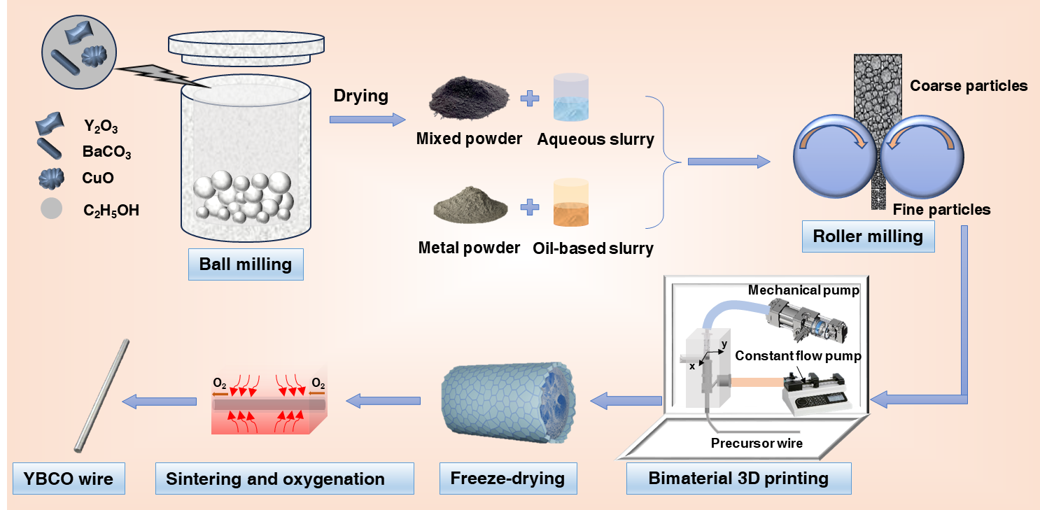

Figure S1.
Fabrication flowchart of Ag-core YBCO superconducting wires via DIW bimaterial co-printing and post-processing.

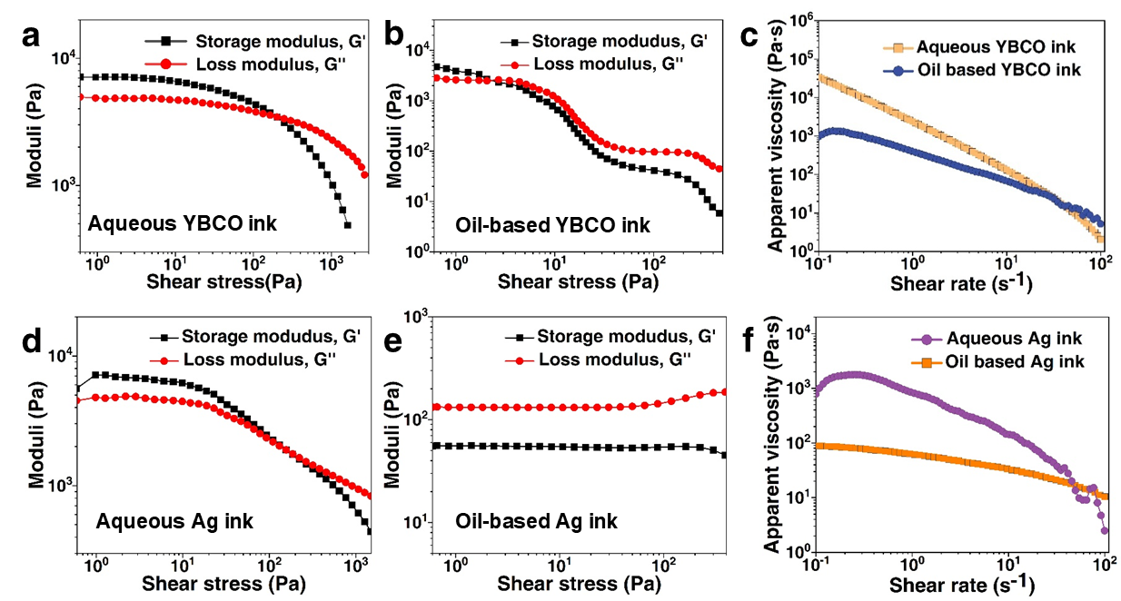

Figure S2.
Rheological properties of aqueous and oil-based inks. a, The relationship between storage modulus (G') and loss modulus (G'') of the aqueous YBCO ink as a function of shear stress (τ) demonstrates gel-like behavior (G' > G'' at τ < 110 Pa), indicating excellent structural support and shape retention, suitable for shell formation¹⁻³. b, The oil-based YBCO ink exhibits sol-like behavior (G' < G'' at τ > 1.2 Pa), demonstrating superior fluidity ideal for core structure fabrication^{4,5}. c, Both aqueous and oil-based YBCO inks exhibit shear-thinning behavior, with apparent viscosity (η) decreasing as shear rate ($\dot{γ}$) increases. However, the aqueous ink shows higher η values, making it more suitable for 3D printing of supporting shell structures^{6,7}. d, The aqueous Ag ink exhibits gel-like behavior (G' > G'' at τ < 100 Pa), making it suitable for shell structure fabrication. e, The oil-based Ag ink exhibits sol-state behavior (G' < G''), demonstrating the fluidity required for core structure fabrication. f, The η of both aqueous and oil-based Ag inks is $\dot{γ}$ dependent, with the aqueous ink showing significantly higher η values.

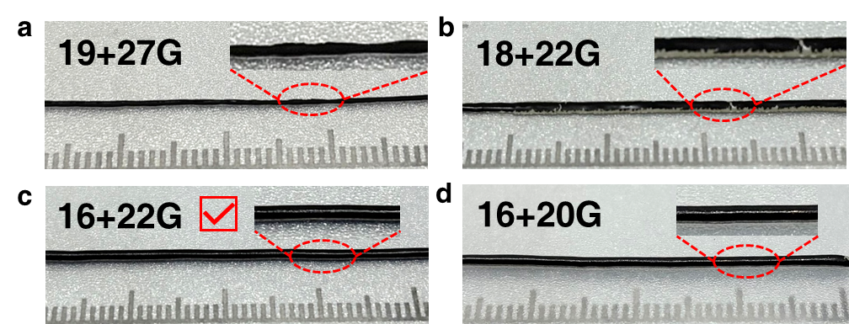

Figure S3.
Real-time sample geometries produced by four nozzle configurations via bimaterial co-printing. a, The 19+27G nozzle configuration, featuring an excessively small orifice diameter, produced non-uniform printed filaments with discontinuous Ag core deposition. b, The 18+22G nozzle configuration resulted in an oversized inner inlet diameter (0.4 mm) and an insufficient outer shell thickness (0.2 mm), which failed to fully encapsulate the Ag core, eventually leading to Ag ink leakage. c, The 16+22G nozzle configuration enabled the printing of precursor filaments with well-defined supporting structures and smooth, stable morphology without collapse. d, In the 16+20G configuration, the Ag core is excessively thick (0.6 mm), while the outer supporting YBCO shell is only 0.3 mm thick, which may lead to shell cracking during high-temperature co-sintering (Table S1).

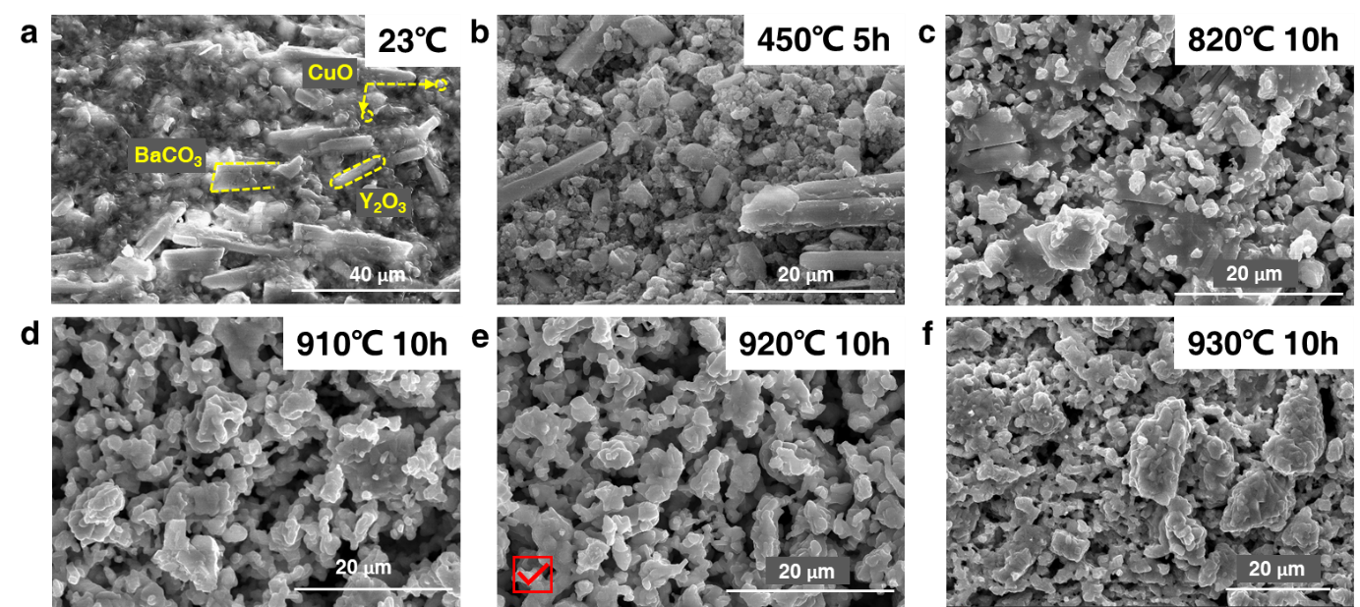

Figure S4.
SEM analysis of the microstructure of aqueous YBCO ink at different thermal treatment stages. a, After drying at room temperature (23 °C), three types of raw material particles are clearly observed: spherical CuO particles⁹, rod-shaped Y₂O₃ particles¹⁰, and irregular BaCO₃ particles¹¹. A thin oily film on the particle surfaces consists of dried residues of CMC and ESO. b, After heat treatment at 450 °C for 5 hours, the surface residues are completely removed, revealing sharp and well-defined particle morphologies. c, At 820 °C for 10 hours, partial particle contact is observed, although the reaction remains incomplete. d, Sintering at 910 °C for 10 hours results in non-uniform grain growth, with a wide particle size distribution. e, At 920 °C for 10 hours, an optimal microstructure is achieved, characterized by uniform grain size and a three-dimensionally interconnected pore network. f, At 930 °C for 10 hours leads to excessive grain growth and pore closure, resulting in a dense microstructure unfavorable for atomic diffusion.

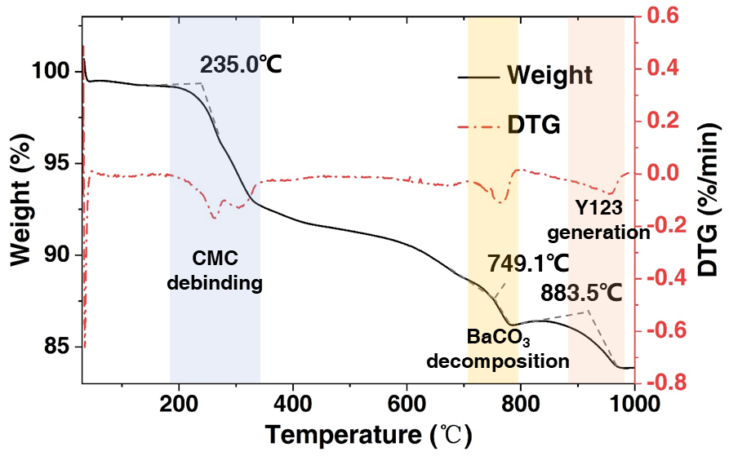

Figure S5.
TG-DTG curve of the aqueous YBCO ink.

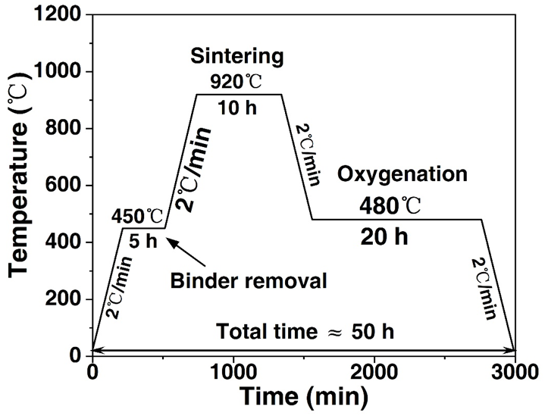

Figure S6.
Post-processing sintering protocol for Ag-core YBCO superconducting wires.

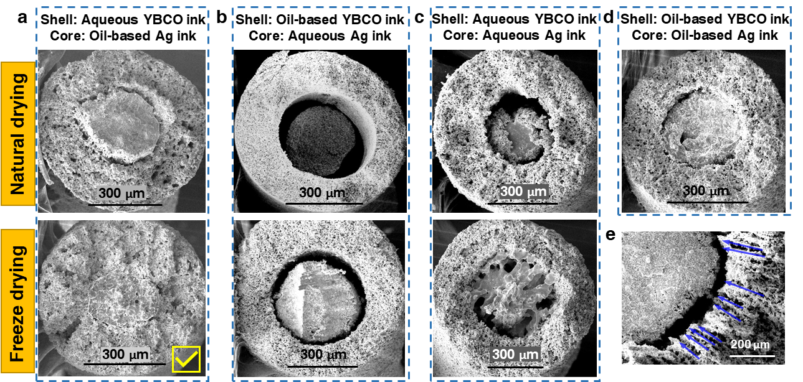

Figure S7.
Cross-sectional SEM analysis of sintered Ag-core YBCO wires fabricated using different ink pairings and drying methods. a, For the aqueous YBCO ink/oil-based Ag ink system, natural drying followed by sintering resulted in minor interfacial cracks, whereas freeze-drying led to tight interfacial bonding with no obvious cracks or voids. b, For the oil-based YBCO ink/aqueous Ag ink system, significant interfacial cracks were observed after sintering under both drying methods. c, For the aqueous YBCO ink/aqueous Ag ink system, both drying methods resulted in pronounced interfacial cracks and voids, along with severe shrinkage of the Ag core. d, For the oil-based YBCO ink/oil-based Ag ink system, natural drying followed by sintering produced slight interfacial cracking. e, In the aqueous YBCO ink/oil-based Ag ink system, radial growth of ice crystals during freeze-drying left behind well-aligned radial pores.

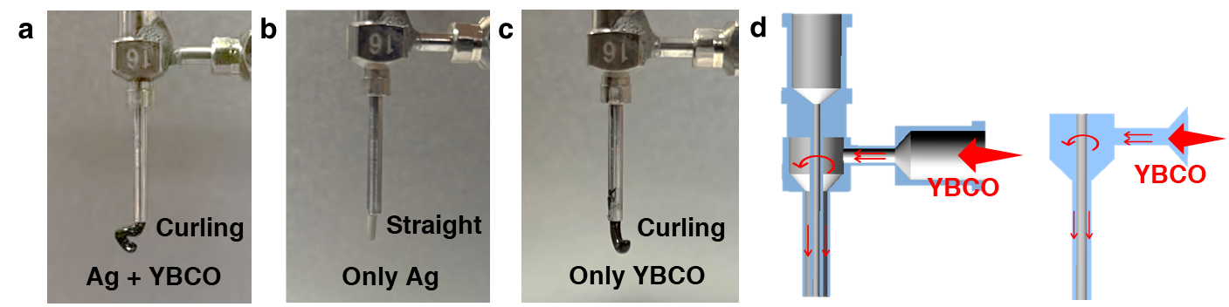

Figure S8.
Problems encountered with conventional nozzles during bimaterial co-extrusion 3d printing and corresponding model simplifications. a, Co-extrusion of both materials induces filament curling. b, Single-material extrusion (Ag ink through inner channel) produces vertically aligned filaments. c, Horizontal YBCO ink extrusion (outer channel only) results in curled filaments. d, Simplified computational model retaining only the outer feed channel.

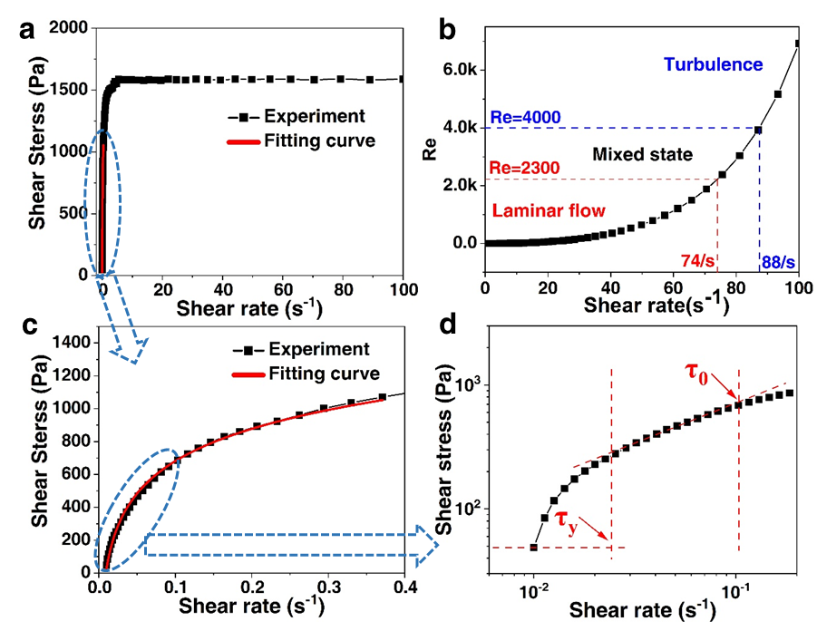

Figure S9.
Rheological characterization of aqueous YBCO ink. a, Shear stress (τ) as a function of shear rate ($\dot{γ}$). b, Reynolds number (Re) versus $\dot{γ}$, demonstrating laminar flow at $\dot{γ}$ < 74 s⁻¹ (equivalent to linear velocity 7.4 cm·s⁻¹). c, τ-$\dot{γ}$ relationship in the low-shear regime (0 ≤ $\dot{γ}$ ≤ 0.4 s⁻¹). d, Viscoelastic properties at $\dot{γ}$ < 0.1 s⁻¹, where τ_{y} denotes yield stress and τ₀ represents critical shear stress.

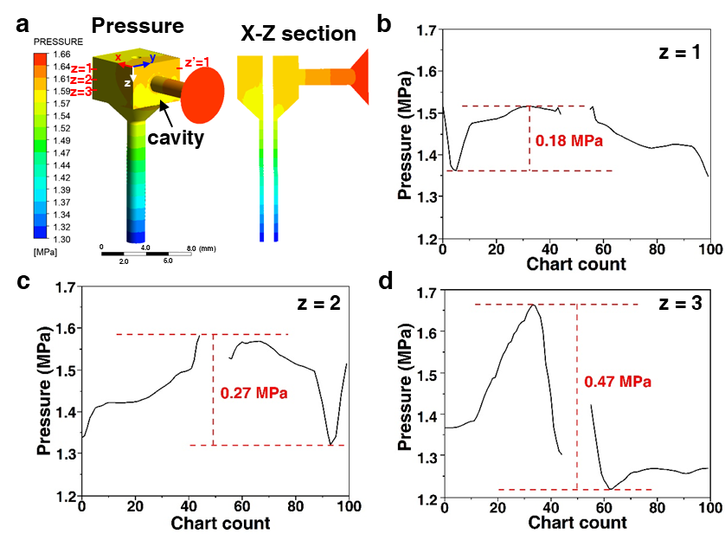

Figure S10.
CFD-simulated pressure distribution of aqueous YBCO ink in conventional nozzle outer feed channel. a, Pressure distribution contour map. b, Pressure profile along the diagonal line (z = 1) of the z–z′ cross-section, showing a maximum pressure difference of 0.18 MPa. c, Pressure profile along the diagonal line (z = 2), with a maximum pressure difference of 0.27 MPa. d, Pressure profile along the diagonal line (z = 3), exhibiting a maximum pressure difference of 0.47 MPa.

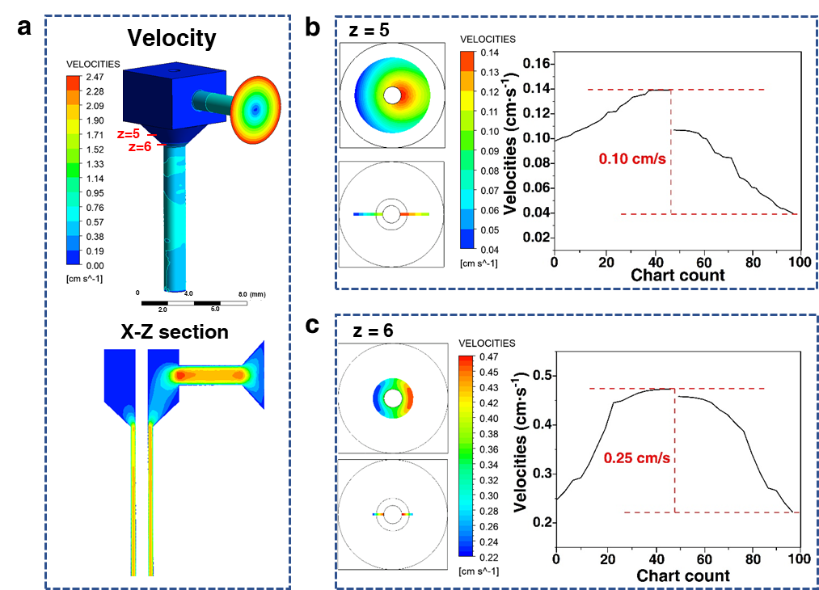

Figure S11.
CFD simulation of velocity distribution for aqueous YBCO ink in the outer feed channel of a conventional nozzle. a, Velocity distribution contour map. b, Radial velocity profile at z = 5, showing a maximum velocity difference of 0.1 cm/s. c, Radial velocity profile at z = 6, with a maximum velocity difference of 0.25 cm/s.

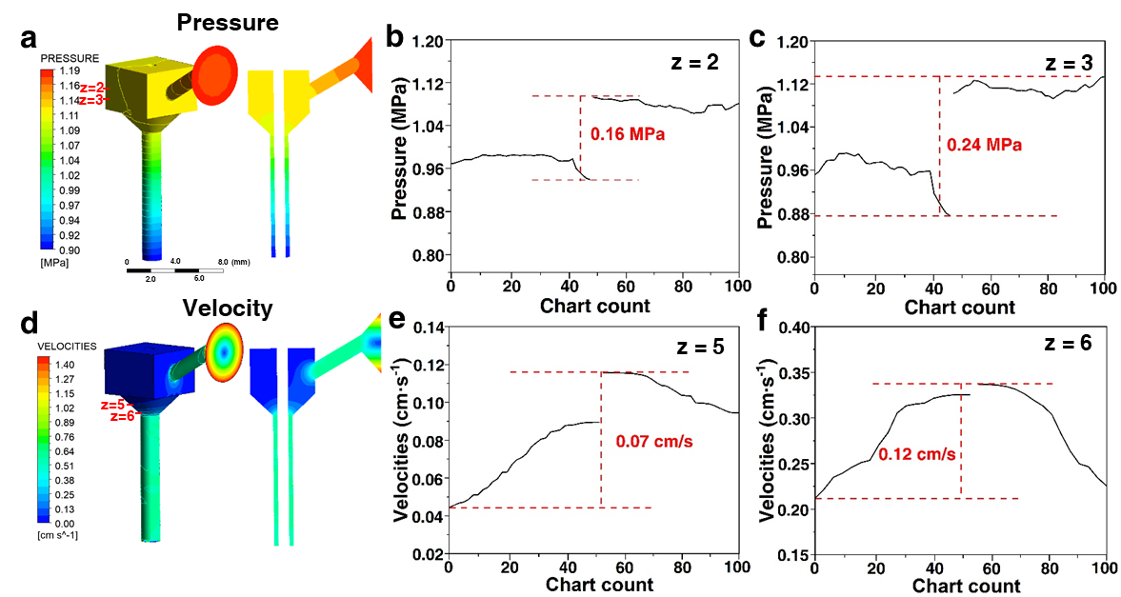

Figure S12.
CFD Simulation Results at a Feed Angle of 30°. a, Pressure distribution contour map. b, Pressure profile along the diagonal at z = 2, with a maximum pressure difference of 0.16 MPa. c, Pressure profile along the diagonal at z = 3, with a maximum pressure difference of 0.24 MPa. d, Velocity distribution contour map. e, Radial velocity profile at z = 5, showing a maximum velocity difference of 0.07 cm/s. f, Radial velocity profile at z = 6, with a maximum velocity difference of 0.12 cm/s.

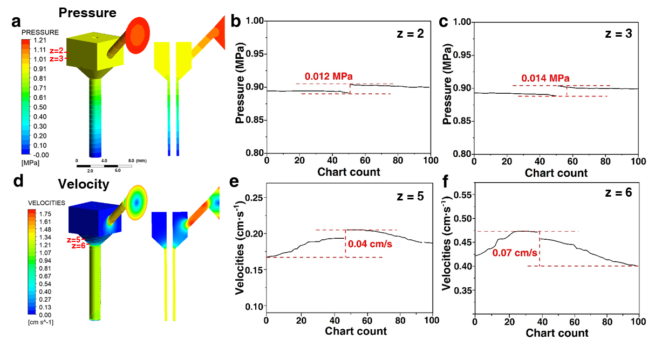

Figure S13.
CFD Simulation Results at a Feed Angle of 45°. a, Pressure distribution contour map. b, Pressure profile along the diagonal at z = 2, showing a maximum pressure difference of 0.012 MPa. c, Pressure profile along the diagonal at z = 3, with a maximum pressure difference of 0.014 MPa. d, Velocity distribution contour map. e, Radial velocity profile at z = 5, with a maximum velocity difference of 0.04 cm/s. f, Radial velocity profile at z = 6, showing a maximum velocity difference of 0.07 cm/s.

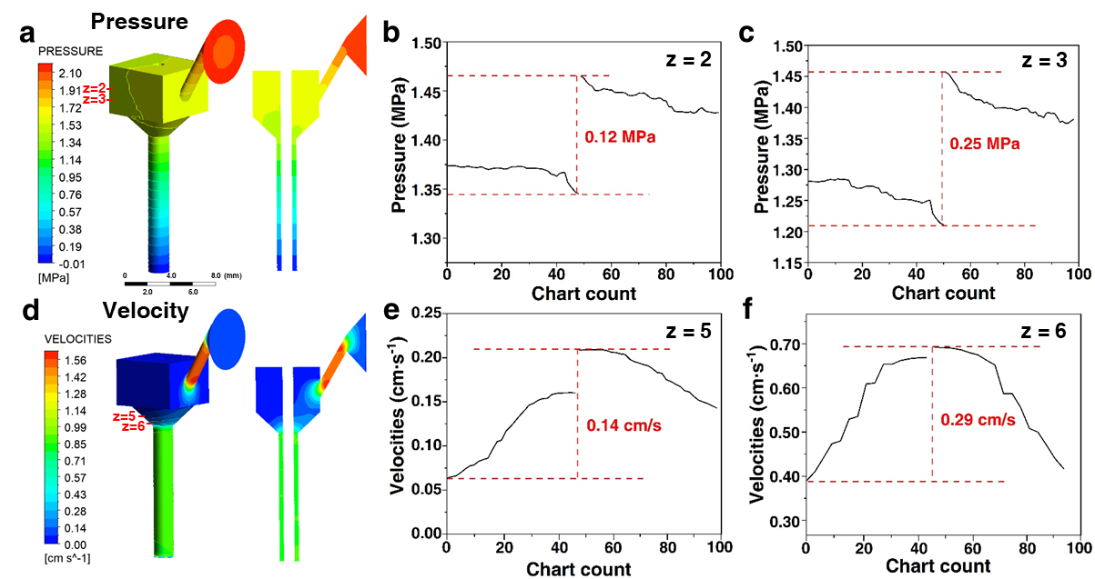

Figure S14.
CFD Simulation Results at a Feed Angle of 60°. a, Pressure distribution contour map. b, Pressure profile along the diagonal at z = 2, with a maximum pressure difference of 0.12 MPa. c, Pressure profile along the diagonal at z = 3, with a maximum pressure difference of 0.25 MPa. d, Velocity distribution contour map. e, Radial velocity profile at z = 5, with a maximum velocity difference of 0.14 cm/s. f, Radial velocity profile at z = 6, with a maximum velocity difference of 0.29 cm/s.

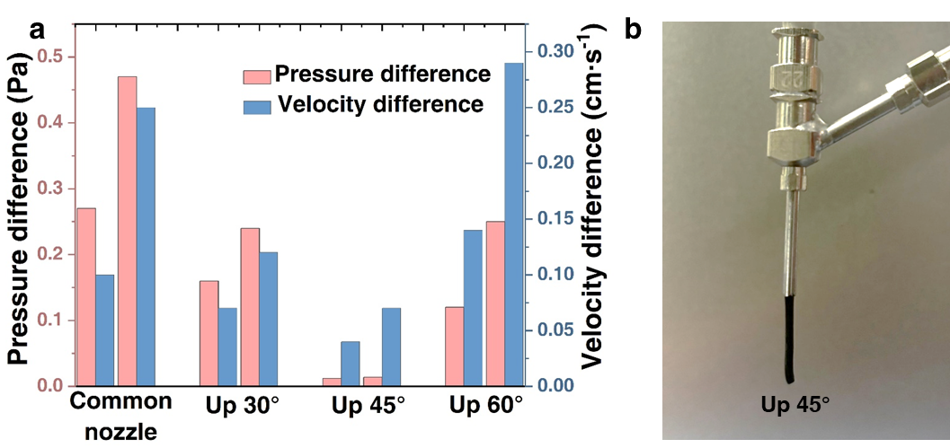

Figure S15.
Comparison of pressure and velocity differences for nozzles with different inlet angles and the printing performance using the modified nozzle. a, Pressure differences along the diagonal (at z = 2 and z = 3) and velocity differences along the radial line (at z = 5 and z = 6) for nozzles with different inlet angles. b, The curling phenomenon was eliminated after adjusting the inlet orientation upward by 45°.

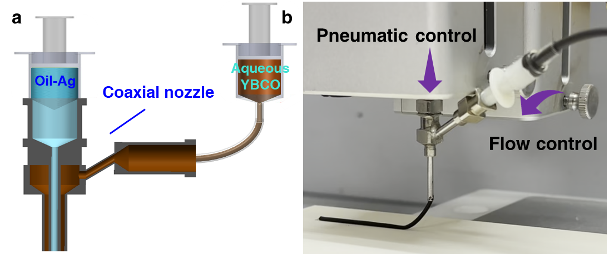

Figure S16.
Dual-ink continuous co-flow control system. a, Nozzle cross-sectional schematic showing oil-based Ag ink supplied through the inner channel and aqueous YBCO ink through the outer channel. b, The inner channel connects to the 3D printer's mechanical motion platform with pneumatic control, while the outer channel employs a constant-flow pump for precise flow rate regulation.

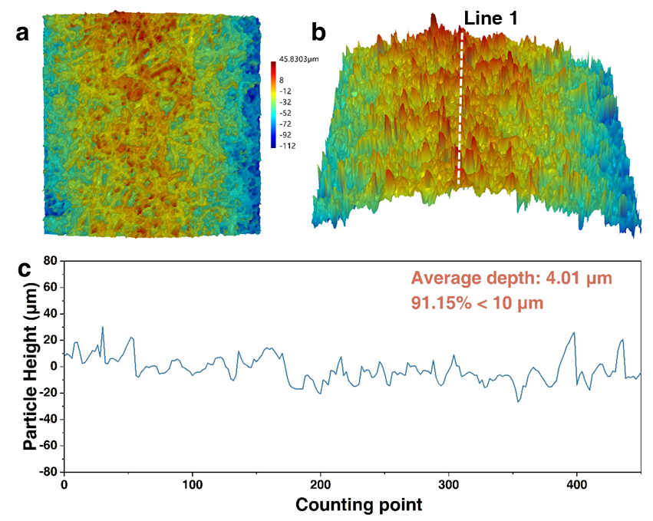

Figure S17.
Surface topography analysis by extended-depth confocal microscopy. a, Surface height map. b, Three-dimensional reconstructed surface morphology. c, Height distribution profile along Line 1, showing an average peak-to-valley height of 4.01 μm with 91.15% of surface pores <10 μm in depth.

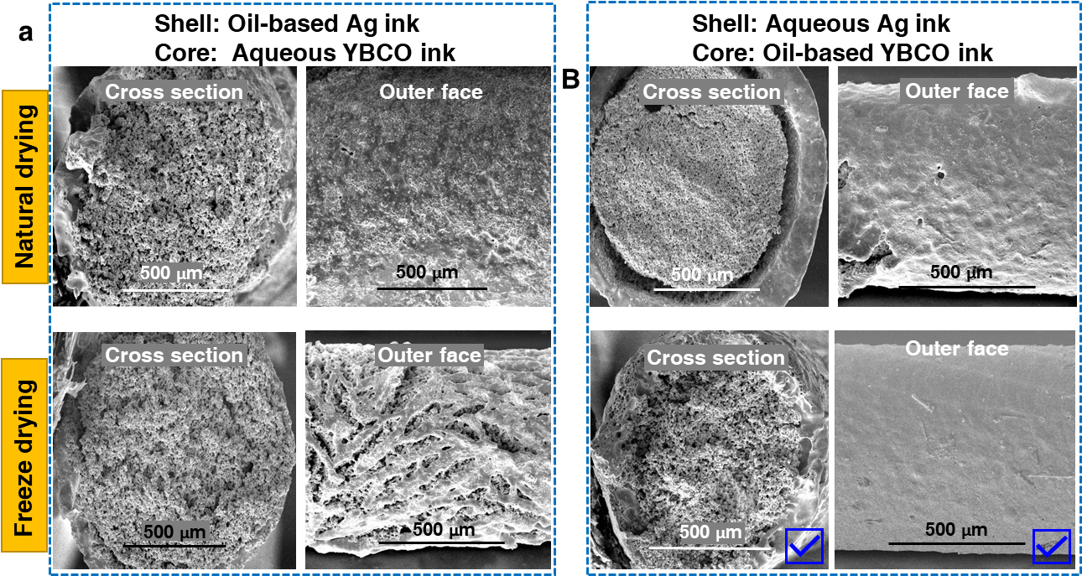

Figure S18.
SEM analysis of the cross-section of Ag-coated YBCO wires sintered using different ink combinations and drying methods. a, For oil-based Ag ink combined with water-based YBCO ink, the outer Ag shell exhibits an uneven and pitted surface after natural drying and sintering, whereas freeze-drying followed by sintering leads to cracking in the outer Ag. b, For water-based Ag ink combined with oil-based YBCO ink, natural drying and sintering result in distinct interfacial cracks, whereas freeze-drying and sintering yield a tightly bonded interface with a smooth and uniform outer Ag shell.

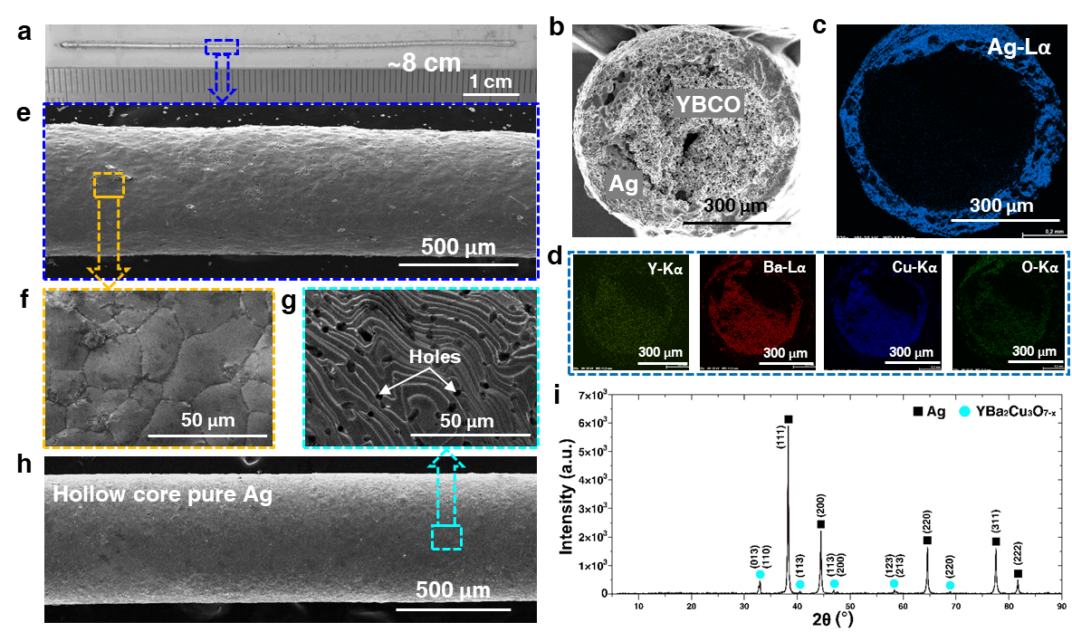

Figure S19.
Macroscopic and Microscopic Characterization of Ag-Coated YBCO Superconducting Wires. a, An approximately 8 cm-long straight-printed superconducting wire. b, SE image of the wire's cross-section. c,d, EDS mapping of Ag, Y, Ba, Cu, and O on the cross-section. e,f, SE images of the outer surface of the Ag-coated YBCO wire, exhibiting a cellular-like structure. g,h, SE images of the outer surface of a hollow 3D-printed pure Ag structure, showing a streamlined morphology. i, XRD pattern of the superconducting wire.

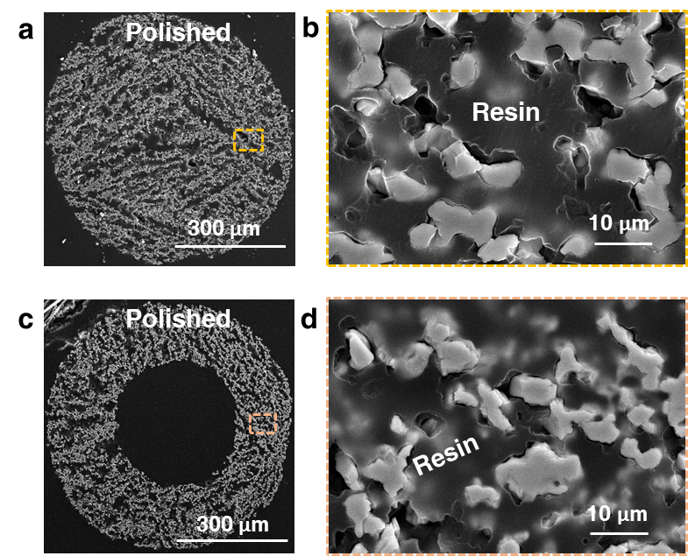

Figure S20.
SEM characterization of two structural wire types. a,b, 3D-printed solid-core YBCO wires. c,d, 3D-printed hollow-core YBCO wires.

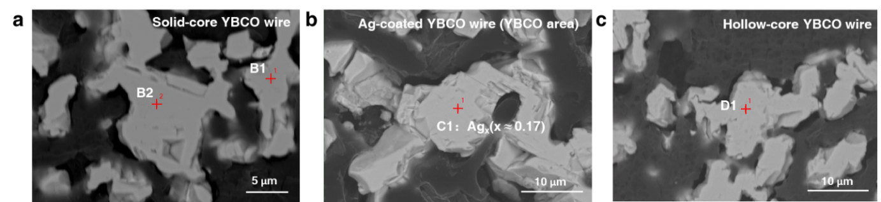

Figure S21.
BSE images of EPMA point analysis for three structural wire types. a, Solid-core YBCO wire. b, Ag-coated YBCO wire. c, Hollow-core YBCO wire

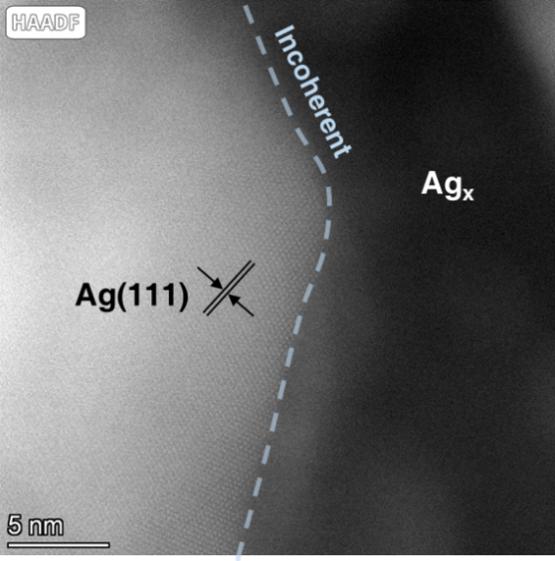

Figure S22.
HAADF imaging with electron beam aligned along Ag [110] zone axis through specimen tilt adjustment.

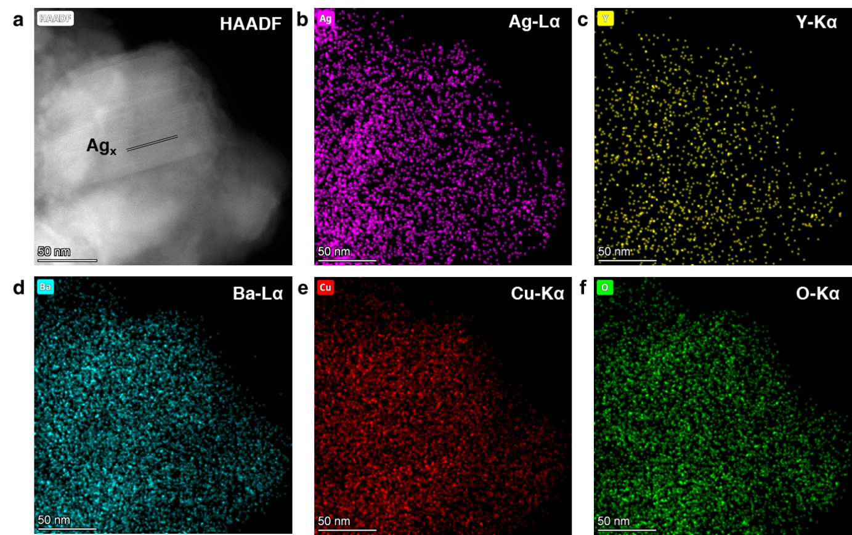

Figure S23.
Elemental mapping analysis of the Ag_{x} Phase by STEM-EDS. a, HAADF image. b-f, Elemental distribution maps of Ag, Y, Ba, Cu, and O, respectively.

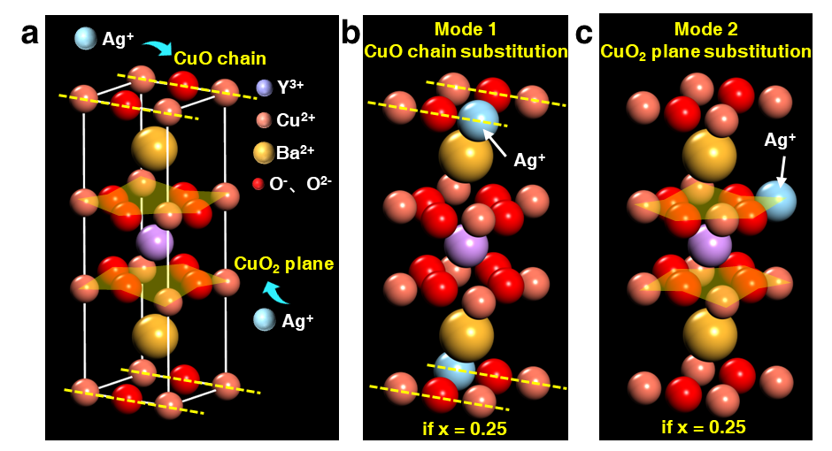

Figure S24.
Possible crystal structures of Ag_{x} phase. a, Two substitution modes of Ag⁺ for Cu²⁺ in the Y123 unit cell: replacement at Cu(1) sites in Cu-O chains (Mode 1) and substitution at Cu(2) sites in Cu-O planes (Mode 2). b, One possible configuration of Ag_{x} (x = 0.25) following Mode 1 substitution. c, The unique structural arrangement of Ag_{x} (x = 0.25) resulting from Mode 2.

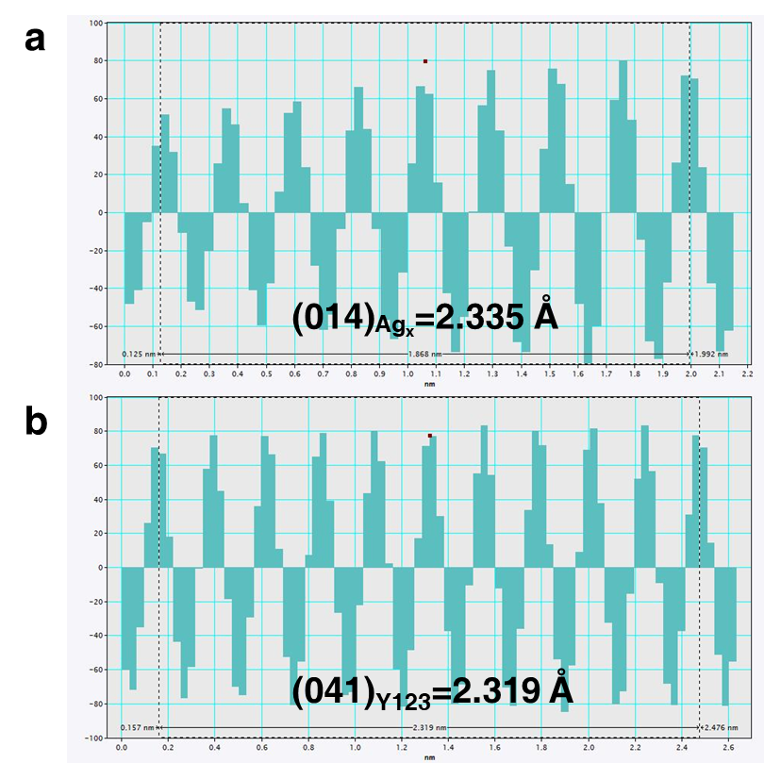

Figure S25.
IFFT live profile analysis. a, Ag_{x}(014). b, Y123(041).

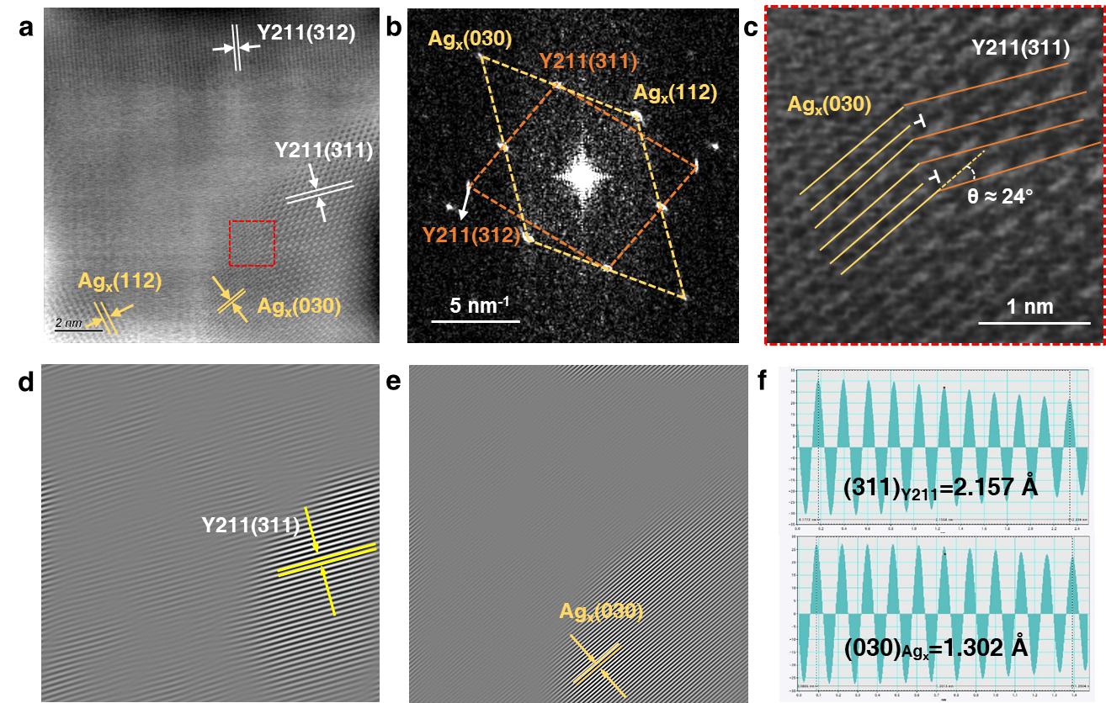

Figure S26.
Structural characterization of the incoherent Y211(311)/Ag_{x}(030) interface. a,c, HRTEM images. b, FFT pattern. d,e, IFFT reconstructions. f, IFFT live profile analysis.

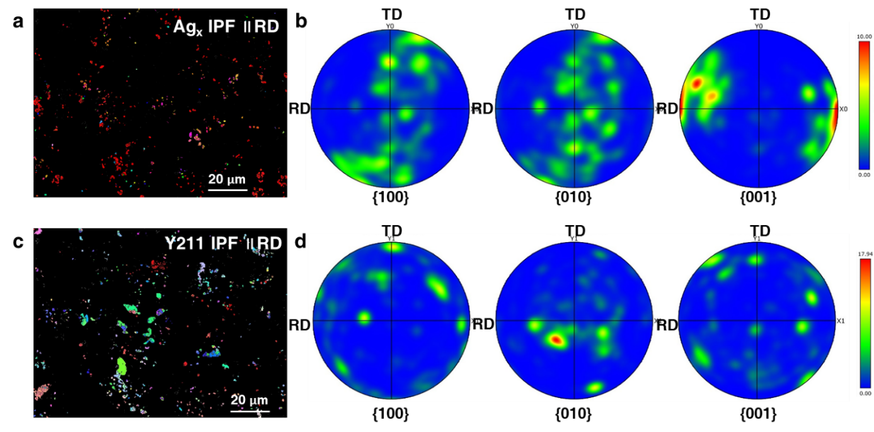

Figure S27.
Grain orientation analysis of Ag_{x} and Y211 phases. a, IPF map of Ag_{x} phase parallel to RD direction. b, PF of Ag_{x} phase. c, IPF map of Y211 phase parallel to RD direction. d, PF of Y211 phase.

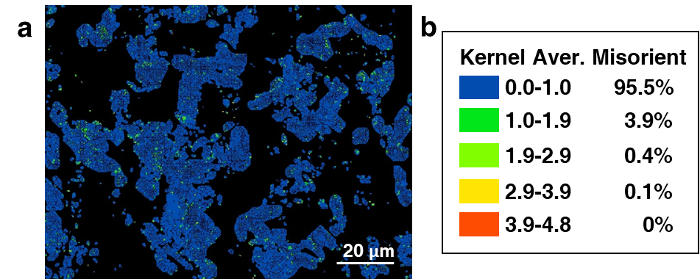

Figure S28.
KAM map of the YBCO region in an Ag-core YBCO wire. a, KAM distribution map. b, Color legend.

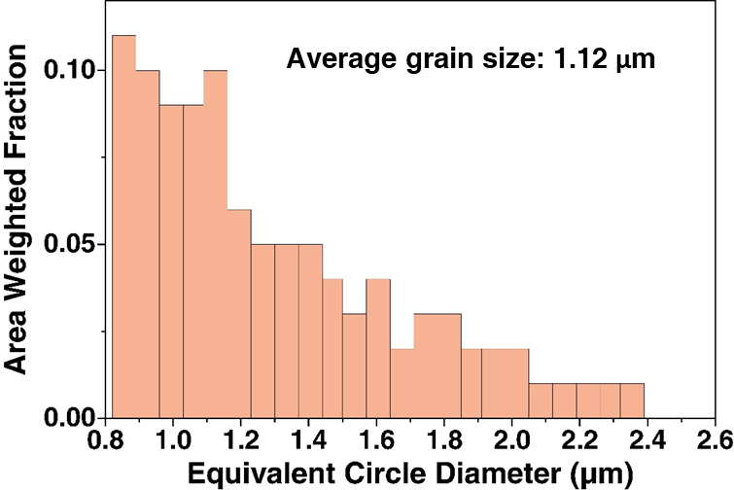

Figure S29.
Grain size distribution of Y123 phase in Ag-core YBCO composites.

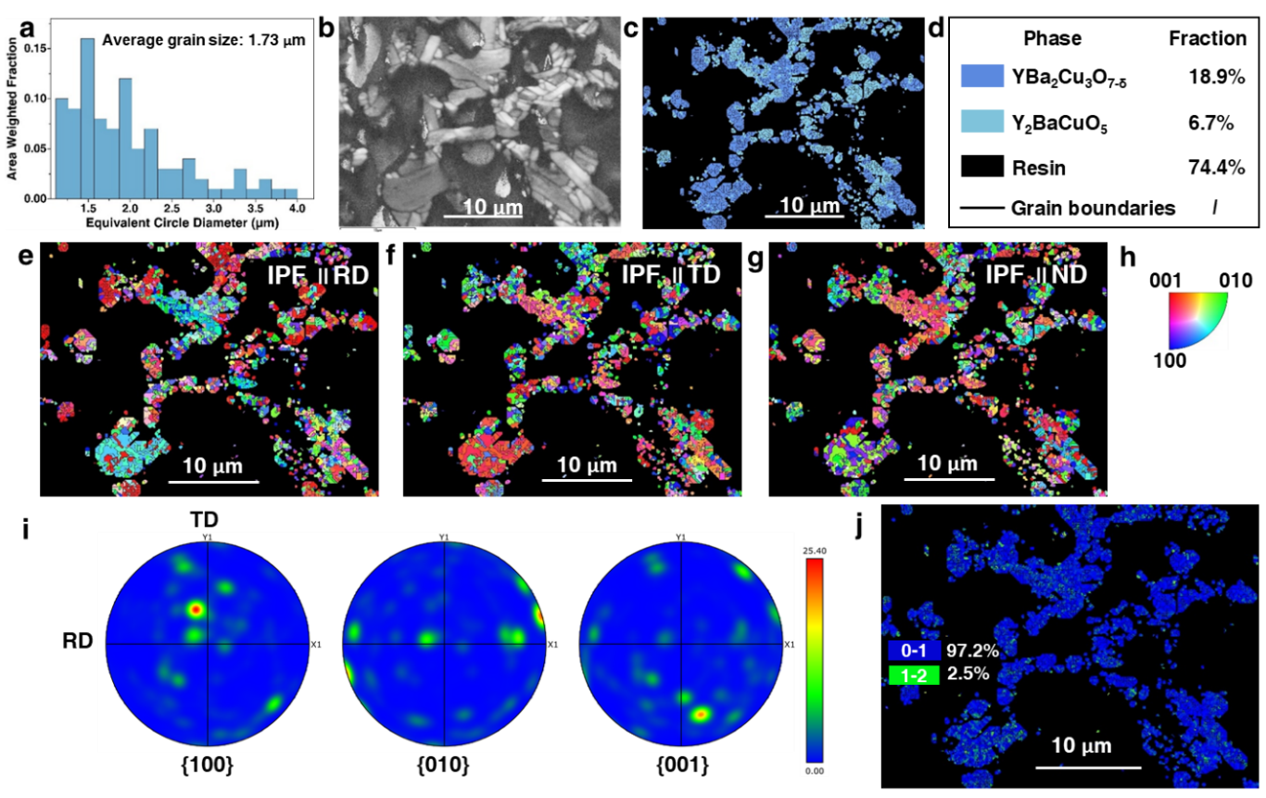

Figure S30.
EBSD analysis of SC-YBCO wires. a, Grain size distribution. b, Band contrast map. c, Phase distribution map. d, Corresponding color legend with phase fractions. e, RD-direction IPF map. f, TD-direction IPF map. g, ND-direction IPF map. h, IPF color key. i, Y123-PF. j, KAM map.

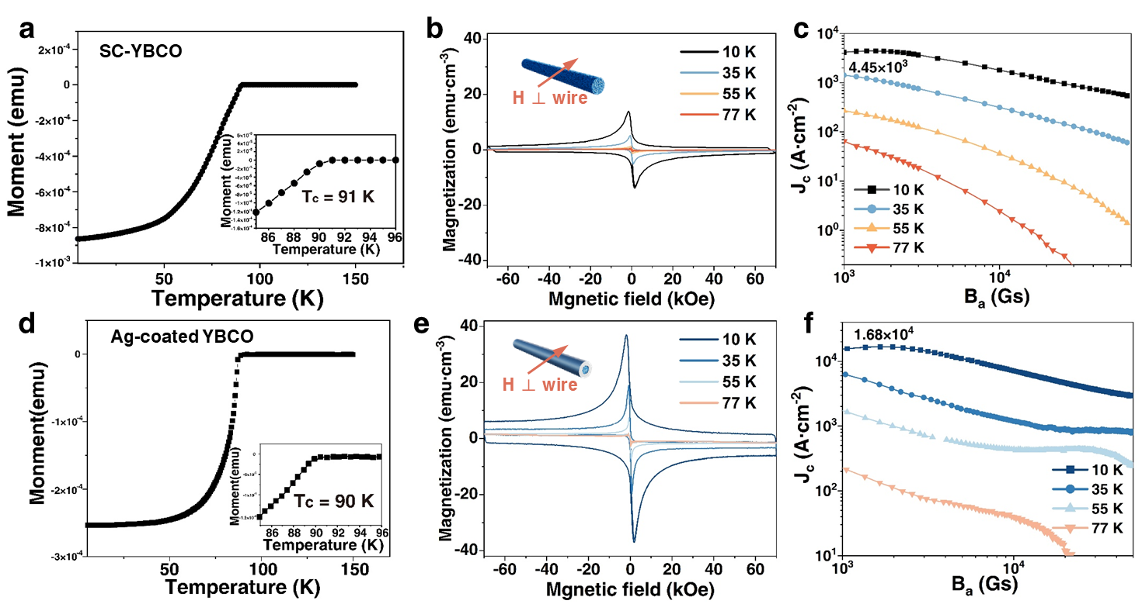

Figure S31.
Magnetization measurement curves of SC-YBCO and Ag-coated YBCO superconducting wires. a, Temperature dependence of magnetic susceptibility for SC-YBCO, with T_{c} = 91 K. b, Magnetization hysteresis characteristics of SC-YBCO. c, J_{c} of SC-YBCO at different temperatures. d, Temperature dependence of magnetic susceptibility for Ag-coated YBCO, with T_{c} = 90 K. e, Magnetization hysteresis characteristics of Ag-coated YBCO. f, J_{c} of Ag-coated YBCO at different temperatures.

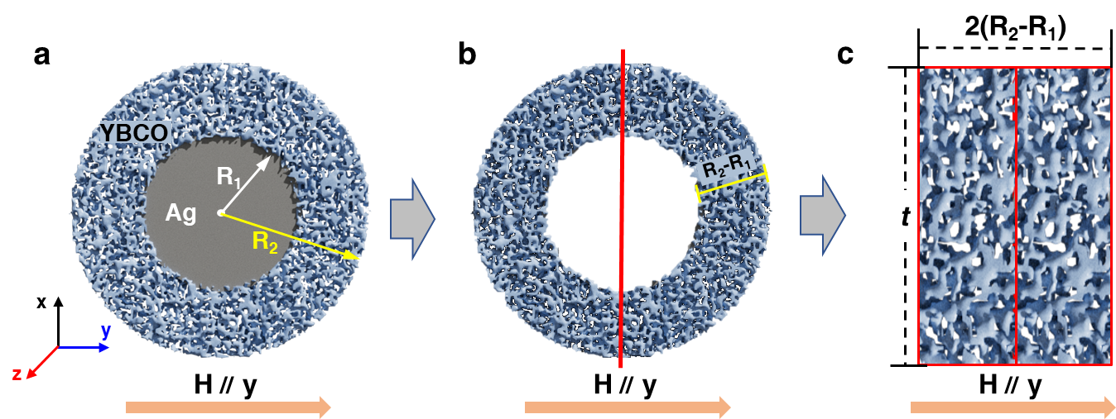

Figure S32.
Extended Bean model for Ag-core YBCO composite structure. a, Cross-section of superconducting wire. b, YBCO shell cross-section. c, Geometrically equivalent model of two superimposed strips.

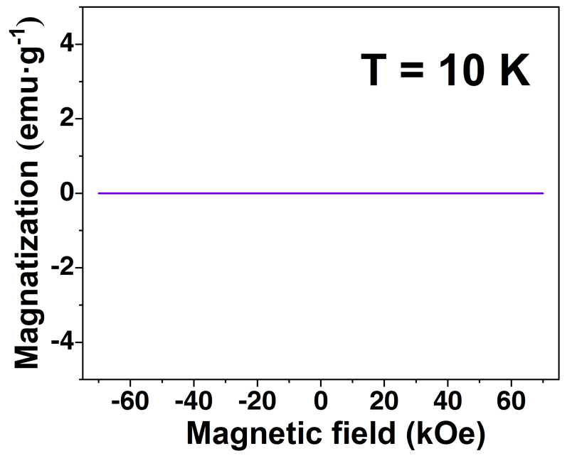

Figure S33.
M-H curve of 3D-printed pure Ag at 10 K.

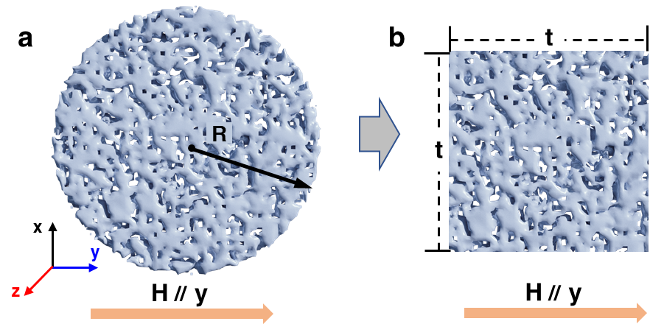

Figure S34.
Extended Bean model for SC-YBCO wire. a, Wire cross-section. b, Equivalent model.

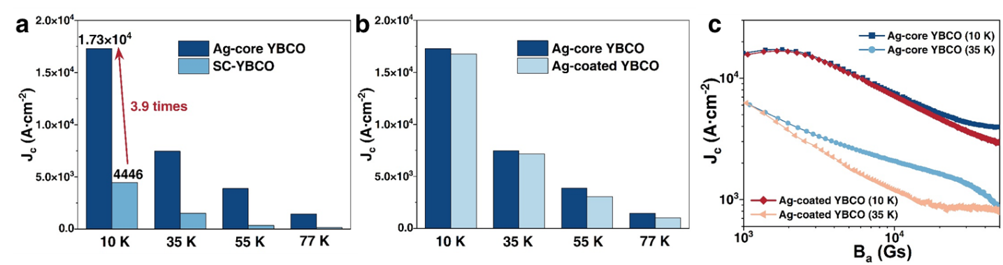

Figure S35.
J_{c} comparisons. a, J_{c} comparison between Ag-core YBCO and SC-YBCO superconducting wires. b, J_{c} comparison between Ag-core YBCO and Ag-coated YBCO superconducting wires. c, Comparison of J_{c} degradation trends under increasing magnetic field for Ag-core YBCO versus Ag-coated YBCO superconducting wires.

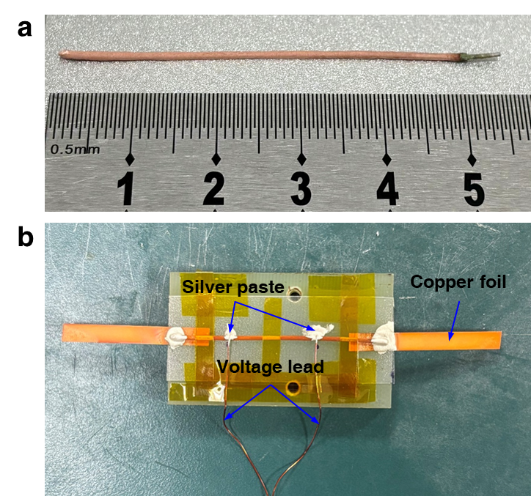

Figure S36.
Four-probe I_{c} measurement of the superconducting wire. a, ~5 cm wire segment with magnetron-sputtered Cu coating. b, Schematic of the four-point probe measurement setup.

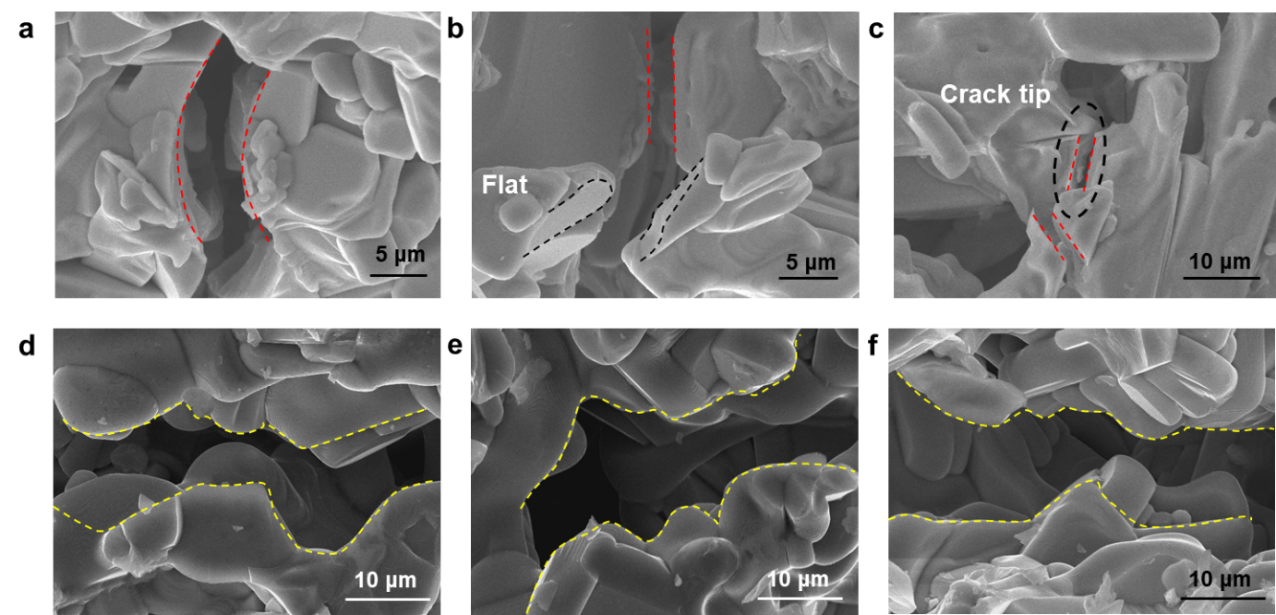

Figure S37.
Micromorphology of cracks in Ag-core YBCO superconducting wire and 3DP-YBCO bulk samples observed by SEM. (A to C) Transgranular fracture characteristics of Ag-core YBCO superconducting wire during in situ SEM three-point bending. (D to F) Intergranular fracture features in 3DP-YBCO bulk material under three-point bending.

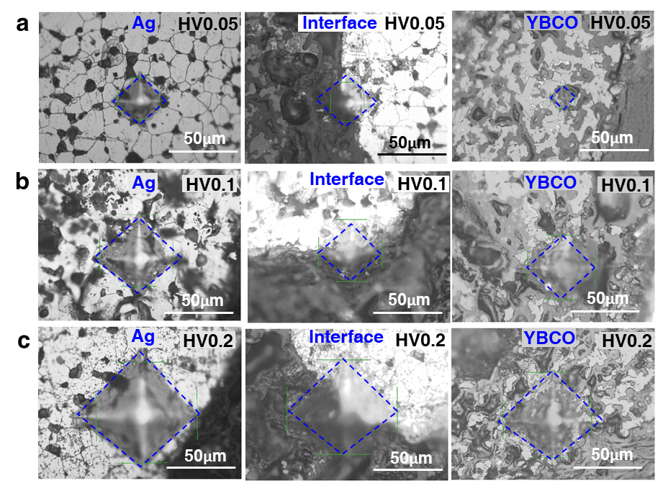

Figure S38.
Micro-Vickers hardness indentation morphology of Ag-core YBCO superconducting wire. a, 0.05 kgf load (HV 0.05). b, 0.10 kgf load (HV 0.10). c, 0.20 kgf load (HV 0.20).

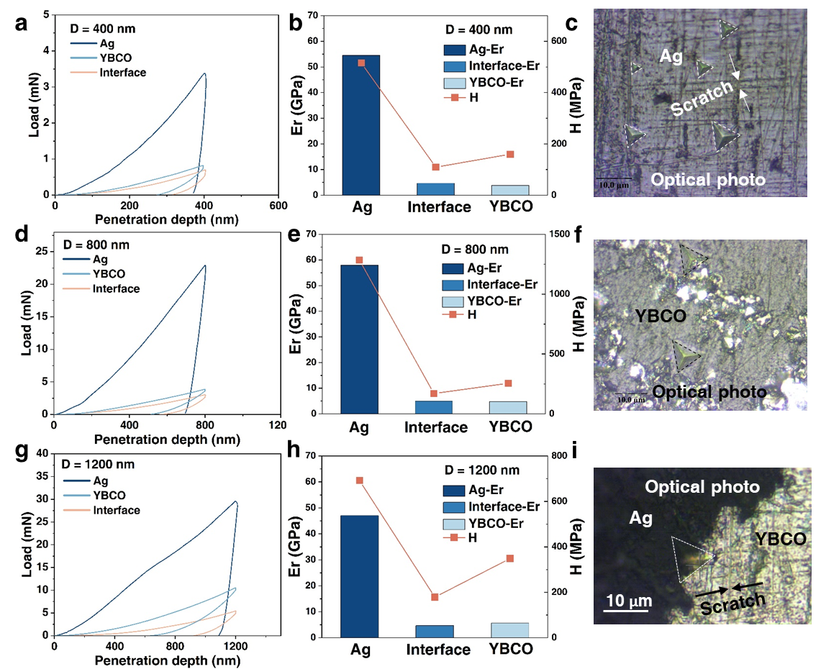

Figure S39.
Nanoindentation characterization of Ag-core YBCO superconducting wire at varying penetration depths. a,b, Load-displacement curves (D = 400 nm). c, Optical micrograph of indentation in Ag region. d,e, Load-displacement curves (D = 800 nm). f, Optical micrograph of indentation in YBCO region. g,h, Load-displacement curves (D = 1200 nm). i, Optical micrograph of indentation in Ag/YBCO interface region.

Table S1.
YBCO layer thickness and Ag core diameter corresponding to different nozzle specifications.

Nozzle type | YBCO thickness | Ag core diameter
19G+27G | 0.3 mm | 0.2 mm
18G+22G | 0.2 mm | 0.4 mm
16G+22G | 0.5 mm | 0.4 mm
16G+20G | 0.3 mm | 0.6 mm

Table S2.
Key rheological parameters obtained from Herschel-Bulkley model fitting of the shear stress (τ)-shear rate ($\dot{γ}$) curve for aqueous YBCO ink.

Sample | τ_{y}(Pa) | K(Pa·s^{n}) | n | τ₀(Pa) | $\dot{γ}0$(s⁻¹)
Water-based YBCO ink | 48.8 | 1623 | 0.231 | 867.52 | 0.01

Table S3.
Elemental percentage analysis from cross-sectional EDS mapping of the superconducting wire.

Element | Mass Norm (%) | Atom (%)
Y | 10.82 | 5.21
Ba | 34.26 | 10.68
Cu | 22.62 | 15.23
O | 24.61 | 65.84
Ag | 7.69 | 3.05

Table S4.
Comparison of Y123 lattice constants calculated from XRD patterns with orthorhombic Y123 reference data.

Crystal axis | This work | Literature²⁵ | Deviation
a(Å) | 3.8421 | 3.8430 | 0.02%
b(Å) | 3.8919 | 3.8810 | 0.28%
c(Å) | 11.6446 | 11.6730 | 0.24%

Table S5.
Possible phases and their crystal structures in the YBCO-Ag system.

Possible phases in the system | Crystal structure | Lattice constant
Possible phases in the system | Crystal structure | a(Å) | b(Å) | c(Å)
YBa₂Cu₃O₇(Y123)²⁶ | Orthorhombic | 3.8185 | 3.8856 | 11.6804
Y₂BaCuO₅(Y211)²⁶ | Orthorhombic | 5.6593 | 7.1319 | 12.1802
YBa₂Ag_{x}Cu_{3-x}O_{7-δ}(Ag_{x})²⁷ | Orthorhombic | 3.8308 | 3.8933 | 11.7170
Ag (28) | Cubic | 4.0790 | 4.0790 | 4.0790
Ag₂O (29) | Cubic | 4.7200 | 4.7200 | 4.7200

Table S6.
Phase composition and elemental distribution analysis by EPMA.

Sample | Point | EPMA results（at.%） |  |  |  |  | Phase
Sample | Point | Y | Ba | Ag | Cu | O | Phase
Ag-core YBCO | A1 | 7.7554 | 15.0966 | 1.0740 | 22.2534 | 53.8206 | Ag_{x}(x ≈ 0.14)
Ag-core YBCO | A2 | 7.8441 | 14.9218 | 1.4878 | 22.3134 | 53.4330 | Ag_{x}(x ≈ 0.19)
Solid-core YBCO | B1 | 8.0162 | 14.0159 | 0 | 23.1781 | 54.7897 | Y123
Solid-core YBCO | B2 | 8.1256 | 14.2144 | 0 | 23.5751 | 54.0849 | Y123
Ag-coated YBCO | C1 | 7.4833 | 14.5341 | 1.3155 | 22.4297 | 54.2374 | Ag_{x}(x ≈ 0.17)
Hollow-core YBCO | D1 | 8.4552 | 14.3539 | 0 | 24.3137 | 52.8772 | Y123

Table S7.
Quantitative mechanical parameters from tensile and three-point bending tests.

Mechanical parameters | T = 300 K |  | T = 77 K
Mechanical parameters | Test | Ag-core YBCO wire | 3DP-YBCO bulk | Test | Ag-core YBCO wire | 3DP-YBCO bulk
Yield Strength (MPa) | Tensile | 22.26 | — | Tensile | 25.16 | —
Static toughness (MJ·m⁻³) | Tensile | 225.8 | — | Tensile | 61 | —
Yield Strain  (%) | Tensile | 1.25 | — | Tensile | 0.22 | —
Elastic Modulus  (GPa) | Tensile | 2.76 | — | Tensile | 12.61 | —
Yield Strength (MPa) | Bending | 19.26 | 1.96 | Bending | 33.28 | 8.86
Static toughness (MJ·m⁻³) | Bending | 1361.8 | 52.2 | Bending | 502 | 2.4
Yield Strain  (%) | Bending | 4.30 | 2.68 | Bending | 1.02 | 0.027
Elastic Modulus  (GPa) | Bending | 2.35 | 0.074 | Bending | 9.50 | 33.33

Table S8.
Micro-Vickers hardness indentation data of different regions in Ag-core YBCO superconducting wires.

Test location | Load (Kg) | Hardness (MPa) | Indentation length  d₁ (μm) | Indentation length  d₂ (μm)
Ag | HV0.05 | 77.9 | 34.38 | 34.64
Interface | HV0.05 | 110 | 29.13 | 29.01
YBCO | HV0.05 | 250 | 19.60 | 18.91
Ag | HV0.1 | 52.5 | 60.02 | 58.84
Interface | HV0.1 | 60.0 | 56.30 | 54.89
YBCO | HV0.1 | 63.4 | 55.23 | 52.96
Ag | HV0.2 | 54.4 | 82.54 | 82.60
Interface | HV0.2 | 67.4 | 75.18 | 73.19
YBCO | HV0.2 | 72.8 | 72.55 | 70.16

Video S1.
Fabrication of Ag-core YBCO precursor filaments via bimaterial DIW 3D printing.

Video S2.
In situ SEM three-point bending mechanical response of superconducting wires.

Data S1. (separate file)
Theoretical d-spacings (Å) of YBa₂Cu₃O_{7-δ} corresponding to different (hkl) planes (PDF Card - 00-038-1433).

Data S2. (separate file)
Theoretical d-spacings (Å) of YBa₂Ag_{x}Cu_{3-x}O_{7-δ} corresponding to different (hkl) planes (PDF Card - 04-006-3247).

Data S3. (separate file)
Theoretical d-spacings (Å) of Y₂BaCuO₅ corresponding to different (hkl) planes (PDF Card - 01-079-0238).

References
1 Yu, S., Castellani, R., Pereira, A., Valette, R. & Budtova, T. Additive-free 3D-printed nanostructured carboxymethyl cellulose aerogels. International Journal of Biological Macromolecules 300, 140277, doi:https://doi.org/10.1016/j.ijbiomac.2025.140277 (2025).
2 Roy, N., Saha, N., Kitano, T. & Saha, P. Novel hydrogels of PVP–CMC and their swelling effect on viscoelastic properties. Journal of Applied Polymer Science 117, 1703-1710, doi:https://doi.org/10.1002/app.32056 (2010).
3 Liu, J. et al. Injectable, tough and adhesive zwitterionic hydrogels for 3D-printed wearable strain sensors. Chemical Engineering Journal 475, 146340, doi:https://doi.org/10.1016/j.cej.2023.146340 (2023).
4 Kavimughil, M., Leena, M. M., Moses, J. A. & Anandharamakrishnan, C. Effect of material composition and 3D printing temperature on hot-melt extrusion of ethyl cellulose based medium chain triglyceride oleogel. Journal of Food Engineering 329, 111055, doi:https://doi.org/10.1016/j.jfoodeng.2022.111055 (2022).
5 Adams, D., Ounaies, Z. & Basak, A. Printability Assessment of Ethyl Cellulose Biopolymer Using Direct Ink Writing. JOM 73, 3761-3770, doi:10.1007/s11837-021-04911-8 (2021).
6 Smith, P. T., Basu, A., Saha, A. & Nelson, A. Chemical modification and printability of shear-thinning hydrogel inks for direct-write 3D printing. Polymer 152, 42-50, doi:https://doi.org/10.1016/j.polymer.2018.01.070 (2018).
7 Petta, D., Grijpma, D. W., Alini, M., Eglin, D. & D’Este, M. Three-Dimensional Printing of a Tyramine Hyaluronan Derivative with Double Gelation Mechanism for Independent Tuning of Shear Thinning and Postprinting Curing. ACS Biomaterials Science & Engineering 4, 3088-3098, doi:10.1021/acsbiomaterials.8b00416 (2018).
8 Dadashi, A. & Azadi, M. Experimental bending fatigue data of additive-manufactured PLA biomaterial fabricated by different 3D printing parameters. Progress in Additive Manufacturing 8, 255-263, doi:10.1007/s40964-022-00327-1 (2023).
9 Clary, D. R. & Mills, G. Preparation and Thermal Properties of CuO Particles. The Journal of Physical Chemistry C 115, 1767-1775, doi:10.1021/jp110102r (2011).
10 Huang, Z. et al. A new method for the preparation of transparent Y₂O₃ nanocrystalline ceramic with an average grain size of 20 nm. Scripta Materialia 182, 57-61, doi:https://doi.org/10.1016/j.scriptamat.2020.02.044 (2020).
11 Alavi, M. A. & Morsali, A. Syntheses of BaCO₃ nanostructures by ultrasonic method. Ultrasonics Sonochemistry 15, 833-838, doi:https://doi.org/10.1016/j.ultsonch.2008.02.006 (2008).
12 Tan, L. et al. Effect of Na⁺ and Ca²⁺ on the Thermal Degradation of Carboxymethylcellulose in Air. Polymers and Polymer Composites 25, 309-314 (2017).
13 Arvanitidis, I., Siche, D. & Seetharaman, S. A study of the thermal decomposition of BaCO₃. Metallurgical and Materials Transactions B 27, 409-416, doi:10.1007/BF02914905 (1996).
14 Huang, T. W. et al. The formation of superconducting YBa₂Cu₃O_{7−x} through solid state reaction. Journal of Crystal Growth 91, 402-409, doi:https://doi.org/10.1016/0022-0248(88)90259-X (1988).
15 Munson, B. R., Okiishi, T. H., Huebsch, W. W. & Rothmayer, A. P. Fluid mechanics. (Wiley Singapore, 2013).
16 Evju, Ø. & Mardal, K.-A. in Modeling the Heart and the Circulatory System (ed Alfio Quarteroni) 177-195 (Springer International Publishing, 2015).
17 Damianou, Y., Georgiou, G. C. & Moulitsas, I. Combined effects of compressibility and slip in flows of a Herschel–Bulkley fluid. Journal of Non-Newtonian Fluid Mechanics 193, 89-102, doi:https://doi.org/10.1016/j.jnnfm.2012.09.004 (2013).
18 Herschel, W. H. & Bulkley, R. Konsistenzmessungen von Gummi-Benzollösungen. Kolloid-Zeitschrift 39, 291-300, doi:10.1007/BF01432034 (1926).
19 Boyer, F. & Fabrie, P. Mathematical Tools for the Study of the Incompressible Navier-Stokes Equations andRelated Models. Vol. 183 (Springer Science & Business Media, 2012).
20 Lomtev, I. & Karniadakis, G. E. A discontinuous Galerkin method for the Navier–Stokes equations. International Journal for Numerical Methods in Fluids 29, 587-603, doi:https://doi.org/10.1002/(SICI)1097-0363(19990315)29:5<587::AID-FLD805>3.0.CO;2-K (1999).
21 Habib, A., Quigley, C., Sarah, R., Hurd, W. & Clark, S. Design and Fabrication of In-House Nozzle System to Extrude Multi-Hydrogels for 3D Bioprinting Process. Journal of Manufacturing Science and Engineering 146, doi:10.1115/1.4063357 (2023).
22 Dholabhai, P. P. & Uberuaga, B. P. Beyond Coherent Oxide Heterostructures: Atomic-Scale Structure of Misfit Dislocations. Advanced Theory and Simulations 2, 1900078, doi:https://doi.org/10.1002/adts.201900078 (2019).
23 Gyorgy, E. M., van Dover, R. B., Jackson, K. A., Schneemeyer, L. F. & Waszczak, J. V. Anisotropic critical currents in Ba₂YCu₃O₇ analyzed using an extended Bean model. Applied Physics Letters 55, 283-285, doi:10.1063/1.102387 (1989).
24 Pilkey, W. D. Analysis and design of elastic beams: Computational methods. (John Wiley & Sons, 2002).
25 Hoenle, W. , Von, H. G. S., Can X-ray crystal structure analysis decide between twinning by pseudo-merohedry and statistical distribution in YBa₂Cu₃O₇? 184, 301-305, doi:doi:10.1524/zkri.1988.184.3-4.301 (1988).
26 Wong-Ng, W., McMurdie, H., Paretzkin, B., Hubbard, C. & Dragoo, A. ICDD Grant-in-Aid. NBS, GAITHERSBURG, MD, USA (1987).
27 Behera, D., Mishra, N. C. & Patnaik, K. Ag-doping-induced coordination incompatibility and its effect on superconductivity in YBCO. Journal of Superconductivity 10, 27-32, doi:10.1007/BF02763947 (1997).
28 Davey, W. P. Precision Measurements of the Lattice Constants of Twelve Common Metals. Physical Review 25, 753-761, doi:10.1103/PhysRev.25.753 (1925).
29 Hanawalt, J., Rinn, H. & Frevel, L. Chemical analysis by X-ray diffraction. Industrial & Engineering Chemistry Analytical Edition 10, 457-512 (1938).

