APPENDIX
- Change in clinical parameters following SGLT2 inhibition

Change in clinical parameters following SGLT2 inhibition
 |  | Baseline | Follow-up | Mean difference (95% CI) | p value
Weight (kg) |  | 80.7+/-19.4 | 79.5+/-18.1 | -1.1 (-0.8 to 3.1) | p = 0.245
Blood pressure (mmHg)
 | Systolic | 130.6+/-21.6 | 127.4+/-19.9 | +3.1 (-4.5 to 10.8) | p = 0.411
 | Diastolic | 76.8+/-11.7 | 76.6+/-11.6 | -0.2 (-3.7 to 4.1) | p = 0.913
Heart rate (bpm) |  | 72.0+/-11.8 | 74.6+/-11.2 | +2.6 (-7.4 to 2.2) | p = 0.276
Saturations (%) |  | 95.1+/-2.1 | 95.2+/-2.1 | +0.1 (-1.0 to 0.9) | p = 0.908
KCCQ 12 score |  | 42.3+/-13.4 | 52.6+/-10.4 | +9.3 (-12.6 to -6.1) | p<0.001
NYHA score |  | 2.4+/-0.5 | 1.6+/-0.6 | -0.8 (0.6 to 1.0) | p<0.001

Table demonstrating change in clinical parameters and QoL scores following SGLT2 inhibition. Data displayed as mean+/-SD. Significance defined as p value <0.05.
CI: Confidence interval, KCCQ-12: Kansas City Cardiomyopathy Questionnaire-12, NYHA: New York Heart Association

2.0. ECHOCARDIOGRAPHIC RESULTS
2.1. Table demonstrating baseline and follow-up echocardiographic parameters
Echocardiographic parameters
 | Number (n) | Baseline | Follow-up | Mean difference (95% CI) | p value
Global longitudinal strain (%) | 36 | -13.9+/-3.8 | -14.1+/-3.7 | -0.1 (-0.8 to 1.1) | p=0.803
LVEF (%) | 36 | 45.2+/-9.7 | 45.7+/-9.8 | +0.4 (-3.1 to 2.3) | p=0.759
LVMi (g/m2) | 39 | 101.4+/-3.9 | 102.9+/-3.9 | +1.48 (-7.7 to 4.7) | p=0.737
LVEDVi (mls/m2) | 36 | 57.3+/-16.2 | 59.0+/-20.5 | +1.2 (-2.9 to 0.6) | p=0.648
LVESVi (mls/m2) | 36 | 31.9+/-13.6 | 34.9+/-15.4 | +2.9 (-8.5 to 2.6) | p=0.282
LAVi (mls/m2) | 37 | 30.0+/-13.1 | 30.6+/-12.9 | +0.5 ( -0.4 to 2.9) | p=0.754
RAai (mls/m2) | 34 | 8.8+/-2.7 | 9.6+/-4.3 | +0.8 (-2.2 to 0.6) | p=0.248
Rvdi (cm/m2) | 36 | 3.7+/-0.7 | 4.1+/-2.6 | +0.4 (-1.3 to 0.5) | p=0.243
TAPSE (mm) | 30 | 21.4+/-4.2 | 20.5+/-3.9 | -0.9 (-0.7 to 2.5) | p=0.243

Table demonstrating change in indexed echocardiographic parameters following SGLT2 inhibition using a paired, two-tailed students t-test with significance defined as p<0.05.

CI: Confidence interval, SGLT2i: Sodium-glucose co-transport 2 inhibitor, GLS: Global longitudinal strain, LAVi: Left atrial volume index, LVEF: Left ventricular ejection fraction, LVMI: Left ventricular mass index, LVEDVi: Left ventricular end diastolic volume index, LVESVi: Left ventricular end systolic volume index, RAai: Right atrial area index, RVdi: Right ventricular diameter index, TAPSE: Tricuspid annular plane systolic excursion

2.2. Bar chart demonstrating echocardiographic volumetric changes following SGLT2 inhibition.
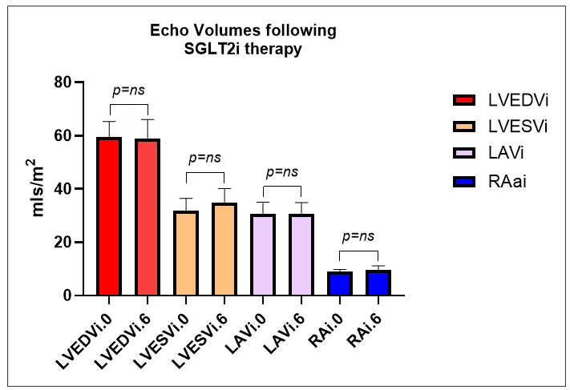
Bar chart demonstrating change in indexed echocardiographic volumetric parameters following SGLT2 inhibition using a paired, two-tailed students t-test with significance defined as p<0.05.

SGLT2i: Sodium-glucose co-transport 2 inhibitor, LAVi: Left atrial volume index, LVEDVi: Left ventricular end diastolic volume index, LVESVi: Left ventricular end systolic volume index, RAai: Right atrial area index.

2.3. Bar chart demonstrating 2-dimensional echocardiographic changes following SGLT2 inhibition.
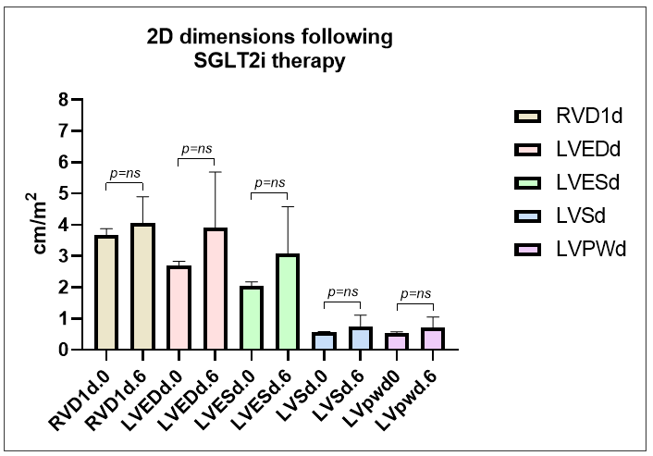
Bar chart demonstrating change in indexed 2-D echocardiographic parameters following SGLT2 inhibition using a paired, two-tailed students t-test with significance defined as p<0.05.

SGLT2i: Sodium-glucose co-transport 2 inhibitor, LVEDdi: Left ventricular end diastolic diameter index, LVESd: Left ventricular end systolic diameter, LVSd: Left ventricle septum diameter, Left ventricle posterior wall diameter.

2.4. Bar chart demonstrating change in LV Mass following SGLT2 inhibition.
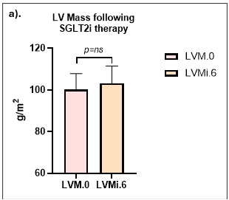
Bar chart demonstrating change in indexed LV Mass following SGLT2 inhibition. Analysis performed using a paired, two-tailed students t-test with significance defined as p<0.05. LV Mass calculated using the Devereux formula.

SGLT2i: Sodium-glucose co-transport 2 inhibitor, LVMi: Left ventricle mass indexed.

2.5. Bar chart demonstrating change in LV global longitudinal strain following SGLT2 inhibition.
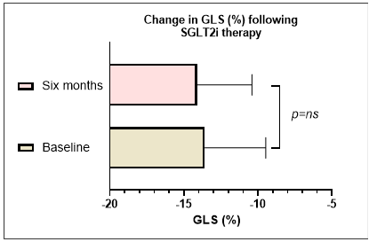

Bar chart demonstrating change in GLS (%) following SGLT2 inhibition. Analysis performed using a paired, two-tailed students t-test with significance defined as p<0.05.

SGLT2i: Sodium-glucose co-transport 2 inhibitor, GLS: Global longitudinal strain.

2.6. Bar chart demonstrating change in LVEF following SGLT2 inhibition.
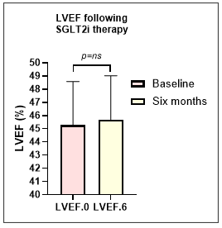
Bar chart demonstrating change in LVEF (%) following SGLT2 inhibition. Analysis performed using a paired, two-tailed students t-test with significance defined as p<0.05.

SGLT2i: Sodium-glucose co-transport 2 inhibitor, LVEF: Left ventricular ejection fraction.

3.0. SUB-ANALYSIS BY REVERSE CARDIAC REMODELING
3.1 Demographics delineated by RCR +/-
DEMOGRAPHICS DELINEATED BY RCR
 |  | RCR +ve (n=12) | RCR -ve (n=24) | P value
Age (yrs) |  | 68.3+/-6.0 | 66.5+/-9.6 | p=0.578
Gender
 | Male (n, %) | 9 (25) | 16 (66.7) | p=0.456
 | Female (n, %) | 3 (75) | 8 (33.3) | p=0.456
Time on SGLT2i (months) |  | 7.0+/-1.0 | 7.0+/-0.9 | p=0.987
Aetiology HF
 | Ischaemic (n, %) | 5 (41.7) | 9 (37.5) | p=0.809
 | Non-ischaemic (n, %) | 7 (58.3) | 15 (62.5) | p=0.809
Left ventricular ejection fraction (%) |  | 47.2+/-8.8 | 41.9+/-10.8 | p=0.02
SBP (mmHg) |  | 129.3+/-20.9 | 128.9+/-25.1 | p=0.479
DBP (mmHg) |  | 75.2+/-10.4 | 81.2+/-12.3 | p=0.401
Creatinine (mmol) |  | 93.9+/-25.9 | 111.9+/-49.1 | p=0.278
Comorbidities (n, %)
 | Hypertension | 6 (50.0) | 13 (54.2) | p=0.813
 | Chronic kidney disease | 5 (41.7) | 9 (37.5) | p=0.809
 | Hypercholesterolaemia | 2 (16.7) | 9 (37.5) | p=0.201
 | Myocardial infarction | 4 (33.3) | 9 (37.5) | p=0.806
 | COPD | 3 (25.0) | 4 (16.7) | p=0.551
 | Type 2 DM | 0 (0.0) | 2 (8.3) | p=0.303
 | Atrial fibrillation | 3 (25.0) | 7 (29.2) | p=0.792
Table: Demographics of study population delineated by +/-RCR. Continuous data presented as mean+/-SD. A X² analysis used to assess differences in categorical variables with a two tailed independent t-test for continuous variables. Significance defined as p<0.05.

COPD: Chronic obstructive pulmonary disease, DBP: Diastolic blood pressure, DM: Diabetes mellitus, HF: Heart failure, RCR: Reverse cardiac remodeling, SGLT2i: Sodium-glucose co-transport 2 inhibitor, SBP: Systolic blood pressure.

3.2. Change in standard biomarkers delineated by RCR +/-
Standard care biomarkers
Biomarker | RCR-
Biomarker | (n) | Baseline | Follow-up | Mean diference | 95% CI (p)
Creatinine (mmol/L) | 24 | 95.5+/-27.9 | 94.9+/-28.3 | -0.6+/-12.1 | [-4.5 to 5.7] p=0.802
Haemoglobin (g/dL) | 24 | 137.5+/-11.8 | 145.7+/-11.9 | +8.1+/-6.8 | [5.2 to 11.0] p<0.001
Platelets (x10^9/L) | 24 | 235.5+/-84.1 | 237.2+/-73.2 | +1.8+/-56.5 | [-25.6 to 11.5] p=0.881
Haematocrit (%) | 24 | 40.5+/-3.7 | 43.0+/-3.3 | +2.5+/-2.2 | [1.0 to 3.4] p<0.001
MCV (fL) | 24 | 92.2+/-5.0 | 92.0+/-5.9 | -0.2+/-2.9 | [-1.1 to 1.4] p=0.800
WCC (x10^9/L) | 24 | 7.4+/-1.9 | 7.3+/-2.3 | -0.1+/-1.7 | [-3.6 to 1.3] p=0.679
CRP (mg/L) | 24 | 3.3+/-3.8 | 4.5+/-4.5 | +1.2+/-5.8 | [-1.2 to 3.6] p=0.321
Troponin (ng/L) | 24 | 11.0+/-5.7 | 10.2+/-6.7 | -0.8+/-3.9 | [-2.6 to 0.9] p=0.308
NT-proBNP (ng/L) | 24 | 377+/-442.2 | 412+/-519.5 | +35+/-304.5 | [-93.0 to 164.1] p=0.573
HbA1c (mmol/mol) | 24 | 37.4+/-3.3 | 37.4+/-3.4 | 0.0+/-2.2 | [-0.9 to 0.90 p=1.0
Cholesterol (mmol/L) | 24 | 4.6+/-1.2 | 4.5+/-0.9 | -0.1+/-0.8 | [-0.3 to 0.4] p=0.739
Biomarker | RCR+
Biomarker | (n) | Baseline | Follow-up | Mean difference | 95% CI (p)
Creatinine (mmol/L) | 12 | 109.9+/-50.7 | 101.4+/-24.8 | -8.5+/-38.7 | [-33.1 to 16.1] p=0.463
Haemoglobin (g/dL) | 12 | 142.3+/-15.9 | 150.3+/-14.8 | +8.0+/-11.3 | [0.8 to 15.2] p=0.03
Platelets (x10^9/L) | 12 | 172.6+/-81.2 | 204.1+/-40.3 | +31.4+/-90.6 | [-26.3 to 89.1] p=0.257
Haematocrit (%) | 12 | 41.5+/-4.9 | 44.7+/-4.6 | +3.2+/-4.4 | [0.4 to 5.9] p=0.027
MCV (fL) | 12 | 90.5+/-4.5 | 91.5+/-4.1 | +1.0+/-2.8 | [-0.8 to 2.7] p=0.249
WCC (x10^9/L) | 12 | 6.1+/-1.7 | 6.7+/-1.4 | +0.6+/-2.4 | [-1.0 to 2.1] p=0.431
CRP (mg/L) | 12 | 7.8+/-8.7 | 4.7+/-7.3 | -3.0+/-8.7 | [-2.5 to 8.6] p=0.256
Troponin (ng/L) | 12 | 15.1+/-9.2 | 12.4+/-6.5 | -2.7+/-5.9 | [-6.4 to 1.8] p=0.146
NT-proBNP (ng/L) | 12 | 1209+/-1402.1 | 1148+/-1560.8 | -60.9+/-957.1 | [-669.0 to 547.2] p=0.830
HbA1c (mmol/mol) | 12 | 39.4+/-11.0 | 38.5+/-5.4 | -0.8+/-8.6 | [-6.6 to 4.9] p=0.759
Cholesterol (mmol/L) | 12 | 3.5+/-1.2 | 5.9+/-7.3 | +2.5+/-7.4 | [-2.1 to 7.2] p=0.262
Table: Within group mean differences in biomarker levels following SGLT2 inhibition in patients with and without RCR, as defined by improvement of GLS ≥10%. Data presented as mean+/-SD. Significance defined as p<0.05. All p-values two-sided.
RCR: Reverse cardiac remodelling, SGLT2i: Sodium-glucose co-transport 2 inhibitor.

4.0. ECHOCARDIOGRAPHIC CORRELATION ANALYSIS
4.1. Standard of care biomarker correlation with LV GLS (%)

Correlation of standard biomarkers with LV GLS (%)
Biomarker | r | P
Haemoglobin | 0.103* | p=0.556
Platelets | 0.228 | p=0.145
Haematocrit | 0.254* | p=0.469
MCV | 0.014 | p=0.671
WCC | 0.244 | p=0.231
CRP | -0.256 | p=0.081
Troponin | -0.081 | p=0.417
NT-proBNP | 0.018 | p=0.151
HbA1c | 0.101 | p=0.217
Creatinine | -0.071 | p=0.913
Cholesterol | 0.102 | p=0.764
Table demonstrating correlation of standard biomarkers with delta change in GLS (%). Pearson correlation* used to assess normally distributed data and Spearman where non-normally distributed. Significance defined as p<0.05. All p-values two-sided.

CRP: C-reactive protein, HbA1c: glycosylated haemoglobin, LV: Left ventricle, GLS: Global longitudinal strain, NT-proBNP: NT-pro brain natriuretic peptide, SGLT2i: Sodium-glucose co-transport 2 inhibitor

5.0. QUALITY OF LIFE ANALYSIS
5.1. Analysis of effect of time on change in KCCQ-12 score.
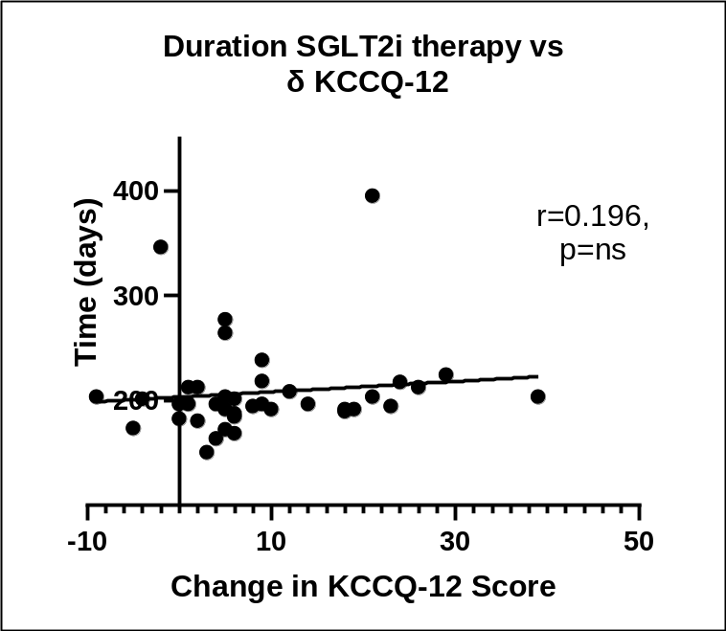
Figure demonstrating scatter plot with delta change in KCCQ-12 score plotted against a). LV GLS (%), b). LVEF (%) and c). LV Mass.
Analysis performed using Pearson bivariate regression with two-sided p value. Significance defined as p<0.05.

SGLT2i: Sodium-glucose co-transport 2 inhibitor, GLS: Global longitudinal strain, LVEF: Left ventricular ejection fraction, KCCQ-12: Kansas City Cardiomyopathy Questionnaire-12.

5.2. Analysis of correlation of echocardiographic changes with change in KCCQ-12.
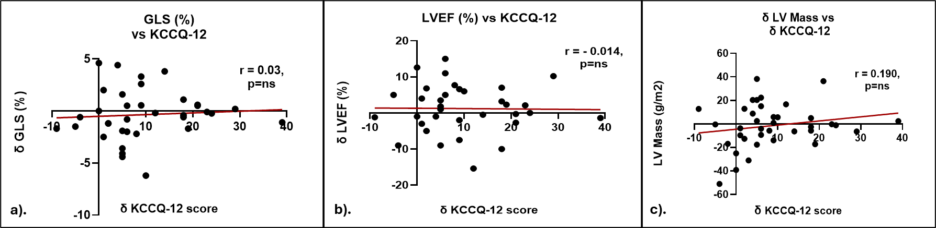
Figure demonstrating scatter plot with delta change in KCCQ-12 score plotted against a). LV GLS (%), b). LVEF (%) and c). LV Mass.
Analysis performed using Pearson bivariate regression with two-sided p value. Significance defined as p<0.05.

SGLT2i: Sodium-glucose co-transport 2 inhibitor, GLS: Global longitudinal strain, LVEF: Left ventricular ejection fraction, KCCQ-12: Kansas City Cardiomyopathy Questionnaire-12.

5.3. Novel biomarker correlation with change in KCCQ-12 score.
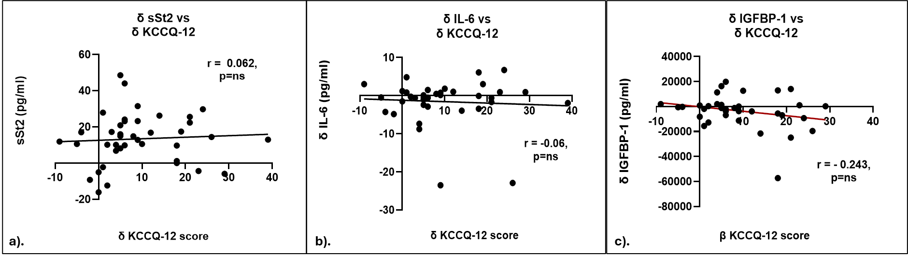
Figure demonstrating scatter plot with delta change in KCCQ-12 score plotted against a). sSt2 (%), b). IL-6 (%) and c). IGFBP-1.
Analysis performed using Pearson bivariate regression with two-sided p value. Significance defined as p<0.05.

SGLT2i: Sodium-glucose co-transport 2 inhibitor, GLS: Global longitudinal strain, LVEF: Left ventricular ejection fraction, KCCQ-12: Kansas City Cardiomyopathy Questionnaire-12.

5.5. Standard biomarker correlation with change in KCCQ-12 score.
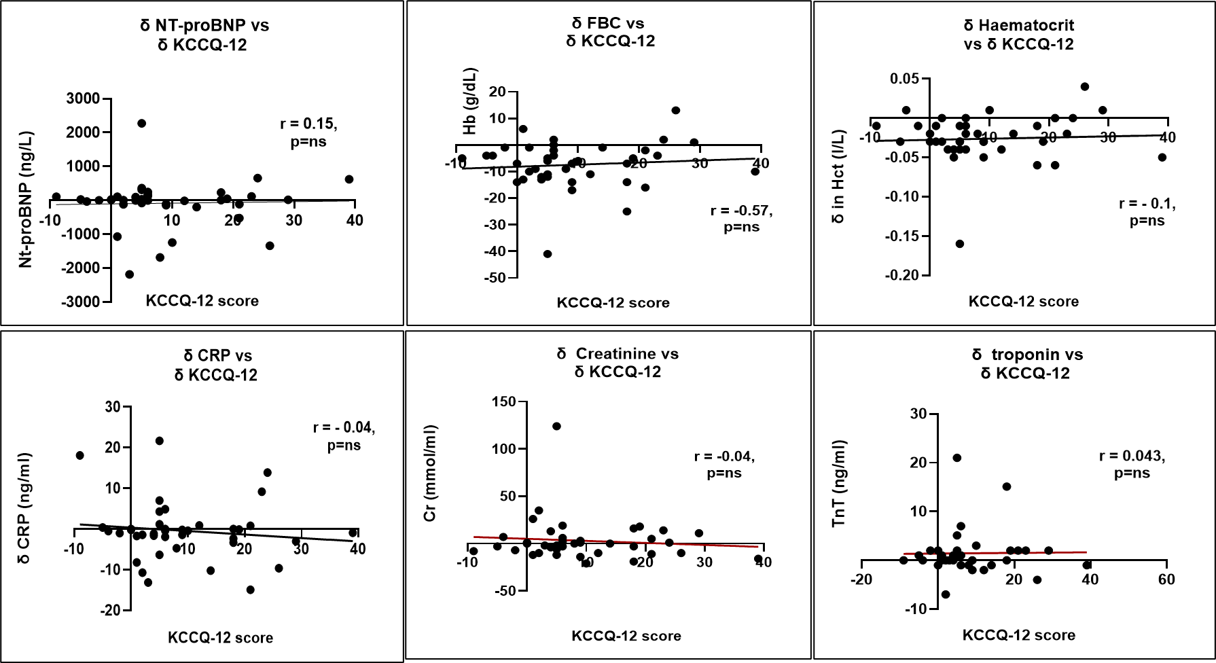

5.6. Standard biomarker correlation with change in KCCQ-12 score (continued)
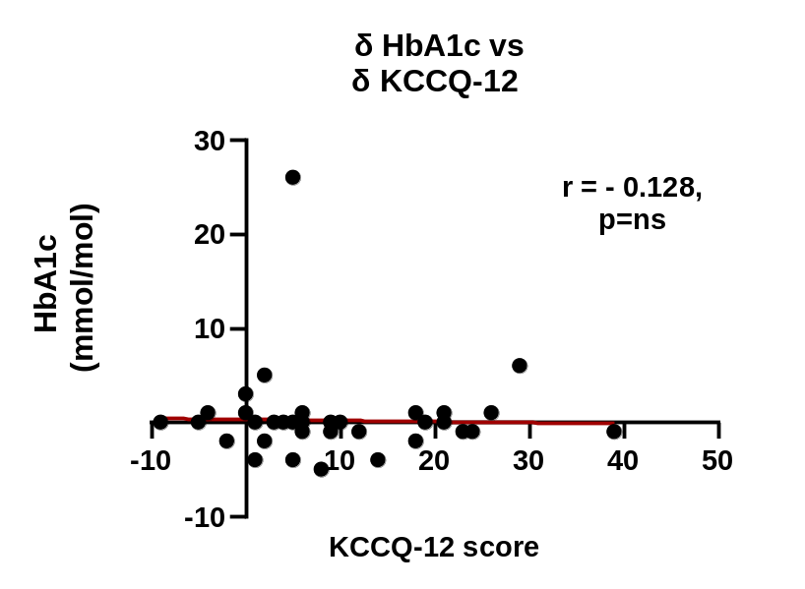
Figure demonstrating scatter plot with delta change in KCCQ-12 score plotted against standard of care biomarkers. Analysis performed using Pearson bivariate regression with two-sided p value. Significance defined as p<0.05.

SGLT2i: Sodium-glucose co-transport 2 inhibitor, GLS: Global longitudinal strain, LVEF: Left ventricular ejection fraction, KCCQ-12: Kansas City Cardiomyopathy Questionnaire-12.

