Biotransformations of HBCDs by Rhodococcus strain stu-38 and identification of transformation products
Fei Yu, Wenqi Luo, Yuyang Li, Shanshan Meng, Xianbin Lin, Lele Li, Xueying Ye, Hui Wang, Tao Peng, Tongwang Huang, Zhong Hu*
Department of Biology, College of Science, Shantou University, Guangdong Province, P.R. China
* Prof. Zhong Hu, corresponding author, E-mail address: hzh@stu.edu.cn, 0086-754-86504189, Department of Biology, Science College, Shantou University, Shantou 515063, Guangdong Province, P.R. China

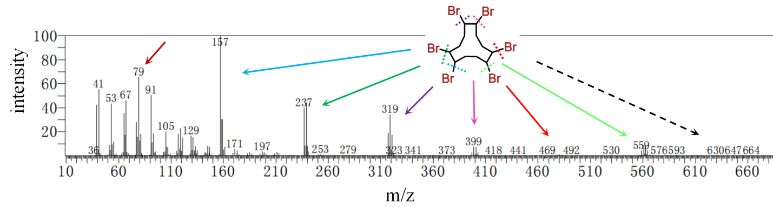
(1)
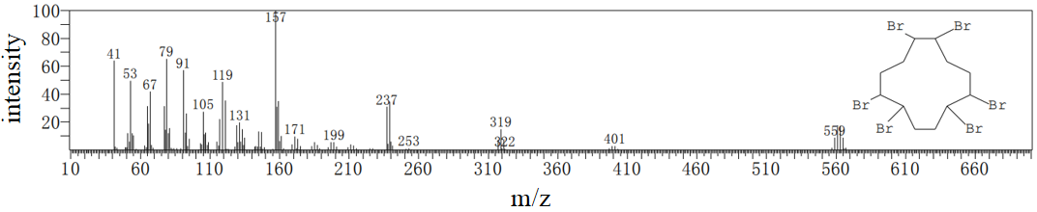
(2)
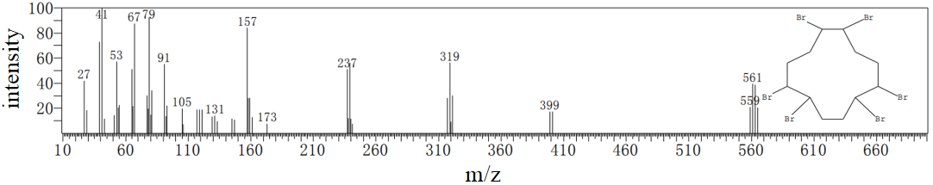
(3)
Fig. S1 (1) the full scan m/z of HBCDs standard at retention time 24.750 min. (2), (3) are the m/z of HBCD in the spectral library NIST14s and Wiley9. Dashed line shows the lysis of bond. C₁₂H₁₈Br₆, m/z=641.7 as shown by dotted arrow which generally invisible; C₁₂H₁₇Br₅, m/z=560.8; C₁₂H₁₅Br₃, m/z=400.0; C₁₂H₁₄Br₂, m/z=319.1; C₁₂H₁₃Br, m/z=238.2; C₁₂H₁₂, m/z=157.3; C₆H₇ and Br, m/z= 79

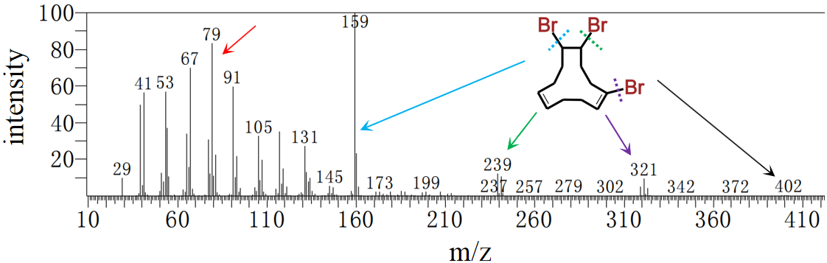
(1)
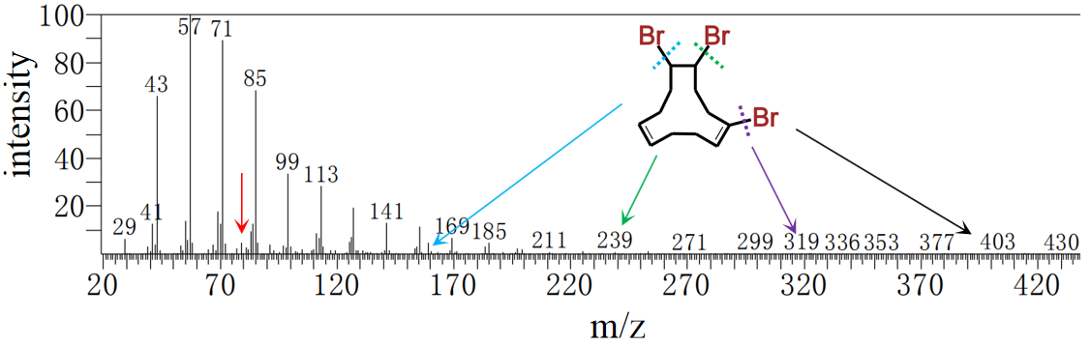
(2)
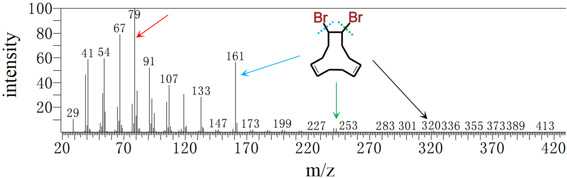
(3)
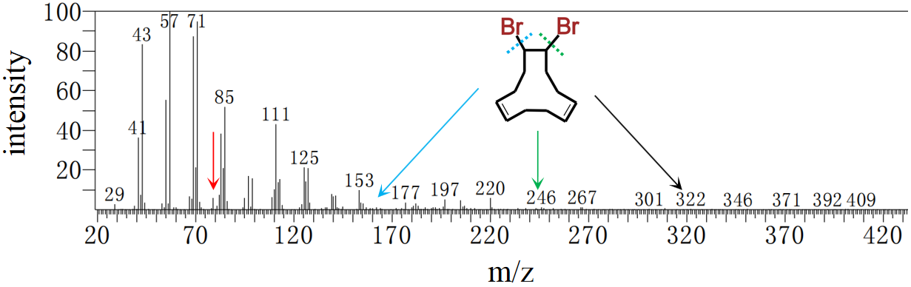
(4)
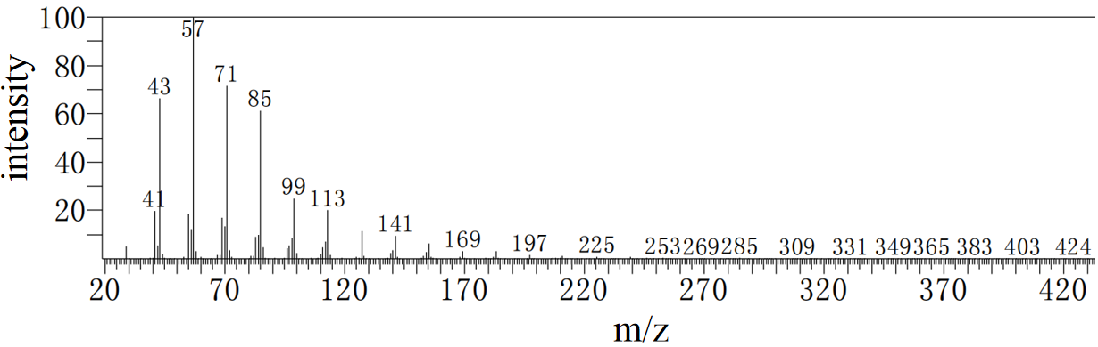
(5)
Fig. S2 The full scan m/z of tribromocyclododecadiene (1) in HBCDs standard solution in acetone at 17.230 min and (2) in the extracts of SW-C in acetone at the retention time 17.250 min. The full scan m/z of debrominated product dibromocyclododecadiene in the (3) acetone, (4) SW and (5) SW-C at the retention time 14.040 min. Dibromocyclododecadiene in the (4) was identified as a biotransformation product. Dashed line shows the lysis of bond. Fragment ions are highlighted by black, green, blue and red arrows. The relative m/z are not found in (c)

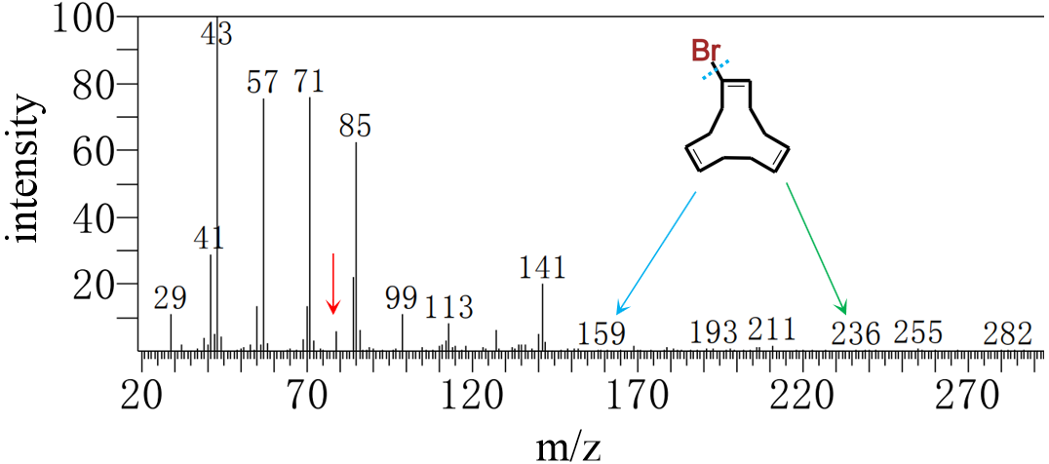
(1)
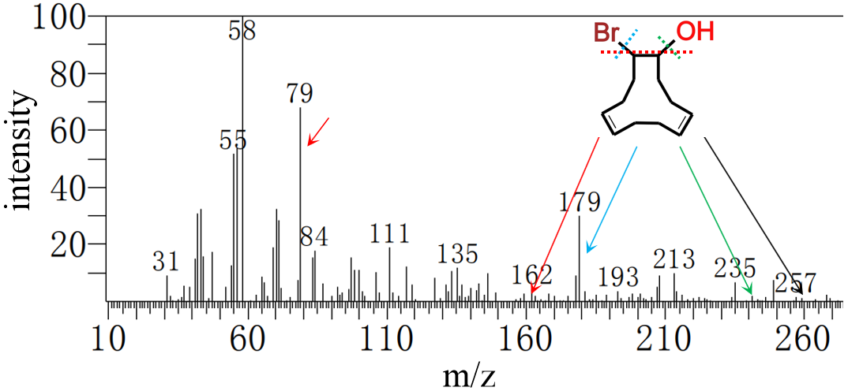
(2)
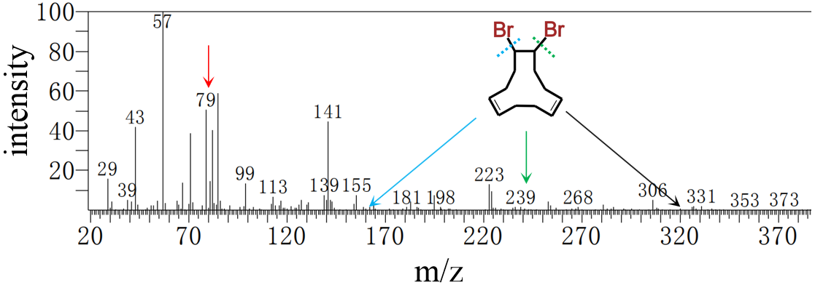
(3)
Fig. S3 the full scan m/z of intermediates of FW at the retention time of 7.945 (1), 8.355 (2), 11.280 (3) min. The black arrow shows the m/z of the proposed structure, the rest arrows show the m/z of fragment ions
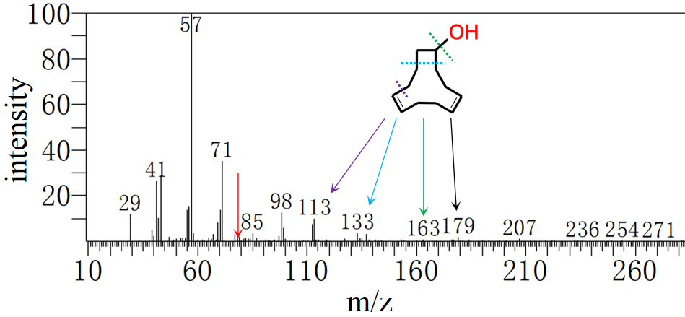
(1)
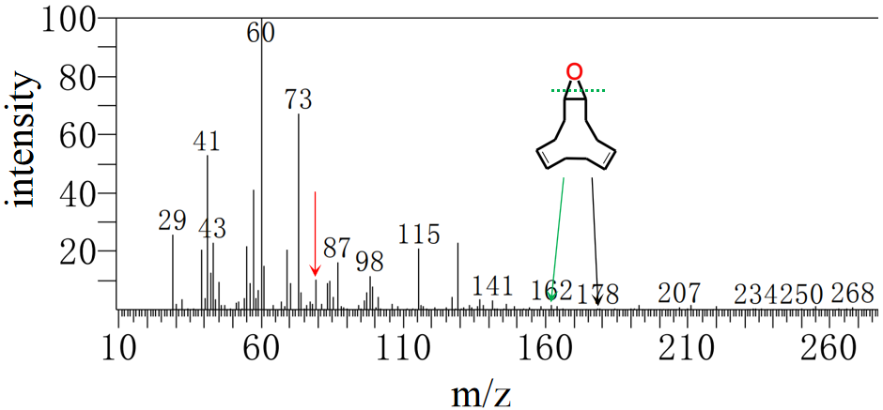
(2)
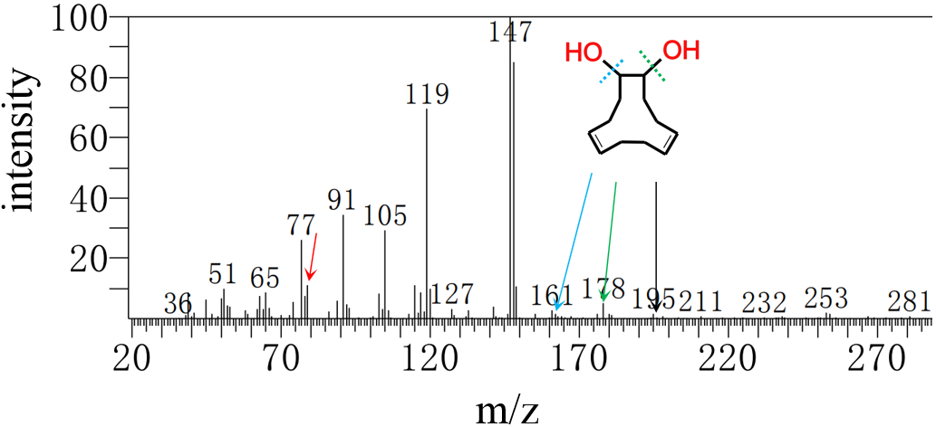
(3)
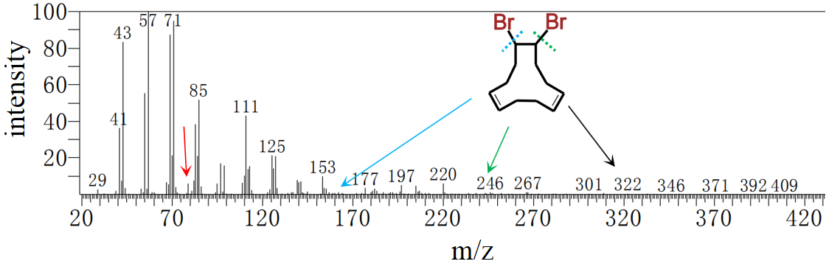
(4)
Fig. S4 the full scan m/z of intermediates of SW at the retention time of 6.115 (1), 6.845 (2), 7.395 (3), 14.065 (4) min. The black arrow shows the m/z of the proposed structure, the rest arrows show the m/z of fragment ions

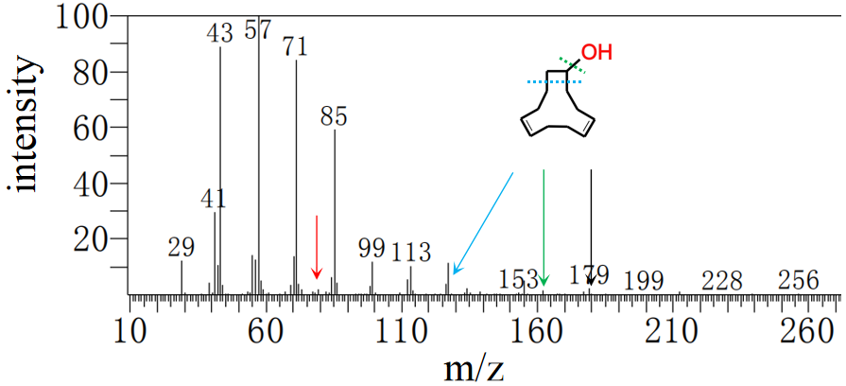
(1)
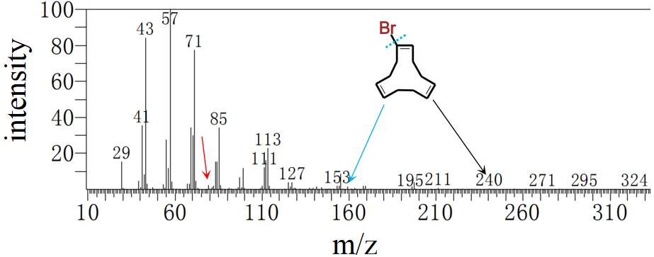
(2)
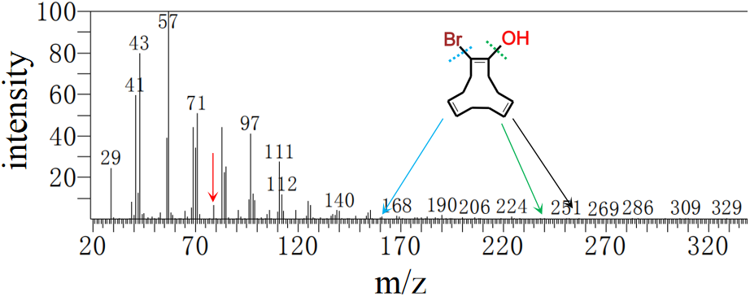
(3)
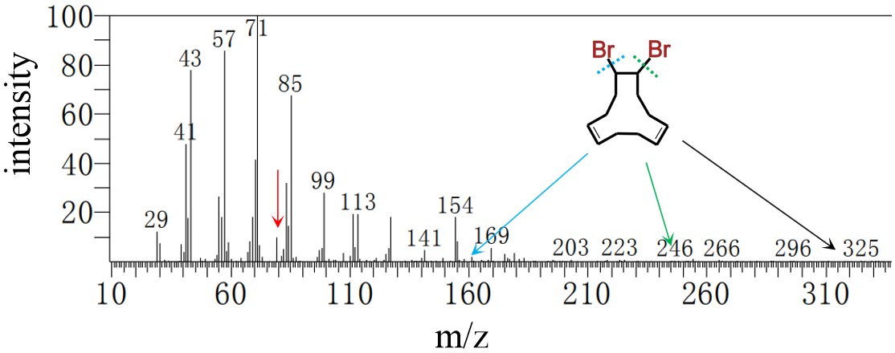
(4)
Fig. S5 the full scan m/z of metabolites of SWLB at the retention time of 7.280 (1), 10.230 (2), 10.910 (3), 13.085 (4) min. The black arrow shows the m/z of the proposed structure, the rest arrows show the m/z of fragment ions

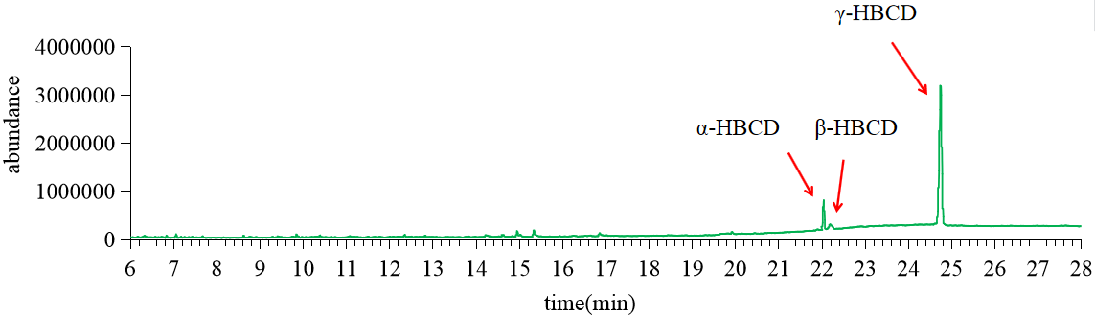
(1)
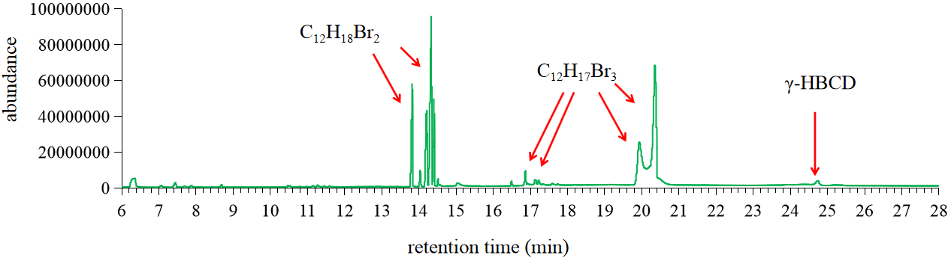
(2)
Fig. S6 (1) the GC-MS chromatograms of HBCDs. Three diastereoisomers of HBCDs appear at 22.042 min, 22.192 min, 24.750 min. (2) the HBCDs and debrominated products tribromocyclododecadiene (C₁₂H₁₇Br₃) and dibromocyclododecadiene(C₁₂H₁₈Br₂) in the acetone

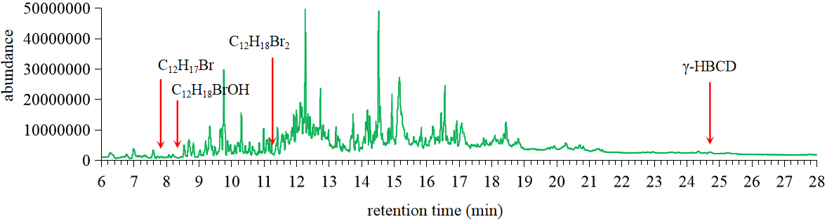
Fig. S7 the GC-MS chromatograms of FW

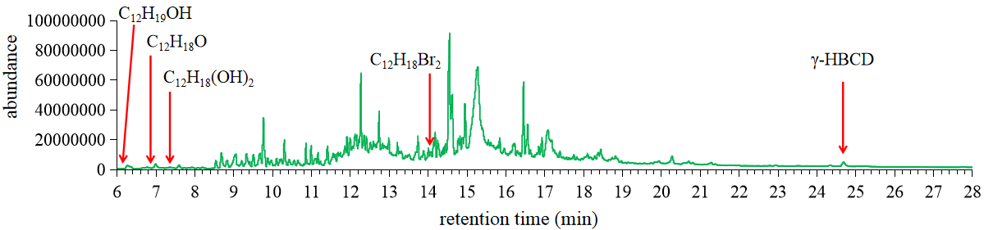
Fig. S8 the GC-MS chromatograms of SW

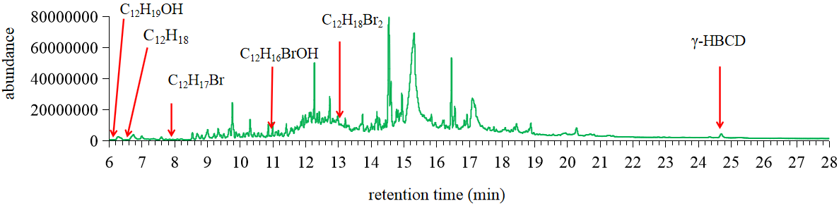
Fig. S9 the GC-MS chromatograms of SWLB

