Supplementary Information
Molecular Cobalt Catalysts for Highly Selective Electrocatalytic Acetylene Semi-Hydrogenation
Fengliang Cao¹, Wenting Feng¹, Debin Kong¹, Xiao Hai², Qingshan Zhao¹, Mingbo Wu³, Song Xue^{1,*}, and Linjie Zhi^{1,*}

¹College of New Energy, Research Center on Advanced Chemical Engineering and Energy Materials, Shandong Key Laboratory of Advanced Electrochemical Energy Storage Technologies, College of Chemistry and Chemical.
China University of Petroleum (East China), Qingdao 266580, P. R. China.
²School of Materials Science and Engineering, Peking University, Beijing 100871, P. R. China.
³College of Chemical Engineering, Qingdao University of Science & Technology, Qingdao 266100, P. R. China
Keywords: Acetylene semi-hydrogenation, Ethylene purification, Molecular catalysts, Molecular regulation, Water dissociation

Corresponding Authors: Song Xue (song.xue@upc.edu.cn), Linjie Zhi (zhilj@upc.edu.cn)

Supplementary Figures and Tables
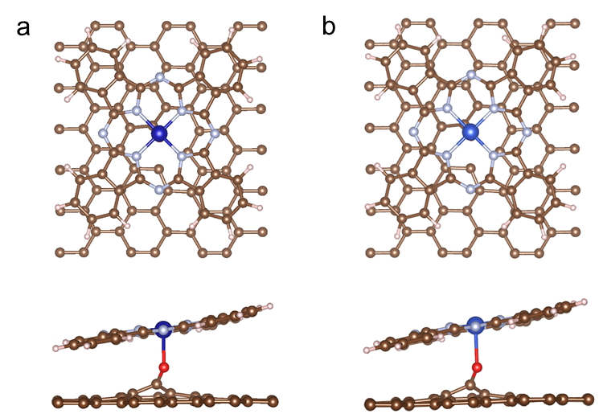
Figure S1. Atomic structures of (a) CoPc/OCNT and (b) CuPc/OCNT models.

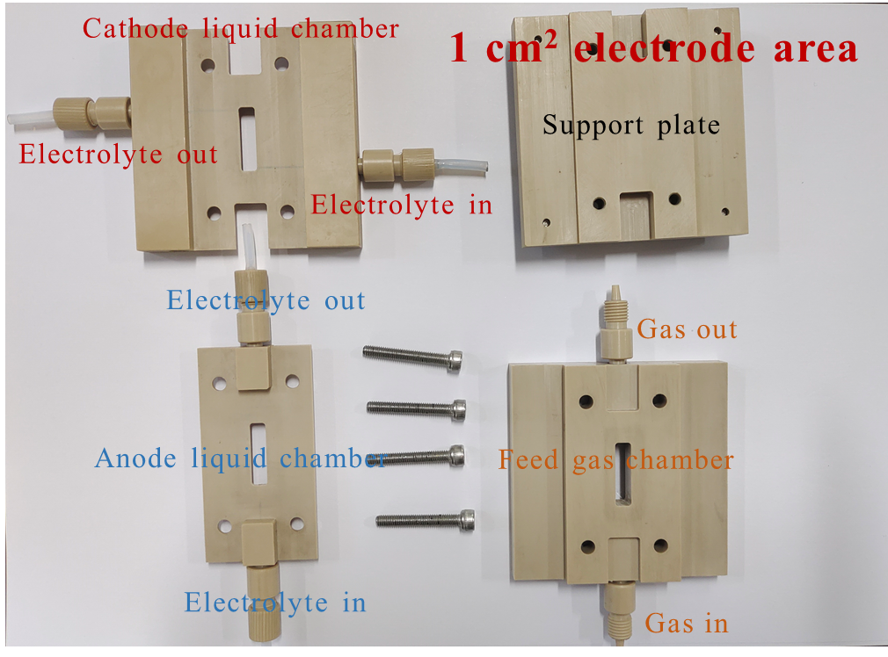
Figure S2. Digital graph of the 1 cm² flow cell, which is mainly consisted by cathode liquid chamber, anode liquid chamber, feed gas chamber and support plate.

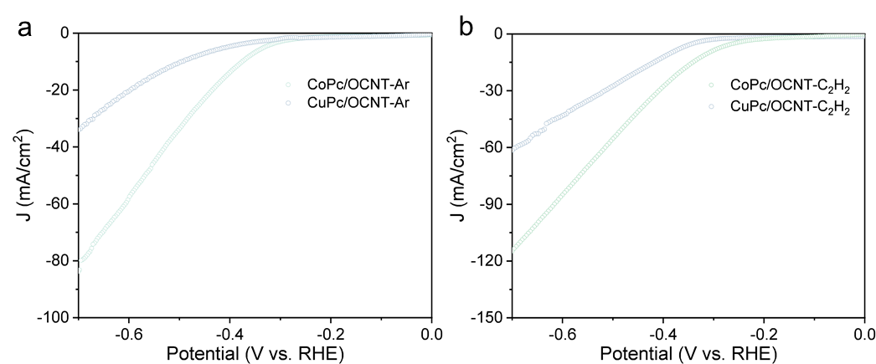
Figure S3. LSV curves under (a) Ar and (b) C₂H₂.

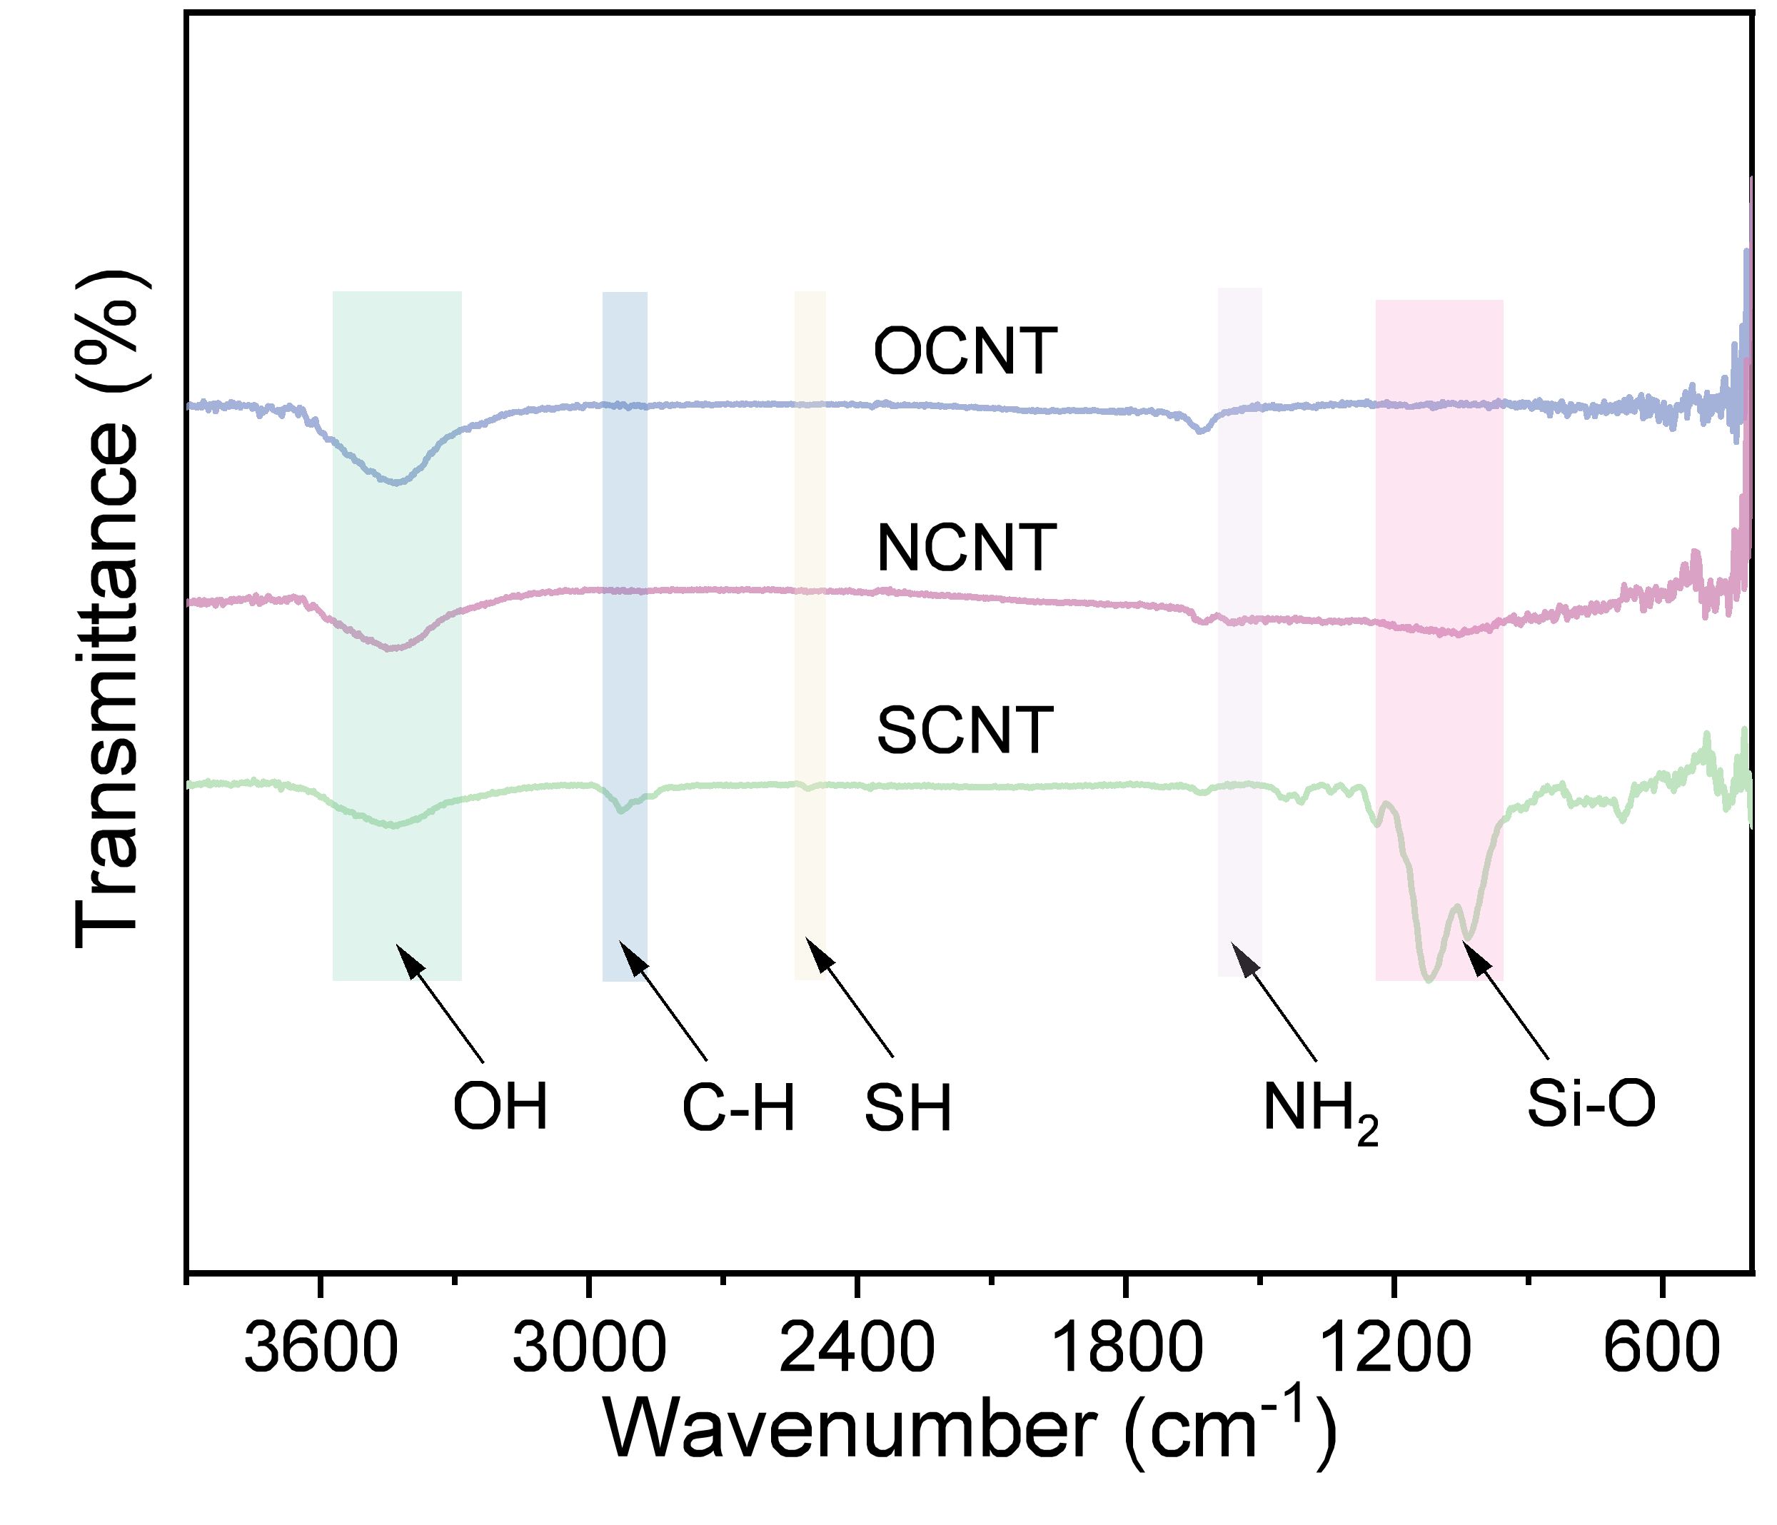
Figure S4. FT-IR spectra of OCNT, NCNT, and SCNT.

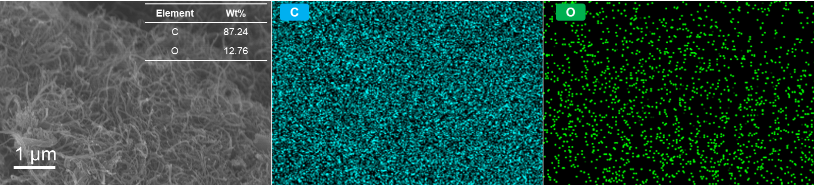
Figure S5. SEM image (inset: elemental content of OCNT obtained from EDS mapping) and corresponding EDS mapping distribution of OCNT for C (blue), O (green).

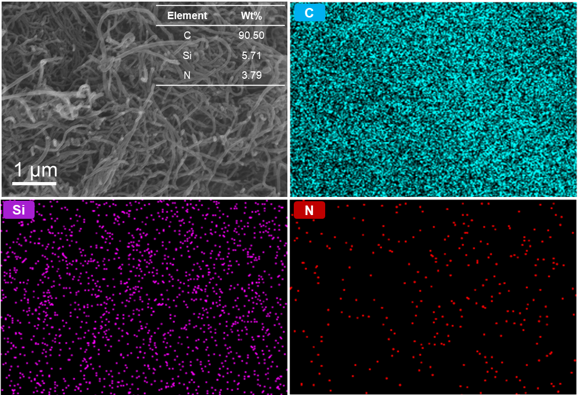
Figure S6. SEM image and corresponding EDS mapping distribution of NCNT for C (blue), Si (purple), N (red). The inset is the elemental content of NCNT obtained from EDS mapping.

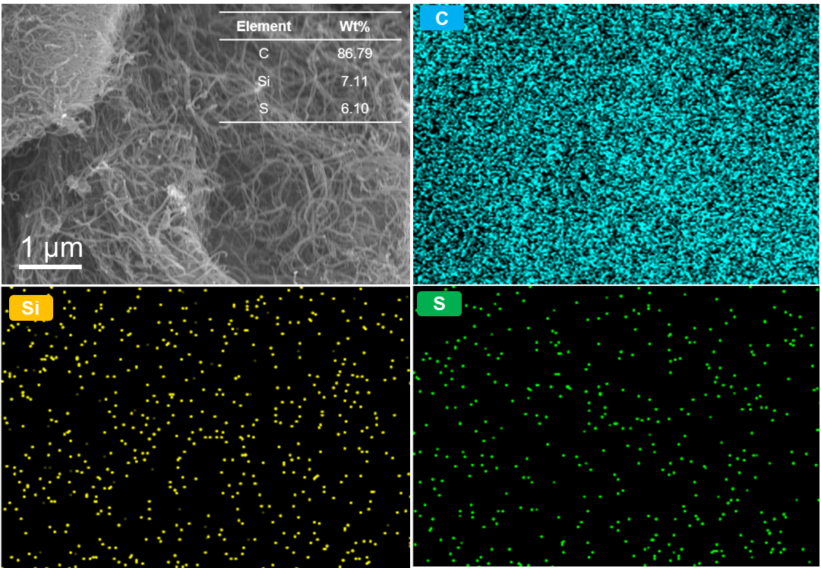
Figure S7. SEM image and corresponding EDS mapping distribution of SCNT for C (blue), Si (yellow), S (green). The inset is elemental content of SCNT obtained from EDS mapping.

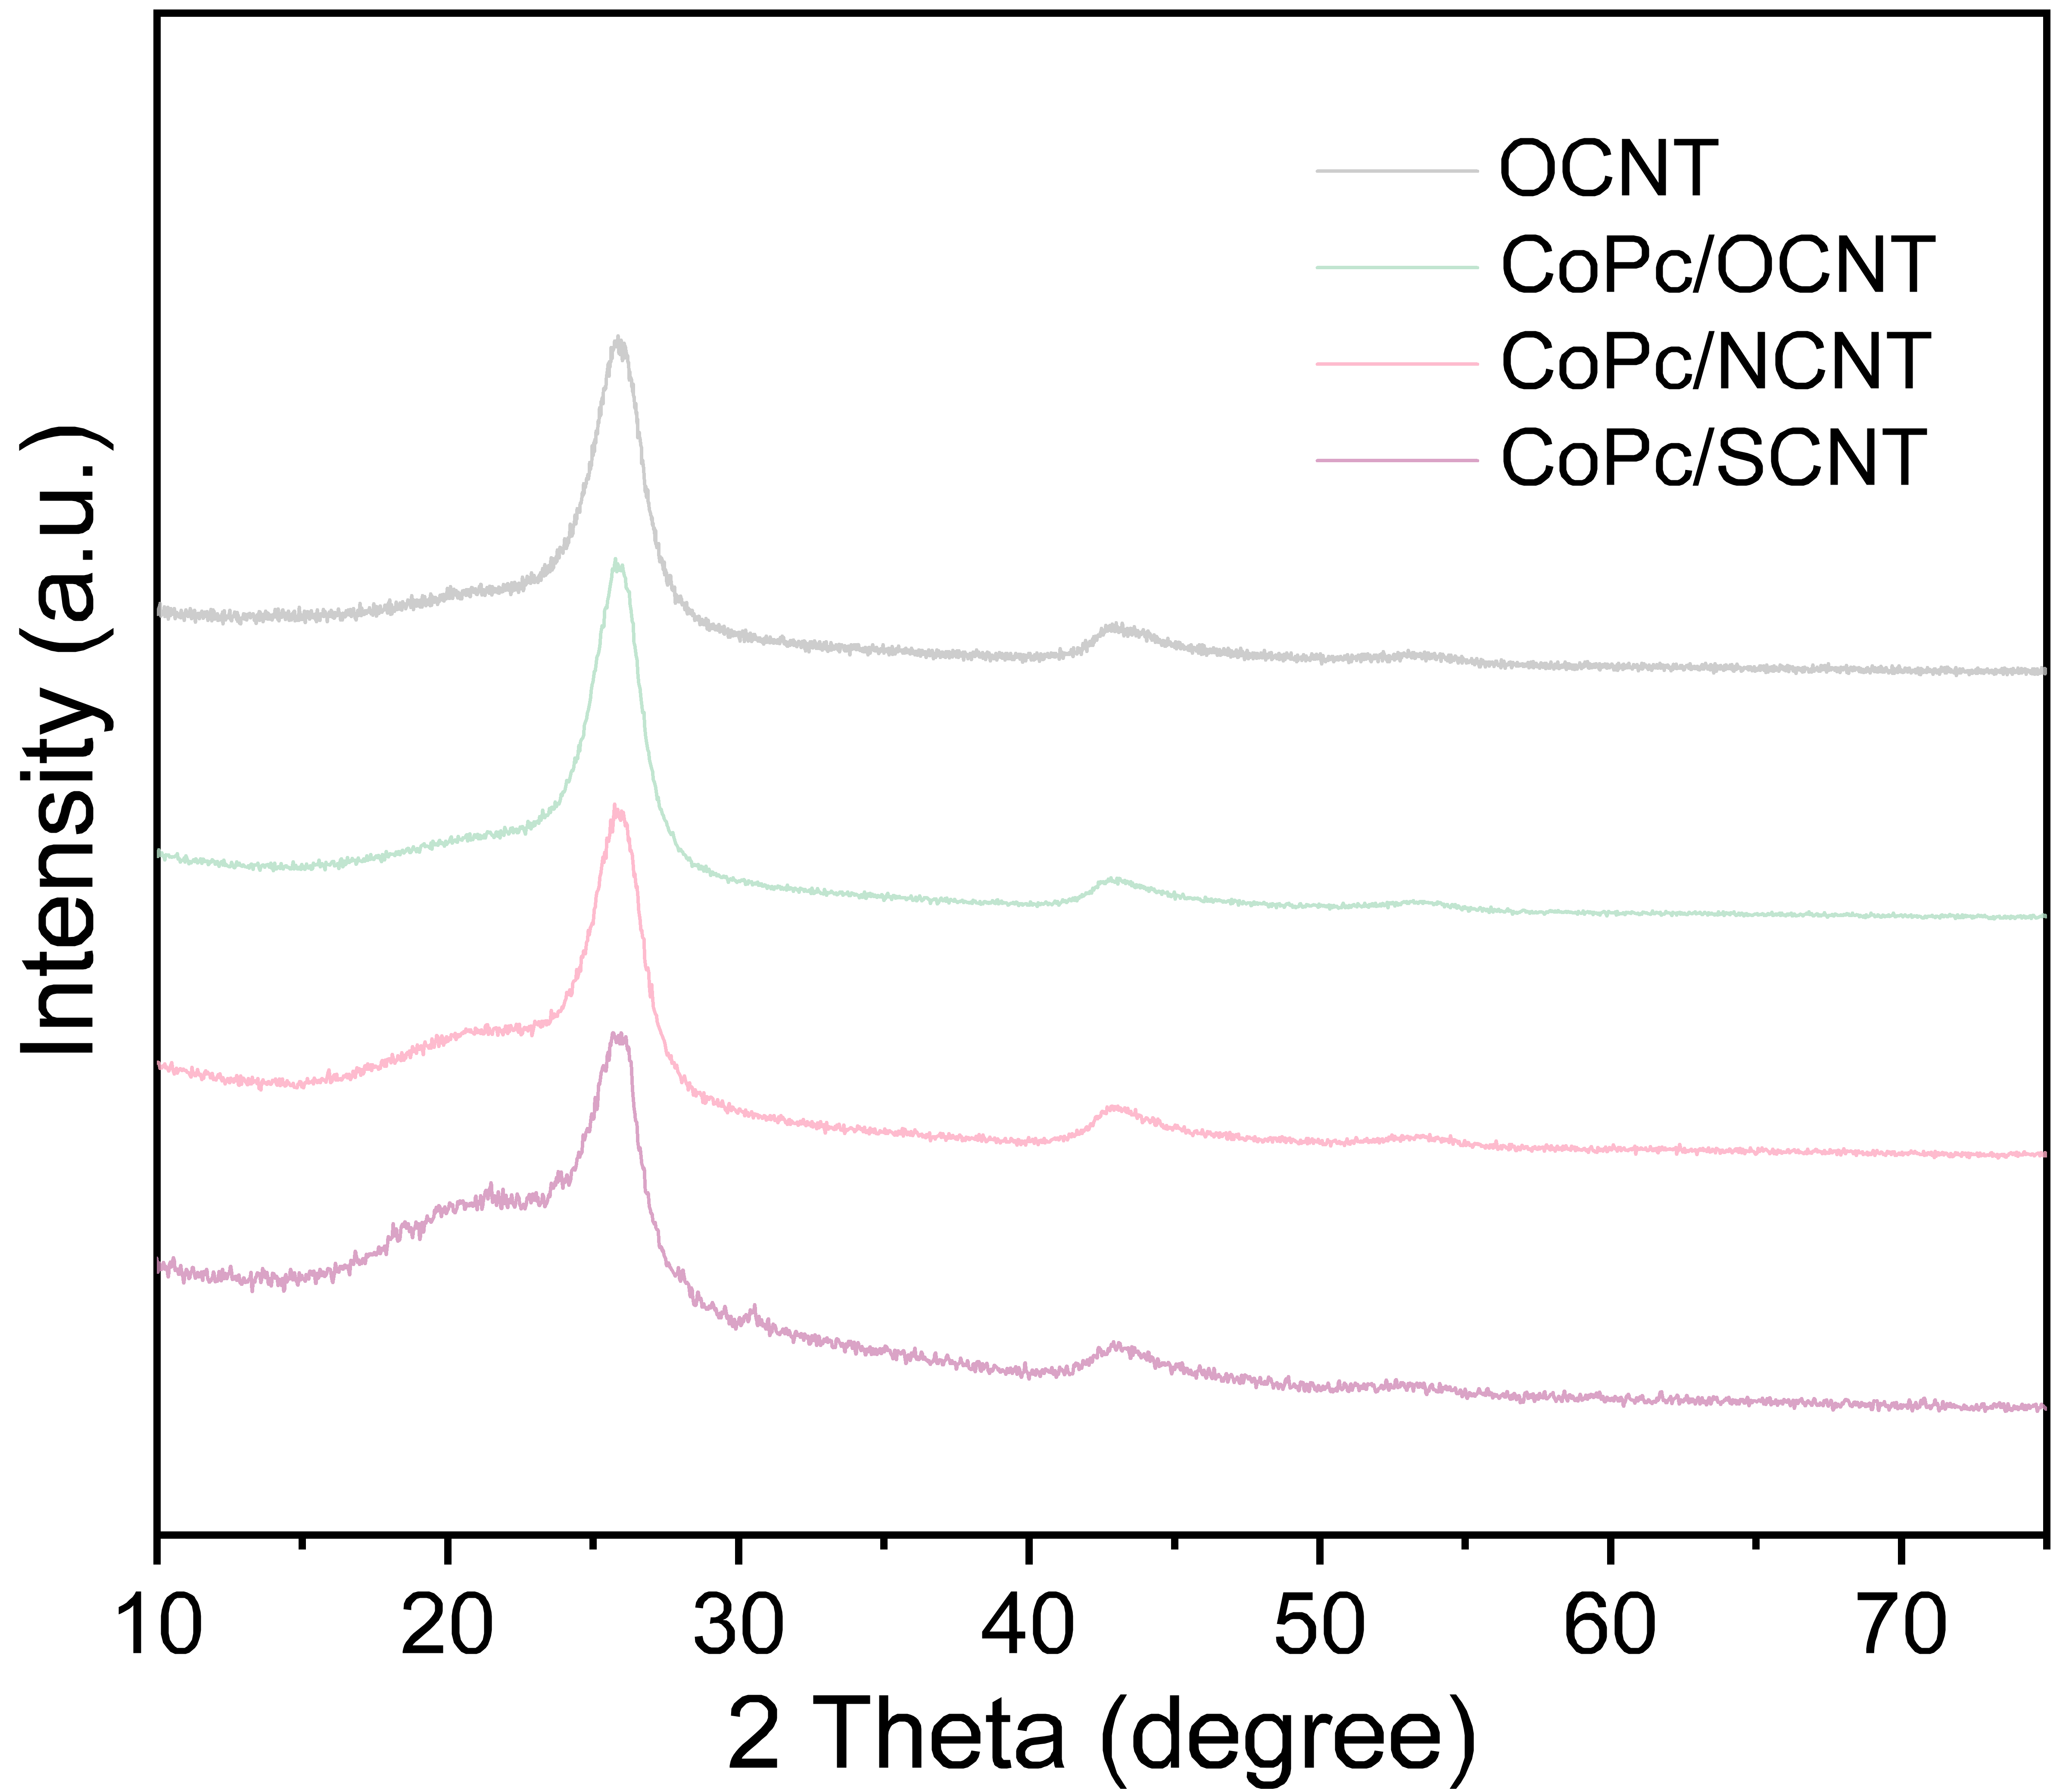
Figure S8. XRD patterns of OCNT, CoPc/OCNT, CoPc/NCNT, and CoPc/SCNT.

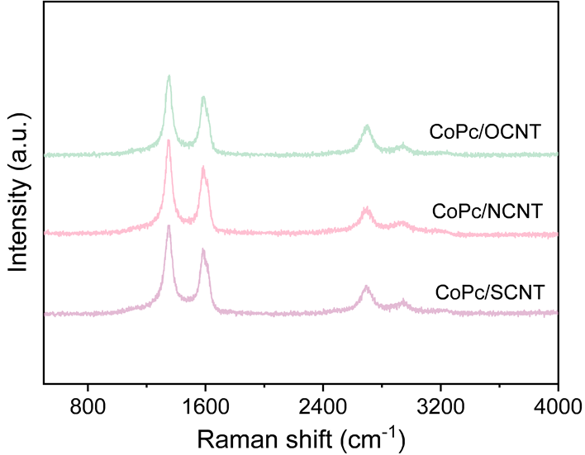
Figure S9. Raman spectra of CoPc/OCNT, CoPc/NCNT, and CoPc/SCNT.

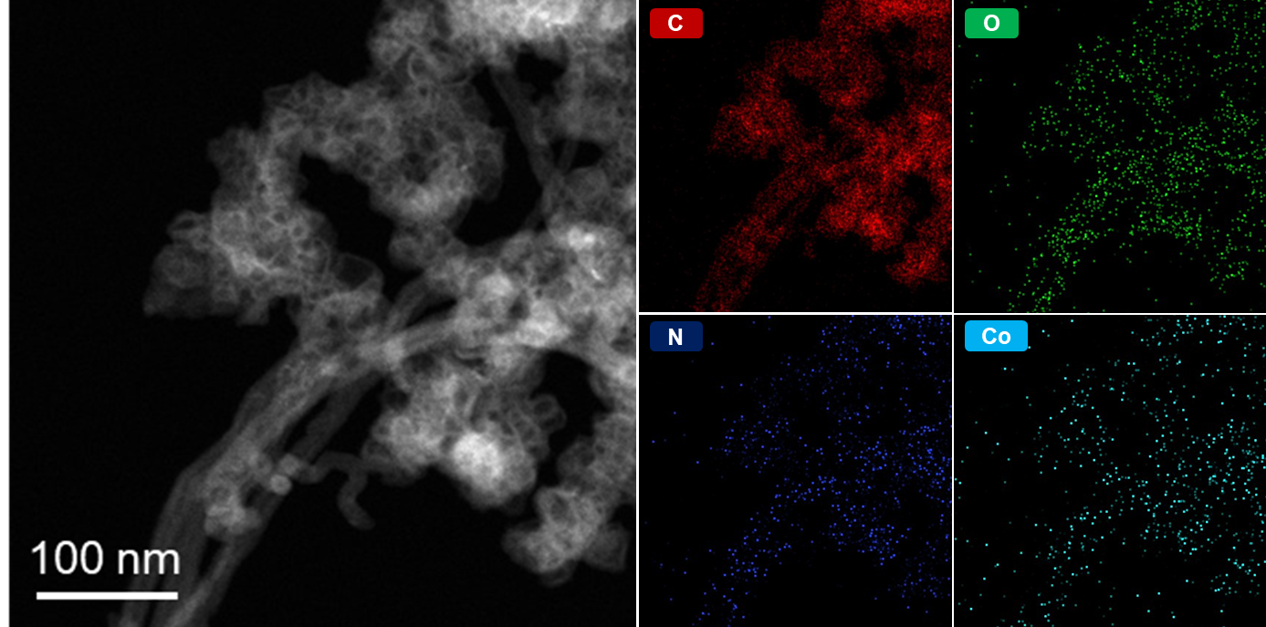
Figure S10. HAADF-STEM image and corresponding EDS mapping distribution of CoPc/OCNT for C (red), O (green), N (dark blue), and Co (light blue).

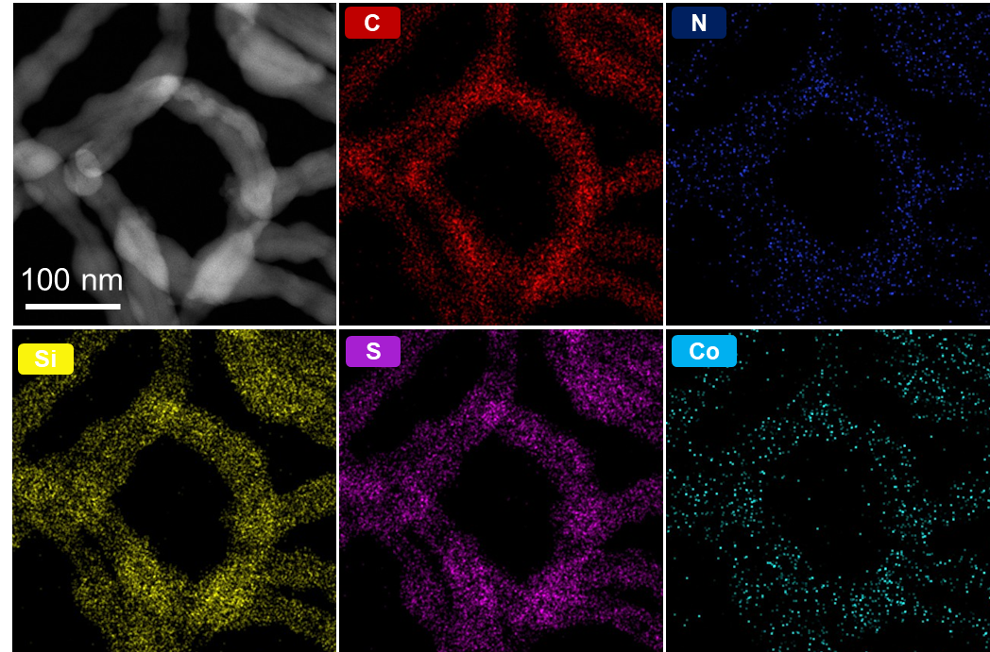
Figure S11. HAADF-STEM image and corresponding EDS mapping distribution of CoPc/SCNT for C (red), N (dark blue), Si (yellow), S (purple), and Co (light blue).

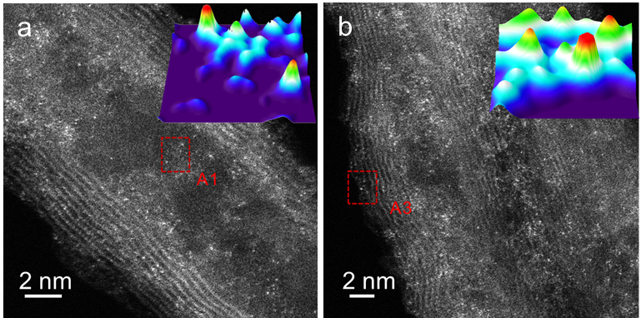
Figure S12. AC-STEM images and 3D atom-overlapping Gaussian-function map for CoPc/OCNT and CoPc/SCNT.

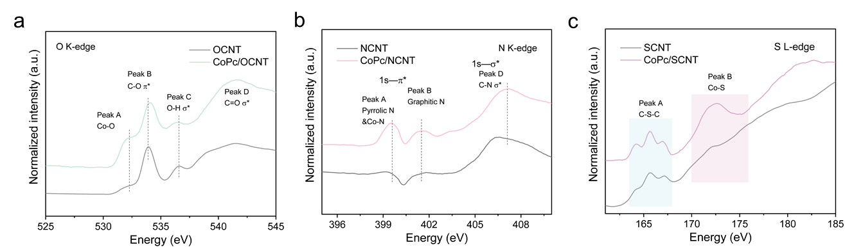
Figure S13. (a) O K-dege XANES spectra of OCNT and CoPc/OCNT. (b) N K-edge spectra of NCNT and CoPc/NCNT. (c) S L-edge spectra of SCNT and CoPc/SCNT.

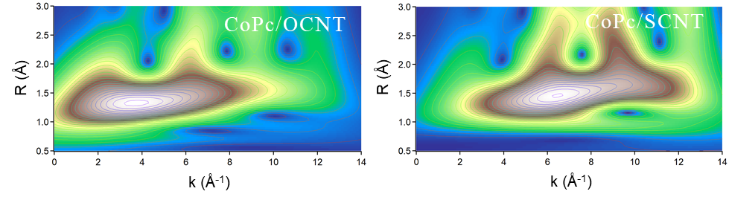
Figure S14. WT Co K-edge EXAFS profiles of CoPc/OCNT and CoPc/SCNT.

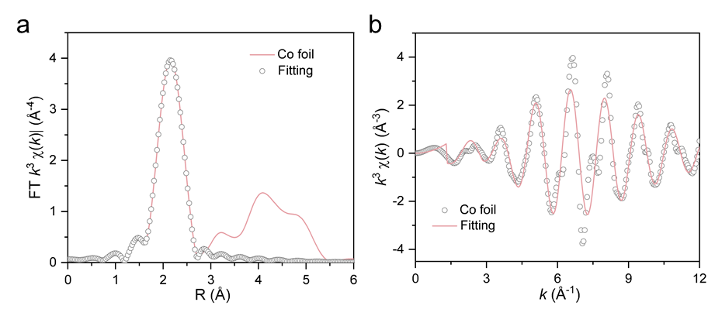
Figure S15. EXAFS fitting curves of Co foil in the (a) R space and (b) k space.

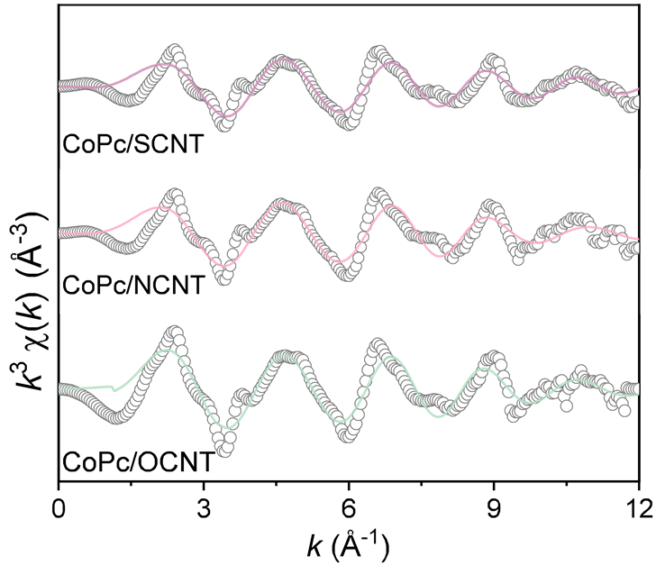
Figure S16. EXAFS fitting curves of CoPc/OCNT, CoPc/NCNT, and CoPc/SCNT in the k space.

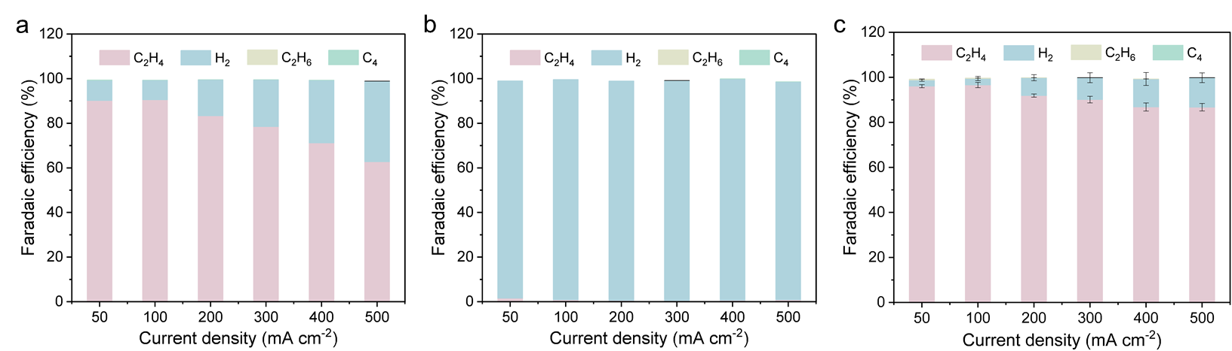
Figure S17. Faraday efficiency of the obtained products over CoPc/NCNT in acidic, neutral, and basic medium. The measurements were conducted by a three-electrode 1 cm² flow cell in 1 M (a) KCl, (b) H₂SO₄ or (c) KOH, at room temperature under 100% C₂H₂/Ar flow. The results are presented without iR compensation.

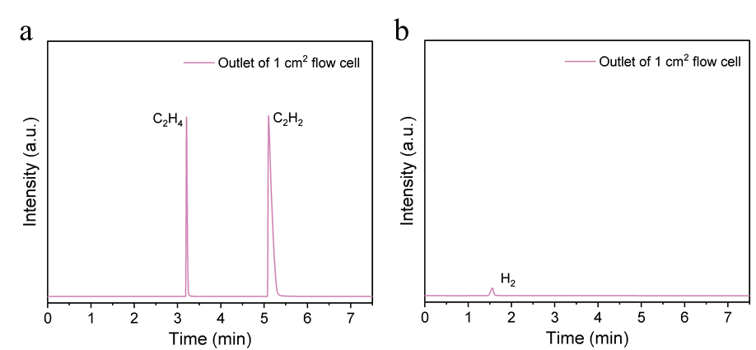
Figure S18. Gas chromatography analysis of the outlet gas from 1 cm² flow cell at 0.5 A. Ethylene is identified as the main production, accompanied by a small amount of H₂.

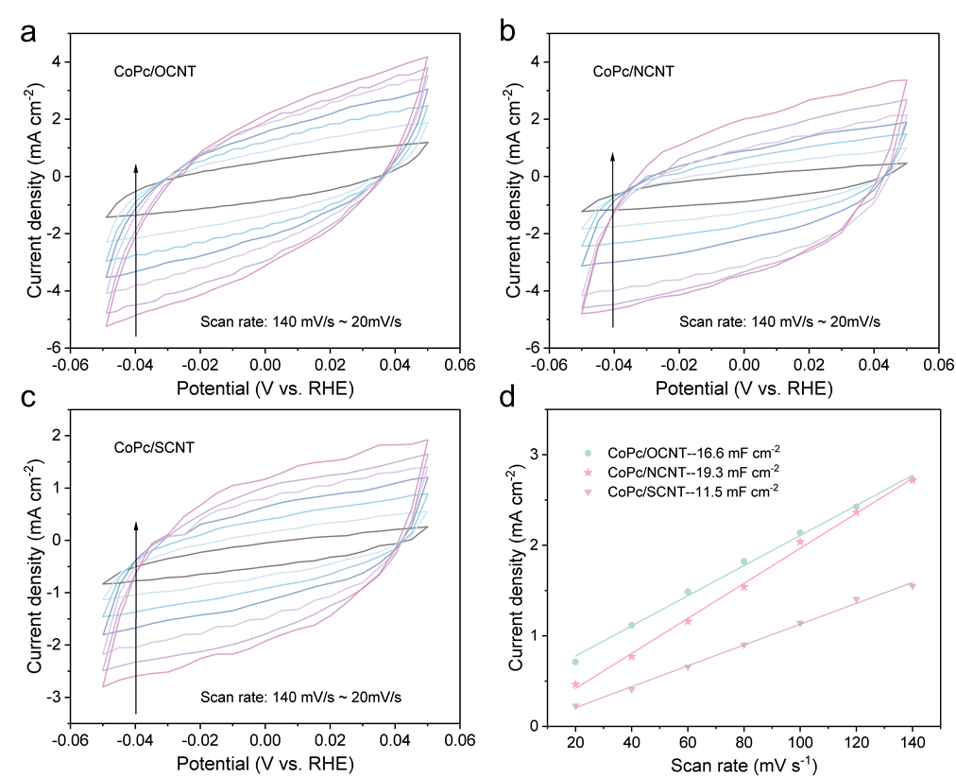
Figure S19. Electrochemical capacitance measurements. Cyclic voltammogram curves of (a) CoPc/OCNT, (b) CoPc/NCNT, and (c) CoPc/SCNT at different scan rates. (d) Corresponding charging current densities as a function of the applied scan rate.
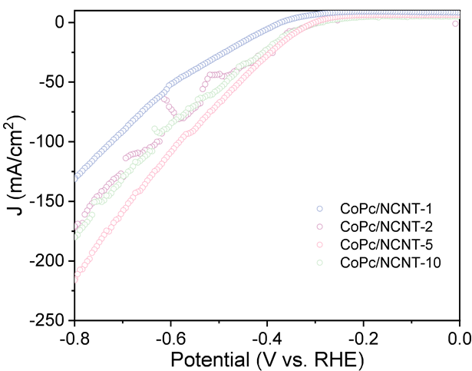
Figure S20. LSV curves in 100% C₂H₂ over CoPc/NCNT-A (A stand for the amount of CoPc per 100 mg NCNT). The results are presented without iR compensation.
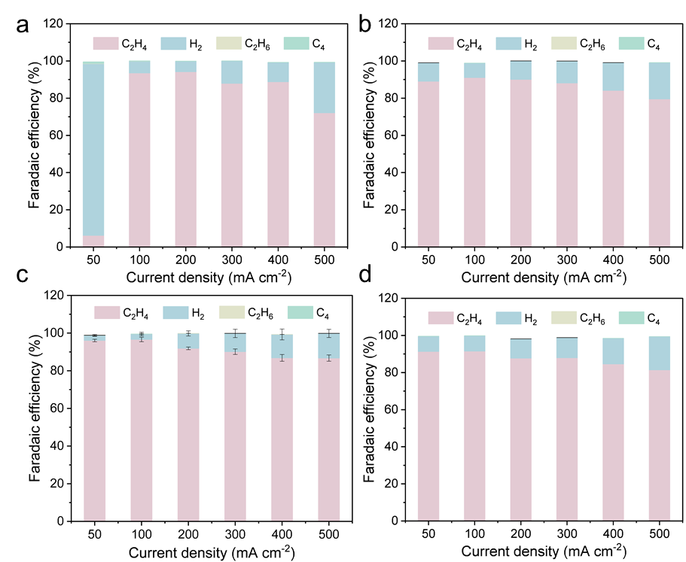
Figure S21. Faraday efficiency of the obtained products over (a) CoPc/NCNT-1, (b) CoPc/NCNT-2, (c) CoPc/NCNT-5, and (d) CoPc/NCNT-10 at various current densities. The results are presented without iR compensation.

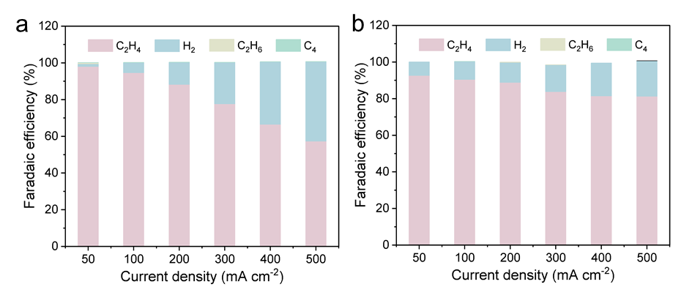
Figure S22. Faraday efficiency of the obtained products over gas diffusion layers with (a) 0.2 mg cm⁻² and (b) 0.6 mg cm⁻² CoPc/NCNT catalyst. The results are presented without iR compensation.

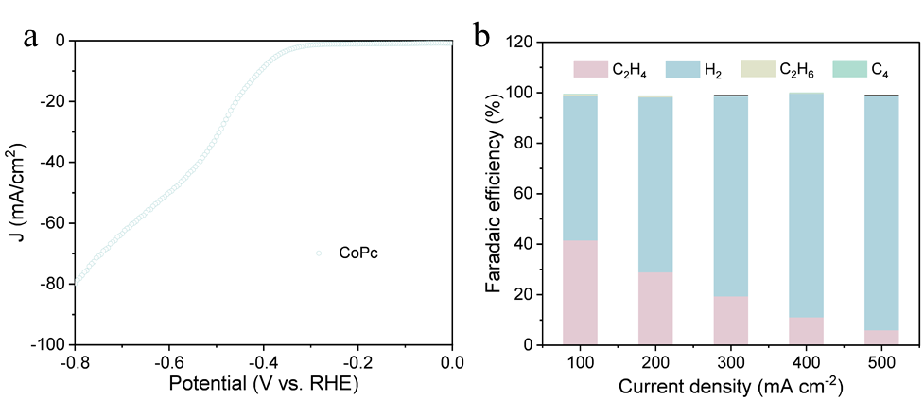
Figure S23 (a) LSV curves in 100% C₂H₂ over CoPc. (b) Faraday efficiency of the obtained products over CoPc at various current densities. The results are presented without iR compensation.

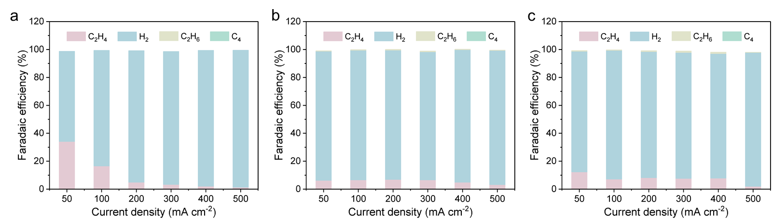
Figure S24. Faraday efficiency of the obtained products over (a) OCNT, (b) NCNT, and (c) SCNT at various current densities. The results are presented without iR compensation.

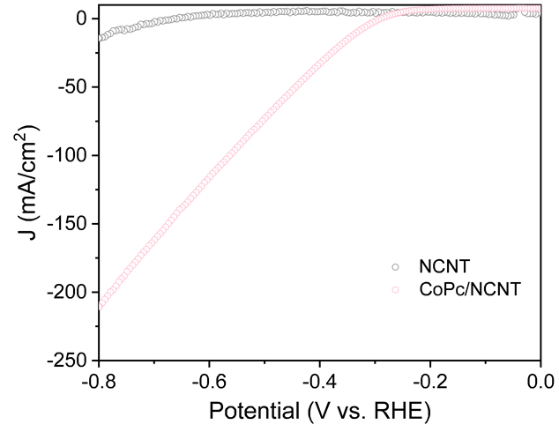
Figure S25. LSV curves in 100% C₂H₂ over NCNT and CoPc/NCNT. The results are presented without iR compensation.

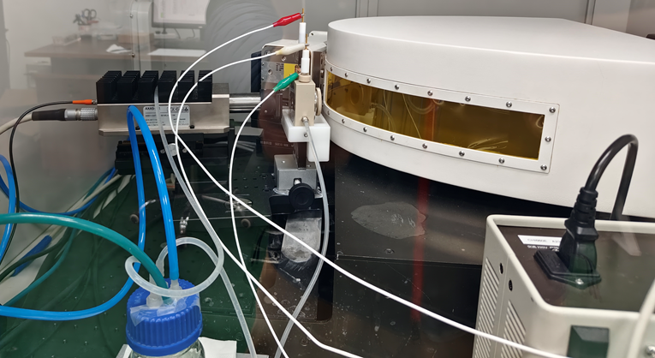
Figure S26. In situ XANES experiment for identifying the changing structure of the CoPc/NCNT electrocatalyst.
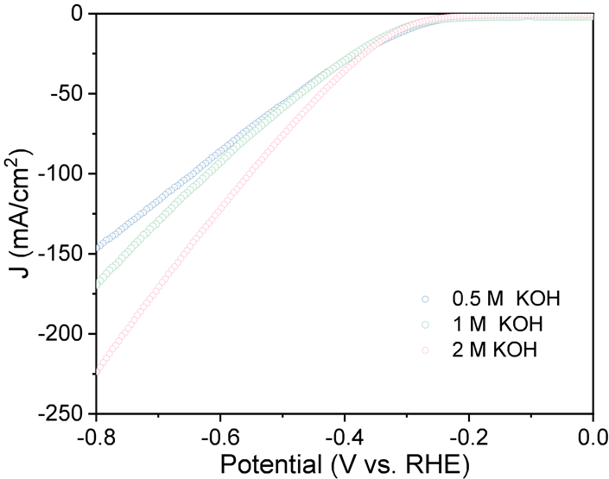
Figure S27. KOH concentration effect on the Faraday efficiency of C₂H₄ over CoPc/NCNT. Measurements were conducted using a three-electrode 1 cm² flow cell at room temperature under 100% C₂H₂ flow. The results are presented without iR compensation.

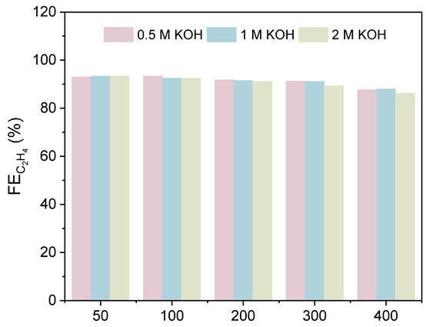
Figure S28. KOH concentration effect on the Faraday efficiency of C₂H₄ over CoPc/NCNT. Measurements were conducted using a three-electrode 1 cm² flow cell at room temperature under 100% C₂H₂ flow. The results are presented without iR compensation.
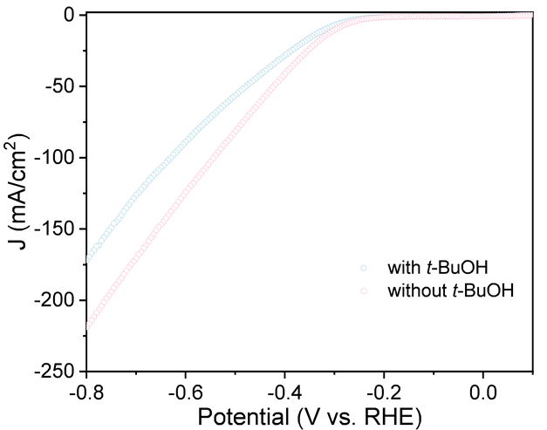
Figure S29. LSV curves over CoPc/NCNT in 1 M KOH solution with and without 50 mM t-BuOH. Measurements were conducted using a three-electrode 1 cm² flow cell at room temperature under 100% C₂H₂ flow. The results are presented without iR compensation.

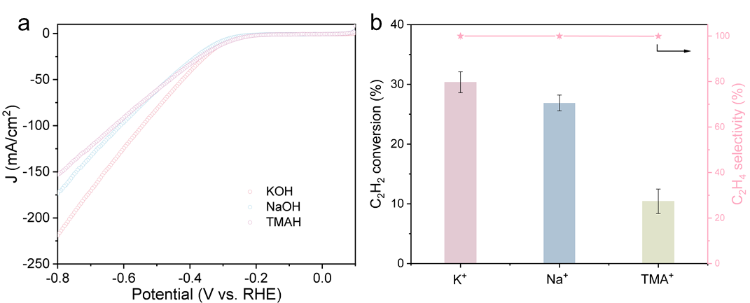
Figure S30. (a) LSV curves and (b) C₂H₂ conversion in 100% C₂H₂ over CoPc/NCNT with 1 M KOH, 1 M NaOH and 1 M TMAH electrolyte. Measurements were conducted using a three-electrode 1 cm² flow cell at room temperature under 100% C₂H₂ flow (20 mL min⁻¹). The results are presented without iR compensation.

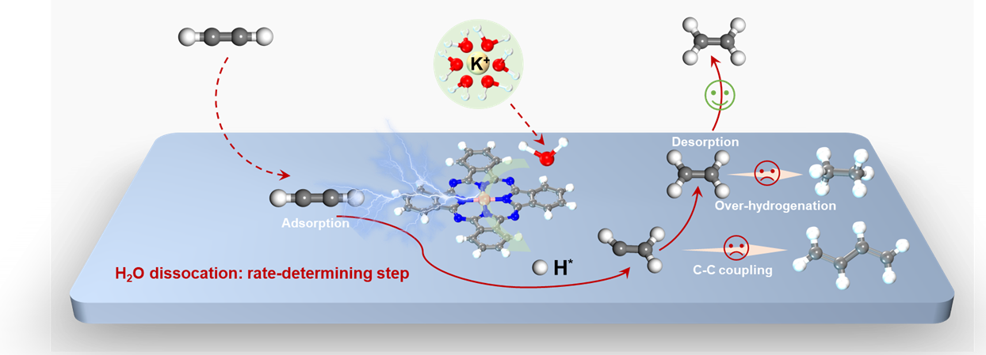
Figure S31. Proposed EASH reaction mechanism over CoPc/NCNT.

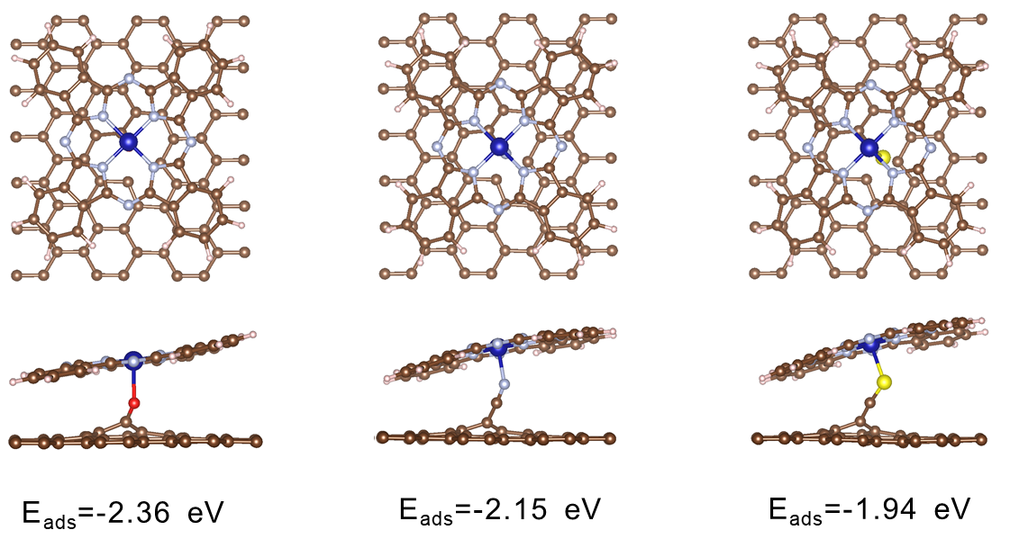
Figure S32. Binding energy of CoPc on the surface of OCNT, NCNT, and SCNT.

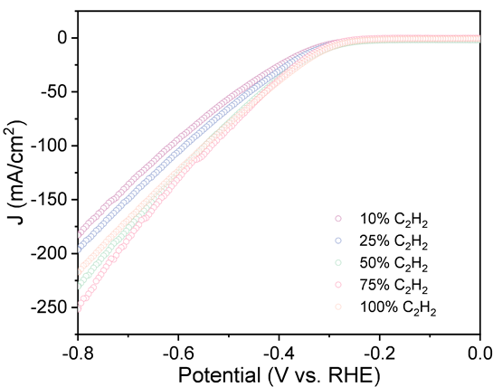
Figure S33. LSV curves in different concentrations of C₂H₂ over CoPc/NCNT. The results are presented without iR compensation.

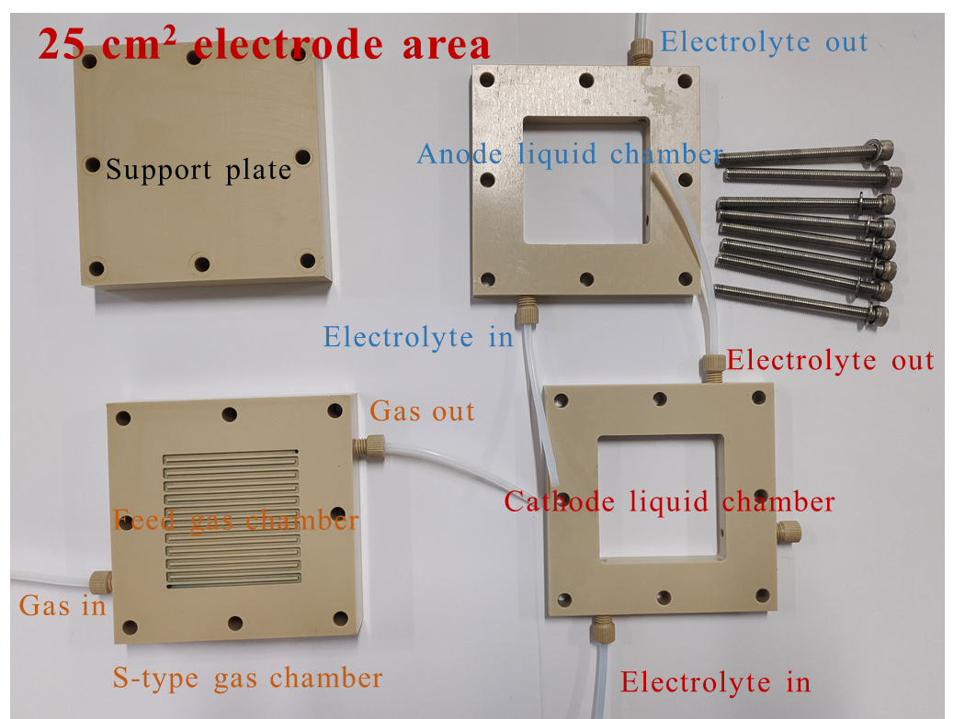
Figure S34. Component photograph of the three-electrode 25 cm² flow cell.

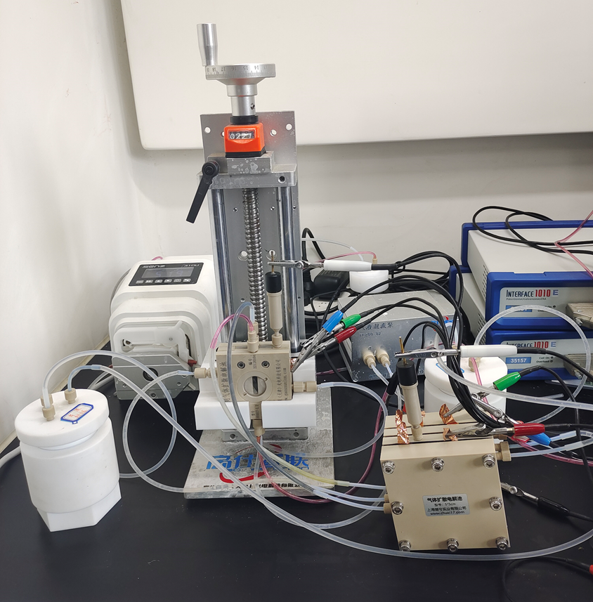
Figure S35. Homemade tandem device integrating a 1 cm² flow cell with a 25 cm² one.

Table S1. Co mass loading of CoPc/OCNT, CoPc/NCNT, and CoPc/SCNT.
Catalysts | Loading (wt. %)
CoPc/OCNT | 0.55
CoPc/NCNT | 0.41
CoPc/SCNT | 0.60

Table S2. Co K-edge EXAFS curve-fitting parameters of Co₁/NCLC-T and reference samples.
Sample | Path | CN | R (Å) | σ² (×10⁻³Å²） | ∆E₀ (eV) | R factor
Co foil | Co-Co | 12 | 2.49 | 6 | 0.7 | 0.001
CoPc/OCNT | Co-N | 4.1 | 1.91 | 3.3 | 5.0 | 0.017
CoPc/OCNT | Co-O | 1.1 | 1.96 | 2.3 | 5.0 | 0.017
CoPc/NCNT | Co-N1 | 4.0 | 1.92 | 3.4 | -0.47 | 0.014
CoPc/NCNT | Co-N2 | 1.1 | 2.13 | 1.0 | -0.47 | 0.014
CoPc/SCNT | Co-N | 4.3 | 1.90 | 5.7 | -0.48 | 0.015
CoPc/SCNT | Co-S | 0.8 | 2.18 | 1.6 | -0.48 | 0.015
CN: coordination numbers; R: bond distance; σ²: Debye-Waller factors; ΔE₀: the inner potential correction. R factor: goodness of fit. Error bounds (accuracies) that characterize the structural parameters obtained by EXAFS spectroscopy were estimated as CN ± 20%, R ± 1%, σ² ± 20%, and ΔE₀ ± 20%. Ѕ₀², 0.8, was obtained from the experimental EXAFS fit of Co foil reference by fixing CN as the known crystallographic value and was fixed to all the samples.

Table S3. Performance summary of recently reported acetylene semi-hydrogenation catalysts.
 | Sample | Gas composition | Temperature (°C) | SV (mL g_{cat}⁻¹ h⁻¹) | TOF (min⁻¹) | Specific selectivity (%) | Stability (h) | Ref.
Electrocatalytic | CoPc/NCNT | 100 | 25 | 3 × 10⁵ | 9.7 × 10³ | 100 | 60 | This work
Electrocatalytic | ED-Cu NPs | 100 | 25 | 9 × 10⁵ | 5.3 × 10² | 100 | 56 | Nat. Sustain. (2023) Doi: 10.1038/s41893-023-01084-x
Electrocatalytic | Cu-F | 70 | 25 | 1.6 × 10³ | 17.6 | 94 | 43 | Nat. Commun. 14, 8384 (2023)
Electrocatalytic | Cu MPs | Saturated by C₂H₂ | 25 | 1.4 × 10³ | 5.1 | 80 | 100 | Nat. Commun. 12, 7072 (2021)
Electrocatalytic | NHC-Cu | 1 | 25 | 9.6 × 10⁵ | 1.26 | 99 | 100 | Nat. Commun. 12, 6574 (2021)
Thermocatalytic | Ni₁Cu₂/g-C₃N₄ | 0.5 | 160 | 1.2 × 10⁴ | 1.9 × 10⁻³ | 90 | 350 | Nat. Nanotechnol. 16, 1141-1149 (2021)
Thermocatalytic | Cu₁/ND@G | 1 | 200 | 3 × 10³ | 1.7 × 10⁻³ | 98 | 60 | Nat. Commun. 10, 4413-4419 (2019)
Thermocatalytic | Ni₃ZnC_{0.7} | 0.5 | 200 | - | - | 93 | 12 | Nat. Commun. 11, 3324-3332 (2020)
Thermocatalytic | Pd_{n}/ND@G | 1 | 180 | 6 × 10⁴ | 6.4 × 10⁻² | 90 | 30 | J. Am. Chem. Soc. 132, 4321-4327 (2010)
Thermocatalytic | Ni₃Ga | 0.5 | 200 | 4 × 10⁴ | 8.4 × 10⁻⁵ | 77 | 50 | Adv. Mater. 28, 4747 (2016)

