Supplementary Materials for

Dopamine modulation of motor and implicit learning contributions to auditory temporal attention

Arnaud Zalta, Lena-Franziska Spitz, Alfons Schnitzler, Benjamin Morillon and Esther Florin

Corresponding authors: arnaud.zalta@gmail.com

The PDF file includes:

Figs. S1

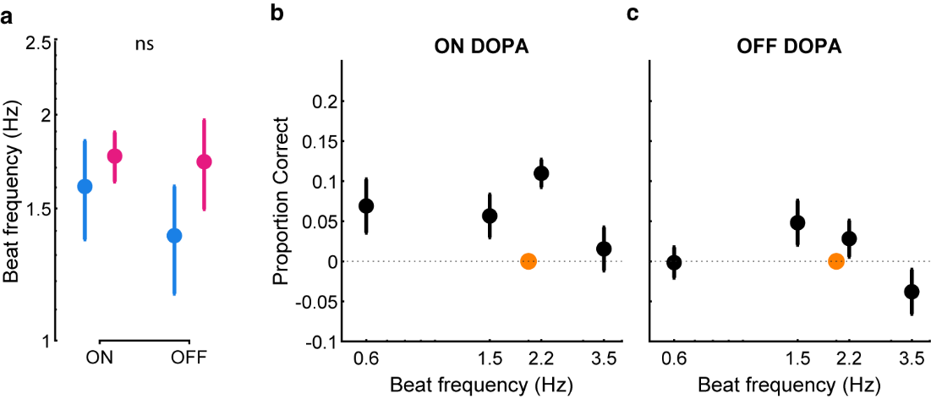
Supplementary figure 1. a. Individual estimates of the optimal tempo of auditory temporal attention in the passive (pale blue) and tracking (pink) conditions for PD patients ON or OFF-DOPA medication. b. Impact of tracking on performance in PD patients ON-DOPA medication. Difference in performance between the tracking and the passive condition for each tempo. c. Same as (b) but for the performance of PD patients OFF-DOPA medication. *p < 0.05; ns: non-significant.

