Supplementary Materials

A cross-modal epidermal sensor enables single-channel fusion of biopotential and biomechanical signals

Xiaodong Wu^{1,2,3,4#✉️}, Jinchao Wang^{1#}, Cheng Zhu^{1#}, Lifei Zheng^{1#}, Yangyang Song^{1#}, Xuyi Zhang⁵, Zhentao Yao¹, Yangyang Han⁶, Zhuqing Wang¹, Zhou Jiang⁷, Zhimeng Liu^{8✉️}, & Yuxin Liu^{2,3,4✉️}

¹ School of Mechanical Engineering, Sichuan University, Chengdu, China
² Department of Biomedical Engineering, National University of Singapore, Singapore, Singapore
³ Institute for Health Innovation and Technology, National University of Singapore, Singapore, Singapore
⁴ The N.1 Institute for Health, National University of Singapore, Singapore, Singapore
⁵ School of Engineering Science, Royal Institute of Technology, Stockholm, Sweden
⁶ State Key Laboratory of Polymer Materials Engineering, Sichuan University, Chengdu, China
⁷ NHC Key Laboratory of Chronobiology, Sichuan University, Chengdu, China
⁸ College of Electrical Engineering, Sichuan University, Chengdu, China
# These authors contributed equally to this work
✉E-mail: xiaodong_wu@scu.edu.cn; zhimengliu@scu.edu.cn; lyx@nus.edu.sg

This file Includes:
Note S1 - Note S2
Figure S1 - Figure S29
Table S1 - Table S2
Movie S1 - Movie S3
Reference S1 - Reference S23

Supplementary Note S1. Intrinsic tradeoffs in existing dry skin electrodes
Compared to the widely used hydrogel-based electrodes, dry electrodes do not suffer dehydration problems and offer promising solutions for long-term biosignal monitoring. Two common approaches have been developed to fabricate skin-conformal dry electrodes. The first method is to reduce the thickness of electrodes to improve flexibility and adaptability to curved surfaces. For instance, tattoo-like ultrathin electrodes have been proposed (Figure S1a), which have proven to be effective in improving skin conformability and reducing motion artifacts. Nevertheless, the interaction between electrode and skin (typically van der Waals' force) is not robust enough, with potential detachment and failure of the electrodes especially during dynamic motions. Additionally, the connection between fragile electrodes with external circuitry is vulnerable to mechanical stress.
Another approach is to incorporate conductive fillers (e.g., metal nanomaterials, carbon nanomaterials, etc.) into adhesive polymeric matrix (Figure S1b). However, the composite electrodes typically suffer from intrinsic tradeoffs among conductivity, adhesiveness and elasticity. Specifically, a higher loading of conductive fillers results in higher conductivity and the adhesiveness and elasticity are deteriorated due to the restrained molecular mobility caused by the conductive fillers, and vice versa. This makes it difficult to achieve high conductivity, adhesiveness and elasticity simultaneously.
In summary, existing dry skin electrodes typically suffer from tradeoff between conformability and robustness in tattoo electrodes, tradeoff between conductivity and adhesivity/elasticity in composite electrodes (Figure S1c). These tradeoffs pose challenges to develop desirable skin electrodes where high conductivity, adhesiveness and elasticity are concurrently needed.

Supplementary Note S2. Characterizations of the synthesized EPU, APU and NPU materials
The mechanical properties of the synthesized EPU are shown in Figure S3a. The ultra-soft and highly stretchable EPU is used as the elastic backing layer of the CARD electrodes. The FTIR spectrum of EPU is shown in Figure S3b. The characteristic peaks at 3311 cm⁻¹ and 1537 cm⁻¹ are attributed to the N-H stretching vibration of the urethane bond. The C=O stretching vibration from urethane can be detected at 1704 cm⁻¹. Moreover, the signals corresponding to the hydroxyl group around 3480 cm⁻¹ and the isocyanate group at 2265 cm⁻¹ completely disappear. The results indicate that the designed EPU was successfully synthesized through the curing reaction between the prepolymer and THEA. The synthesized EPU exhibits a mechanical strength of 28.7 MPa, with an elongation at break exceeding 500% (Figure S3c), revealing the high elasticity.
The synthesized APU material has good water solubility (Figure S5a), which facilitates the facile recycling as well as painless peeling of the final electrode from human skin with water. The Fourier transform infrared spectroscopy (FTIR) spectrum of synthesized APU is presented in Figure S5b. The characteristic peaks at 3325 cm⁻¹ and 1531 cm⁻¹ are ascribed to the N-H stretching vibrations of urea and urethane groups in APU. The peaks at 2969 cm⁻¹ and 2867 cm⁻¹ are attributed to the C-H stretching vibrations, and the peaks at 1718 cm⁻¹ and 1640 cm⁻¹ are assigned to the C=O stretching vibration from urethane and urea groups, respectively. The peak at 1239 cm⁻¹ belongs to the C-O-C asymmetric stretching vibration from the urethane group, and the 1096 cm⁻¹ ascribes to the C-O-C symmetric stretching vibration from PTMG and Ymer N120. Besides, the signal of isocyanate group from IPDI at 2265 cm⁻¹ disappear completely. The FTIR spectrum of APU matches well with the chemical structure design. The synthesized APU displays a number average molecular weight (Mn) of 24.6k with a polydispersity index of 2.9 (Figure S5c). Moreover, the ¹H-NMR spectrum of the APU shows that all chemical shifts of protons are consistent with the expected chemical structure of APU (Figure S5d). These results demonstrate the successful synthesis of the designed APU material.
The NPU material was synthesized using water as the dispersion agent, with NPU aqueous emulsion obtained after synthesis (Figure S7a). The NPU material is designed to have good ethanol solubility, which facilitates the facile recycling of the final CARD electrodes. After drying, NPU material can be fully dissolved in ethanol, forming clear NPU ethanol solution (Figure S7b).
The Fourier transform infrared spectroscopy (FTIR) spectrum of the synthesized NPU is shown in Figure S7c. The peaks at 3319 cm⁻¹ and 1540 cm⁻¹ are assigned to the N-H stretching vibrations of urea and urethane groups in NPU. The peaks at 2938 cm⁻¹ and 2849 cm⁻¹ are attributed to the C-H stretching vibrations. The C=O stretching vibrations from urethane and urea groups are detected at 1720 cm⁻¹ and 1639 cm⁻¹, respectively. The peak at 1237 cm⁻¹ is ascribed to the C-O-C asymmetric stretching vibration from the urethane group, and the 1099 cm⁻¹ belongs to the C-O-C symmetric stretching vibration from PTMG and Ymer N120. The characteristic peak at 2265 cm⁻¹, ascribed to the -NCO group disappears completely. All characteristic peaks correspond to the NPU chemical structure design.
Additionally, the synthesized NPU has a number-average molecular weight (Mn) of 33.9 kDa with a polydispersity index of 3.1 (Figure S7d). Moreover, the ¹H-NMR spectrum of NPU indicates that all proton chemical shifts are in agreement with the anticipated chemical structure of NPU (Figure S7e). The results indicate that the designed EPU has been successfully synthesized.
The mechanical properties of NPU and NPU/AgNF composite layers can be reflected from the tensile stress-strain curves in Figure S7f. The original NPU is highly stretchable (over 1200%). After incorporating 30 wt% AgNF, the NPU/AgNF composite can still be stretched to over 800% and meanwhile shows high conductivity of 82.6 S/cm. This NPU/AgNF composition is employed to construct the final CARD electrodes unless otherwise specified.

Figure S1. Conventional strategies to fabricate dry electrodes with desirable conformability. (a) Ultrathin tattoo electrodes, which are typically attached to skin via van der Waals' force. (b) Adhesive composite electrodes based on embedment of conductive fillers into adhesive polymer matrix. The bottom plots show the typical tradeoff between conductivity and adhesiveness in APU and AgNF composites. (c) Illustration depicting the tradeoffs between conformability and robustness (in tattoo electrodes), conductivity and adhesivity (in composite electrodes), conductivity and elasticity (in composite electrodes).

Figure S2. Synthetic route of the elastic polyurethane (EPU) material. In EPU, the cross-linked structural design, coupled with the incorporation of polybutadiene chain segments that function as molecular springs, enhances strength and elasticity, resulting in EPU with superior flexibility and resilience.

Figure S3. Characterizations of elastic polyurethane (EPU) materials. (a) Digital photos showing the EPU film with high elasticity. (b) FTIR spectrum of EPU. (c) Strain-stress curve of EPU.

Figure S4. Synthetic route of the adhesive polyurethane (APU) material. The APU molecular chain contains a large number of polar groups (urethane and urea groups), which can form intermolecular interactions and hydrogen bonding forces with the skin. In addition, the introduction of polypropylene glycol chain segments in APU, which have a low glass transition temperature, imparts good flexibility to the APU. This leads to an increase in the contact area between the APU and the skin, as well as an increase in intermolecular interactions per unit area. These two factors endow the designed APU with good adhesion property.

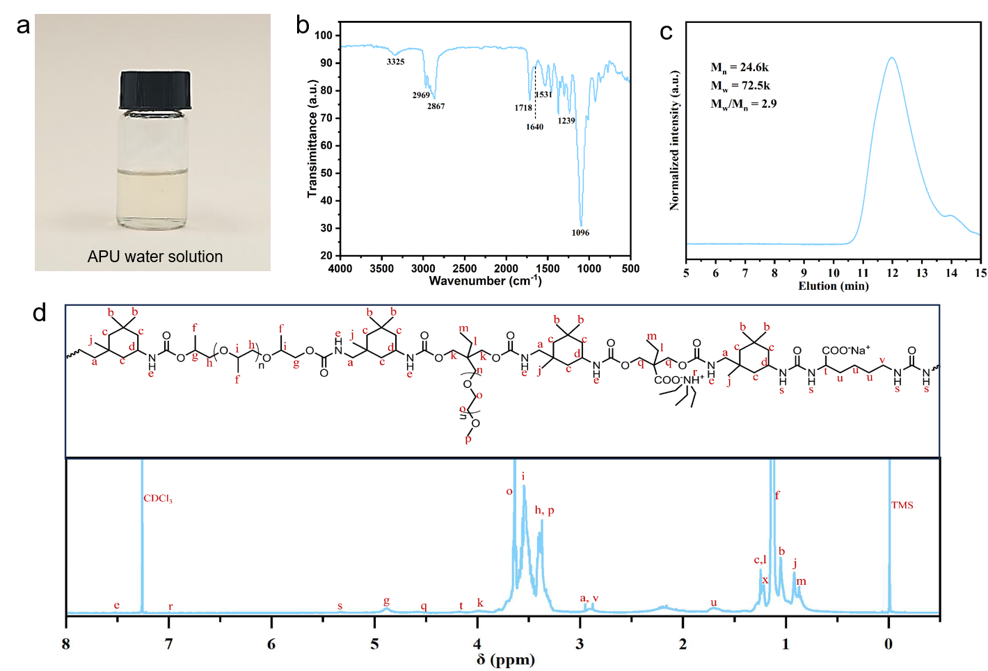
Figure S5. Characterizations of the adhesive polyurethane (APU) material. (a) Photo of APU water solution. (b) FTIR spectrum of APU. (c) GPC spectrum of APU. (d) ¹H-NMR (400 MHz, CDCl₃ δ/ppm) spectrum of APU.

Figure S6. Synthetic route of the non-adhesive polyurethane (NPU) material. For the designed NPU, ethanol-soluble polytetramethylene glycol (PTMG) chain segments and urea groups are incorporated into the soft and hard segments of the molecular chain, respectively. This enables the NPU to be dissolved quickly in ethanol and also improves its flexibility and strength.
Figure S7. Characterizations of the non-adhesive polyurethane (NPU) material. (a) Photo of the originally synthesized NPU aqueous emulsion. (b) Photo of NPU dissolved in ethanol solution. (c) FTIR spectrum of NPU. (d) GPC spectrum of NPU. (e) ¹H-NMR spectrum of NPU. (f) Tensile stress-strain curves of NPU and NPU/AgNF composites with different AgNF loadings.

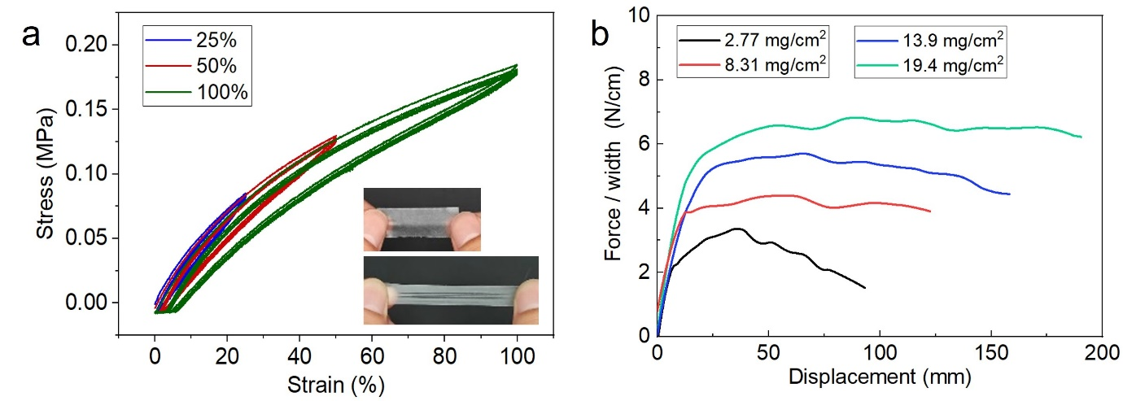
Figure S8. (a) Cyclic stress-strain curves of the synthesized EPU as the backing layer of CARD electrodes, indicating good elasticity and resilience. This can be ascribed to the cross-linked structure in EPU and the polybutadiene chains functioning as molecular springs. (b) Peel force-displacement curves of the APU coated on EPU substrate (APU@EPU) with different APU area densities based on standard 90º peeling test (inset) on glass substrate, indicating high adhesiveness of the synthesized APU material.

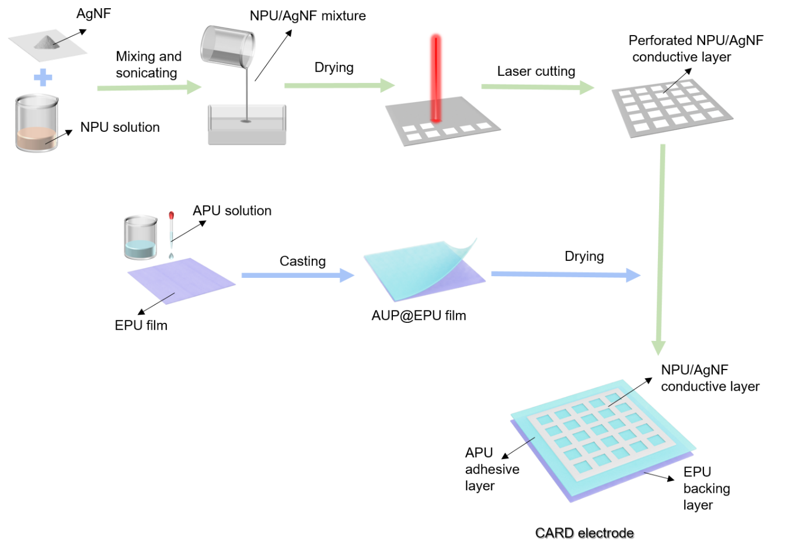
Figure S9. Schematic illustrating the whole fabrication process of the CARD electrodes.

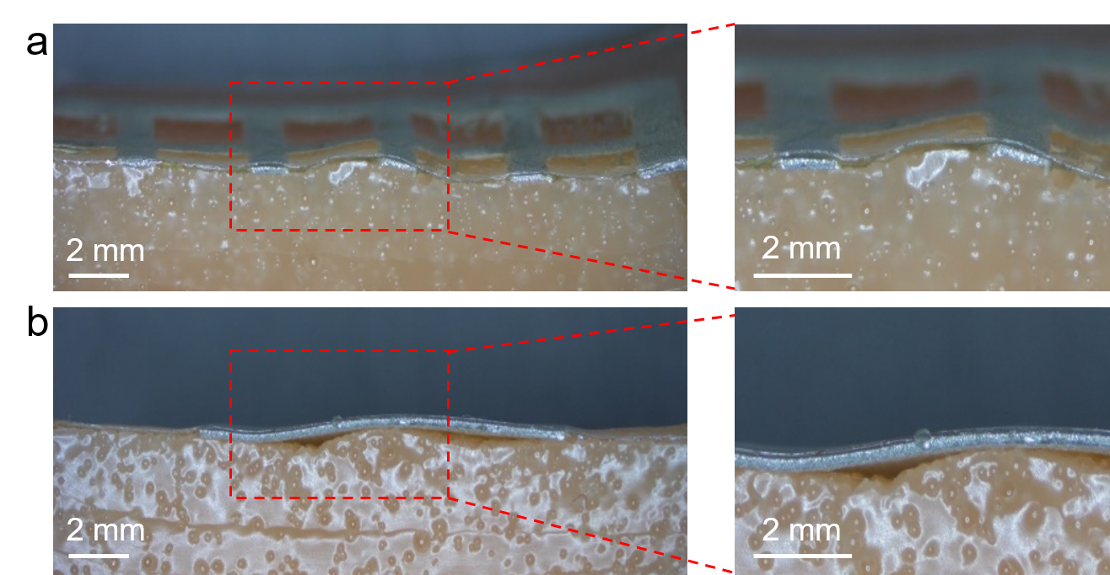
Figure S10. Cross-sectional microscope images showing the interface morphologies of the heterogeneously configured CARD electrodes (a) and homogeneous electrodes (b) attached to a curved skin replica. The homogeneous electrodes (NPU/AgNF) are attached to the skin replica by an adhesive tape for comparison. As clearly observed, the perforated conductive skeleton of the heterogeneously configured CARD electrodes is tightly pressed onto the rugged skin replica, benefiting from the strong adhesion between the adhesive layer and skin replica through the perforated openings. No interfacial gaps or voids are observed between the CARD electrodes and skin replica, confirming the high conformability and robust interfaces of CRAD electrodes with curved surface. In contrast, homogeneous electrodes with similar composition (NPU/AgNF) cannot fully adapt to the curved structure, with obvious interfacial gaps and voids observed between the electrodes and skin replica.

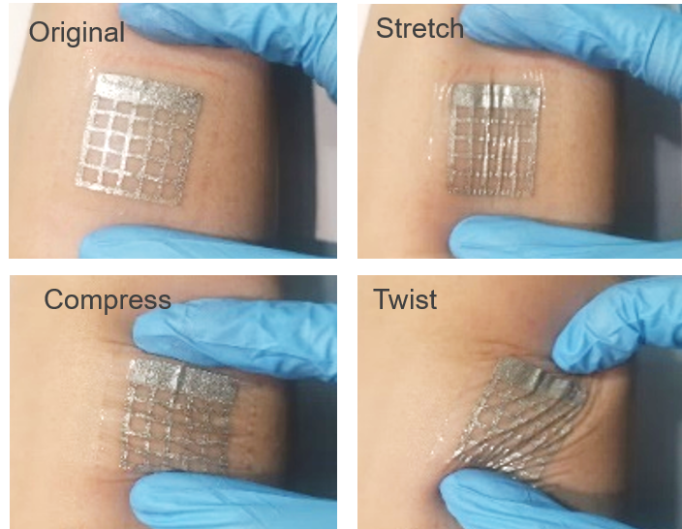
Figure S11. Photographs showing conformal and robust adhesion of CARD electrodes on human skin surface under different deformations.

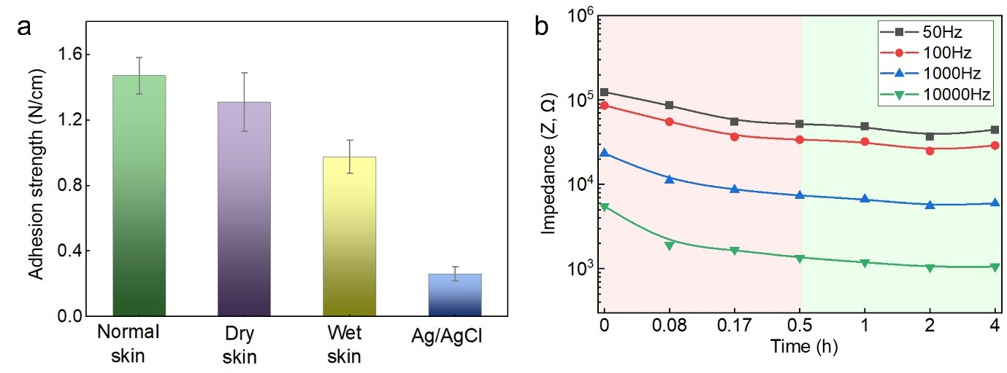
Figure S12. (a) skin adhesion strength of CARD electrodes measured at different skin conditions based on standard 90º peeling test. (b) Impedance variations measured between CARD electrodes and skin at different attachment times. The skin-electrode impedance decreases gradually and begins to saturate after 0.5 h. This can be attributed to the strong mutual adhesion between the adhesive layer and skin, which drives the CARD electrodes to gradually adapt to the viscoelastic skin.

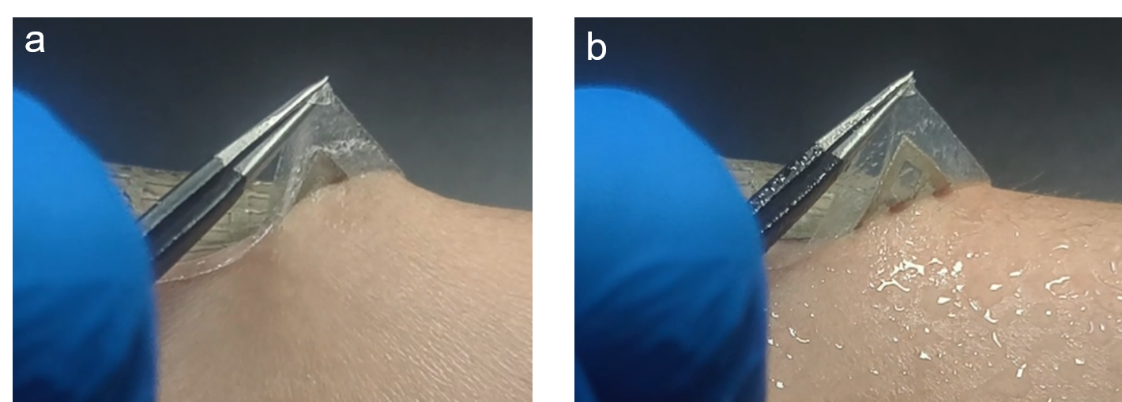
Figure S13. Photographs showing the skin-adhesive properties of the CARD electrode before (a) and after (b) spraying DI water to the interface between electrode and skin. The APU intermediate layer can be fully dissolved by liquid water, which facilitates the painless peeling of the CARD electrode from skin.

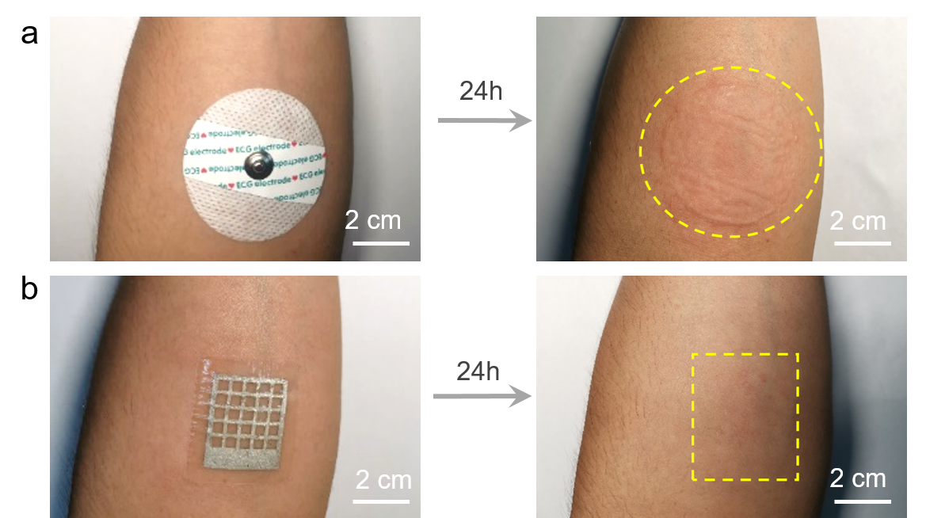
Figure S14. Digital picture showing the skin conditions before and after attaching commercial Ag/AgCl gel electrode (a) and CARD electrodes (b) on forearm for 24 hours. No obvious skin redness or irritability are observed for CARD electrodes, indicating desirable biocompatibility and safety of the CARD electrodes.

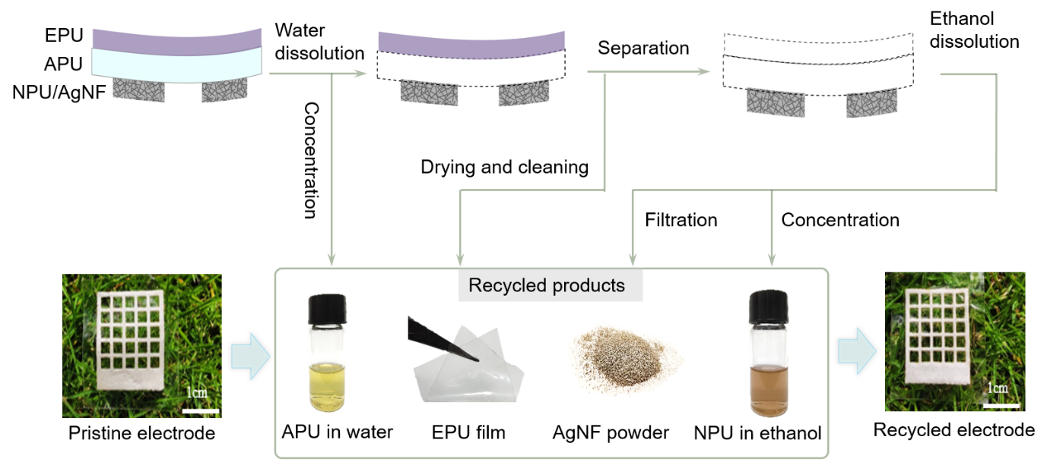
Figure S15. Schematic and digital photos depicting the full recycling process of the CARD electrodes. The EPU, APU and NPU layers are molecularly engineered with different solubility (i.e., insoluble, water-soluble, and ethanol-soluble). This makes it possible to fully recycle all of the electrode ingredients via an eco-friendly process with only water and ethanol used as the solvents. New batches of CARD electrodes were reconstructed with the recycled products.

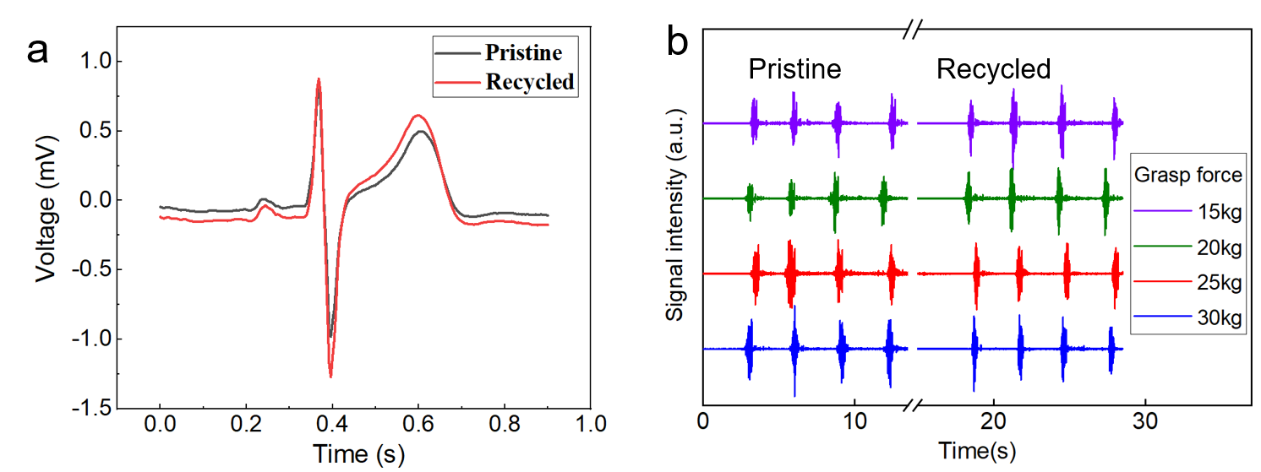
Figure S16. (a) ECG signals recorded with pristine and recycled CARD electrodes. (b) EMG signals recorded by pristine and recycled CARD electrodes. The ECG and EMG signals recorded with pristine and recycled CARD electrodes exhibit similar signal qualities. These results indicate that the recycling and regenerating processes do not deteriorate the performance of CARD electrodes, which is beneficial for the repeated use of the electrodes.

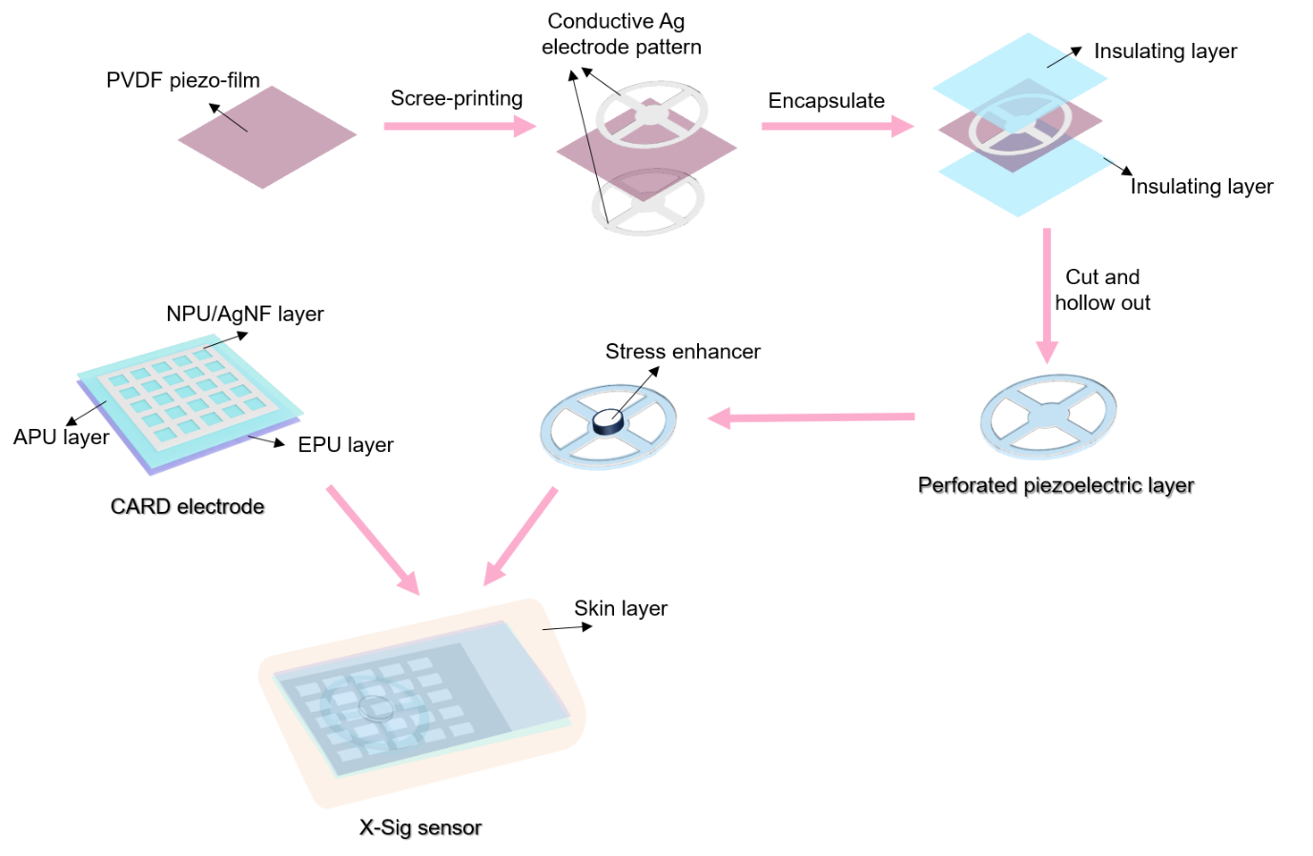
Figure S17. Schematic illustrating the fabrication process of X-Sig sensor based on CARD electrode and perforated piezoelectric sensing layer.

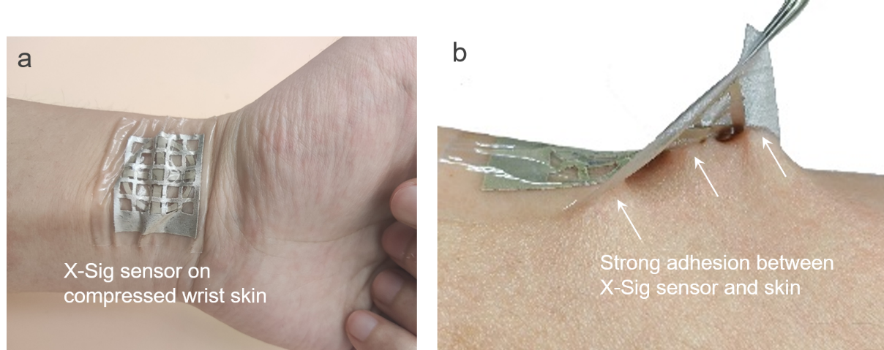
Figure S18. Photographs showing the conformal contact of the X-Sig sensor on compressed wrist skin (a) and strong adhesion between the X-Sig sensor and skin during peeling process (b).

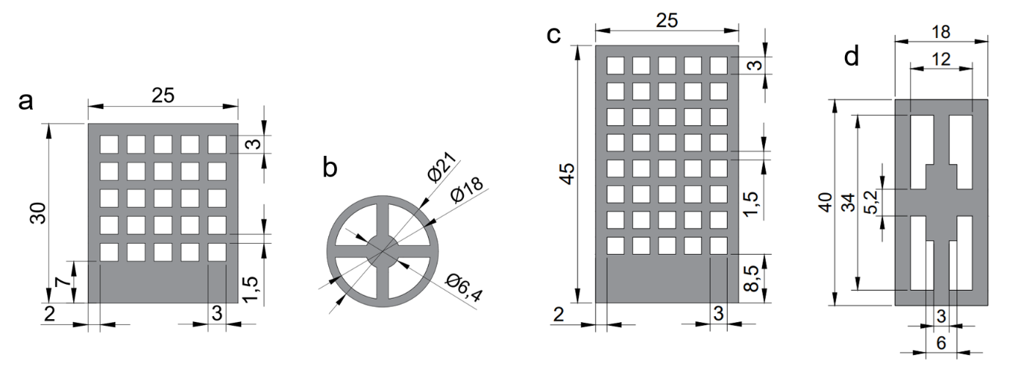
Figure S19. Diagram showing the pattern and dimensions of the perforated conductive layer in CARD electrode and the perforated piezoelectric layer in X-Sig sensor for RPW signal detection (a-b) and for FMG signal detection (c-d). Units for a-d: mm.

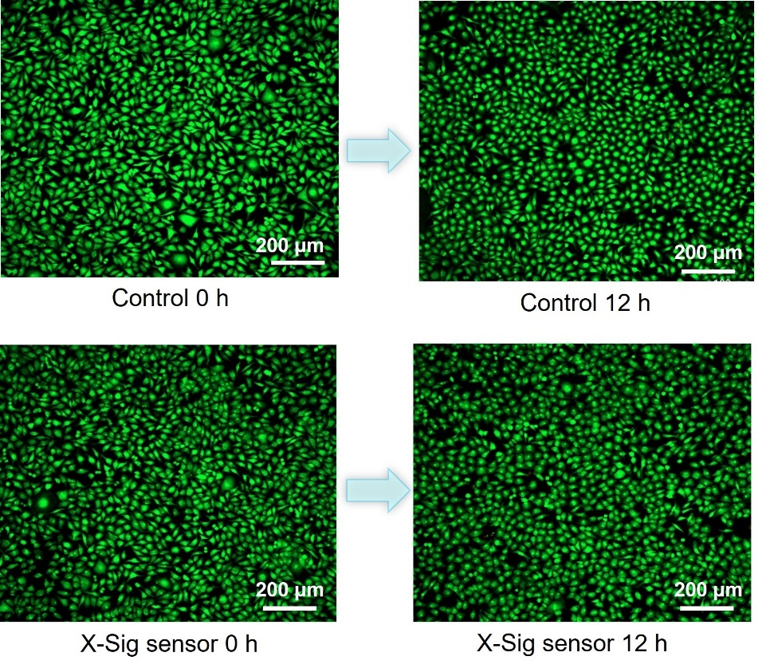
Figure S20. Cell viability test with or without C-MEB sensor extract solution (1 mg/mL). L929 cells and calcein-AM/PI double staining kit were used for the cell viability test.

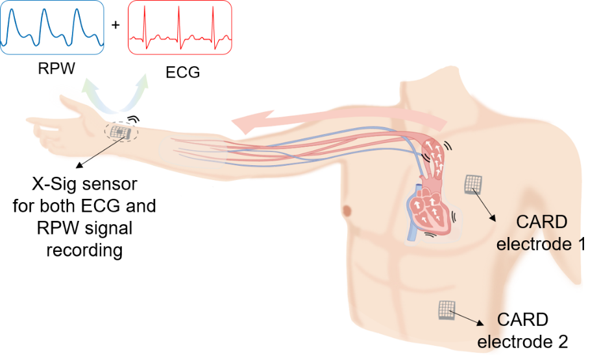
Figure S21. Schematic illustrating the attachment of a X-Sig sensor to the radial artery position of the subject’s right hand to record both RPW and ECG signals. Another two CARD electrodes are affixed to the subject's left chest and left abdomen to assist ECG signal recording.

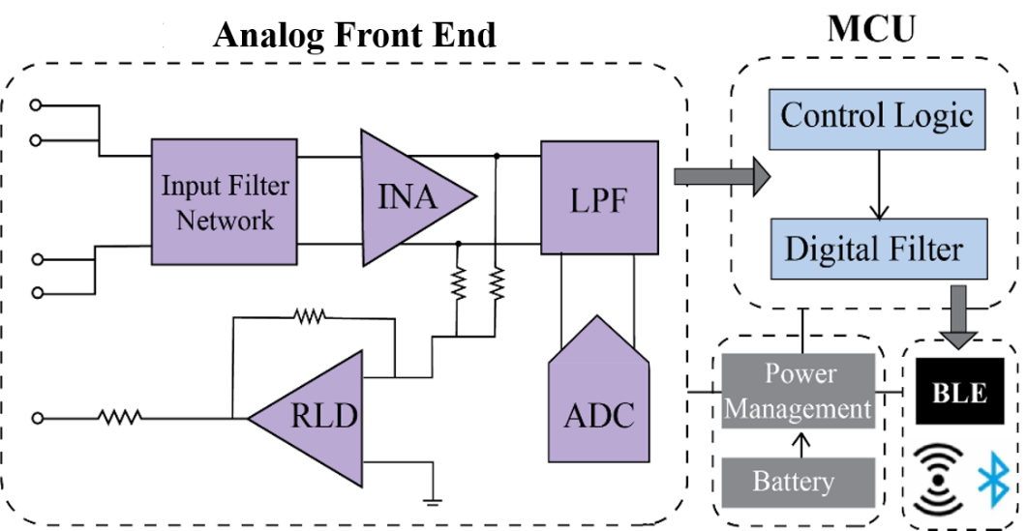
Figure S22. Diagram illustrating the data acquisition circuit for recording ECG signals and ECG- RPW fused signals for analysis of dynamic haemodynamics. The circuit mainly consists of an analog front end, an MCU, a low-power BLE module, and a battery.

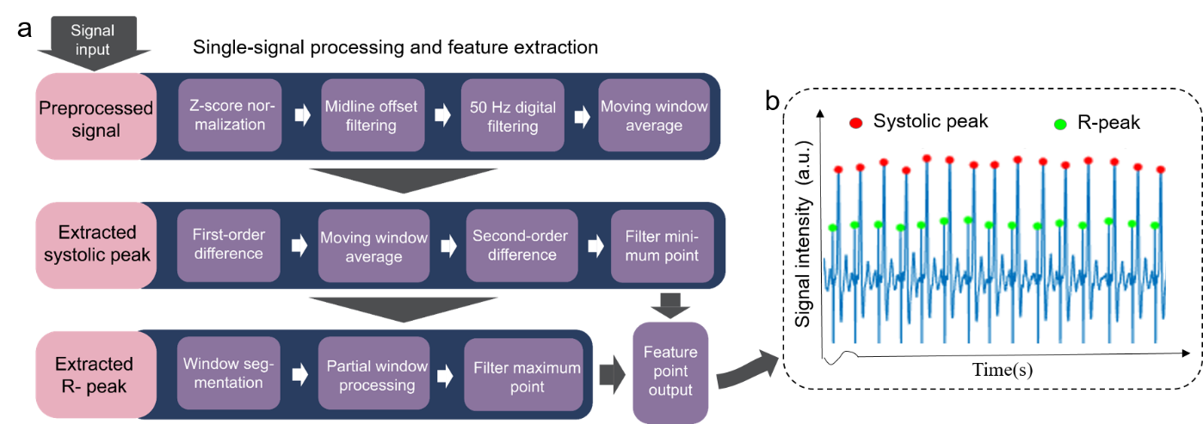
Figure S23. (a) Schematic diagram showing the signal processing as well as feature extraction method for both RPW feature (e.g., systolic peak) and ECG feature (e.g., R peak) from the fused single-channel signal. (b) The real-time extracted systolic peak and R peak from the single-channel signal.

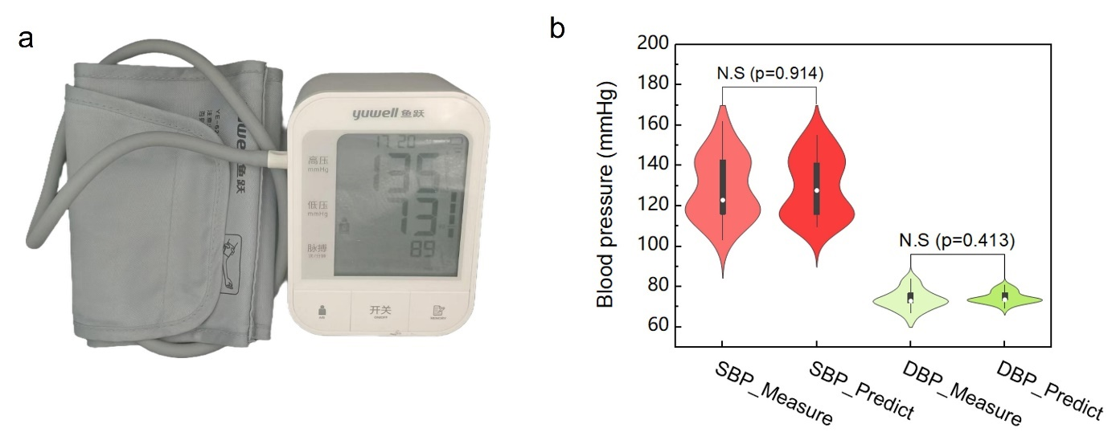
Figure S24. (a) Picture showing the commercial electronic sphygmomanometer used for blood pressure measurement and calibration. (b) Violin plots of the predicted and measured diastolic blood pressure (DBP) and systolic blood pressure (SBP), n=25. The predicted BP values via our sensor are in good agreement with the practically measured values using the commercial sphygmomanometer.

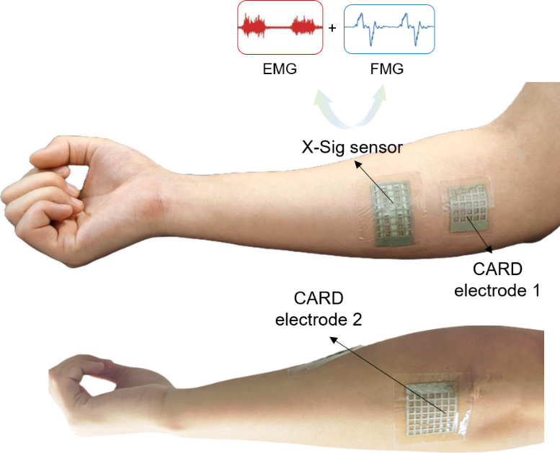
Figure S25. Picture showing the attaching position of the X-Sig sensor on the forearm for resolving elusive musculation and classifying hand gestures based on FMG, EMG, and FMG-EMG fused signals. The X-Sig sensor is attached to the flexor digitorum superficialis. Two CARD electrodes are used as auxiliary and reference electrodes to assist EMG recording.

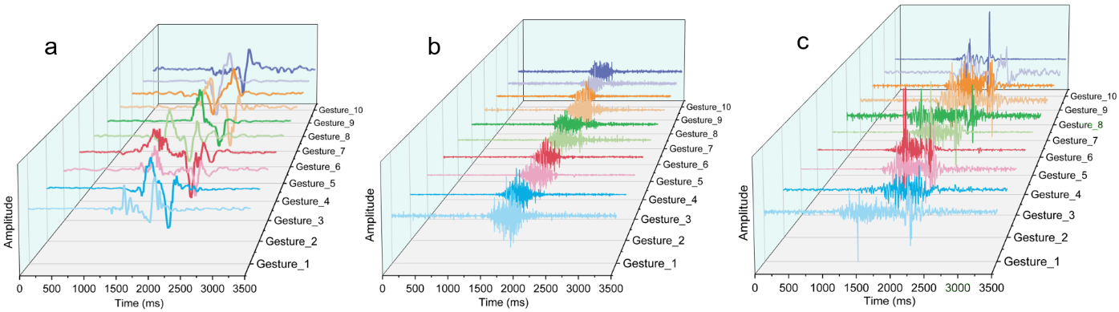
Figure S26. Representative FMG signal (a), EMG signal (b), and FMG-EMG fused signal (c) when the participant performed ten distinct hand gestures.

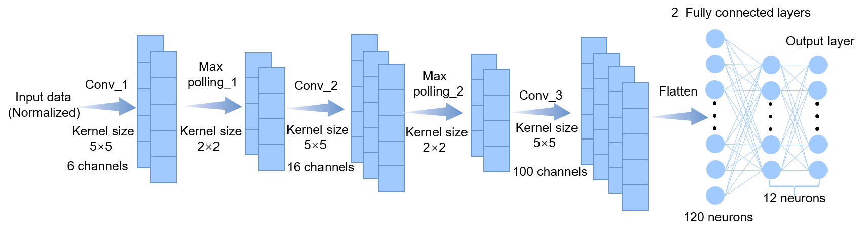
Figure S27. Diagram showing the architecture of the CNN model used for gesture recognition based on FMG signal, EMG signal and FMG-EMG fused signal.

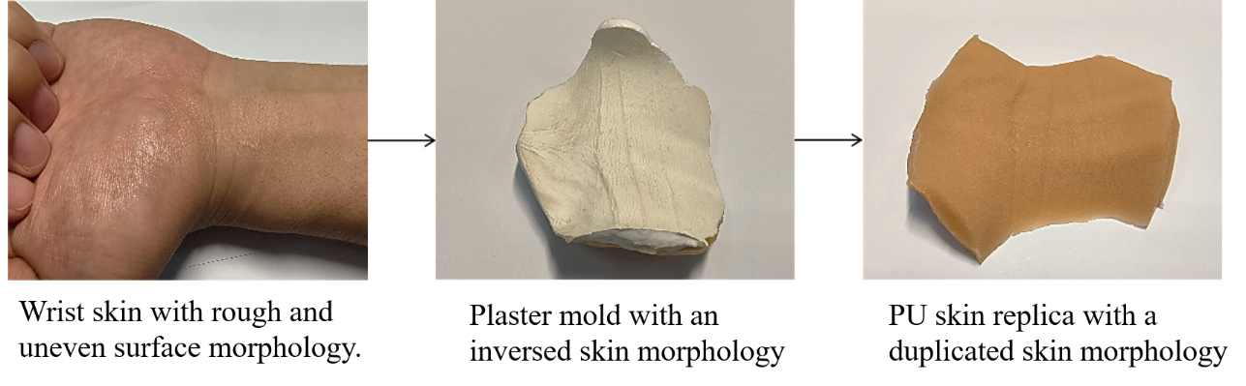
Figure S28. Photographs showing the fabrication process of skin replica using medical gypsum.

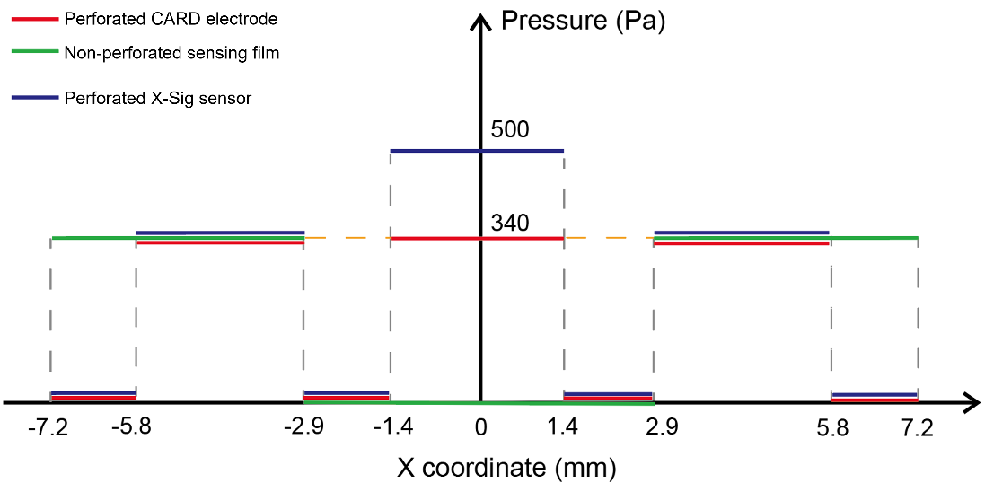
Figure S29. Simulated pressure distribution to mimic the adhesion distribution between top adhesive layer and bottom targeted surface.

Table S1. Comparison of different adhesive epidermal electrodes for biopotential signal recording
Materials system | Adhesion strength (N/cm) | Impedance@10Hz  (kΩ*cm²) | Electrode type | References
Gallium Indium Alloy/Pressure Sensitive Adhesive (PSA) | 0.36 | ≈ 40 | Ultrathin Tattoo | [S1]: Adv. Sci. 2022, 9, 2202043.
Silk Fibroin (SF)/Polypyrrole (PPy) | 0.4 | ≈ 300 | Conductive composite | [S2]: ACS Materials Lett. 2020, 2, 478−484.
Waterborne Polyurethane (WPU)/ PEDOT:PSS/D-sorbitol | 0.6 | ≈ 75 | Ultrathin Tattoo | [S3]: Nat. Commun. 2020, 11, 4683.
Water Polyurethane (WPU)/Deep Eutectic Solvent (DES)/Tannic Acid (TA) | 0.13 | ≈ 15.8 | Ionogels | [S4]: ACS Appl. Mater. Interfaces 2021, 13, 20735−20745.
PEDOT:PSS/Polyvinyl Alcohol (PVA)/Tannic Acid (TA)/Ethylene Glycol (EG) | 0.32 | ≈ 256 | Conductive composite | [S5]: ACS Appl. Mater. Interfaces 2022, 14, 39159−39171.
Thermoplastic Rubber (TPE)/AgNW | 0.21 | ≈ 350 | Ultrathin Tattoo | [S6]: Adv. Electron. Mater. 2020, 6, 2000306.
Hydroxypropyl Methylcellulose (HPMC)/PEDOT:PSS/Ag | 0.07 | ≈ 200 | Ultrathin Tattoo | [S7]: Chem. Eng. J. 2024, 490, 151118.
Alginate–Polyacrylamide (Alg-PAAm)/LiCl | 0.9 | ≈ 12.7 | Ionogels | [S8]: Adv. Mater. 2020, 32, 2003723.
Polyacrylamide (PAAM)/poly[2(methacryloyloxy)ethyl] dimethyl-(3-sulfopropyl) ammonium hydroxide (PSBMA)/Laponite XLG/Al³⁺/Tannic Acid(TA)/Glycerine | 0.59 | ≈ 200 | Ionogels | [S9]: Adv. Funct. Mater. 2022, 32, 2200457.
Thermoplastic polyurethane (TPU)/Cpolyacrylamids (PAM) /Calcium alginate microspheres (Ca-Alg) | 0.3 | ≈ 400 | Hydrogel–elastomer hybrid | [S10]: Adv. Funct. Mater. 2020, 30, 1909540.
Thermoplastic polyurethane (TPU)/AgNWs/Poly(N-isopropylacrylamide) (PNIPAm) | 0.69 | ≈ 500 | Temperature-Triggered Adhesive | [S11]: Chem. Eng. J. 2024, 488 150459.
EPU/APU/NPU-AgNF | 1.47 | 77.7 | Heterogeneous & hierarchical electrode | This work

Table S2. Comparison of DBP & SBP monitoring with different sensors and methodologies
Method | Signal channel number | DBP  (ME/SD) | SBP  (ME/SD) | Demonstrated BP measurement | References
Piezoelectric pressure sensor | 2 | 0.11/3.68 | -0.05/4.61 | Dynamic BP | [S12]: Nat. Commun. 2023, 14, 5009.
PPG | 2 | -0.91/3.84 | -0.36/3.36 | Static BP | [S13] Annu. Int. Conf. IEEE Eng. Med. Biol. Soc. 2017:1712-1715.
PPG | 2 | 2.12/0.26 | 2.94/0.72 | Static BP | [S14]: IEEE Sensors J. 2022, 22, 2475–2483.
ECG+PPG | 2 | 3.23/4.75 | 4.43/6.09 | Static BP | [S15]: Opt. Quantum Electron. 2021,53, 93.
Piezoelectric ultrasound transducer | 32 | 0.17/4.92 | 0.17/4.92 | Dynamic BP | [S16]: Nat. Biotechnol. 2024,42, 448–457.
Resistive pressure sensor+ECG | 2 | 0.24/5.19 | 0.07/9.66 | Dynamic BP | [S17]: Biosens. Bioelectron. 2022, 205, 114072.
Bioimpedance sensor | 4 | 0.11/3.97 | 0.11/5.27 | Dynamic BP | [S18]: npj Digital Med. 2023, 6, 59.
PPG | 2 | -0.97/4.58 | -0.81/4.57 | Static BP | [S19]: Microsyst Nanoeng. 2023,9, 117.
Bioimpedance sensor | 6 | 0.79/6.6 | 0.8/5 | Dynamic BP | [S20]: Sci. Rep. 2022,12, 319.
Bioimpedance tattoos | 2 | 0.2/4.5 | 0.2/5.8 | Dynamic BP | [S21]: Nat. Nanotechnol. 2022,17, 864–870
ECG+PPG | 2 | 0.9/5.6 | 0.6/9.8 | Static BP | [S22]: Conf. Proc. IEEE Eng. Med. Biol. Soc. 2005, 2005, 5877-5880.
ECG+PPG | 2 | -0.08/4.06 | -0.37/5.21 | Static BP | [S23]: IEEE Trans. Biomed. Eng. 2016,63, 964–972.
Cross-modal sensor | 1 | 0.96/3.51 | -0.43/6.11 | Dynamic BP | This work
PPG: Photoplethysmography
ECG: Electrocardiogram
ME/SD: Mean Difference/ Standard Deviation

Captions for Supplementary Movies

Movie S1. Water assisted peeling process of adhesive CARD electrode from skin surface.
Movie S2. Continuous monitoring of ECG signal with X-Sig sensor under different skin deformations.
Movie S3. Continuous monitoring of HR, SBP, and DBP with X-Sig sensor. A commercial sphygmomanometer is employed for reference.

Supplementary References
S1. Tang L, Yang S, Zhang K, Jiang X. Skin Electronics from Biocompatible In Situ Welding Enabled By Intrinsically Sticky Conductors. Adv Sci 9, 2202043 (2022).
S2. Yang H, et al. Adhesive Biocomposite Electrodes on Sweaty Skin for Long-Term Continuous Electrophysiological Monitoring. ACS Mater Lett 2, 478-484 (2020).
S3. Zhang L, et al. Fully organic compliant dry electrodes self-adhesive to skin for long-term motion-robust epidermal biopotential monitoring. Nat Commun 11, 4683 (2020).
S4. Wang S, et al. Self-Adhesive, Stretchable, Biocompatible, and Conductive Nonvolatile Eutectogels as Wearable Conformal Strain and Pressure Sensors and Biopotential Electrodes for Precise Health Monitoring. ACS Appl Mater Interfaces 13, 20735-20745 (2021).
S5. Cao J, et al. Stretchable and Self-Adhesive PEDOT:PSS Blend with High Sweat Tolerance as Conformal Biopotential Dry Electrodes. ACS Appl Mater Interfaces 14, 39159-39171 (2022).
S6. Yang X, et al. Ultrathin, Stretchable, and Breathable Epidermal Electronics Based on a Facile Bubble Blowing Method. Adv Electron Mater 6, 2000306 (2020).
S7. Ma C, et al. Compliant and breathable electrospun epidermal electrode towards artifact-free electrophysiological monitoring. Chem Eng J 490, 151118 (2024).
S8. Pan L, et al. A Compliant Ionic Adhesive Electrode with Ultralow Bioelectronic Impedance. Adv Mater 32, 2003723 (2020).
S9. Yang G, et al. Adhesive and Hydrophobic Bilayer Hydrogel Enabled On‐Skin Biosensors for High‐Fidelity Classification of Human Emotion. Adv Funct Mater 32, 2200457 (2022).
S10. Pan S, et al. Mechanically Interlocked Hydrogel–Elastomer Hybrids for On‐Skin Electronics. Adv Funct Mater 30, 1909540 (2020).
S11. Zheng Y, et al. Skin Temperature-Triggered Switchable Adhesive Coatings for Wearing Comfortable Epidermal Electronics. Chem Eng J 488, 150459 (2024).
S12. Li J, et al. Thin, soft, wearable system for continuous wireless monitoring of artery blood pressure. Nat Commun 14, 5009 (2023).
S13. Chen Y, Cheng S, Wang T, Ma T. Novel blood pressure estimation method using single photoplethysmography feature. In: 2017 39th Annual International Conference of the IEEE Engineering in Medicine and Biology Society (EMBC)) (2017).
S14. Byfield R, Miller M, Miles J, Guidoboni G, Lin J. Towards Robust Blood Pressure Estimation From Pulse Wave Velocity Measured by Photoplethysmography Sensors. IEEE Sens J 22, 2475-2483 (2022).
S15. Yang S, Zhang Y, Cho S-Y, Correia R, Morgan SP. Non-invasive cuff-less blood pressure estimation using a hybrid deep learning model. Opt Quantum Electron 53, 1-20 (2021).
S16. Lin M, et al. A fully integrated wearable ultrasound system to monitor deep tissues in moving subjects. Nat Biotechnol 42, 448-457 (2023).
S17. Gong S, et al. A gold nanowire-integrated soft wearable system for dynamic continuous non-invasive cardiac monitoring. Biosens Bioelectron 205, 114072 (2022).
S18. Sel K, Osman D, Huerta N, Edgar A, Pettigrew RI, Jafari R. Continuous cuffless blood pressure monitoring with a wearable ring bioimpedance device. npj Digital Med 6, 59 (2023).
S19. Wang L, Tian S, Zhu R. A new method of continuous blood pressure monitoring using multichannel sensing signals on the wrist. Microsyst Nanoeng 9, 117 (2023).
S20. Ibrahim B, Jafari R. Cuffless blood pressure monitoring from a wristband with calibration-free algorithms for sensing location based on bio-impedance sensor array and autoencoder. Sci Rep 12, 319 (2022).
S21. Kireev D, et al. Continuous cuffless monitoring of arterial blood pressure via graphene bioimpedance tattoos. Nat Nanotechnol 17, 864-870 (2022).
S22. Poon CCY, Zhang YT. Cuff-less and Noninvasive Measurements of Arterial Blood Pressure by Pulse Transit Time. 2005 IEEE Engineering in Medicine and Biology 27th Annual Conference, 5877-5880 (2005).
S23. Ding X-R, Zhang Y-T, Liu J, Dai W-X, Tsang HK. Continuous Cuffless Blood Pressure Estimation Using Pulse Transit Time and Photoplethysmogram Intensity Ratio. IEEE Trans Biomed Eng 63, 964-972 (2016).

