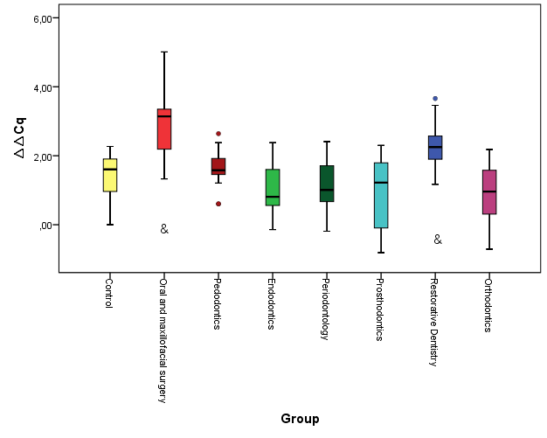
Graph 1. Box plots showing the distribution of the ∆∆Cq parameter in the groups. The value of telomere length was calculated from ΔΔCq. &p < 0.001 significant difference compared to the control group.

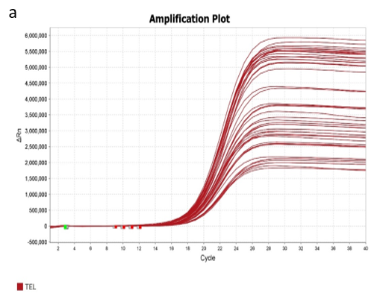

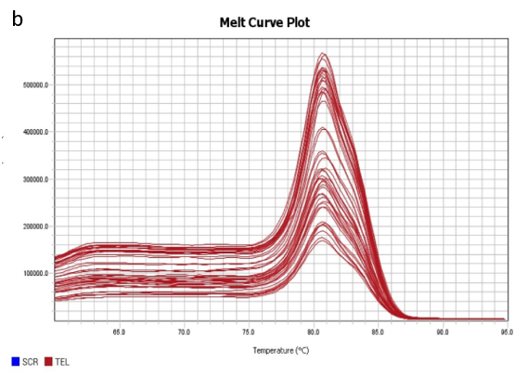
Graph 2. Real-Time PCR reaction performed using telomere primers a) Amplification, b) Melting curve graph

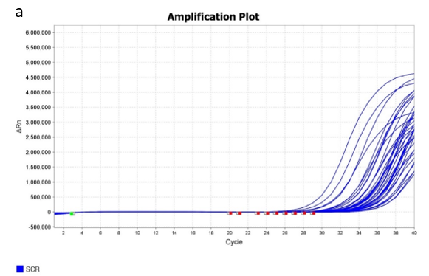

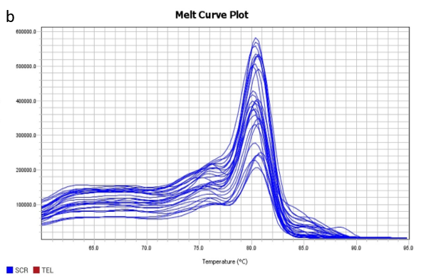
Graph 3. Real-Time PCR reaction performed using SCR primers a) Amplification, b) Melting curve graph

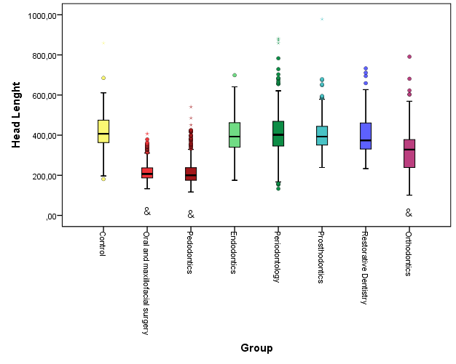
Graph 4. Box plots showing the distribution of head length values in the groups. &p < 0.001 significant difference compared to the control group.

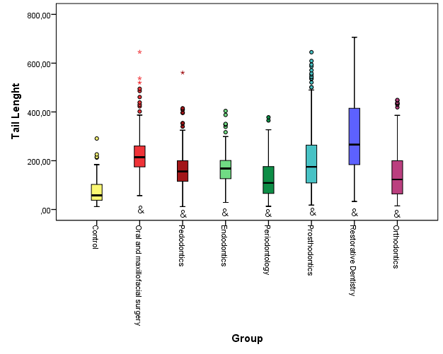
Graph 5. Box plots showing the distribution of tail length values in the groups. &p < 0.001 significant difference compared to the control group.
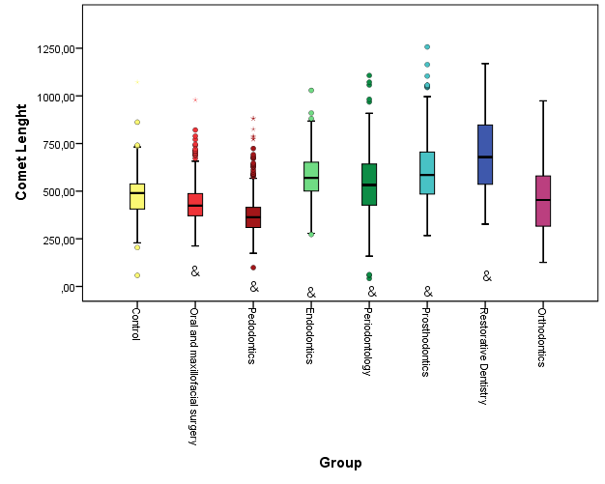
Graph 6. Box plots showing the distribution of comet length values in the groups. &p < 0.001 significant difference compared to the control group.

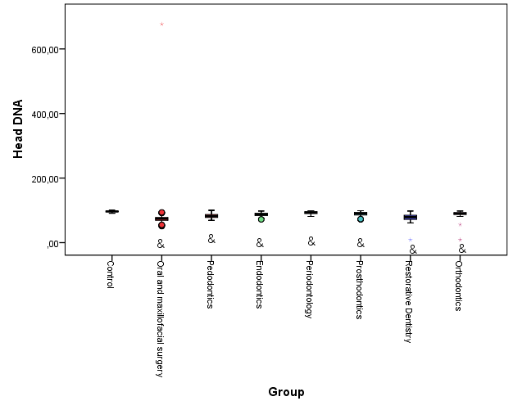
Graph 7. Box plots showing the distribution of head DNA values in the groups. &p < 0.001 significant difference compared to the control group.
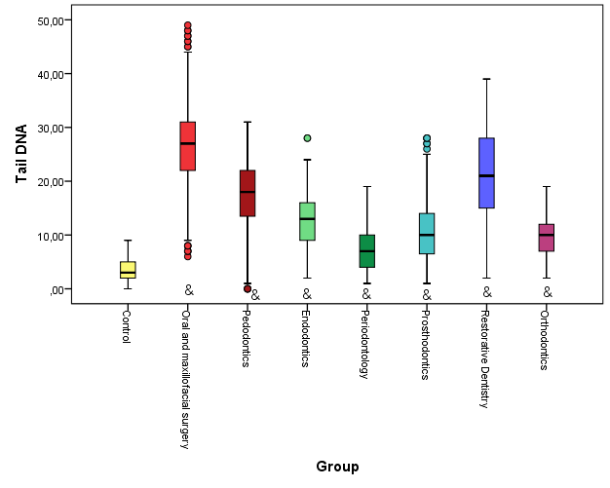
Graph 8. Box plots showing the distribution of tail DNA values in the groups. &p < 0.001 significant difference compared to the control group.

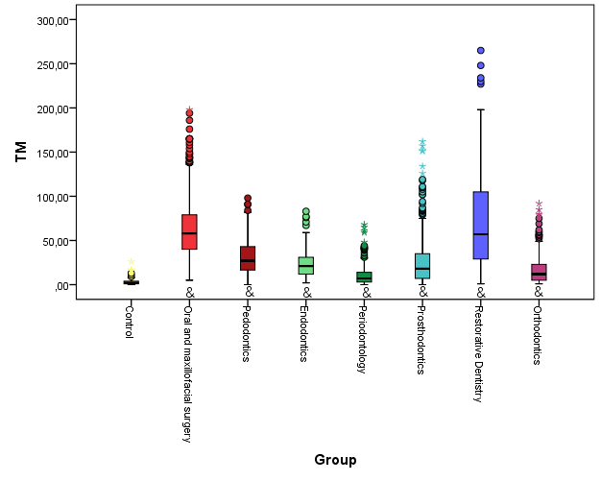
Graph 9. Box plots showing the distribution of TM (tail moment) values in the groups. &p < 0.001 significant difference compared to the control group.
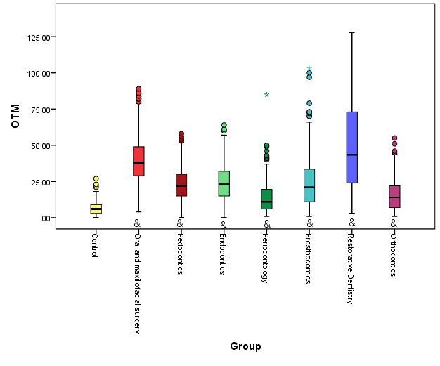
Graph 10. Box plots showing the distribution of OTM (olive tail moment) values in the groups. &p < 0.001 significant difference compared to the control group.

