Supporting Figure 1: Comparison of seasonal mean precipitation composite anomalies (mm/day) for Excess, Deficient, and Normal years between GPCP, MMCFSv1, and MMCFSv2. These years are classified based on the normalized values from individual datasets—observations and models.

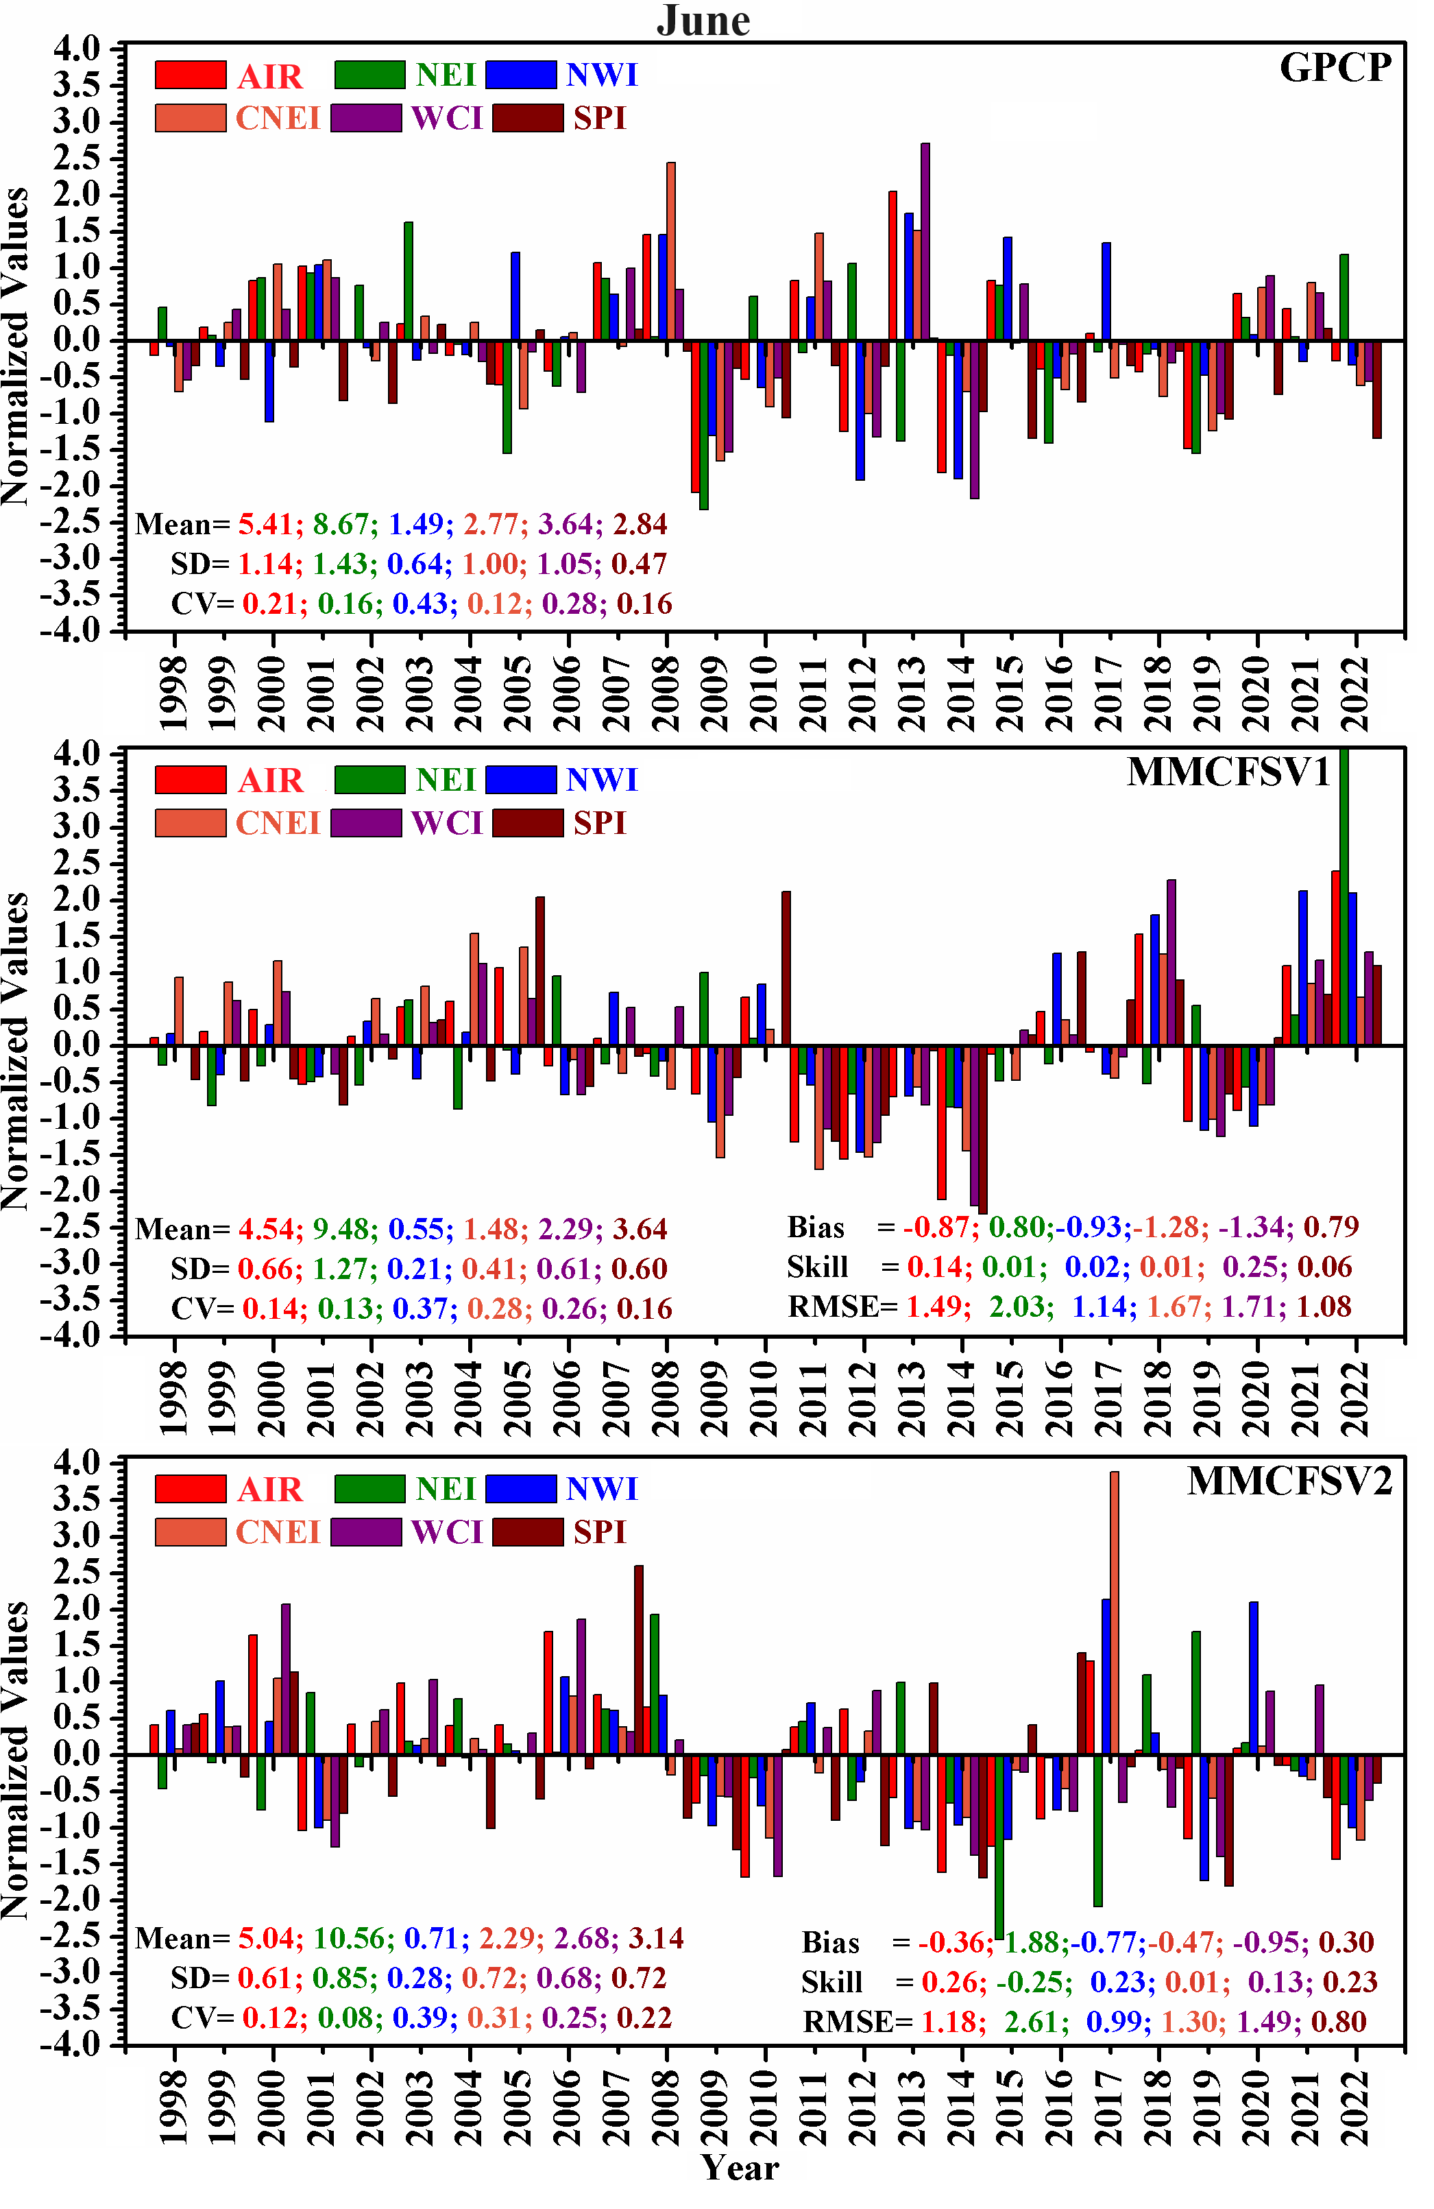
Supporting Figure 2: Inter-annual variability of ISMR (June) over India (AIR) and five homogeneous regions from GPCP, MMCFSv1, and MMCFSv2 from 1998 – 2022. Precipitation Mean (mm/day), Standard Deviation (S.D.), and Coefficient of Variation (CV) are mentioned for AIR and each of the five homogeneous regions.
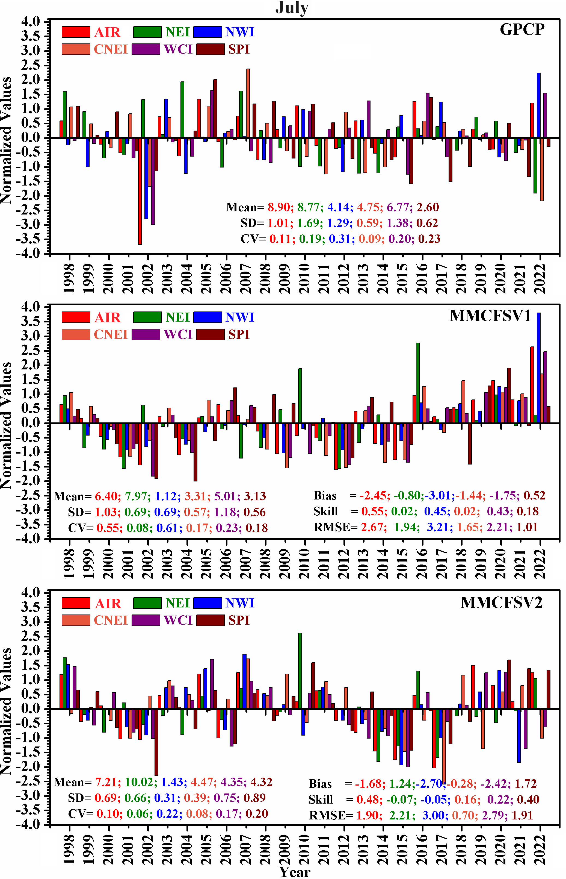
Supporting Figure 3. Same as Supporting Figure 1, but inter-annual variability of ISMR during July.
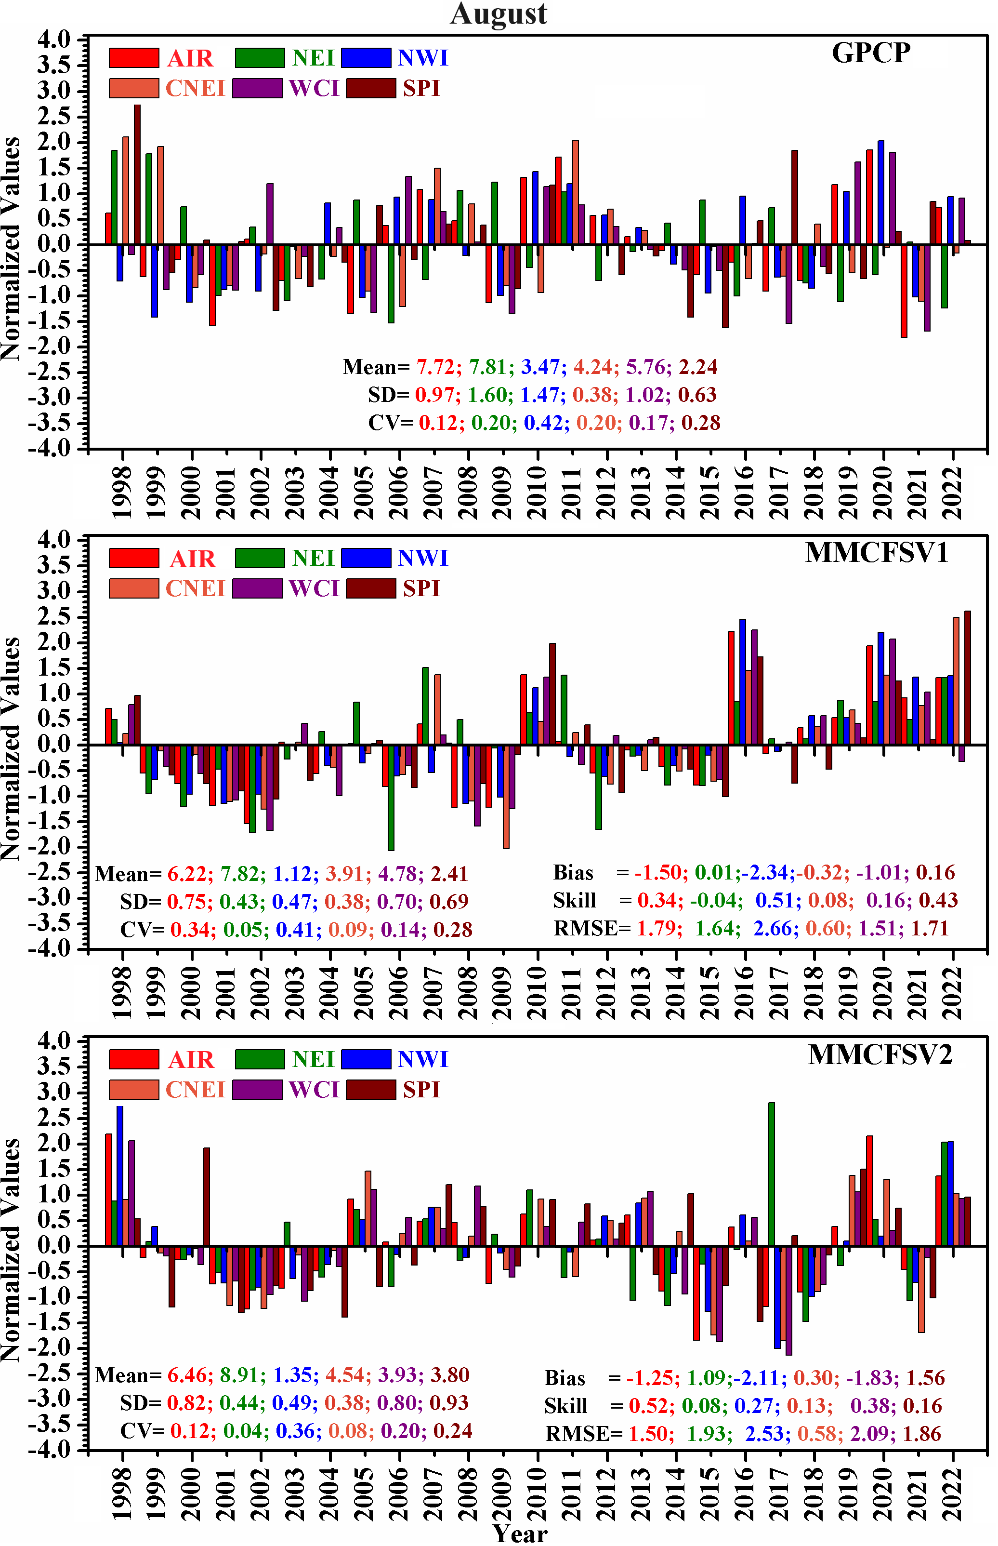
Supporting Figure 4. Same as Supporting Figure 1, but inter-annual variability of ISMR during August.
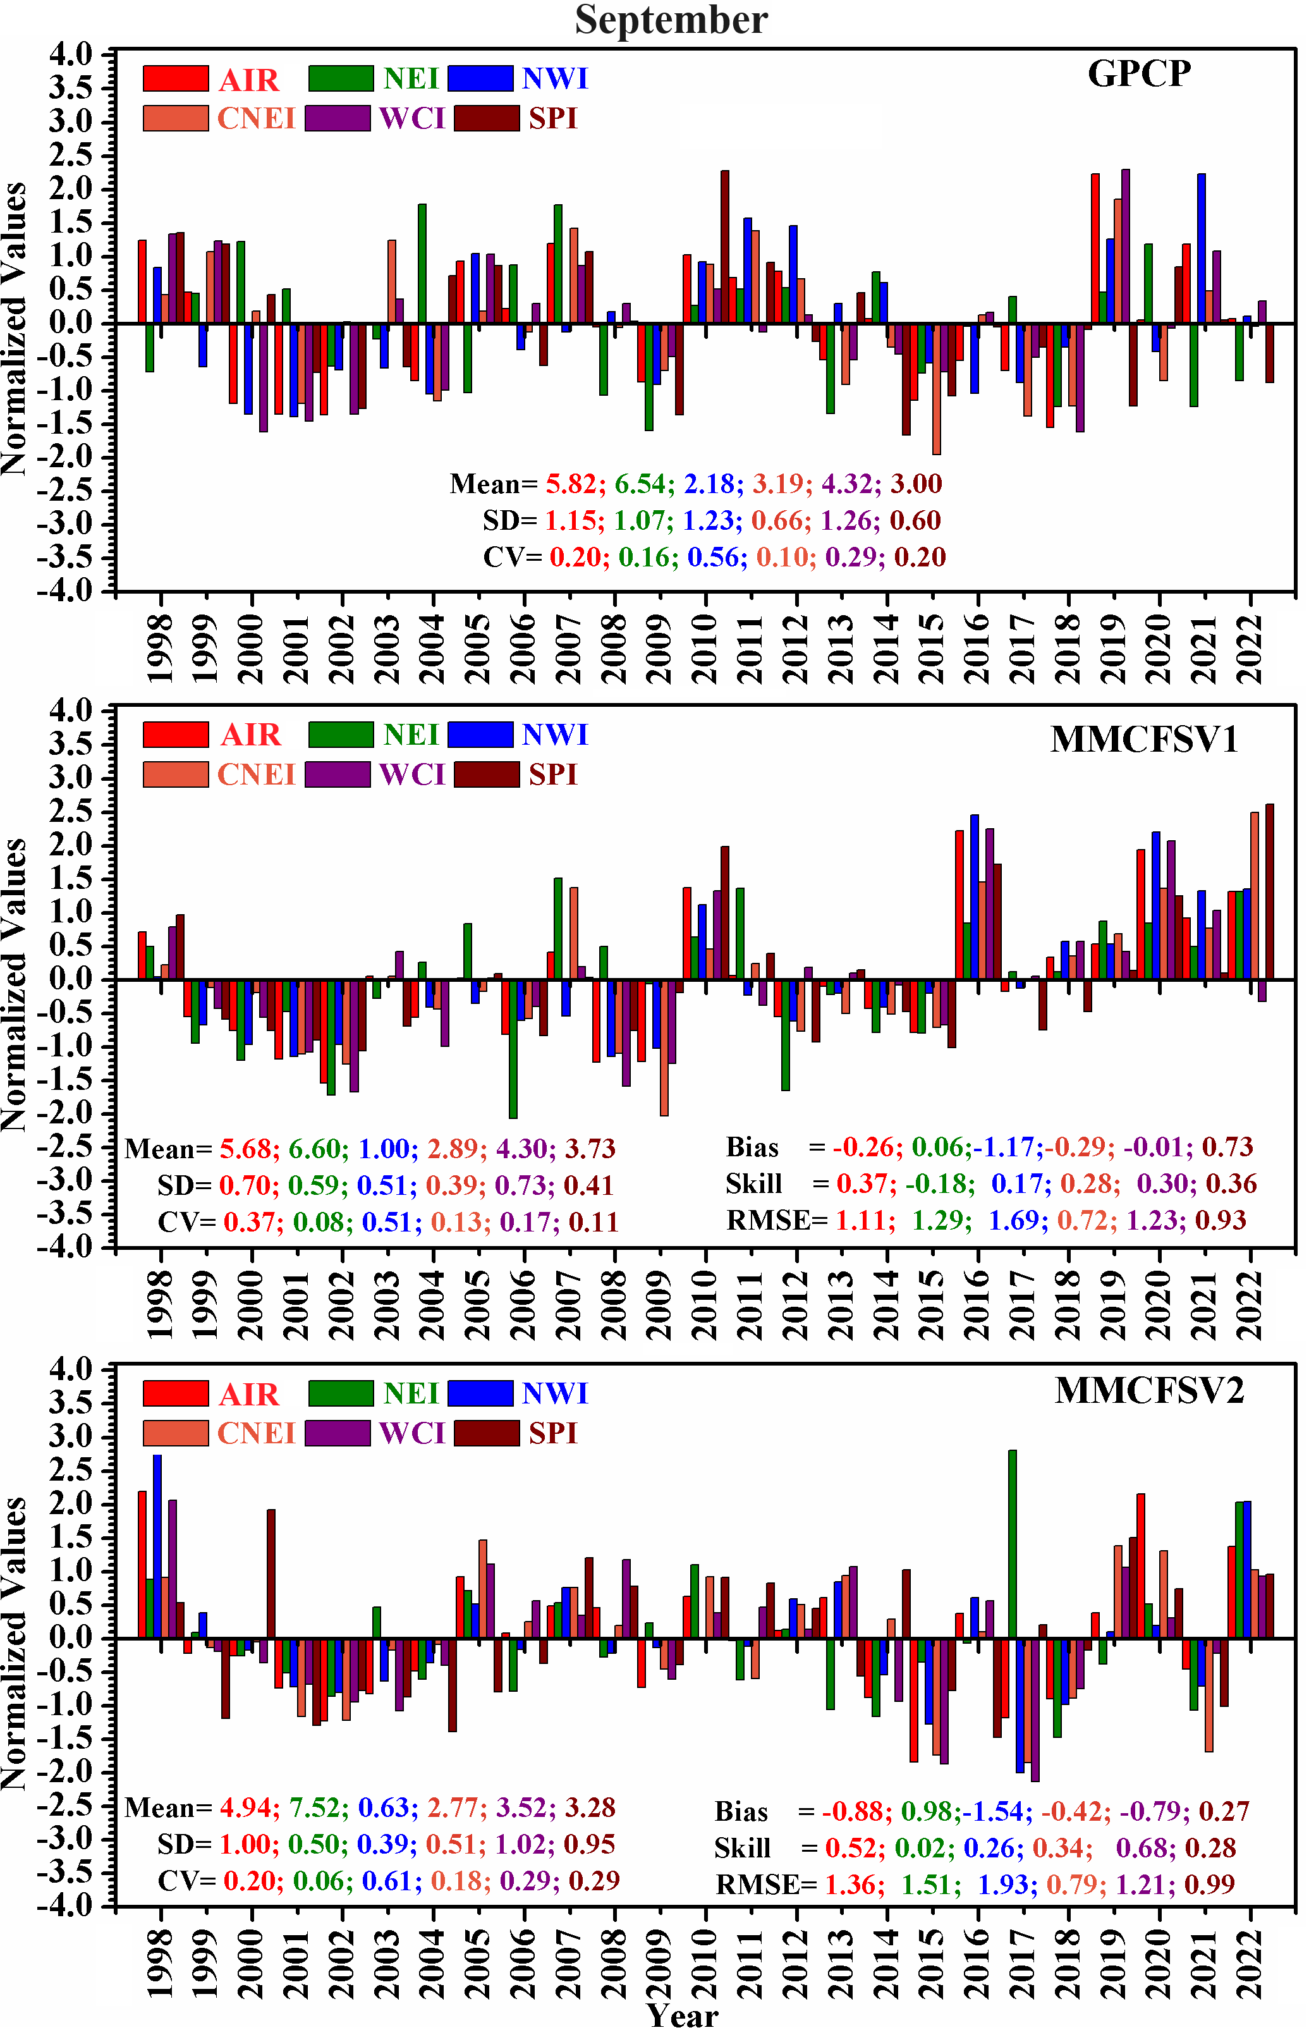
Supporting Figure 5. Same as Supporting Figure 1, but inter-annual variability of ISMR during September.

