The Cost of Urban Expansion: Habitat Loss and Shifting Distribution of Long-Legged Wading Birds in a Peri-Urban landscape gradient
Anindya Naskar^{1,2}(ORCID: 0000-0003-3248-3898), Gopinathan Maheswaran^{1*}(ORCID: 0000-0003-2496-9556)
¹Zoological Survey of India, M-Block, New Alipore, Kolkata 700 053, India
²Department of Zoology, University of Calcutta, 35, Ballygunge Circular Road, Kolkata 700 019, India
* Corresponding author: maheswaran@zsi.gov.in
Supplementary Material

S1 table: Description of different spectral indices used for LULC
Index | Formula | Definition
EVI (Enhanced vegetation index) | (2.5 * (NIR - RED)) / (NIR + 6 * RED - 7.5 * BLUE + 1) | It measures vegetation greenness using near-infrared (NIR) and red spectral bands, like NDVI. However, it offers improved sensitivity in regions with dense vegetation by minimizing atmospheric disturbances and background canopy noise; ranges between −1 to +1
NBR (Normalized Burn Ratio) | (NIR - SWIR2) / (NIR + SWIR2) | NBR (Normalized Burn Ratio) is designed to identify burned areas and assess fire severity using the difference between near-infrared (NIR) and shortwave infrared (SWIR) reflectance; ranges between −1 and +1
NDWI (Normalized difference  Water index) | GREEN - SWIR) / (GREEN + SWIR) | NDWI (Normalized Difference Water Index) is used to enhance and detect water bodies by leveraging the reflectance difference between the near-infrared (NIR) and green bands. Higher NDWI values typically indicate water presence; ranges between −1 and +1
NDMI (Normalized difference  moisture index) | (NIR - SWIR1) / (NIR + SWIR1) | Estimates vegetation water content in plants using near-infrared (NIR) and shortwave infrared (SWIR) spectral bands; ranges between −1 and +1; higher values indicate greater vegetation water content
NDBI (Normalized difference  built-up index) | (SWIR1 - NIR) / (SWIR1 + NIR) | Used to highlights the built-up urban areas using the difference between shortwave infrared (SWIR) and near-infrared (NIR) spectral bands; ranges between −1 and +1
NDBaI (Normalized Difference Bareness Index) | (SWIR1 - SWIR2) / (SWIR1 + SWIR2) | It is developed to map bare land features by combining information from built-up and bare soil indicators; ranges between −1 and +1

S2 table: Description of the seasonal changes of different phases
Season | Month | Description
Stage 1 | October-November | Post monsoon transition phase, high water level, water chestnut cultivation.
Stage 2 | December-January | Wintering, early dry phase, aquaculture recycling, agricultural land ploughed, and paddy seeding phase.
Stage 3 | February-March | Pre-summer transition, aquaculture recycling, vegetative phase of paddy.
Stage 4 | April-May | Pre-monsoon drought stress, paddy harvesting.

S3 table: Description of different spectral indices used for GLMM
Index | Formula | Definition
EVI (Enhanced vegetation index) | (2.5 * (NIR - RED)) / (NIR + 6 * RED - 7.5 * BLUE + 1) | It measures vegetation greenness using near-infrared (NIR) and red spectral bands, like NDVI. However, it offers improved sensitivity in regions with dense vegetation by minimizing atmospheric disturbances and background canopy noise; ranges between −1 to +1
NDWI (Normalized difference  Water index) | GREEN - SWIR) / (GREEN + SWIR) | NDWI (Normalized Difference Water Index) is used to enhance and detect water bodies by leveraging the reflectance difference between the near-infrared (NIR) and green bands. Higher NDWI values typically indicate water presence; ranges between −1 and +1
LST (Land surface  Temperature) | (BT / (1 + (0.00115 * BT / 1.4388) * Ln(ε))) | It represents the temperature of the Earth’s surface in degrees Celsius (°C), derived from thermal infrared (TIR) satellite data. It reflects the radiative heat emitted from the land surface and can vary significantly especially inside the heterogeneous urban area

S4 table: Land use class transition matrix from 2000 to 2022.
LULC Classes |  | 2000 Image (km²)
 |  | WB | B | BL | AL | TC | FV | Total
2022  Image  (km²) | WB | 104.953 | 9.921 | 9.044 | 38.040 | 0.308 | 36.793 | 199.060
2022  Image  (km²) | B | 2.730 | 221.236 | 73.706 | 104.823 | 57.917 | 9.510 | 469.923
2022  Image  (km²) | BL | 0.458 | 18.020 | 194.030 | 175.807 | 53.062 | 8.498 | 449.875
2022  Image  (km²) | AL | 11.176 | 54.693 | 330.385 | 895.092 | 396.561 | 88.394 | 1776.302
2022  Image  (km²) | TC | 0.488 | 0.642 | 9.819 | 85.050 | 245.768 | 19.366 | 361.133
2022  Image  (km²) | FV | 13.702 | 6.921 | 31.032 | 142.834 | 35.377 | 114.745 | 344.611
2022  Image  (km²) | Total | 133.508 | 311.434 | 648.016 | 1441.647 | 788.993 | 277.306 | 3600.904
WB waterbody, B built-up, BL bare land, AL agricultural land, TC tree cover, FV flooded vegetation.

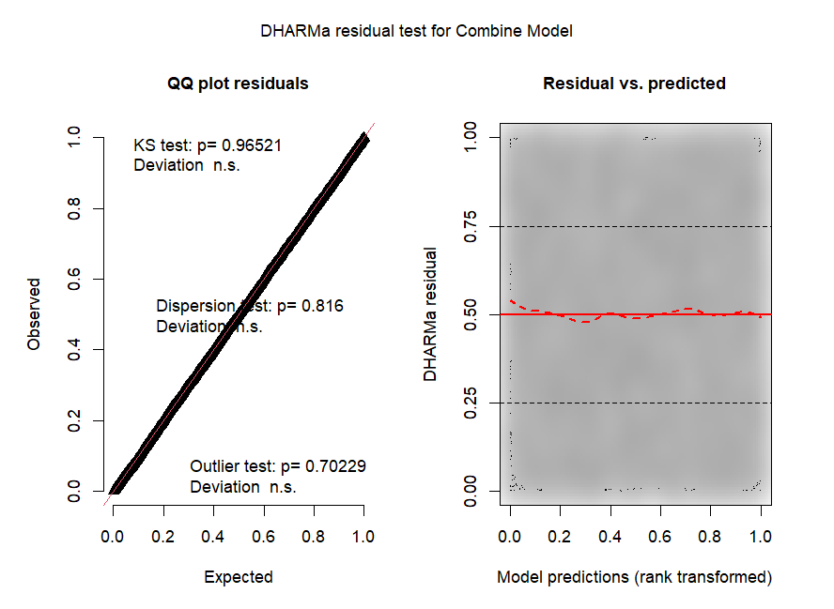
Figure S1: Showing the DHARMa scaled residual plot for the combined model

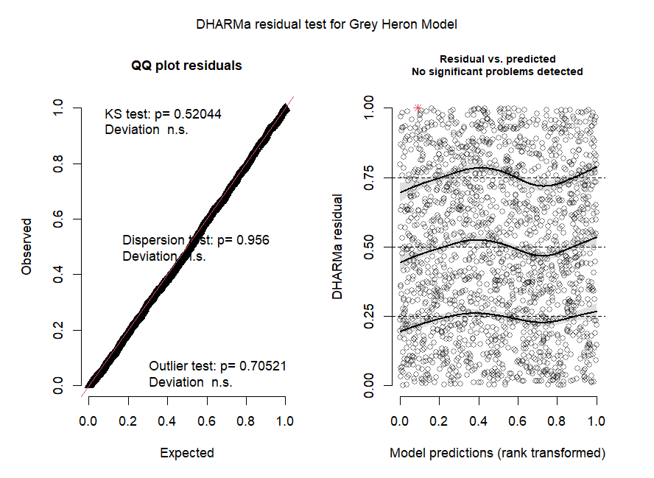
Figure S2: Showing the DHARMa scaled residual plot for Ardea cinerea Model
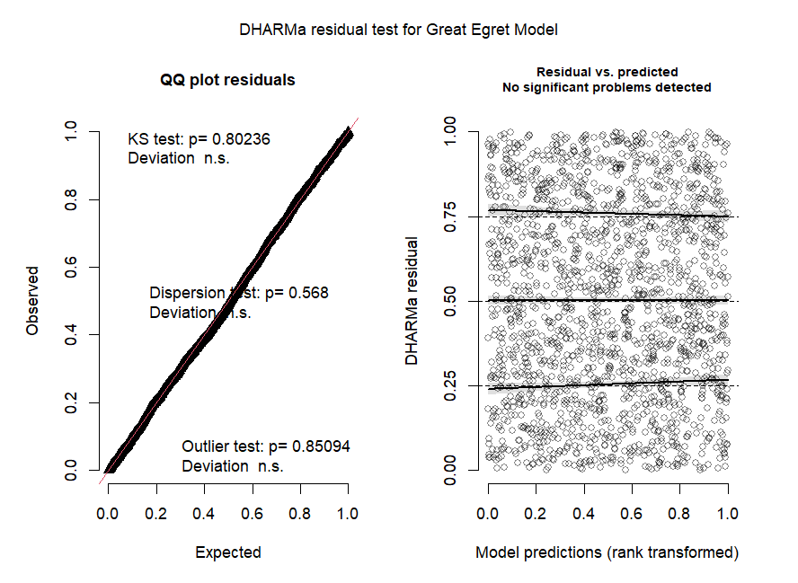Figure S3: Showing the DHARMa scaled residual plot for Ardea alba Model
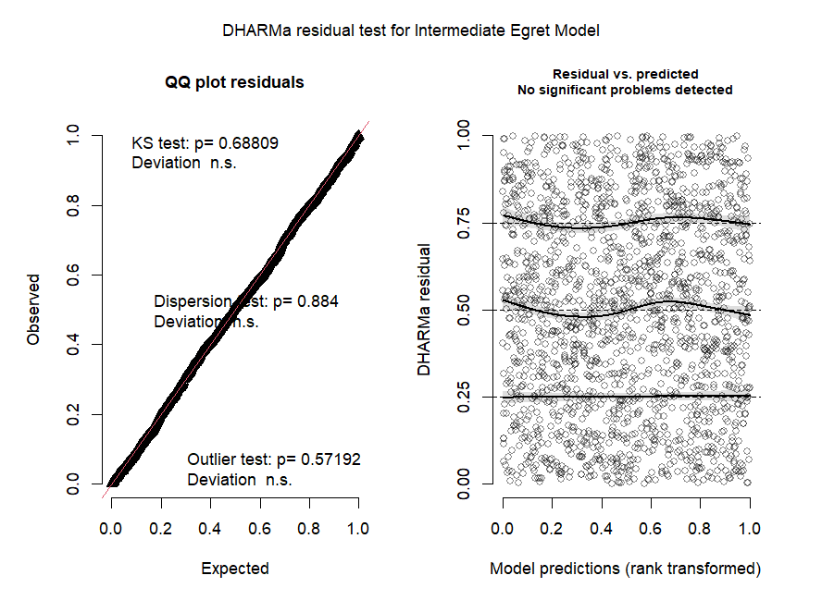
Figure S4: Showing the DHARMa scaled residual plot for Ardea intermedia Model
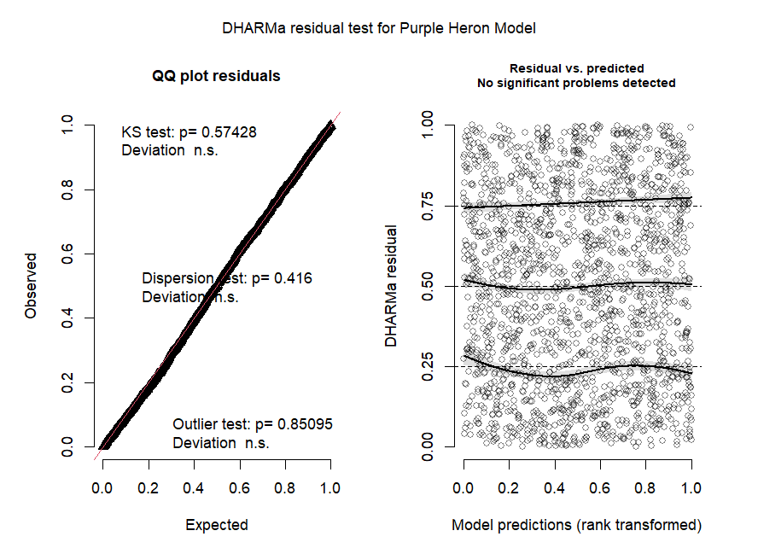
Figure S5: Showing the DHARMa scaled residual plot for Ardea purpurea Model
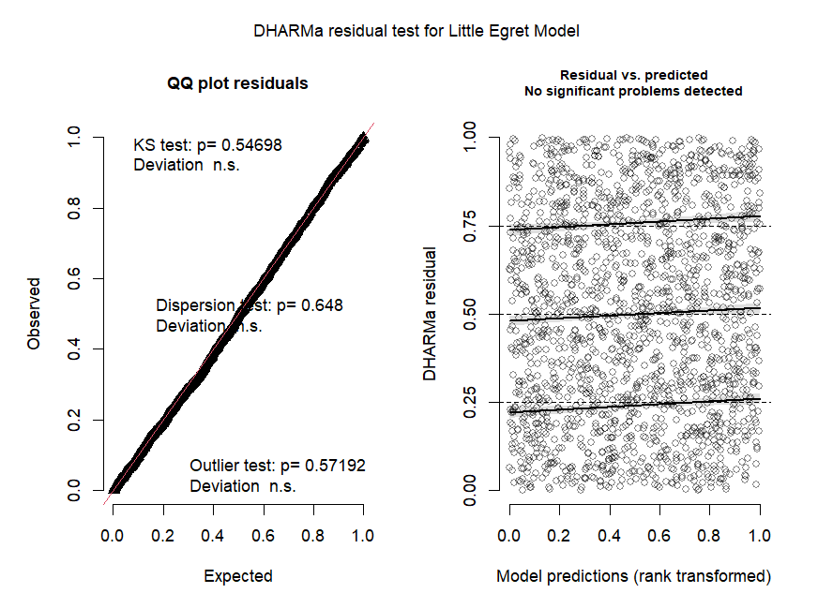
Figure S6: Showing the DHARMa scaled residual plot for Egretta garzetta Model
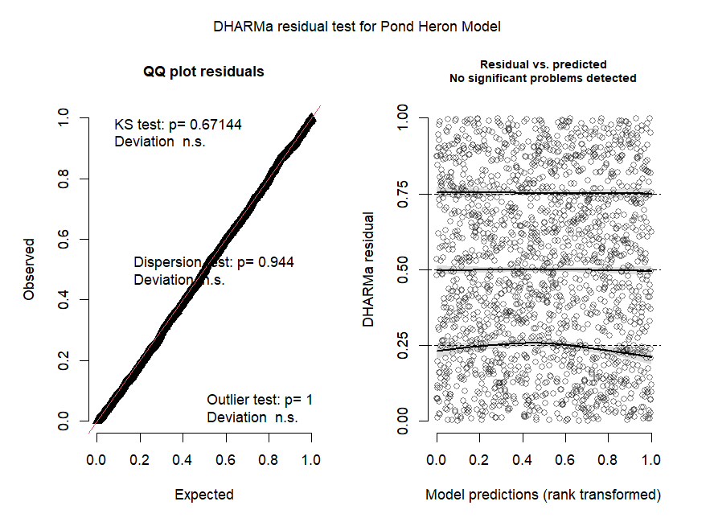
Figure S7: Showing the DHARMa scaled residual plot for Ardeola grayii Model
S5 table: GLMM of the occurrence of heron and egrets in response to the predictor variables.
Species | AIC | BIC | CR² | MR² | Variables | Est | SE | Z value | P value | 2.50% | 97.50%
Combined | 8209.40 | 8282.30 | 0.82 | 0.13 | (Intercept) | -0.69 | 0.15 | -4.67 | 0.000 | -0.98 | -0.40
 |  |  |  |  | disw | -0.41 | 0.09 | -4.56 | 0.000 | -0.59 | -0.23
 |  |  |  |  | EVI | -0.39 | 0.11 | -3.50 | 0.000 | -0.61 | -0.17
 |  |  |  |  | LST | -0.10 | 0.05 | -1.95 | 0.051 | -0.20 | 0.00
 |  |  |  |  | al | 0.32 | 0.19 | 1.72 | 0.085 | -0.04 | 0.68
 |  |  |  |  | b | -0.48 | 0.19 | -2.55 | 0.011 | -0.84 | -0.11
 |  |  |  |  | bl | -1.08 | 0.21 | -5.27 | 0.000 | -1.49 | -0.68
 |  |  |  |  | fv | -0.96 | 0.19 | -5.11 | 0.000 | -1.33 | -0.59
 |  |  |  |  | Year2022 | 0.21 | 0.07 | 2.95 | 0.003 | 0.07 | 0.35
Species | AIC | BIC | CR² | MR² | Variables | Est | SE | Z value | P value | 2.50% | 97.50%
GH | 1071.80 | 1115.70 | 0.82 | 0.66 | (Intercept) | -2.78 | 0.30 | -9.41 | 0.000 | -3.36 | -2.20
 |  |  |  |  | disw | -1.62 | 0.49 | -3.32 | 0.001 | -2.58 | -0.66
 |  |  |  |  | EVI | -1.05 | 0.30 | -3.49 | 0.000 | -1.64 | -0.46
 |  |  |  |  | tc | 0.54 | 0.20 | 2.67 | 0.008 | 0.14 | 0.94
 |  |  |  |  | bl | -1.61 | 0.37 | -4.30 | 0.000 | -2.34 | -0.88
 |  |  |  |  | fv | -0.90 | 0.23 | -3.83 | 0.000 | -1.35 | -0.44
 |  |  |  |  | Year2022 | 0.51 | 0.18 | 2.79 | 0.005 | 0.15 | 0.87
Species | AIC | BIC | CR² | MR² | Variables | Est | SE | Z value | P value | 2.50% | 97.50%
GE | 1214.10 | 1252.50 | 0.75 | 0.52 | (Intercept) | -2.20 | 0.24 | -9.29 | 0.000 | -2.67 | -1.74
 |  |  |  |  | disw | -0.69 | 0.30 | -2.27 | 0.023 | -1.29 | -0.10
 |  |  |  |  | EVI | -0.96 | 0.26 | -3.66 | 0.000 | -1.48 | -0.45
 |  |  |  |  | bl | -1.83 | 0.33 | -5.61 | 0.000 | -2.47 | -1.19
 |  |  |  |  | fv | -1.11 | 0.23 | -4.75 | 0.000 | -1.56 | -0.65
 |  |  |  |  | Year2022 | 0.67 | 0.17 | 3.82 | 0.000 | 0.32 | 1.01
Species | AIC | BIC | CR² | MR² | Variables | Est | SE | Z value | P value | 2.50% | 97.50%
IE | 1986.40 | 2019.30 | 0.46 | 0.12 | (Intercept) | -0.45 | 0.15 | -3.08 | 0.002 | -0.73 | -0.16
 |  |  |  |  | EVI | -0.41 | 0.15 | -2.68 | 0.007 | -0.72 | -0.11
 |  |  |  |  | disw | -0.36 | 0.15 | -2.30 | 0.021 | -0.66 | -0.05
 |  |  |  |  | al | 1.22 | 0.19 | 6.27 | 0.000 | 0.84 | 1.60
 |  |  |  |  | tc | 0.28 | 0.15 | 1.86 | 0.063 | -0.02 | 0.57
Species | AIC | BIC | CR² | MR² | Variables | Est | SE | Z value | P value | 2.50% | 97.50%
PH | 1097.80 | 1130.70 | 0.69 | 0.33 | (Intercept) | -3.27 | 0.30 | -11.03 | 0.000 | -3.85 | -2.69
 |  |  |  |  | tc | -1.07 | 0.41 | -2.63 | 0.009 | -1.86 | -0.27
 |  |  |  |  | al | 0.97 | 0.24 | 4.01 | 0.000 | 0.49 | 1.44
 |  |  |  |  | b | -0.59 | 0.28 | -2.12 | 0.034 | -1.14 | -0.05
 |  |  |  |  | bl | 0.49 | 0.27 | 1.82 | 0.068 | -0.04 | 1.01
Species | AIC | BIC | CR² | MR² | Variables | Est | SE | Z value | P value | 2.50% | 97.50%
LE | 1529.90 | 1590.30 | 0.73 | 0.36 | (Intercept) | -0.18 | 0.23 | -0.78 | 0.434 | -0.64 | 0.27
 |  |  |  |  | disw | -0.76 | 0.21 | -3.73 | 0.000 | -1.17 | -0.36
 |  |  |  |  | EVI | -0.58 | 0.23 | -2.50 | 0.012 | -1.04 | -0.13
 |  |  |  |  | tc | 0.52 | 0.25 | 2.10 | 0.036 | 0.04 | 1.01
 |  |  |  |  | al | 0.87 | 0.32 | 2.71 | 0.007 | 0.24 | 1.50
 |  |  |  |  | LST | -0.21 | 0.11 | -1.88 | 0.060 | -0.43 | 0.01
 |  |  |  |  | b | -0.42 | 0.29 | -1.43 | 0.153 | -0.99 | 0.16
 |  |  |  |  | bl | -1.22 | 0.33 | -3.72 | 0.000 | -1.86 | -0.58
 |  |  |  |  | fv | -1.28 | 0.31 | -4.14 | 0.000 | -1.89 | -0.68
 |  |  |  |  | Year2022 | 0.69 | 0.16 | 4.28 | 0.000 | 0.37 | 1.00
Species | AIC | BIC | CR² | MR² | Variables | Est | SE | Z value | P value | 2.50% | 97.50%
POH | 500.70 | 555.60 | 0.71 | 0.24 | (Intercept) | 6.12 | 0.66 | 9.34 | 0.000 | 4.84 | 7.41
 |  |  |  |  | disw | -0.47 | 0.20 | -2.34 | 0.019 | -0.86 | -0.08
 |  |  |  |  | tc | -0.93 | 0.45 | -2.07 | 0.038 | -1.81 | -0.05
 |  |  |  |  | al | -0.76 | 0.53 | -1.43 | 0.154 | -1.80 | 0.28
 |  |  |  |  | LST | -0.42 | 0.19 | -2.19 | 0.029 | -0.79 | -0.04
 |  |  |  |  | b | -0.91 | 0.44 | -2.08 | 0.038 | -1.77 | -0.05
 |  |  |  |  | bl | -0.76 | 0.44 | -1.72 | 0.085 | -1.62 | 0.10
 |  |  |  |  | fv | -1.23 | 0.46 | -2.65 | 0.008 | -2.13 | -0.32
 |  |  |  |  | Year2022 | -0.97 | 0.32 | -3.07 | 0.002 | -1.60 | -0.35
disw distance from waterbody, b built-up, bl bare land, al agricultural land, tc tree cover, fv flooded vegetation, EVI Enhanced vegetation index, LST Land Surface Temperature,

