Fig. S1. Scree Plot Showing Variance Explained by Principal Components Under Moisture Stress for Morphophysiological and yield traits
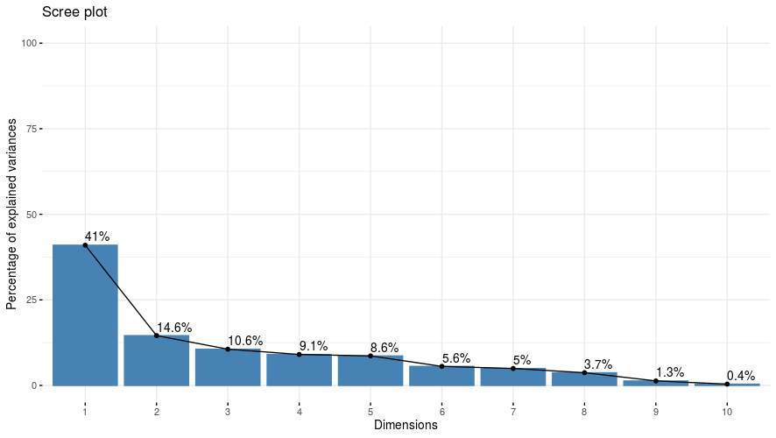

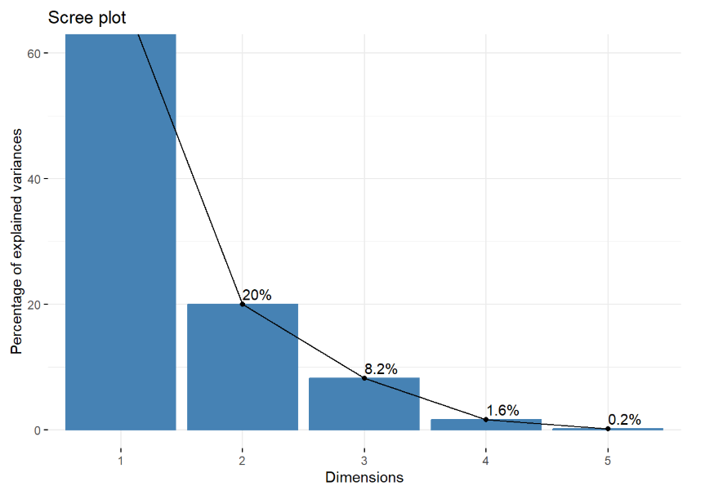
Fig. S2. Scree Plot Showing Variance Explained by Principal Components Under Moisture Stress for seedling traits

Table S1: ANOVA for augmented design for different morpho-physiological traits under both stress and non-stress conditions.
 | Source | Block  (eliminating treatments) | Treatment (ignoring Blocks) | Checks | Genotypes | Checks v/s Genotypes | Error
 | df | 7 | 224 | 4 | 219 | 1 | 28
Plant height | Non-stress | 3.66 | 87.6** | 296.8** | 83.88** | 64.75* | 9.55
Plant height | Stress | 1.42 | 85.89** | 496.14** | 78.43** | 78.24** | 0.74
Days to 50% flowering | Non-stress | 39.57 | 155.48** | 38.21 | 152.09** | 1365.74** | 32.04
Days to 50% flowering | Stress | 16.33 | 132.75** | 110.35** | 128.84** | 1078.72** | 10.29
SPAD I | Non-stress | 33.44* | 23.8* | 156.68** | 21.13* | 76.85* | 11.74
SPAD I | Stress | 6.23 | 26.92** | 32** | 26.67** | 61.11** | 3.92
SPAD II | Non-stress | 47.77 | 27.7 | 35.36 | 27.65 | 9.29 | 26.49
SPAD II | Stress | 6.84 | 32.42** | 25.63** | 32.53** | 35.53* | 5.01
Canopy temperature I | Non-stress | 13.33* | 6.41** | 2.89 | 6.48** | 6.06 | 2.85
Canopy temperature I | Stress | 3.86 | 3.28* | 3.45 | 3.28* | 2.36 | 1.75
Canopy temperature II | Non-stress | 8.79* | 3.19** | 1.41 | 3.24** | 0.61 | 1.01
Canopy temperature II | Stress | 6.63 | 5.17** | 6.78** | 5.16** | 0.83 | 0.94
Membrane stability | Non-stress | 165.13* | 62.71** | 50.14 | 62.99** | 51.47 | 23.16
Membrane stability | Stress | 17.88 | 355** | 258.03** | 352.67** | 1253.5** | 8.9
Spike length | Non-stress | 0.99 | 1.54** | 3.77** | 1.44** | 14.92** | 0.59
Spike length | Stress | 0.43 | 1.27** | 5.06** | 1.16** | 10.33** | 0.41
Number of Seeds per spike | Non-stress | 15.57 | 82.17** | 203.48** | 78.55** | 388.1** | 34.67
Number of Seeds per spike | Stress | 31.84 | 105.62** | 137.14** | 102.56** | 649.32** | 14.95
Thousand grain weight | Non-stress | 13.11 | 38.12** | 159.23** | 36.05** | 7.3 | 9.43
Thousand grain weight | Stress | 20.59 | 40.78** | 104.37** | 39.78** | 4.85 | 11.82
Grain yield | Non-stress | 0 | 0.03** | 0.11** | 0.02** | 0.03** | 0
 | Stress | 0 | 0.01** | 0.11** | 0.01** | 0.02** | 0
* P <= 0.05; ** P <= 0.01

Table S2: ANOVA for augmented design for different seedling traits under two moisture regimes

 | Source | Block  (eliminating Treatments) | Treatment (ignoring Blocks) | Checks | Genotypes | Checks v/s Genotypes | Error
 | df | 7 | 224 | 4 | 219 | 1 | 28
Germination percentage | Non-stress | 34.29 | 158.89** | 108.75* | 149.76** | 566.43** | 31.61
Germination percentage | Stress | 156.79 | 714.35** | 2935.0** | 659.93** | 3697.05** | 87.59
Coleoptile length | Non-stress | 0.12 | 0.51** | 1.38** | 0.49** | 0.10 | 0.08
Coleoptile length | Stress | 1.35 | 5.09** | 10.0** | 4.96** | 14.63** | 0.63
Root to shoot ratio | Non-stress | 0.01 | 0.01** | 0.03** | 0.01** | 0.00 | 0.0
Root to shoot ratio | Stress | 0.02 | 0.13** | 0.13** | 0.13** | 0.00 | 0.03
Seedling vigour I | Non-stress | 130816.47 | 452936.30* | 307911.14 | 443742.70* | 3046435.39** | 242901.81
Seedling vigour I | Stress | 159384.90 | 1088056.68** | 4682951.31** | 1025985.76** | 239936.92 | 69438.0
Seedling vigour II | Non-stress | 111931.10 | 736541.02** | 834800.28** | 738108.98** | 120.73 | 95456.15
Seedling vigour II | Stress | 38510.10 | 1139690.5** | 5301519.6** | 1064778.0** | 823298.1** | 26701.74
* - P = < 0.05; ** P = < 0.01
Table S3: Mean per cent reduction in the performance of various traits under moisture stress condition in durum wheat genotypes

Traits | Percent reduction
SPAD 2 | 6.977
SPAD 1 | 2.949
Canopy Temperature 1 (⁰C) | -10.1817
Canopy Temperature 2 (⁰C) | -22.2579
Membrane Stability (%) | 24.84302
Plant Height (cm) | 4.806455
Spike Length (cm) | 9.604196
Number of Seeds per Spike | 8.661906
1000 Seed weight (g) | 3.607573
Days to 50% Flowering | 4.6875
Grain Yield (Kg/plot) | 26.84101
Coleoptile length | 27.55
Germination percentage | 46.97
Seedling vigour I | 51.16
Seedling vigour II | 57.30
Root to shoot ratio | -50.22

