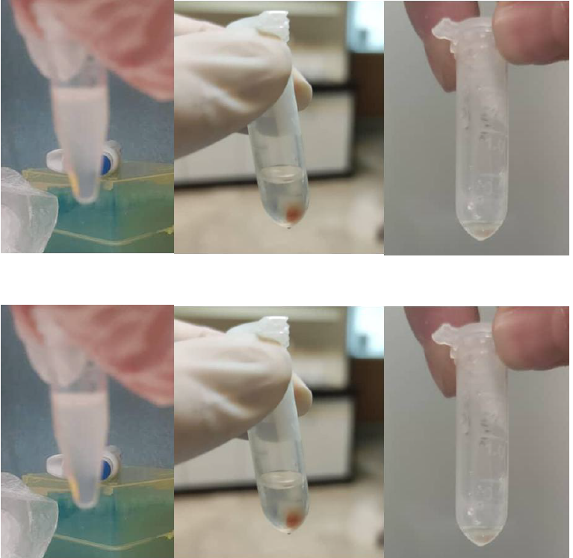
Figure 1. RNA extraction procedure – RNA from tissue in the plate and after extraction

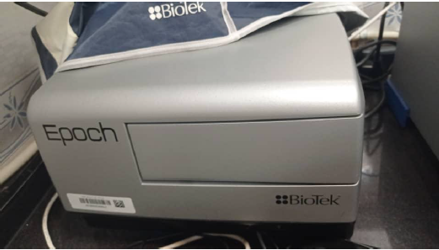

Figure 2. NanoDrop spectrophotometer
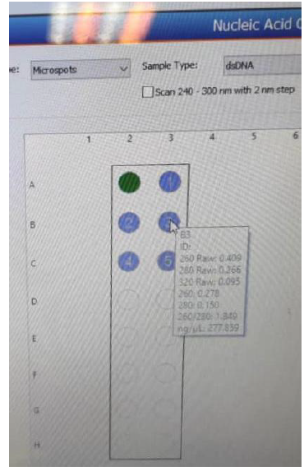

Figure 3. Concentration of extracted RNA.

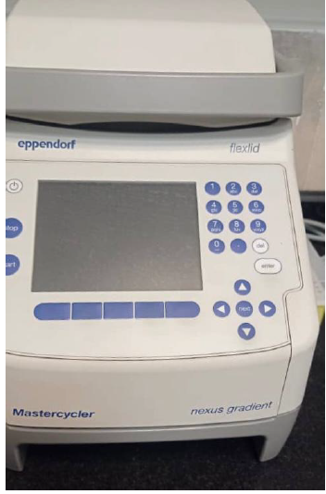

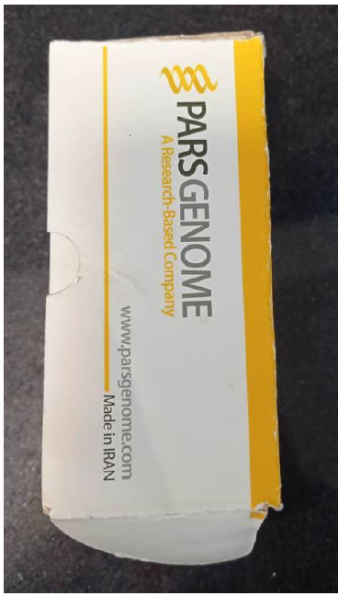
Figure 4. The real-time PCR machine

Figure 5. cDNA synthesis kit

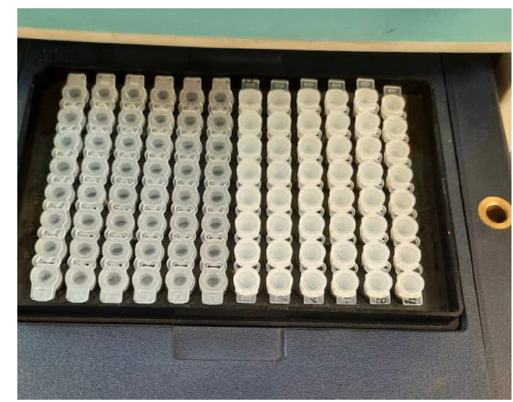

Figure 6. Samples loaded in the Real-Time PCR machine
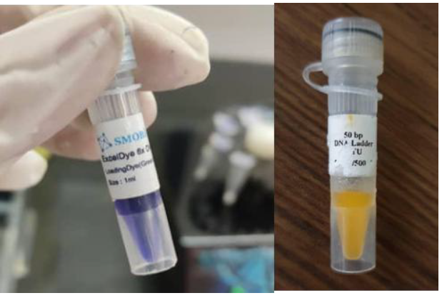

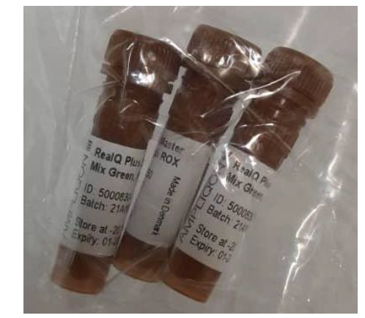
Figure 7. Dye for gel electrophoresis and 50 bp ladder

Figure 8. Syber Green
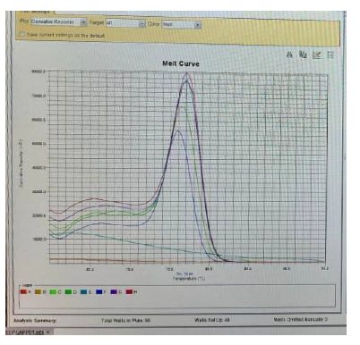

Figure 9. Melt curve plot for miR214

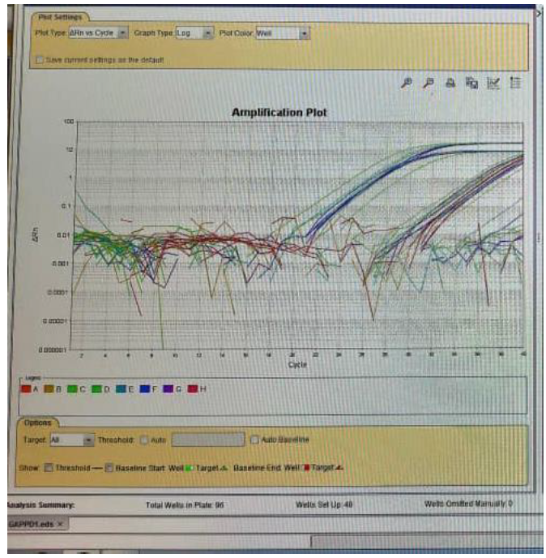

Figure 10. Amplification plot graph showing amplification; the first curve corresponds to the housekeeping gene, and the second curve corresponds to the miR214 gene

