Table 1 Synthesis of Xanthene Derivatives Using MgO@CSCA Catalyst
Entry | Aldehyde Substituent | Reaction Time (h) | Yield (%) | Melting Point (°C) | Final Compound
2a | 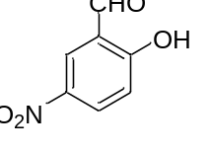 | 2.5 | 86.36 | 173–175 | 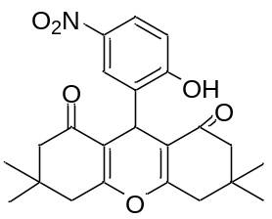
2b | 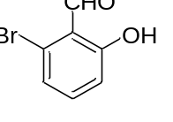 | 2.0 | 89.68 | 177–178 | 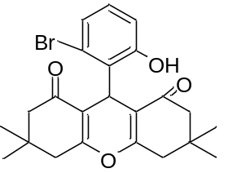
2c | 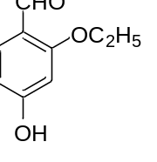 | 3.0 | 85.14 | 183–184 | 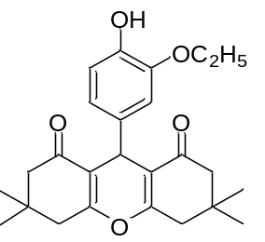
2d | 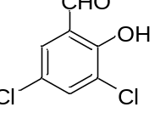 | 2.3 | 88.58 | 180-181 | 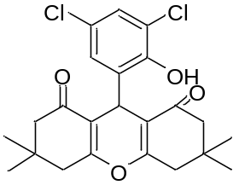
2e | 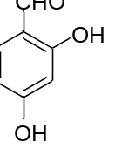 | 2.0 | 85.48 | 170-171 | 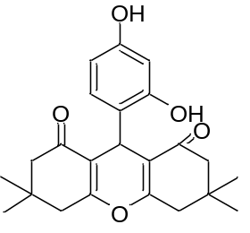
2f | 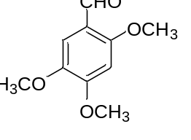 | 2.4 | 88.92 | 193-164 | 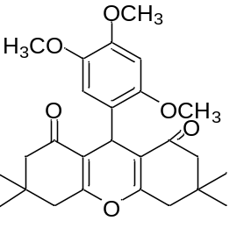
2g | 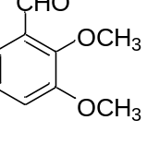 | 2.2 | 85.55 | 190-191 | 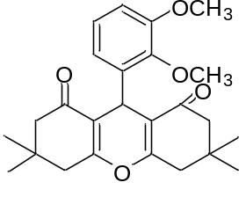
2h | 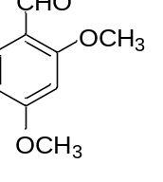 | 2.1 | 82.98 | 186-187 | 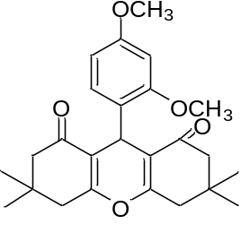
2i | 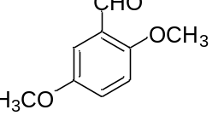 | 2.5 | 86.37 | 189-190 | 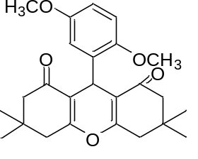
2j | 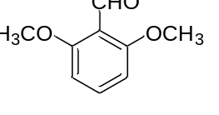 | 2.2 | 85.19 | 195-197 | 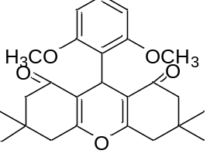

Table 2: Comparison of Catalysts for Synthesis of 9-Phenyl Xanthene Derivative
Catalyst | Amount (g or mol%) | Reaction Time (h) | Yield (%) | Reusability (Cycles) | Solvent | Reference
p-TSA | 0.1 mmol | 6.0 | 70-73 | 0 | Ethanol | [25]
Sulfamic Acid (MW 700W) | 0.05 g | 0.05 | 75-77 | 0 | - | [26]
Grinding/ Glacial Acetic Acid | 1 drop | 0.50 | 52-56 | 0 | - | [26]
Ionic liquid [bmim][BF₄]/80°C | 1.0 mL | 4.0 | 66-69 | 2 | Water | [27]
Ultrasonic Irradiation/Ammonium Acetate/ 60°C | 0.1g | 1.0 | 55-57 | 0 | Ethanol | [28]
Montmorillonitek-10 clay/reflux | 0.2 g | 6.0 | 70-73 | 2 | Toluene | [29]
TBAB/RT | 0.1 mmol | 4.0 | 65-67 | 2 | MDC | [30]
Choline chloride: Urea /90°C | 1:2 | 3.0 | 70-72 | 3 | - | [31]
Baker yeast/phosphate buffer/ 30°C | 1.0g | 24.0 | 56-58 | 0 | - | [32]
CSCA extracted MgO-Nps/80°C | 0.1 mmol | 0.15 | 85-89 | 5 | Water | This work

Table 3: CSCA extracted MgO nanoparticles catalyst recycling potential
No of cycle | Run 1 | Run 2 | Run 3 | Run 4 | Run 5
Yield (%) | 85-89 | 75-76 | 69-70 | 60-61 | 55-56
Time(min) | 10.00 | 20.00 | 30.00 | 40.00 | 60.00
TON | 1.60 | 1.55 | 1.40 | 1.30 | 1.25
TOF | 118.0 | 110.0 | 105.0 | 102.0 | 100.5

