Biomarkers in the rock outcrop of the Kazusa Group reveal paleoenvironments of the Kuroshio region
Hiroto Kajita^{1,2,3,4,*}, Ayumi Maeda^{1,2,3,4}, Masayuki Utsunomiya³, Toshihiro Yoshimura⁴, Naohiko Ohkouchi⁴, Atsushi Suzuki³, Hodaka Kawahata^{1,2}
¹ Atmosphere and Ocean Research Institute, University of Tokyo, 5-1-5, Japan
² Department of Earth and Planetary Science, Graduate School of Science, University of Tokyo, Japan
³ Geological Survey of Japan, National Institute of Advanced Industrial Science and Technology, Japan
⁴ Biogeochemistry Research Center, Japan Agency for Marine-Earth Science and Technology, Japan
* Correspondence: H.K., Email: kajita322@frontier.hokudai.ac.jp, Tel: (+81) 04 7136 6135

Supplementary Figures and Figure Legends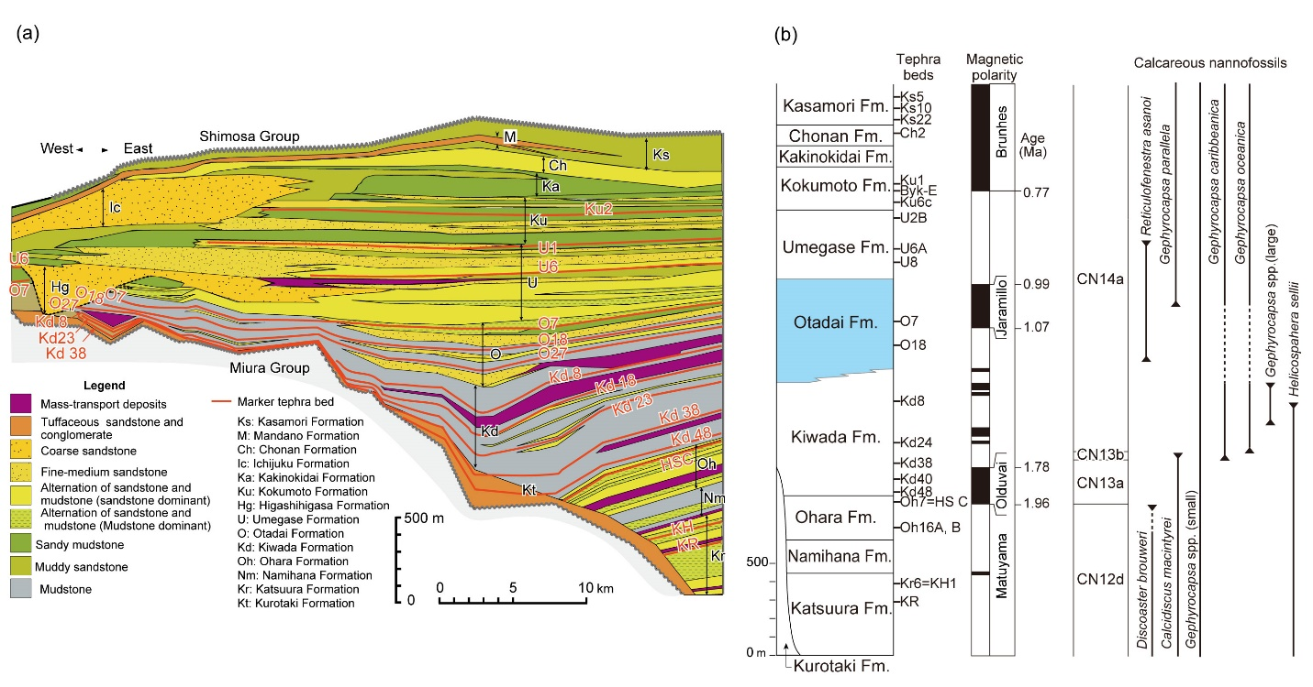

Figure 2. Geotectonic background of Pleistocene Kazusa Group on the Boso Peninsula, central Japan summarized in ref. 1. (a) Stratigraphic eastwest cross-section and (b) Chronostratigraphy of the Kazusa Group on the Boso Peninsula. The Otadai Formation is coloured red.

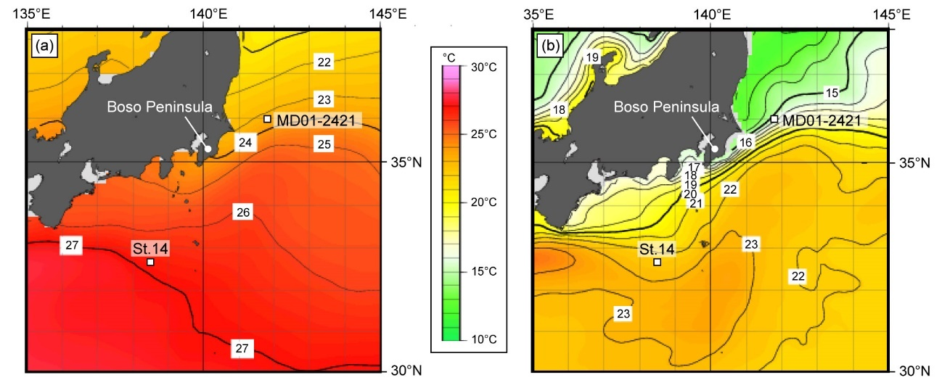
Supplementary Figure 2. Average ocean temperature in June (1980–2010) at (a) the surface, and (b) 50 m depth near the Boso Peninsula. Maps were generated by the Japan Meteorological Agency using a comprehensive analysis by the Ocean General Circulation Model and observation data from satellites, ships, buoys, and floats (https://www.jma.go.jp/jma/index.html).

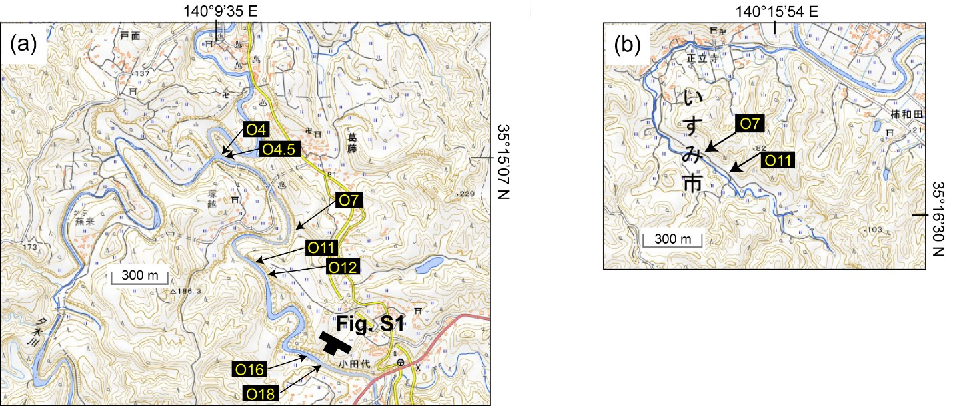
Supplementary Figure 3. Location maps of the (a) Yoro River, and (b) Shoryuji sections. Topographic maps were provided by the Geospatial Information Authority of Japan.

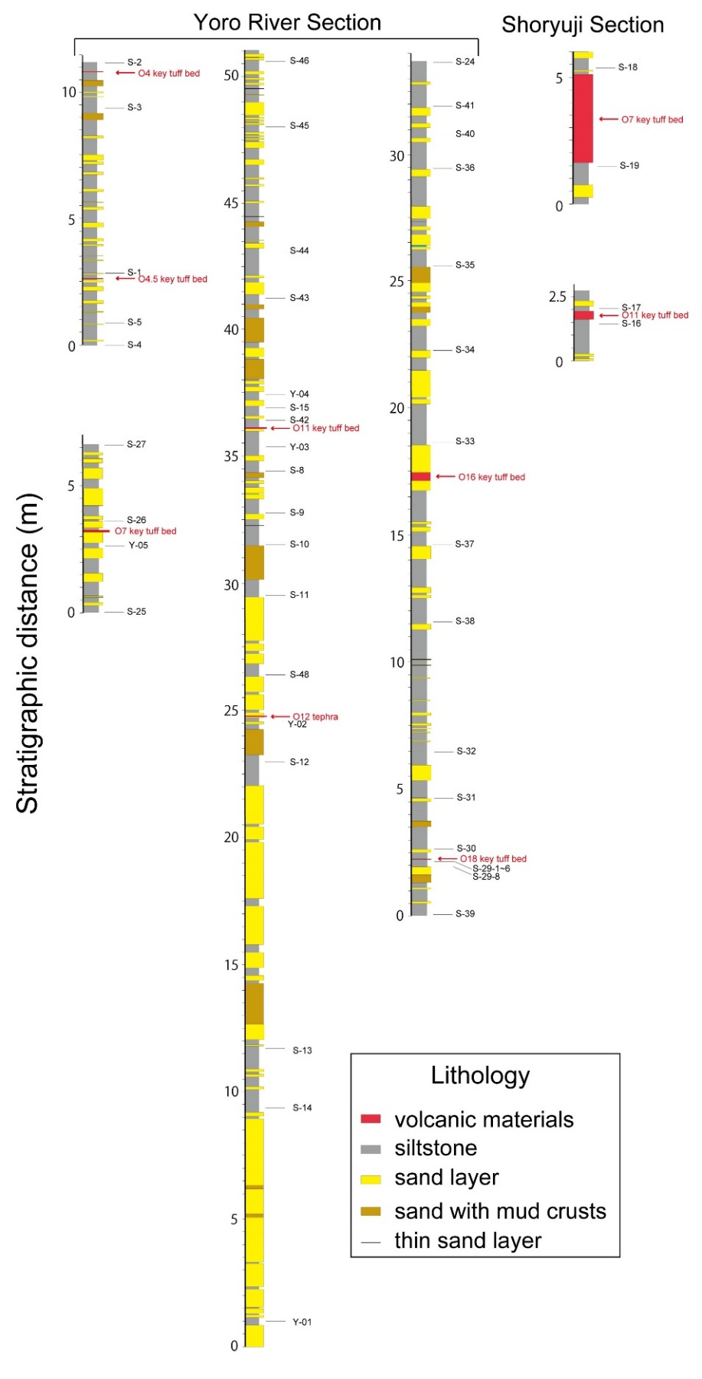
Supplementary Figure 4. Sampling horizons for this study along the Yoro River and Shoryuji sections with the key intercalated tuff beds.
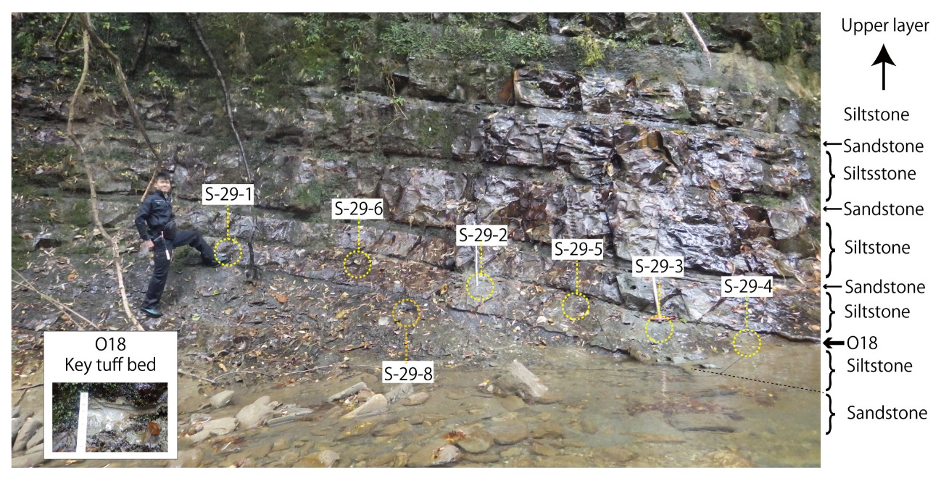
Supplementary Figure 5. Photograph of sampling points in the siltstone bed just below the O18 key tuff bed.

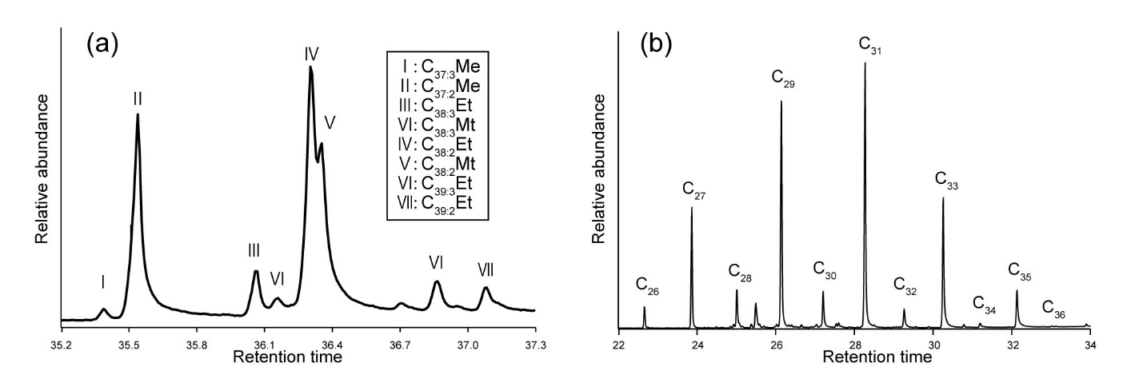
Supplementary Figure 6. Representative chromatograms of (a) LCAs and (b) n-alkanes in sample S-8 taken from between the O11 and O12 key tuff beds.

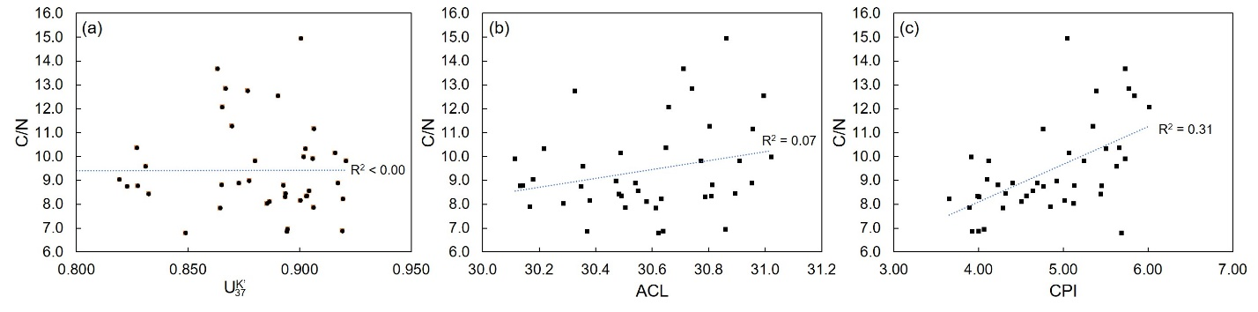
Supplementary Figure 7. Relationship between C/N ratio and (a) ${\text{U}}_{\text{37}}^{\text{K'}}$, (b) ACL, (c) CPI with coefficient of determination (R²).

Supplementary Tables
Supplementary Table 1. Variations of multiple proxy records within one siltstone bed just below the O18 key tuff bed (Sample S-29-1 to S-29-6). The values from turbidite sandstone bed (S-29-8) just below the S-29 siltstone bed are also shown. The detailed sampling locations are shown in Supplementary Fig. 1.

Sample ID | $${\text{U}}_{\text{37}}^{\text{K'}}$$ | ${\text{U}}_{\text{37}}^{\text{K'}}$-SST (°C) | ACL | CPI | C/N
S-29-1 | 0.912 | 26.3 | 30.6 | 4.91 | 7.7
S-29-2 | 0.893 | 25.7 | 30.4 | 5.09 | 8.1
S-29-3 | 0.912 | 26.3 | 30.4 | 4.89 | 8.4
S-29-4 | 0.911 | 26.3 | 30.7 | 4.72 | 9.3
S-29-5 | 0.898 | 25.9 | 30.5 | 3.96 | 9.4
S-29-6 | 0.899 | 25.9 | 30.6 | 4.27 | 8.4
Average | 0.904 | 26.1 | 30.6 | 4.64 | 8.6
1σ | 0.008 | 0.254 | 0.123 | 0.434 | 0.69
S-29-8 | 0.916 | 26.4 | 30.8 | 2.36 | 11.7

Supplementary Table 2. Multiple proxy records of all collected samples in the Yoro River section. The sampling locations were correlated to the cumulative depth of hemipelagic silty stone (CDHS) of TR-3 core comparing the sedimentation rate between the key tuff beds observed both in TR-3 and outcrops.

Sample ID | CDHS (m) | $${\text{U}}_{\text{37}}^{\text{K'}}$$ | ${\text{U}}_{\text{37}}^{\text{K'}}$-SST (°C) | ACL | CPI | C/N
S-2 | 27.90 | 0.894 | 25.8 | 30.4 | 3.93 | 6.9
S-3 | 28.79 | 0.906 | 26.1 | 30.5 | 3.89 | 7.9
S-1 | 32.75 | 0.864 | 24.9 | 30.6 | 4.29 | 7.8
S-5 | 33.95 | 0.887 | 25.5 | 30.6 | 4.51 | 8.1
S-4 | 34.54 | 0.877 | 25.3 | 30.5 | 4.92 | 9.0
S-27 | 56.04 | 0.831 | 23.8 | 30.4 | 5.63 | 9.6
S-26 | 57.14 | 0.849 | 24.4 | 30.6 | 5.69 | 6.8
Y-05 | 57.99 | 0.827 | 23.7 | 30.6 | 5.66 | 10.4
S-25 | 59.89 | 0.832 | 23.9 | 30.5 | 5.44 | 8.4
S-46 | 62.35 | 0.863 | 24.8 | 30.7 | 5.73 | 13.7
S-45 | 63.79 | 0.865 | 24.9 | 30.7 | 6.02 | 12.1
S-44 | 67.18 | 0.890 | 25.6 | 31.0 | 5.84 | 12.5
S-43 | 68.37 | 0.901 | 26.0 | 30.9 | 5.05 | 14.9
Y-04 | 69.43 | 0.916 | 26.4 | 31.0 | 3.92 | 10.0
S-15 | 69.70 | 0.903 | 26.0 | 30.8 | 3.99 | 8.3
S-42 | 70.01 | 0.919 | 26.5 | 30.6 | 4.00 | 6.9
Y-03 | 70.85 | 0.941 | 27.2 | 31.0 | 4.40 | 8.9
S-8 | 71.56 | 0.919 | 26.5 | 30.6 | 3.66 | 8.2
S-9 | 71.87 | 0.894 | 25.7 | 30.8 | 4.01 | 8.3
S-10 | 72.35 | 0.894 | 25.7 | 30.9 | 4.32 | 8.4
S-11 | 73.28 | 0.895 | 25.8 | 30.9 | 4.06 | 7.0
S-48 | 74.08 | 0.906 | 26.1 | 31.0 | 4.76 | 11.2
Y-02 | 74.88 | 0.912 | 26.3 | 30.9 | 4.12 | 9.8
S-12 | 75.28 | 0.865 | 24.9 | 30.8 | 4.23 | 8.8
S-13 | 77.40 | 0.880 | 25.3 | 30.8 | 5.25 | 9.8
S-14 | 78.77 | 0.867 | 24.9 | 30.7 | 5.77 | 12.8
Y-01 | 79.44 | 0.870 | 25.1 | 30.8 | 5.35 | 11.3
S-24 | 90.70 | 0.823 | 23.6 | 30.3 | 4.77 | 8.7
S-41 | 91.69 | 0.819 | 23.5 | 30.2 | 4.10 | 9.0
S-40 | 92.09 | 0.795 | 22.8 | 30.2 | 4.85 | 7.9
S-36 | 92.74 | 0.827 | 23.7 | 30.1 | 5.45 | 8.8
S-35 | 94.12 | 0.893 | 25.7 | 30.1 | 5.13 | 8.8
S-34 | 95.02 | 0.903 | 26.0 | 30.2 | 5.51 | 10.3
S-33 | 96.21 | 0.906 | 26.1 | 30.1 | 5.73 | 9.9
S-37 | 97.85 | 0.877 | 25.2 | 30.3 | 5.39 | 12.8
S-38 | 98.64 | 0.916 | 26.4 | 30.5 | 5.07 | 10.2
S-32 | 101.19 | 0.917 | 26.5 | 30.5 | 4.69 | 8.9
S-31 | 101.84 | 0.885 | 25.5 | 30.3 | 5.12 | 8.0
S-30 | 102.97 | 0.903 | 26.0 | 30.5 | 4.56 | 8.3
S-29 | 103.00 | 0.904 | 26.1 | 30.6 | 4.64 | 8.6
S-39 | 103.82 | 0.900 | 25.9 | 30.4 | 5.02 | 8.2

Reference
- Utsunomiya, M., Mizuno, K., Naya, T., Omura, K. & Nagai, M. Correlation between a Tephra Bed from Deep (2038 m) Underground below Chiba City, and Kd48 in the Lowermost Kiwada Formation (Lower Pleistocene). Jour. Geography (Chigaku Zasshi) 129, 355-374 (2020).

