Supporting information for
Construction of a Stage-aware Water Quality Prediction Model Driven by the Temporal Evolution of Key Factors

Water Resources Management

Ying Liu ª, Zelin Jing ª, Zhengjiang Lin ^{b*}, Yurou Wang ª, Qingsong Chen ^{c}, Miaohan Liu ^{a, d}, Yu Chen ^{a*}
ª Faculty of Environment Science and Engineering, Southwest Jiaotong University, Chengdu 611756, China
^{b} School of Environment, Beijing Normal University, Beijing 100875, China
^{c} Sichuan Province Environmental Protection Technology & Engineering Co., Ltd, Chengdu 610000, China
^{d} Ya'an City Health Inspection, Ya'an 625000, China
ª* Correspondence: chenyu1123@swjtu.edu.cn; Tel.: +86-1388-072-7070
^{b}* Correspondence: 453765775@qq.com; Tel.: +86-1527-283-6520
Table S3 Preliminary Screening Results of Input Variables (Stage I)
target variables | Input Variables
TP_{s(t)} | TP_{s(t-1)}, T_{w(t-1)}, pHw_{(t-1)}, DO_{s(t-1)}, EC_{w(t-1)},COD_{Mnw(t-1)}, COD_{Mns(t-1)}
TN_{s(t)} | TURB_{s(t-1)}, TN_{s(t-1)}, COD_{Mns(t-1)}, pH_{w(t-1)}, TP_{s(t-1)}, T_{w(t-1)}
AN_{s(t)} | AN_{s(t-1)}, TP_{w(t-1)}, TN_{w(t-1)} , COD_{Mns(t-1)}, TURB_{s(t-1)}, pH_{w(t-1)}, DO_{s(t-1)}
COD_{Mns(t)} | EC_{s(t-1)}, EC_{w(t-1)}, DO_{s(t-1)}，DO_{w(t-1)}, T_{s(t-1)}, TN_{s(t-1)}, AN_{s(t-1)}, COD_{Mns(t-1)}, COD_{Mnw(t-1)},TP_{w(t-1)}, TP_{s(t-1)},TURB_{s(t-1)},

Table S4 Input Variables Excluded from the Candidate Set (Stage II)
target variables | Input Variables Excluded
TP_{s(t)} | T_{s(t-1)}, pH_{w(t-1)}, pH_{s(t-1)}
TN_{s(t)} | TURB_{s(t-1)}, T_{s(t-1)}, T_{w(t-1)}, pH_{w(t-1)}
AN_{s(t)} | TURB_{s(t-1)}, T_{s(t-1)}, T_{w(t-1)}, DO_{s(t-1)}, pH_{w(t-1)}
COD_{Mns(t)} | TURB_{s(t-1)}, T_{w(t-1)}, pH_{w(t-1)}

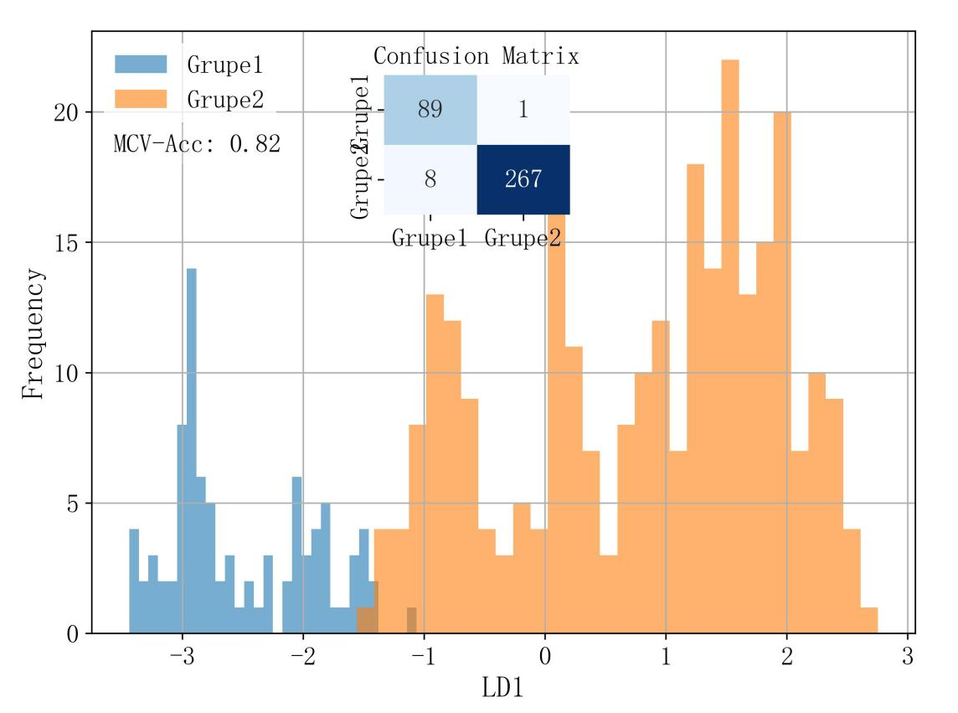
Fig. S10 LDA discrimination plots (winter/spring-summer-autumn)

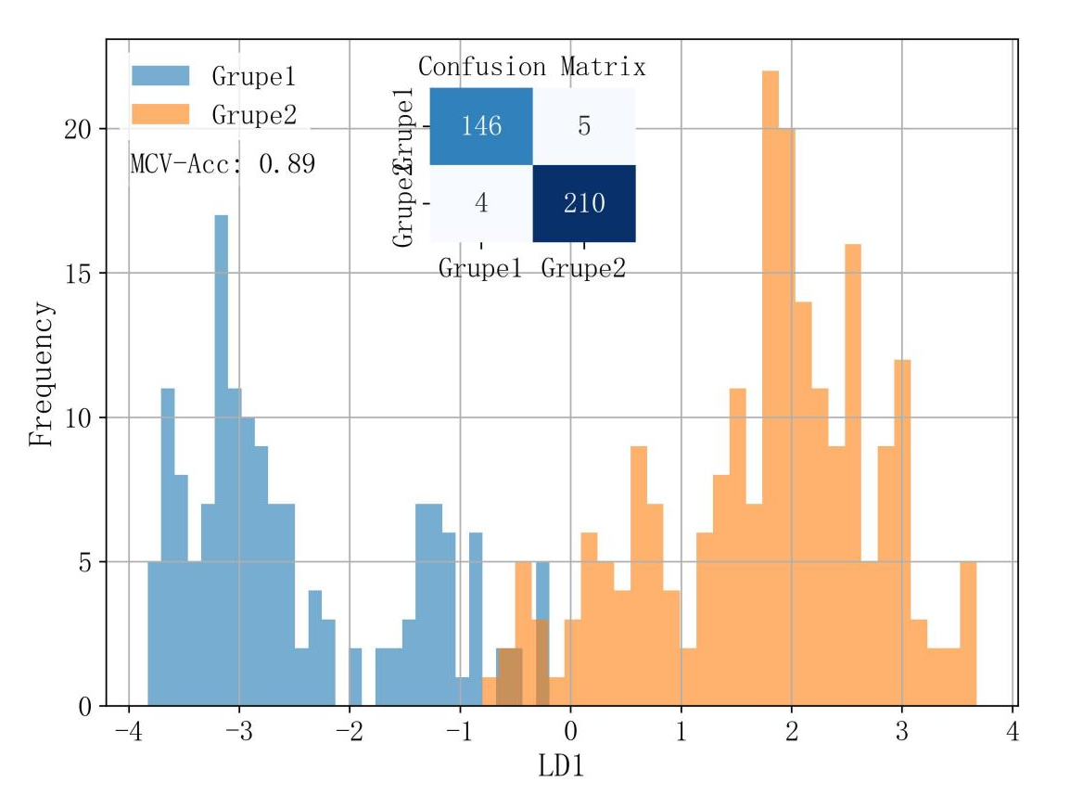
Fig. S11 LDA discrimination plots (150days/215days)

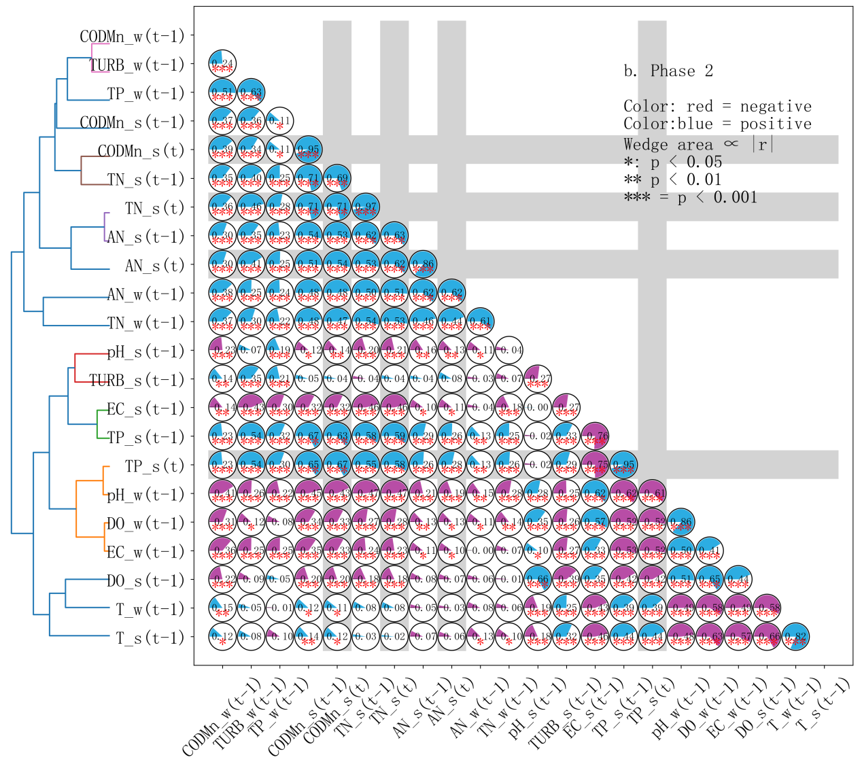
Fig. S12 Hierarchical clustering of input variables based on correlation (Period 2)

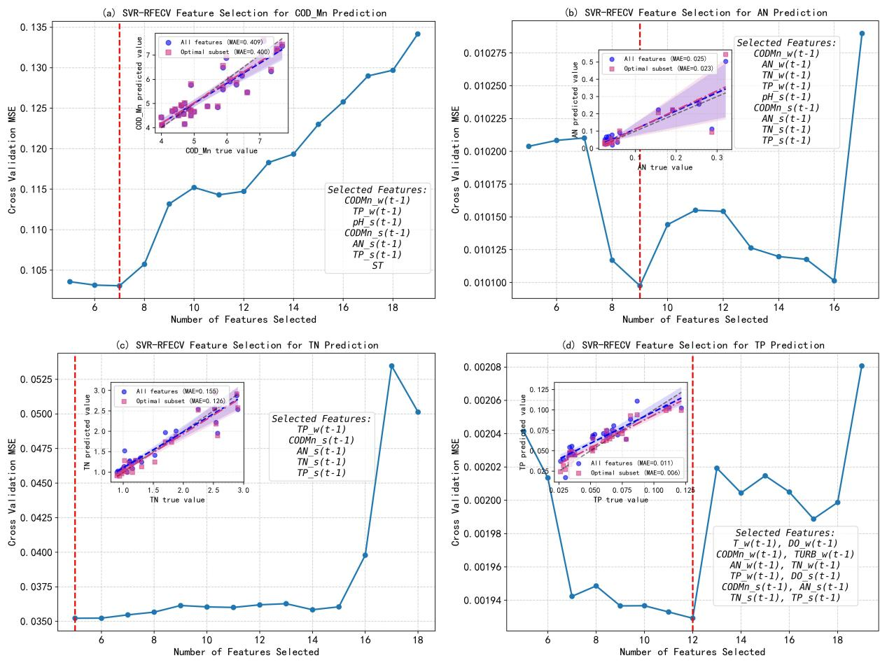
Fig. S13 Performance Evaluation of SVR-RFE Feature Selection (Stage II)

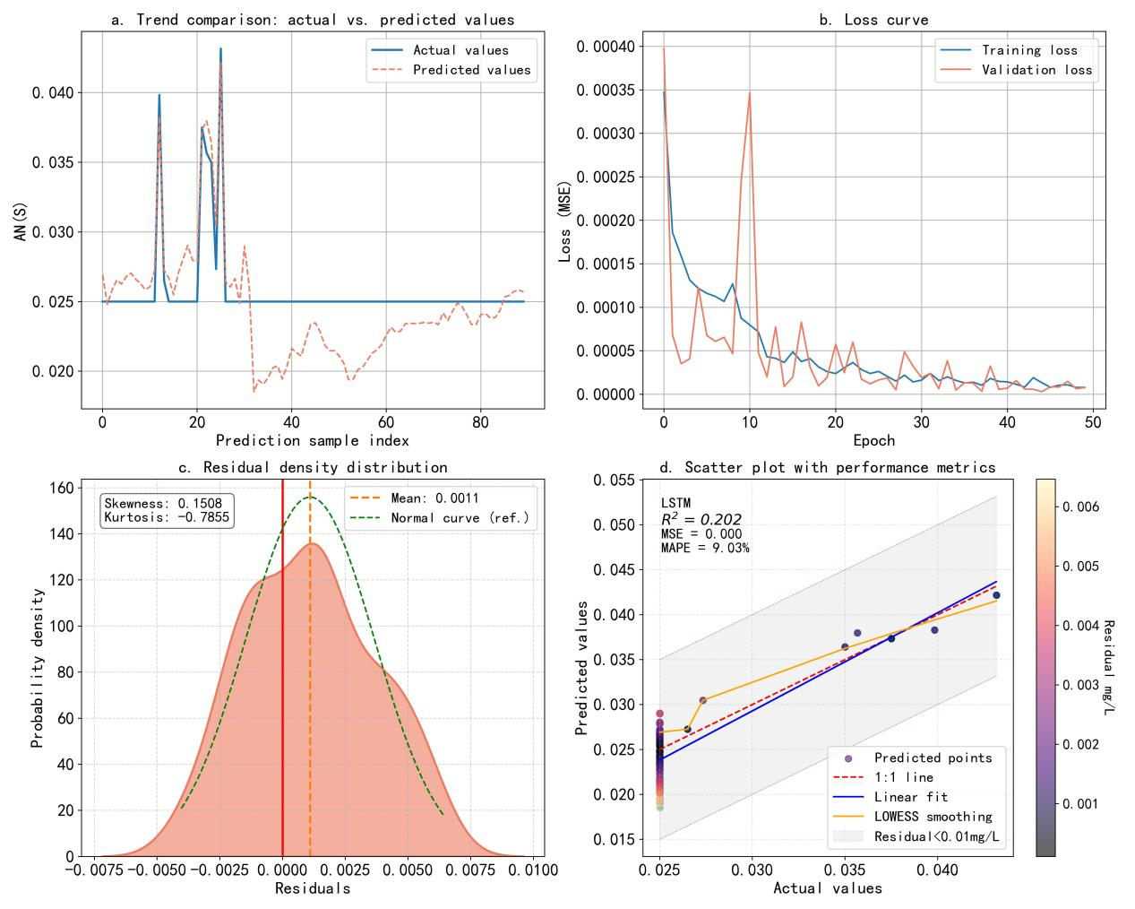
Fig. S14 Period-Specific Modeling:AN(s) Prediction Results and Model Performance Evaluation for Stage I

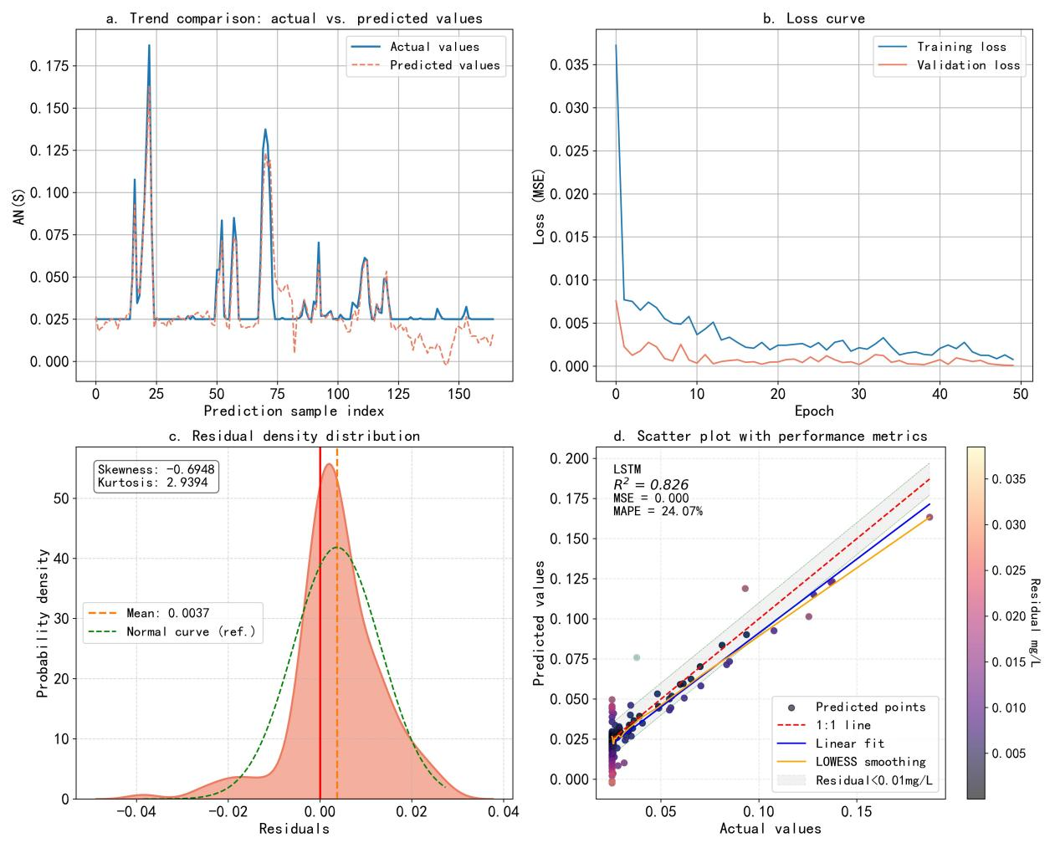
Fig. S15 Period-Specific Modeling:AN(s) Prediction Results and Model Performance Evaluation for Stage II

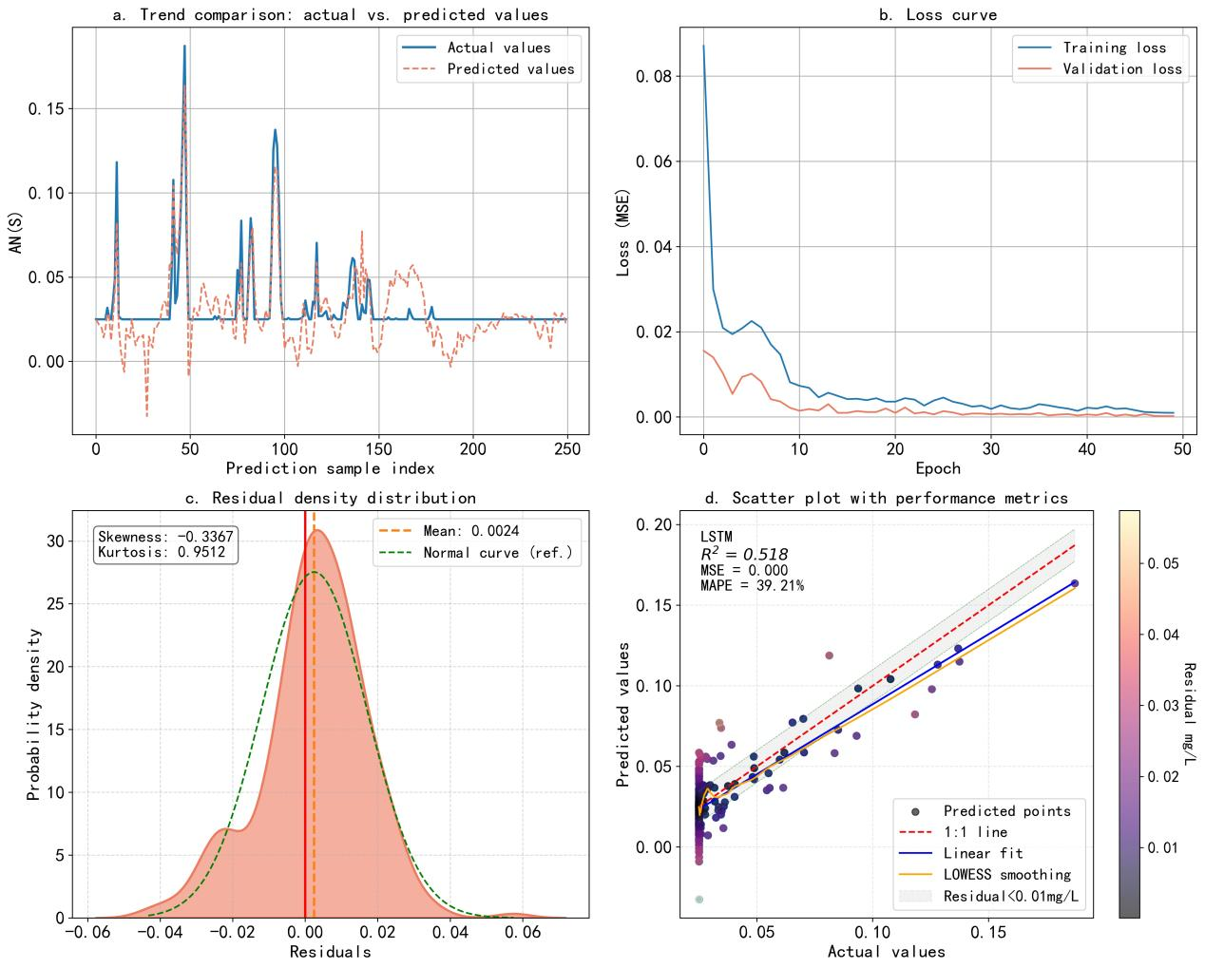
Fig. S16 Period-Specific Modeling: AN(s) Prediction Results and Model Performance Evaluation for Full-Stage

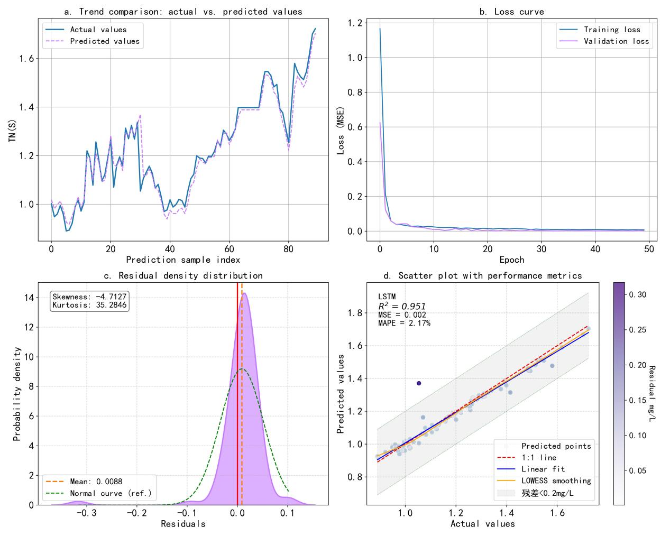
Fig. S17 Period-Specific Modeling: TN(s) Prediction Results and Model Performance Evaluation for Stage I

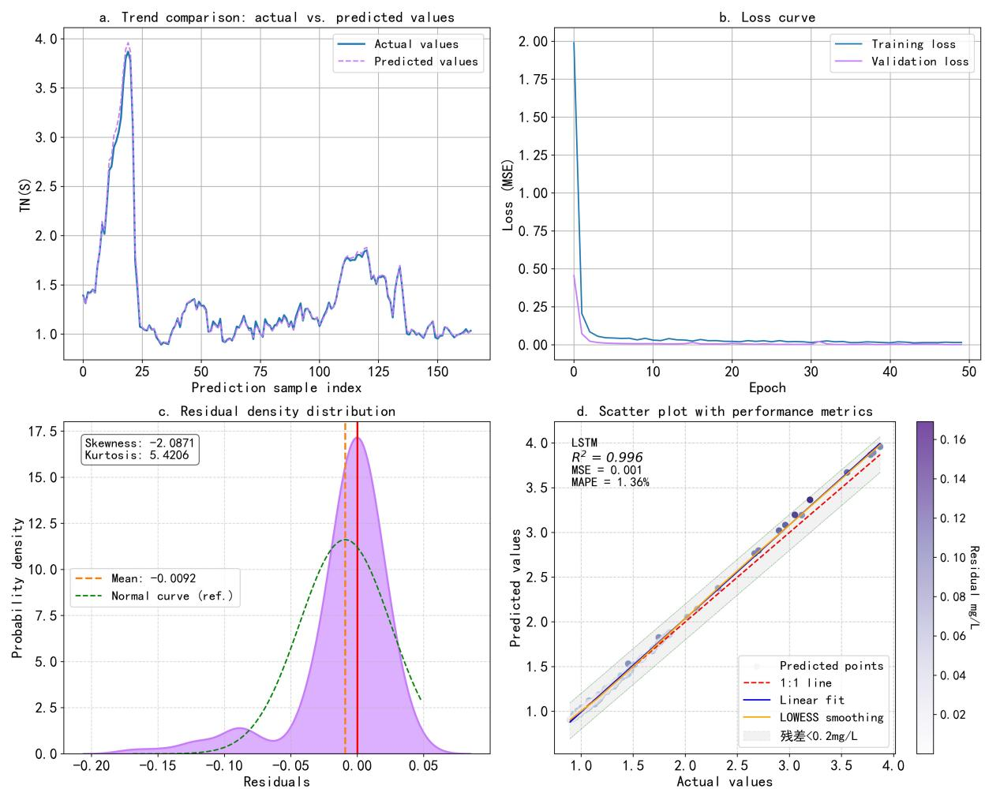
Fig. S18 Period-Specific Modeling: TN(s) Prediction Results and Model Performance Evaluation for Stage II

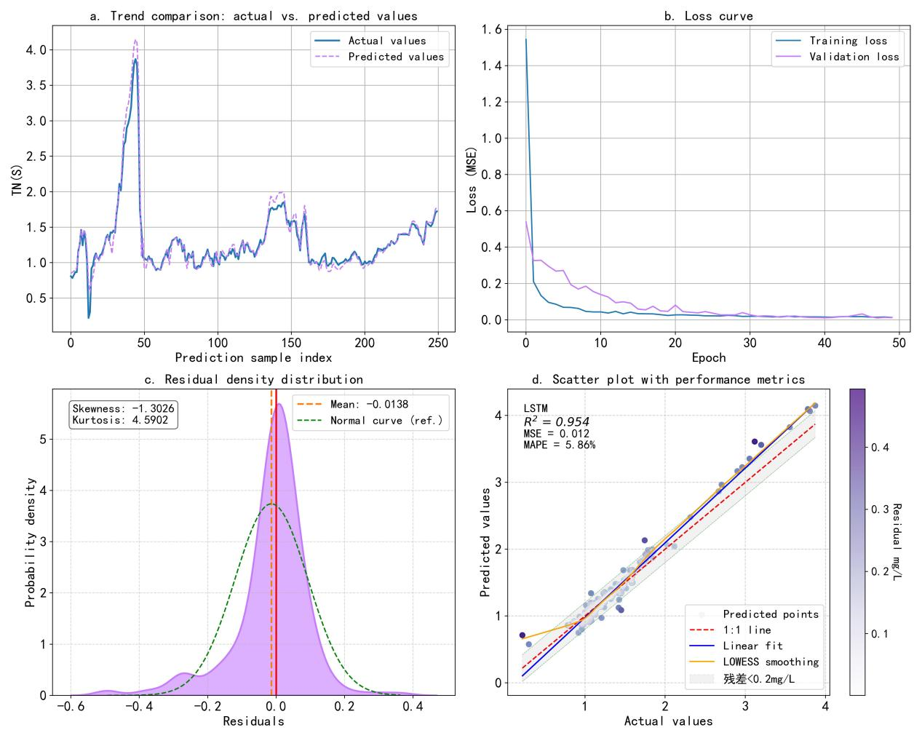
Fig. S19 Period-Specific Modeling: TN(s) Prediction Results and Model Performance Evaluation for Full-Stage

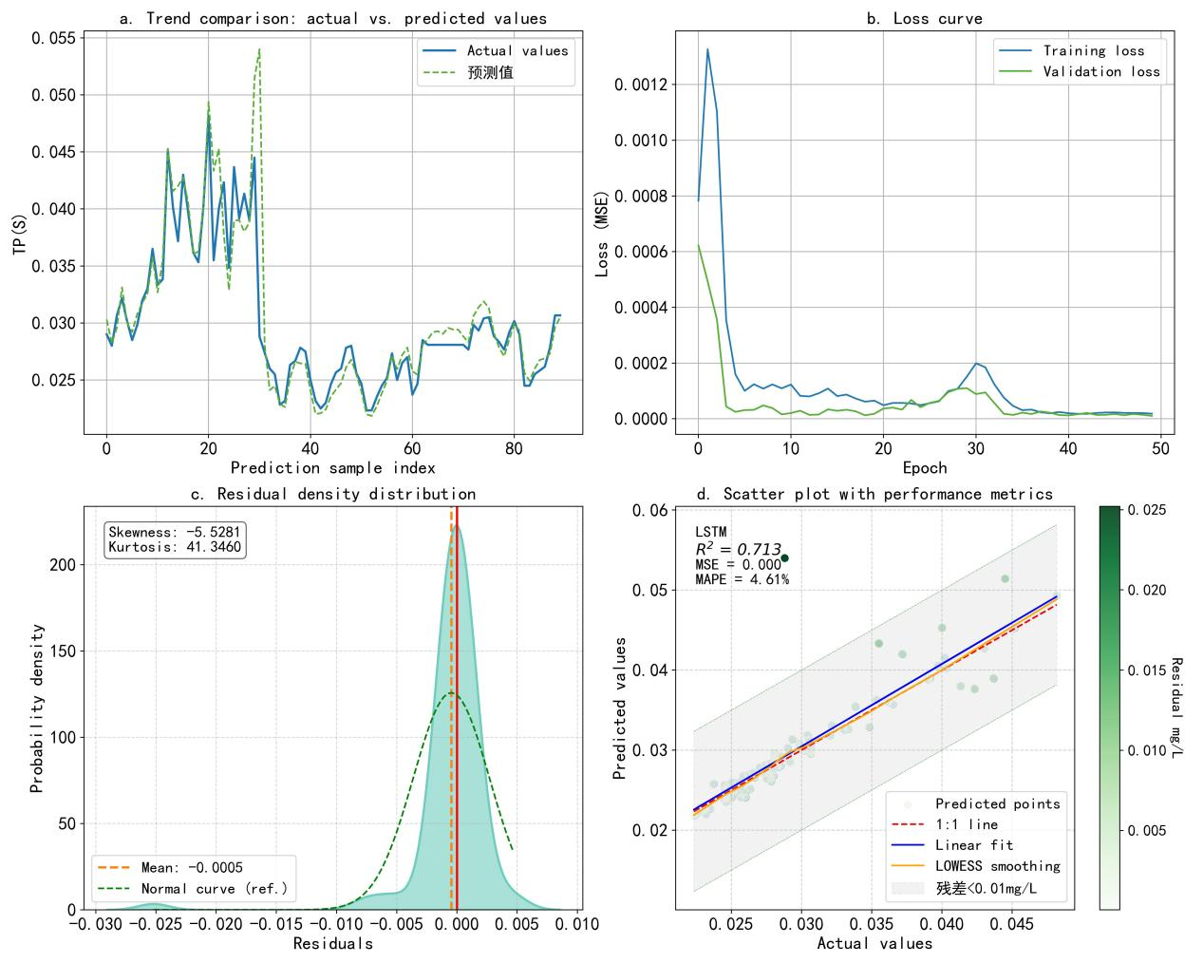
Fig. S20 Period-Specific Modeling: TP(s) Prediction Results and Model Performance Evaluation for Stage I

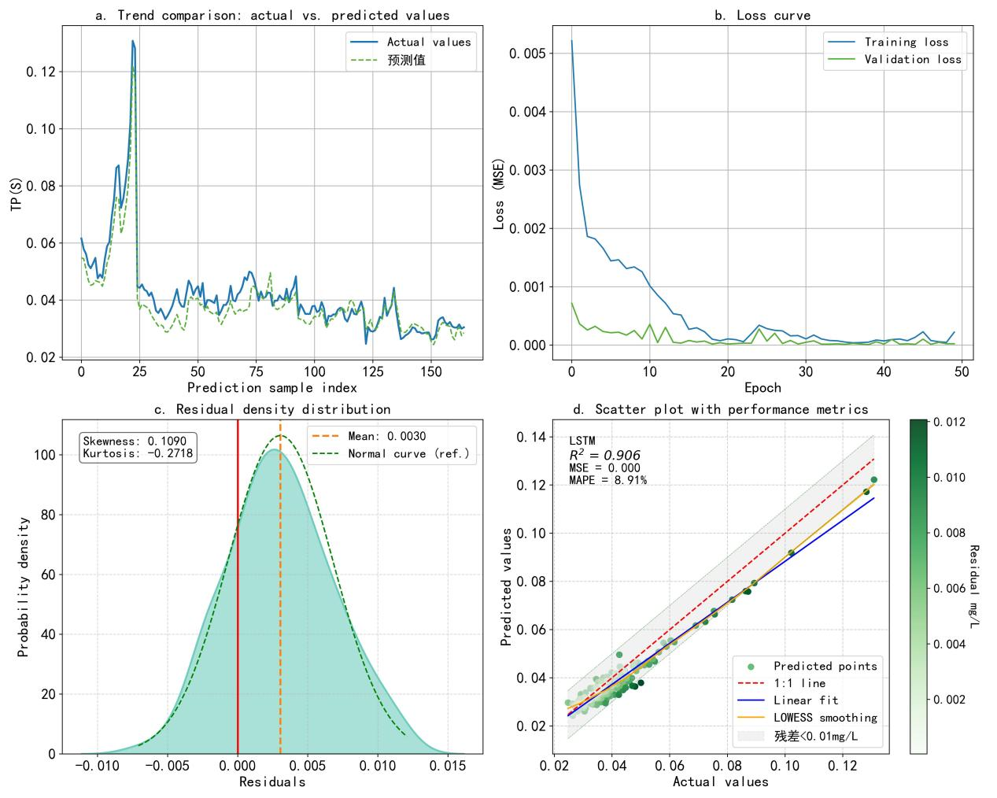
Fig. S21 Period-Specific Modeling: TP(s) Prediction Results and Model Performance Evaluation for Stage II

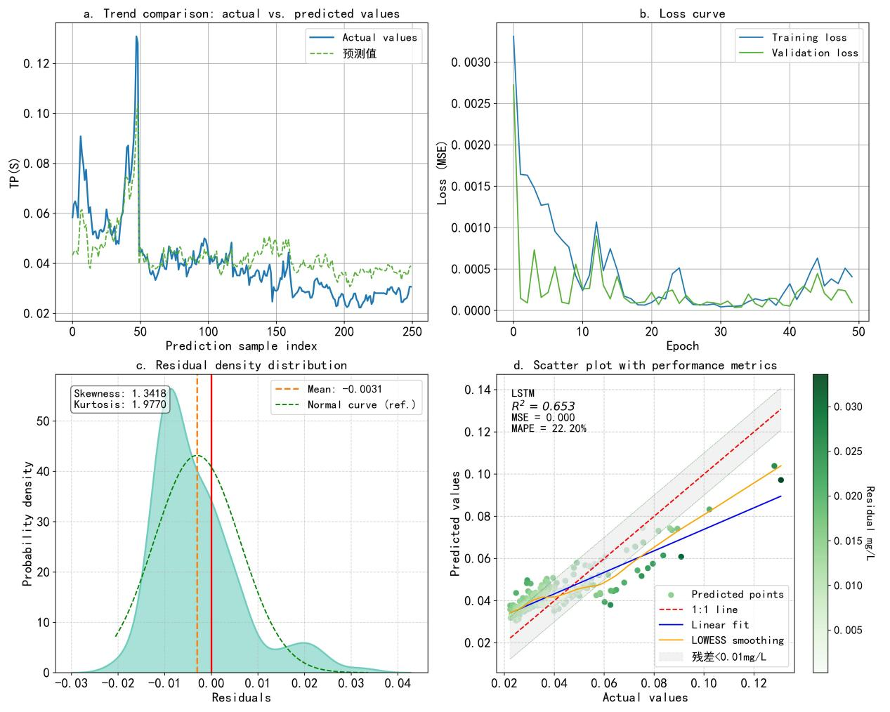
Fig. S22 Period-Specific Modeling: TP(s) Prediction Results and Model Performance Evaluation for Full-Stage

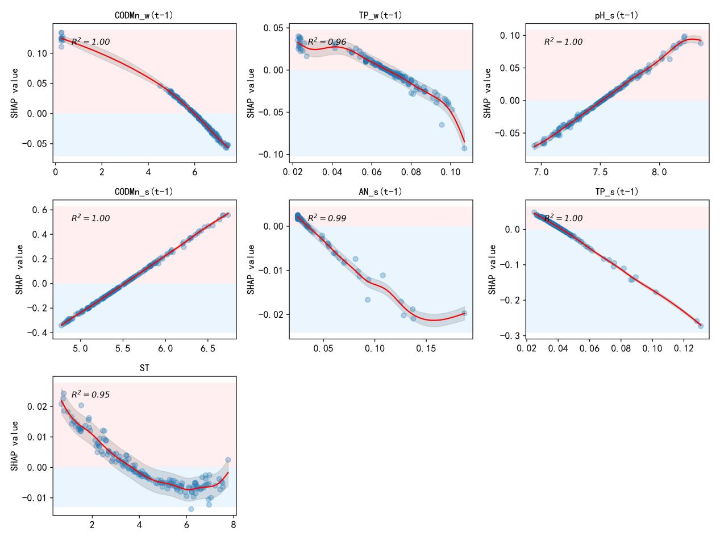
Fig. 23 Response profiles of key influencing factors on COD_{Mns(t)} (Stage II)

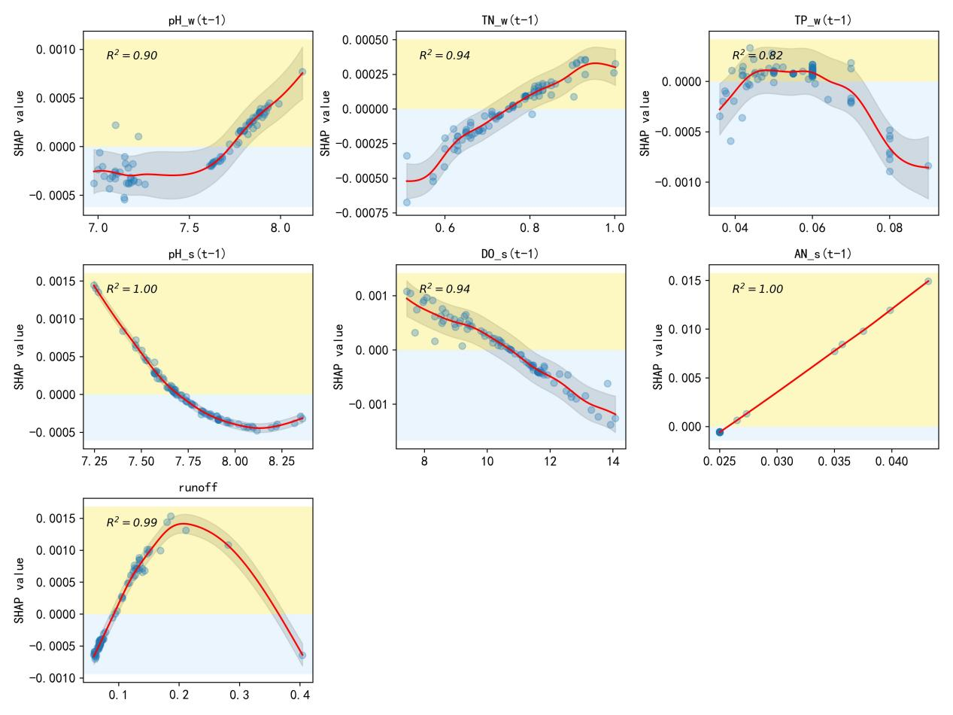
Fig. S24 Response profiles of key influencing factors on ANs(t) (Stage I)

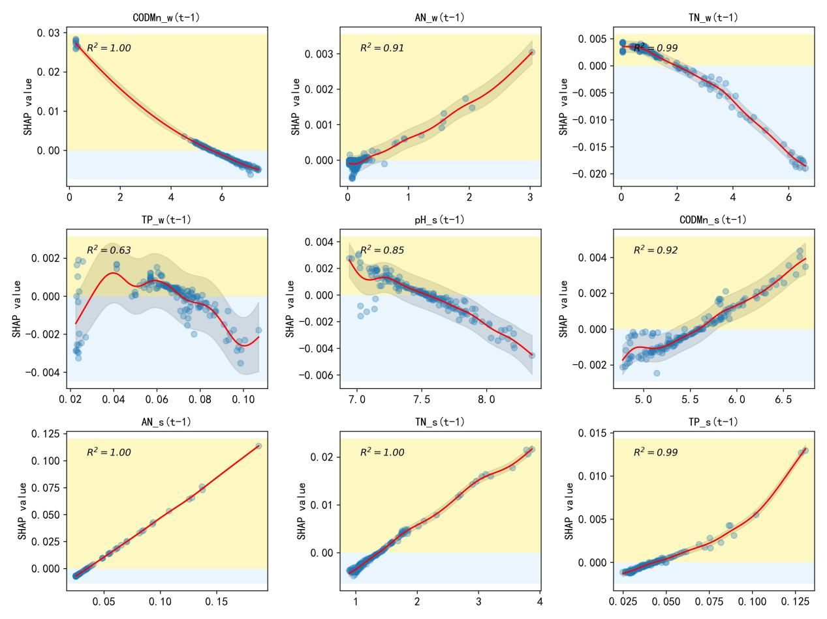
Fig. S25 Response profiles of key influencing factors on ANs(t) (Stage II)

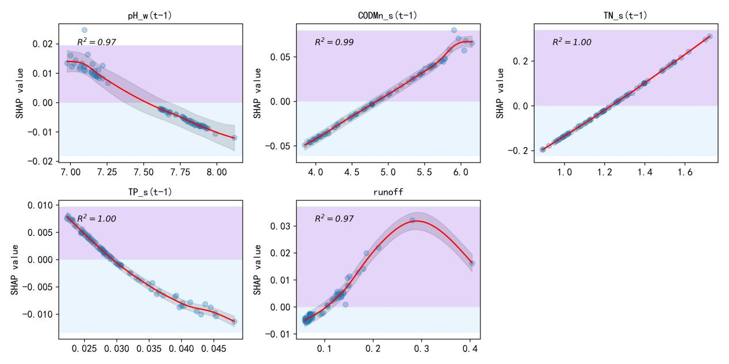
Fig. S26 Response profiles of key influencing factors on TNs(t) (Stage I)

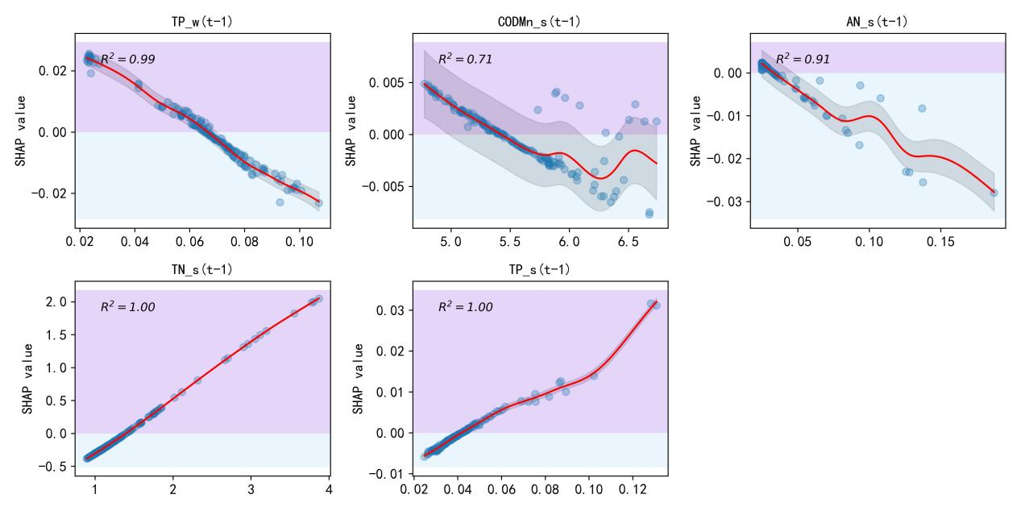
Fig. S27 Response profiles of key influencing factors on TNs(t) (Stage II)

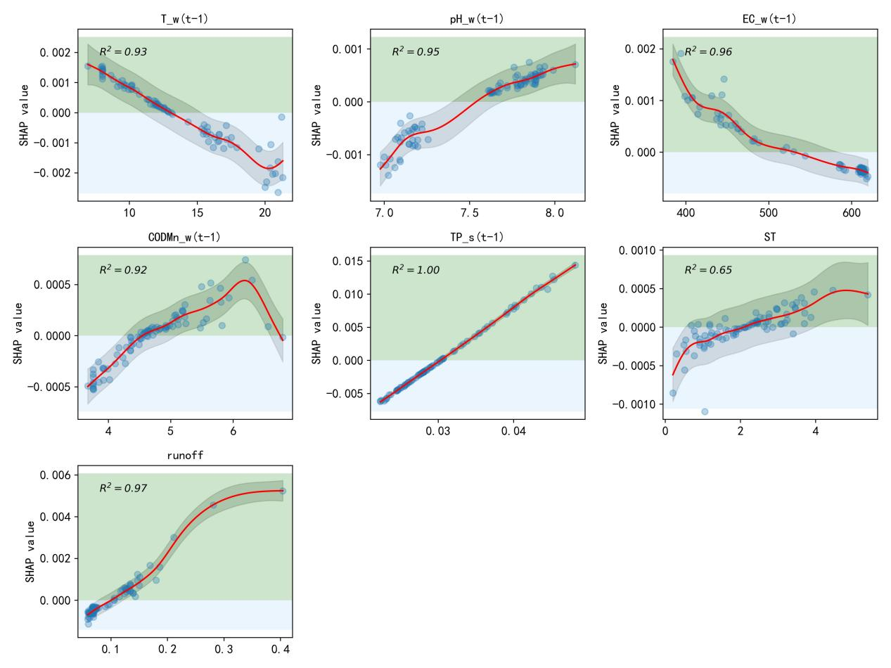
Fig. S28 Response profiles of key influencing factors on TPs(t) (Stage I)

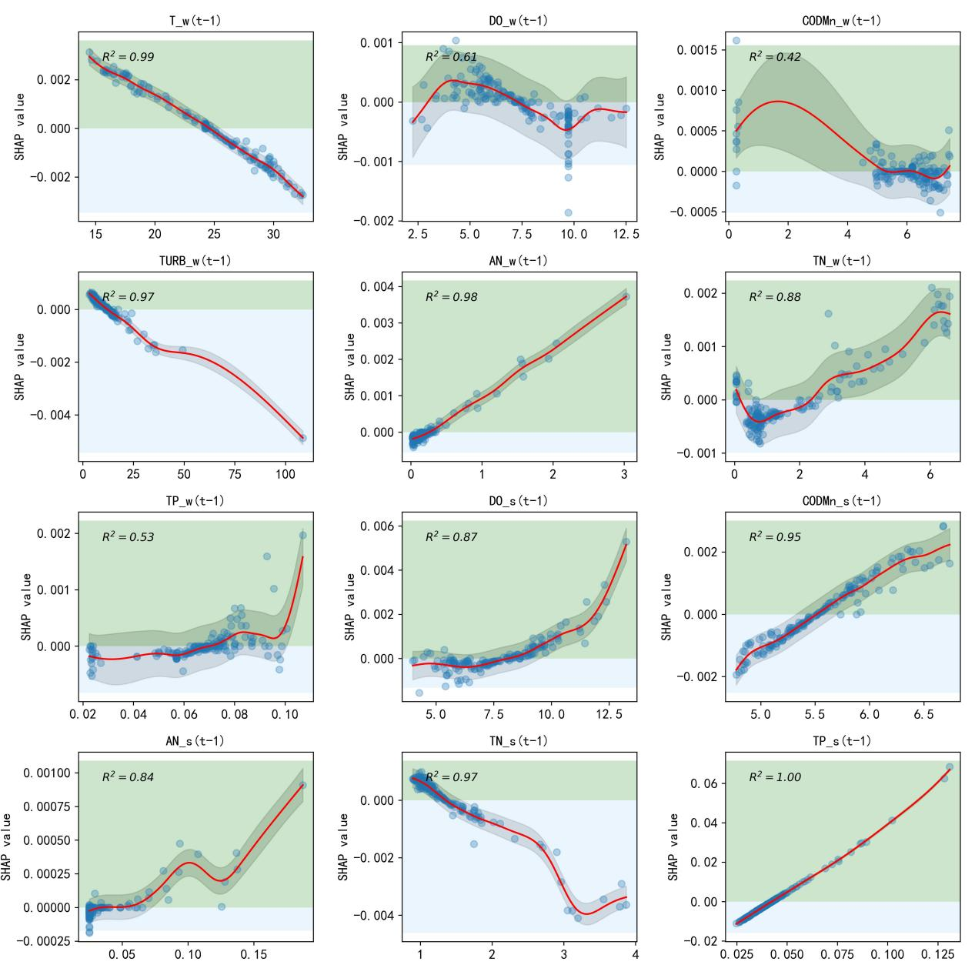
Fig. S29 Response profiles of key influencing factors on TPs(t) (Stage II)

