Additional file 2
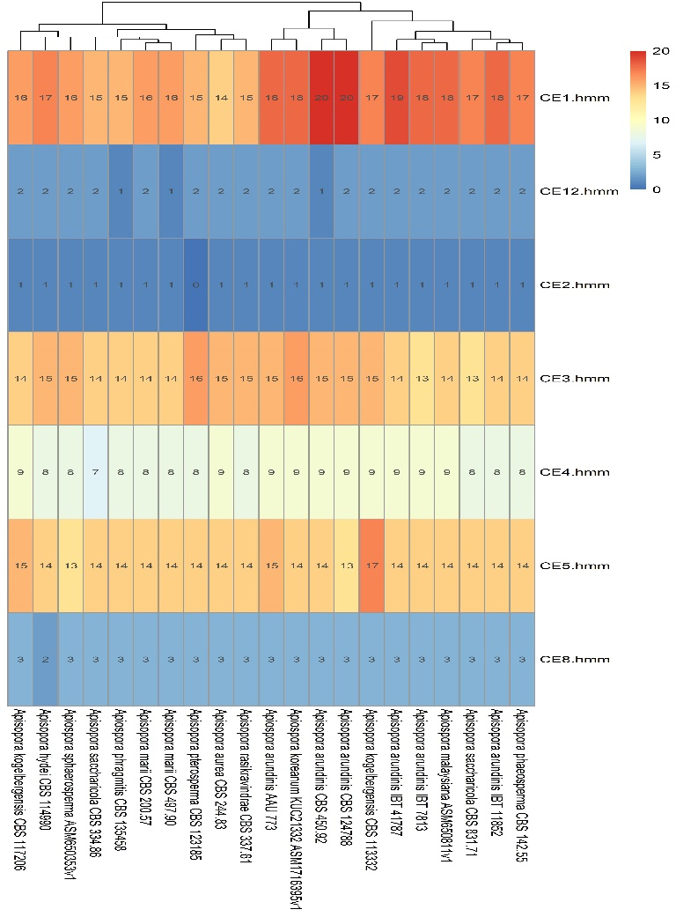
Figure S1 – Distribution of CAZyme-related genes located in the 21 Apiospora genome assemblies.
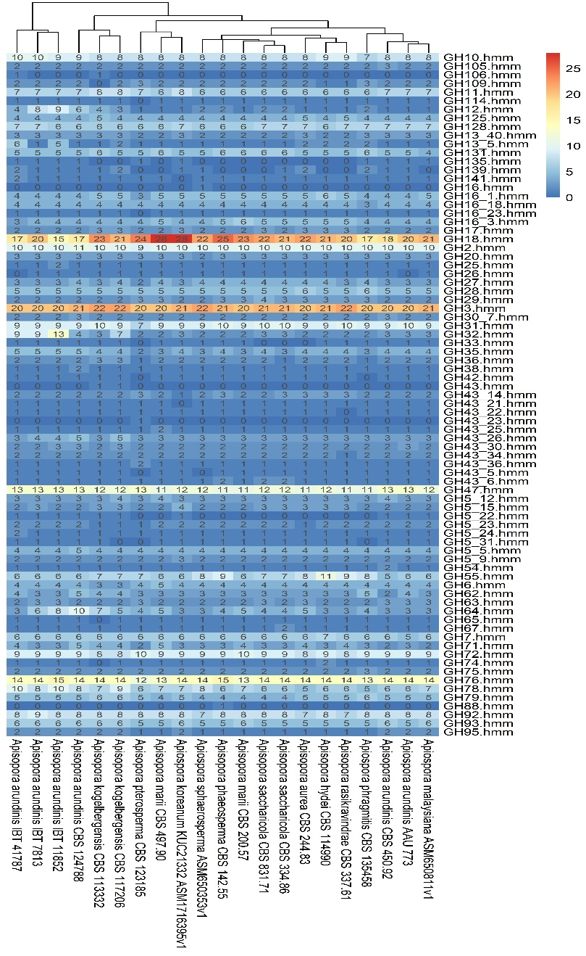
Figure S2 - Distribution of CAZyme-related genes located in the 21 Apiospora genome assemblies.

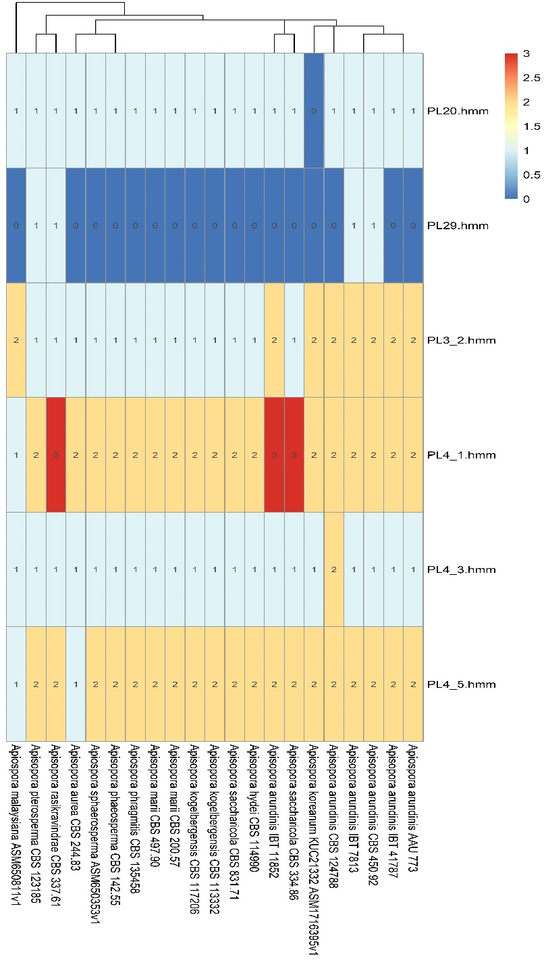
Figure S3 - Distribution of CAZyme-related genes located in the 21 Apiospora genome assemblies.

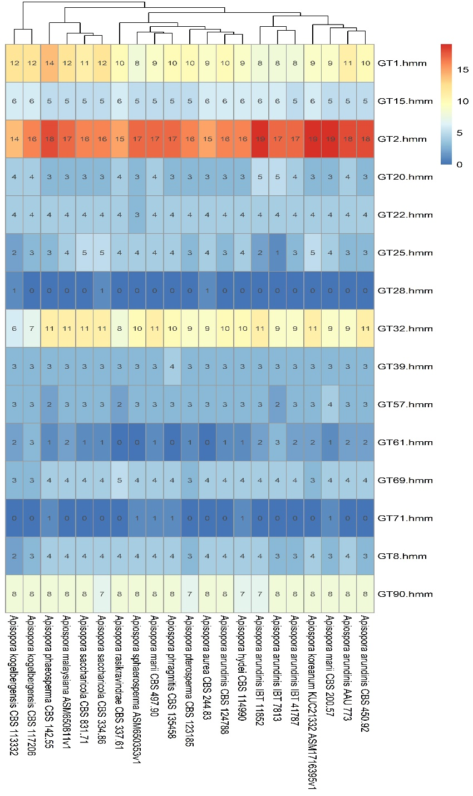
Figure S4 - Distribution of CAZyme-related genes located in the 21 Apiospora genome assemblies.

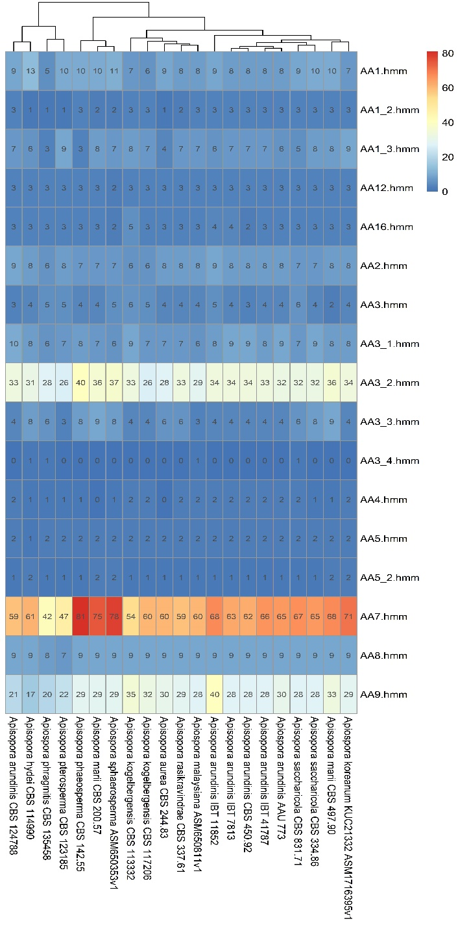
Figure S5 - Distribution of CAZyme-related genes located in the 21 Apiospora genome assemblies.

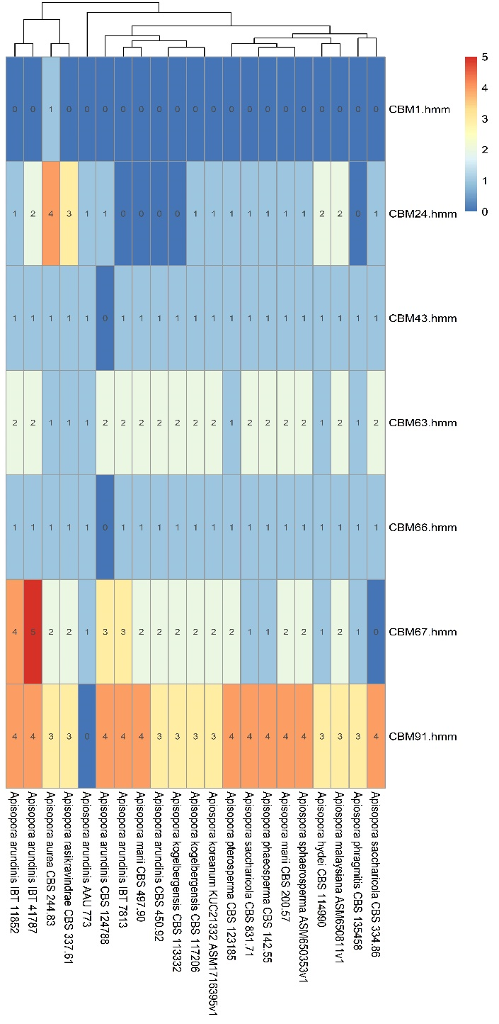
Figure S6 - Distribution of CAZyme-related genes located in the 21 Apiospora genome assemblies.

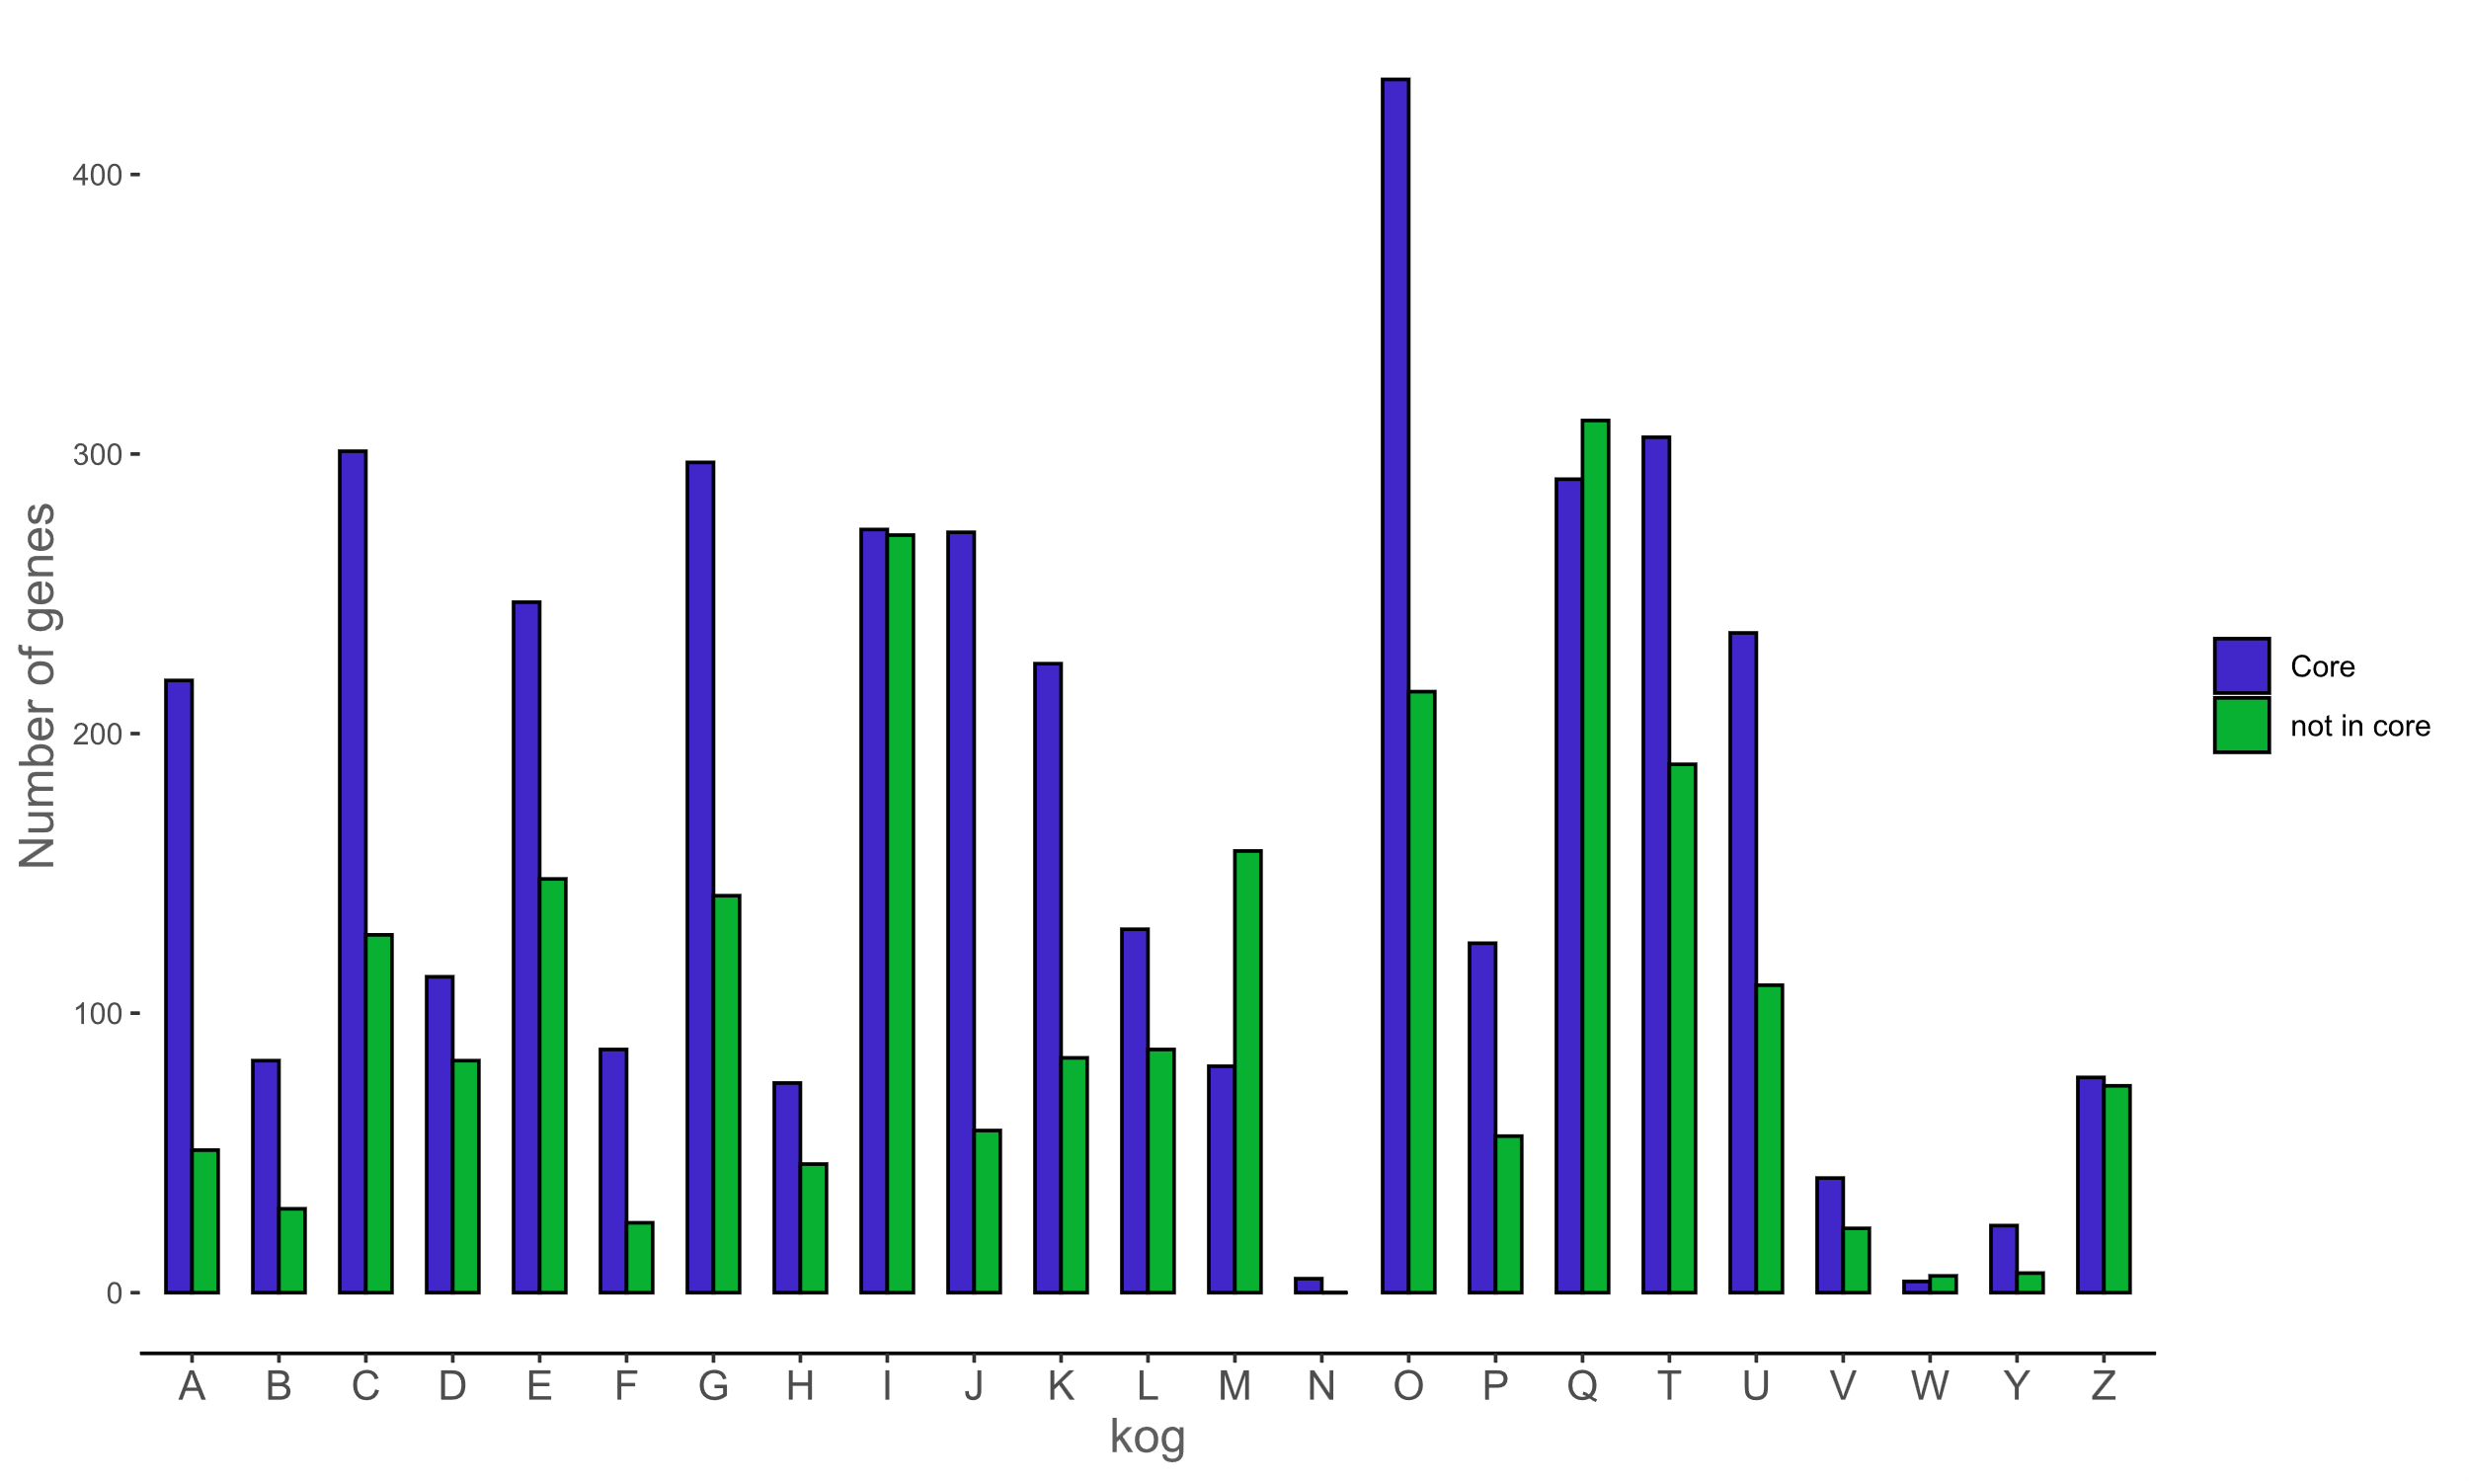
Figure S7 – Distribution of genes with KOG associated terms in the core genome (blue) and in the dispensable genome (green).

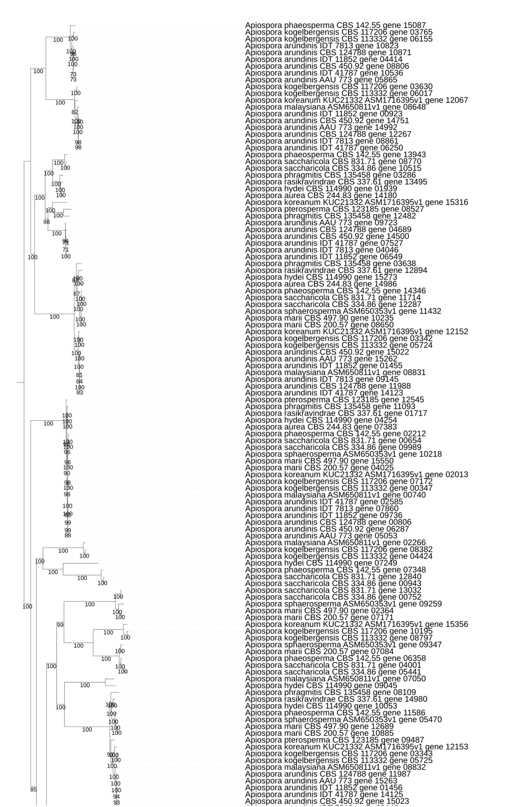
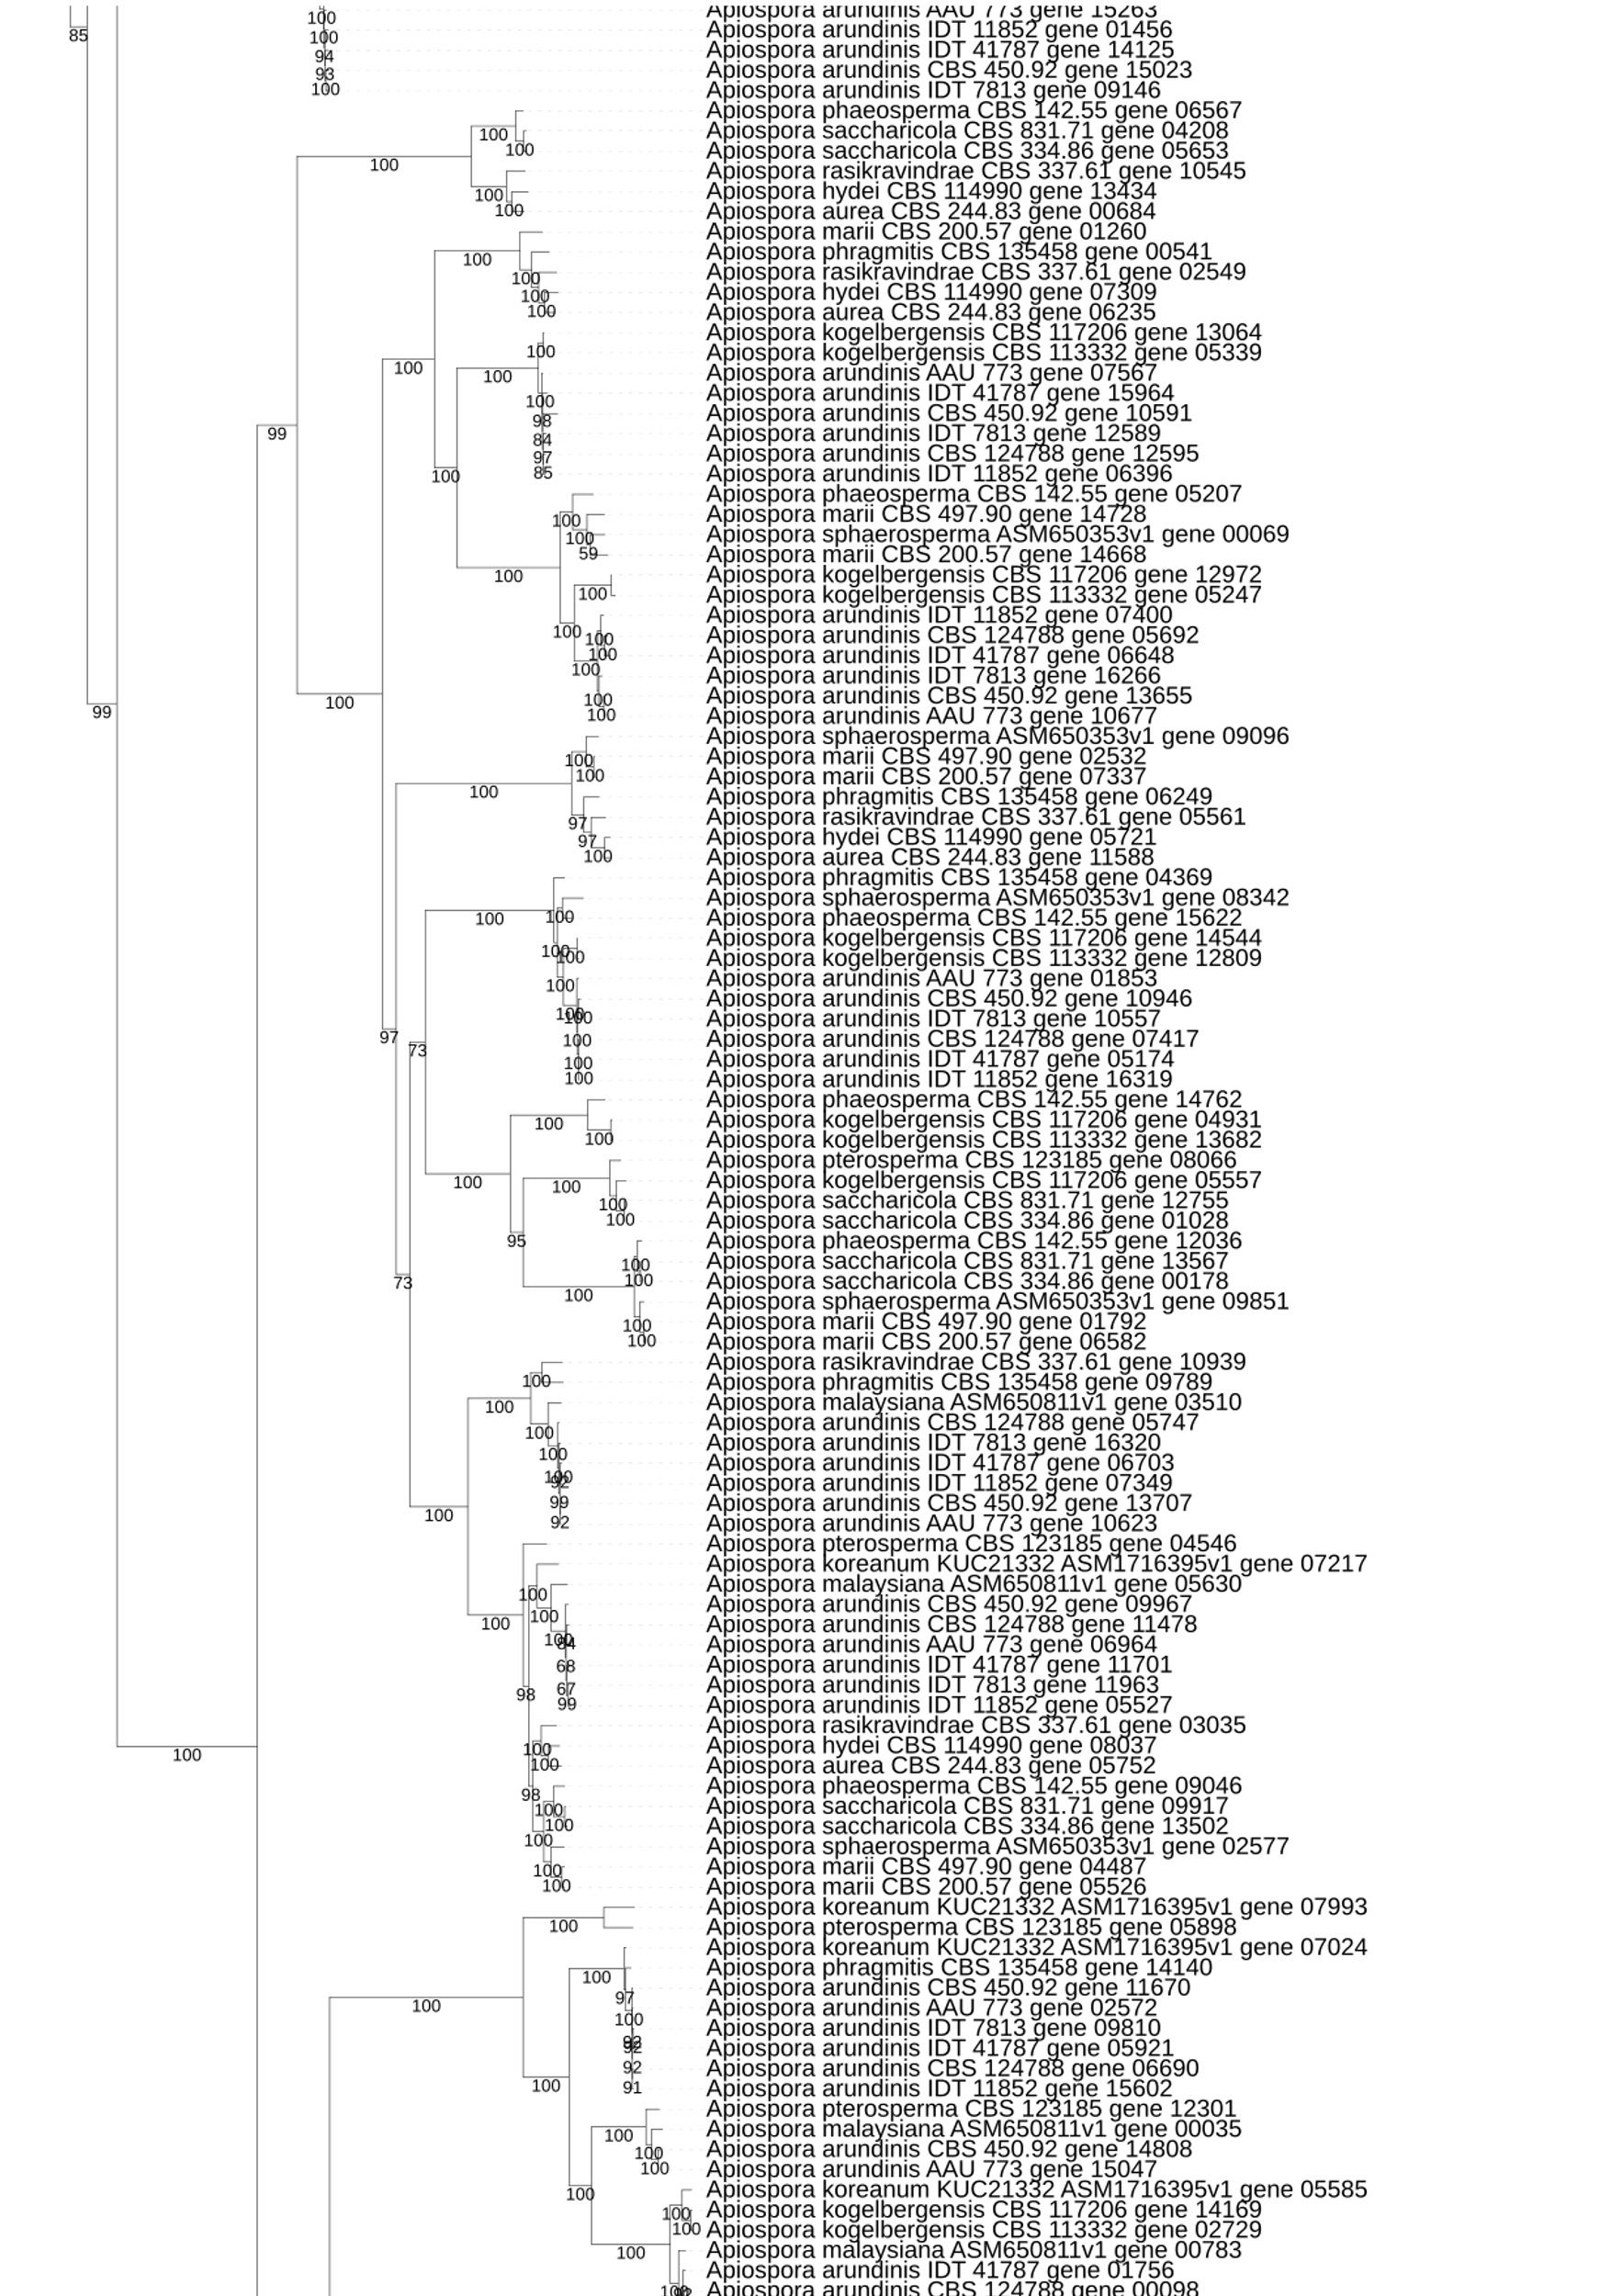

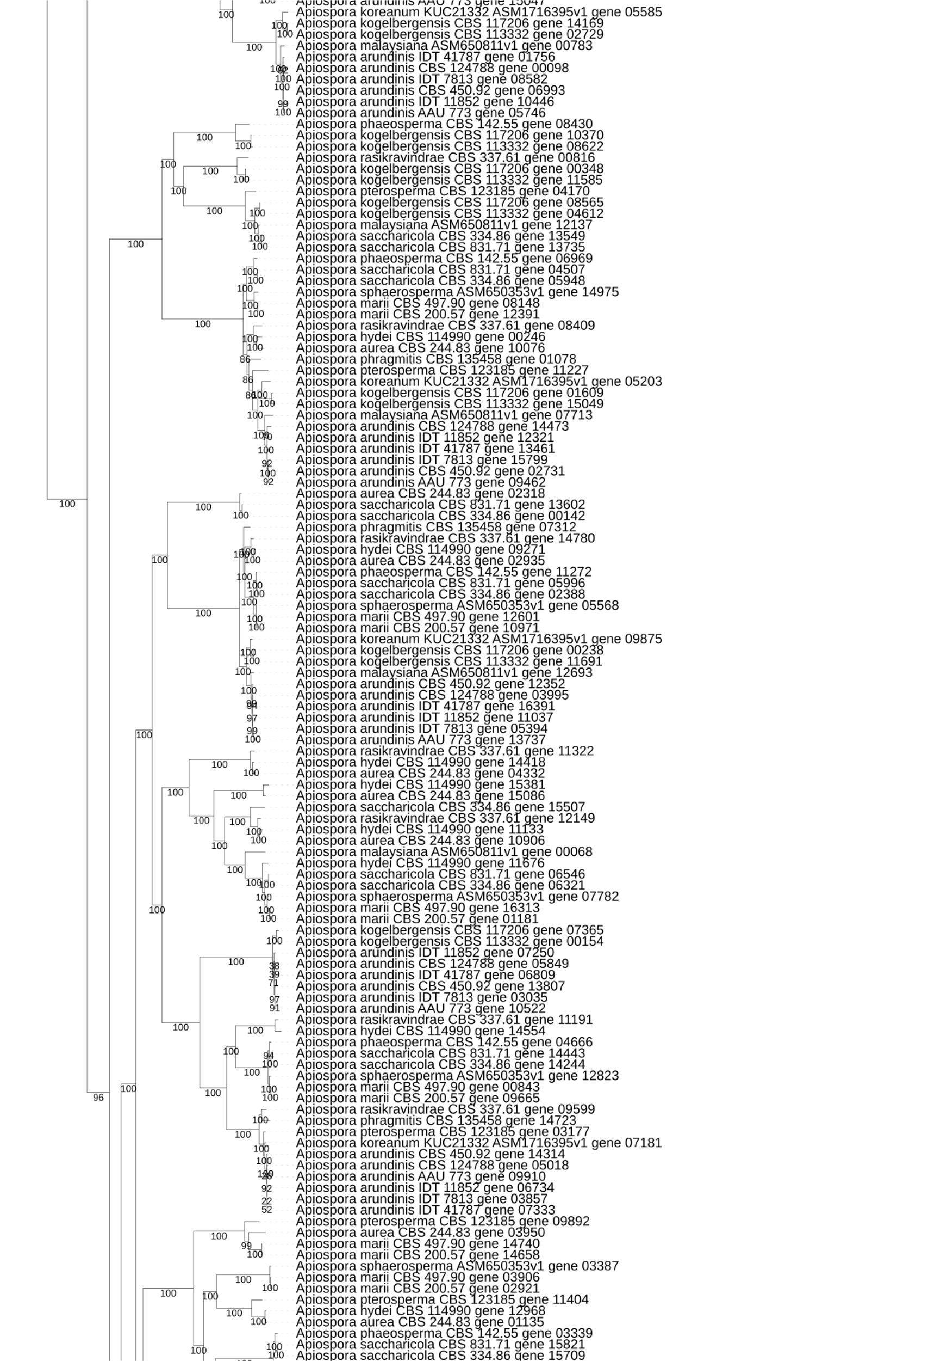

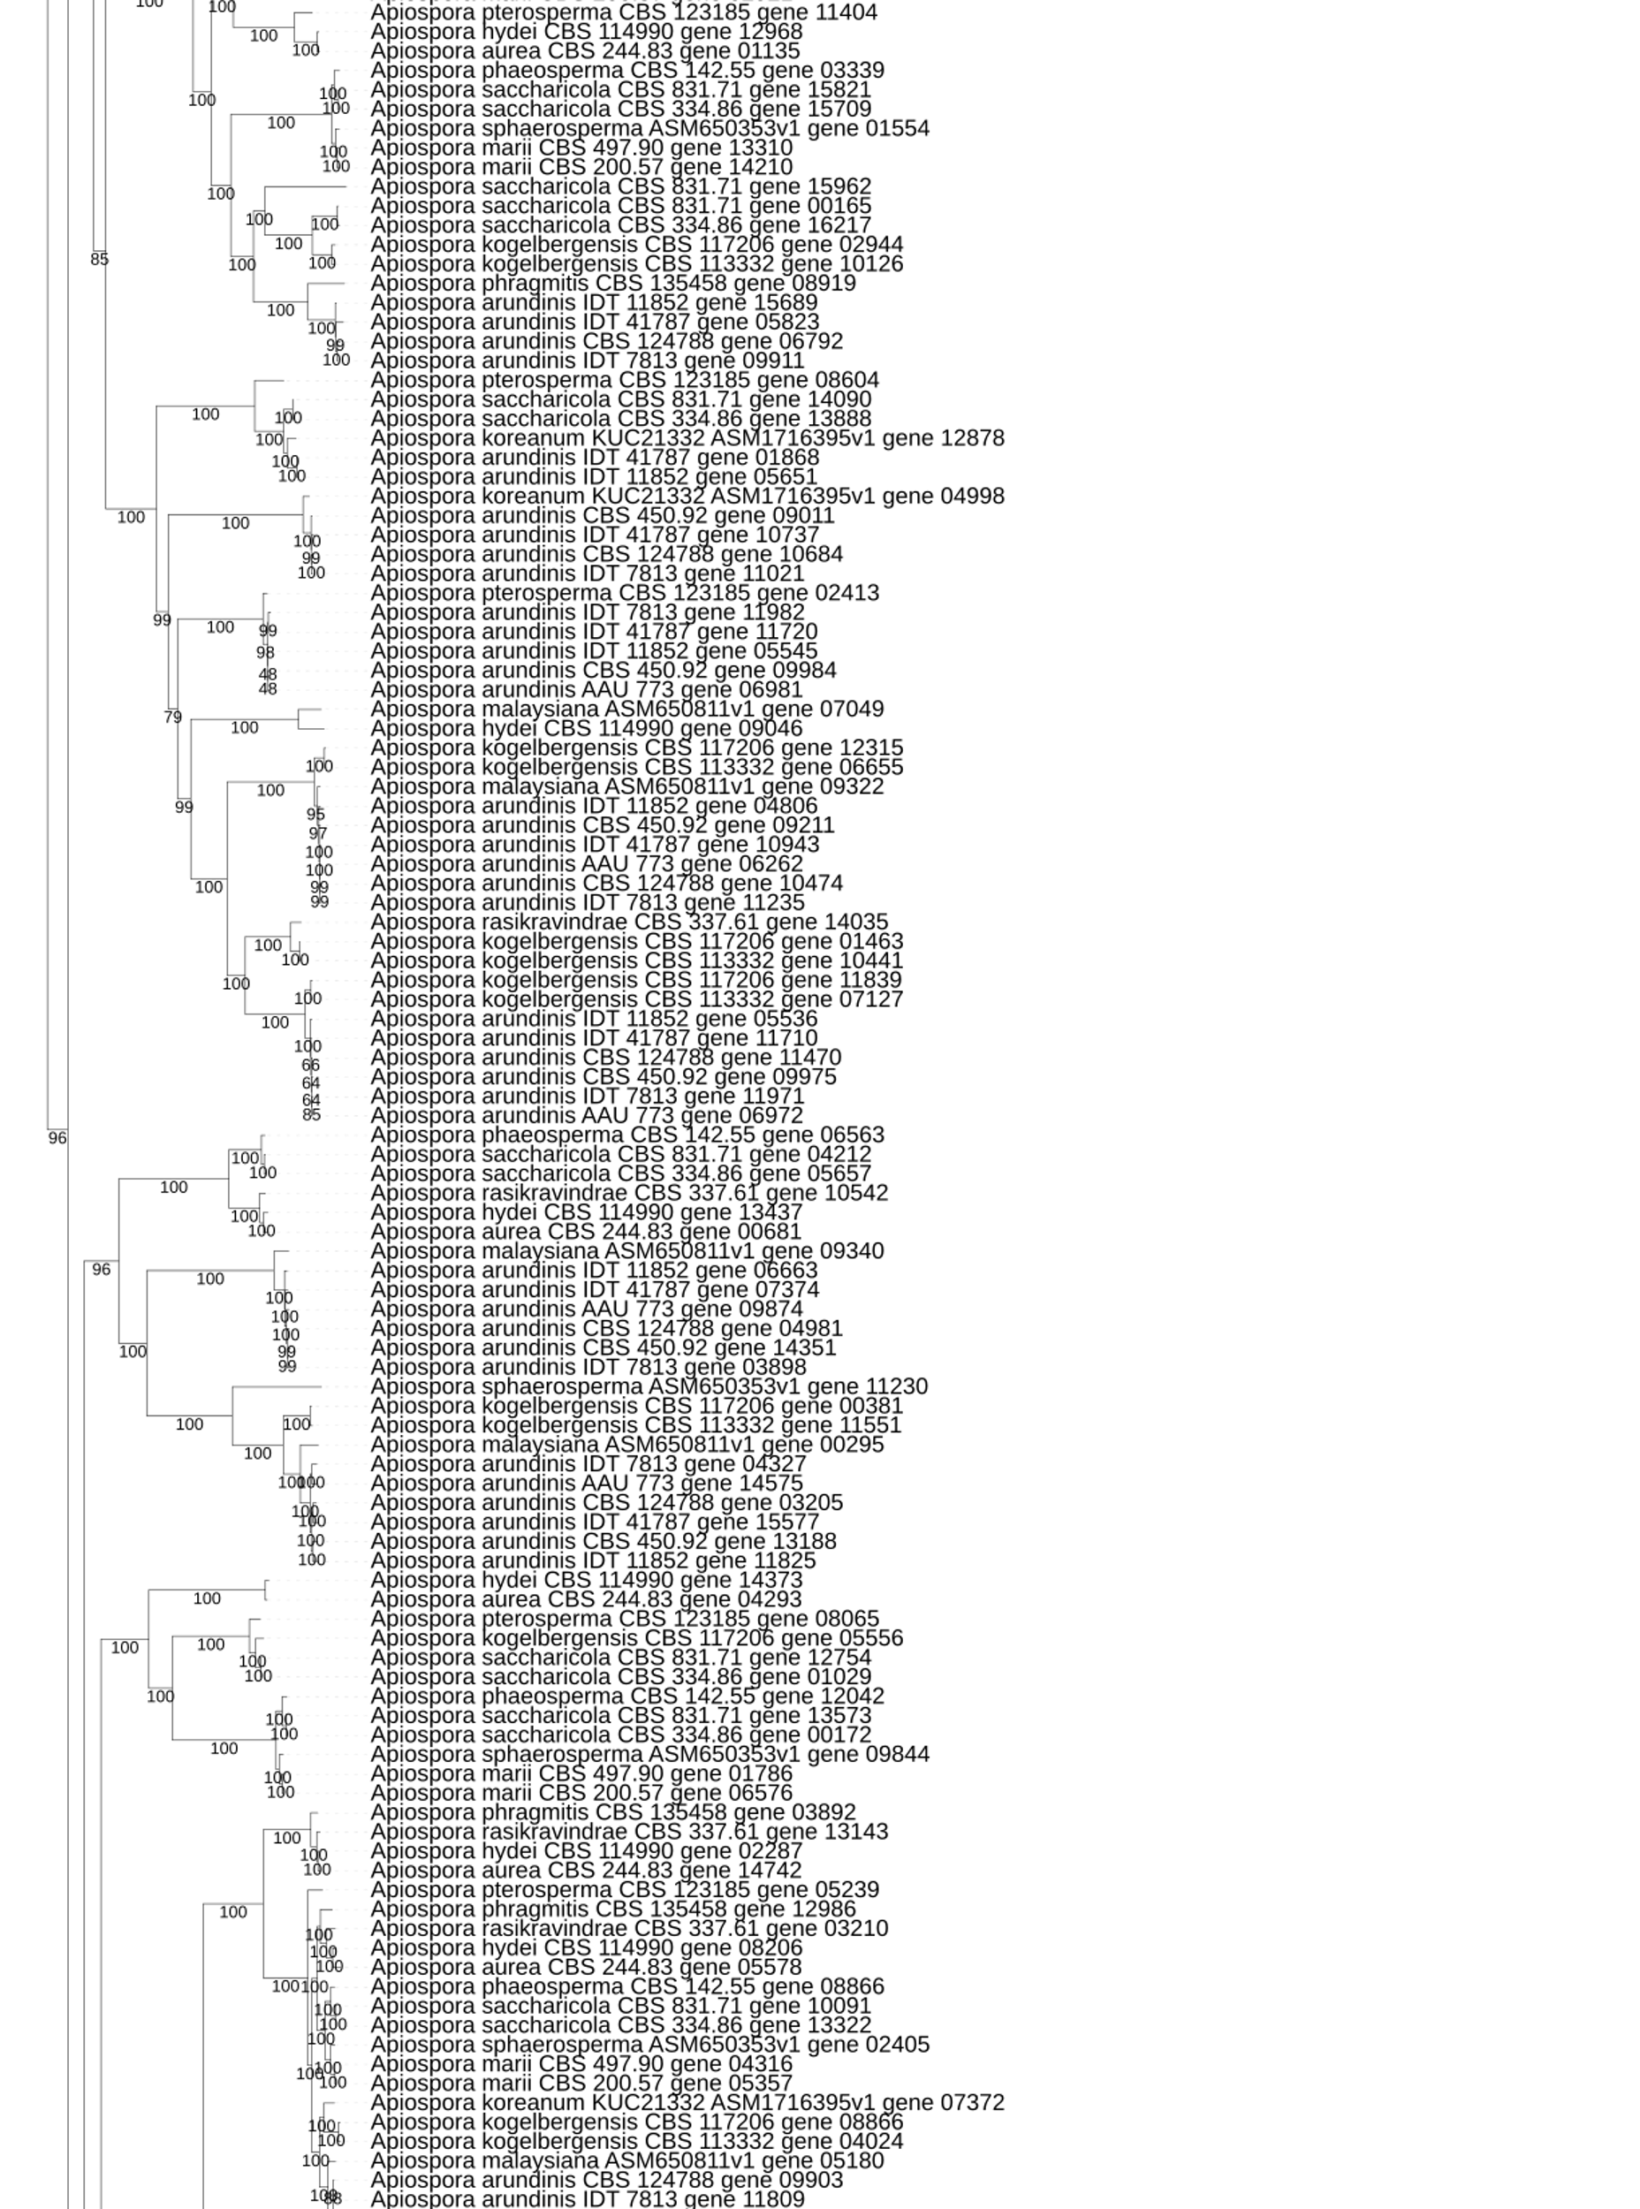

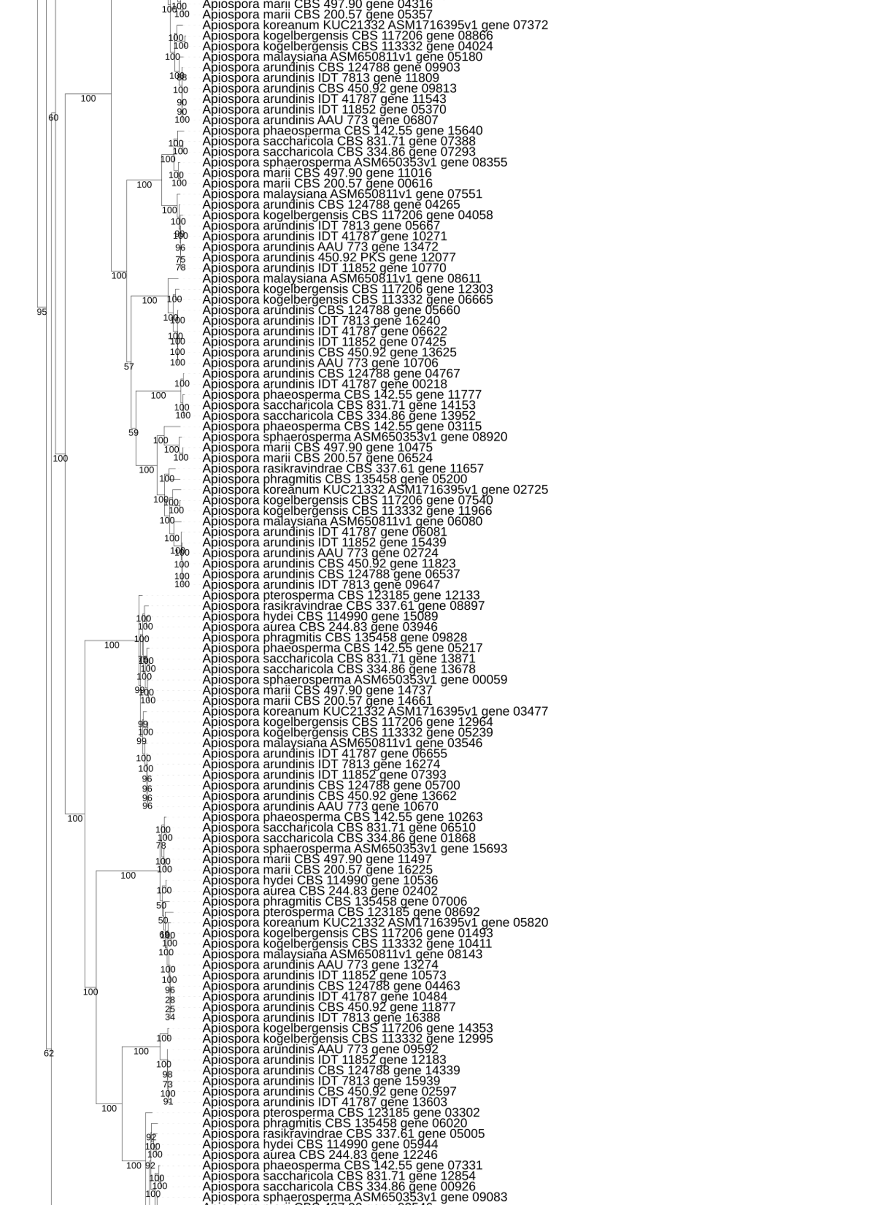

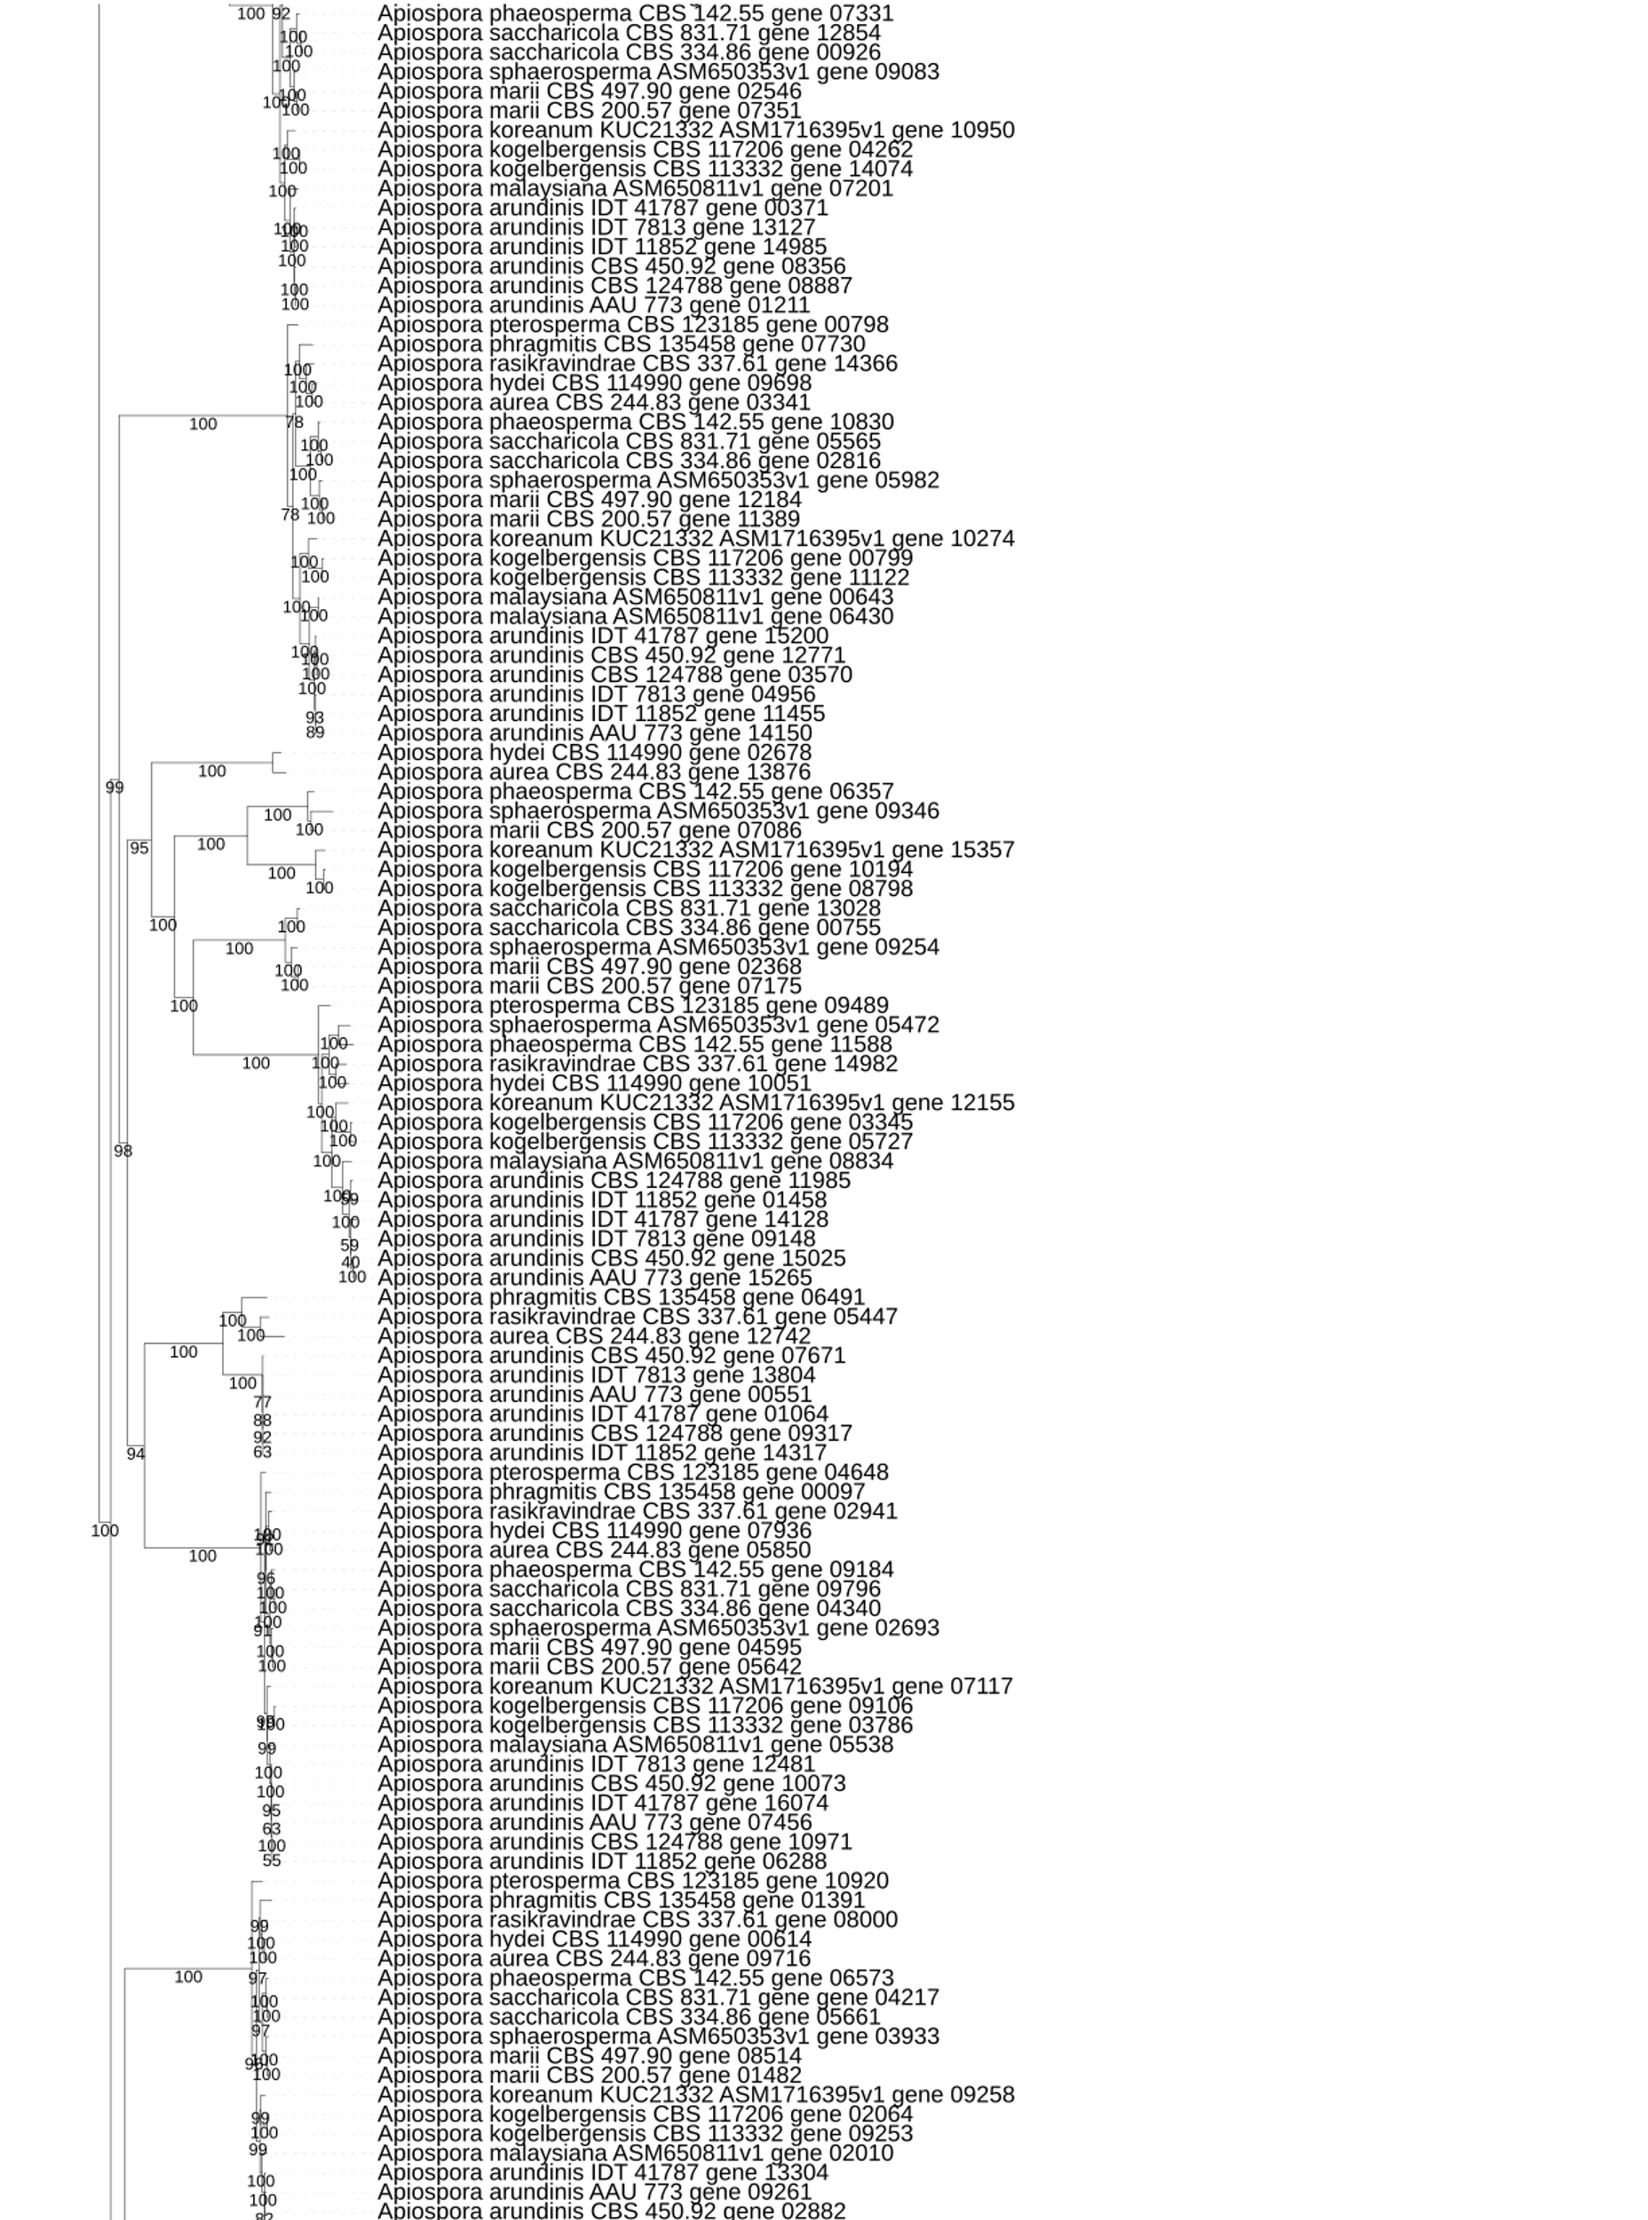
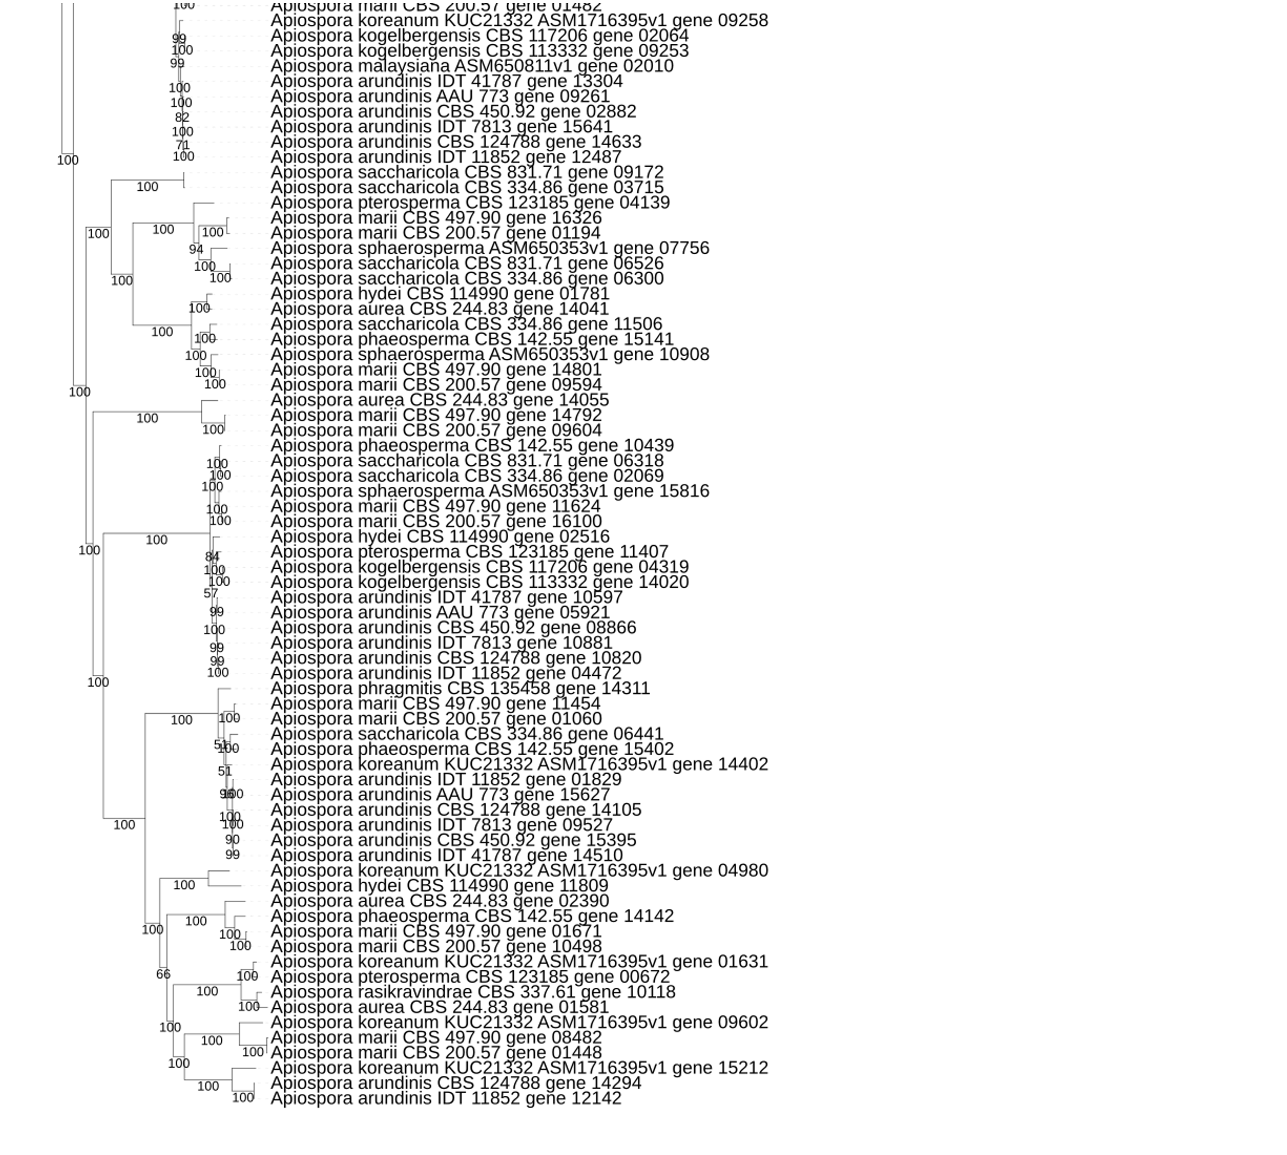
Figure S8 – Phylogenetic analysis of the PKS core genes located in the 21 Apiospora genome assemblies.

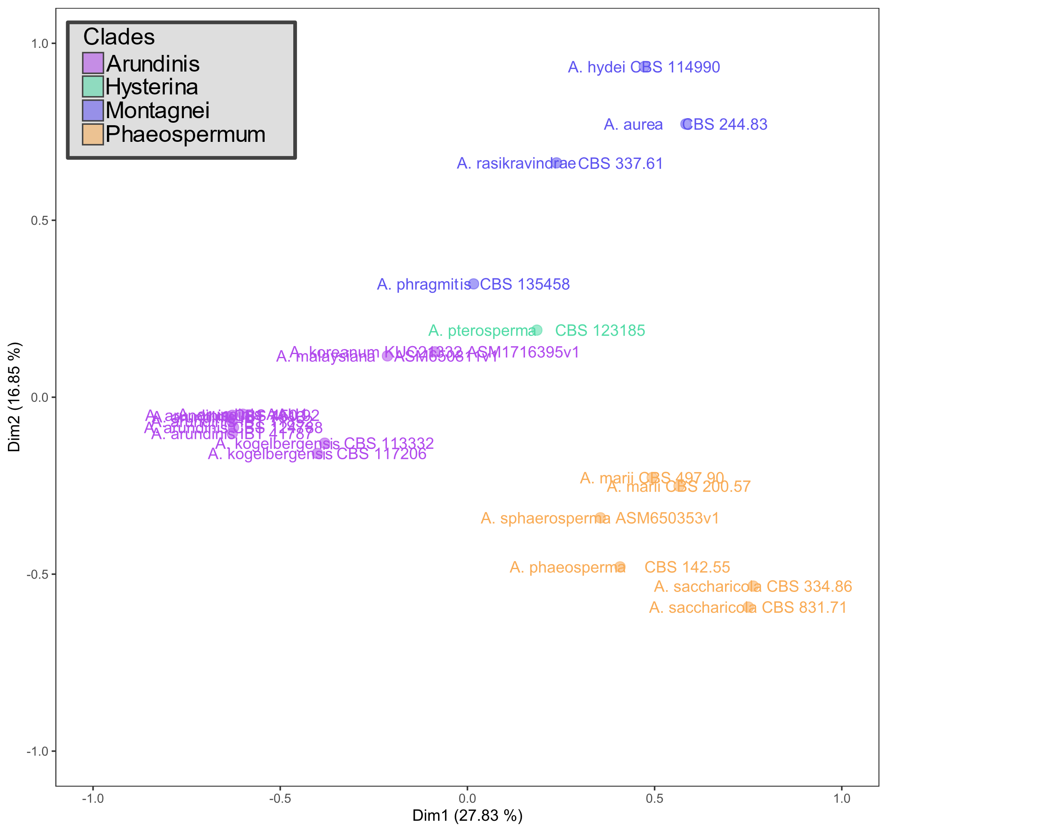
Figure S9 – MCA analysis of the PKS profiles from all the Apiospora genomes.

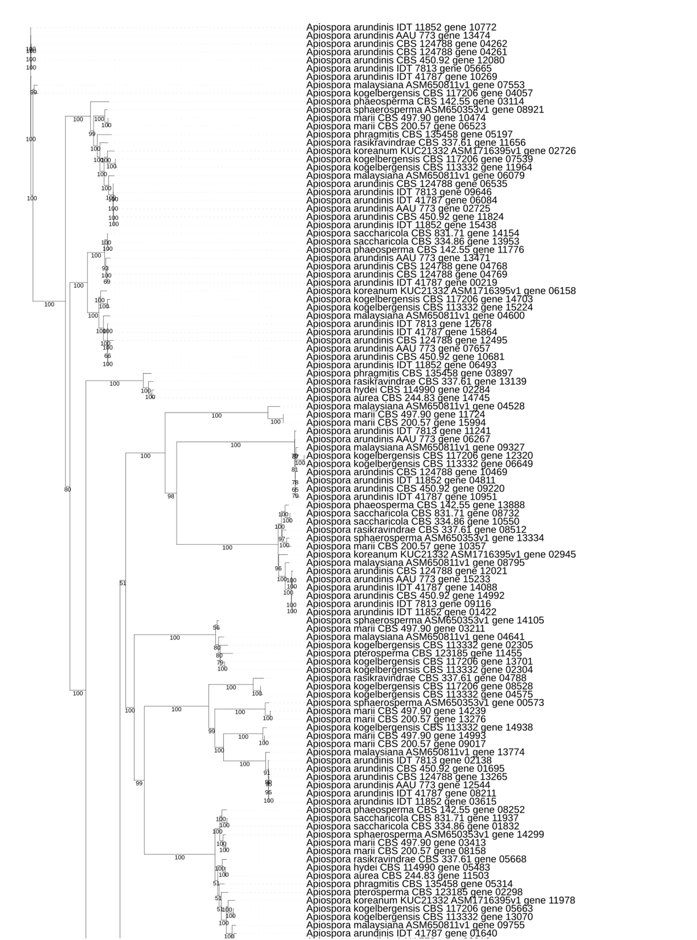
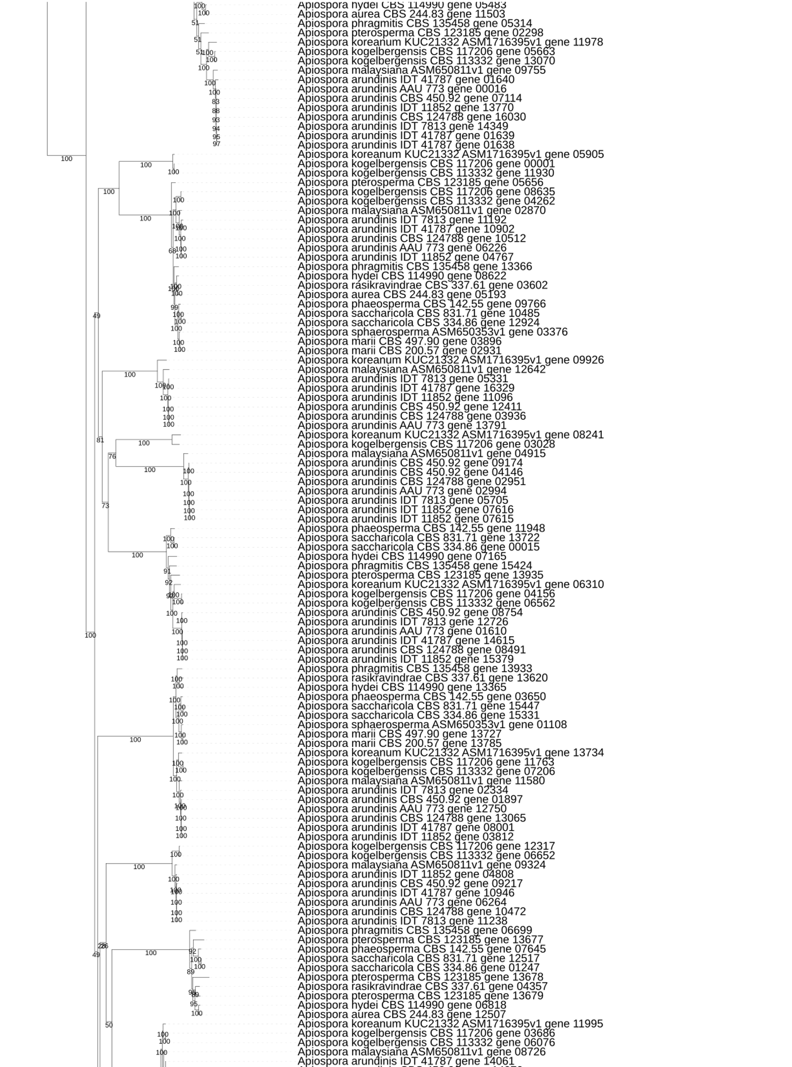
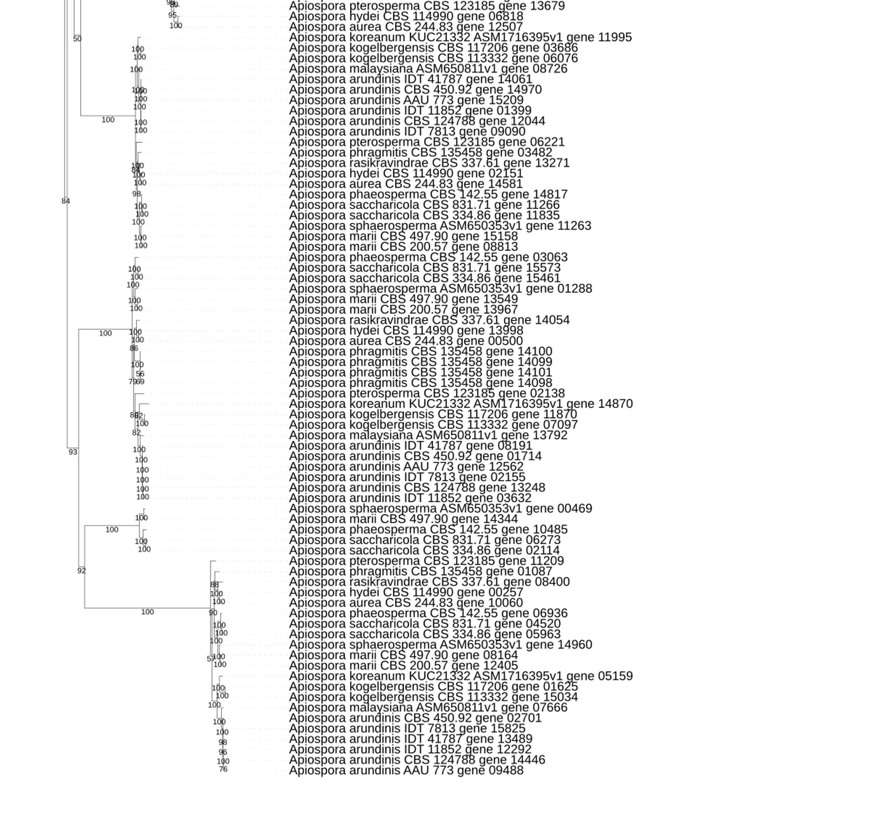
Figure S10 – Phylogenetic analysis of the NRPS core genes located in the 21 Apiospora genome assemblies.
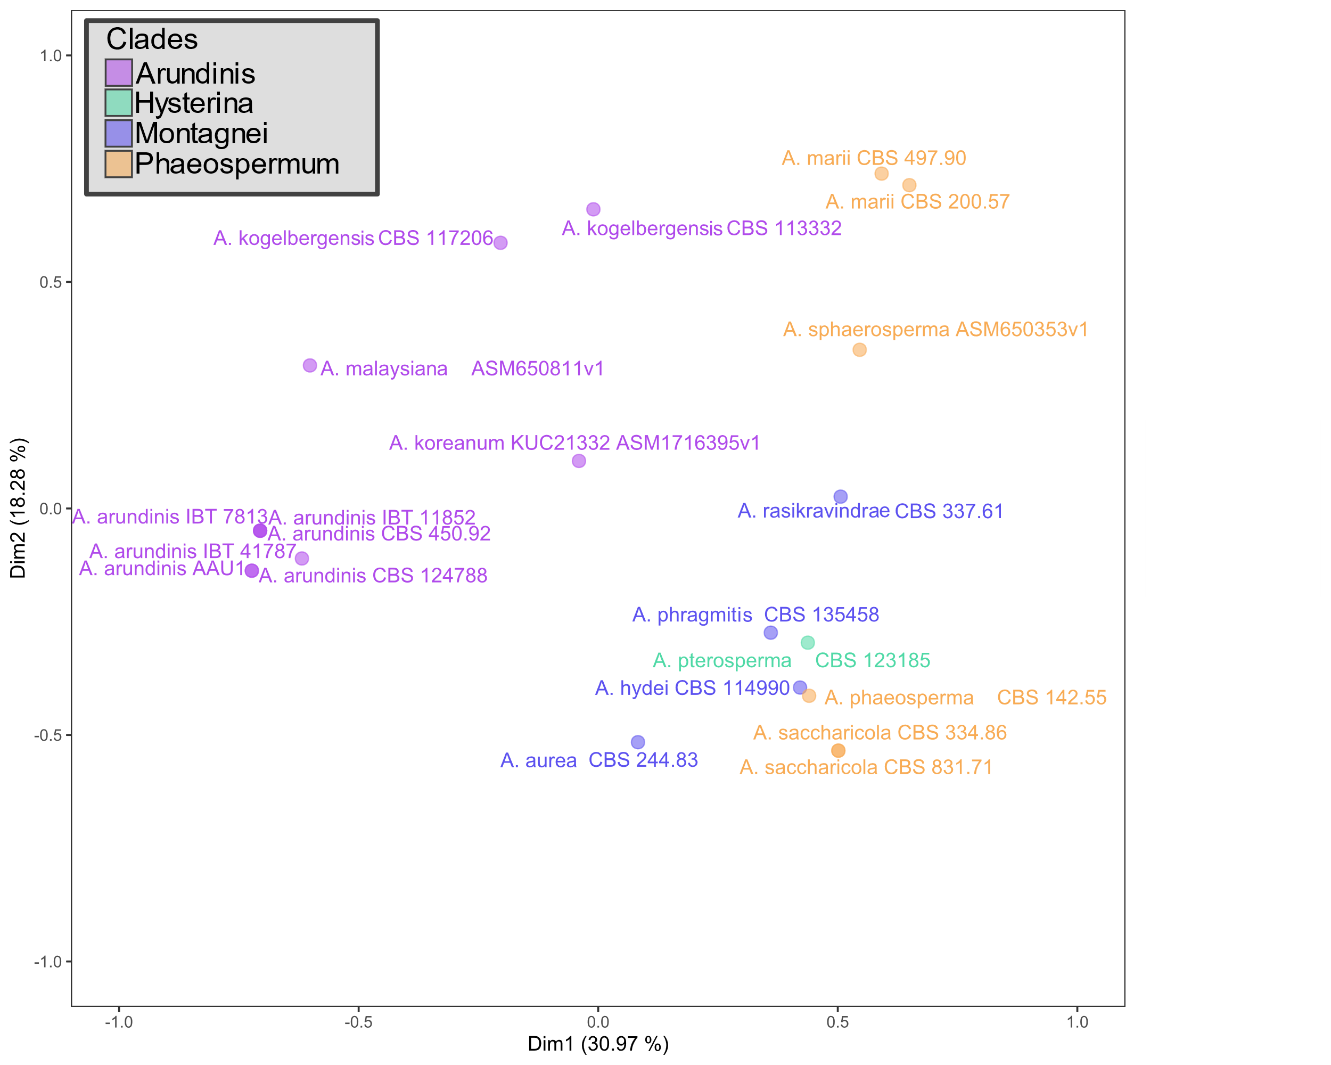
Figure S11 – MCA analysis of the NRPS profiles from all the Apiospora genomes.

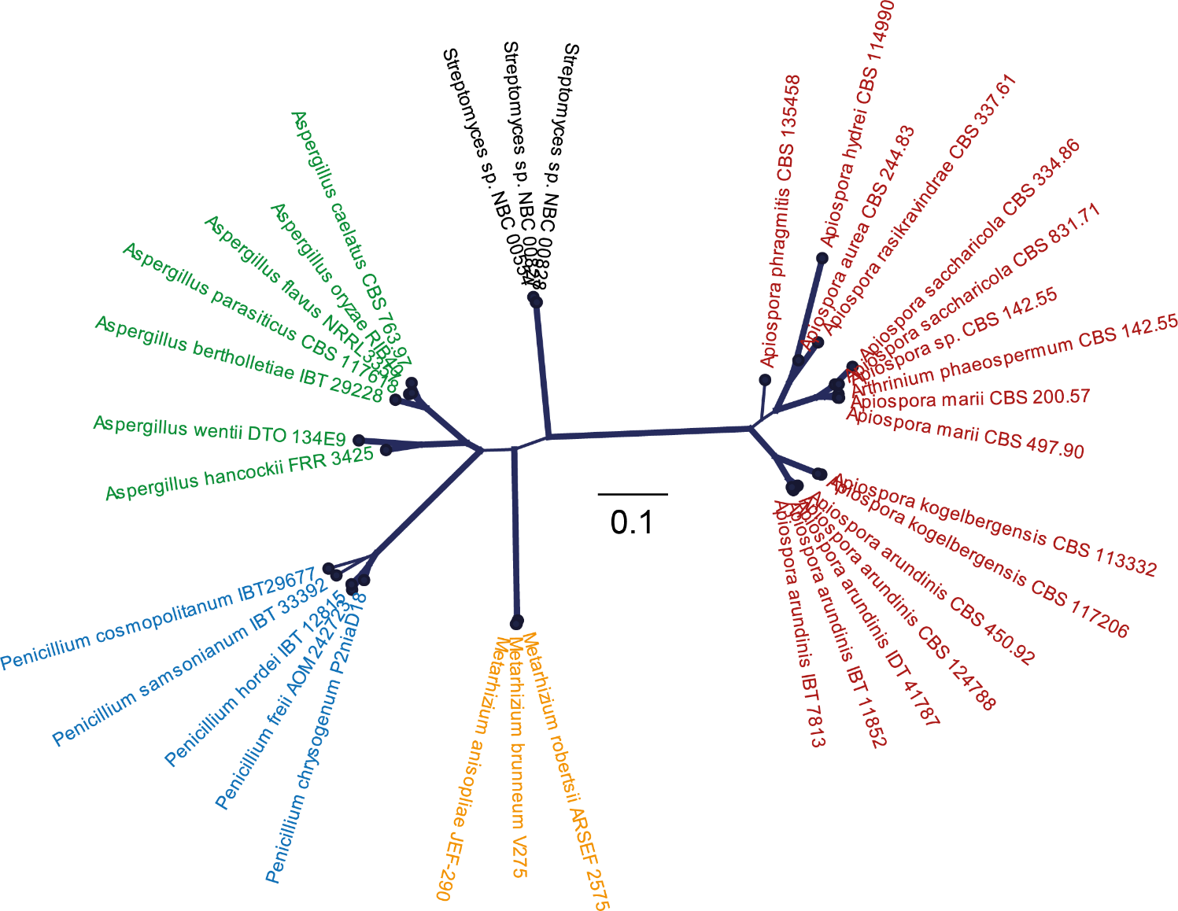

Figure S12 – Radial tree showing the phylogenetic relationship between 3-NPA oxidoreductase protein sequences from available genome sequenced Apiospora strains and selected strains of Aspergillus, Metarhizium, Penicillium and Streptomyces. Bold lines represents bootstrap values of >80% from 100 replications. Note that Apiospora arundinis AAU 773, Apiospora KUC21332, Apiospora malaysiana and Apiospora pterosperma did not contain the gene..

