Supporting Information

Magnetically Guided Theranostics: Enhancing the Contrast of Magnetic Resonance Imaging with Multiple-Layer Montmorillonite-Based Iron/Platinum Nanoparticles for the Treatment of Orthotopic Hepatocellular Carcinoma

Ming-Hsien Chan,‡ Chi-Ning Lu,‡ Yi-Lung Chung, Yu-Chan Chang, Chien-Hsiu Li, Chi-Long Chen*, Da-Hua Wei*, and Michael Hsiao*

Michael Hsiao, Ming-Hsien Chan, and Chien-Hsiu Li − Genomics Research Center, Academia Sinica, Taipei 115, Taiwan
Chi-Ning Lu − Department of Chemistry, Saint Michael's College, Vermont 05439, USA
Da-Hua Wei and Yi-Lung Chung − Graduate Institute of Manufacturing Technology and Department of Mechanical Engineering, National Taipei University of Technology, National Taipei University of Technology, Taipei 106, Taiwan
Yu-Chan Chang − Department of Biomedical Imaging and Radiological Sciences, National Yang Ming Chiao Tung University, Taipei 112, Taiwan
Chi-Long Chen − Department of Pathology, College of Medicine and Department of Pathology, Taipei Medical University Hospital, Taipei 11031, Taiwan
Michael Hsiao − Department of Biochemistry, College of Medicine, Kaohsiung Medical University, Kaohsiung 807, Taiwan

*Corresponding Authors:
Michael Hsiao, ORCID: orcid.org/0000-0002-6131-5706; Email: mhsiao@gate.sinica.edu.tw
Da-Hua Wei, ORCID: orcid.org/0000-0001-7603-3739; Email: : dhwei@ntut.edu.tw
Chi-Long Chen, ORCID: orcid.org/0000-0003-2875-1669; Email: : chencl@tmu.edu.tw
Supporting Figure 1
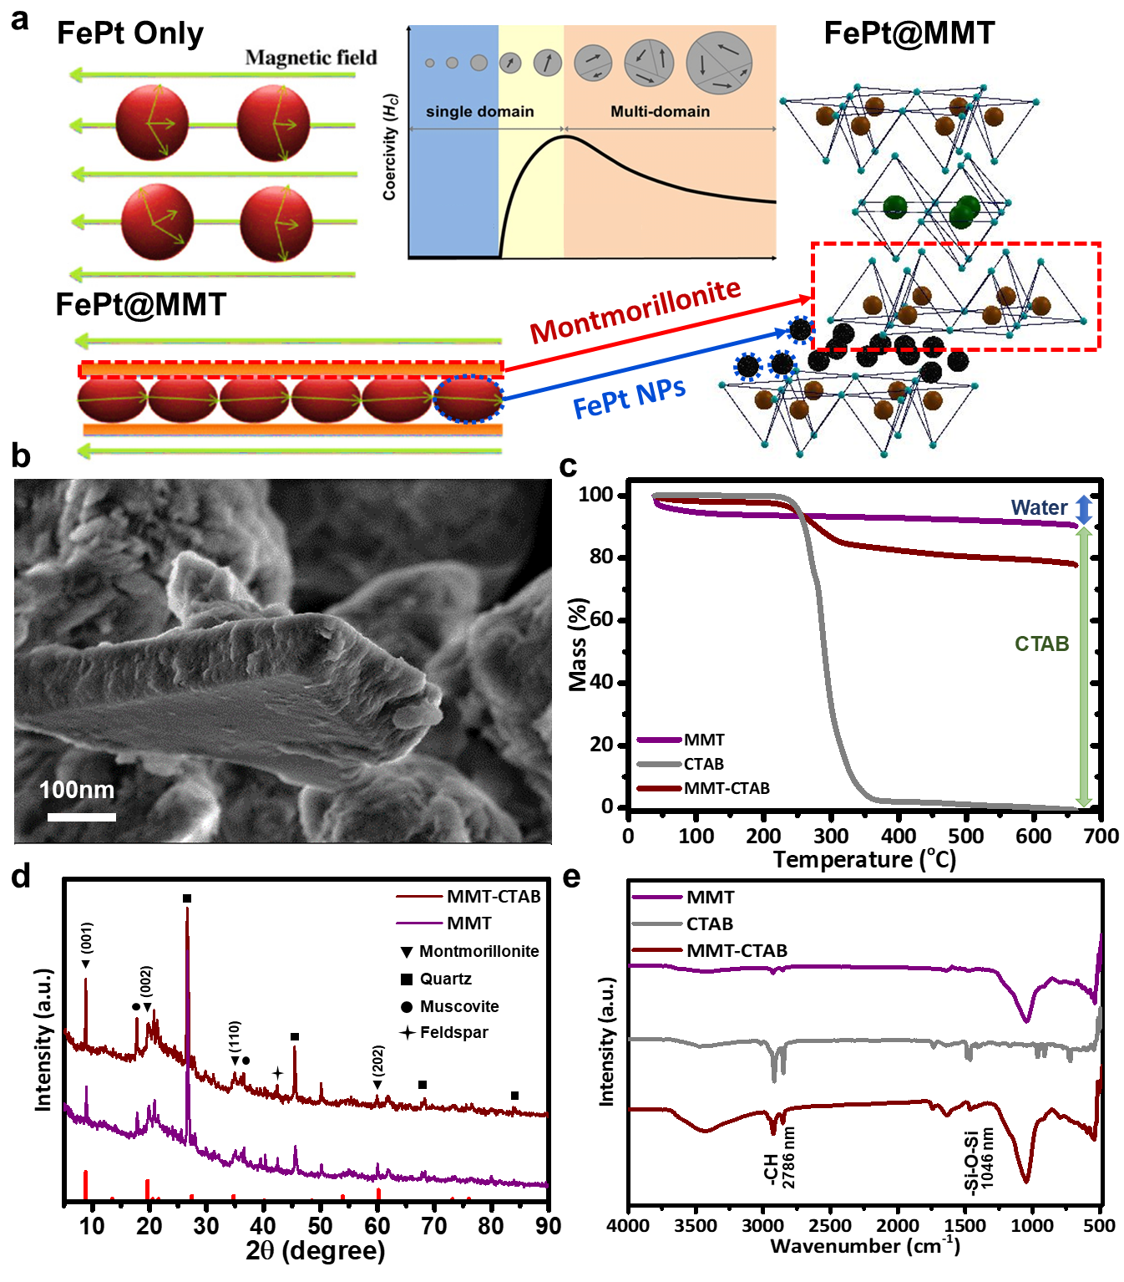
Figure S1. The characterization of MMT and CTAB-modified MMT. (a) The schematic shows the possible mechanism related to layer-shaped MMT that can limit the space FePt NPs and increase the magnetic properties. (b) SEM image of CTAB-modified MMT. (c) TGA analysis evaluates the weight loss after removing the CTAB molecules. (d) The XRD patterns of MMT and CTAB-modified MMT. (e) FTIR spectrum detection of the Si–O, and C–H functional group has been successfully modified with MMT.
Supporting Figure 2
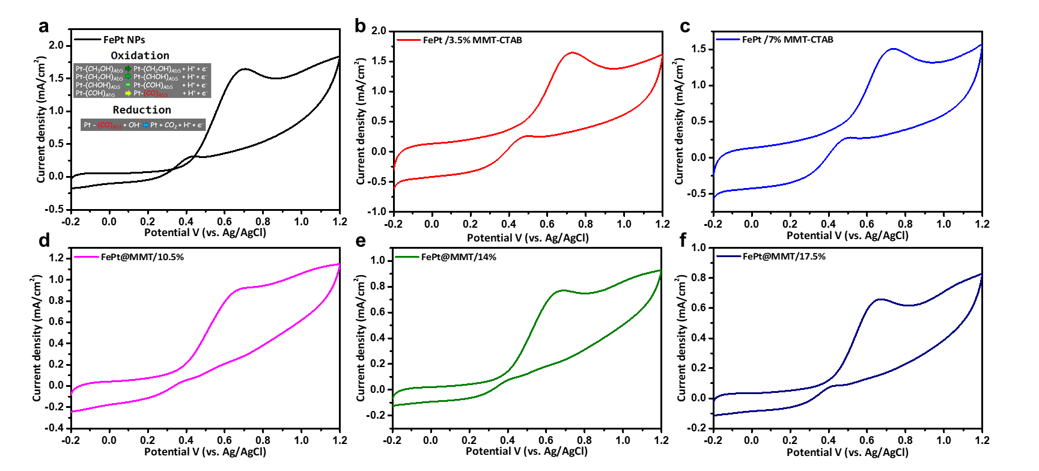
Figure S2. Experimental results of electrochemical detection. Cyclic voltammetry of series (a) FePt NPs, (b) FePt@MMT/3.5%, (c) FePt@MMT/7%, (d) FePt@MMT/10.5%, (e) FePt@MMT/14%, and (f) FePt@MMT/17.5% nanocomposites analysis (Insert: Direct methanol fuel cell reaction).

Supporting Figure 3
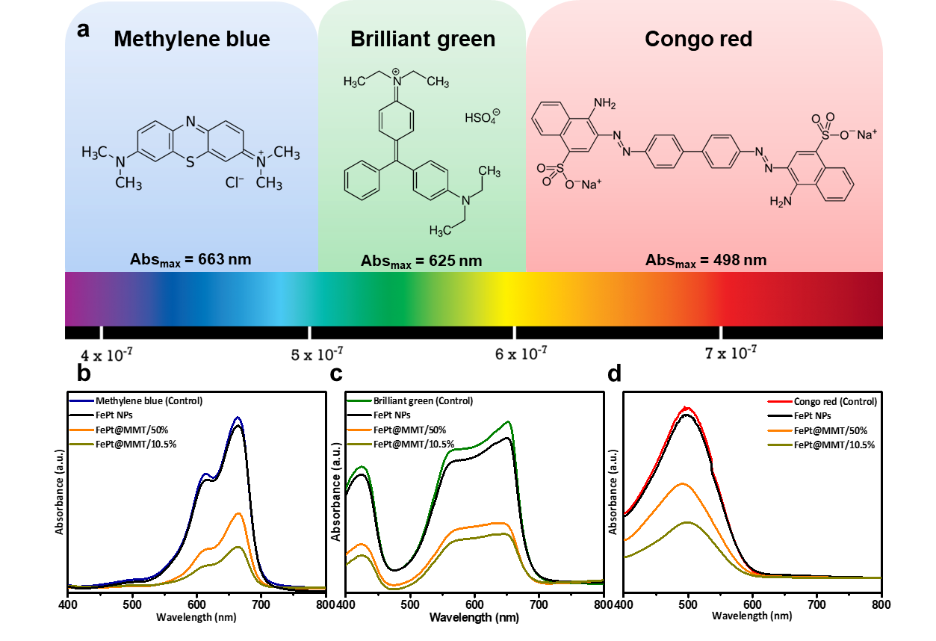
Figure S3. Experimental results of dye adsorption with FePt@MMT. The change of (a and c) Congo red and (b and d) Methylene blue concentration after adding FePt@MMT and CTAB-modified FePt@MMT nanocomposites were measured by ultraviolet-visible absorption spectrometer to judge the ability of the sample to adsorb dye.
Supporting Figure 4
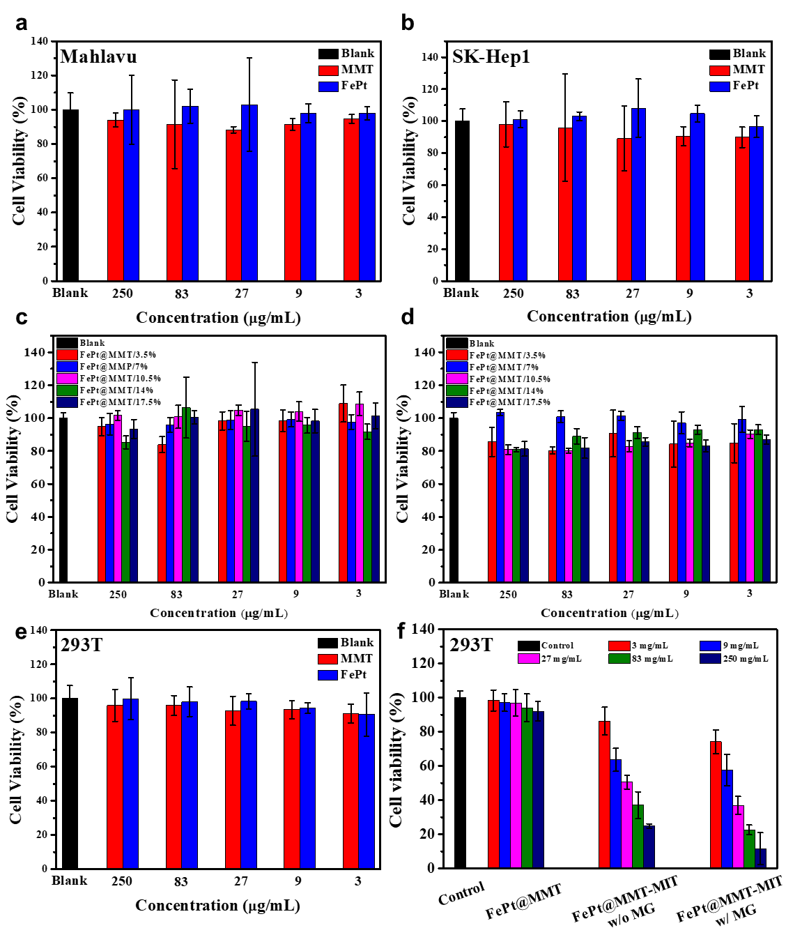
Figure S4. Cell viability analysis. The toxicity of FePt NPs and FePt@MMT nanocomposites were tested and stored at different concentrations for 48 hours. The results showed that the effect of different concentrations on cell viability was not significantly reduced, and the cell survival rate was maintained above 80%. Prove that FePt NPs and FePt@MMT nanocomposites have good biocompatibility in (a, c) Mahlavu, (b, d) SK-Hep1, and (e) 293T. Moreover, the different treatment groups were evaluated the (f) cell toxicity of 293T.

Supporting Figure 5
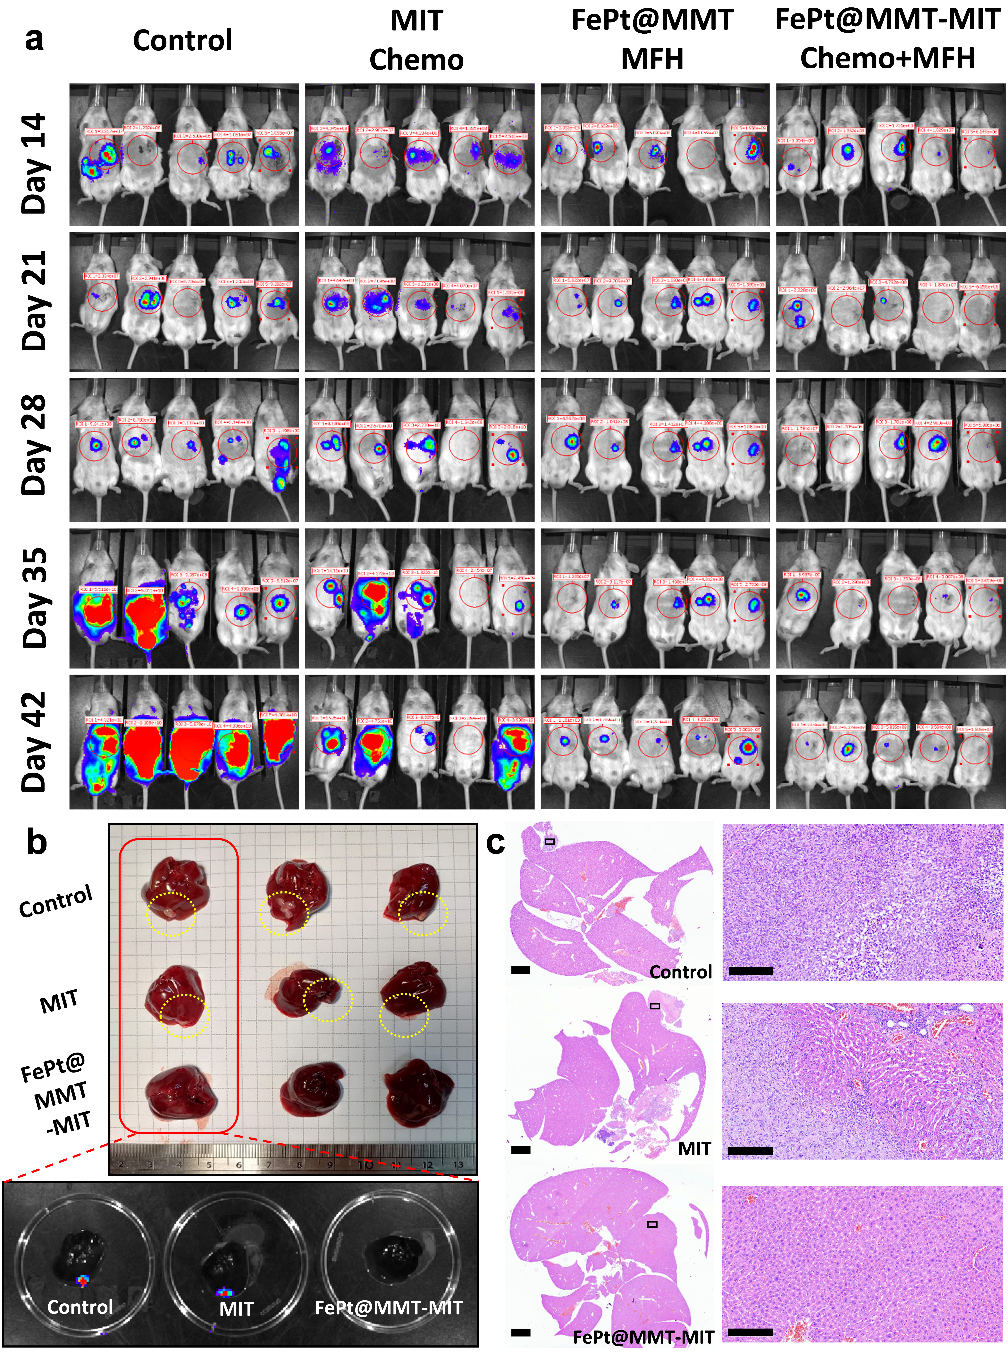
Figure S5. Long-term IVIS results of orthotopic implant-Mahlavu/SK-Hep1 cells for 6 weeks’ evaluation. (a) A total of four groups of mice were Control, MIT, FePt@MMT and FePt@MMT-MIT for IVIS long-term tracking with the Mahlavu HCC cell line. Orthotopic SK-Hep1 cell line implant and evaluate with the (b) IVIS result and photo imagines of liver tissues. (c) The H&E staining of orthotopic SK-Hep1 liver tissues.
Supporting Table 1

Table 1. Ms, ΔT/Δt and SAR values of FePt NPs and FePt@MMT nanocomposites.
Sample | m_{Sample}  (g) | m_{water}  (L) | M_{s}  (emu/g) | ΔT/Δt  (℃/s) | SAR  (W/g)
FePt NPs | 6×10⁻³ | 1×10⁻³ | 14.67 | 0.0193 | 13.37
FePt@MMT/3.5% | 6×10⁻³ | 1×10⁻³ | 17.21 | 0.0303 | 21.02
FePt@MMT/7% | 6×10⁻³ | 1×10⁻³ | 19.69 | 0.0341 | 23.64
FePt@MMT/10.5% | 6×10⁻³ | 1×10⁻³ | 24.54 | 0.0574 | 39.74
FePt@MMT/14% | 6×10⁻³ | 1×10⁻³ | 18.37 | 0.0319 | 22.08
FePt@MMT/17.5% | 6×10⁻³ | 1×10⁻³ | 15.41 | 0.0250 | 17.33

Supporting Table 2

Table 2. The change UV-Vis value of solution concentration with different dyes after adsorption of nanoparticles for 10 min.
Sample  C/C₀ | Control | FePt NPs | FePt@MMT 50% | FePt@MMT 10.5%
Concentration of Methylene blue (%) | 100 | 95.03 | 45.58 | 23.93
Concentration of Brilliant green (%) | 100 | 90.31 | 37.86 | 32.31
Concentration of Congo red (%) | 100 | 96.16 | 54.28 | 32.65

