Supplementary figure legends
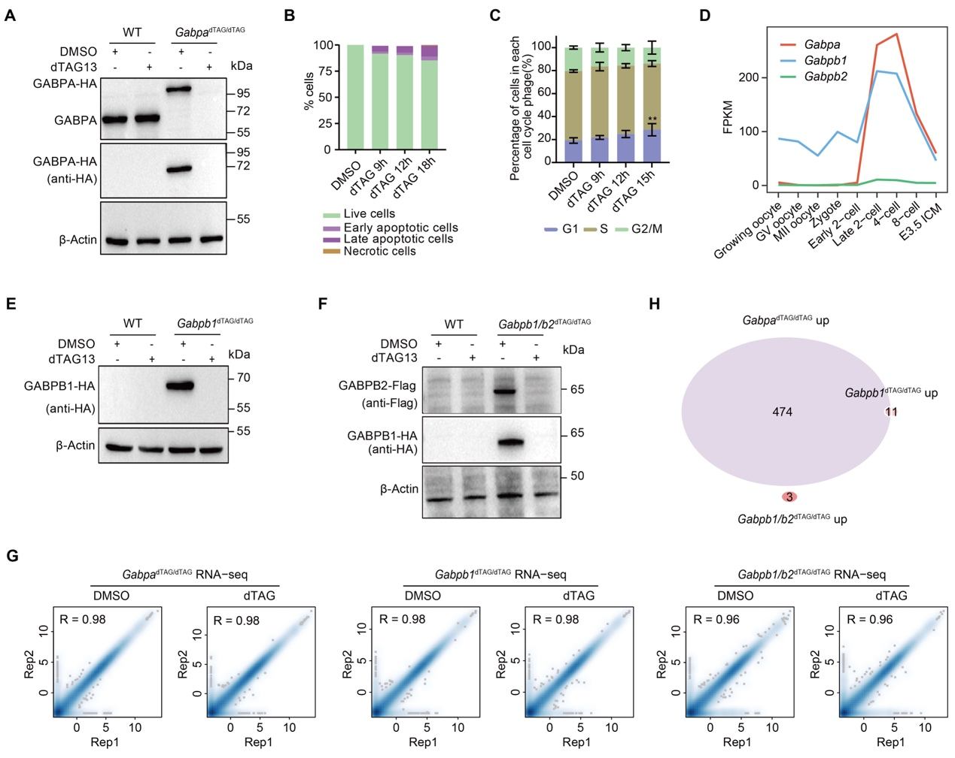
Figure S1. Validation and phenotype of GABPA, GABPB1 and GABPB1&B2 depletion
(A) Western blot analyses of GABPA and GABPA-HA protein levels in Gabpa^{dTAG/dTAG} mESCs treated with DMSO or 500 nM dTAG13 for 1 hour. β-Actin serves as a loading control.
(B) Apoptosis assay showing percentages of live, early apoptotic, late apoptotic, and necrotic cells in Gabpa^{dTAG/dTAG} mESCs treated with DMSO or 500 nM dTAG13 for the indicated times (9, 12, 18 hours).
(C) Cell cycle analysis of Gabpa^{dTAG/dTAG} mESCs treated with DMSO or 500 nM dTAG13 for the indicated times (9, 12, 15 hours). Percentages of cells at G1, S, and G2/M phases are shown. **P < 0.01, two-way ANOVA.
(D) The gene expression levels of Gabpa, Gabpb1 and Gabpb2 during early mouse development. FPKM, fragments per kilobase million.
(E) Western blot analyses of GABPB1-HA in Gabpb1^{dTAG/dTAG} mESCs treated with DMSO or 500 nM dTAG13 for 1 hour.
(F) Western blot analyses of GABPB2-Flag and GABPB1-HA in Gabpb1/b2 ^{dTAG/dTAG} mESCs treated with DMSO or 500 nM dTAG13 for 1 hour.
(G) Scatter plots showing the Pearson correlation coefficient of RNA-seq between two replicates in mESCs with DMSO and dTAG treatment after GABPA, GABPB1 and GABPB1&B2 depletion for 12 hours.
(H) Venn diagram showing the overlapping significantly upregulated genes after GABPA, GABPB1 and GABPB1&B2 depletion for 12 hours.

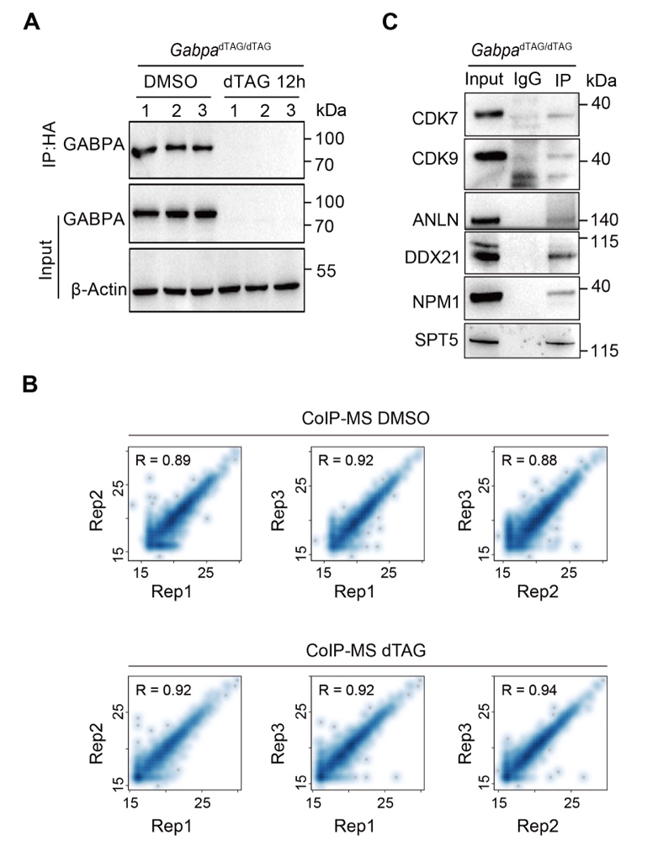
Figure S2. Validation of the GABPA interactome
(A) Western blot of GABPA-HA and β-Actin in input lysates and HA-IP samples from Gabpa^{dTAG/dTAG} mESCs treated with DMSO or 500 nM dTAG13 for 12 hours.
(B) Scatter plots showing the Pearson correlation coefficient of CoIP-MS intensity with DMSO and dTAG treatment.
(C) Co-IP analyses of GABPA-HA interactions with CDK7, CDK9, and other transcriptional regulators identified through CoIP-MS (ANLN, DDX21, NPM1, and SPT5).

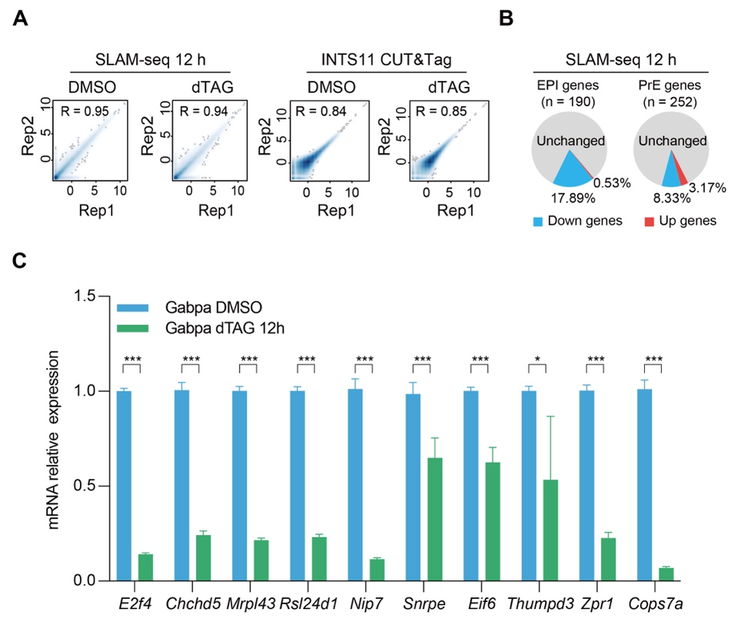
Figure S3. Gene expression after GABPA depletion for 12 hours
(A) Scatter plots showing the Pearson correlation coefficient of SLAM-seq and INTS11 CUT&Tag between two replicates in mESCs with DMSO and dTAG treatment after GABPA degradation for 12 hours.
(B) The percentage of down- and up-regulated EPI and PrE genes after GABPA depletion for 12 hours.
(C) RT-qPCR analyses showing expression of GABPA target genes (E2f4, Chchd5, etc.) that have more than three GABPA binding motifs around the promoter region in Gabpa^{dTAG/dTAG} mESCs treated with DMSO or 500 nM dTAG13 for 12 hours. The data are presented as the mean ± SD (n = 3). Data are normalized to DMSO controls. *P < 0.05, ***P < 0.001.

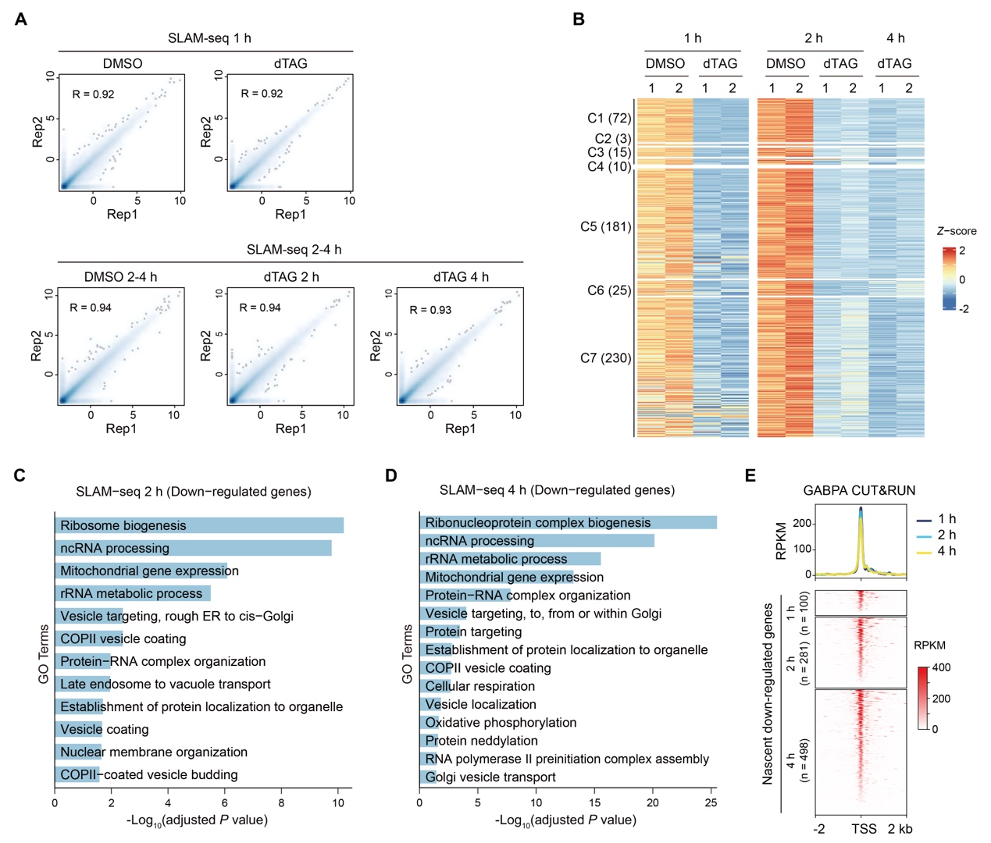
Figure S4. GABPA rapidly activates a core transcriptional program critical for ribosome biogenesis and RNA processing
(A) Scatter plots showing the Pearson correlation coefficient of SLAM-seq between two replicates in mESCs with DMSO and dTAG treatment after GABPA depletion for 1, 2, and 4 hours.
(B) Heatmaps showing differentially expressed genes, clustered with the Venn diagram in Figure 4D.
(C and D) GO enrichment analyses of down-regulated genes in SLAM-seq after GABPA depletion for 2 hours (C) and 4 hours (D). The enriched terms are ranked by -log₁₀(adjusted P value).
(E) The GABPA CUT&RUN signals around the TSS region (TSS ± 2 kb) of nascent down-regulated genes are illustrated as the heatmap (bottom) and the metaplot (top).
﻿
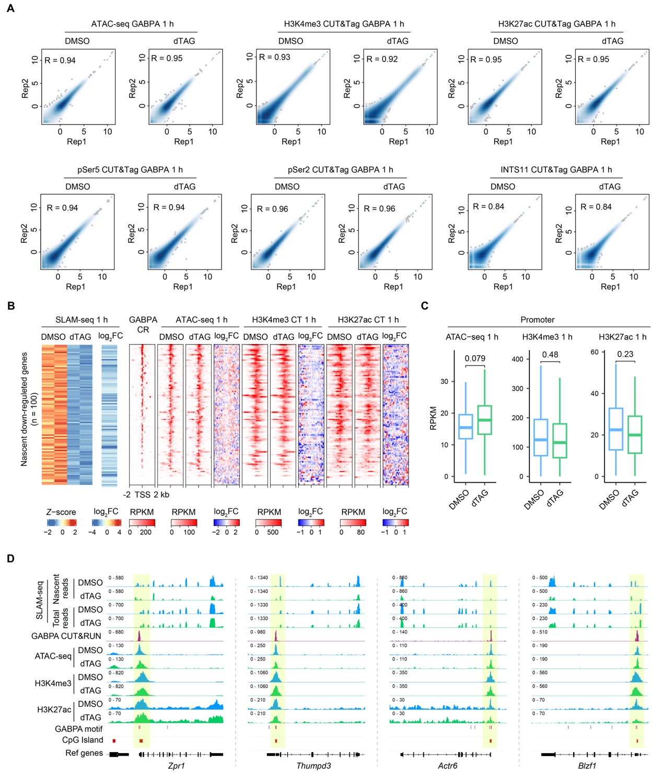
Figure S5. GABPA does not regulate gene expression by remodeling chromatin accessibility and histone modification during the immediate early response
(A) Scatter plots showing the Pearson correlation coefficient of ATAC-seq and CUT&Tag between two replicates in mESCs with DMSO and dTAG treatment after GABPA depletion for 1 hour.
(B) Heatmaps showing the nascent down-regulated genes after GABPA depletion for 1 hour, as well as the GABPA, ATAC-seq, H3K4me3 and H3K27ac CUT&Tag signals around the TSS of related genes.
(C) Box plots showing the chromatin accessibility and histone modification changes at the promoter of nascent down-regulated genes. The central band represents the median, the lower and upper edges of the box represent the first and third quartiles, respectively. P values were calculated using Wilcoxon tests.
(D) Examples of the genome browser view of SLAM-seq, GABPA CUT&RUN, ATAC-seq, H3K4me3 and H3K27ac CUT&Tag results in mESCs with DMSO and dTAG treatment for 1 hour.

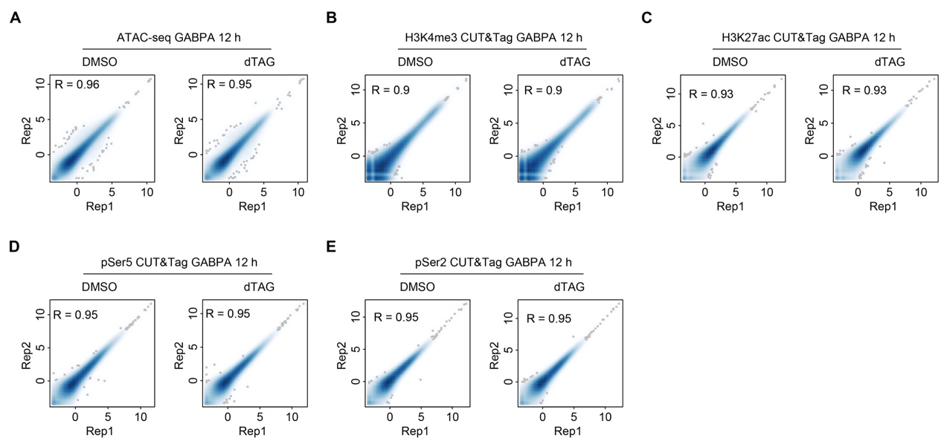
Figure S6. Correlation of replicates for ATAC-seq and CUT&Tag with DMSO and dTAG treatment for 12 hours
- E) Scatter plots showing the Pearson correlation coefficient of ATAC-seq (A), H3K4me3 (B), H3K27ac (C), pSer5 (D) and pSer2 (E) CUT&Tag between two replicates in mESCs with DMSO and dTAG treatment for 12 hours.

