Comparative genomics and transcriptomics of the Spiroplasma glossinidia strain sGff reveal insights into host interaction and trypanosome resistance in Glossina fuscipes fuscipes

Daniel J. Bruzzese¹*, Fabian Gstöttenmayer^{1,2}*, Brian L. Weiss¹, Hager Khalil², Robert Mach³ Adly M.M Abd-Alla², and Serap Aksoy¹

¹Department of Epidemiology of Microbial Diseases, Yale School of Public Health, New Haven, CT, United States
²Insect Pest Control Laboratory, Joint FAO/IAEA Centre of Nuclear Techniques in Food and Agriculture, Vienna, Austria
³Institute of Chemical, Environmental, and Bioscience Engineering, Vienna University of Technology, Gumpendorfer Straße 1a, 1060 Vienna, Austria.

* equally contributing first authors

Corresponding authors:
Daniel J. Bruzzese; email: daniel.bruzzese@yale.edu
Fabian Gstöttenmayer; email: fabian.gstoettenmayer@yale.edu

Supplementary Figures 1-4:

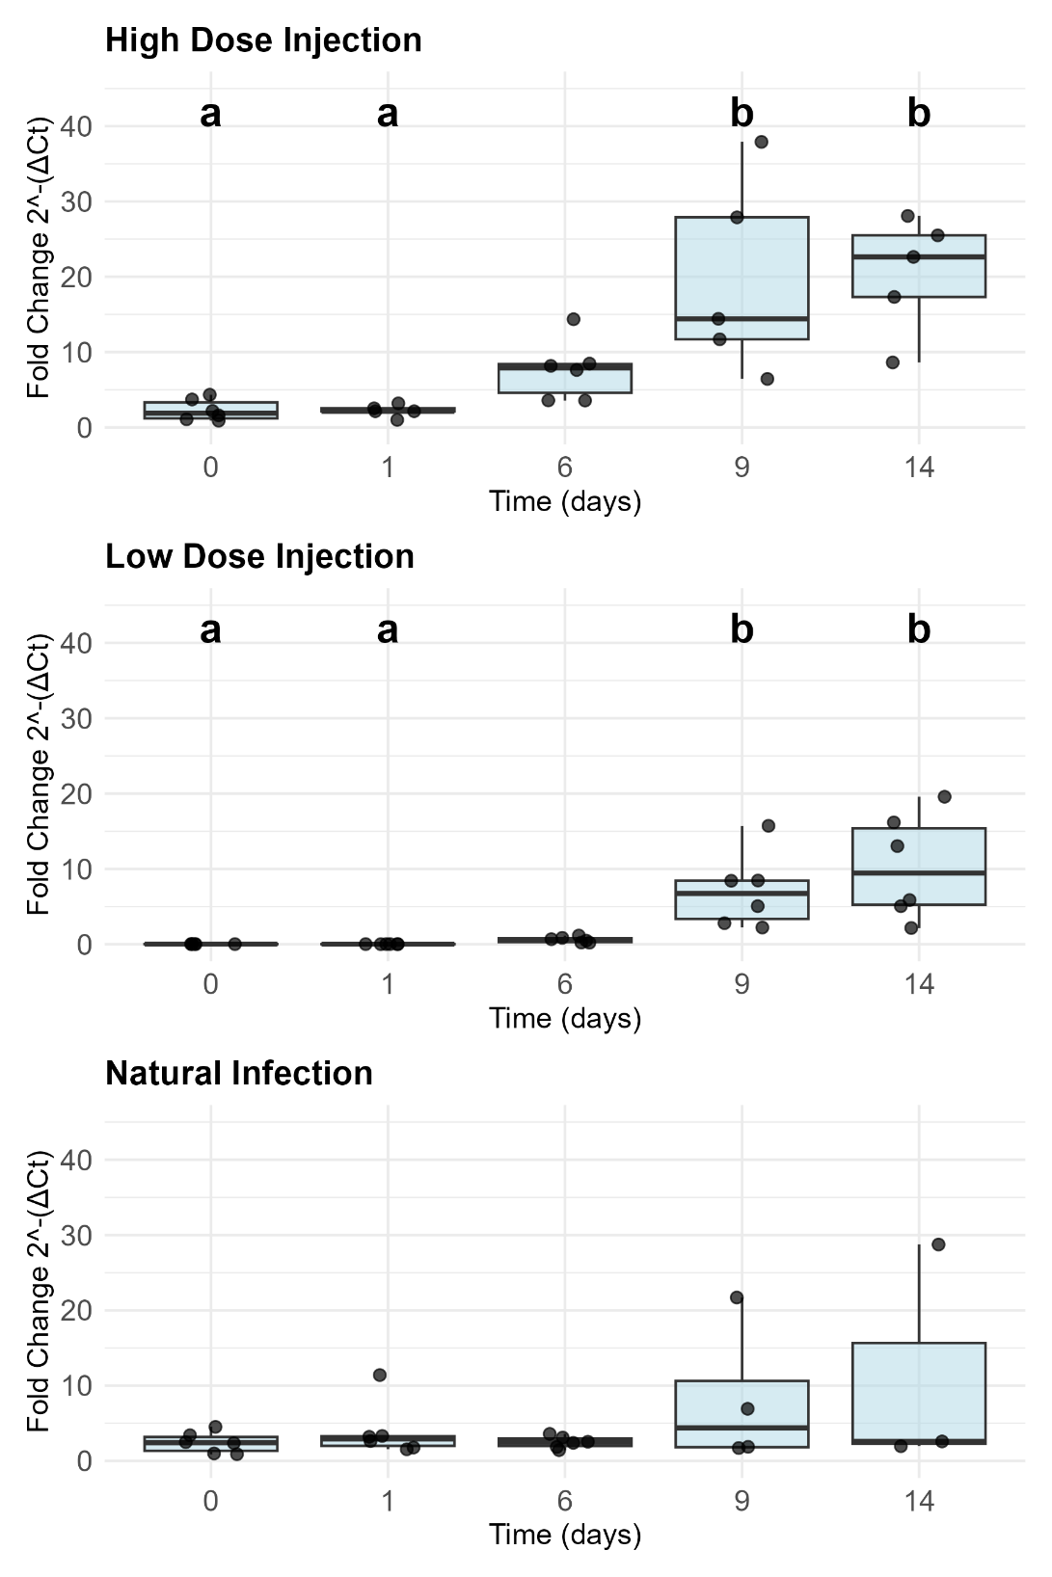
Supplementary Figure 1. Relative quantification of sGff in injected naive and naturally infected Gff over 14 days. Teneral sGff negative Gff flies were injected with high and low doses of cultured sGff. Gff with a natural infection of sGff were kept as a control group. Whole fly samples were collected on days 0, 1, 6, 9 and 14 and subjected to quantitative PCR (qPCR). sGff fold-change over time was calculated by normalization to housekeeping gene β-tubulin and according to the 2-(ΔCt) formula.

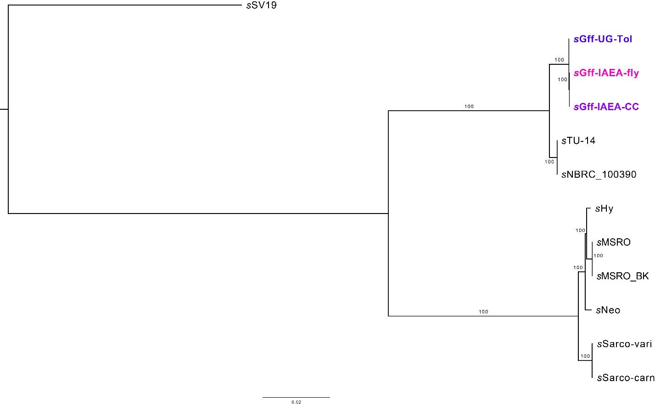

Supplementary Figure 2. A RAxML tree showing the relationship between sGff and members of the Spiroplasma poulsonii clade. Bootstrap values are listed on branches, and the tree is midpoint rooted.

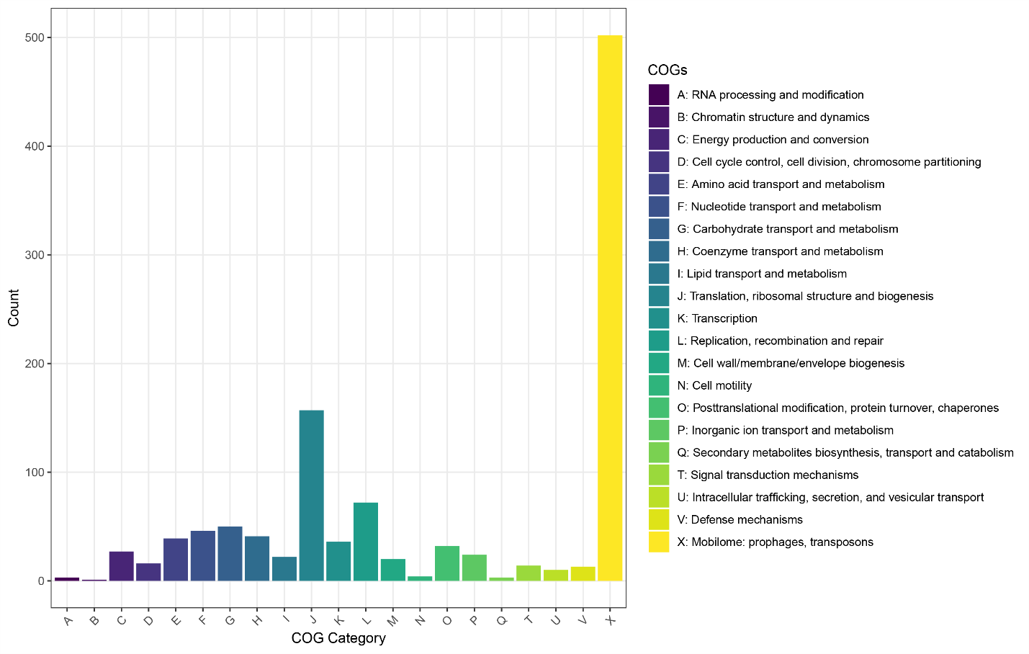
Supplementary Figure 3. A COG plot representing the functional categories of sGff genes. 646 sGff genes had unknown COG annotations and were not shown on this plot.

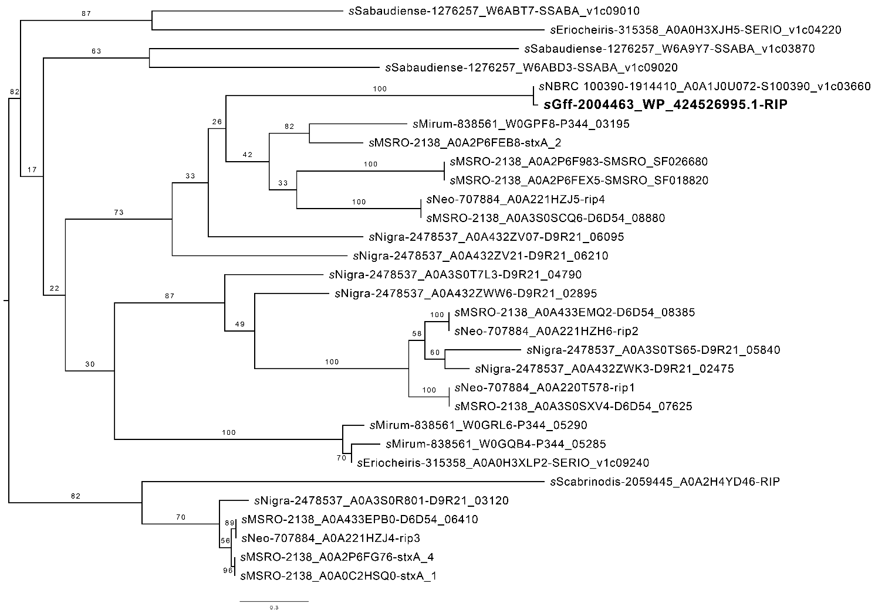
Supplementary Figure 4. RAxML tree of Spiroplasma RIP domains. The sGff RIP is sister to sNBRC_100390, further supporting their sister taxa status. Bootstrap support values are listed on branches, and the tree is midpoint rooted. Each tip name contains the Spiroplasma strain, the NCBI tax id, the InterPro accession, and the gene name (see supplementary Table 3 for details).

