Online Resource 1. International Classification of Diseases-10 diagnostic codes
Comorbidities | KCD-7
Anemia | D50, D51, D52, D53, D55, D56, D57, D58, D59, D60, D61, D62, D63, D64
Cancer | C
Congestive heart failure | I50, I11.0, I13.0, I13.2
Diabetes mellitus | E10, E11, E12, E13, E14
Dyslipidemia | E78
Extracranial/unclassified  major bleeding | D62, D68.3, D69.8, D69.9, H11.3, H21.0, H31.3, H35.6, H43.1, H45.0, H92.2, I23.0, I31.2, J94.2, M25.0, N02, N42.1, N92.3, N93.0, N93.8, N93.9, N95.0, R04, R31, R58, S26.0, T79.2
Gastrointestinal hemorrhage | I85.0, I98.3, K22.11, K22.6, K22.8, K25.0, K25.2, K25.4, K25.6, K26.0, K26.2, K26.4, K26.6, K27.0, K27.2, K27.4, K27.6, K28.0, K28.2, K28.4, K28.6, K29.0, K31.81, K55.21, K57.01, K57.03, K57.11, K57.13, K57.21, K57.23, K57.31, K57.33, K57.41, K57.43, K57.51, K57.53, K57.81, K57.83, K57.91, K57.93, K62.5, K66.1, K92.0, K92.1, K92.2
Hypertension | I10, I11, I12, I13
Intracranial hemorrhage | I60, I61, I62, S06.4, S06.5, S06.6
Liver disease | B15, B16, B17, B18, B19, K70, K71.3, K71.4, K71.5, K71.6, K71.7, K72, K73, K74, K75, K76, K77
Mechanical prosthetic valve | Z95.2, Z95.3, Z95.4
Mitral stenosis | I05, I34, Q21.18, Q23.2, Q23.3, Q23.4
Myocardial infarction | I21, I22, I23, I24, I25.2
Peripheral artery disease | I70, I73, I77.1, I79.2
Prior stroke | I63, I64
Renal disease | I12, I13, N03, N05, N10, N11, N12, N13, N14, N15, N16, N17, N18, N19, Z49, Z940, Z992
Severe renal disease | N183, N184, N185, Y841, Z49, Z940, Z992
Thromboembolism | I26, I74, I80, I82, I676
Transient ischemic attack | G45

Online Resource 2. Drug code for data extraction
DRUG | General name
Anticoagulant
apixaban | 6170
dabigatran | 6137
edoxaban | 6436
rivaroxaban | 5114
warfarin | 2491
Antiplatalet
aspirin | 1107, 1108, 1110, 4897, 5179, 6675
clopidogrel | 1369, 4925, 4952, 4988, 5015
prasugrel | 5973
ticagrelor | 6159
ACE inhibitor
alacepril | 1042
azilsartan | 6624, 6735, 6736
benazepril | 1147
captopril | 1229, 2622, 2623
cilazapril | 1330
delapril | 1409
enalapril | 1516, 4403, 4536, 4537, 4660
fosinopril | 1635
imidapril | 1734
lisinopril | 1845, 4992, 4993
moexipril | 1968, 4408, 4979
perindopril | 2113, 4901, 5016, 5562
quinapril | 2219
ramipril | 2224, 4471, 4472, 4486, 4487
temocapril | 2350
zofenopril | 5104
ARB
candesartan | 1226, 4237, 6529, 6530, 6531, 6618, 6619, 6620, 6621, 6737, 7063, 7064, 7065, 7066, 7067
eprosartan | 4292, 4605
fimasartan | 5152, 5220, 5268, 6519, 6520, 6521, 6527, 6546, 6547, 6548, 6549, 6550, 6843, 6844, 6845, 6846, 6847, 6881, 6882, 6883, 6884, 6885, 7075, 7076, 7077, 7107, 7161, 7175, 7198, 7199
irbesartan | 1773, 3857, 3858, 5240, 5241, 5270, 5271
losartan | 1857, 2625, 3789, 4869, 5027, 5030, 5139, 6374, 6375, 6376, 6628, 6629, 6630, 6639, 6640, 6641, 6642, 6643, 6644, 6920, 6921, 6922, 6923, 6924, 6925, 7090, 7091, 7211
olmesartan | 4685, 4774, 5005, 5006, 5136, 5197, 5198, 5199, 5200, 5201, 5209, 5263, 5264, 5265, 5269, 5475, 5476, 5477, 5478, 5479, 5480, 5822, 5824, 6294, 6295, 6296, 6313, 6328, 6329, 6330, 6441, 6442, 6532, 6773, 6774, 6775, 6776, 6868, 6869
telmisartan | 3788, 4432, 4433, 5026, 5115, 5116, 5117, 5212, 5213, 5214, 6231, 6299, 6300, 6301, 6302, 6316, 6317, 6448, 6635, 6636, 6637, 6638, 6712, 6713, 6714, 6715, 6716, 6717, 6770, 6771, 6827, 6828, 6829, 6973, 6974, 6975, 6976, 7017, 7018, 7019, 7020, 7021, 7022, 7097, 7098, 7099, 7100, 7101, 7102, 7122, 7123, 7124, 7125
valsartan | 2471, 3564, 4426, 4928, 4929, 4958, 5222, 5223, 5224, 5226, 5227, 5228, 5229, 5230, 5231, 5232, 5233, 5234, 5250, 5251, 5252, 5253, 6297, 6298, 6349, 6350, 6351, 6352, 6514, 6795, 6796, 6797, 6803, 6904, 6905, 6906, 6907, 6914, 6915
Beta Blocker
atenolo | 1114, 2621, 4602, 4831
betaxolol | 1168
bisoprolol | 1179, 4698, 4699, 4700
carteolol | 1248
celiprolol | 1291
metoprolol | 1938, 1940, 2624, 2626
nadolol | 1983
nebivolol | 4895, 6830, 6831, 6832, 6912, 6930, 7089
propranolol | 2199
Calcium Channel Blocker
amlodipine | 1076, 4598, 4599, 4646, 4708, 4723, 4724, 4725, 4762, 4797, 4832, 4865, 4928, 4929, 4958, 4959, 5005, 5006, 5017, 5027, 5030, 5115, 5116, 5117, 5139, 5189, 5197, 5198, 5199, 5200, 5201, 5212, 5213, 5214, 5226, 5227, 5228, 5229, 5230, 5231, 5232, 5233, 5234, 5475, 5476, 5477, 5478, 5479, 5480, 5822, 5824, 6145, 6231, 6294, 6295, 6296, 6313, 6328, 6329, 6330, 6374, 6375, 6376, 6448, 6519, 6520, 6521, 6527, 6529, 6530, 6531, 6628, 6629, 6630, 6635, 6636, 6637, 6638, 6639, 6640, 6641, 6642, 6643, 6644, 6712, 6713, 6714, 6715, 6716, 6717, 6739, 6740, 6741, 6770, 6771, 6773, 6774, 6775, 6776, 6786, 6795, 6796, 6797, 6803, 6827, 6828, 6829, 6843, 6844, 6845, 6846, 6847, 6868, 6869, 6904, 6905, 6906, 6907, 6914, 6915, 6920, 6921, 6922, 6923, 6924, 6925, 6973, 6974, 6975, 6976, 7063, 7064, 7065, 7066, 7067, 7075, 7076, 7077, 7097, 7098, 7099, 7100, 7101, 7102, 7107, 7122, 7123, 7124, 7125, 7161, 7175
azelnidipine | 7014
benidipine | 1151
cilnidipine | 1331
diltiazem | 1457
efonidipine | 4412
felodipine | 1575, 2624, 4471, 4472
lacidipine | 1803
lercanidipine | 1820, 5222, 5223, 5224
manidipine | 1880
nicardipine | 2010
nifedipine | 2014, 5282
nisoldipine | 3562
verapami | 2476
Digitalis glycosides
digoxin | 1448
Loop diuretics
azosemide | 1129
furosemide | 1638
torasemide | 2420
xipamide | 2494
NSAIDs
aceclofenac | 1009, 7132
acemetacin | 1010
aspirin | 2568
celecoxib | 3477, 7246
cinnoxicam | 1338
clonixin | 1366
dexibuprofen | 1423
dexketoprofen | 4543
diclofenac | 1434, 1435, 2519
emorfazone | 1515
etodolac | 1566
etoricoxib | 6369
fenoprofen | 1578
flufenamic acid | 1603
harpagophyti | 1683
ibuprofen | 1728, 1729, 3134, 3636
imidazole | 1735
ketoprofen | 1797
ketorolac | 1800
lornoxicam | 3555
loxoprofen | 1861
mefenamic acid | 1890
meloxicam | 1897
morniflumate | 4584
nabumetone | 1981
naproxen | 1994, 1995, 5180, 5235, 5274
nimesulide | 2018
pelubiprofen | 4934, 6977
piroxicam | 2140, 2142
polmacoxib | 6364
pranoprofen | 2165
proglumetacin | 2186
pyrazinobutazone | 2213
salsalate | 2259
sulindac | 2332
talniflumate | 2344
tenoxicam | 2353
tiaprofenic acid | 2389
tolfenamic acid | 2415
zaltoprofen | 2499
Proton pump inhibitor
dexlansoprazole | 6219
esomeprazole | 3672, 4980, 5099, 5180, 5235, 5274, 6707, 6841, 6944, 6945, 7061, 7080, 7195, 7196
fexuprazan | 7047
ilaprazole | 5055
lansoprazole | 1813, 7184
omeprazole | 2044, 6402, 6645
pantoprazol | 2088, 2089, 5192, 6567
rabeprazole | 2222, 7046, 7059, 7060
revaprazan | 4886
tegoprazan | 6758
Rhythm control drug
amiodarone | 1074
dronedarone | 5974
flecainide | 1593
propafenone | 2195
sotalol | 2304
Statin
atorvastatin | 1115, 4723, 4724, 4725, 5022, 5189, 5240, 5241, 5270, 5271, 6145, 6338, 6339, 6346, 6348, 6718, 6719, 6720, 6721, 6738, 6881, 6882, 6883, 6884, 6885, 6904, 6905, 6906, 6907, 6940, 7063, 7064, 7065, 7066, 7067, 7112, 7198, 7199, 7213
fluvastatin | 1624
lovastatin | 1858
pitavastatin | 4709, 6349, 6350, 6351, 6352, 6793, 6994, 6995
pravastatin | 2166, 5193
rosuvastatin | 4540, 5250, 5251, 5252, 5253, 5263, 5264, 5265, 5269, 6297, 6298, 6299, 6300, 6301, 6302, 6316, 6317, 6407, 6408, 6409, 6441, 6442, 6532, 6546, 6547, 6548, 6549, 6550, 6618, 6619, 6620, 6621, 6634, 6639, 6640, 6641, 6642, 6643, 6644, 6646, 6647, 6648, 6712, 6713, 6714, 6715, 6716, 6717, 6725, 6726, 6727, 6728, 6729, 6730, 6737, 6739, 6740, 6741, 6770, 6771, 6773, 6774, 6775, 6776, 6786, 6795, 6796, 6797, 6803, 6830, 6831, 6832, 6833, 6834, 6843, 6844, 6845, 6846, 6847, 6868, 6869, 6912, 6914, 6915, 6920, 6921, 6922, 6923, 6924, 6925, 6930, 7011, 7017, 7018, 7019, 7020, 7021, 7022, 7089, 7097, 7098, 7099, 7100, 7101, 7102, 7122, 7123, 7124, 7125
simvastatin | 2278, 4710, 4711, 5078, 6314, 6315

Online Resource 3. Outcome Definitions and Diagnostic Criteria
Outcome | ICD-10 code and definition | Diagnostic definition
Composite outcome | Defined as the occurrence of any of the following: Myocardial infarction or Ischemic stroke or In-hospital death or Revascularization
Myocardial infarction | I21, I22 | Primary diagnosis and ≥1 admission
Ischemic stroke | I63, I64 | Primary diagnosis, ≥1 admission, and ≥1 brain imaging (CT or MRI)
In-hospital death |  | Death was coded in general information (Table 200)
Revascularization | PCI or CABG or Atherectomy or PTCA | ≥1 admission and corresponding procedure code
PCI | M6561, M6562, M6563, M6564, M6565, M6566, M6567 | Admission and procedure codes
CABG | O1640, O1641, O1642, O1647, O1648, O1649, OA640, OA641, OA642, OA647, OA648, OA649 | Admission and procedure codes
Atherectomy | M6571, M6572 | Admission and procedure codes
PTCA | M6551, M6552, M6553, M6554 | Admission and procedure codes
Total bleeding | Defined as the occurrence of any of the following: Intracranial hemorrhage or gastrointestinal bleeding or extracranial/unclassified major bleeding
Gastrointestinal bleeding | I85.0, I98.3, K22.11, K22.6, K22.8, K25.0, K25.2, K25.4, K25.6, K26.0, K26.2, K26.4, K26.6, K27.0, K27.2, K27.4, K27.6, K28.0, K28.2, K28.4, K28.6, K29.0, K31.81, K55.21, K57.01, K57.03, K57.11, K57.13, K57.21, K57.23, K57.31, K57.33, K57.41, K57.43, K57.51, K57.53, K57.81, K57.83, K57.91, K57.93, K62.5, K66.1, K92.0, K92.1, K92.2 | Primary diagnosis and ≥1 admission
Intracranial hemorrhage | I60, I61, I62, S06.4, S06.5, S06.6 | Primary diagnosis, ≥1 admission, and ≥1 brain imaging (CT or MRI)
Extracranial/unclassified  major bleeding | D62, D68.3, D69.8, D69.9, H11.3, H21.0, H31.3, H35.6, H43.1, H45.0, H92.2, I23.0, I31.2, J94.2, M25.0, N02, N42.1, N92.3, N93.0, N93.8, N93.9, N95.0, R04, R31, R58, S26.0, T79.2 | (Primary diagnosis and ≥1 admission) or red blood cell transfusion
CABG, coronary artery bypass surgery; KCD, Korean Standard Classification of Diseases; PCI, percutaneous coronary intervention; PTCA, percutaneous transluminal coronary angioplasty.
Online Resource 4. Incidence rate of TAT vs DAPT
Outcomes | Group | Patient number | Event | Event rate | Person year | Incidence rate
Composite  Outcome | DAPT | 3346 | 361 | 10.79 | 1527 | 236.41
Composite  Outcome | TAT | 3346 | 287 | 8.58 | 1549 | 185.26
Myocardial  infarction | DAPT | 3346 | 154 | 4.6 | 1565 | 98.43
Myocardial  infarction | TAT | 3346 | 122 | 3.65 | 1583 | 77.08
Ischemic  stroke | DAPT | 3346 | 71 | 2.12 | 1600 | 44.37
Ischemic  stroke | TAT | 3346 | 49 | 1.46 | 1615 | 30.35
Revascularization | DAPT | 3346 | 99 | 2.96 | 1590 | 62.25
Revascularization | TAT | 3346 | 80 | 2.39 | 1607 | 49.79
In-hospital  death | DAPT | 3346 | 108 | 3.23 | 1620 | 66.68
In-hospital  death | TAT | 3346 | 70 | 2.09 | 1631 | 42.92
Total  bleeding | DAPT | 3346 | 72 | 2.15 | 1601 | 44.97
Total  bleeding | TAT | 3346 | 66 | 1.97 | 1612 | 40.93
DAPT, dual antiplatelet therapy; TAT, triple antithrombotic therapy.

Online Resource 5. Forest plot of subgroup analysis
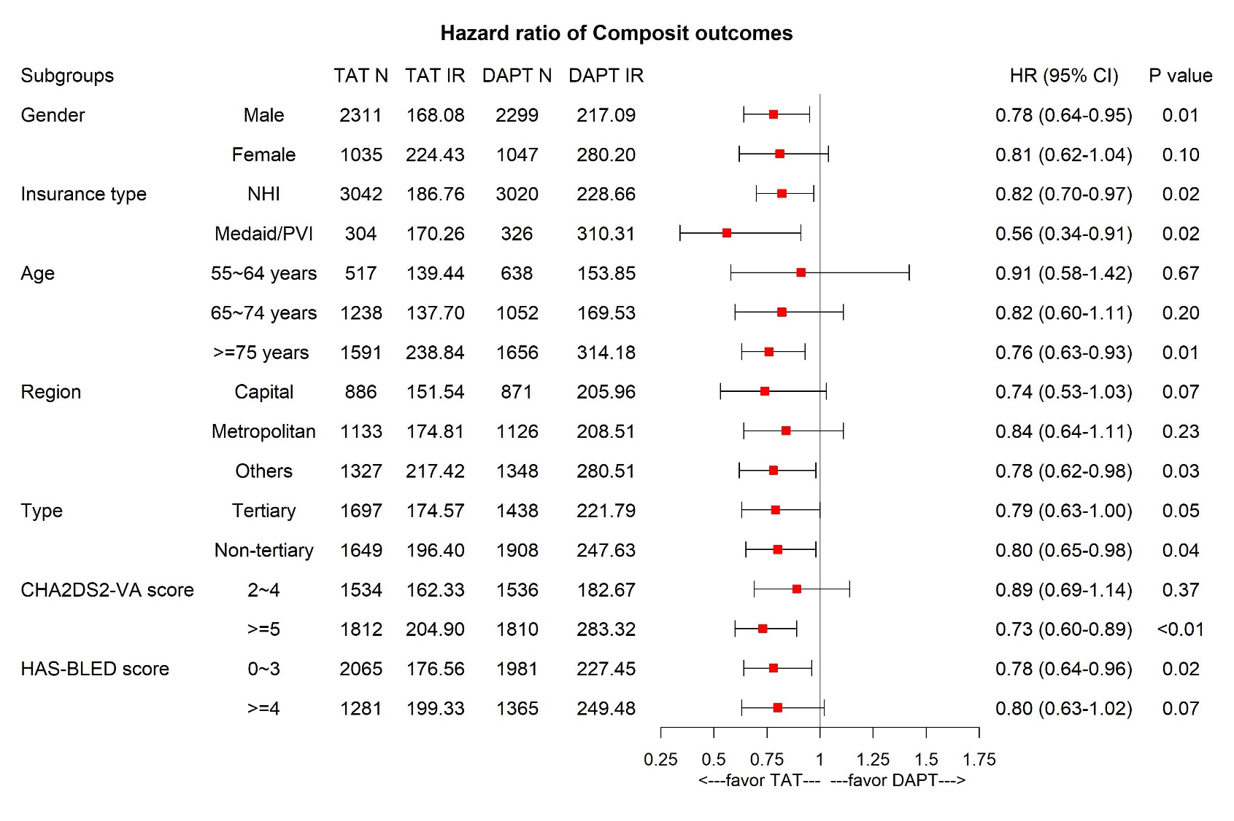
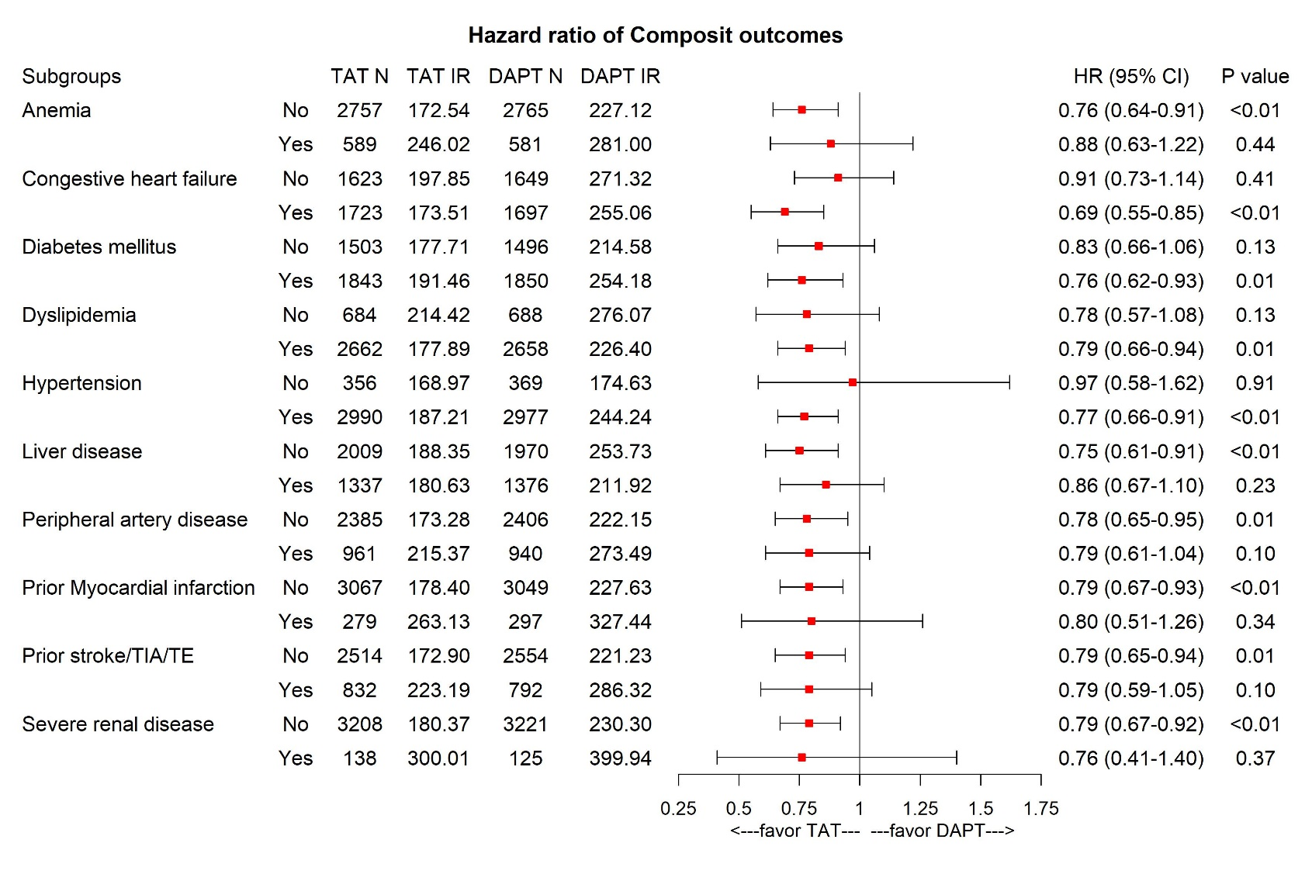
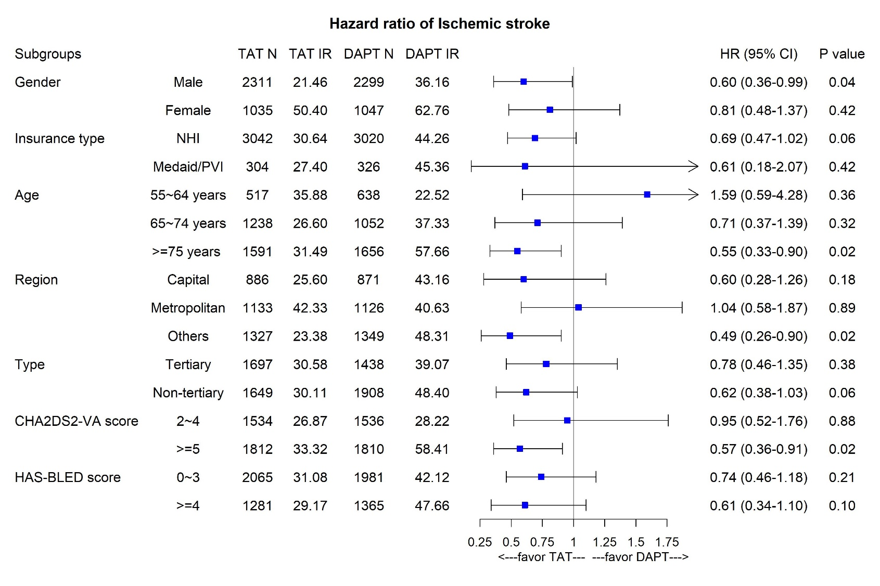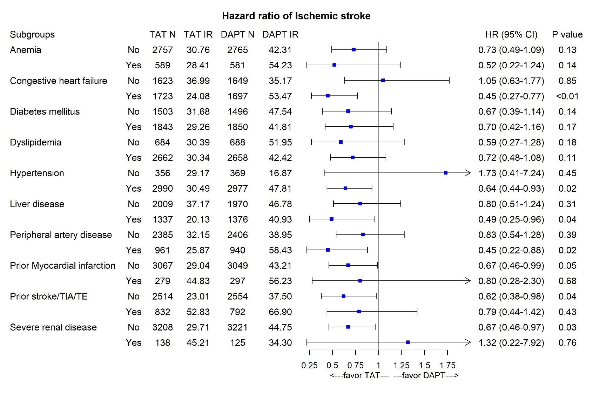
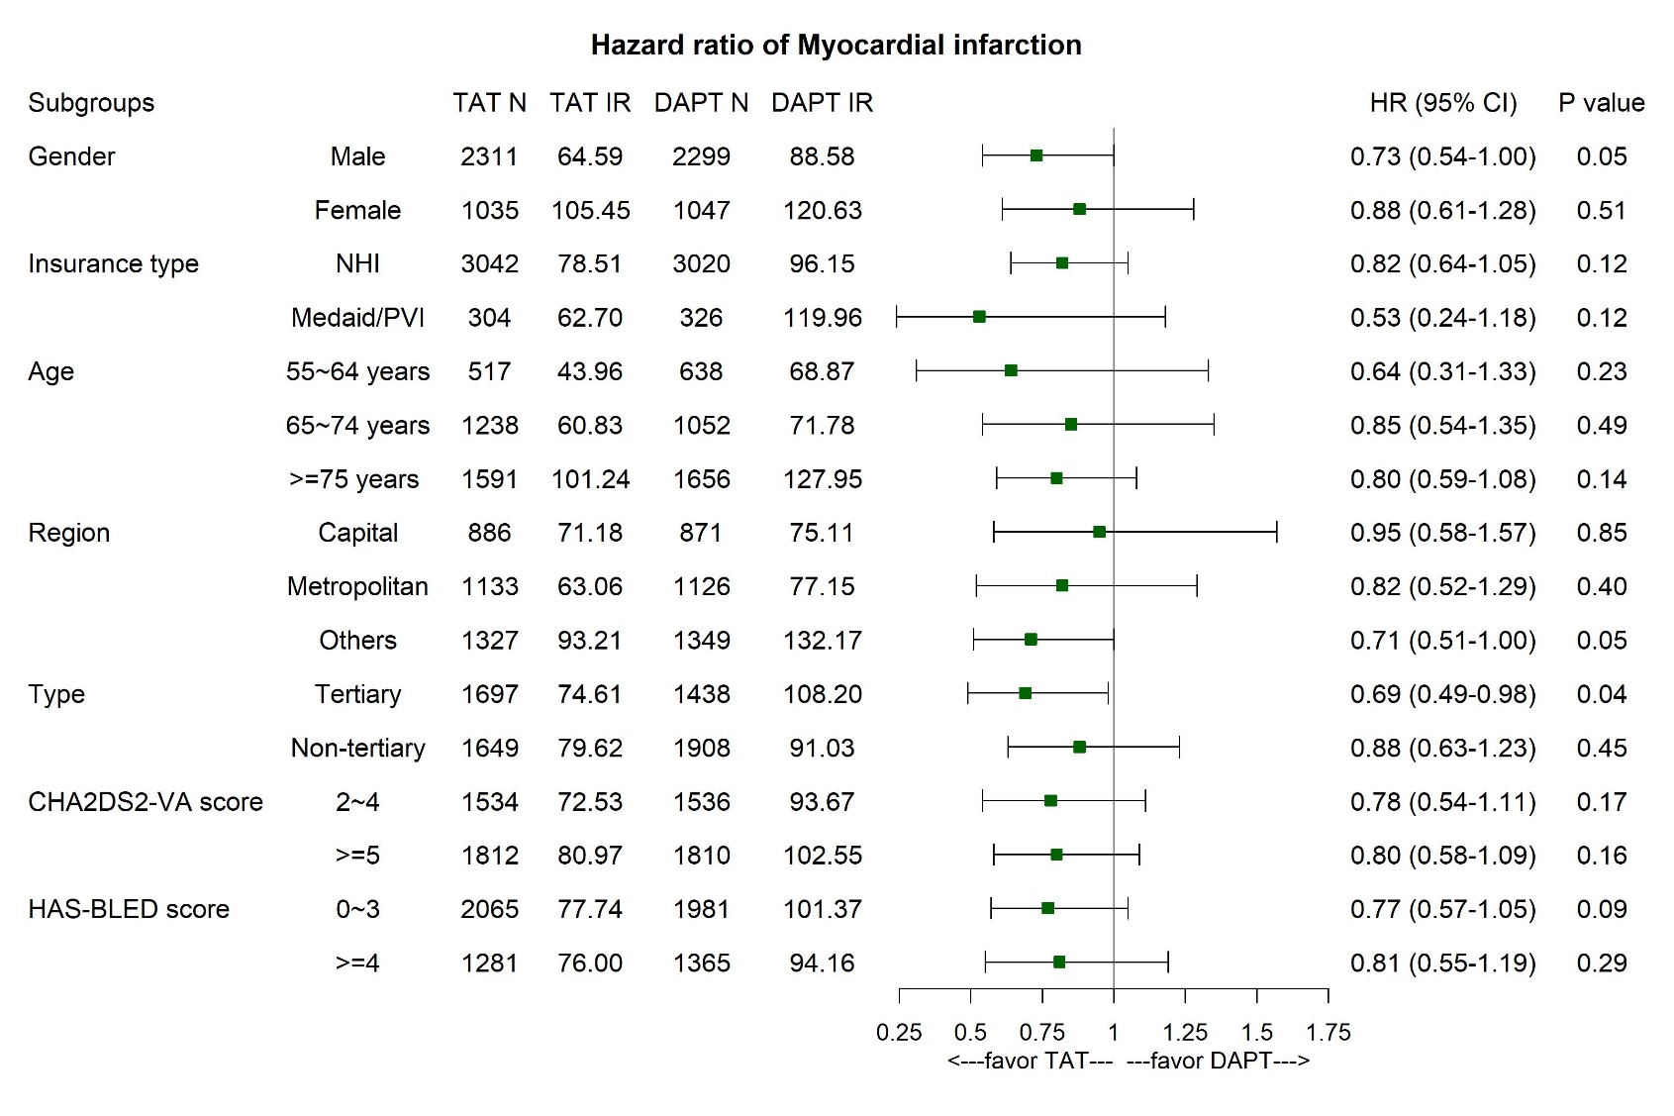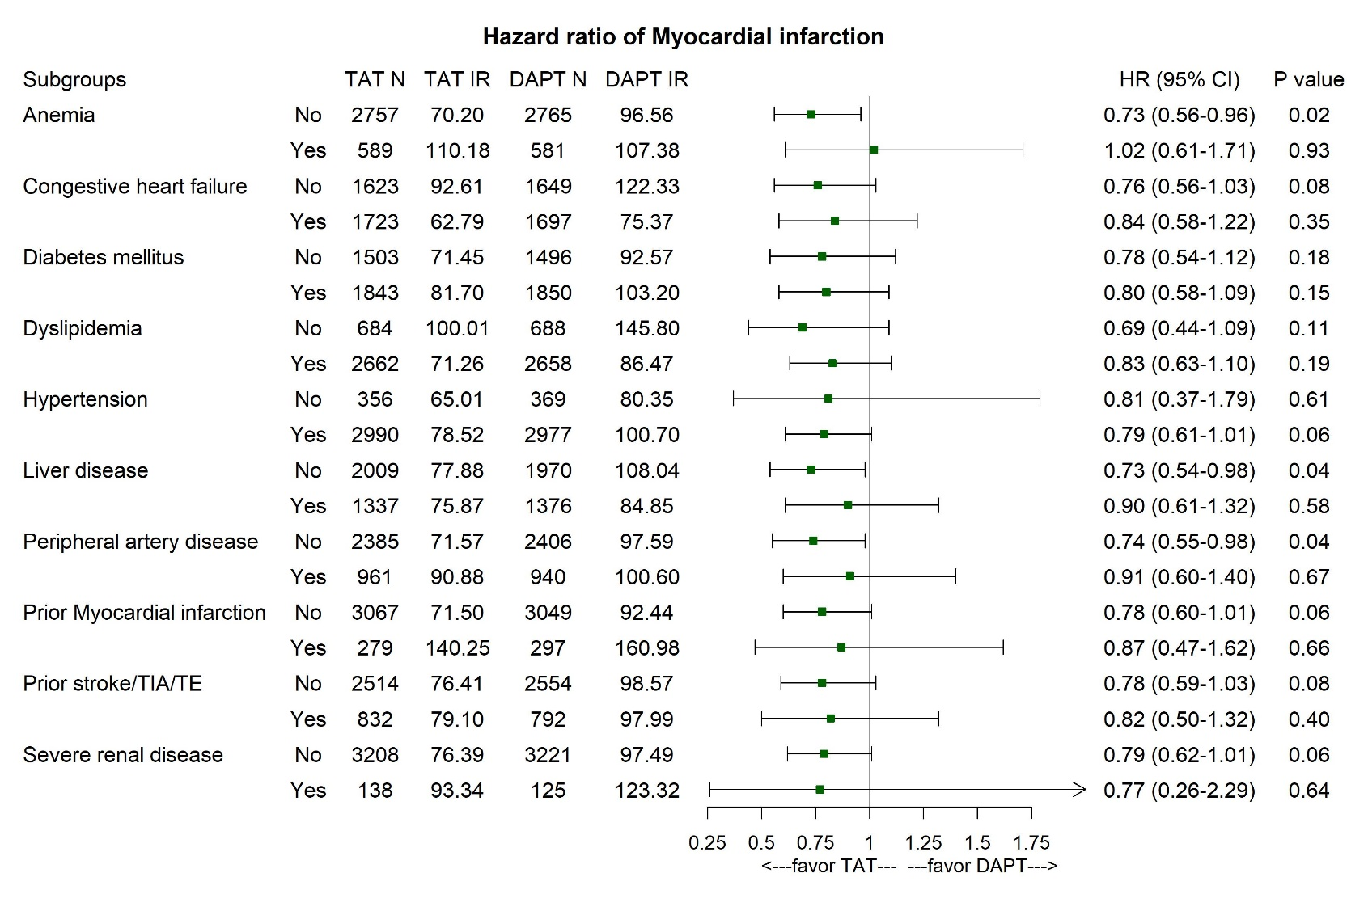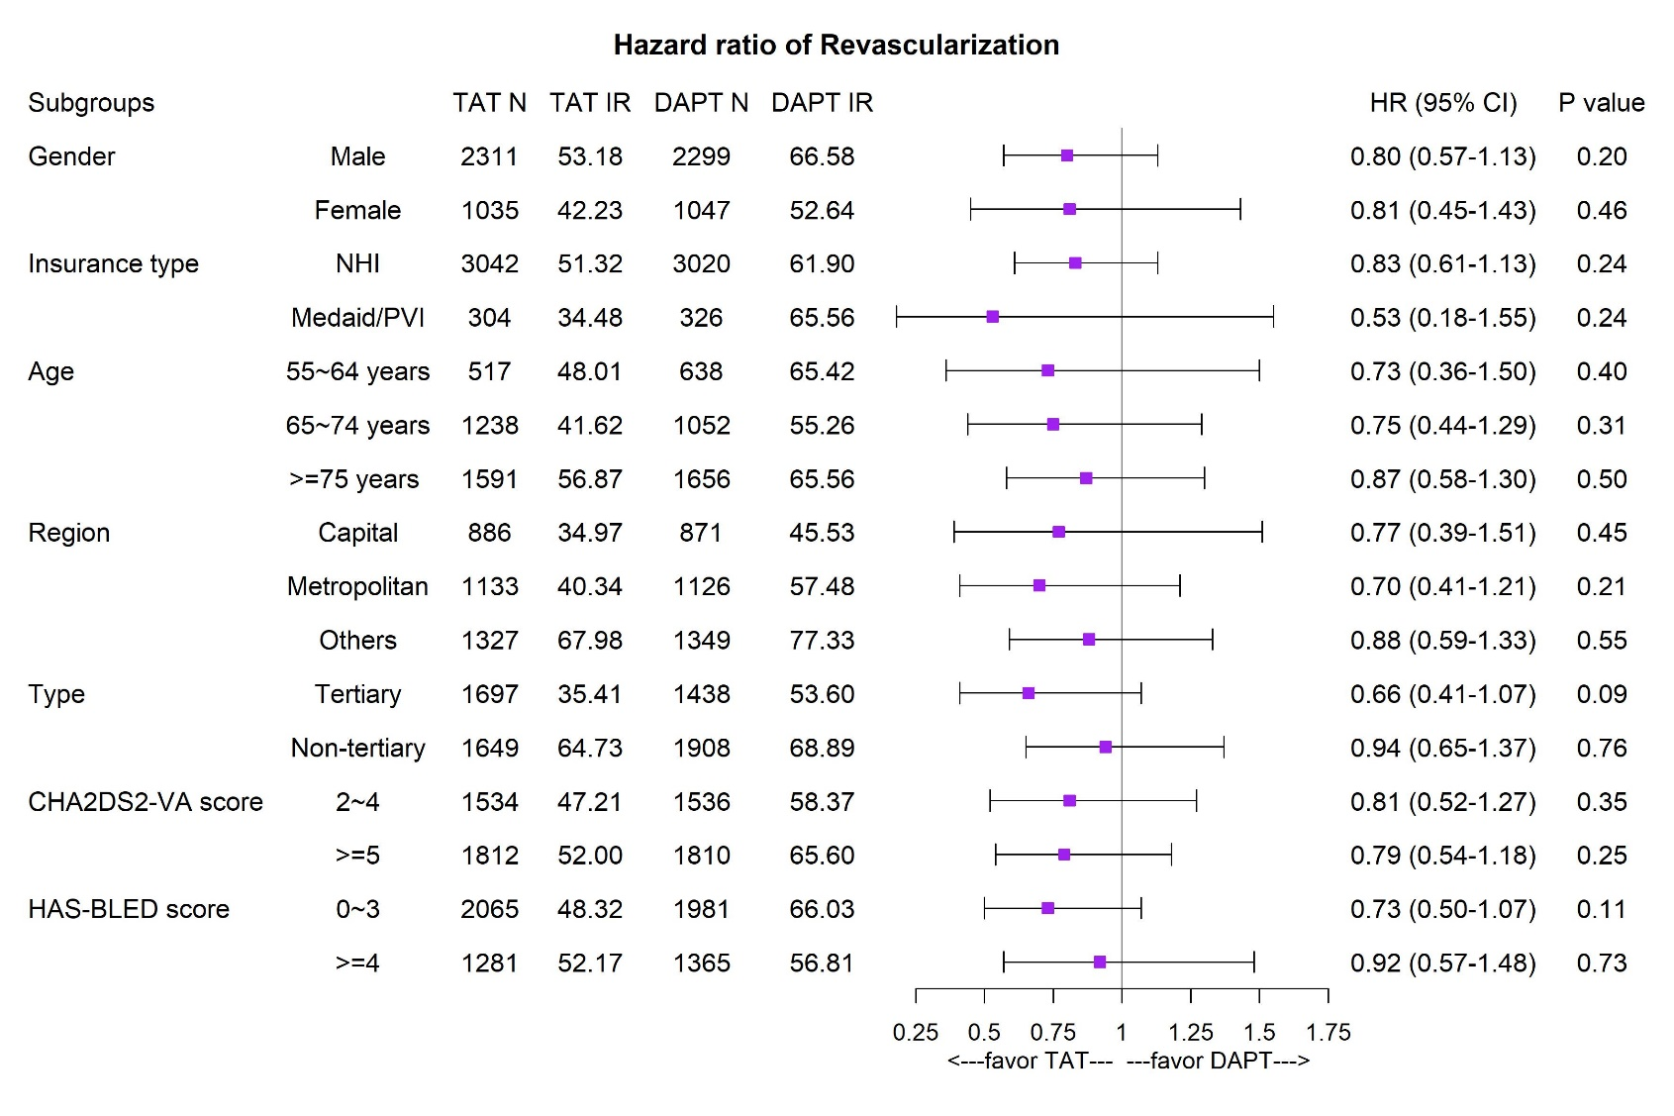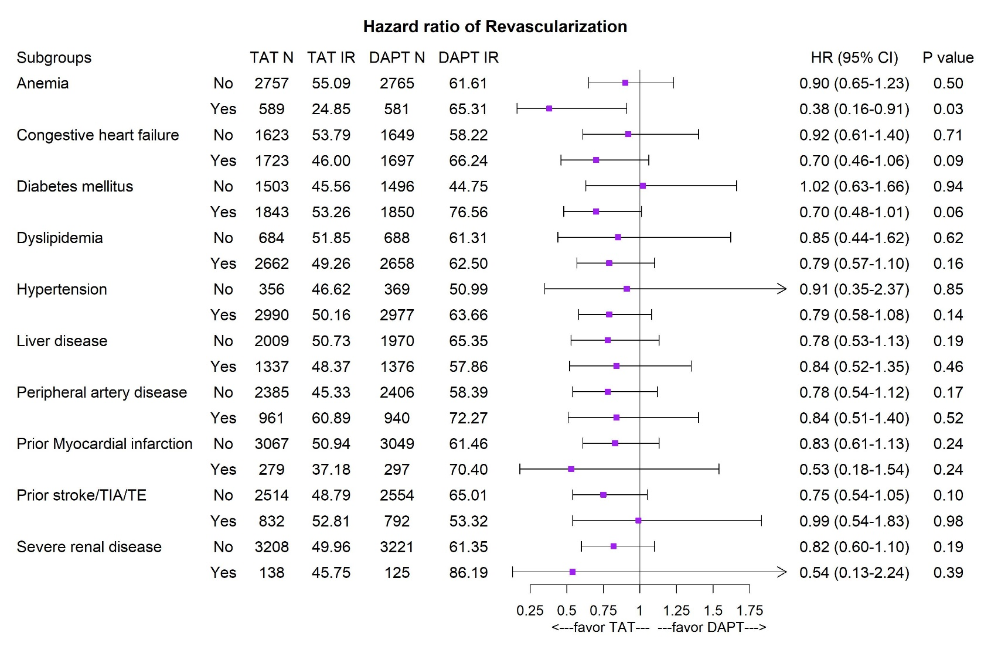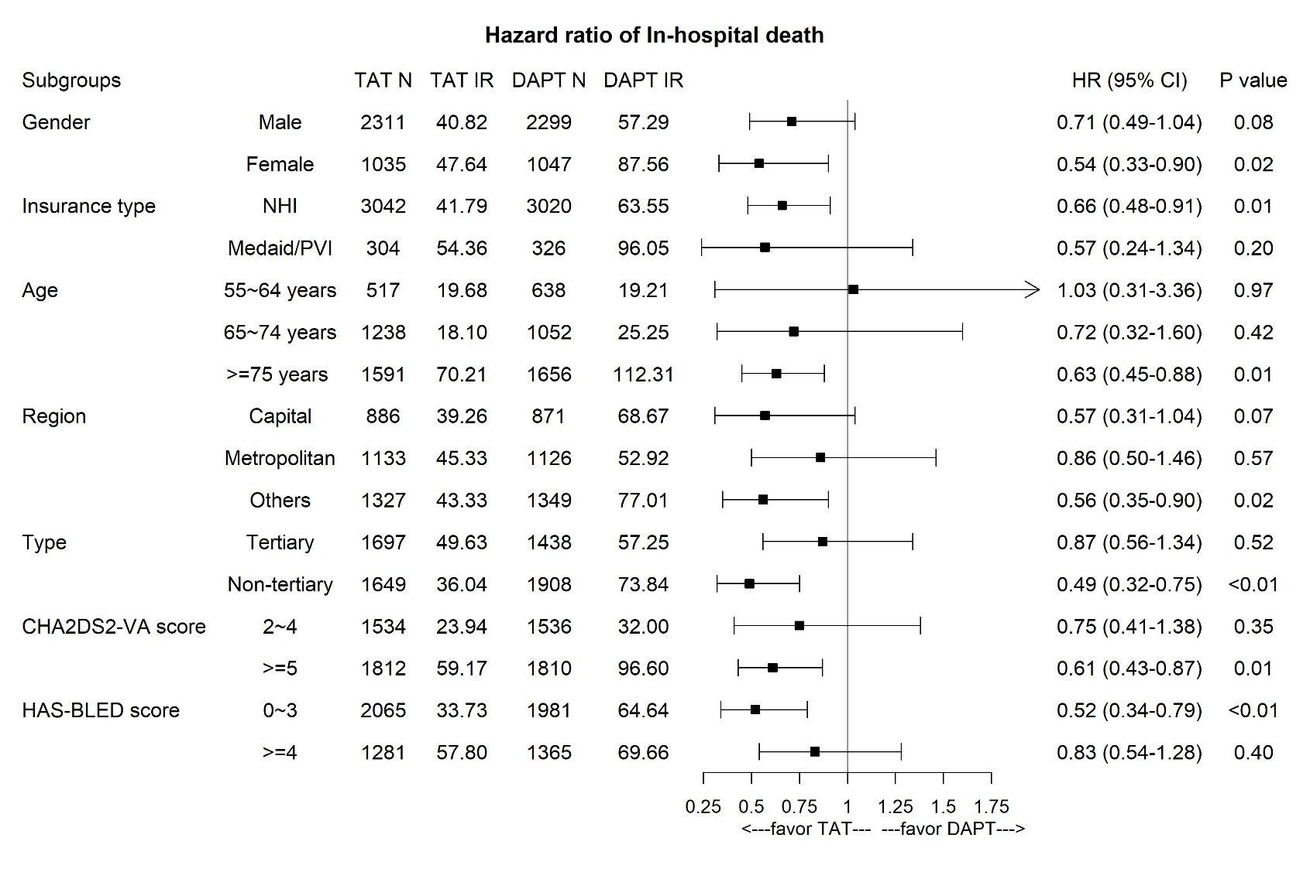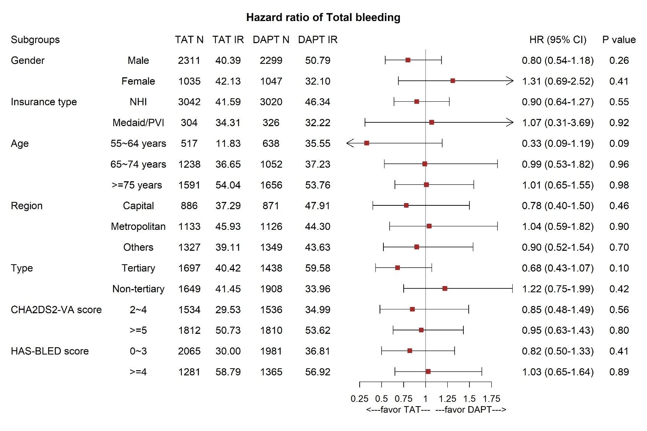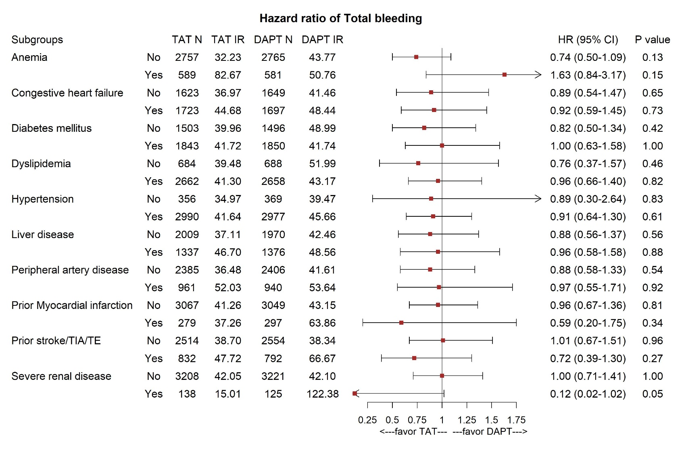
Online Resource 6. Forest plot for Cox hazard ratio of TAT vs DAPT in sensitive analysis:
(A) Variation in censoring criteria
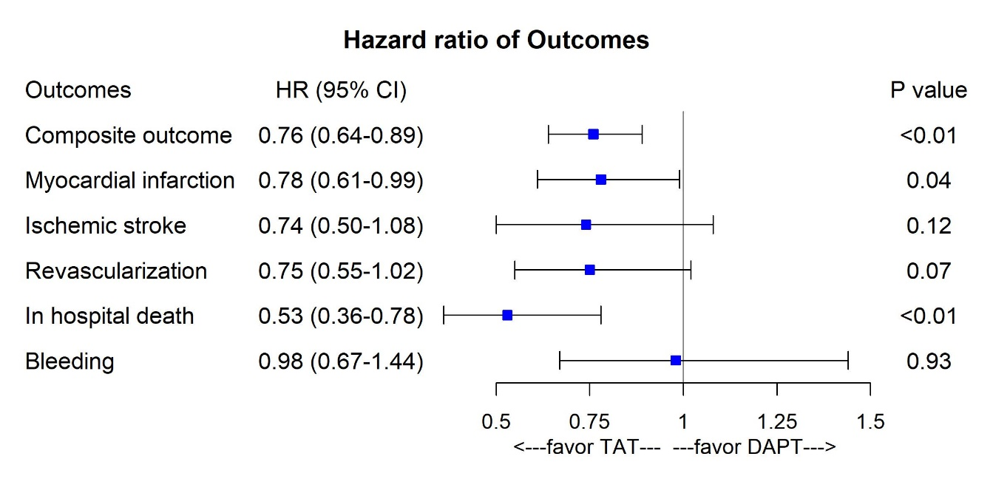
(B) Variation in treatment continuity
