Supplementary material
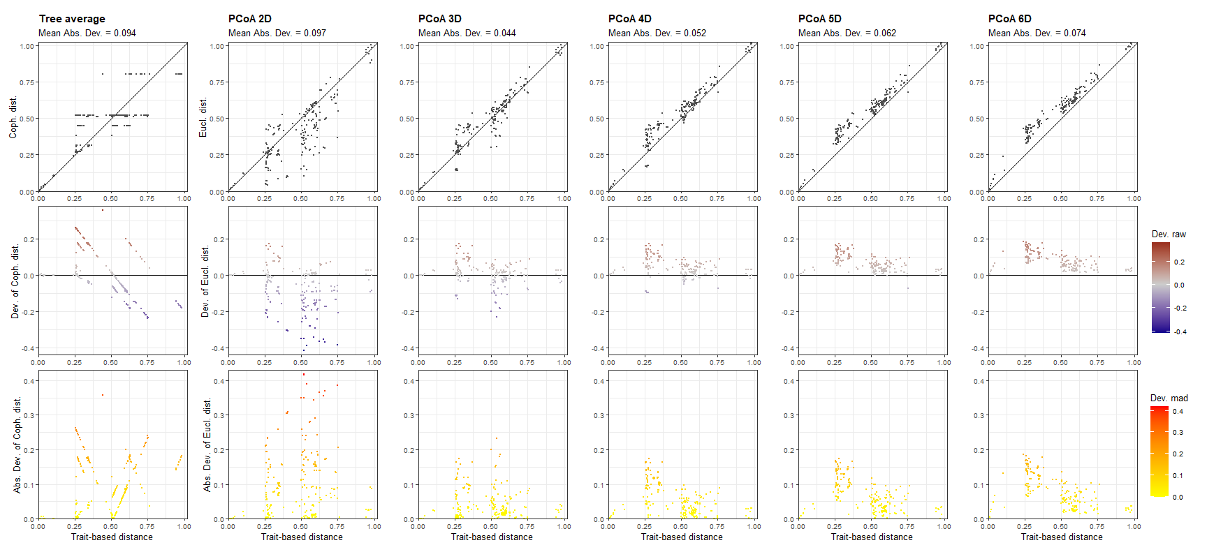
Figure S1. Quality of functional spaces and UPGMA dendrogram with a single plot with three panels for each space. Each column represents a functional space and the x-axis of all panels represents trait-based distances. The y-axis is different for each row: in the first row, it represents the functional distances of species in multidimensional space; in the second row, it shows the raw deviation of species distances in functional space compared to trait-based distances; and in the third row, it shows the absolute or squared deviation of distance ('scaled') in functional space.

Table S1. Akaike Information Criteria (AIC) of the variables forest cover (FC), number of patches (NP), mean patch area (PS) and edge density (ED) analyzed in relation to total species richness, forest-dependent species richness, non-forest-dependent species richness and functional richness of medium- to large-bodied mammals in the Colombian Caribbean. In bold, the lowest AIC values and the selected scale are highlighted.
 |  | Species richness | Forest-dependent | Non-forest-dependent | Functional richness
Variable | Scale (km) | AIC | AIC | AIC | AIC
 | 0.5 | 176.45 | 136.09 | 145.47 | -33.78
 | 1 | 176.62 | 137.06 | 143.78 | -33.47
FC | 2 | 176.49 | 135.98 | 145.21 | -33.58
 | 4 | 175.85 | 134.95 | 146.25 | -34.20
 | 6 | 175.71 | 134.37 | 146.27 | -34.13
 | 0.5 | 176.50 | 137.68 | 146.00 | -33.36
 | 1 | 176.58 | 136.70 | 142.75 | -33.04
NP | 2 | 176.31 | 136.76 | 146.11 | -33.83
 | 4 | 175.45 | 134.83 | 146.51 | -33.70
 | 6 | 175.16 | 135.02 | 146.58 | -33.96
 | 0.5 | 176.62 | 137.27 | 144.94 | -33.49
 | 1 | 176.63 | 135.35 | 142.69 | -33.46
PS | 2 | 176.37 | 135.71 | 145.58 | -33.98
 | 4 | 175.43 | 133.87 | 146.40 | -34.17
 | 6 | 175.49 | 134.63 | 146.46 | -33.96
 | 0.5 | 173.41 | 139.30 | 142.08 | -34.10
 | 1 | 175.71 | 139.73 | 145.20 | -33.13
ED | 2 | 175.53 | 139.43 | 145.51 | -33.40
 | 4 | 176.41 | 139.82 | 145.81 | -33.09
 | 6 | 176.54 | 139.81 | 146.51 | -33.06

Table S2. Variance Inflation Factor (VIF) of the analyzed variables. a. Includes the variables forest cover (FC), number of patches (NP), mean patch area (PS) and edge density (ED). b. Includes the variables forest cover (FC), number of patches (NP) and edge density (ED).
Species richness
Variable | VIF a | VIF b
FC | 8.78226 | 3.097019
NP | 6.952472 | 3.101056
PS | 19.21299
ED | 1.351447 | 1.036109
Forest-dependent
 | VIF a | VIF b
FC | 28.737091 | 2.403799
NP | 46.262708 | 2.84313
PS | 122.449441
ED | 1.284248 | 1.289931
Non-forest-dependent
 | VIF a | VIF b
FC | 15.221271 | 1.558295
NP | 32.877821 | 1.826241
PS | 70.267162
ED | 1.325663 | 1.325652
Functional Richness
 | VIF a | VIF b
FC | 11.050424 | 1.363097
NP | 10.507206 | 1.263711
PS | 30.939902
ED | 1.406398 | 1.13426

Table S3. Values of the residual autocorrelation test based on Moran's I, values of the overdispersion test based on Pearson's residuals for the residuals of all fitted GLM models. Test results are expressed as p-values. Significant values are in bold.
Global model | Moran´s I (p-value) | Moran´s I index | Overdispersion test
Landscape structure analysis:
Y ~ FC+ NP+ ED
Y:
Richness species | 0.23 | 0.26 | 0.42
Forest-dependent | 0.91 | -0.06 | 0.28
Non-forest-dependent | 0.021 | 0.39 | 0.92
Functional richness | 0.21 | 0.05

Table S4. The models of the eight possible combinations of explanatory variables plus the null models and the corresponding AIC values, (FC) forest cover, (ED) edge density and (NP) number of patches.
Model
Species richness | (Intercept) | FC | ED | NP | df | logLik | AICc | ΔAIC | ωi
ED+NP | 2.66794 |  | 0.09686 | -0.19994 | 3.00000 | -81.15433 | 169.10865 | 0.00000 | 0.42362
ED | 1.66054 |  | 0.08520 |  | 2.00000 | -82.68296 | 169.75301 | 0.64436 | 0.30694
FC+ED | 0.42261 | 0.14236 | 0.09518 |  | 3.00000 | -81.60680 | 170.01359 | 0.90494 | 0.26944
Forest Dependent
FC | -1.48657 | 0.31715 |  |  | 2.00000 | -63.35354 | 131.09418 | 0.00000 | 0.34526
ED+NP | 2.41960 |  | 0.09707 | -0.34646 | 3.00000 | -62.51489 | 131.82978 | 0.73559 | 0.23901
NP | 2.27206 |  |  | -0.24454 | 2.00000 | -63.78872 | 131.96453 | 0.87035 | 0.22344
FC+NP | -1.93277 | 0.34785 | 0.06169 |  | 3.00000 | -62.73243 | 132.26486 | 1.17068 | 0.19228
Non-forest dependent
ED | 0.79726 |  | 0.14067 |  | 2.00000 | -66.99876 | 138.38462 | 0.00000 | 0.41111
NP | 0.92395 |  |  | 0.18978 | 2.00000 | -67.68879 | 139.76467 | 1.38005 | 0.20620
FC+ED | 1.46530 | -0.12041 | 0.12192 |  | 3.00000 | -66.54684 | 139.89368 | 1.50906 | 0.19331
ED+NP | 0.73597 |  | 0.10596 | 0.10326 | 3.00000 | -66.56739 | 139.93477 | 1.55015 | 0.18938
Functional Richness
NULL | 0.15267 |  |  |  | 2.00000 | 19.44328 | -34.45800 | 0.00000 | 0.38470
FC | -0.16290 | 0.04085 |  |  | 3.00000 | 20.10043 | -33.31197 | 1.14602 | 0.21690
ED | 0.10494 |  | 0.01564 |  | 3.00000 | 20.04992 | -33.21094 | 1.24705 | 0.20622
NP | 0.35317 |  |  | -0.03835 | 3.00000 | 19.97941 | -33.06993 | 1.38807 | 0.19218

Table S5. Coefficients of the best models: (CA) forest cover, (ED) edge density and (NP) number of patches.
 |  |  | Confidence intervals
Richness species | Average model coefficients | Standard error | 2.5% | 97.5% | Akaike weights (ωi)
(Intercept) | 1.75374095 | 1.09537 | -0.42004969 | 3.92753159
ED | 0.092828683 | 0.0437 | 0.00377923 | 0.18187814 | 1
NP | -0.199941822 | 0.1161 | -0.43673613 | 0.03685249 | 0.42
FC | 0.142362354 | 0.09911 | -0.05976713 | 0.34449184 | 0.27
Forest Dependent
(Intercept) | 0.201078213 | 2.25253 | -4.25180442 | 4.65396084
FC | 0.328131052 | 0.15289 | 0.016673 | 0.6395891 | 0.55
ED | 0.081298043 | 0.06388 | -0.0485984 | 0.21119449 | 0.43
NP | -0.297218155 | 0.14276 | -0.58683985 | -0.00759646 | 0.46
Non-forest dependent
(Intercept) | 0.940916529 | 0.46187 | 0.01093531 | 1.87089775
ED | 0.127823349 | 0.07123 | -0.01714004 | 0.27278674 | 0.80
NP | 0.148356719 | 0.11286 | -0.08042396 | 0.3771374 | 0.40
FC | -0.120412241 | 0.12378 | -0.37287009 | 0.13204561 | 0.19
Functional richness
(Intercept) | 0.112910407 | 0.24153 | -0.3518584 | 0.57767922
FC | 0.04084567 | 0.03612 | -0.03369691 | 0.11538825 | 0.46
ED | 0.015636449 | 0.01453 | -0.01408852 | 0.04536141 | 0.15
NP | -0.038347031 | 0.03796 | -0.11597923 | 0.03928517 | 0.4

