Supplementary Material for

“Multi-step Evaluation of Transitioned Anisotropy (META) Slicer:
A Novel Iterative Nonplanar Anisotropy-aware Slicing Approach”

Table S-1 Summary of the approximate global element sizes and corresponding total element counts used in the mesh sensitivity analysis for the case studies. Red-highlighted regions denote insufficient mesh resolution leading to inaccurate results. Green-highlighted regions indicate mesh convergence with acceptable accuracy. Blue-highlighted regions represent overly refined meshes that incur excessive computational cost without significant improvement in solution accuracy.
 | Approximate Global Element Size (Total Elements)
Case Study | Ultracoarse | Coarse | Normal | Fine | Ultrafine
Open-hole Tensile | 5.0 (4,343) | 4.0 (7,488) | 3.0 (14,781) | 2.0 (41,841) | 1.0 (250,297)
Compression Diamond | 3.0 (2,398) | 2.5 (4,362) | 2.0 (7,966) | 1.5 (17,275) | 1.0 (54,214)
Genus Four | 5.0 (12,805) | 4.0 (25,486) | 3.0 (47,139) | 2.0 (343,598) | 1.0 (846,592)
Double Loops | 3.0 (46,571) | 2.5 (73,480) | 2.0 (132,171) | 1.5 (272,339) | 1.0 (728,816)
Mounting Bracket | 3.0 (13,268) | 2.5 (22,641) | 2.0 (42,801) | 1.5 (91,007) | 1.0 (279,928)

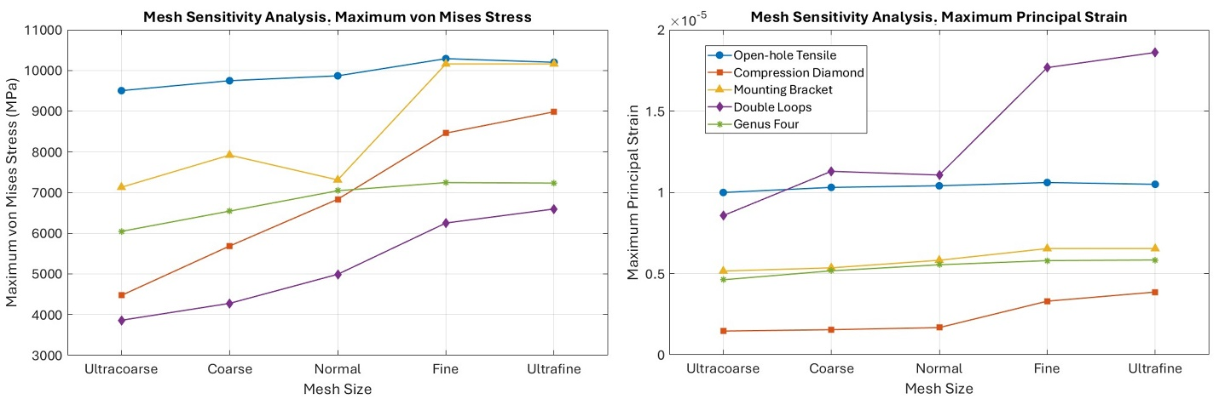
Figure S-1 Mesh sensitivity analysis results for the case studies, illustrating the effect of mesh refinement on solution accuracy and computational cost.

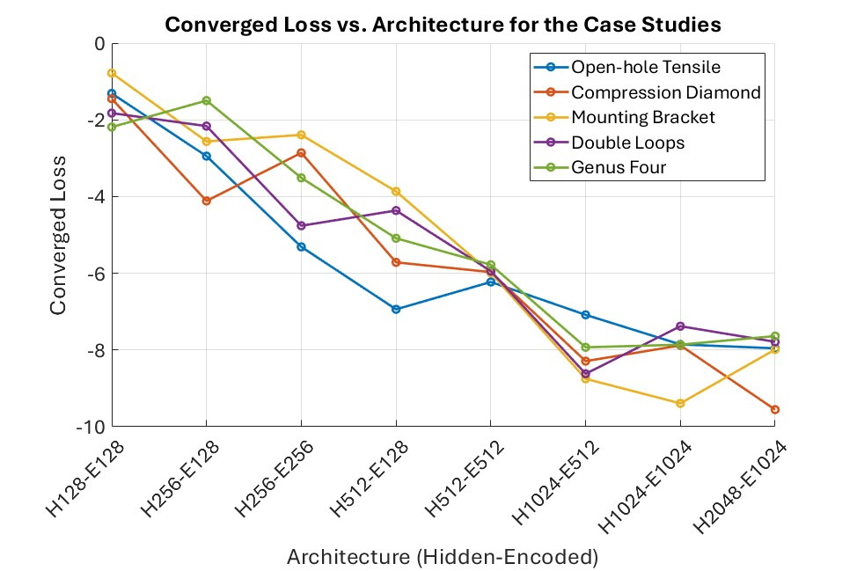
Figure S-2 Relationship between hidden and encoded layer sizes and the corresponding converged loss values, illustrating the impact of network architecture on model performance.

