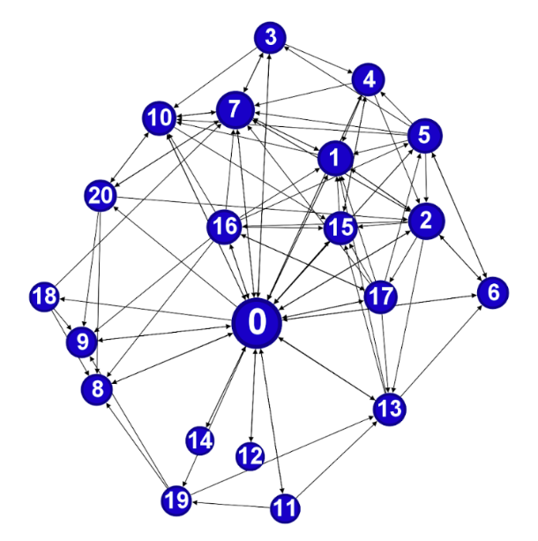
Supplementary Figure 1 – South Africa collaboration network. Each stakeholder is represented by a number. 0: African government 1: African Union and Africa Centres for Disease Control and Prevention (CDC) 2: National Institutes of Health (NIH) – Africa; 3: South African consortium composed of Biovac, Afrigen Biologics and Vaccines; 4: African Medicines Agency 5: Vaccines Task Force for Sustainable Manufacturing in Africa (Vac-Task); 6: African vaccine manufacturers 7: Multilateral organizations: WHO 8: Multilateral organizations: GAVI; 9: Multilateral organizations: CEPI; 10: Covax Initiative; 11: Population; 12: NGOs; 13: Research institutions; 14: End-anthropological institutions; 15: South African Health Products Regulatory Authority (SAHPRA); 16: Vaccine manufacturers (AstraZeneca, Serum Institute of India); 17: University of Oxford - Original developer of the ChAdOx1-S vaccine; 18: University of the Witwatersrand - Local partner in South Africa that conducted the clinical trials; 19: Civil Society and Media; 20: UNICEF.

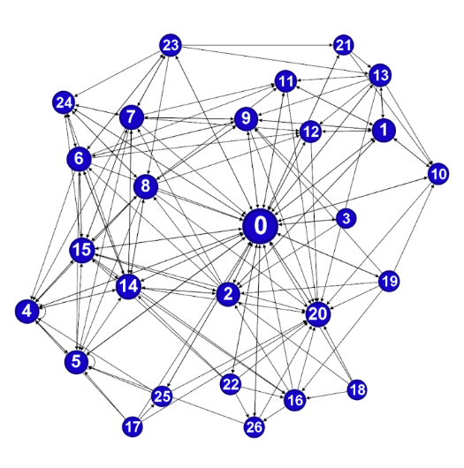
Supplementary Figure 2. India Collaboration Network. 0: Indian Government; 2: Public Health Organizations; 3: Ministry of Health and Family Welfare of India ( MoHFW ); Regional Organizations (by example , SAARC); 5: ICMR research institutes; 6. NIV research institutes; 7: Regulatory authorities: Drug Controller General of India Indian regulatory agencies; 8: ICMR Regulatory authorities - Drug Controller General of India 9: International organizations (WHO): 10: International organizations (UNICEF); 11: International organizations (CEPI); 12: International organizations (GAVI); 13: COVAX Initiative; 14: Indian pharmaceutical industry: Serum Institute of India Indian; 15: Pharmaceutical industry: Bharat Biotec; 16: Healthcare professionals 17; 18. Communities/civil society; 19. NGOs and implementing organizations Media Low- and middle-income countries.

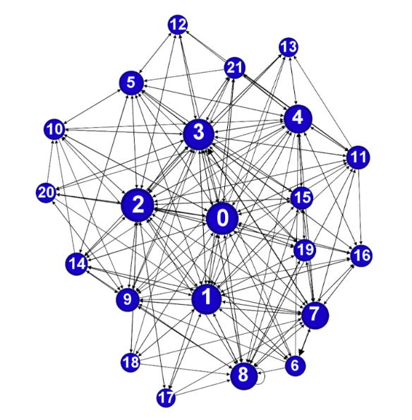
Supplementary Figure 3. Collaboration network in Brazil. 0: Federal Government; 1: Brazilian Ministry of Health; 2: Fiocruz; 3: Bio-Manguinhos/Fiocruz; 4: Anvisa; 5: PNI; 6. Institute of Applied Economic Research (IPEA); 7. AstraZeneca University of Oxford; 8: Brazilian scientific community; 9: Brazilian population; 10: Unifesp; 11: Private initiative; 12: Clinical trial volunteers; 13: Legislative branch; 14: Serum Institute; 15: International organizations (WHO); 16: International organizations (UNICEF); 17: International organizations (CEPI); 18: COVAX; 19: Communication; 20: Journalism; 21: Funding agencies: Finep, CNPq

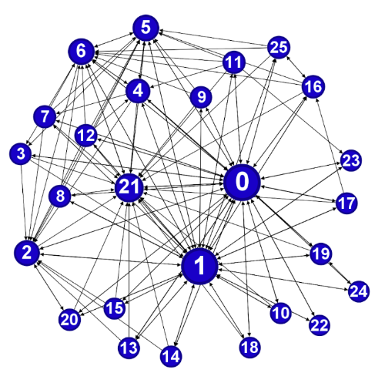
Supplementary Figure 4. UK collaboration network. 0: UK Government; 1: Government (VTF – Vaccine Taskforce); 2: US Chief Medical Officers; 3: UK Government: Cabinet Office Briefing Room (COBRA); 4: Emergency Committee; 5: Regulatory Pharmacists; 6: Agency: Regulatory MHRA; 7: Agency: EMA; 8: International organizations (WHO); 9: International organization (GAVI); 10: International organizations (CEPI) 11: Research institutions National Health Service (NHS); 12: Public Health England (PHE); 13: Scientific Advisory Group for Emergencies (SAGE); 14: National Institute for Health and Care Excellence (NICE); 15: British Medical Association; 16: University: Oxford; 17: Academia/researchers; 18: Wellcome Trust 19: COVAX Initiative; 20: UK Department of Health and Social Care (DHSC); 21: UKVN delivery partners (UKRI, BBSRC, EPSRC, Innovate UK, NIHR); 22: Healthcare professionals, including nurses and other NHS workers; 23: General population; 24: Low- and middle-income countries (LMICs); 25: Astrazeneca.

