Supplementary materials

Supplementary figure 1. Original cosine similarity matrix

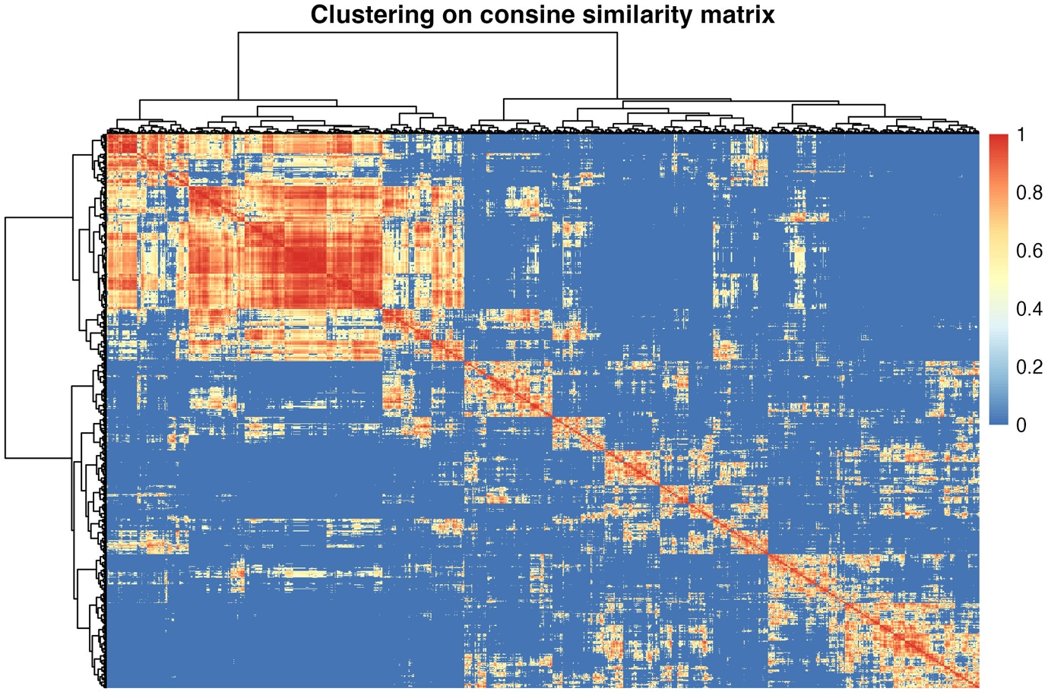

Supplementary figure 2. Average silhouette width in clustering analysis
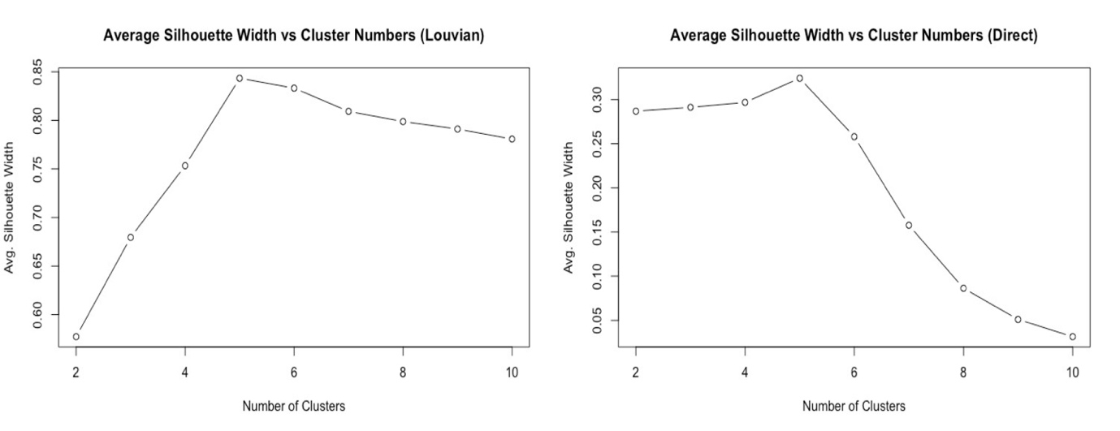
Left: Average silhouette width in clustering analysis on co-assignment matrix; Right: Average silhouette width in clustering analysis on original similarity matrix. Both suggested 5 as the optimal number of clusters.

Supplementary table 1. Age and education stratified reference for MMSE
Age | Education | Mean | SE | 5% | 25% | 50% | 75% | 95%
60 | No formal | 20.5 | 0.3 | 20.1 | 20.4 | 20.5 | 20.7 | 21.0
60 | Primary | 24.0 | 0.2 | 23.6 | 23.8 | 24.0 | 24.1 | 24.4
60 | Lower secondary | 26.3 | 0.2 | 25.9 | 26.1 | 26.3 | 26.4 | 26.7
60 | Upper secondary | 27.2 | 0.2 | 26.8 | 27.1 | 27.2 | 27.4 | 27.6
60 | Tertiary | 28.3 | 0.3 | 27.8 | 28.1 | 28.3 | 28.4 | 28.7
65 | No formal | 20.2 | 0.2 | 19.8 | 20.0 | 20.2 | 20.3 | 20.5
65 | Primary | 23.6 | 0.2 | 23.4 | 23.5 | 23.6 | 23.7 | 23.9
65 | Lower secondary | 25.9 | 0.1 | 25.7 | 25.8 | 25.9 | 26.0 | 26.2
65 | Upper secondary | 26.9 | 0.1 | 26.6 | 26.8 | 26.9 | 26.9 | 27.1
65 | Tertiary | 27.9 | 0.2 | 27.6 | 27.8 | 27.9 | 28.0 | 28.2
70 | No formal | 20.1 | 0.2 | 19.8 | 20.0 | 20.1 | 20.2 | 20.4
70 | Primary | 23.5 | 0.1 | 23.3 | 23.4 | 23.5 | 23.6 | 23.8
70 | Lower secondary | 25.8 | 0.1 | 25.6 | 25.8 | 25.8 | 25.9 | 26.1
70 | Upper secondary | 26.8 | 0.1 | 26.5 | 26.7 | 26.8 | 26.9 | 27.0
70 | Tertiary | 27.8 | 0.2 | 27.5 | 27.7 | 27.8 | 27.9 | 28.1
75 | No formal | 19.4 | 0.2 | 19.1 | 19.3 | 19.4 | 19.5 | 19.7
75 | Primary | 22.9 | 0.1 | 22.6 | 22.8 | 22.9 | 23.0 | 23.1
75 | Lower secondary | 25.2 | 0.1 | 24.9 | 25.1 | 25.2 | 25.3 | 25.4
75 | Upper secondary | 26.1 | 0.2 | 25.8 | 26.0 | 26.1 | 26.2 | 26.4
75 | Tertiary | 27.1 | 0.2 | 26.8 | 27.0 | 27.1 | 27.3 | 27.5
80 | No formal | 17.9 | 0.2 | 17.6 | 17.8 | 17.9 | 18.0 | 18.2
80 | Primary | 21.3 | 0.2 | 21.1 | 21.2 | 21.3 | 21.5 | 21.6
80 | Lower secondary | 23.7 | 0.2 | 23.4 | 23.5 | 23.7 | 23.8 | 23.9
80 | Upper secondary | 24.6 | 0.2 | 24.3 | 24.5 | 24.6 | 24.7 | 24.9
80 | Tertiary | 25.6 | 0.2 | 25.3 | 25.5 | 25.6 | 25.8 | 26.0
85 | No formal | 16.2 | 0.2 | 15.8 | 16.1 | 16.2 | 16.4 | 16.6
85 | Primary | 19.7 | 0.2 | 19.3 | 19.5 | 19.7 | 19.8 | 20.0
85 | Lower secondary | 22.0 | 0.2 | 21.6 | 21.8 | 22.0 | 22.1 | 22.3
85 | Upper secondary | 22.9 | 0.2 | 22.5 | 22.8 | 22.9 | 23.1 | 23.3
85 | Tertiary | 24.0 | 0.2 | 23.5 | 23.8 | 24.0 | 24.1 | 24.4
90 | No formal | 14.6 | 0.3 | 14.1 | 14.4 | 14.6 | 14.9 | 15.2
90 | Primary | 18.1 | 0.3 | 17.5 | 17.9 | 18.1 | 18.3 | 18.6
90 | Lower secondary | 20.4 | 0.3 | 19.8 | 20.2 | 20.4 | 20.6 | 20.9
90 | Upper secondary | 21.3 | 0.3 | 20.8 | 21.1 | 21.3 | 21.6 | 21.9
90 | Tertiary | 22.4 | 0.4 | 21.8 | 22.1 | 22.4 | 22.6 | 22.9
95 | No formal | 13.4 | 0.7 | 12.3 | 12.9 | 13.4 | 13.8 | 14.4
95 | Primary | 16.8 | 0.6 | 15.7 | 16.4 | 16.8 | 17.2 | 17.9
95 | Lower secondary | 19.1 | 0.6 | 18.0 | 18.7 | 19.1 | 19.5 | 20.2
95 | Upper secondary | 20.0 | 0.7 | 19.0 | 19.6 | 20.0 | 20.5 | 21.1
95 | Tertiary | 21.1 | 0.7 | 20.0 | 20.6 | 21.1 | 21.5 | 22.2
100 | No formal | 12.2 | 1.3 | 10.1 | 11.4 | 12.2 | 13.1 | 14.3
100 | Primary | 15.7 | 1.3 | 13.6 | 14.8 | 15.7 | 16.5 | 17.8
100 | Lower secondary | 18.0 | 1.3 | 15.9 | 17.1 | 18.0 | 18.8 | 20.1
100 | Upper secondary | 18.9 | 1.3 | 16.8 | 18.1 | 18.9 | 19.8 | 21.0
100 | Tertiary | 20.0 | 1.3 | 17.9 | 19.1 | 20.0 | 20.8 | 22.1

Supplementary table 2. Age and education stratified reference for GDS-15

Age | Education | Mean | SE | 5% | 25% | 50% | 75% | 95%
60 | No formal | 3.4 | 0.2 | 3.1 | 3.3 | 3.4 | 3.5 | 3.6
60 | Primary | 3.1 | 0.1 | 2.9 | 3.1 | 3.1 | 3.2 | 3.4
60 | Lower secondary | 2.5 | 0.1 | 2.3 | 2.5 | 2.5 | 2.6 | 2.8
60 | Upper secondary | 2.6 | 0.1 | 2.4 | 2.5 | 2.6 | 2.7 | 2.8
60 | Tertiary | 2.0 | 0.1 | 1.8 | 1.9 | 2.0 | 2.1 | 2.2
65 | No formal | 3.5 | 0.1 | 3.3 | 3.4 | 3.5 | 3.6 | 3.7
65 | Primary | 3.3 | 0.1 | 3.1 | 3.2 | 3.3 | 3.3 | 3.4
65 | Lower secondary | 2.7 | 0.1 | 2.5 | 2.6 | 2.7 | 2.7 | 2.8
65 | Upper secondary | 2.7 | 0.1 | 2.6 | 2.6 | 2.7 | 2.7 | 2.8
65 | Tertiary | 2.1 | 0.1 | 1.9 | 2.0 | 2.1 | 2.2 | 2.3
70 | No formal | 3.6 | 0.1 | 3.4 | 3.6 | 3.6 | 3.7 | 3.8
70 | Primary | 3.4 | 0.1 | 3.3 | 3.3 | 3.4 | 3.4 | 3.5
70 | Lower secondary | 2.8 | 0.1 | 2.7 | 2.7 | 2.8 | 2.8 | 2.9
70 | Upper secondary | 2.8 | 0.1 | 2.7 | 2.8 | 2.8 | 2.9 | 3.0
70 | Tertiary | 2.2 | 0.1 | 2.1 | 2.2 | 2.2 | 2.3 | 2.4
75 | No formal | 3.9 | 0.1 | 3.7 | 3.8 | 3.9 | 3.9 | 4.1
75 | Primary | 3.6 | 0.1 | 3.5 | 3.6 | 3.6 | 3.7 | 3.8
75 | Lower secondary | 3.0 | 0.1 | 2.9 | 3.0 | 3.0 | 3.1 | 3.2
75 | Upper secondary | 3.1 | 0.1 | 2.9 | 3.0 | 3.1 | 3.1 | 3.2
75 | Tertiary | 2.5 | 0.1 | 2.3 | 2.4 | 2.5 | 2.6 | 2.7
80 | No formal | 4.3 | 0.1 | 4.1 | 4.2 | 4.3 | 4.4 | 4.5
80 | Primary | 4.1 | 0.1 | 3.9 | 4.0 | 4.1 | 4.1 | 4.2
80 | Lower secondary | 3.5 | 0.1 | 3.3 | 3.4 | 3.5 | 3.5 | 3.6
80 | Upper secondary | 3.5 | 0.1 | 3.3 | 3.4 | 3.5 | 3.6 | 3.7
80 | Tertiary | 2.9 | 0.1 | 2.7 | 2.8 | 2.9 | 3.0 | 3.1
85 | No formal | 4.8 | 0.1 | 4.5 | 4.7 | 4.8 | 4.8 | 5.0
85 | Primary | 4.5 | 0.1 | 4.3 | 4.4 | 4.5 | 4.6 | 4.7
85 | Lower secondary | 3.9 | 0.1 | 3.7 | 3.8 | 3.9 | 4.0 | 4.1
85 | Upper secondary | 3.9 | 0.1 | 3.7 | 3.9 | 3.9 | 4.0 | 4.1
85 | Tertiary | 3.4 | 0.1 | 3.1 | 3.3 | 3.4 | 3.5 | 3.6
90 | No formal | 5.1 | 0.2 | 4.8 | 5.0 | 5.1 | 5.3 | 5.4
90 | Primary | 4.9 | 0.2 | 4.6 | 4.8 | 4.9 | 5.0 | 5.2
90 | Lower secondary | 4.3 | 0.2 | 4.0 | 4.2 | 4.3 | 4.4 | 4.6
90 | Upper secondary | 4.3 | 0.2 | 4.0 | 4.2 | 4.3 | 4.4 | 4.6
90 | Tertiary | 3.7 | 0.2 | 3.4 | 3.6 | 3.7 | 3.9 | 4.1
95 | No formal | 5.4 | 0.3 | 4.9 | 5.2 | 5.4 | 5.6 | 5.9
95 | Primary | 5.2 | 0.3 | 4.6 | 4.9 | 5.2 | 5.4 | 5.7
95 | Lower secondary | 4.6 | 0.3 | 4.0 | 4.3 | 4.6 | 4.8 | 5.1
95 | Upper secondary | 4.6 | 0.3 | 4.0 | 4.4 | 4.6 | 4.8 | 5.1
95 | Tertiary | 4.0 | 0.3 | 3.5 | 3.8 | 4.0 | 4.2 | 4.6
100 | No formal | 5.6 | 0.5 | 4.8 | 5.3 | 5.6 | 6.0 | 6.5
100 | Primary | 5.4 | 0.5 | 4.5 | 5.0 | 5.4 | 5.8 | 6.3
100 | Lower secondary | 4.8 | 0.5 | 3.9 | 4.4 | 4.8 | 5.2 | 5.7
100 | Upper secondary | 4.8 | 0.5 | 3.9 | 4.5 | 4.8 | 5.2 | 5.7
100 | Tertiary | 4.3 | 0.5 | 3.4 | 3.9 | 4.3 | 4.6 | 5.2

Supplementary table 3. Age and sex stratified reference for MNA-SF
Age | Sex | Mean | SE | 5% | 25% | 50% | 75% | 95%
60 | Female | 12.8 | 0.1 | 12.7 | 12.8 | 12.8 | 12.9 | 12.9
60 | Male | 12.9 | 0.1 | 12.7 | 12.8 | 12.9 | 12.9 | 13.0
65 | Female | 12.7 | 0.0 | 12.6 | 12.6 | 12.7 | 12.7 | 12.7
65 | Male | 12.7 | 0.0 | 12.7 | 12.7 | 12.7 | 12.8 | 12.8
70 | Female | 12.5 | 0.0 | 12.5 | 12.5 | 12.5 | 12.6 | 12.6
70 | Male | 12.6 | 0.0 | 12.5 | 12.5 | 12.6 | 12.6 | 12.6
75 | Female | 12.4 | 0.0 | 12.3 | 12.3 | 12.4 | 12.4 | 12.4
75 | Male | 12.4 | 0.0 | 12.3 | 12.4 | 12.4 | 12.4 | 12.5
80 | Female | 12.1 | 0.1 | 12.0 | 12.1 | 12.1 | 12.1 | 12.2
80 | Male | 12.1 | 0.1 | 12.1 | 12.1 | 12.1 | 12.2 | 12.2
85 | Female | 11.7 | 0.1 | 11.6 | 11.7 | 11.7 | 11.8 | 11.9
85 | Male | 11.8 | 0.1 | 11.7 | 11.7 | 11.8 | 11.8 | 11.9
90 | Female | 11.4 | 0.1 | 11.2 | 11.3 | 11.4 | 11.4 | 11.5
90 | Male | 11.4 | 0.1 | 11.2 | 11.3 | 11.4 | 11.5 | 11.6
95 | Female | 11.0 | 0.2 | 10.6 | 10.8 | 11.0 | 11.1 | 11.3
95 | Male | 11.0 | 0.2 | 10.7 | 10.9 | 11.0 | 11.1 | 11.3
100 | Female | 10.6 | 0.3 | 10.1 | 10.4 | 10.6 | 10.8 | 11.1
100 | Male | 10.6 | 0.3 | 10.1 | 10.4 | 10.6 | 10.9 | 11.2

Supplementary table 4. Age and sex stratified reference for SPBB

Age | Sex | Mean | SE | 5% | 25% | 50% | 75% | 95%
60 | Female | 8.9 | 0.2 | 8.7 | 8.8 | 8.9 | 9.0 | 9.2
60 | Male | 8.9 | 0.1 | 8.6 | 8.8 | 8.9 | 9.0 | 9.1
65 | Female | 8.7 | 0.1 | 8.6 | 8.7 | 8.7 | 8.8 | 8.9
65 | Male | 8.7 | 0.1 | 8.5 | 8.6 | 8.7 | 8.7 | 8.8
70 | Female | 8.4 | 0.1 | 8.3 | 8.3 | 8.4 | 8.4 | 8.5
70 | Male | 8.3 | 0.1 | 8.2 | 8.3 | 8.3 | 8.4 | 8.5
75 | Female | 7.7 | 0.1 | 7.6 | 7.6 | 7.7 | 7.8 | 7.9
75 | Male | 7.7 | 0.1 | 7.5 | 7.6 | 7.7 | 7.7 | 7.8
80 | Female | 6.8 | 0.1 | 6.6 | 6.7 | 6.8 | 6.9 | 7.0
80 | Male | 6.7 | 0.1 | 6.6 | 6.7 | 6.7 | 6.8 | 6.9
85 | Female | 5.8 | 0.1 | 5.6 | 5.8 | 5.8 | 5.9 | 6.1
85 | Male | 5.8 | 0.1 | 5.6 | 5.7 | 5.8 | 5.9 | 6.0
90 | Female | 4.9 | 0.2 | 4.5 | 4.7 | 4.9 | 5.1 | 5.3
90 | Male | 4.8 | 0.2 | 4.5 | 4.7 | 4.8 | 5.0 | 5.2
95 | Female | 4.0 | 0.4 | 3.3 | 3.7 | 4.0 | 4.3 | 4.7
95 | Male | 3.9 | 0.4 | 3.2 | 3.6 | 3.9 | 4.2 | 4.6
100 | Female | 3.1 | 0.7 | 1.9 | 2.6 | 3.1 | 3.6 | 4.3
100 | Male | 3.0 | 0.7 | 1.8 | 2.5 | 3.0 | 3.5 | 4.2

Supplementary table 5. Age and sex stratified reference for sensory score

Age | Sex | Mean | SE | 5% | 25% | 50% | 75% | 95%
60 | Female | 8.9 | 0.1 | 8.7 | 8.8 | 8.9 | 8.9 | 9.1
60 | Male | 8.8 | 0.1 | 8.6 | 8.7 | 8.8 | 8.9 | 9.0
65 | Female | 8.8 | 0.1 | 8.7 | 8.7 | 8.8 | 8.8 | 8.9
65 | Male | 8.7 | 0.1 | 8.6 | 8.6 | 8.7 | 8.7 | 8.8
70 | Female | 8.6 | 0.1 | 8.5 | 8.6 | 8.6 | 8.6 | 8.7
70 | Male | 8.5 | 0.1 | 8.4 | 8.5 | 8.5 | 8.6 | 8.6
75 | Female | 8.1 | 0.1 | 8.0 | 8.0 | 8.1 | 8.1 | 8.2
75 | Male | 8.0 | 0.1 | 7.9 | 8.0 | 8.0 | 8.0 | 8.1
80 | Female | 7.1 | 0.1 | 7.0 | 7.1 | 7.1 | 7.2 | 7.3
80 | Male | 7.0 | 0.1 | 6.9 | 7.0 | 7.0 | 7.1 | 7.2
85 | Female | 6.3 | 0.1 | 6.1 | 6.2 | 6.3 | 6.4 | 6.5
85 | Male | 6.2 | 0.1 | 6.1 | 6.2 | 6.2 | 6.3 | 6.4
90 | Female | 5.6 | 0.2 | 5.3 | 5.5 | 5.6 | 5.7 | 5.9
90 | Male | 5.5 | 0.2 | 5.2 | 5.4 | 5.5 | 5.6 | 5.8
95 | Female | 4.8 | 0.3 | 4.2 | 4.6 | 4.8 | 5.0 | 5.3
95 | Male | 4.7 | 0.3 | 4.1 | 4.5 | 4.7 | 4.9 | 5.2
100 | Female | 4.0 | 0.7 | 3.0 | 3.6 | 4.0 | 4.5 | 5.1
100 | Male | 3.9 | 0.7 | 2.9 | 3.5 | 3.9 | 4.4 | 5.0

Supplementary table 6. Characteristics of different aging patterns

Community | 1 | 2 | 3 | 4 | 5
Community | N = 2,315 | N = 534 | N = 397 | N = 608 | N = 2,171
Female | 1,212 (52%) | 266 (50%) | 197 (50%) | 327 (54%) | 1,207 (56%)
Male | 1,103 (48%) | 268 (50%) | 200 (50%) | 281 (46%) | 964 (44%)
Age | 69 (65, 72) | 71 (66, 77) | 70 (66, 74) | 70 (66, 75) | 72 (68, 79)
No formal education | 97 (4.2%) | 44 (8.2%)** | 18 (4.5%)+ | 41 (6.7%)# | 464 (21%)^
Primary education | 392 (17%) | 111 (21%) | 98 (25%) | 162 (27%) | 732 (34%)
Lower secondary education | 734 (32%) | 174 (33%) | 133 (34%) | 200 (33%) | 500 (23%)
Upper secondary education | 704 (30%) | 137 (26%) | 102 (26%) | 132 (22%) | 342 (16%)
Tertiary education | 388 (17%) | 68 (13%) | 46 (12%) | 73 (12%) | 133 (6.1%)
N (medical history available) | 1701 | 403 | 302 | 442 | 1662
Hypertension* | 1,084 (64%) | 277 (69%) | 161 (53%)+ | 301 (68%) | 1,150 (69%)^
Coronary artery disease* | 209 (12%) | 72 (18%) | 36 (12%)+ | 51 (12%) | 263 (16%)^
Myocardial infarction | 33 (1.9%) | 9 (2.2%) | 9 (3.0%) | 9 (2.0%) | 29 (1.7%)
Other cardiovascular diseases | 94 (5.5%) | 22 (5.5%) | 17 (5.6%) | 38 (8.6%) | 105 (6.3%)
COPD | 20 (1.2%) | 10 (2.5%) | 5 (1.7%) | 4 (0.9%) | 46 (2.8%)
Other pulmonary diseases | 37 (2.2%) | 15 (3.7%) | 8 (2.6%) | 9 (2.0%) | 45 (2.7%)
Gastrointestinal diseases* | 62 (3.6%) | 23 (5.7%) | 43 (14%)+ | 12 (2.7%) | 76 (4.6%)
Chronic hepatic diseases | 14 (0.8%) | 3 (0.7%) | 1 (0.3%) | 6 (1.4%) | 14 (0.8%)
Chronic renal diseases | 30 (1.8%) | 13 (3.2%) | 8 (2.6%) | 4 (0.9%) | 42 (2.5%)
Intracranial haemorrhage | 18 (1.1%) | 6 (1.5%) | 4 (1.3%) | 7 (1.6%) | 25 (1.5%)
Ischaemic cerebral vascular diseases | 71 (4.2%) | 15 (3.7%) | 10 (3.3%) | 21 (4.8%) | 104 (6.3%)
Dementia* | 4 (0.2%) | 0 (0%) | 2 (0.7%) | 1 (0.2%) | 20 (1.2%)^
Parkinson's disease* | 5 (0.3%) | 2 (0.5%) | 0 (0%) | 3 (0.7%) | 25 (1.5%)^
Epilepsy | 1 (<0.1%) | 0 (0%) | 2 (0.7%) | 1 (0.2%) | 9 (0.5%)
Other neurological diseases | 8 (0.5%) | 3 (0.7%) | 1 (0.3%) | 3 (0.7%) | 17 (1.0%)
Diabetes mellitus | 503 (30%) | 112 (28%) | 77 (25%) | 116 (26%) | 466 (28%)
Depression or anxiety | 10 (0.6%) | 3 (0.7%) | 2 (0.7%) | 0 (0%) | 31 (1.9%)
Osteoarthritis | 98 (5.8%) | 31 (7.7%) | 21 (7.0%) | 22 (5.0%) | 123 (7.4%)
Osteoporosis | 47 (2.8%) | 14 (3.5%) | 14 (4.6%) | 10 (2.3%) | 61 (3.7%)
Malignancy | 33 (1.9%) | 3 (0.7%) | 9 (3.0%) | 8 (1.8%) | 15 (0.9%)
Cataract* | 109 (6.4%) | 47 (12%)** | 20 (6.6%) | 26 (5.9%) | 163 (9.8%)
Glaucoma | 10 (0.6%) | 3 (0.7%) | 3 (1.0%) | 0 (0%) | 17 (1.0%)
Hypothyroidism | 63 (3.7%) | 22 (5.5%) | 19 (6.3%) | 9 (2.0%) | 70 (4.2%)
Hyperthyroidism | 32 (1.9%) | 7 (1.7%) | 7 (2.3%) | 5 (1.1%) | 15 (0.9%)
Other chronic diseases | 11 (0.6%) | 1 (0.2%) | 3 (1.0%) | 0 (0%) | 10 (0.6%)

Data shown in n (%); Median (Q1, Q3); * significant difference across groups; ** difference between community 1 and 2; + difference between community 1 and 3; # difference between community 1 and 4; ^ difference between community 1 and 5.

