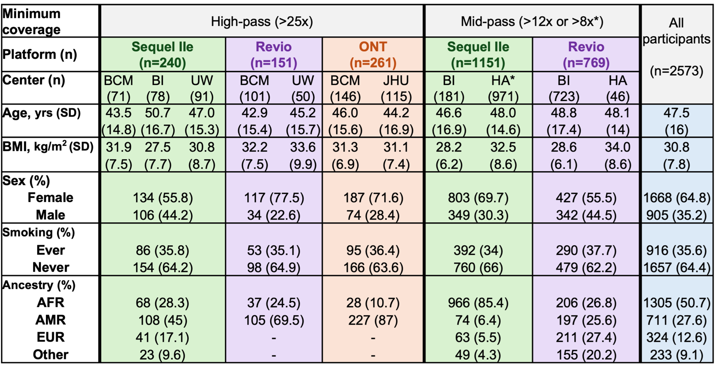
Table 1. Characteristics of All of Us participants included in csTL analysis using lrWGS data. Metrics in table are shown as mean (SD) or count (%). Participants' ancestry was based on ancestry prediction information provided by All of Us. To protect participant privacy and in accordance with All of Us data and statistics dissemination policy, ancestry groups with fewer than 20 individuals are not shown. Empty categories may include zero or low-count values. For reporting purposes, we combined counts of sex, smoking status and ancestry across centers that used the same sequencing platform and coverage threshold.

