Fig. S1. Correlation of Protein Abundance to Clinical Variables. (A) Scree plot showing percent explained variance (y-axis) in each principal component (x-axis). Seventy-five percent of explained variation is contained within the first 24 principal components. (B) Principal component Spearman clinical correlation plot shows significance of correlation of protein abundances to clinical variables. (C) Principal component Spearman $r^{2}$clinical correlation plot shows significance of correlation of protein abundances to clinical variables. Asterisks in cells for panels C and D represent clinical variables with significant correlation to proteomics data at given PC.
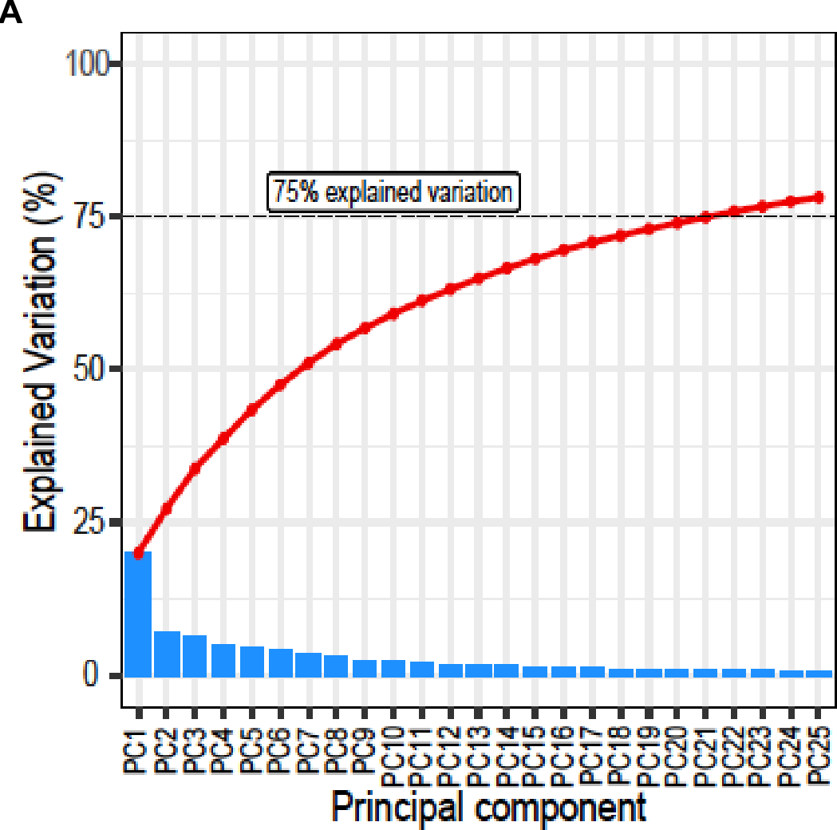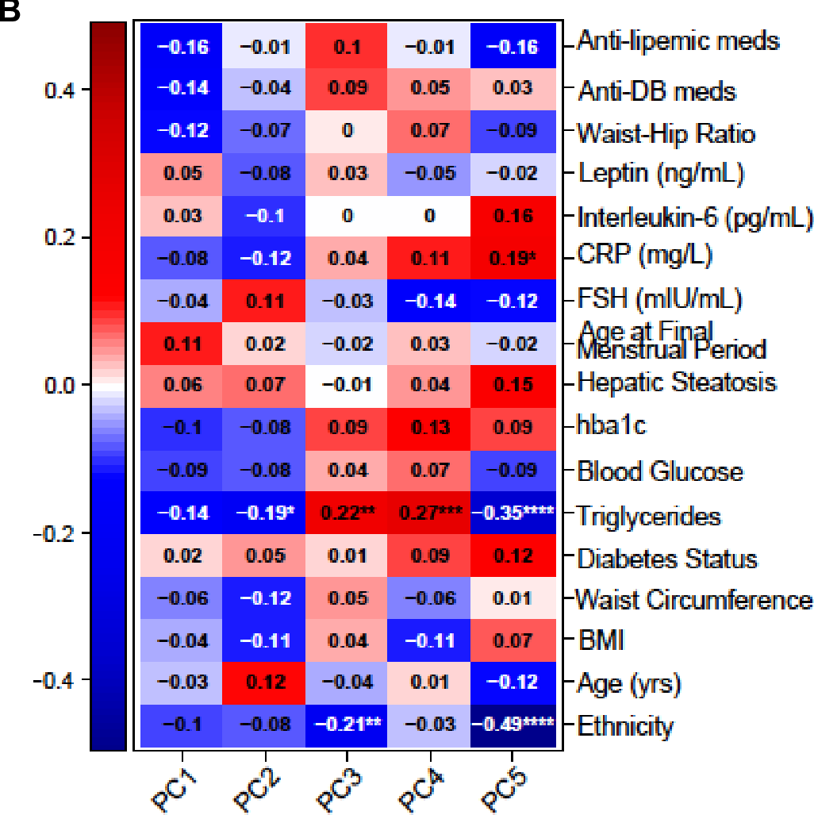
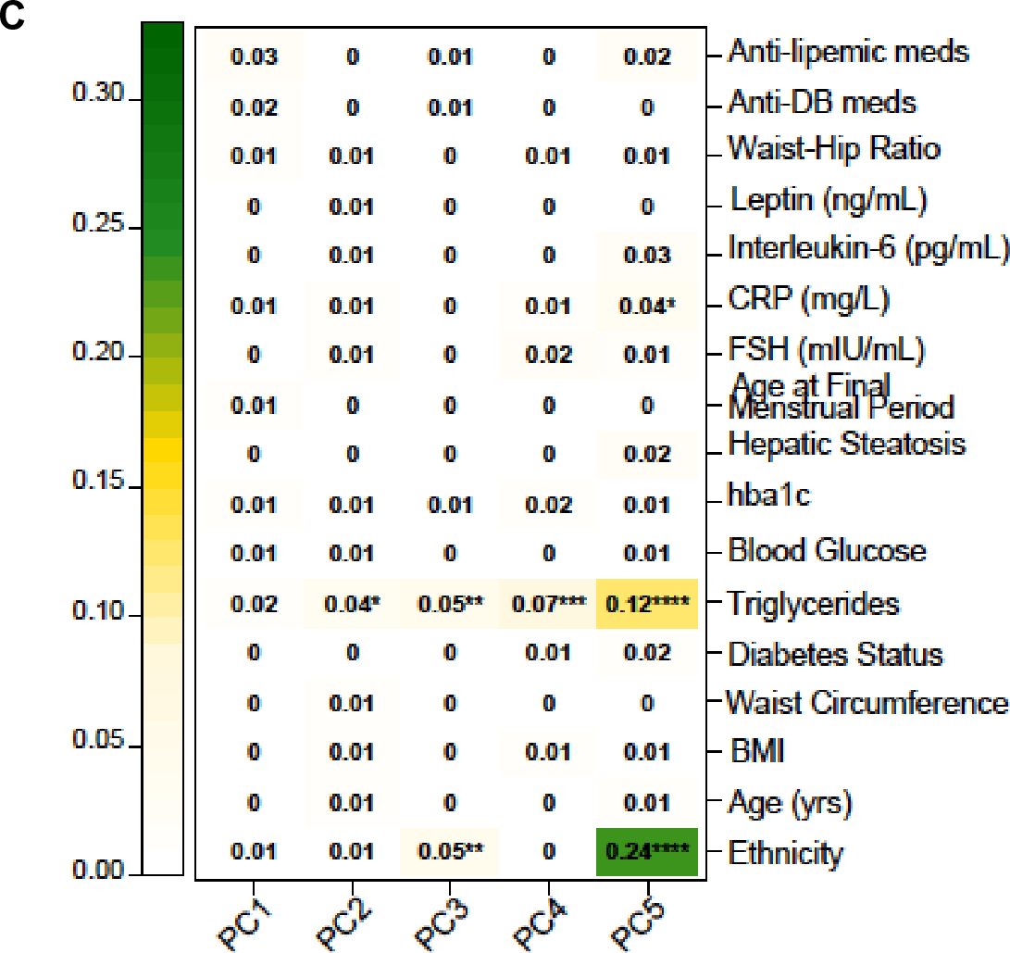
Table S1. Study cohort demographic information and clinical characteristics among women with hepatic steatosis, by diabetes status (N = 75):
Parameter | No Diabetes | Diabetes
N | 43 | 32
Age (y) | 59.84 ± 3.04 | 59.00 ± 2.64
Race n (%)
Black | 24 (55.81) | 14 (43.75)
White | 19 (44.19) | 18 (56.25)
BMI (kg/m²) | 36.50 ± 7.66 | 37.91 ± 7.58
WC (cm) | 106.30 ± 13.68 | 114.18 ± 10.98
TG (mg/dL) | 120.49 ± 72.53 | 198.59 ± 94.38
FG (mg/dL) | 98.12 ± 13.22 | 168.31 ± 103.27
HbA1c (%) | 5.76 ± 0.50 | 8.07 ± 2.03

