Supplementary materials 1. Short interval intracortical inhibition and the cortical silent period.
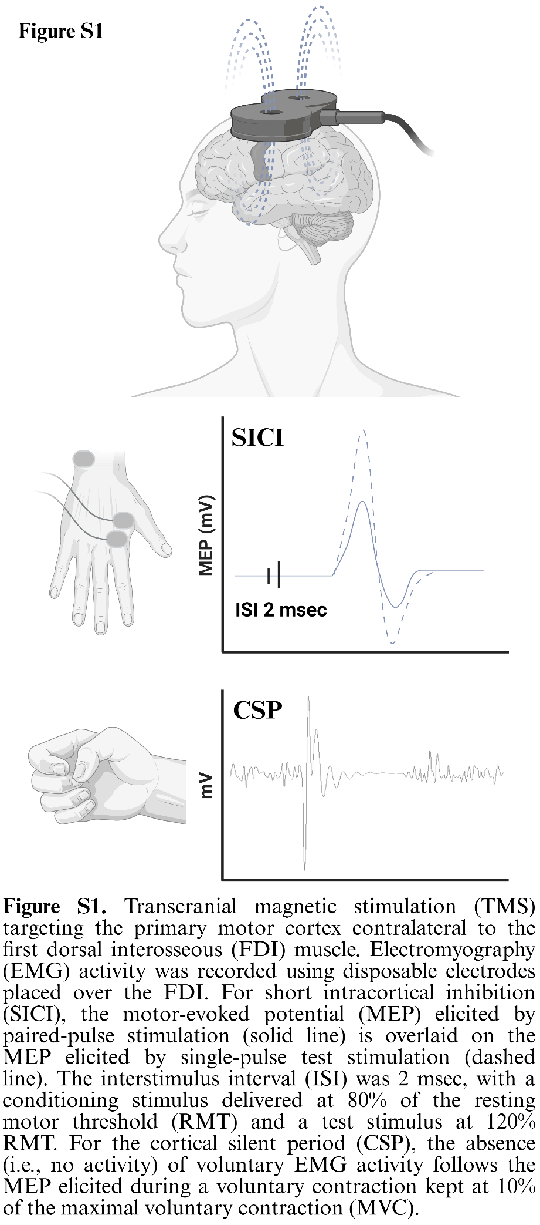
Short interval intracortical inhibition (SICI) is assessed with a paired-pulse protocol whereby a conditioning stimulus (e.g., 80% of the resting motor threshold - RMT) is followed by a suprathreshold conditioned stimulus (e.g., 120% RMT) delivered after, e.g., 2 msec (Figure S1). The motor-evoked potential (MEP; solid line) obtained during SICI is normalized (i.e., ratio) by the MEP elicited with a single-pulse unconditioned stimulus (120% RMT; dashed line), with values lower than one reflecting inhibition. SICI is though to be a cortical phenomenon primarily mediated by GABA_{A} receptors. While findings in Parkinson's disease (PD) are mixed, an abnormal reduction in SICI (i.e., lower inhibition) is a consistent alteration in those individuals, that tends to be restored by dopaminergic medications¹⁻⁷.
The cortical silent period (CSP) refers to a brief pause (i.e., no activity) in the electromyographic (EMG) activity measured during sustained voluntary muscle contraction (Figure S1). The CSP appears shortly after an MEP is elicited with a single magnetic stimulus. The ongoing muscle contraction is kept at a specific intensity calculated as a percentage of the maximal voluntary contraction (MVC). The CSP duration ranges from approximately 100 to 300 msec and reflects both spinal and cortical inhibitory processes. The early phase (~first 50 msec) is believed to involve spinal mechanisms, including recurrent inhibition via Renshaw cells and motoneuron after-hyperpolarization mediated by calcium-dependent potassium currents (i.e., intrinsic property). In contrast, the remaining portion is attributed to cortical inhibition mediated by GABA_{B} receptors, leading to reduced excitatory drive onto spinal α-motoneurons. While findings in PD are mixed, the CSP is often reported to be shortened in those individuals, with dopaminergic treatment partially restoring its duration¹⁻⁸.

Supplementary materials 2. Training volume, intensity and load.
Methods
Training volume/intensity was estimated using external and internal parameters. Specifically, external parameters included total training time, average training session duration, and total/average distance covered during the training program in kilometers (km). Internal parameters included the average heart rate (HR) and rate of perceived exertion (RPE) during the training session as well as the time spent in each training zone (i.e., 50% ≤ Z1 < 60% HRmax, 60% ≤ Z2 < 70% HRmax, 70% ≤ Z3 < 80% HRmax, 80% ≤ Z4 < 90% HRmax, 90% ≤ Z5 < 100% HRmax). Additionally, training loads (TLs) were estimated using validated formula using the RPE and HR⁹. The RPE-related TL was calculated as:
$$TL=\sum{RPE session\left(n\right)*Training Session Duration(n)}$$
n = training session 1, 2, …, 36.
For example, if a participant reported a RPE of 12 (scale 6–20) for a session lasting 45 minutes, the resulting TL was calculated as 12 × 45 = 540 arbitrary units (AU). We then calculated the overall TL (TL_{sum}) as the sum of the individual TLs from each training session.
Whereas the HR-related TLs were calculated using the Training Impulse (TRIMP) formulas as:
$$TRIMPavg=\sum{HR average\left(n\right)*\frac{Training Session Duration\left(n\right)}{60}}$$
n = training session 1, 2, …, 36.
and
$$TRIMPzone=\sum_{k=i}^{n}{Duration in HR zone*Zone Index(i)}$$
i: HR zone (i.e., Z1, Z2, Z3, Z4, and Z5).
Zone index(i): Z1 = 1, Z2 = 2, Z3 = 3, Z4 = 4, Z5 = 5.
For example, if a participant exercised at an average HR of 130 bpm for 45 minutes, the resulting TRIMP_{avg} is 97.5 AU. Whereas, if the same participant exercised for 45 minutes at an average HR of 130 bpm but spent 10 minutes in Z2 (60-70% HRmax), 20 minutes in Z3 (70-80% HRmax), and 15 minutes in Z4 (80-90% HRmax), the resulting TRIMP_{zone} is 140 AU.
Finally, given that a recent systematic review found that specific training volumes, calculated in metabolic equivalents per week (METs/week), are associated with motor improvements measured by the UPDRS Part III (motor examination)¹⁰, we also calculated METs/week. Specifically, METs were calculated using the Physical Activity Compendium[10] and, since HR data were collected during training sessions, METs were also estimated using a previously published formula that was developed and validated in a large cohort of 11,257 individuals, including participants with various diseases and those taking beta-blockers^{11, 12}. The formula uses an HR index and is calculated as follows:
$$METs=\left(6.10* \frac{HR avg}{HR rest}\right)-5.10$$
HR avg: average HR during training.
HR rest: resting HR.
It should be noted that HR data were collected for all participants during 97.0±4.1% of the overall training time. METs/week estimated using the HR index method were not significantly different (676.53±274.56 vs. 594.69±80.32; t-test, p = 0.229) and significantly associated (r = 0.627, p = 0.022) with METs/week values calculated using the Physical Activity Compendium, as conducted in a previous systematic review of exercise trials in PD¹⁰.

Results
Training-related variables are reported in Table S2.
Table S2. Training-related variables.
 | Mean | Std Dev | Min | Max
Sessions | 35.2 | 1.8 | 30.0 | 36.0
Total Training Time (h) | 24:51:39 | 1:43:38 | 21:36:07 | 27:05:23
HR average | 103.1 | 18.7 | 79.0 | 142.0
HR average training | 106.8 | 20.4 | 81.0 | 150.0
Avg %HR max | 77.5 | 5.6 | 62.5 | 84.7
METs/week (HR index method) | 676.5 | 274.6 | 336.3 | 1126.7
METs/weekly (PA method) | 594.7 | 80.3 | 495.7 | 742.2
Time spent in Z1 (%) | 5.7 | 10.8 | 0.0 | 39.4
Time spent in Z2 (%) | 12.0 | 8.9 | 0.9 | 33.2
Time spent in Z3 (%) | 31.2 | 11.5 | 11.4 | 51.3
Time spent in Z4 (%) | 38.1 | 15.0 | 10.0 | 63.3
Time spent in Z5 (%) | 9.9 | 5.6 | 1.6 | 17.7
Polar - Total time recorded (%) | 96.9 | 4.1 | 89.9 | 100.0
Steps per session (average) | 3919.8 | 446.5 | 3021.0 | 4564.0
Km per session (average) | 3.5 | 0.4 | 2.7 | 4.4
Total km | 120.7 | 17.0 | 88.1 | 152.2
TL [AU] per session | 546.0 | 95.8 | 409.2 | 725.0
TRIMP_{zone} average | 138.7 | 21.8 | 83.8 | 176.5
TRIMP_{ave} average | 71.7 | 13.9 | 50.9 | 99.2
Footnotes: Avg %HR max = Percentage of the HR average during training relative to the HR max achieved during the CPET test at T0; HR average = HR average during the training session, including war-up and cool-down; HR average training = HR average during training excluding warm-up and cool-down.

Supplementary material 3. Sleep architecture of the participants tested with a different system.
The pre-post changes in macro sleep architecture of the four participants that were tested with a different polysomnography system are reported in Table S3. Overall, the changes in macro sleep architecture align with the changes observed in the whole sample, particularly for N3 (min and percentage), SE_{TIB} and SE_{TSP}.
Table S3. Sleep architecture
 | T0 (baseline) |  |  | T1 (post-training)
 | N | Mean | SD | N | Mean | SD
TIB (min) | 4 | 468.88 | 21.23 | 4 | 429.00 | 53.90
SOL (min) | 4 | 17.88 | 15.46 | 4 | 13.63 | 9.79
TSP (min) | 4 | 435.50 | 36.67 | 4 | 404.63 | 45.78
TST (min) | 4 | 349.88 | 66.31 | 4 | 344.25 | 53.92
SE_{TIB} (TIB - %) | 4 | 74.28 | 11.43 | 4 | 80.18 | 5.22
SE_{TSP} (TSP - %) | 4 | 79.90 | 10.18 | 4 | 84.83 | 4.59
WASO (min) | 4 | 85.63 | 38.48 | 4 | 60.38 | 17.02
N1 (min) | 4 | 27.63 | 19.77 | 4 | 14.63 | 3.61
N2 (min) | 4 | 222.63 | 76.09 | 4 | 221.63 | 83.08
N3 (min) | 4 | 34.00 | 39.79 | 4 | 54.50 | 55.61
R (min) | 4 | 65.63 | 13.14 | 4 | 53.50 | 19.92
N1 (%) | 4 | 7.68 | 4.65 | 4 | 4.23 | 0.44
N2 (%) | 4 | 63.45 | 15.06 | 4 | 63.15 | 14.61
N3 (%) | 4 | 9.73 | 11.69 | 4 | 17.15 | 17.59
R (%) | 4 | 19.15 | 4.21 | 4 | 15.50 | 5.63
Footnotes: N = non-rapid eye movement sleep (NREM) sleep stage 1, 2, and 3; R = rapid eye movement sleep stage; SD = standard deviation; SE = sleep efficiency; SOL = sleep onset latency; TIB = time in bed; TSP = total sleep period; TST = total sleep time; WASO = wake after sleep onset.

Supplementary materials 4. NREM sleep oscillations.
NREM sleep oscillations variables:
- Slow wave density during artifact-free N2/N3 stages (i.e., count/min)
- Slow wave peak-to-peak amplitude (µV) during artifact-free N2/N3 stages
- Slow wave slope (µV/s) from min to max during artifact-free N2/N3 stages
- Slow wave frequency (Hz) during artifact-free N2/N3 stages

- Sleep spindles density (count/min) during artifact-free N2/N3 stages
- Sleep spindles amplitude (µV) during artifact-free N2/N3 stages
- Sleep spindles frequency (Hz) during artifact-free N2/N3 stages

Figure S4. Sleep slow wave (left) and spindles (right) characteristics.
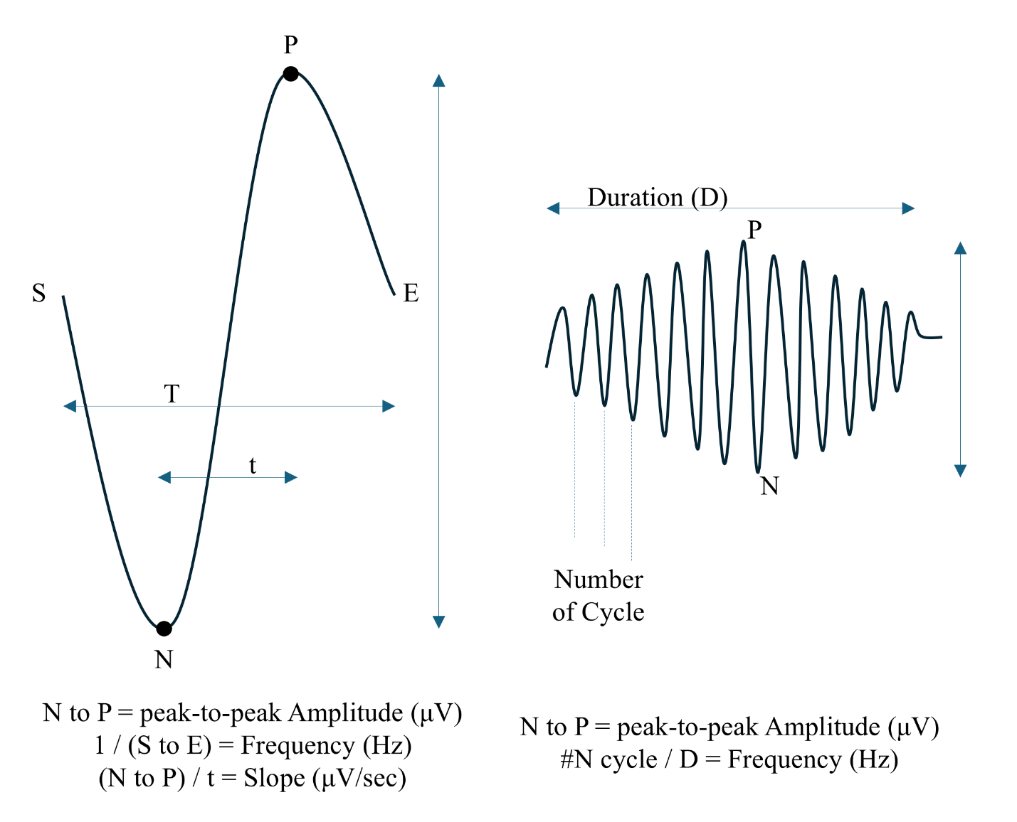

Supplementary material 5. Hypnodensity-related variables.
Supplementary Methods
Sleep ambiguity represents the proportion of epochs (%) during which the probability of the sleep stage with higher probability (MAX) is ≤ 95%, calculated as:
$$=\frac{\sum{(p\left(i\right)MAX ≤ 0.95)}}{Total N. of Epoch}$$
A lower sleep ambiguity (%) value indicates lower sleep ambiguity, with 0% indicating no ambiguity.
Mean sleep ambiguity is calculated for each epoch (i.e., i) using sleep stage with higher probability (MAX) as:
$$=μ100*(1-p(i)MAX)$$
It indexes the average (i.e., μ) percentage of the ambiguity across all epochs, with 0% indicating no ambiguity (p = 1).
While sleep ambiguity provides the proportion of unstable epochs (%) by dichotomizing stable vs. unstable epochs, mean sleep ambiguity captures the (average) percentage of ambiguity.
Sleep continuity is calculated from two adjacent epochs of the same class (i.e., NREM) as:
$$=μ[100*(1-abs(p(i)MAX - p(i+1)MAX)]$$
It indexes the probability that two consecutive sleep epochs belong to the same class (i.e., NREM), with values closer/equal to 100% indicating perfect continuity and no fragmentation.
Stable sleep is calculated for two consecutive NREM epochs as:
$$=\frac{\sum{[(p(i)N2 + p(i)N3 > 0.95)∧\left(p\left(i+1\right)N2 + p\left(i+1\right)N3>0.95\right)∧(Both epochs∈NREM)]}}{Total N. of Epoch pairs}$$
A higher index indicates that deep, restorative (N2+N3) NREM sleep is stable across NREM sleep epochs, with 100% reflecting perfect stability. This index assumes that N1 represents the lightest and most unstable sleep stage, N3 reflects the deepest and most stable NREM sleep stage, and N2 lies between the two.
Sleep depth is a weighted average calculated for NREM sleep epochs as:
$$=μ[100*\frac{(p(i)N1 + 2*p(i)N2 + 4*p(i)N3)}{4}]$$
A higher value reflects greater sleep depth, assuming that N1 represents the lightest sleep stage, N3 reflects the deepest NREM sleep stage, and N2 lies between the two.
Supplementary Results
Pre-post changes are reported in Table S5.
Table S5. Baseline and post-training changes in NREM hypnodensity-related parameters.
 | T0 (baseline) |  |  | T1 (post-training)
 | N | Mean | SD | N | Mean | SD
NREM Ambiguity (%) | 13 | 35.21 | 18.45 | 13 | 28.72 | 14.39
NREM Ambiguity Average (%) | 13 | 26.55 | 5.88 | 13 | 25.65 | 5.40
*NREM Stable sleep (%) | 13 | 28.72 | 12.96 | 13 | 36.04 | 10.60
NREM Continuity (%) | 13 | 92.56 | 1.44 | 13 | 92.49 | 1.34
NREM Depth Average (%) | 13 | 57.29 | 7.88 | 13 | 59.26 | 7.24
Footnotes: * = significant change at follow-up (T1); NREM = non-rapid eye movement sleep.
Additionally, NREM stable sleep was significantly associated with disease duration at T0 (adjR² = 0.24, β = -0.30, 95%CI = -0.34, -0.00, p = 0.048; age, p = 0.867).
Figure S5. NREM stable sleep and disease duration.
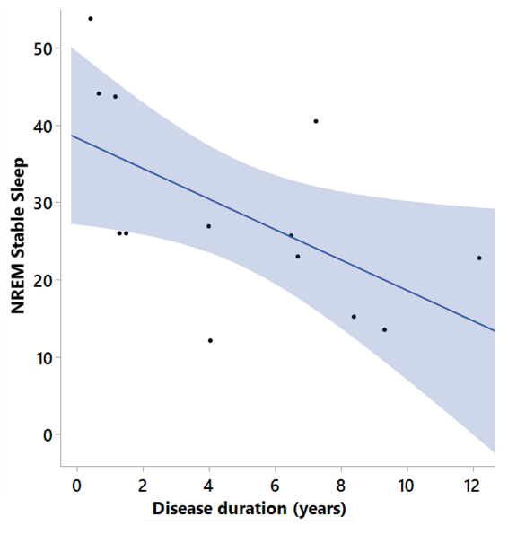
Supplementary Discussion
Arguably, the hypnodensity-derived variables might be sensitive to treatment effects, as well as useful for monitoring disease progression¹³⁻¹⁶ in PD. They might also be valid markers to characterize different PD subtypes¹⁷ and/or distinguishing Parkinsonian syndromes¹⁸. Future larger longitudinal RCTs or available datasets can be leveraged to expand our preliminary results.
Supplementary materials 6. Resting excitability and SICI.
Resting excitability was assessed using a single-pulse transcranial magnetic stimulation (TMS) protocol, with 30 magnetic pulses delivered every five seconds at 120% of the resting motor threshold during rest¹⁹. The motor-evoked potential (MEP) amplitude during the resting excitability protocol was quantified by averaging the peak-to-peak amplitude of each MEP²⁰.
In Figure S6 are reported the pre-post changes in SICI including points indicating each participant.
Figure S6. SICI.
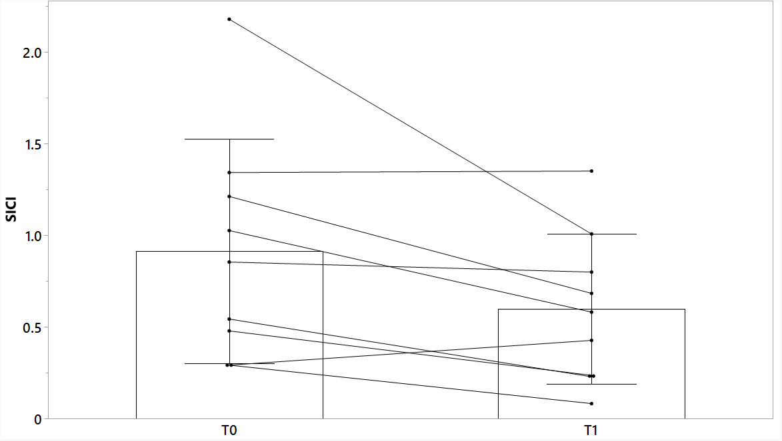
Supplementary materials 7. Baseline characteristics of all included participants.
Variable | N | Mean ± SD
Age (years) | 15 | 66.02 ± 9.04
Education (years) | 15 | 15.13 ± 2.90
Disease duration (years) | 15 | 5.37 ± 3.77
LEDD (mg) | 15 | 736.33 ± 551.28
V̇O_{2peak} (ml*kg⁻¹*min⁻¹) | 15 | 26.34 ± 9.36
PPO (Watts) | 15 | 132.33 ± 59.46
HR max | 15 | 130.67 ± 26.69
PASIPD | 15 | 15.60 ± 9.88
HADS | 15 | 11.93 ± 5.26
BDI-II | 15 | 10.70 ± 6.80
MDS-UPDRS III | 15 | 20.00 ± 6.04
Rigidity | 15 | 2.93 ± 1.71
Tremor | 15 | 1.60 ± 1.99
Bradykinesia | 15 | 13.33 ± 6.23
Axial | 15 | 2.13 ± 1.41
SCOPA-Cog | 15 | 27.07 ± 5.52
PD Fatigue | 15 | 2.81 ± 1.01
PDSS-2 | 15 | 17.53 ± 7.97
PDSS-MS at night | 15 | 5.00 ± 2.90
PDSS-PDs at night | 15 | 3.13 ± 3.07
PDSS-Disturbed sleep | 15 | 9.40 ± 5.10

Supplementary materials 8. Potential predictors of V̇O₂_{peak} changes.
The time spent in specific training zones was the only training-related variable that was significantly associated with V̇O₂_{peak} changes (ΔV̇O₂_{peak}). Specifically, ΔV̇O₂_{peak} was positively correlated with time spent in Z5 (90-100% HRmax; r = 0.559; p = 0.047) and a negatively correlated with time spent in Z3 (70-80% HRmax; r = -0.659; p = 0.014)²¹. Notably, the time spent in these training zones was not correlated with age, disease duration, LEDD, baseline V̇O₂_{peak}, and baseline MDS-UPDRS-III scores. Additionally, the time (i.e., minutes and percentage) spent in Z5 and Z3 were not significantly associated (time: r = -0.268, p = 0.377; percentage: r = -0303, p = 0.314), ruling out a possible time-opportunity cost. This finding suggests that, in our small PD cohort (i.e., early disease stages), baseline fitness level, age, and disease severity may not have affected the ability to achieve more vigorous training intensities required to maximize the benefits of exercise²¹⁻²⁵. However, it is important to stress that training loads and clinical improvements in Parkinson’s disease likely follow an inverted U-shaped relationship¹⁰. This knowledge underscores the need for long-term (e.g., years), individualized programs with adaptive progression strategies aligned with evolving clinical goals.
References
1. Ammann C, Dileone M, Pagge C, et al. Cortical disinhibition in Parkinson’s disease. Brain 2020; 143: 3408-3421. DOI: 10.1093/brain/awaa274.
2. Cantello R, Tarletti R and Civardi C. Transcranial magnetic stimulation and Parkinson’s disease. Brain research reviews 2002; 38: 309-327.
3. Hallett M. Transcranial magnetic stimulation: a primer. Neuron 2007; 55: 187-199. DOI: 10.1016/j.neuron.2007.06.026.
4. Lefaucheur J-P. Motor cortex dysfunction revealed by cortical excitability studies in Parkinson's disease: influence of antiparkinsonian treatment and cortical stimulation. Clinical Neurophysiology 2005; 116: 244-253. DOI: https://doi.org/10.1016/j.clinph.2004.11.017.
5. Rossini PM, Burke D, Chen R, et al. Non-invasive electrical and magnetic stimulation of the brain, spinal cord, roots and peripheral nerves: Basic principles and procedures for routine clinical and research application. An updated report from an I.F.C.N. Committee. Clinical neurophysiology : official journal of the International Federation of Clinical Neurophysiology 2015; 126: 1071-1107. 2015/03/24. DOI: 10.1016/j.clinph.2015.02.001.
6. Taube W and Lauber B. Changes in the cortical GABAergic inhibitory system with ageing and ageing-related neurodegenerative diseases. The Journal of Physiology 2024; n/a. DOI: https://doi.org/10.1113/JP285656.
7. Latorre A, Rocchi L, Berardelli A, et al. The interindividual variability of transcranial magnetic stimulation effects: Implications for diagnostic use in movement disorders. Mov Disord 2019; 34: 936-949. 20190610. DOI: 10.1002/mds.27736.
8. Hupfeld K, Swanson C, Fling B, et al. TMS-induced silent periods: A review of methods and call for consistency. J Neurosci Methods 2020; 346: 108950.
9. Borresen J and Lambert MI. The quantification of training load, the training response and the effect on performance. Sports medicine 2009; 39: 779-795.
10. Wang J, Yuan Y, Xie T, et al. Optimal dose and type of exercise to improve motor symptoms in adults with Parkinson's disease: A network meta-analysis. Journal of Science and Medicine in Sport 2025. DOI: https://doi.org/10.1016/j.jsams.2025.01.003.
11. Franklin BA, Brinks J, Berra K, et al. Using Metabolic Equivalents in Clinical Practice. The American Journal of Cardiology 2018; 121: 382-387. DOI: https://doi.org/10.1016/j.amjcard.2017.10.033.
12. Wicks JR, Oldridge NB, Nielsen LK, et al. HR index--a simple method for the prediction of oxygen uptake. Medicine and science in sports and exercise 2011; 43: 2005-2012. DOI: 10.1249/mss.0b013e318217276e.
13. Dijkstra F, de Volder I, Viaene M, et al. Polysomnographic predictors of sleep, motor, and cognitive dysfunction progression in parkinson’s disease. Current Neurology and Neuroscience Reports 2022; 22: 657-674.
14. Latreille V, Carrier J, Lafortune M, et al. Sleep spindles in Parkinson's disease may predict the development of dementia. Neurobiol Aging 2015; 36: 1083-1090. 2014/12/03. DOI: 10.1016/j.neurobiolaging.2014.09.009.
15. Schreiner SJ, Imbach LL, Werth E, et al. Slow-wave sleep and motor progression in Parkinson disease. Ann Neurol 2019; 85: 765-770. 2019/03/20. DOI: 10.1002/ana.25459.
16. Zahed H, Zuzuarregui JRP, Gilron Re, et al. The Neurophysiology of Sleep in Parkinson's Disease. Movement Disorders 2021; 36: 1526-1542. DOI: https://doi.org/10.1002/mds.28562.
17. Fereshtehnejad S-M, Romenets SR, Anang JBM, et al. New Clinical Subtypes of Parkinson Disease and Their Longitudinal Progression: A Prospective Cohort Comparison With Other Phenotypes. JAMA Neurology 2015; 72: 863-873. DOI: 10.1001/jamaneurol.2015.0703.
18. Briel N, Marti C, Werth E, et al. Sleep Phenotypes of α-Synucleinopathies and Tauopathies with Parkinsonism. 2025.
19. Rossini PM, Burke D, Chen R, et al. Non-invasive electrical and magnetic stimulation of the brain, spinal cord, roots and peripheral nerves: Basic principles and procedures for routine clinical and research application. An updated report from an I.F.C.N. Committee. Clinical Neurophysiology 2015; 126: 1071-1107. DOI: https://doi.org/10.1016/j.clinph.2015.02.001.
20. Nepveu JF, Thiel A, Tang A, et al. A Single Bout of High-Intensity Interval Training Improves Motor Skill Retention in Individuals With Stroke. Neurorehabil Neural Repair 2017; 31: 726-735. 20170708. DOI: 10.1177/1545968317718269.
21. Garber CE, Blissmer B, Deschenes MR, et al. American College of Sports Medicine position stand. Quantity and quality of exercise for developing and maintaining cardiorespiratory, musculoskeletal, and neuromotor fitness in apparently healthy adults: guidance for prescribing exercise. Med Sci Sports Exerc 2011; 43: 1334-1359. 2011/06/23. DOI: 10.1249/MSS.0b013e318213fefb.
22. Cristini J, Weiss M, De Las Heras B, et al. The effects of exercise on sleep quality in persons with Parkinson’s Disease: a systematic review with meta-analysis. Sleep Med Rev 2021; 55. DOI: https://doi.org/10.1016/j.smrv.2020.101384.
23. de Laat B, Hoye J, Stanley G, et al. Intense exercise increases dopamine transporter and neuromelanin concentrations in the substantia nigra in Parkinson’s disease. npj Parkinson's Disease 2024; 10: 34. DOI: 10.1038/s41531-024-00641-1.
24. Johansson ME, Cameron IGM, Van der Kolk NM, et al. Aerobic Exercise Alters Brain Function and Structure in Parkinson's Disease: A Randomized Controlled Trial. Ann Neurol 2022; 91: 203-216. DOI: https://doi.org/10.1002/ana.26291.
25. Kelly NA, Ford MP, Standaert DG, et al. Novel, high-intensity exercise prescription improves muscle mass, mitochondrial function, and physical capacity in individuals with Parkinson's disease. J Appl Physiol (1985) 2014; 116: 582-592. 2014/01/11. DOI: 10.1152/japplphysiol.01277.2013.

