Supplementary Data

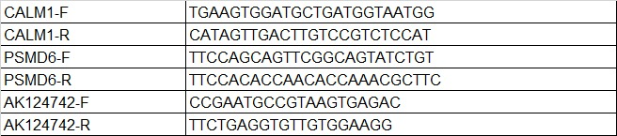
List of primer sequences used for RT-PCR analysis in this study. F: Forward primer. R: reverse primer.

Correlation of fertilization percentage with sperm parameters.
Parameter | correlation coefficient | P-value
count | +0.039 | Ns
morphology | +0.337 | p < 0.001

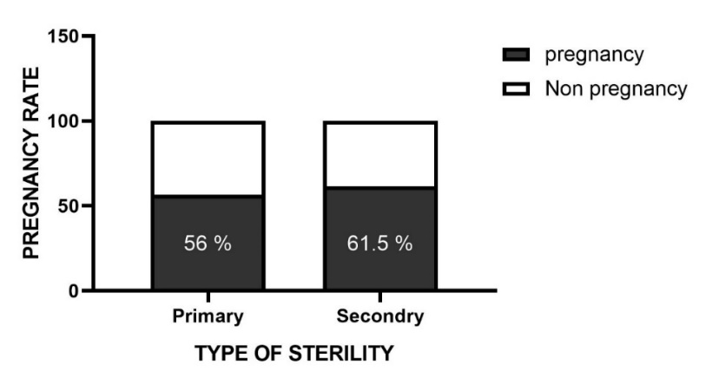
Comparison of chemical fertility percentage in cases with primary infertility compared with cases with secondary infertility (p =0.747).

Comparison of the expression of genes studied in each blood group. The mean expression of PSMD6 gene in AB blood group was significantly higher than other groups and this difference was significant (p <0.05).

