Supplementary

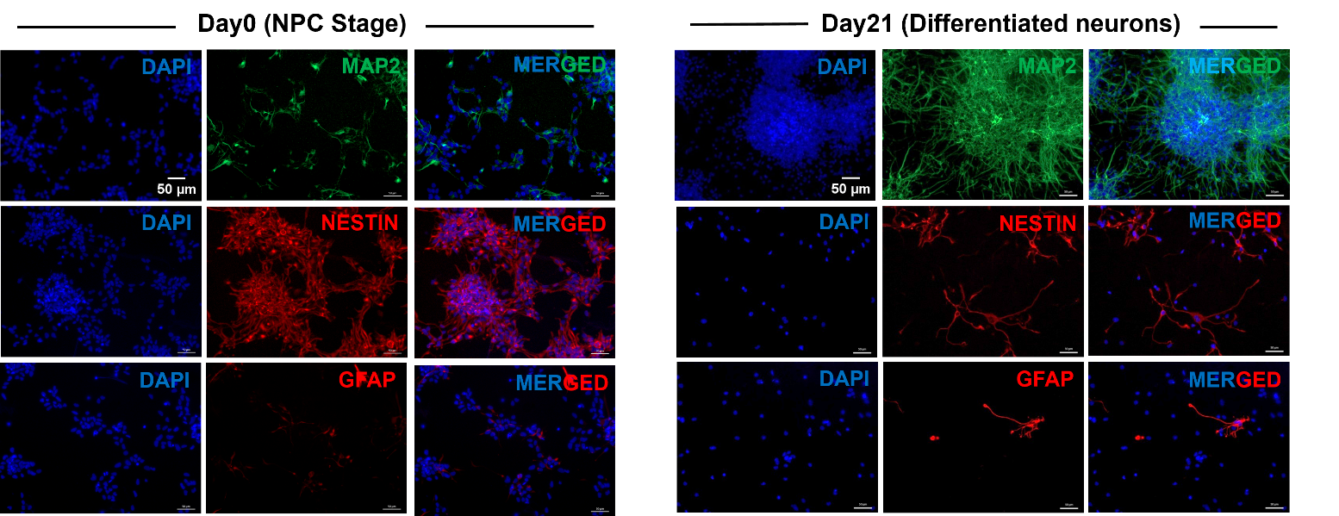

Figure S1 Fluorescence microscope images showing neuronal markers, MAP2, nestin, and astrocytic marker, GFAP in neural progenitor cells before (left panel) and after (right panel) neuronal differentiation. Scale bar, 50µm.

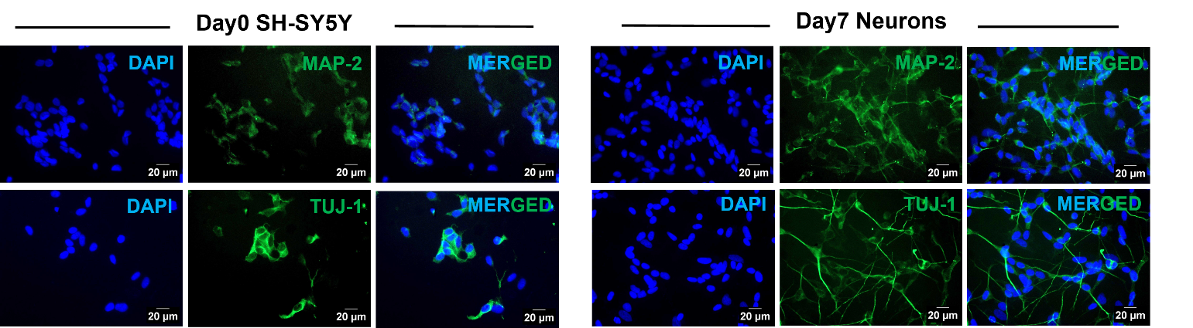

Figure S2 Fluorescence microscope images showing neuronal markers MAP2 and TUJ1 in SHSY-5Y cells before (left panel), and after (right panel) differentiation. Scale bar, 20µm.
.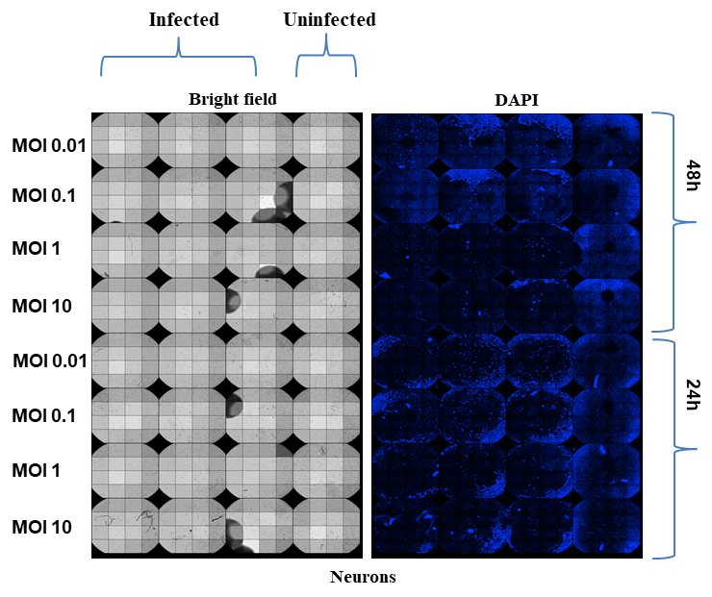

Figure S3 Microscopy images showing cell death with DAPI staining, at different MOI and time points, post SARS-CoV-2 infection in 96 well plate.

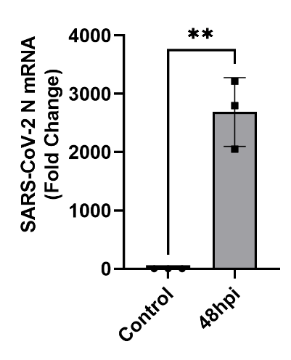
A B

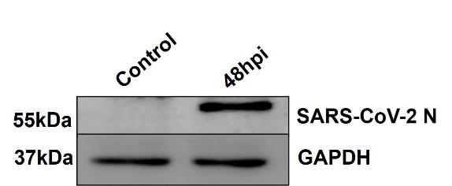

Figure S4 A) Bar graph shows relative mRNA expression of SARS-CoV-2 nucleocapsid (N) and B) Representative western blot image shows the expression of SARS-CoV-2 N protein in infected neurons. GAPDH was used as a loading control.

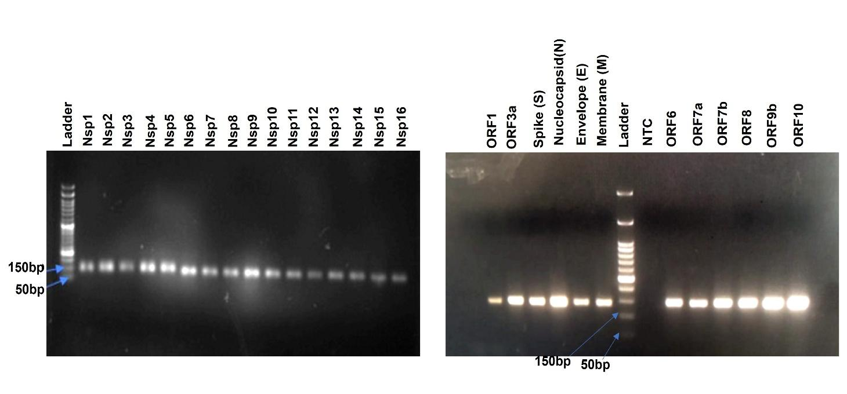

Figure S5 Representative agarose gel picture showing the PCR amplicons of respective SARS-CoV-2 genes in mRNA extracted from transduced HEK293T cells. NTC represents non-target control.

A

B

Figure S6 Representative FACS density plots showing AnnexinV/PI staining. A) Top panel shows density plots for unstained (leftmost), untreated stained with only AnnexinV (middle) and rotenone treated, AnnexinV stained (rightmost) cells. Bottom panel shows density plots for unstained (leftmost), untreated, stained with only PI (middle), and H₂O₂ treated, PI stained (rightmost) cells. B) Representative density plots showing AnnexinV/PI staining in indicated viral protein expressing cells. Vector refers to the empty vector control.

A
Splash RNA (shRNA sequence for MTCH1 knockdown)
Sense Antisense

1. 5’-GACTATCATATGCTTACCGTAACTTGAAAGTATTTCGATTTCTTGGCTTTATATATCTTGTGGAAAGGACGAAACACCGGCTTCCCTGAAGAAAGTTGTGAACTCGAGTTCACAACTTTCTTCAGGGAAGTTTTTGAATTCTCGACC-3’

2. 5’-GACTATCATATGCTTACCGTAACTTGAAAGTATTTCGATTTCTTGGCTTTATATATCTTGTGGAAAGGACGAAACACCGGCTGGGATTCTTCGTTGGATTAACTCGAGTTAATCCAACGAAGAATCCCAGTTTTTGAATTCTCGACC-3’
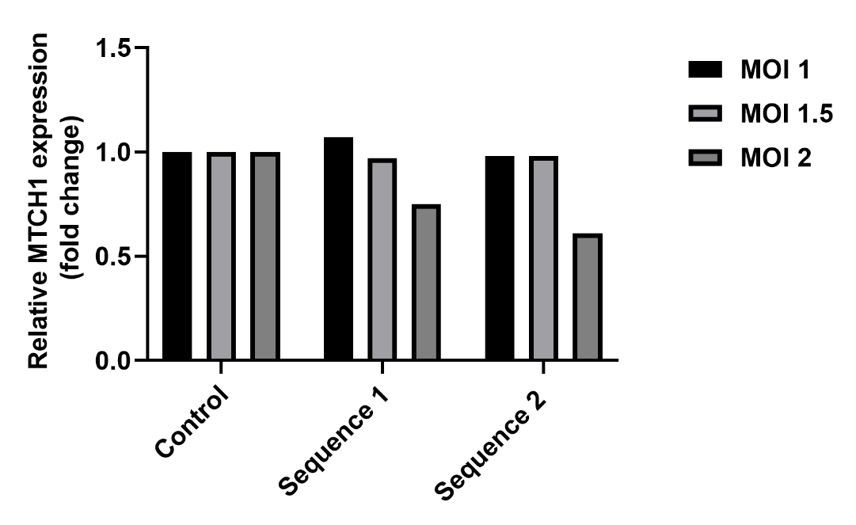
B

Figure S7 MTCH1 shRNA sequences used to target MTCH1 and its effect on MTCH1 mRNA expression at different MOIs. A) Nucleotide sequence of the shRNA construct used to target MTCH1. The sense and antisense strands are shown, including the loop sequence, designed according to the standard shRNA construction protocol. Yellow and red highlighted sequence shows restriction sites for NdeI and EcoRI B) Bar graph shows relative MTCH1 expression 48hrs following transduction with the indicated shRNA at varying multiplicities of infection. GAPDH was used as a housekeeping control.

Table 1: List of primers for RT-qPCR

Gene | Forward Primer (5’-3’) | Reverse Primer (5’-3’)
MLKL | AGAGCTCCAGTGGCCATAAA | TACGCAGGATGTTGGGAGAT
RIPK3 | GACTCCCGGCTTAGAAGGACT | CTGCTCTTGAGCTGAGACAGG
Caspase3 | TGTTTGTGTGCTTCTGAGCC | CACGCCATGTCATCATCAAC
LC3BII | GAGAAGCAGCTTCCTGTTCTGG | GTGTCCGTTCACCAACAGGAAG
Caspase1 | GCCTGTTCCTGTGATGTGGAG | TGCCCACAGACATTCATACAGTTTC
MTCH1 | TACGTGAAGCTGCTCATCCA | CTTGGCGTAGGTGAAGAAGC

Table 2: List of antibodies for western blotting

Antibody | Company | Catalog number
pMLKL | Cell Signalling Technology | 91689
pRIPK3 | Cell Signalling Technology | 93654
Cleaved Caspase 3 | Cell Signalling Technology | 9661
Cleaved Caspase 1 | Cell Signalling Technology | 4199
LC3BII | Sigma | L7543
MTCH1 | Abcam | ab230006
Anti-strepII | Abcam | ab184224
β-actin | Sigma | A3854
Gapdh | Santa Cruz | sc-32233
MAP2 | Abcam | ab11268
Nestin | Millipore Sigma | AB5922
GFAP | Dako | Z0334

Table 3: List of SARS-CoV-2 plasmids

Gene | Without Insert(bp) | With Insert(bp)
Orf3a | 8825 | 9738
Orf3b | 8825 | 9078
Orf6 | 8825 | 9096
E | 8825 | 9138
N | 8825 | 10170
Orf7a | 8825 | 9276
Orf7b | 8825 | 9036
Orf8 | 8825 | 9276
Orf9b | 8825 | 9204
Orf9c | 8825 | 9126
Nsp1 | 8825 | 9453
Nsp2 | 8825 | 10830
Nsp5 | 8825 | 9834
Nsp7 | 8825 | 9165
Nsp8 | 8825 | 9510
Nsp9 | 8825 | 9255
Nsp10 | 8825 | 9333
Nsp11 | 8825 | 8955
Nsp12 | 8825 | 11712
Nsp13 | 8825 | 10719
Nsp14 | 8825 | 10491
Nsp15 | 8825 | 9954
Empty | 8825 | 8825

