Shifting Beyond Classical Drug Synergy in Combinatorial Therapy through Solubility Alterations
Elham Gholizadeh^{1,ϕ}; Ehsan Zangene^{1,ϕ}; Uladzislau Vadadokhau¹; Danilo Ritz²; Juho J. Miettinen³; Rabah Soliymani¹; Marc Baumann¹; Mathias Wilhelm⁴; Esko Kankuri⁵; Paul A. Haynes⁶; Caroline A. Heckman³; Amir A. Saei ^{7,ϙ} and Mohieddin Jafari^{1,ϙ,}*
(1) Department of Biochemistry and Developmental Biology, Faculty of Medicine, University of Helsinki, Helsinki, Finland.
(2) Biozentrum, University of Basel, Basel, Switzerland.
(3) Institute for Molecular Medicine Finland (FIMM), Helsinki Institute of Life Science, iCAN Digital Cancer Medicine Flagship, University of Helsinki, Helsinki, Finland.
(4) Technical University of Munich, Munich, Germany.
(5) Department of Pharmacology, Faculty of Medicine, University of Helsinki, Helsinki, Finland
(6) School of Natural Sciences, Macquarie University, North Ryde, New South Wales 2109, Australia
(7) Department of Microbiology, Tumor and Cell Biology, Karolinska Institutet, Stockholm, Sweden.
ϕ These authors contributed as co-first authors.
^{ϙ} These authors contributed as co-last authors.
* Corresponding author:
Mohieddin Jafari,
mohieddin.jafari@helsinki.fi

Figures
Figure 1. Upset plot showing AML gene overlaps across CoPISA treatment conditions. 3
Figure 2. Bubble plots from PEIMAN2 enrichment for all treatment comparisons in living cells 4
Figure 3. Protein targets of therapy and their PTM status in cell lysates 5

Figure 1. Upset plot showing AML gene overlaps across CoPISA treatment conditions. Rows denote treatments; bar plots indicate the number of genes perturbed per treatment. Connected dots represent intersections between treatments, while bar heights above indicate intersection sizes. Colors map to individual treatments for visual clarity. This visualization highlights shared and unique AML gene responses, providing insights into convergent and divergent mechanisms of action.

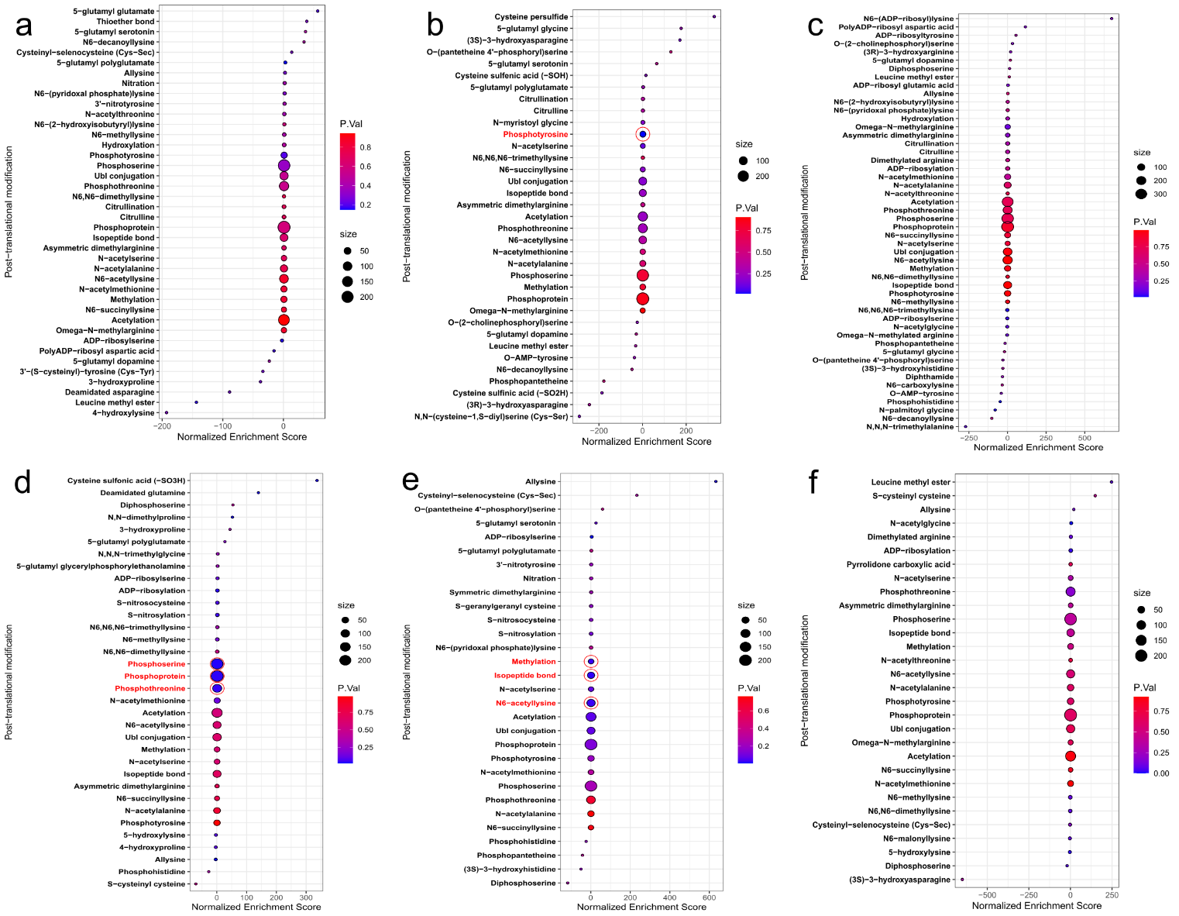
Figure 2. Bubble plots from PEIMAN2 enrichment for all treatment comparisons in living cells: (a) treatment with drug L; (b) treatment with drug S; (c) treatment with combination LS; (d) treatment with drug R; (e) treatment with drug U; (f) treatment with combination RU. The red circles with PTM highlighted in red denote the selected PTMs for the refined MaxQuant search.

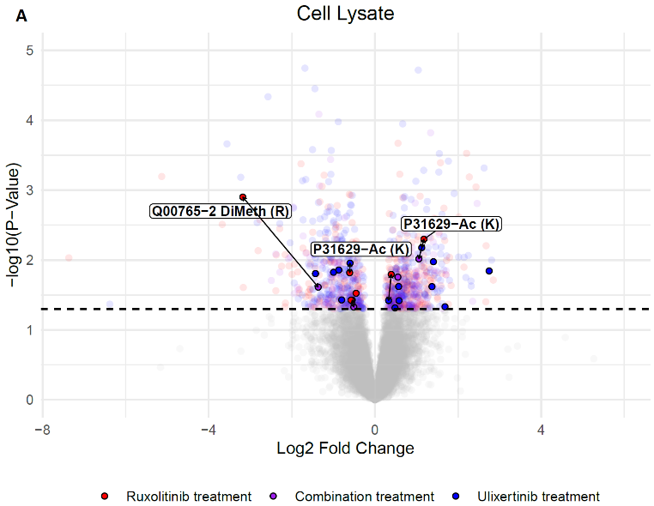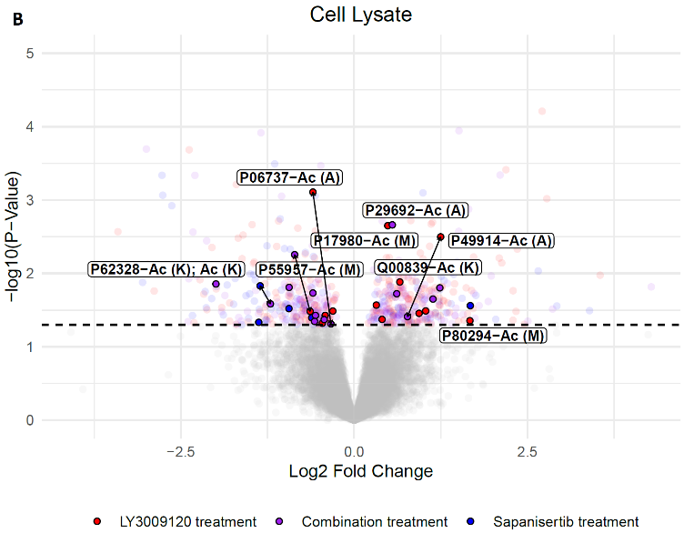
Figure 3. Protein targets of therapy and their PTM status in cell lysates treated with (a) ruxolitinib (3 μM) (red), ulixertinib (3 μM) (blue), and their combination, RU (purple); and (b) LY3009120 (red), sapanisertib (500 nM) (blue), and their combination, LS (purple). Highlighted points indicate proteins with PTM(s) identified in mass spectrometry data. The PTM(s) name and the site of modification are listed after the protein identifier through a hyphen. PTMs listed through commas were identified on the same peptide. Arrows indicate solubility change in the same protein from different treatments. P(Y)-tyrosine phosphorylation, P(T)-threonine phosphorylation, P(S)-serine phosphorylation, and Ac(K)-lysine acetylation.

