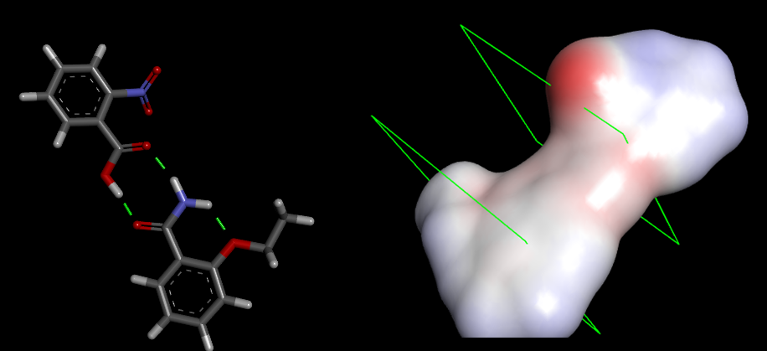

- Lowest conformation with the angle, N3-C4-C5-C6
- Partition coefficient value suggests that EA-NBA has pharmaceutics behaviour
- RMSD values show the simulation’s relative stability

