Cocrystals of ethenzamide with 2-nitrobenzoic acid - Conformational analysis, MD simulations and DFT investigations
Y.Sheena Mary^{a*}, Y.Shyma Maryª, Razieh Razavi^{b}

ªThushara, Neethinagar-64, Kollam, Kerala, India
^{b} Department of Chemistry, Faculty of Science, University of Jiroft, Jiroft, Iran

*Author for correspondence: email: marysheena2018@rediffmail.com

Fig.S1 PES curves and conformations
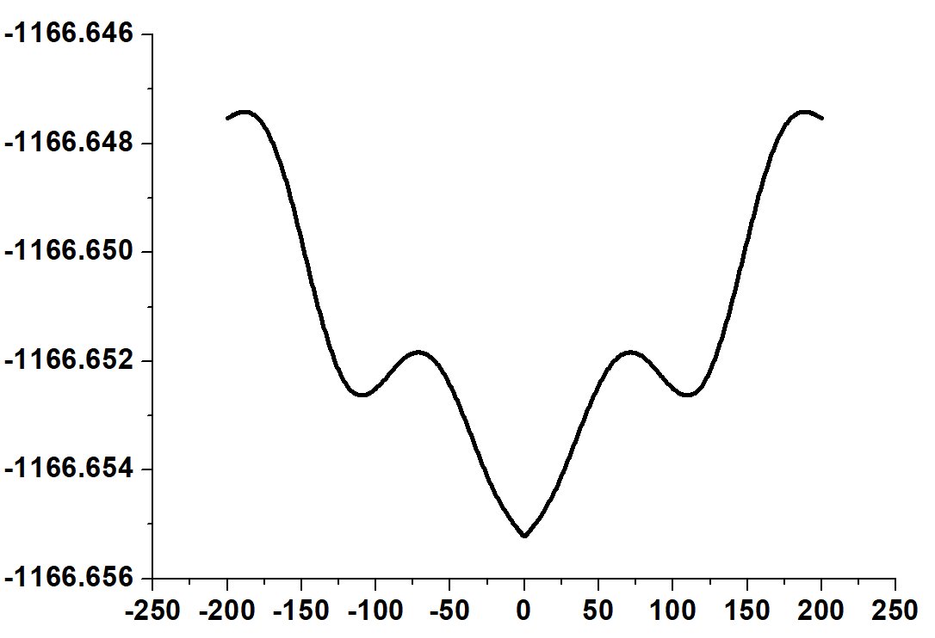 | 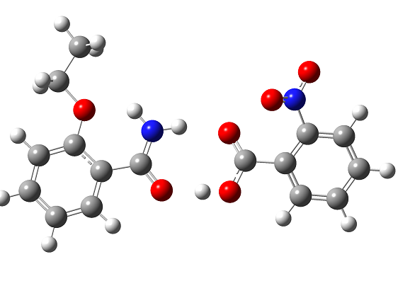
τ(1) C6-O2-C8-C12
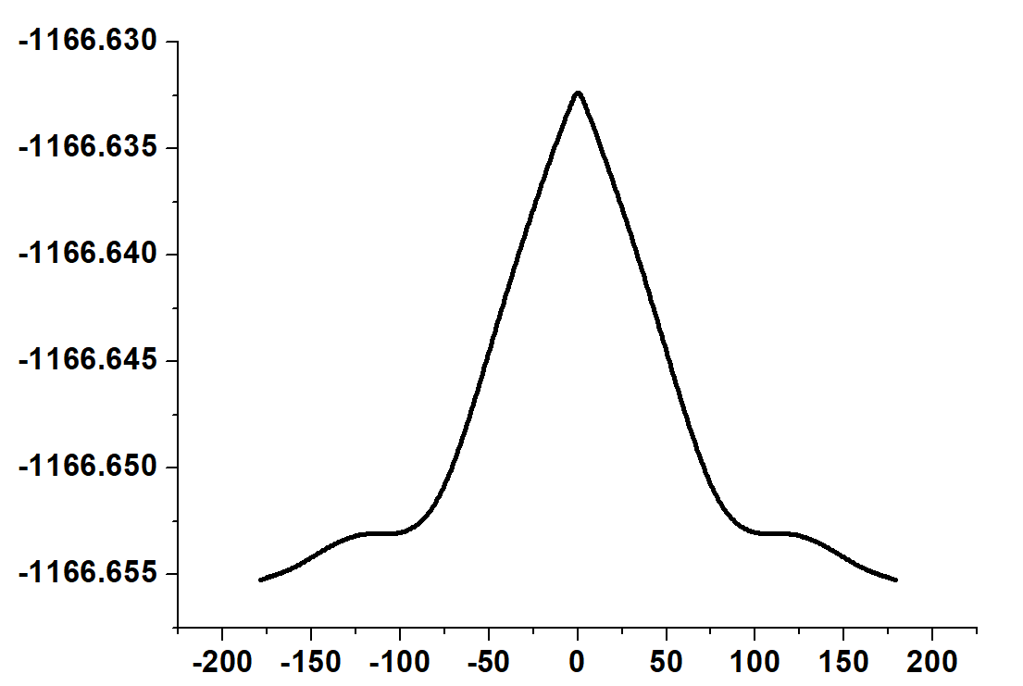 | 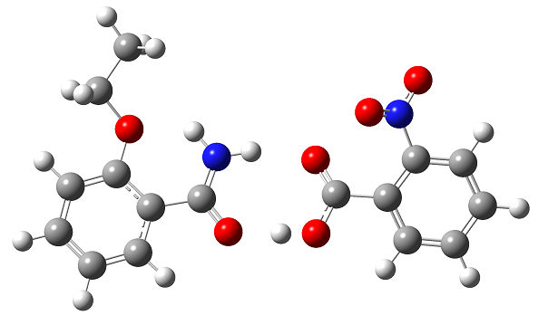
τ(2) C8-O2-C6-C5
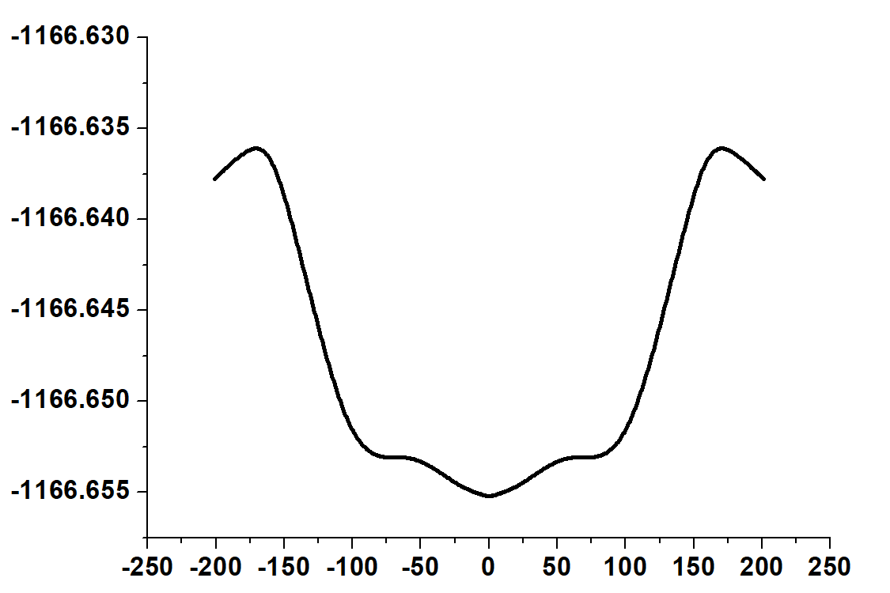 | 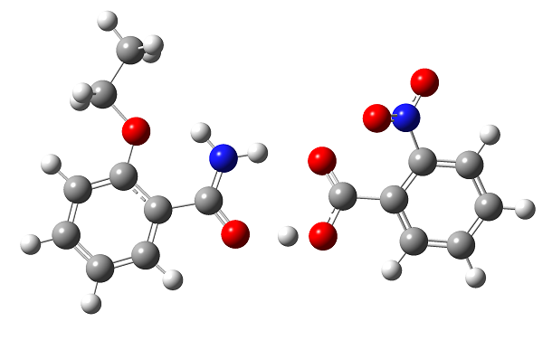
τ(3) C8-O2-C6-C10
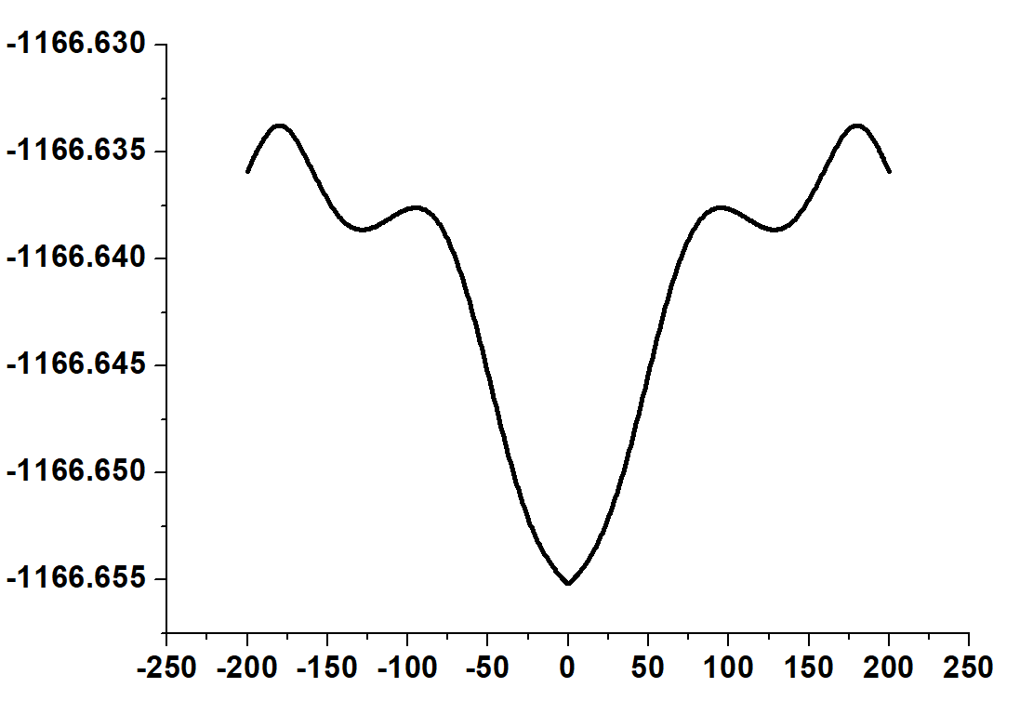 | 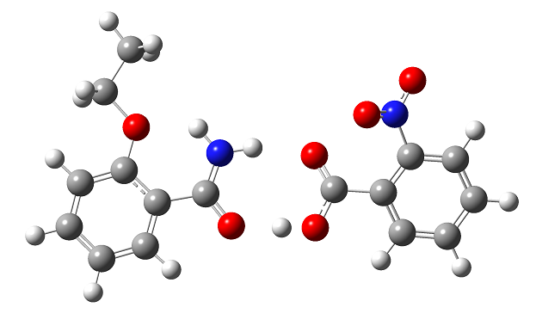
τ(4) N3-C4-C5-C7
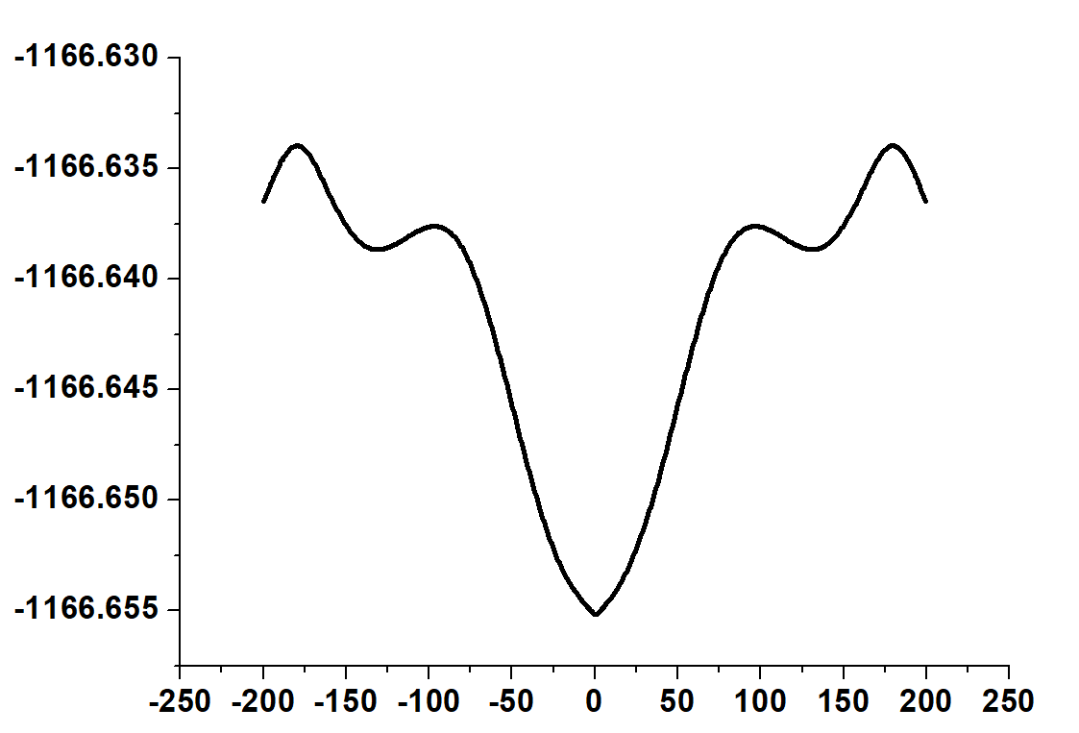 | 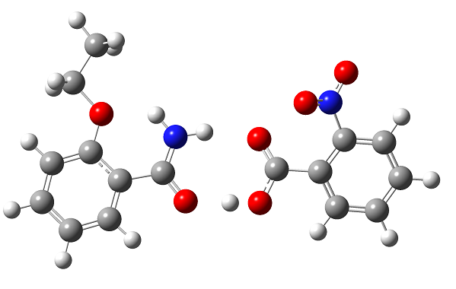
τ(5)N3-C4-C5-C6

Fig.S2 Correlation graphs (a) bond lengths (b) bond angles
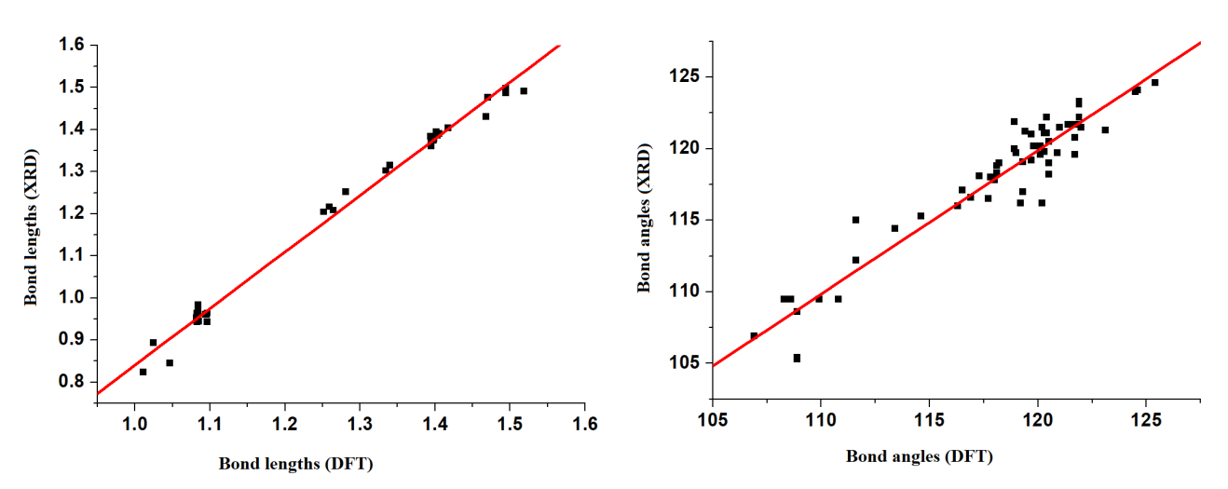

Fig.S3 Theoretical UV spectrum of EA-NBA
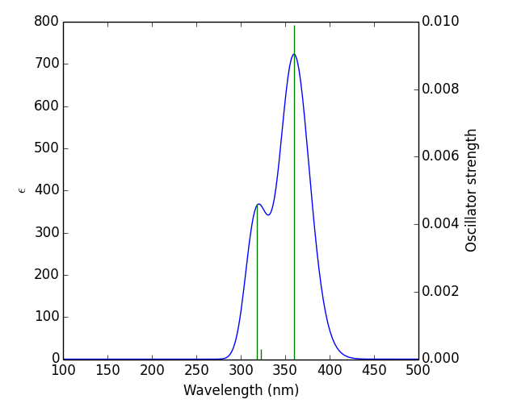

Fig.S4 Surface of the cocrystal, EA-NBA
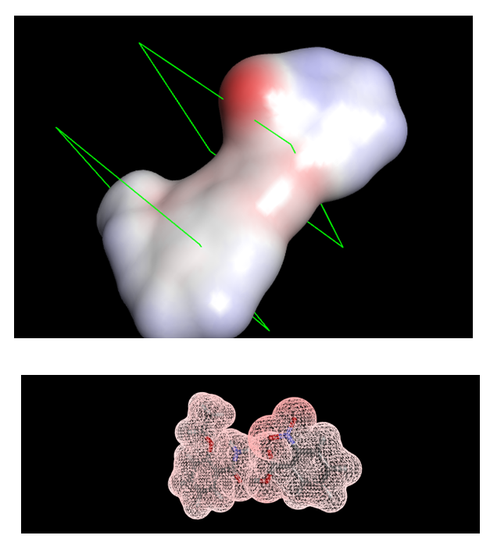

Fig.S5 Intermolecular and H-bond interaction of EA-NBA
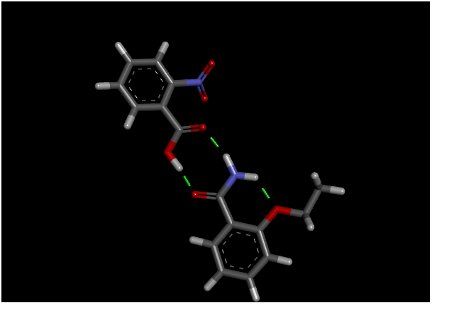
Fig.S6 ESP map of EA-NBA
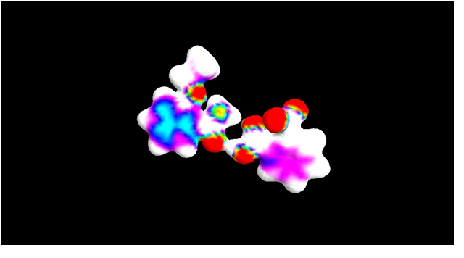

Fig.S7 Critical points of EA-NBA
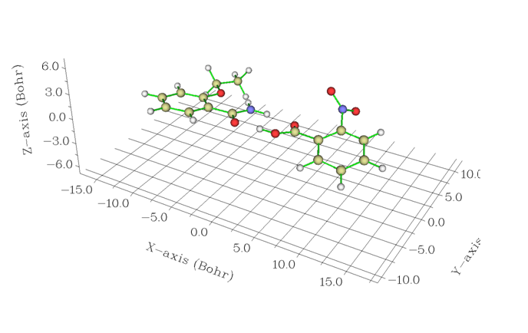

Fig.S8 Some molecular properties in EA-NBA
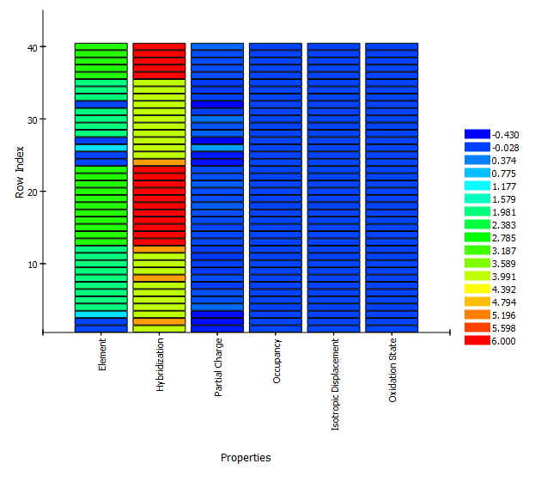

Fig.S9 Amino acid interactions in EA-NBA with (a) 2ABZ (b) 5JCL (c) 3SDP (d) 2V7B

(a)2ABZ
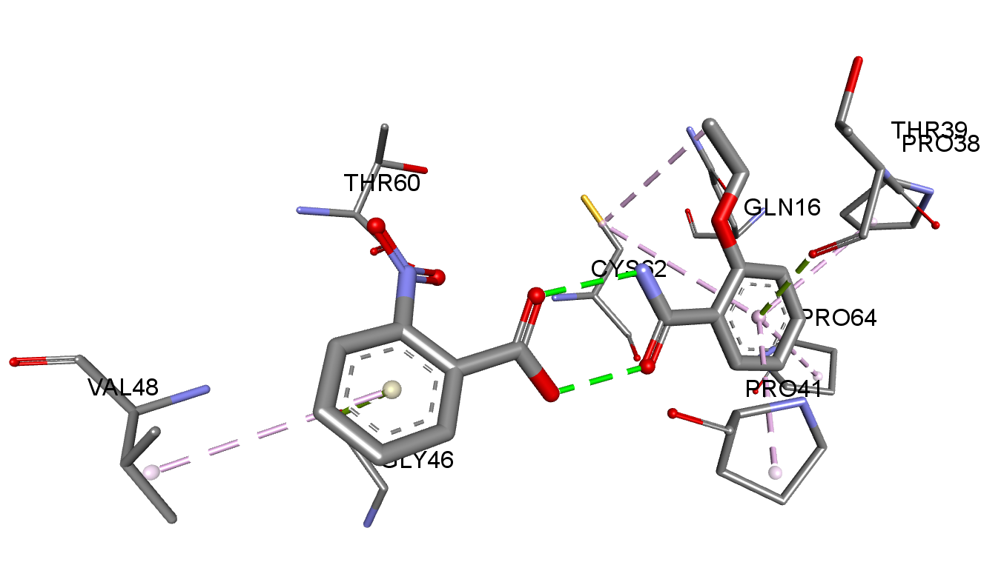
(b)5JCL
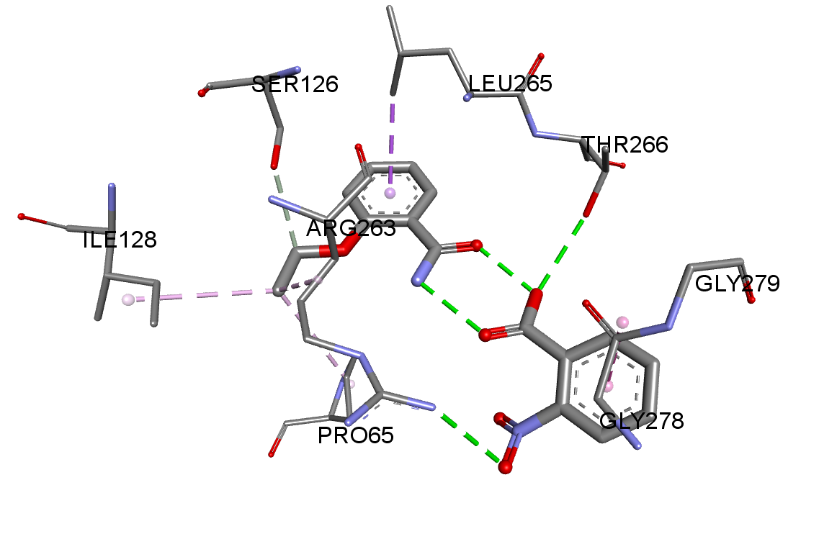
©3SDP
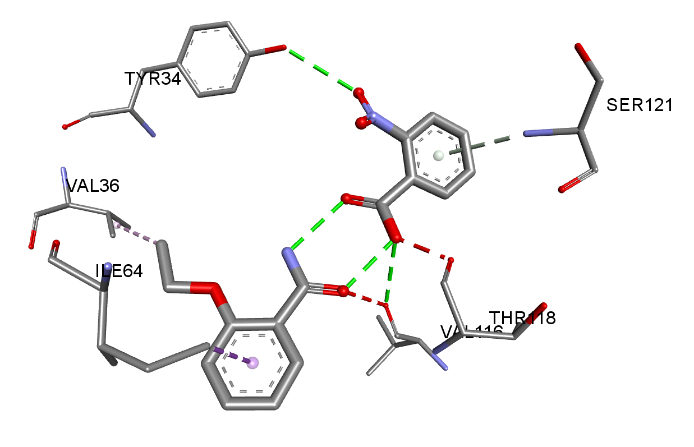
(d)2V7B
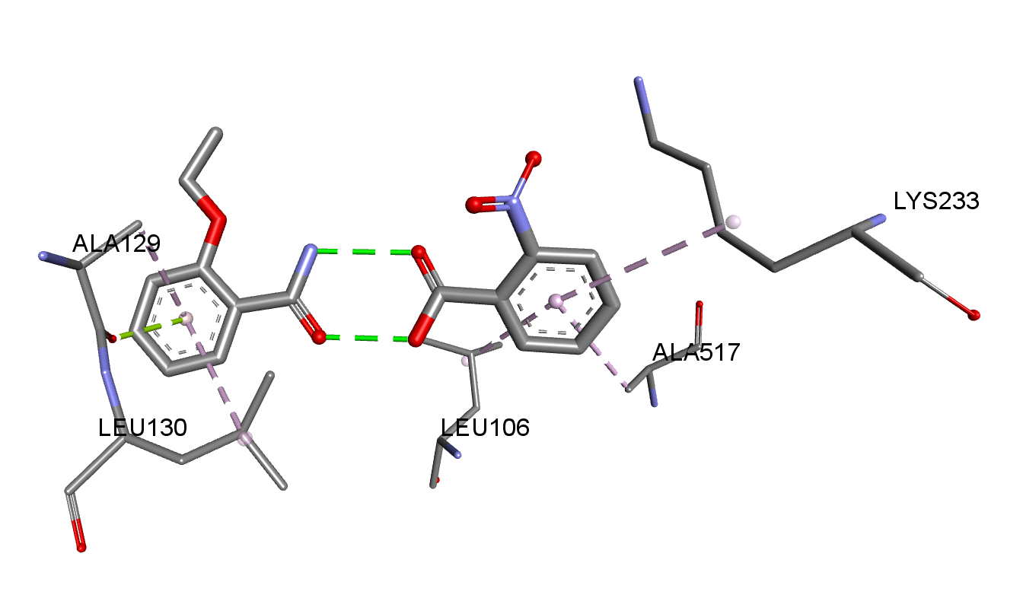

Fig.S10 (a) 100th nano second snapshot of protein-lignd complex (b) Residue wise interactions of ligand with target protein
(a)
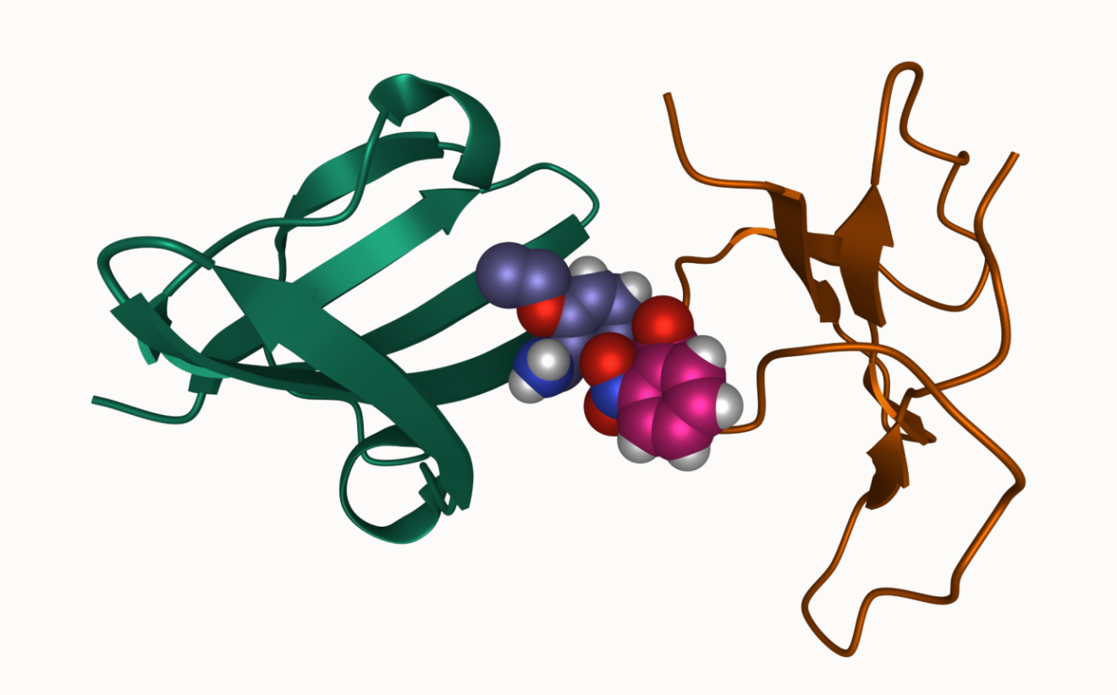

(b1)

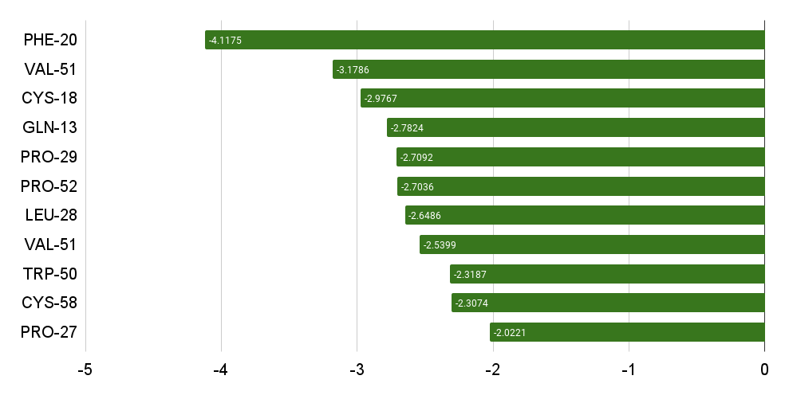
(b2)
