Supplemental data
Supplemental Note: Case Reports
Individual 1
Individual 1 was a 5-year-old Japanese boy born to non-consanguineous parents as the third child. He was delivered spontaneously at 41 weeks of gestation without asphyxia. The patient had no family history of neurological disorders. He showed facial dysmorphisms, including a mildly prominent forehead, flat nasal bridge, and telecanthus. His psychomotor development was severely delayed: sitting at one year and six months of age and cruising around furniture at three years and six months of age. He could not walk independently or speak meaningful words at five years of age. He showed autistic features such as an imbalanced diet. The patient underwent surgery for strabismus, cryptorchidism, and spina bifida occlusion. Brain magnetic resonance imaging (MRI) analysis revealed abnormal signals in the front lateral ventricles and lateral horns at three years and four months of age (Figure 1B). Metabolic diagnostics of peripheral blood samples measured by gas chromatography and mass spectrometry showed a mild elevation in C26:0/C22:0 and a decrease in docosahexaenoic acid and plasmalogen levels [1]. At the latest examination at five years of age, he showed short stature, severe intellectual disability, and hypotonia. The hemizygous de novo c.269A>G, p.(Asp90Gly) variant was identified using trio-based exome sequencing (trio-ES).

Individual 2
Individual 2 was a 6-year-old Canadian male born to Irish and First Nations parents who were non-consanguineous. He is the mother's third child and father's second child. Pregnancy was complicated by gestational diabetes. Prenatal ultrasound showed thickened nuchal translucency (4 mm) at 12 + 1 weeks of gestation, and intrauterine growth restriction with shortened long bones was observed at 20 weeks. He was born at 38 weeks of gestation via induced vaginal delivery with a birth weight of 3515 g. No neonatal complications occurred. He was diagnosed with global developmental delay and hypotonia at approximately two years of age and with autism spectrum disorder at four years of age. He walked without support at the age of 18 months, and first words emerged at the age of approximately 2.5 years. At six years of age, he was speaking short (2-3 word) phrases and developmentally functioned at the level of a 2–3-year-old child. He developed afebrile generalized tonic-clonic seizures at the age of two years. These were well-controlled with optimal doses of levetiracetam. Brain MRI was performed after his first seizure, which showed normal results apart from the abnormal signal intensity of the right temporal lobe and insular cortex (likely due to post-seizure edema). The patient also experienced occasional myoclonic jerks. Other medical issues included chronic constipation, obstructive sleep apnea, mild short stature (height tracking between the 1st and 10th percentiles for age), and type 1 laryngeal cleft. Radiography revealed minor skeletal anomalies (short mid-phalanx of the fifth finger and first metacarpal). On examination at six years of age, his height was 113.4 cm (Z = -1.19), weight was 27.4 kg (Z = 1.56), and head circumference was 53.7 cm (Z = 1.27). His head circumference increased from the 50th to the 90th percentile over the past few years. The neck was short and broad. Hair was curly, blond, and sparse at the temples. He had sparse arched eyebrows, prominent epicanthal folds, malar hypoplasia, a wide nasal bridge and tip, and a short chin (Figure 1A). The ears were normal in shape and set with fleshy lobes; there was a left pretragal skin tag. The hands had short nails and persistent fetal pads, and the feet had broad first toes. Patchy hyperpigmentation was observed on the abdomen and left lower limb. The patient had generalized mild hypotonia with normal reflexes and strength.
Previous genetic testing included normal chromosomal microarray, fragile X and Angelman syndrome testing, and karyotyping of skin fibroblast DNA (to rule out Pallister–Killian syndrome). The hemizygous de novo c.190A>G, p.(Lys64Glu) variant was identified using trio-ES.

Individual 3
Individual 3 is a now 33-year-old male, the third child of non-consanguineous parents from Dutch ancestry. He was referred to our clinic because of autism and a (mild to moderate) intellectual disability. Pregnancy and delivery were uneventful. He was born at 38 weeks gestational age. His birth length was 49 cm (-0.2 standard deviation [SD]) and birth weight 3290 g (+0.2 SD). Shortly after birth he had mild feeding problems. At the age of three months a bilateral inguinal hernia was corrected. At the age of 5.5 years he was diagnosed with autism. At childhood age absence seizure were suspected but electroencephalograms (EEGs) showed no abnormalities. From the age of 17 years onwards he is suffering from tonic-clonic seizures. Despite anti-epileptic treatment, he still has low frequent seizures. Brain MRI was normal. In general, he is social, communicative, cooperative and friendly. During periods he can be aggressive and he is sensitive to changes in his surroundings. Sometimes he has sleeping problems. He has short stature, his height is -3 SD, while his target height is -1 SD. At child age his weight for height was below the mean, but he gained weight, possibly related to his medication and his weight for height is now +3.4 SD. His head circumference is normal. Physical examination showed a mild downslant of palpebral fissures, high arched palate, short philtrum and low-set ears.
Several genetic investigations have been done since he was a child. Karyotyping in blood and fibroblasts, FISH analysis to exclude Williams syndrome, Pallister Killian syndrome and 22q11 deletion syndrome, DNA analysis of the FMR1, PTPN11 and SLC6A8 gene and array analysis did not show any abnormalities.

Individual 4
Individual 4 was the first child of an unrelated parent of German ancestry. The pregnancy was unremarkable until growth retardation was noted in the fourth month. Delivery was initiated at 42 weeks of gestation. His birth length was 44 cm (-3.9 SD), birth weight 2560 g (-2.6 SD), and head circumference 31 cm (-3.7 SD). APGAR scores were 9/10/10. He had feeding problems after birth and frequent respiratory infections during the first months of life. The inguinal hernia was surgically corrected at three months of age. At the age of 1.5 years, he had a generalized tonic-clonic seizure during a febrile infection. Sleep EEG showed mild global dysfunction with bilateral sleep spindles of 3-4 seconds. Globally, psychomotor development was delayed. Free sitting was possible at 12 months, and free walking was possible for two years and three months. Owing to narrow external auditory canals and recurrent middle ear infections, he underwent tympanostomy tube drainage. Brain MRI at the age of 1.5 years showed evidence of supratentorial dilation of the perivascular space. Comprehensive metabolic diagnostics, including amino acids in the cerebrospinal fluid (CSF) and plasma, transferrin electrophoresis (CDG diagnostics), very-long-chain fatty acids, neurotransmitters in the CSF, acylcarnitine profile, organic acids, oligosaccharides, purines/pyrimidines, and glucosaminoglycans in the urine, showed unremarkable results. Genetic diagnostics (karyotyping, array CGH, fragile X syndrome test, and single-exome sequencing in 2018) showed unremarkable results. An ophthalmological examination revealed myopia. Hearing test showed no abnormalities.
During the last clinical examination at the age of seven years, the boy showed a profound developmental disorder. At this age, he had no active speech, produced sounds, or responded reliably. He communicated using pictograms and signs. He walked freely. The patient exhibited behavioral problems, especially hetero- and autoaggressive behavior, low frustration tolerance, and reduced pain sensitivity. He often bit objects to regulate his emotions. Parents reported a strong reaction to glitter and bright objects. He had not yet been trained to use toilets. Melatonin was administered to treat severe sleep problems. So far, he has had approximately 10 febrile seizures with a similar course: generalized tonic-clonic seizures lasting approximately 20 s. Follow-up EEG was not possible because of the child's lack of cooperation. The patient was recently diagnosed with a gallstone. At the last clinical examination, he presented with short stature (-3.2 SD) and microcephaly (-4 SD). Furthermore, facial dysmorphic signs were observed, including a broad nasal root and tip, telecanthus, and a fleshy earlobe. The hemizygous de novo c.204G>C, p.(Glu34Gly*19) variant was identified using trio-based whole-genome sequencing.
Supplemental Figures
FIGURE S1
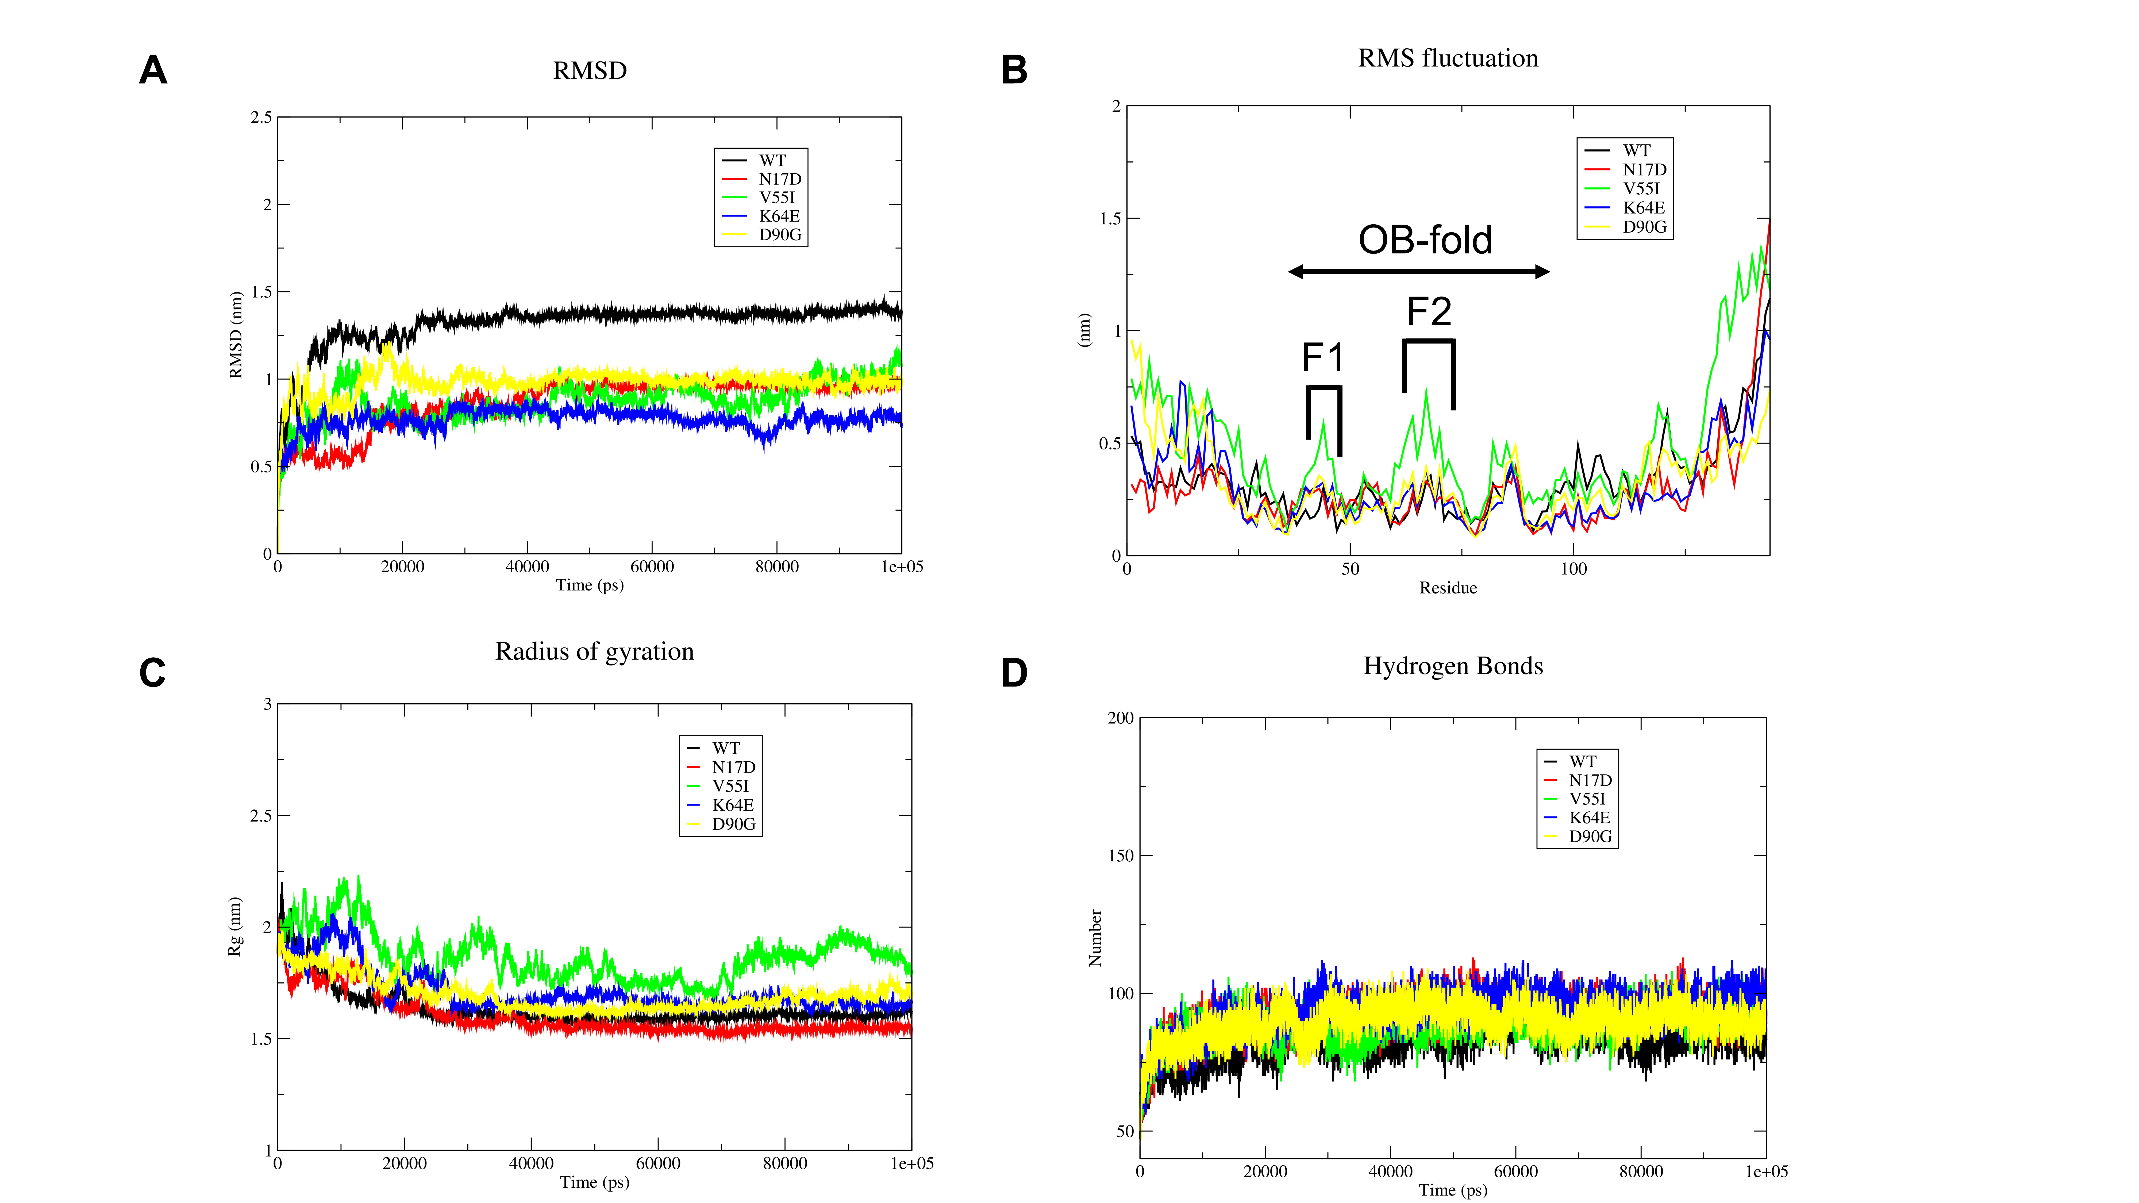

Molecular dynamic analysis of the wild-type (WT) and variant-type (VT). (A) Root-mean-square deviation (RMSD) to understand the stable nature of the protein. The average RMSD (1.2 and 1.49 nm) for the WT compared with VT revealed the stable nature of VT. (B) Highly flexible Root-mean-square fluctuation residues denoted as F1 and F2. (C) Radius of gyration plot used to understand protein compactness. (D) Number of the intramolecular hydrogen bonds formed during the simulation.

FIGURE S2
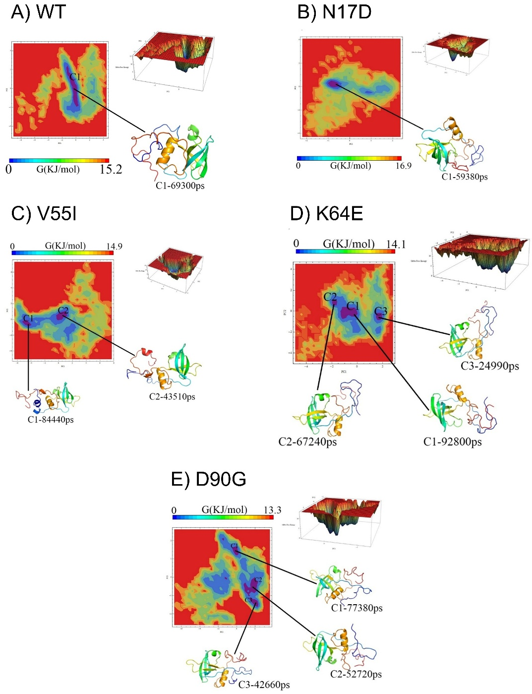

Principal component (PC) analysis-based free-energy landscape analysis was performed for wild-type (WT) and variant strains to understand the path of reaching minimum energy in a global concerted motion. We built the covariance matrix using Cα atoms (432 × 432) to obtain correlated residual motion for the WT and variant models. Subsequently, we generated the free energy landscape contour charts for each PC's unique Gibbs free energy. (A) WT, (B) N17D, (C) V55I, (D) K64E, and (E) D90G variants. The WT model showed a single central cluster basin with a Gibbs free energy of 15.2 kJ/mol, indicating the stable nature of the protein throughout the simulation period. The V55I variant displayed multiple energy cluster basins with a minimum free energy of 14.9 kJ/mol, suggesting moderate conformational flexibility. However, the overall free energy profile and clustering pattern were comparable to WT, supporting the classification of V55I as a benign variant with no significant impact on structural stability. In contrast, the K64E and D90G variants exhibited multiple low-energy basins at 14.1 and 13.3 kJ/mol, respectively, indicating greater conformational heterogeneity and reduced structural stability, possibly associated with pathogenicity. The N17D variant formed a single small cluster with Gibbs free energy values of 16.9 kJ/mol, suggesting structural behavior like WT.

FIGURE S3

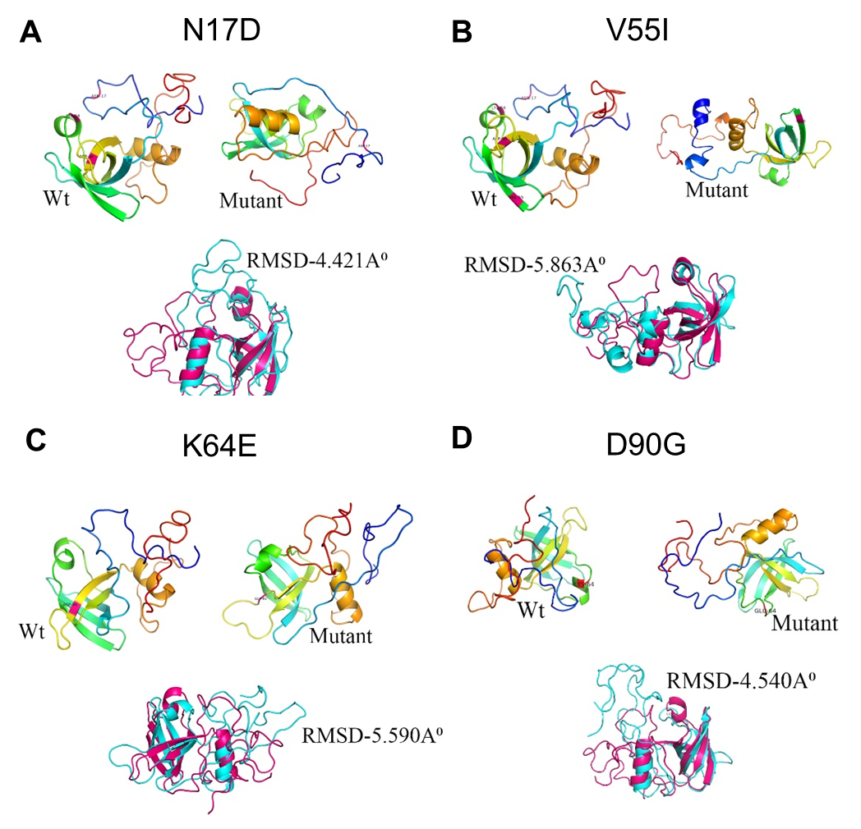
The wild-type (WT) and variant structures of EIF1AX were superimposed on the minimum energy cluster to understand the structural variations. (A) WT-N17D, (B) WT-V55I, (C) WT- K64E, and (D) WT-D90G.
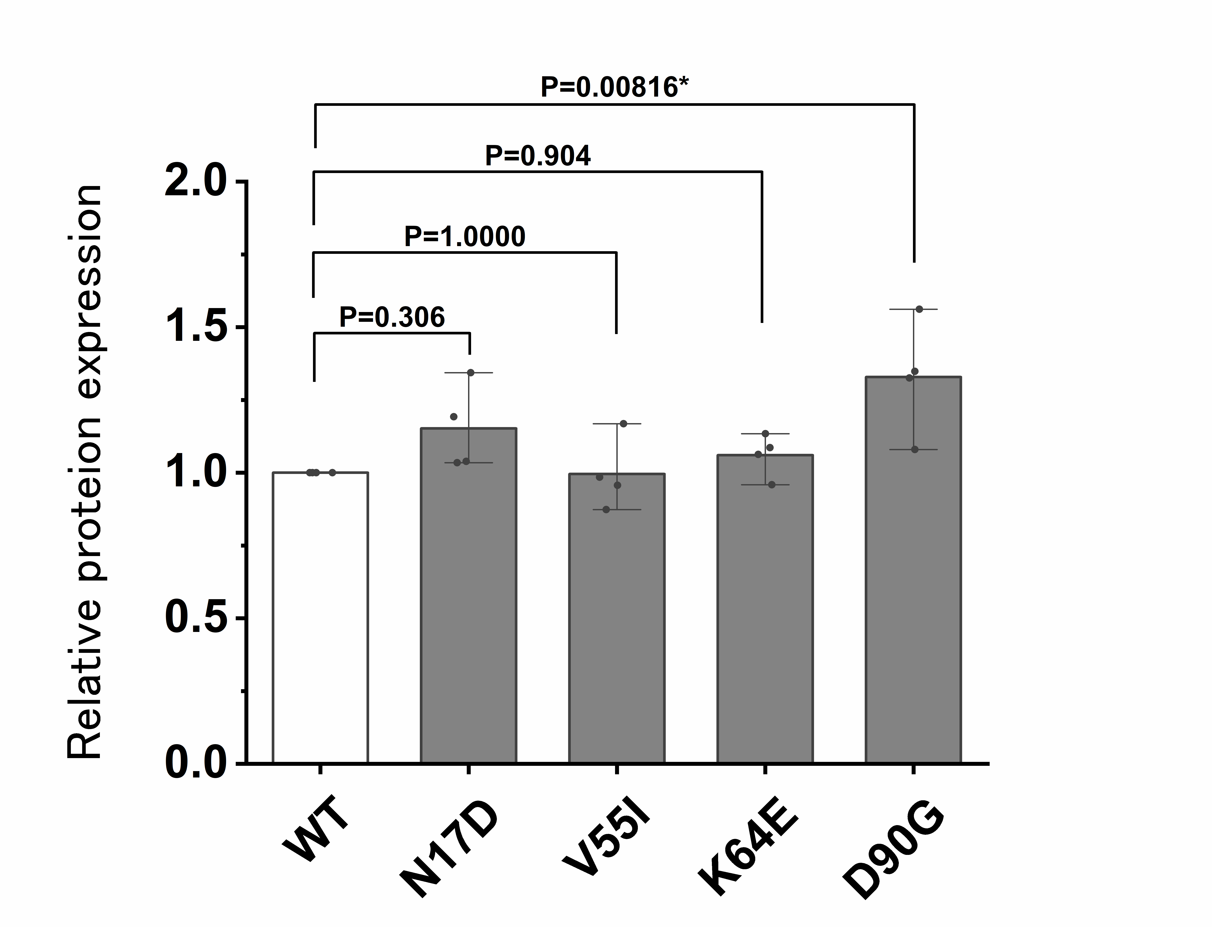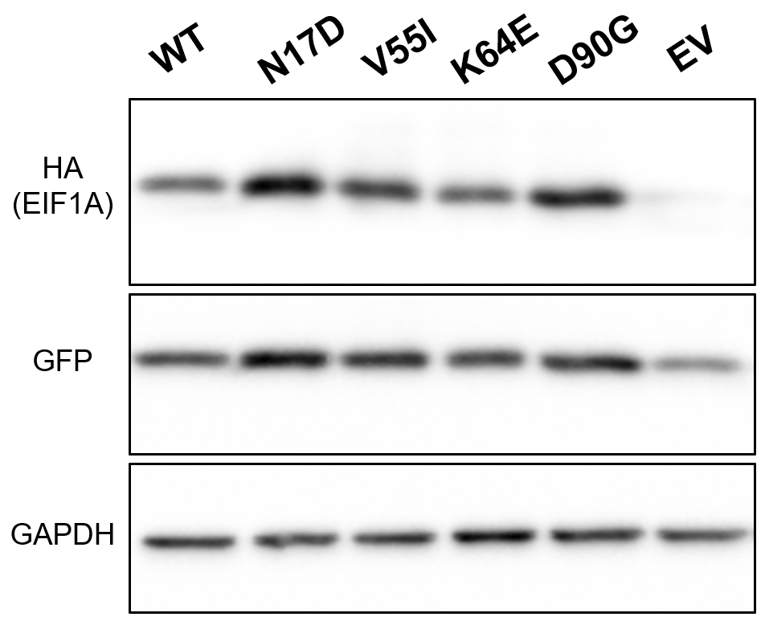FIGURE S4

HEK293FT cells were transfected with wild-type (WT) or variant HA-tagged EIF1AX plasmids. Data were normalized to glyceraldehyde-3-phosphate dehydrogenase (GAPDH; loading control). No differences were observed in the quantities of EIF1AX between the WT and the three variants, except for that in the D90G variant. Western blots were quantified by densitometric analysis using ImageJ software (n = 4). The bars represent standard errors of the mean. Statistical analysis was performed using the EZR software (Saitama Medical Center, Jichi Medical University). *p < 0.01 compared with WT; one-way analysis of variance (ANOVA) with Dunnett’s post-hoc test for multiple comparisons. EV, empty vector.

Supplemental Tables
TABLE S1. Primer sequences for minigene analysis and EIF1AX cDNA expression vectors and mutagenesis.
Primer sets for minigene analysis:
 | Forward primer (5′ > 3′) | Reverse primer (5′ > 3′)
EIF1AX WT | GTGAGCTGTCGAATTAGGTTTTACGACTGACCTTT | GGACCAAGGCCATCGTGAACCAATGAGGGTGAGG
EGFP-splice | GGCGACGTAAACGGCCACAAGTTCA | CTTCAGCTCGATGCGGTTCA

Primer sets for EIF1AX cDNA constructs:
 | Forward primer (5′ > 3′) | Reverse primer (5′ > 3′)
EIF1AX WT | CTCAAGCTTCGATGCCCAAGAATAAAGGTAAAGGAGG | CGGTGGATCCTTAGATGTCATCAATATCTTCATCATCATCTCC
Change vector | GCCGCTCTCGAGATGTATCCAT | GCCGGCGAATTCTTAGATGTCA

Primer sets for mutagenesis:
Variants | Forward primer (5′ > 3′) | Reverse primer (5′ > 3′)
c.49A>G | GATGAGAATGAATCTGAAAAA | CTTACCCCTGCGTCTGTTTT
c.163G>A | ATAAAGAGGTTATGTCACATC | ACCATCGAAACACATTGCTTC
c.190A>G | GAATTGAGAAAAAAGGTTTGG | TCCTCTGATGTGACATAACC
c.204G>C | GAAAAAACGTAGGTGTGATTTGTTTT | CACCTACGTTTTTTCTCAATTTTCCT
c.269A>G | GTGTAATTTTAAAATACAATG | CAGCTTTGTTATCCTGGTAG
TABLE S2. Prediction of EIF1AX variant pathogenicity
Chr | Gene | Variant (NM_001412.4) | gnomAD | SIFT | PolyPhen2HumVar | CADD phred | AlphaMissense | M-CAP | GERP | PhastCons
X | EIF1AX | c.49A>G, p.(Asn17Asp) | - | 0.04 | 0.811 | 24.8 | 0.9769 | 0.061; possibly pathogenic | 4.94 | 1
X | EIF1AX | c.163G>A, p.(Val55Ile) | 5.45 × 10⁻⁶ | 0.21 | 0.02 | 16.67 | 0.0768 | 0.113; possibly pathogenic | 4.29 | 1
X | EIF1AX | c.190A>G, p.(Lys64Glu) | - | 0.01 | 0.866 | 26.6 | 0.9868 | 0.504; possibly pathogenic | 4.31 | 1
X | EIF1AX | c.204G>C, p.(Lys68Asn) | - | 0 | 0.999 | 33 | 0.9964 | 0.835; possibly pathogenic | 5.47 | 1
X | EIF1AX | c.269A>G, p.(Asp90Gly) | - | 0 | 1 | 27.7 | 0.9984 | 0.293; possibly pathogenic | 4.94 | 1

TABLE S3. Splicing predictions of the c.204G>C variant by bioinformatic splicing prediction tools.
Chr | Gene | Variant (NM_001412.4) | SpliceAI |  |  |  | Pangolin |  | SpliceRover
Chr | Gene | Variant (NM_001412.4) | Acceptor Loss | Donor Loss | Acceptor Gain | Donor Gain | Splice Loss | Splice Gain | Donor (Wild type) | Donor (Variant type)
X | EIF1AX | c.204G>C, p.(Lys68Asn) | 0.00 | 0.08 | 0.01 | 0.21 | -0.22 | 0.09 | chrX:20135733
X | EIF1AX | c.204G>C, p.(Lys68Asn) | 103 bp | 0 bp | 2563 bp | -4 bp | 103 bp | -4 bp | 0.061607 | 0.372275

Exome sequencing
DNA was extracted from the peripheral blood samples of individual 1 and his parents, and trio-based exome sequencing was performed for family 1. DNA was captured using the SureSelect Human All Exon V6 Kit (Agilent Technologies) and sequenced using a NextSeq500 platform (Illumina) with 101-bp paired-end reads. The reads were aligned to the reference genome (GRCh38) using BWA-MEM (version 0.7.17), and local realignment and base-quality recalibration were performed using GATK (version 4.1.9.0). Variants were identified using the GATK HaplotypeCaller. The final variants were annotated with Annovar [2] for analyzing predictive value of functional impact of the coding variants; assessment of allele frequencies was performed using the following databases: an in-house database of 218 control exomes, the Human genetic variation database [3], ToMMo 60KJPN Allele Frequency Panel (v20240904) [4], and the gnomAD database [5,6]. Prediction of significance of variants was performed using SIFT [7], Polyphen-2 [8], CADD [9], and M-CAP [10] programs. We used multiple bioinformatics splicing prediction tools, including the deep learning networks SpliceAI, [11] Pangolin, [12] and SpliceRover [13] , to examine the variants affecting mRNA splicing. All the candidate variants were confirmed by Sanger sequencing using ABI 3130xl Genetic Analyzer (Applied Biosystems).

In silico molecular analysis
To study the structure-based stability of the variant protein, we obtained the 3D structure of the eukaryotic translation initiation factor (EIF1AX; PDB ID: 1D7Q) from the Research Collaboratory for Structural Bioinformatics-Protein Data Bank (RCSB-PDB) database (http://www.rcsb.org/), and the structure was processed by removing the crystallographic water molecules and rearranging the sequence number to insert mutations at the desired positions. The mutant models for EIF1AX were generated by introducing point variants at different positions (N17D, V55I, K64E, and D90G) by using the mutagenesis wizard of the PyMOL software.

Molecular dynamics
Molecular dynamic (MD) analysis is a computational method used to investigate the conformational behavior of macromolecules at the molecular level. MD was performed for both the wild-type (WT) and variant EIF1AX models using the GROMACS 2022.3 package. The structures of WT and variants were parameterized with the “CHARMM27” force field [14] and solvated using the transferable intermolecular potential3 points (TIP3P) water model in a cubic cell with periodic boundary condition [15] . Steepest Descent algorithm were used to minimize the structures over 50000 steps with a convergence tolerance of 1000 kJ/mol/nm. The minimized systems were subjected to two ensemble conditions, NVT and NPT; while equilibrating NVT (constant number of particles, volume, and temperature), the complete system was treated using the V-rescale method at 300 K [16], while equilibrating NPT (constant number of particles, pressure, and temperature), a constant pressure of 1 atm was maintained using the Parrinello–Rahman method throughout the system for a time period of 500 ps. The particle mesh Ewald method was used to measure van der Waals forces and long-range electrostatic interactions. To maintain the bond length and geometry of the water molecules, LINCS and SETTLE [17] algorithms were used. Finally, the system was subjected to a 100 ns MD simulation, where its structural coordinates and energy were stored every 2 ps in the trajectory. Furthermore, data from the trajectories were analyzed using the GROMACS built-in utilities g_rms, g_rmsf, g_gyrate, and g_hbond, and the plots were constructed using the Xmgrace module.
Principal component analysis (PCA) is a statistical approach to understand the global concerted motion of macromolecules from the MD trajectories and reduce its dimensionality [15] . The principal components (PCs) were calculated using alpha carbon atoms (Cα) of the proteins using GROMACS. A covariance matrix and eigenvectors of the atomic fluctuations were generated using g_covar and g_anaeig built-in in GROMACS. In general, the top eigenvectors possessing highly relevant biological conformation, fetched from the covariance matrix along with their cosine content values, were calculated; these cosine values were responsible for describing the strenuous motion from globally concerted motion. The cosine values ranged from 0 to 1 for the time period T:
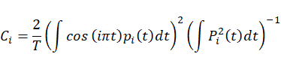
The cosine value (< 0.2) considered to produce the two major principal components was selected to produce smooth free-energy landscape (FEL) contour plots using the g_sham script [18].

Plasmid construct
Human WT EIF1AX cDNA (NM_001412.4) was prepared by polymerase chain reaction (PCR) using a cDNA library transcribed from mRNA derived from healthy human urinary cells. EIF1AX cDNA was ligated into pEF1a-1xHA-C1-hygro to put a HA tag using HindIII and BamHI cut sites. Next, inverse PCR was performed for each EIF1AX variant using the KOD-Plus-Neo polymerase (TOYOBO, Osaka, Japan). WT and variant-type (VT) with the inserted HA-EIF1AX sequences (c.49A>G, c.190A>G, c.163G>A, and c.269A>G) were amplified for use as templates for the WT and VT pEF1a-1xHA-EIF1AX-C1-hygro vectors by adding the EcoRI and XhoI cut sites. These products were ligated into the pCAG-IRES2-EGFP vector (constructed from IRES2-EGFP [Clontech, Palo Alto, CA, USA]) and digested with the EcoRI-HF and XhoI restriction enzymes. We selected the WT and VT plasmid vectors using colony PCR and confirmed the sequences using Sanger sequencing. The primers used are listed in Table S1.

Immunoblot analysis
HEK293FT cells (Thermo Fisher Scientific) were grown in 6-well plate and transfected with 4 µg WT or mutant EIF1AX-expressing plasmids using 12 µg polyethylenimine “MAX” reagent. After 48 h of transfection, the cells were harvested to extract proteins using radioimmunoprecipitation assay lysis buffer (150 mM NaCl; 50 mM Tris-HCl, pH 7.5; 1 % NP-40; 0.5 % sodium deoxycholate; 0.1 % sodium dodecyl sulfate [SDS]; 1× phoshatase inhibitor). Protein concentration was measured using the Pierce BCA Protein Assay Kit (Thermo Fisher Scientific, Waltham, MA, USA). Next, 5 µg of each sample was analyzed by SDS-PAGE and immunoblotting using HRP-conjugated HA-Tag (C29F4) monoclonal antibodies (Catalogue #14031S; 1:10000; rabbit; Cell Signaling Technology, Beverly, MA, USA), HRP-conjugated GAPDH monoclonal antibodies (Catalogue #HRP-60004; 1:50,000; mouse; Proteintech, Rosemont, IL, USA), and anti-green fluorescent protein (GFP; Catalogue #598; 1:5,000; rabbit; MBL, Nagoya, Japan) were used as primary antibodies. The secondary antibodies used for immunoblotting were peroxidase-conjugated AffiniPure goat anti-rabbit immunoglobulin G (IgG;H+L) (Catalogue #111-035-003; 1:5,000; Jackson ImmunoResearch, West Grove, PA, USA). The membrane was treated with Clarity Western blot ECL substrate (BioRad, Hercules, CA, USA), and signals were captured using FUSION-FX7.EDGE (Vilber Lourmat, Co, Torcy, France); protein levels were measured using the ImageJ software [19].

Supplemental References
1. Takemoto Y, Suzuki Y, Horibe R, Shimozawa N, Wanders RJ, Kondo N: Gas chromatography/mass spectrometry analysis of very long chain fatty acids, docosahexaenoic acid, phytanic acid and plasmalogen for the screening of peroxisomal disorders. Brain Dev 2003;25:481-487.
2. Wang K, Li M, Hakonarson H: ANNOVAR: functional annotation of genetic variants from high-throughput sequencing data. Nucleic Acids Res 2010;38:e164.
3. Higasa K, Miyake N, Yoshimura J, Okamura K, Niihori T, Saitsu H et al: Human genetic variation database, a reference database of genetic variations in the Japanese population. J Hum Genet 2016;61:547-553.
4. Tadaka S, Hishinuma E, Komaki S, Motoike IN, Kawashima J, Saigusa D et al: jMorp updates in 2020: large enhancement of multi-omics data resources on the general Japanese population. Nucleic Acids Res 2021;49:D536-d544.
5. Lek M, Karczewski KJ, Minikel EV, Samocha KE, Banks E, Fennell T et al: Analysis of protein-coding genetic variation in 60,706 humans. Nature 2016;536:285-291.
6. Karczewski KJ, Francioli LC, Tiao G, Cummings BB, Alföldi J, Wang Q et al: The mutational constraint spectrum quantified from variation in 141,456 humans. Nature 2020;581:434-443.
7. Ng PC, Henikoff S: Predicting deleterious amino acid substitutions. Genome Res 2001;11:863-874.
8. Adzhubei IA, Schmidt S, Peshkin L, Ramensky VE, Gerasimova A, Bork P et al: A method and server for predicting damaging missense mutations. Nat Methods 2010;7:248-249.
9. Rentzsch P, Witten D, Cooper GM, Shendure J, Kircher M: CADD: predicting the deleteriousness of variants throughout the human genome. Nucleic Acids Res 2019;47:D886-d894.
10. Jagadeesh KA, Wenger AM, Berger MJ, Guturu H, Stenson PD, Cooper DN et al: M-CAP eliminates a majority of variants of uncertain significance in clinical exomes at high sensitivity. Nat Genet 2016;48:1581-1586.
11. Jaganathan K, Kyriazopoulou Panagiotopoulou S, McRae JF, Darbandi SF, Knowles D, Li YI et al: Predicting Splicing from Primary Sequence with Deep Learning. Cell 2019;176:535-548.e524.
12. Zeng T, Li YI: Predicting RNA splicing from DNA sequence using Pangolin. Genome Biol 2022;23:103.
13. Zuallaert J, Godin F, Kim M, Soete A, Saeys Y, De Neve W: SpliceRover: interpretable convolutional neural networks for improved splice site prediction. Bioinformatics 2018;34:4180-4188.
14. Bjelkmar P, Larsson P, Cuendet MA, Hess B, Lindahl E: Implementation of the CHARMM Force Field in GROMACS: Analysis of Protein Stability Effects from Correction Maps, Virtual Interaction Sites, and Water Models. J Chem Theory Comput 2010;6:459-466.
15. David CC, Jacobs DJ: Principal component analysis: a method for determining the essential dynamics of proteins. Methods Mol Biol 2014;1084:193-226.
16. Berendsen HJC, Postma JPM, van Gunsteren WF, DiNola A, Haak JR: Molecular dynamics with coupling to an external bath. The Journal of Chemical Physics 1984;81:3684-3690.
17. Miyamoto S, Kollman PA: SETTLE: An Analytical Version of the SHAKE and RATTLE Algorithm for Rigid Water Models. J Comput Chem 1992;13:952-962.
18. Yadav PK, Antonyraj CB, Basheer Ahamed SI, Srinivas S: Understanding Russell's viper venom factor V activator's substrate specificity by surface plasmon resonance and in-silico studies. PLoS One 2017;12:e0181216.
19. Schneider CA, Rasband WS, Eliceiri KW: NIH Image to ImageJ: 25 years of image analysis. Nat Methods 2012;9:671-675.

