Supplementary Information
Title
Caspase inhibition restores dopaminergic identity through the PKA–CREB–BDNF axis in Parkinson’s disease neurons
Running title Caspase–PKA–CREB axis in Parkinson’s disease neurons
Authors
Giorgia Lucia Benedetto^{1,7}, Raffaele Covello^{2,7}, Stefania Scalise^{2,*}, Caterina Gabriele², Barbara Puccio¹, Desirèe Valente², Clara Zannino^{2,3}, Pietro Hiram Guzzi¹, Pierangelo Veltri⁴, Andrea Quattrone^{1,5}, Verdon Taylor⁶, Marco Gaspari², Aldo Quattrone⁵, Elvira Immacolata Parrotta¹, and Giovanni Cuda²

¹ Department of Medical and Surgical Sciences, University Magna Graecia of Catanzaro, Catanzaro, Italy.
² Department of Experimental and Clinical Medicine, University Magna Graecia of Catanzaro, Catanzaro, Italy.
³ Department of Experimental Medical Science, Lund University, Lund, Sweden.
⁴ Department of Computer Science, Modeling, Electronics and Systems Engineering (DIMES), University of Calabria, Rende, Italy.
⁵ Neuroscience Research Center, University Magna Graecia of Catanzaro, Catanzaro, Italy.
⁶ Embryology and Stem Cell Biology, Department of Biomedicine, University of Basel, Basel, Switzerland.
⁷ These authors contributed equally to this work
* email to: stefania.scalise@unicz.it

Supplemental Figures
- Supplemental Figures 1 to 3 and their legends

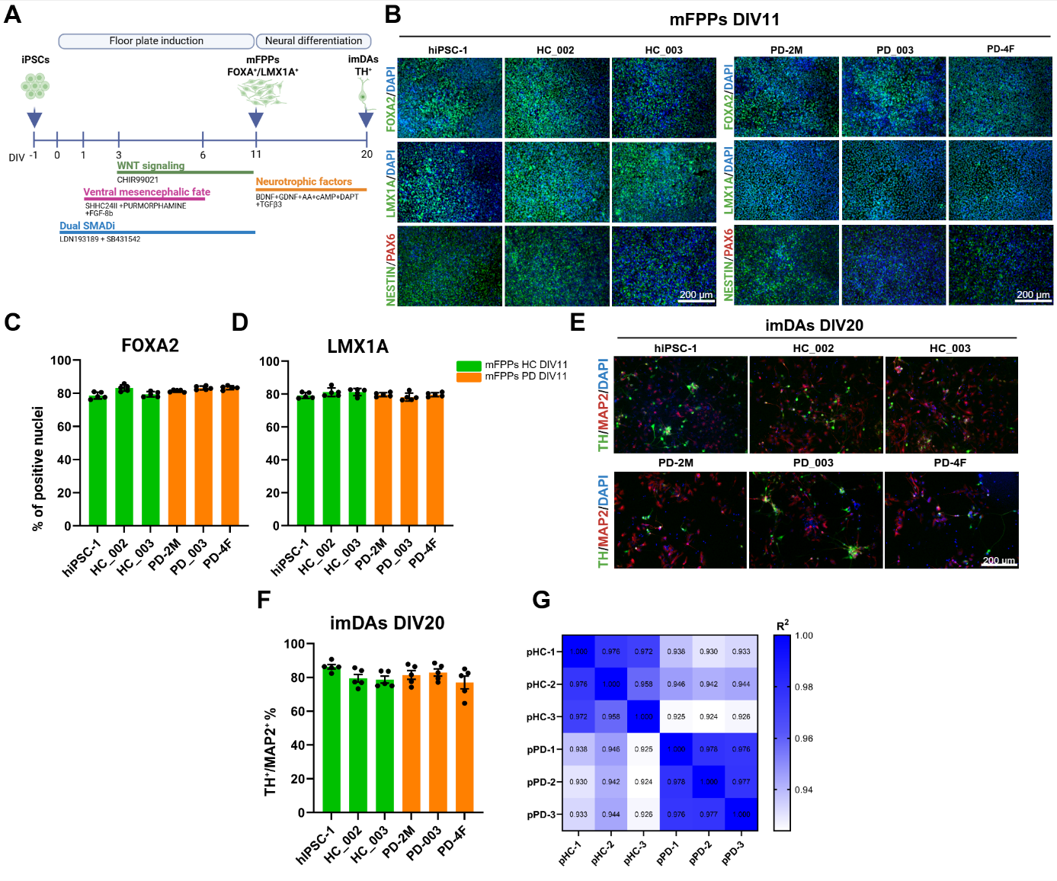
Supplementary Fig. S1 (related to Figure 1). Characterization of mDA neuron differentiation from iPSCs. A Schematic overview of the differentiation protocol from iPSCs to midbrain floor plate progenitors (mFPPs) and subsequently to immature mDA neurons. B Representative immunofluorescence images of FOXA2, LMX1A, NESTIN, and PAX6 (green) in mFPPs at DIV11. Magnification: 20X. C Quantification of FOXA2 and (D) LMX1A positive-nuclei in mFPPs at DIV11. Both quantifications were based on N = 5 images per group, data are presented as mean ± s.e.m.. E Representative immunofluorescence images of TH (green) and MAP2 (red) in mDAs at DIV20. F Quantification of the percentage of TH⁺/MAP2⁺ cells performed at DIV20. Quantification was based on N = 5 images per group. Data are presented as mean ± s.e.m.. G Pearson correlation matrix of RNA-seq data from pooled HC and pooled PD mDA neurons at DIV60. DIV, days in vitro.

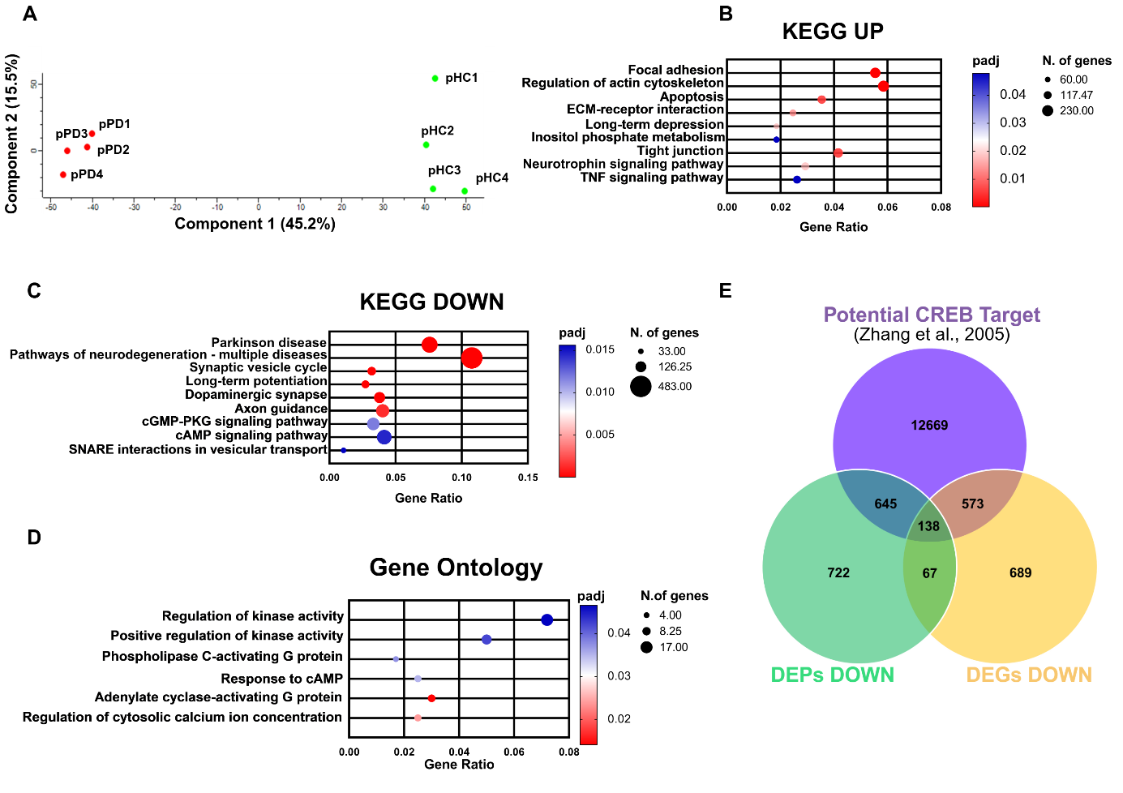
Supplementary Figure S2 (related to Figure 4). Proteomic and transcriptomic analyses reveal PKA-CREB pathway dysregulation in pPD mDA neurons. A Principal Component Analysis (PCA) of proteomic profiles from pHC and pPD mDA neurons at DIV60. B KEGG pathway enrichment analysis of significantly upregulated proteins in pPD compared to pHC. C KEGG pathway enrichment analysis of significantly downregulated proteins in pPD. D GO enrichment analysis of DEPS proteins showing significant association with the PKA-CREB signaling cascade. For (B), (C), and (D), data were analyzed by ClusterProfiler R package, with a significance threshold set at p-value ≤ 0.05. E Venn diagram showing the overlap between downregulated DEPs, downregulated DEGs, and CREB target genes as reported in Zhang et al., 2025.

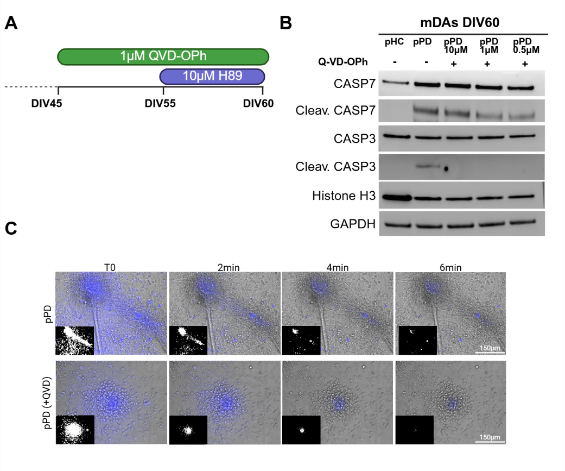
Supplementary Figure S3 (related to Figure 7). Caspase inhibition by Q-VD-OPh in pPD mDA neurons. A Experimental timeline of Q-VD-OPh treatment in mDA neurons. B Western blot analysis of cleaved CASP3 and CASP7 in mDAs neurons after treatment with increasing concentrations of Q-VD-OPh (0.5, 1, and 10 µM). C Representative images of the dopamine analog FFN 102 uptake (0 min) and KCl-induced release captured at 2, 4, and 6 minutes after KCl administration in pPD and Q-VD-OPh-treated pPD mDAs.

