Appendix
Table 1. Mean, variances and univariate skewnesses & kurtoses of the short DSI scale’ items
Items | Mean | Variance | Skewness | Kurtosis
TO1 | 3.212 | 2.051 | -.413 | -.875
TO2 | 3.658 | 1.839 | -.830 | -.510
TO3 | 3.770 | 1.907 | -.996 | -.241
TO4 | 3.667 | 1.822 | -.912 | -.260
TO5 | 3.368 | 2.106 | -.602 | -.655
TO6 | 3.650 | 1.972 | -.851 | -.498
INP1 | 3.298 | 1.539 | -.408 | -.779
INP2 | 3.624 | 1.694 | -.878 | -.234
INP3 | 3.460 | 1.723 | -.685 | -.480
INP4 | 3.039 | 1.888 | -.362 | -.804
INP5 | 3.189 | 1.836 | -.350 | -.905
INP6 | 3.273 | 1.769 | -.364 | -.875
CI1 | 3.612 | 1.734 | -.807 | -.363
CI2 | 3.663 | 1.829 | -.805 | -.467
CI3 | 3.690 | 1.799 | -.845 | -.439
CI4 | 3.720 | 1.747 | -.912 | -.193
CI5 | 3.405 | 2.007 | -.644 | -.680
CI6 | 3.583 | 1.952 | -.764 | -.538
CCP1 | 3.463 | 1.670 | -.513 | -.905
CCP2 | 3.413 | 1.780 | -.437 | -1.004
CCP3 | 3.454 | 1.695 | -.561 | -.758
CCP4 | 3.430 | 1.767 | -.521 | -.799
CCP5 | 3.455 | 1.792 | -.564 | -.708
CCP6 | 3.420 | 1.814 | -.559 | -.697

Table 2. The factorial latent structure for the four dimensional ESEM (continuous data) with item uniquenesses and R-square values

Items/Factors | TO | INP | CI | CCP | Residual Variances | R-SQUARE
TO1 | .497* | .153 | -.048 | 0.089 | .574 | .426
TO2 | .767* | -.001 | .097 | -0.024 | .326 | .674
TO3 | .911* | -.062 | .032 | -0.019 | .233 | .767
TO4 | .932* | -.082 | -.067 | .074 | .226 | .774
TO5 | .565* | .255 | -.100 | -.015 | .527 | .473
TO6 | .775* | .017 | .054 | -.014 | .333 | .667
INP1 | .066 | .541* | .156 | .050 | .441 | .559
INP2 | .190 | .467* | .219 | .028 | .337 | .663
INP3 | .123 | .600* | .146 | -.004 | .360 | .640
INP4 | -.051 | .809* | -.100 | .057 | .433 | .567
INP5 | -.023 | .827* | -.051 | .027 | .364 | .636
INP6 | .003 | .794* | -.020 | .012 | .372 | .628
CI1 | .087 | -.061 | .668* | .202 | .271 | .729
CI2 | .087 | -.043 | .807* | .031 | .249 | .751
CI3 | -.001 | .002 | .892* | .018 | .178 | .822
CI4 | .020 | .027 | .962* | -.123 | .181 | .819
CI5 | -.105 | .129 | .674* | 0.074 | .442 | .558
CI6 | -.039 | .136 | .741* | 0.025 | .314 | .686
CCP1 | .008 | -.036 | .115 | .773* | .290 | .710
CCP2 | -.021 | .103 | -.004 | .786* | .284 | .716
CCP3 | .044 | -.017 | -.018 | .846* | .273 | .727
CCP4 | -.062 | -.006 | .079 | .824* | .302 | .698
CCP5 | .045 | .001 | -.066 | .883* | .246 | .754
CCP6 | .044 | .038 | -.010 | .752* | .351 | .649
Note. * p – value < .001

Table 3. Satorra-Bentler chi-square difference test

MODEL | Scaling | df | χ² | S-B scaled χ² | Δdf | p-value
1. Configural invariance | 1.3566 | 372 | 814.1
2. Weak (λ) invariance | 1.4792 | 452 | 824.4 | 56.15 | 80 | 0.980301167
3. Strong (λ, ν) invariance | 1.4553 | 472 | 873.2 | 55.99 | 20 | 2.91298E-05
4. Strict (λ, ν, δ) invariance | 1.5383 | 496 | 924 | 47.51 | 24 | 0.002905126
5. Latent variance-covariance (λ, ν, δ, ξ/φ) invariance | 1.5446 | 506 | 935.8 | 12.99 | 10 | 0.224430299
6. Latent mean (λ, ν, δ, ξ/φ, η) invariance | 1.5416 | 510 | 942.9 | 7.004 | 4 | 0.135673852

Table 4. Estimated correlation matrix for the latent variables of H-ESEM
Factors | TO | INP | CI | CCP | H-FACTOR
TO | 1.000
INP | .802 | 1.000
CI | .721 | .743 | 1.000
CCP | .733 | .755 | .679 | 1.000
H-FACTOR | .882 | .909 | .818 | .831 | 1.000
Table 5. Goodness of fit indices for ESEM and ESEM within CFA (EWC) with three predictors for two different robust estimators
GFIs | ESEM |  | EWC with predictors
GFIs | MLR | WLSMV | MLR | WLSMV
RMSEA | 0.045  (0.039 0.051) | 0.090  (0.085 0.095) | 0.045  (0.042 0.049) | 0.052  (0.049 0.055)
CFI | 0.965 | 0.983 | 0.941 | 0.983
TLI | 0.948 | 0.975 | 0.927 | 0.980
SRMR | 0.021 | 0.019 | 0.042 | 0.040
Table 6. Factor correlations of EWC for continuous data
 | Estimates | St. dev. | Est./st. dev. | p-value
INP | WITH
TO | 0.728 | 0.049 | 14.920 | 0.000
CI | WITH
TO | 0.719 | 0.042 | 17.329 | 0.000
INP | 0.661 | 0.046 | 14.290 | 0.000
CCP | WITH
TO | 0.728 | 0.041 | 17.751 | 0.000
INP | 0.749 | 0.050 | 15.057 | 0.000
CI | 0.751 | 0.036 | 20.926 | 0.000
Figure 1. Standardizes parameters of free variance EWC with three predictors with WLSMV
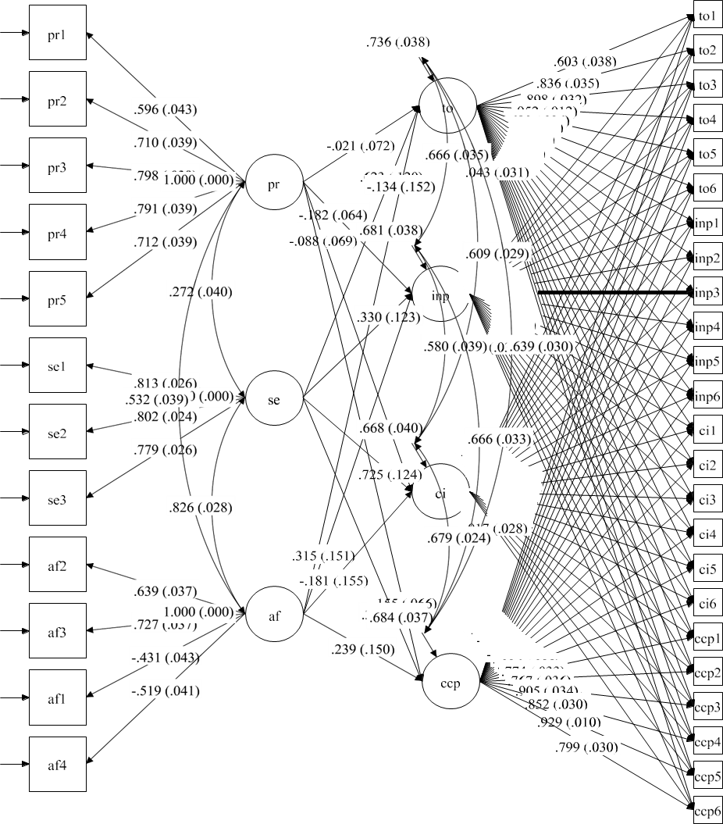
I.Questionnaire items for assessment of students’ funksional digital skills (Helsper et al., 2020)
Please indicate how true the following statements are of you when thinking about how you use the internet and technologies such as mobile phones or computers. Reply thinking about how true this would be of you if you had to do it now, on your own. If you do not understand what the question is asking, tick the box “I do not understand what you mean by this”.
The answer scale used for the digital skills items is:
Not at all  true of me | Not very  true of me | Neither  true nor  untrue of  me | Mostly true  of me | Very true  of me | I do not  understand  what you mean  by this | I do not  want to  answer
1 | 2 | 3 | 4 | 5 | 66 | 99

Dimensions |  | Items
Technical and  operational skills | TO1 | I know how to adjust privacy settings
Technical and  operational skills | TO2 | I know how to turn off the location settings on mobile devices
Technical and  operational skills | TO3 | I know how to protect a device (e.g. with a PIN, a screen pattern, a finger print,facial recognition)
Technical and  operational skills | TO4 | I know how to store photos, documents or other files in the cloud (e.g. Google, Drive, iCloud)
Technical and  operational skills | TO5 | I know how to use private browsing
Technical and  operational skills | TO6 | I know how to block unwanted pop-up messages or ads
Information  navigation and  processing | INP1 | I know how to choose the best keywords for online searches
Information  navigation and  processing | INP2 | I know how to find a website I have visited before
Information  navigation and  processing | INP3 | I know how to find information on a website no matter how it is designed
Information  navigation and  processing | INP4 | I know how to use advanced search functions in search engines
Information  navigation and  processing | INP5 | I know how to check if the information I find online is true
Information  navigation and  processing | INP6 | I know how to figure out if a website can be trusted
Communication  and interaction | CI1 | Depending on the situation, I know which medium or tool to use to communicate
Communication  and interaction | CI2 | with someone (e.g. make a call, send a WhatsApp message, send an email)
Communication  and interaction | CI3 | I know when I should mute myself or disable video in online interactions
Communication  and interaction | CI4 | I know which images and information of me it is OK to share online
Communication  and interaction | CI5 | I know when it is appropriate and when it is not appropriate to use emoticons
Communication  and interaction | CI6 | (e.g. smileys, emojis), text speak (e.g. LOL, OMG) and capital letters
Content creation  and production | CCP1 | I know how to create something that combines different digital media (e.g.
Content creation  and production | CCP2 | photos, music, videos, GIFs)
Content creation  and production | CCP3 | I know how to edit existing digital images, music and videos
Content creation  and production | CCP4 | I know how to ensure that many people will see what I put online
Content creation  and production | CCP5 | I know how to change the things I put online depending on how other people
Content creation  and production | CCP6 | react to it
II. Answer the following questions using a Likert scale, where 1-strongly disagree; 2- somewhat agree; 3-neutral; 4- agree; 5- strongly agree.

- Academic Procrastination Scale-Short Form (APSSF) Yockey (2016)
Pr1 | - I put off projects until the last minute.
Pr2 | - I often find myself doing other things when I should be working on important tasks.
Pr3 | - I delay starting assignments even when I know they are important.
Pr4 | - I waste time instead of working on assignments.
Pr5 | - I do not start assignments until the night before they are due.

- The original German version of the Allgemeine Selbstwirksamkeit Kurzskala (ASKU) (Beierlein et al., 2013)
SE1 | „In schwierigen Situationen kann ich mich auf meine Fähigkeiten verlassen.“  (In difficult situations, I can rely on my abilities.)
SE2 | „Die meisten Probleme kann ich aus eigener Kraft gut meistern.“  (I am able to solve most problems on my own.)
SE3 | „Auch bei überraschenden Ereignissen weiß ich meist einen Ausweg.“  (Even in unexpected situations, I usually know how to cope.)

- ATI-S (Wessel et al., 2019)
AF1(r) | It is enough for me that a technical system works; I don’t care how or why.
AF2 | I like to occupy myself in greater detail with technical systems
AF3 | I like testing the functions of new technical systems.
AF4(r) | It is enough for me to know the basic functions of a technical system.

